• **Culinary Arts Expo**

* **Description**: A showcase of culinary talents from renowned chefs and culinary schools. The expo will feature live cooking demonstrations, tastings of gourmet dishes, and culinary competitions. Attendees can also participate in hands-on cooking classes and explore an array of gourmet products and kitchen gadgets from exhibitors.
* **Time**: Thursday, June 27, 2024, to Friday, June 28, 2024, from 11:00 AM to 8:00 PM
* **Place**: Gourmet Pavilion, 432 Flavor Street, Foodie Town
* **Cost**: $50 per day or $90 for a two-day pass
* **Agenda**:
  + **Day 1**:
    - **11:00 AM**: Expo Opening and Welcome Remarks
    - **11:30 AM**: Live Cooking Demonstration by Celebrity Chef
    - **1:00 PM**: Tasting Session - Global Cuisine
    - **3:00 PM**: Hands-On Cooking Class - Baking Basics
    - **5:00 PM**: Culinary Competition - Appetizer Showdown
    - **7:00 PM**: Networking and Product Exploration
    - **8:00 PM**: Day 1 Closing
  + **Day 2**:
    - **11:00 AM**: Doors Open
    - **11:30 AM**: Live Cooking Demonstration - Fusion Cuisine
    - **1:00 PM**: Tasting Session - Desserts from Around the World
    - **3:00 PM**: Hands-On Cooking Class - Advanced Techniques
    - **5:00 PM**: Culinary Competition - Main Course Mastery
    - **7:00 PM**: Awards Ceremony and Closing Remarks
    - **8:00 PM**: Expo Concludes



• **Historic Walking Tour**

* **Description**: Discover the rich history of the city on this guided walking tour. The tour will visit significant landmarks, historical buildings, and sites of historical events. Expert guides will share fascinating stories and insights about the city's past, making it a perfect educational outing for history buffs and curious minds alike.
* **Time**: Sunday, May 5, 2024, from 2:00 PM to 4:00 PM
* **Place**: Starting at Heritage Square, 101 History Lane, Oldtown
* **Cost**: $20 per person, $15 for students and seniors
* **Agenda**:
  + **2:00 PM**: Meet and Greet at Heritage Square
  + **2:15 PM**: Introduction to the City's History
  + **2:30 PM**: Visit to Historical Landmark #1
  + **3:00 PM**: Walking Tour of Historic Downtown
  + **3:30 PM**: Visit to Historical Landmark #2
  + **4:00 PM**: Q&A Session and Tour Conclusion



• **Science Fair**

* **Description**: An interactive event where students from local schools present their scientific projects and innovations. The fair will include engaging experiments, educational exhibits, and science-themed activities for children. Awards will be given for the most innovative and impactful projects, fostering a spirit of curiosity and learning.
* **Time**: Saturday, March 16, 2024, from 9:00 AM to 4:00 PM
* **Place**: Community Center, 234 Learning Road, Scholar City
* **Cost**: Free admission for students and children, $10 for adults
* **Agenda**:
  + **9:00 AM**: Registration and Exhibit Setup
  + **10:00 AM**: Opening Ceremony and Welcome Address
  + **10:30 AM**: Student Project Presentations Begin
  + **12:00 PM**: Lunch Break and Interactive Experiments
  + **1:00 PM**: Guest Speaker - Topic: The Future of Science
  + **2:00 PM**: Science-Themed Activities for Children
  + **3:00 PM**: Judging and Awards Ceremony
  + **4:00 PM**: Event Conclusion

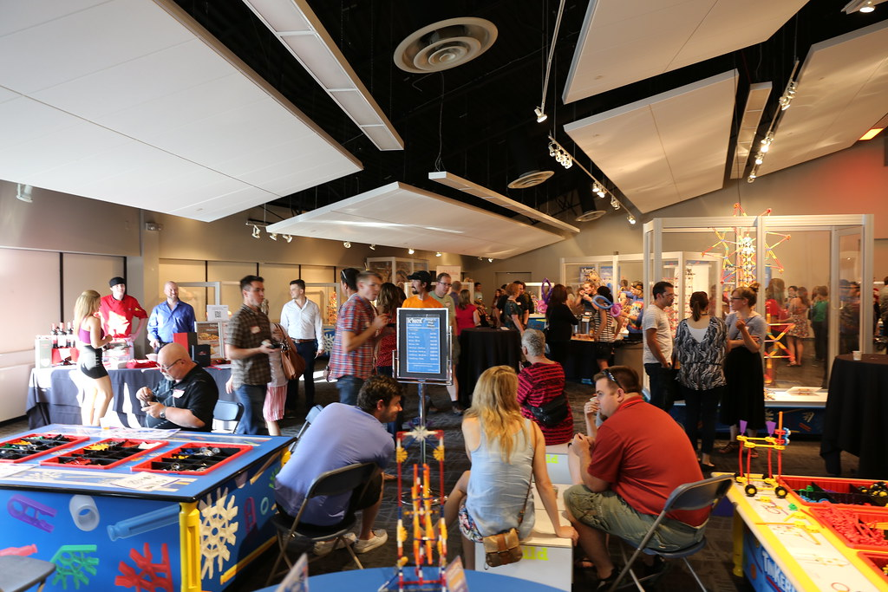

• **Photography Exhibition**

* **Description**: A stunning display of photographs from around the world, showcasing the work of both amateur and professional photographers. The exhibition will feature themed galleries, with opportunities to purchase prints and attend photography workshops. A meet-and-greet session with some of the photographers will be held during the opening night reception.
* **Time**: Friday, February 22, 2024, to Sunday, February 24, 2024, from 10:00 AM to 6:00 PM
* **Place**: Art Gallery, 567 Image Avenue, Pictureville
* **Cost**: $15 per day or $40 for a three-day pass
* **Agenda**:
  + **Day 1**:
    - **10:00 AM**: Exhibition Opening and Welcome Remarks
    - **11:00 AM**: Guided Tour of Themed Galleries
    - **1:00 PM**: Photography Workshop - Basics of Composition
    - **3:00 PM**: Meet-and-Greet with Featured Photographers
    - **6:00 PM**: Day 1 Closing
  + **Day 2**:
    - **10:00 AM**: Doors Open
    - **11:00 AM**: Panel Discussion - Trends in Photography
    - **1:00 PM**: Photography Workshop - Advanced Techniques
    - **3:00 PM**: Photo Editing Demonstration
    - **6:00 PM**: Day 2 Closing
  + **Day 3**:
    - **10:00 AM**: Exhibition Opens
    - **11:00 AM**: Guest Speaker - The Art of Storytelling Through Photos
    - **1:00 PM**: Final Photography Workshop - Creating Impactful Images
    - **3:00 PM**: Closing Remarks and Networking
    - **6:00 PM**: Exhibition Concludes

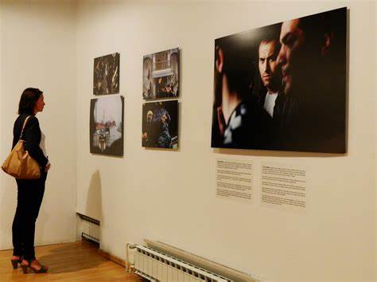

• **Yoga Retreat**

* **Description**: A weekend retreat focusing on wellness with yoga sessions, meditation, healthy meals, and nature walks. Attendees will have the opportunity to unwind, rejuvenate, and learn about holistic health practices from experienced instructors. The serene environment will enhance the overall experience, promoting relaxation and inner peace.
* **Time**: Friday, July 19, 2024, to Sunday, July 21, 2024, from 8:00 AM to 6:00 PM each day
* **Place**: Tranquil Retreat Center, 890 Serenity Road, Peaceville
* **Cost**: $300 per person for the full retreat, including meals and accommodation
* **Agenda**:
  + **Day 1**:
    - **8:00 AM**: Arrival and Welcome Breakfast
    - **9:00 AM**: Opening Yoga Session - Hatha Yoga
    - **11:00 AM**: Guided Meditation
    - **12:00 PM**: Healthy Lunch
    - **2:00 PM**: Workshop - The Basics of Ayurveda
    - **4:00 PM**: Nature Walk and Reflection
    - **6:00 PM**: Day 1 Concludes
  + **Day 2**:
    - **8:00 AM**: Morning Yoga - Vinyasa Flow
    - **10:00 AM**: Mindfulness Meditation
    - **12:00 PM**: Nutritious Lunch
    - **2:00 PM**: Workshop - Integrative Nutrition
    - **4:00 PM**: Free Time for Relaxation or Personal Activities
    - **6:00 PM**: Evening Yoga - Restorative Yoga
  + **Day 3**:
    - **8:00 AM**: Sunrise Yoga - Ashtanga Yoga
    - **10:00 AM**: Breathing Techniques and Pranayama
    - **12:00 PM**: Farewell Lunch
    - **2:00 PM**: Group Discussion - Implementing Wellness at Home
    - **4:00 PM**: Closing Meditation and Reflection
    - **6:00 PM**: Retreat Concludes

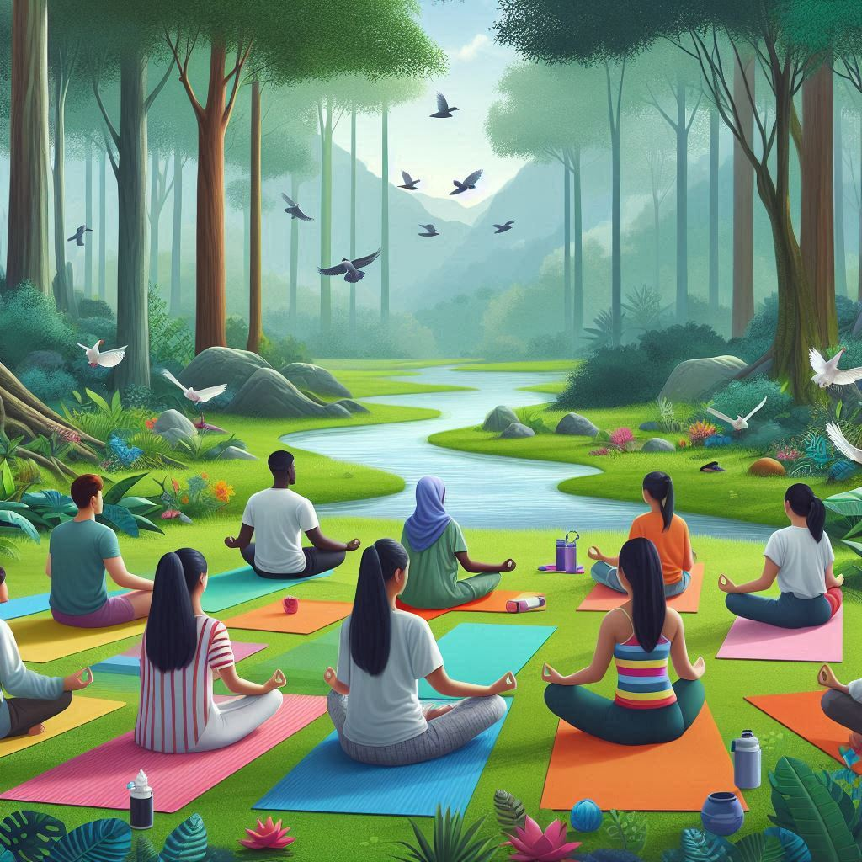

• **Literary Festival**

* **Description**: A celebration of literature featuring renowned authors, poets, and literary critics. The festival will include book signings, readings, panel discussions, and workshops. Attendees can engage with their favorite authors, discover new books, and participate in literary activities.
* **Time**: Friday, September 6, 2024, to Sunday, September 8, 2024, from 10:00 AM to 6:00 PM each day
* **Place**: Grand Library, 567 Book Lane, Literaria City
* **Cost**: $30 per day or $75 for a three-day pass
* **Agenda**:
  + **Day 1**:
    - **10:00 AM**: Festival Opening and Welcome Remarks
    - **11:00 AM**: Author Reading and Q&A - Fiction
    - **1:00 PM**: Book Signing Session
    - **2:00 PM**: Panel Discussion - The Future of Publishing
    - **4:00 PM**: Workshop - Creative Writing Techniques
    - **6:00 PM**: Day 1 Closing
  + **Day 2**:
    - **10:00 AM**: Doors Open
    - **11:00 AM**: Poetry Reading and Q&A
    - **1:00 PM**: Book Signing Session
    - **2:00 PM**: Panel Discussion - Diversity in Literature
    - **4:00 PM**: Workshop - Memoir Writing
    - **6:00 PM**: Day 2 Closing
  + **Day 3**:
    - **10:00 AM**: Doors Open
    - **11:00 AM**: Children's Storytime and Activities
    - **1:00 PM**: Book Signing Session
    - **2:00 PM**: Panel Discussion - Adapting Books to Screen
    - **4:00 PM**: Workshop - Self-Publishing
    - **6:00 PM**: Festival Concludes

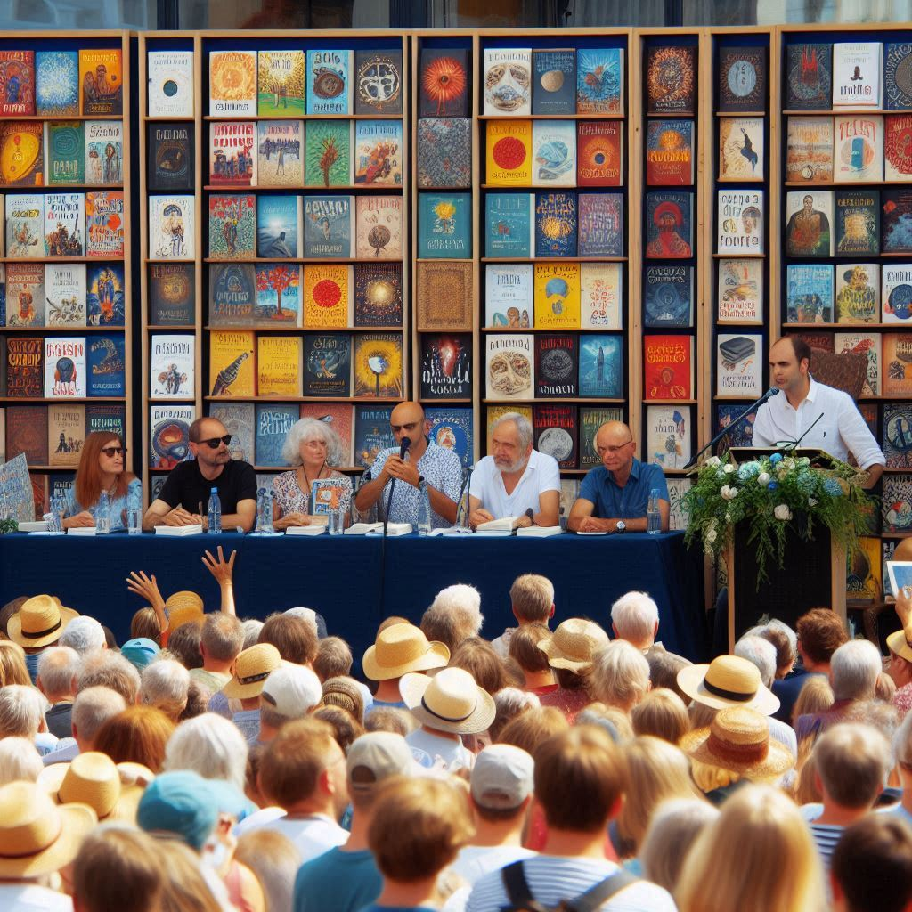

• **Health and Wellness Expo**

* **Description**: A comprehensive expo focused on health and wellness, featuring expert speakers, fitness demonstrations, health screenings, and a marketplace of health products. Attendees can learn about the latest health trends, participate in fitness classes, and receive free health check-ups.
* **Time**: Saturday, April 13, 2024, from 9:00 AM to 5:00 PM
* **Place**: Wellness Center, 123 Healthy Way, Fitville
* **Cost**: $25 per person, free for children under 12
* **Agenda**:
  + **9:00 AM**: Registration and Welcome
  + **9:30 AM**: Health Screening Stations Open
  + **10:00 AM**: Keynote Speaker - The Importance of Mental Health
  + **11:00 AM**: Fitness Class - Yoga for Beginners
  + **12:00 PM**: Healthy Cooking Demonstration
  + **1:00 PM**: Expert Panel - Nutrition Myths Debunked
  + **2:00 PM**: Fitness Class - High-Intensity Interval Training
  + **3:00 PM**: Workshop - Stress Management Techniques
  + **4:00 PM**: Raffle Draw and Closing Remarks
  + **5:00 PM**: Expo Closes

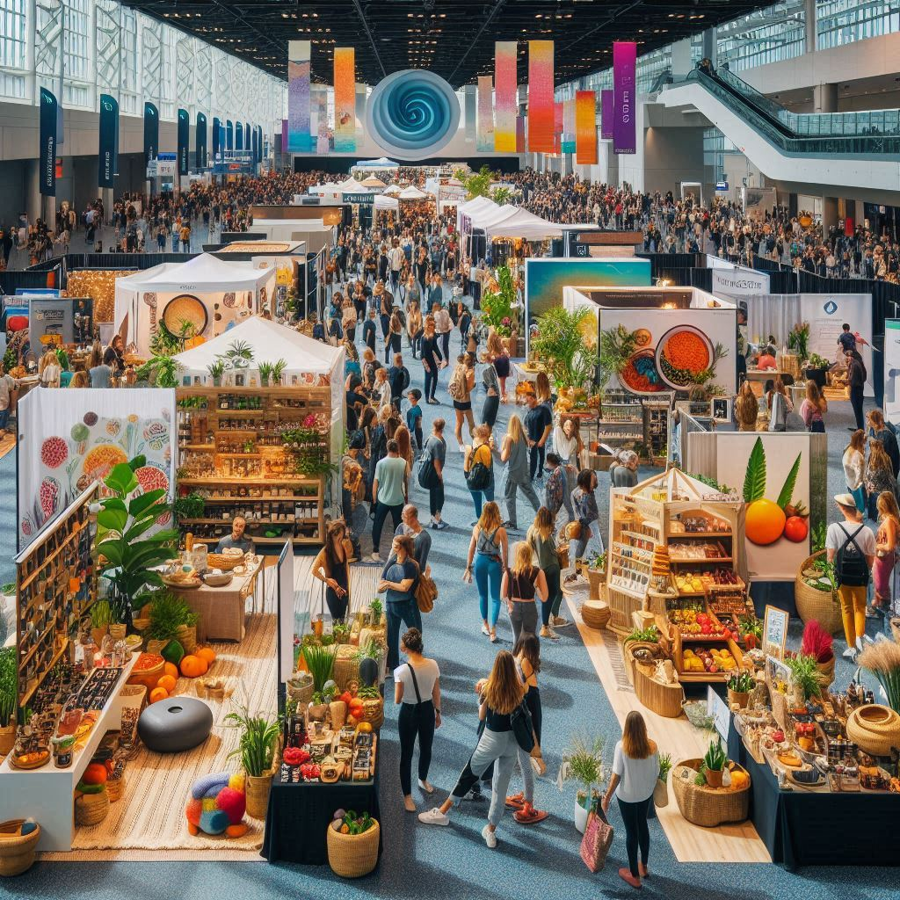

• **Wine and Cheese Tasting**

* **Description**: An evening of fine wine and gourmet cheese tasting. Sommeliers and cheese experts will guide attendees through pairings, offering insights into the origins and flavors of each selection. The event will also feature live music and an opportunity to purchase favorite wines and cheeses.
* **Time**: Saturday, October 19, 2024, from 6:00 PM to 9:00 PM
* **Place**: Vineyard Hall, 789 Grape Lane, Wineville
* **Cost**: $75 per person
* **Agenda**:
  + **6:00 PM**: Welcome Reception and Introduction
  + **6:30 PM**: Wine and Cheese Pairing Session 1
  + **7:30 PM**: Intermission with Live Music
  + **8:00 PM**: Wine and Cheese Pairing Session 2
  + **9:00 PM**: Event Concludes and Purchase Opportunity



• **Tech Startups Summit**

* **Description**: A dynamic event where tech startups showcase their innovations. The summit includes keynote speeches from tech industry leaders, pitch competitions, networking opportunities, and exhibitions of the latest tech products and services. Ideal for entrepreneurs, investors, and tech enthusiasts.
* **Time**: Thursday, November 7, 2024, from 9:00 AM to 6:00 PM
* **Place**: Tech Convention Center, 321 Innovation Blvd, Technopolis
* **Cost**: $100 per person, $50 for students
* **Agenda**:
  + **9:00 AM**: Registration and Breakfast
  + **10:00 AM**: Opening Keynote - The Future of Tech Startups
  + **11:00 AM**: Startup Pitch Competition - Round 1
  + **12:30 PM**: Networking Lunch and Expo Viewing
  + **2:00 PM**: Panel Discussion - Funding Your Startup
  + **3:30 PM**: Startup Pitch Competition - Finals
  + **5:00 PM**: Awards Ceremony
  + **6:00 PM**: Summit Concludes



• **Environmental Conservation Workshop**

* **Description**: A hands-on workshop focused on environmental conservation practices. Participants will learn about sustainable living, conservation techniques, and how to reduce their carbon footprint. The event includes expert talks, practical sessions, and a visit to a local nature reserve.
* **Time**: Sunday, August 18, 2024, from 8:00 AM to 3:00 PM
* **Place**: Green Earth Center, 654 Nature Way, Eco City
* **Cost**: $35 per person
* **Agenda**:
  + **8:00 AM**: Arrival and Breakfast
  + **8:30 AM**: Introduction and Overview
  + **9:00 AM**: Expert Talk - The Importance of Biodiversity
  + **10:00 AM**: Practical Session - Creating a Home Garden
  + **12:00 PM**: Lunch Break with Organic Food
  + **1:00 PM**: Visit to Local Nature Reserve
  + **2:00 PM**: Workshop - Sustainable Living Tips
  + **3:00 PM**: Closing Remarks and Q&A

