## **Project-3**

**Credit Card Customer Attrition: Application of Logistic Regression**

**Description-**

**Building a predictive model by analysing and observing the given data set and arrive at the account level probability of attrition of customers in next six months.**

**Approach-**

1. **Importing Libraries**
2. **Data Exploratory Analysis of given data**
3. **Fitting of the pre-processed data in Logistic Regression Model**
4. **Predict the results using the test data.**

**Problems Faced :-**

1. **Loading the data as the data was given in csv format but separation was ‘;’**
2. **Handling the missing data and unknown values in the given dataset.**
3. **Detecting Outliers & Filling that Outliers.**

**Some Graphs for Visualization and Analysis-**

1. **Education Level**

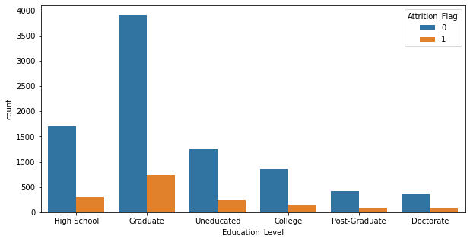

1. **Marital Status**

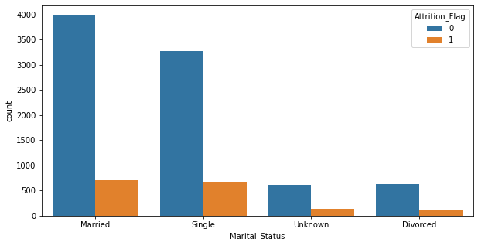

1. **Card Category**

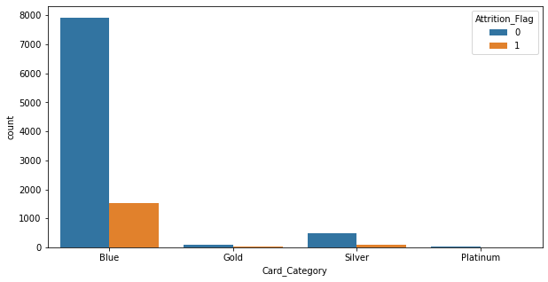

1. **Income** 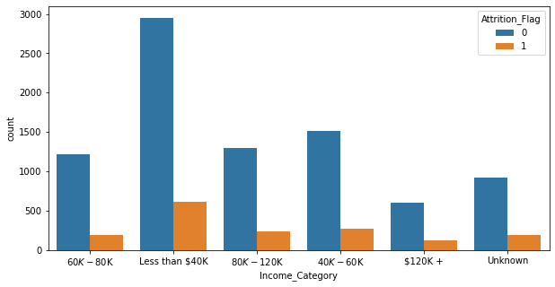

**Result:**

