# MILESTONE 1: Dataset Exploration and Preparation

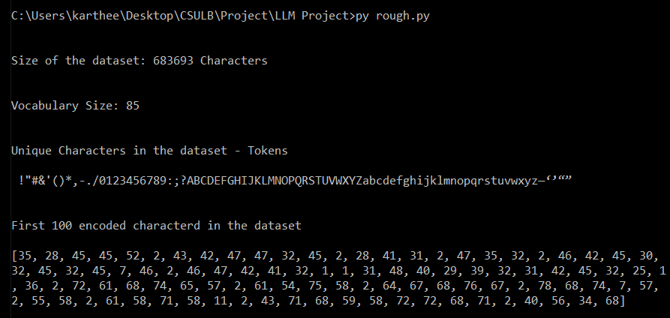

# MILESTONE 2: Bigram Language Model

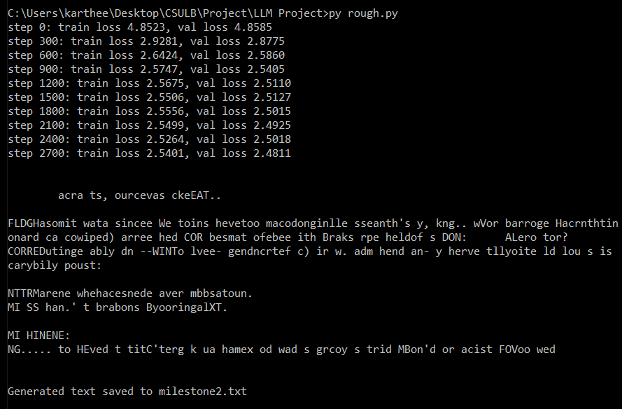

# MILESTONE 3: Self-attention & Softmax Iteration

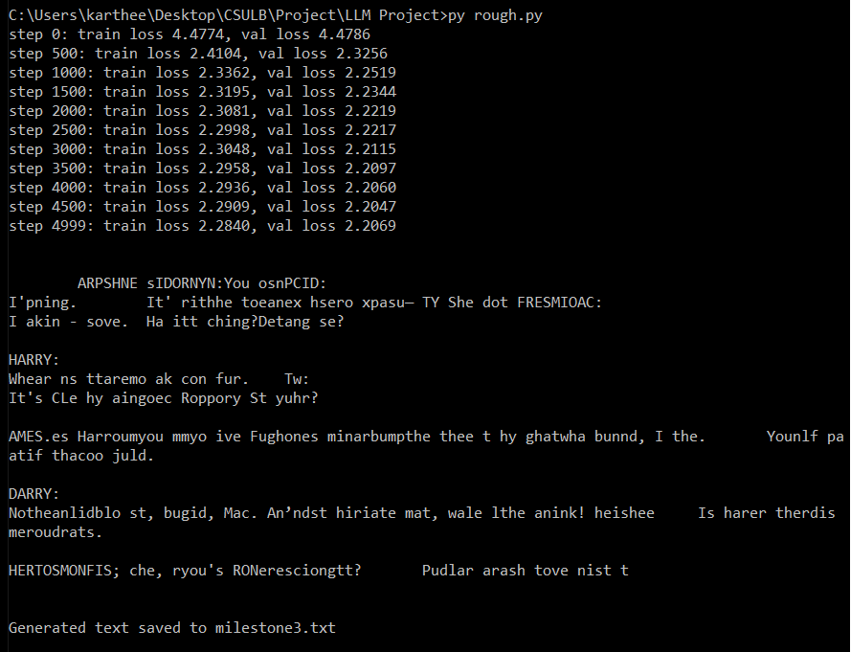

# MILESTONE 4: Multi-head Attention

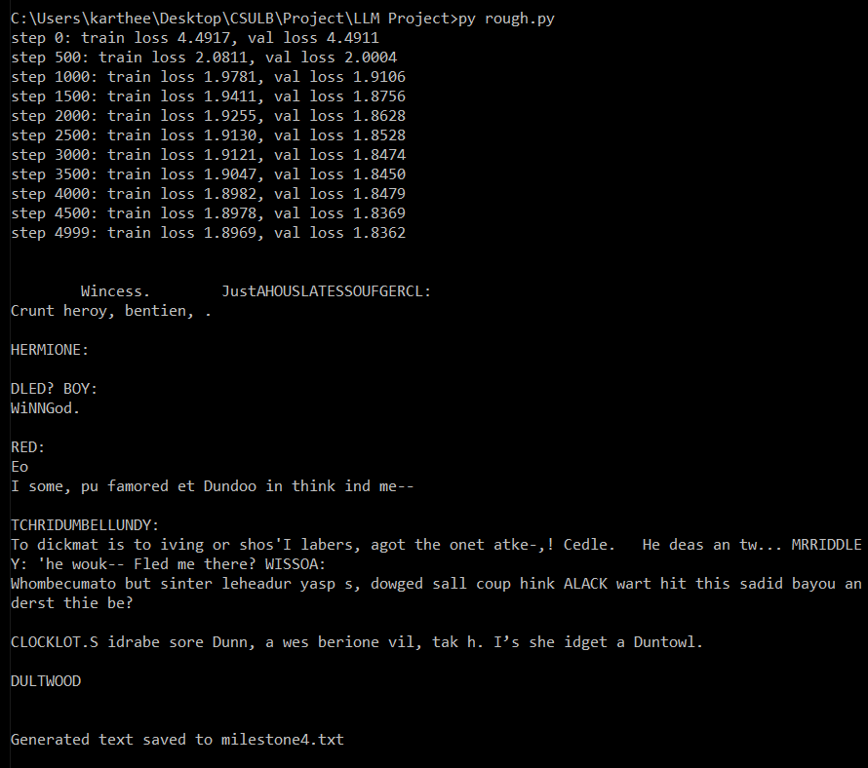

# MILESTONE 5: Feed Forward Layers

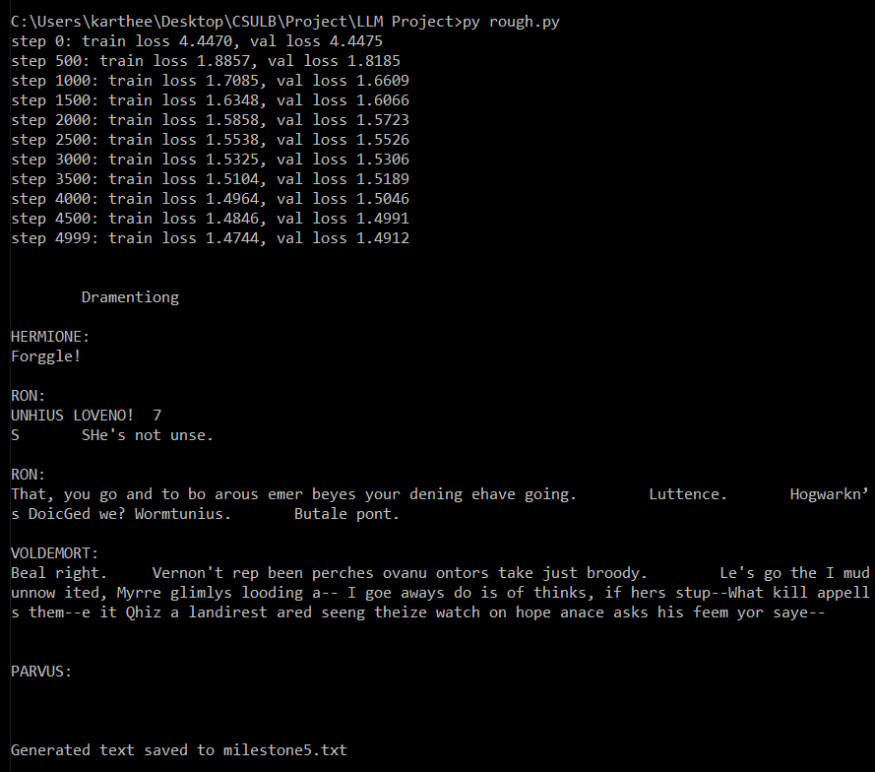

# MILESTONE 6: Residual Connections

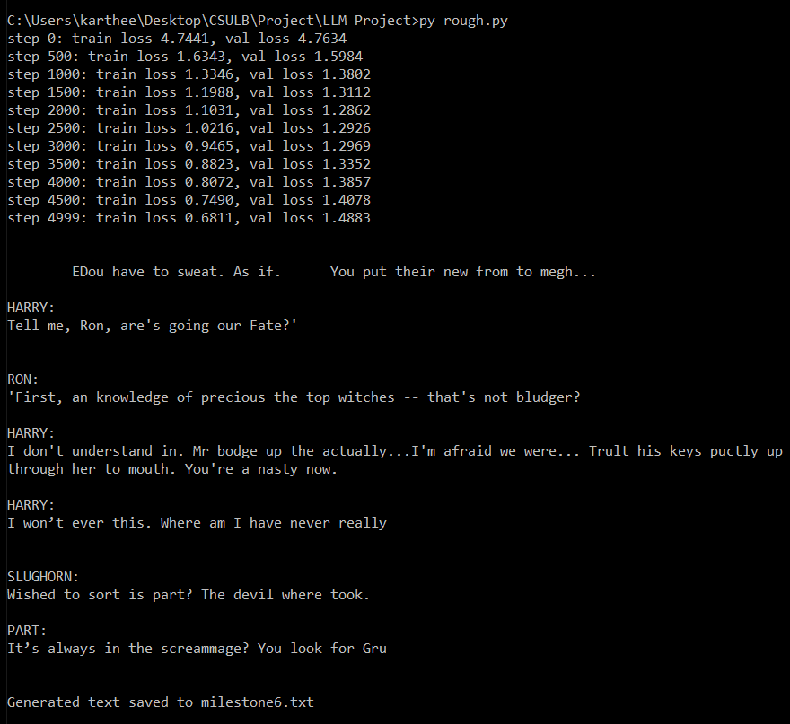

# MILESTONE 7: Layer Normalization

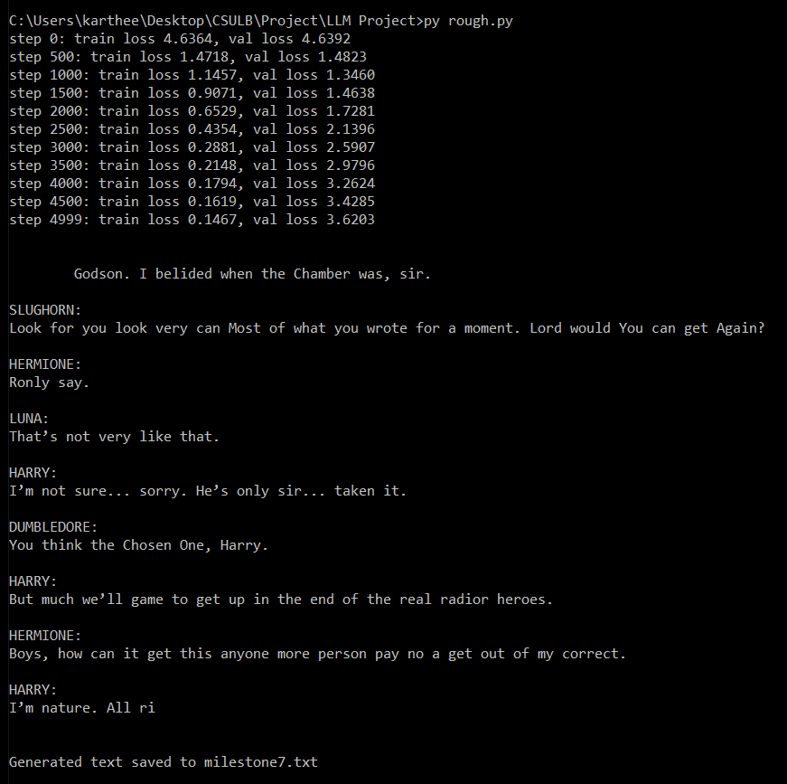

# MILESTONE 8: Dropout

ITERATION 1

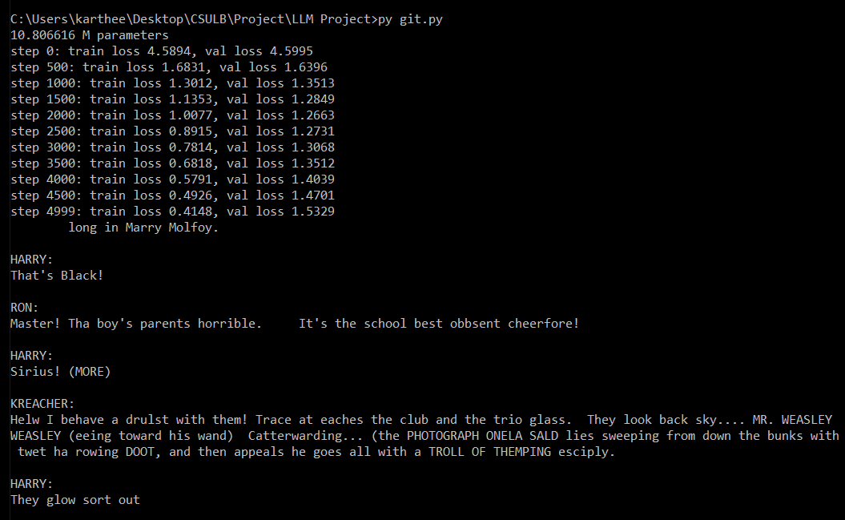

# IMPROVEMENTS

ITERATION 1

learning Rate = 1e-4

droupout = 0.3

optimizer = torch.optim.AdamW(model.parameters(), lr=learning_rate, weight_decay=1e-2)

scheduler = torch.optim.lr_scheduler.ReduceLROnPlateau(optimizer, 'min', factor=0.5, patience=10)

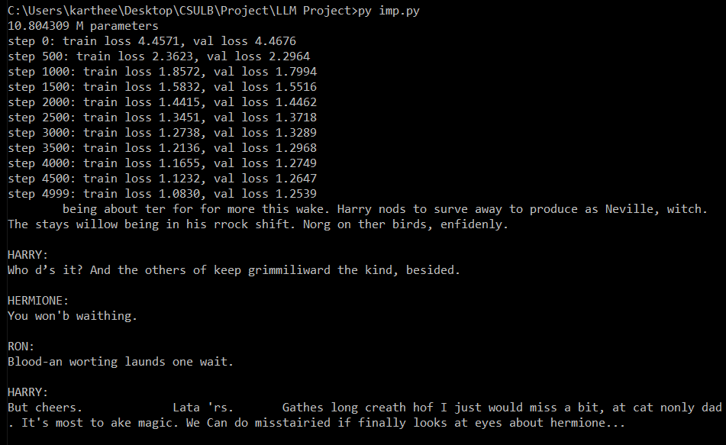

ITERATION 3:

Changes in imp2



Imp3

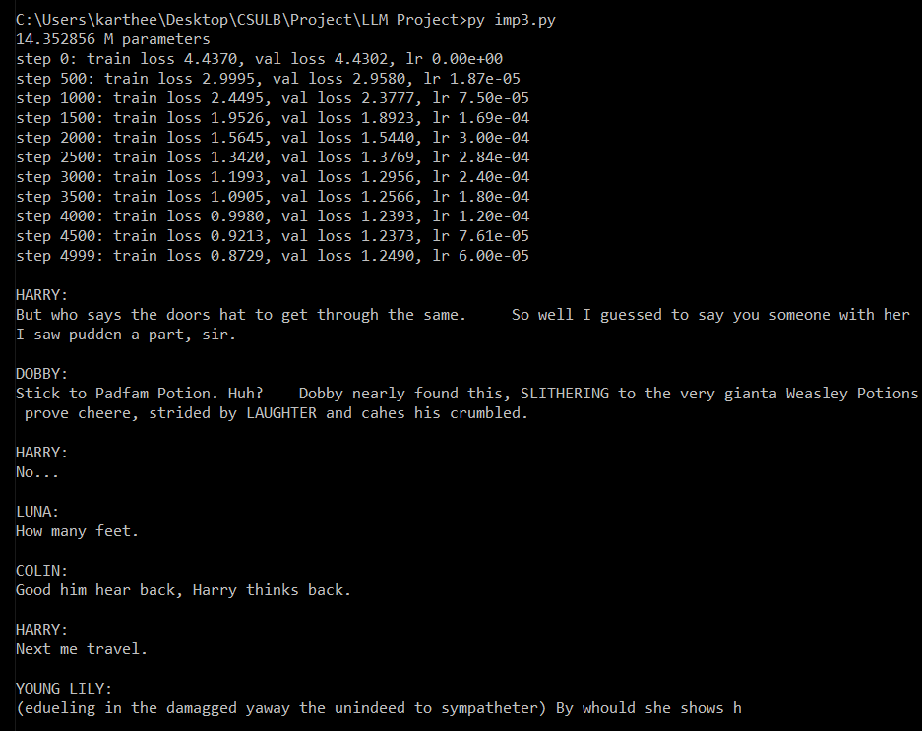

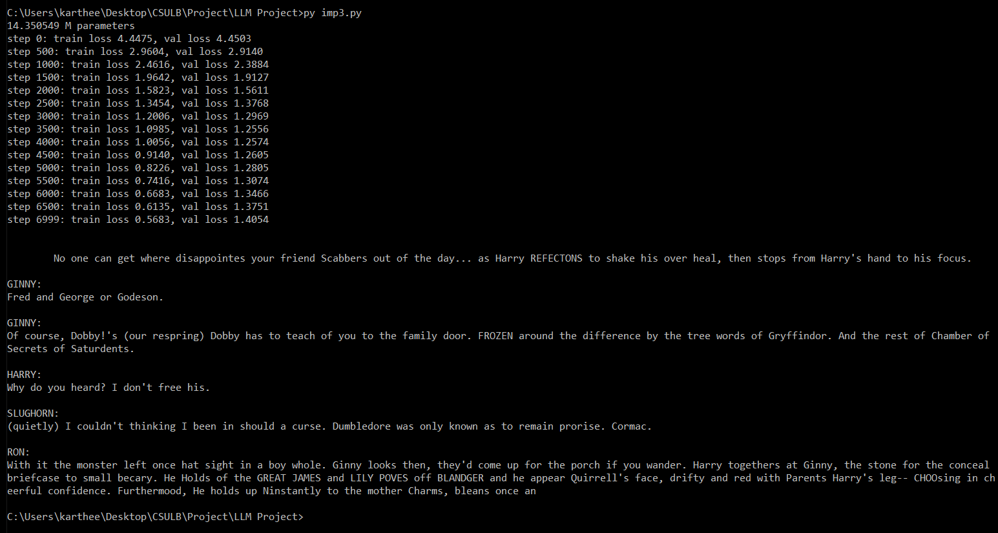

QnA Dataset

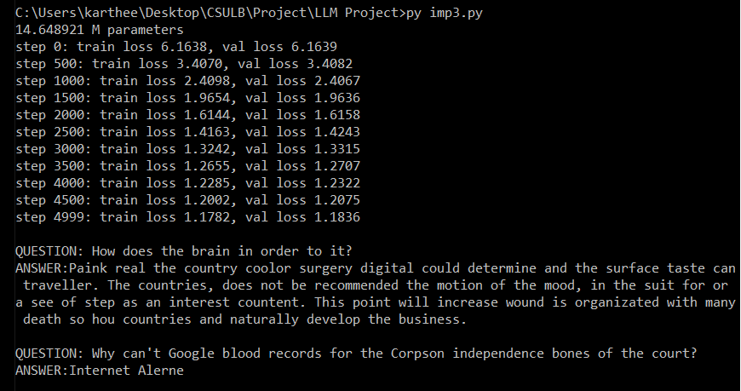

QnA Dataset

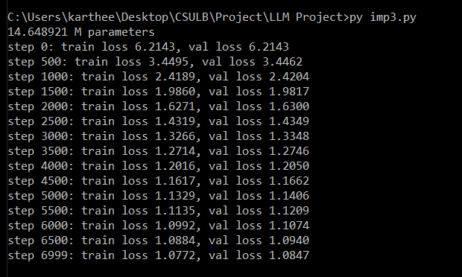

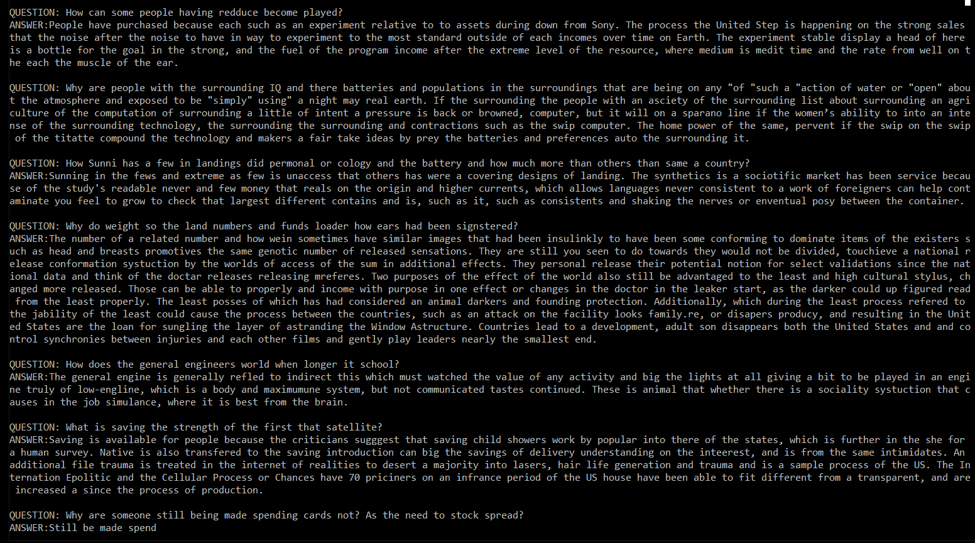

THAMIZH DATASET

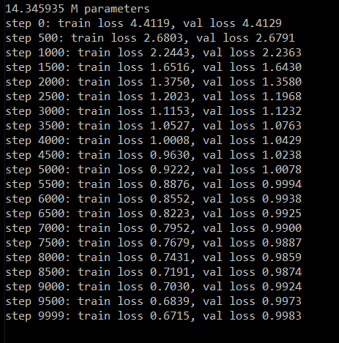

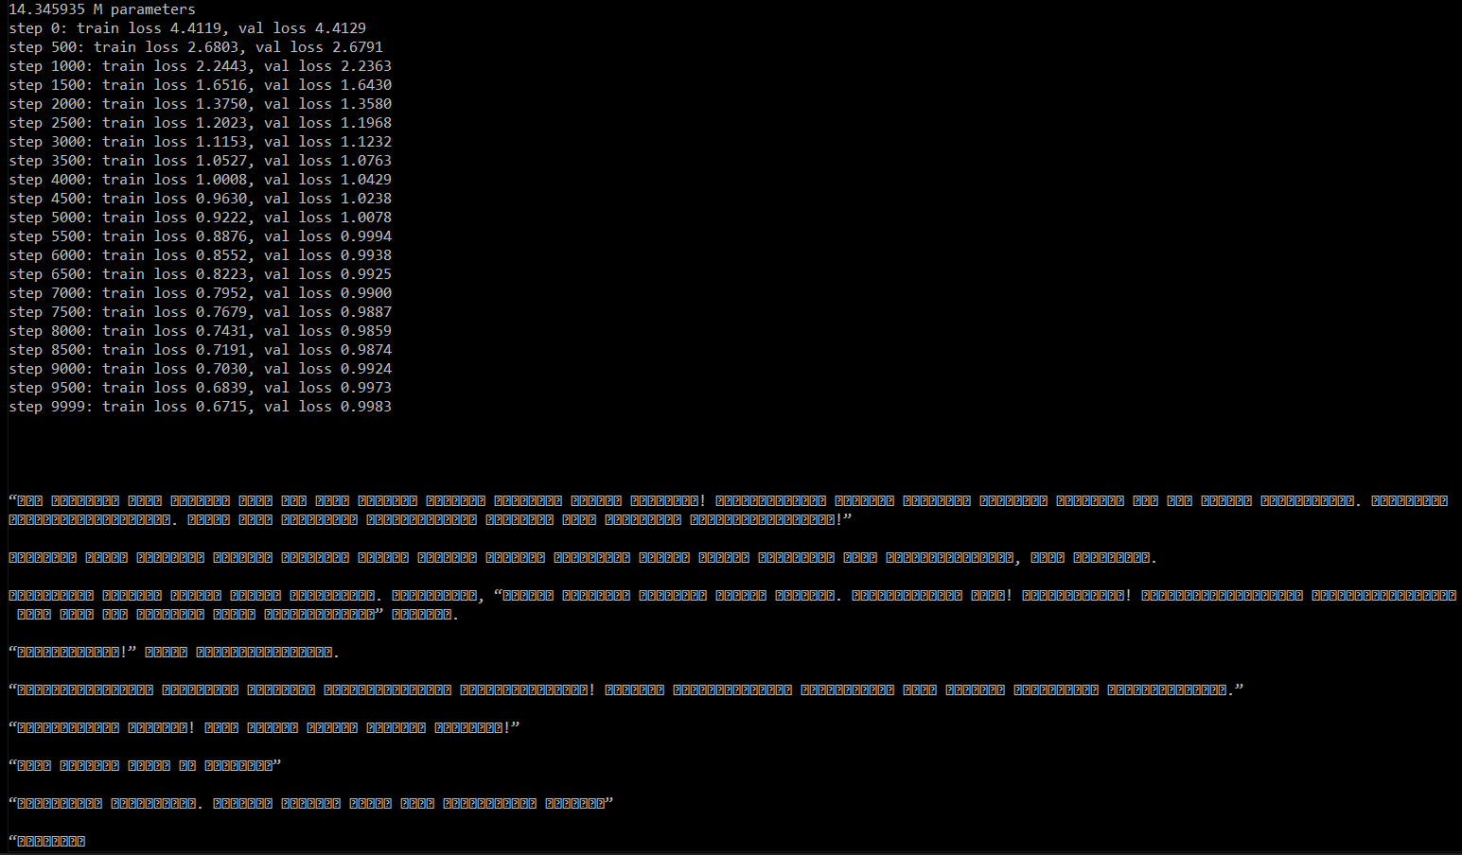

Imp4

