**Project Management**

**Summary:**

Agile process is the software development method we have used. We have divided the project plan into four increments where each increment included improvements in both back end and front end implementation from increment to increment. We have used ScrumDo for our project management and for maintaining the project artifacts. Our team consists of four members’ and the project development has been shared equally between all of us. In each phase two members used to work on back end and two members used to work on front end. And these will be swapped in successive increments.

The below are the tasks that have been scheduled in each of the increments:

If there are any pending backlogs we all worked together to nullify them.

**First Increment:**

1. Design and analysis on the architecture specifications – Siva Krishna

2. Analysis on open source Android projects – BalaKrishna

3. Study of sensors and motion recognition services. - Savya

4. Study of project development tools and technologies. - Swathi

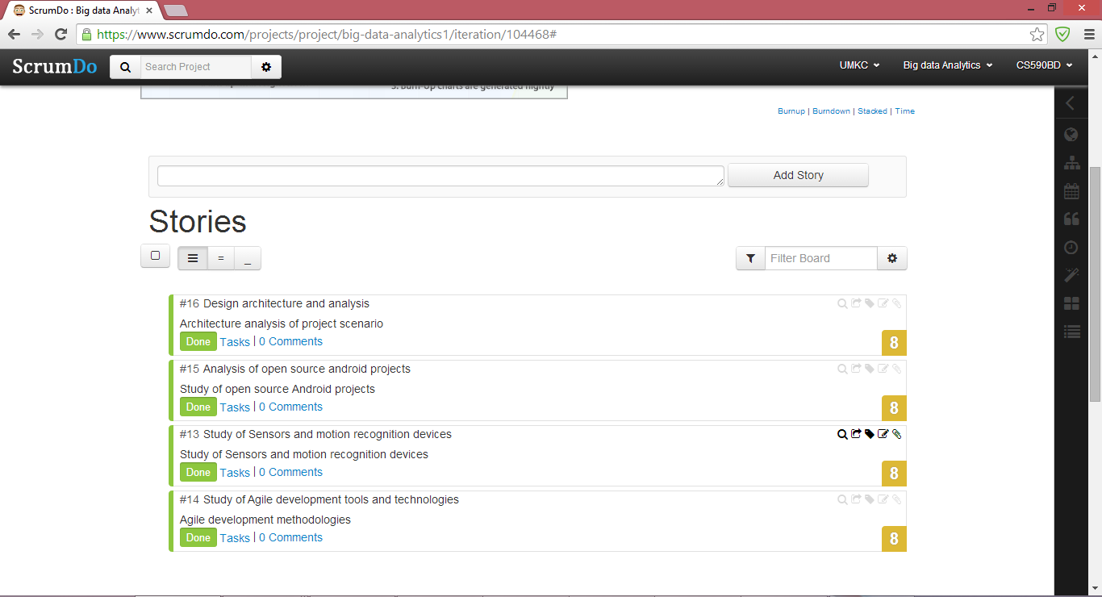

Figure First Increment

**Second Increment:**

1. Collection of data using sensor tag from the application in the log file.- Siva Krishna

2. Creation and storing the file in the HBase.- Savya

3. Testing the data and the application based on sensor control.- Swathi

4. Analyzing related algorithms to perform data analytics.- BalaKrishna

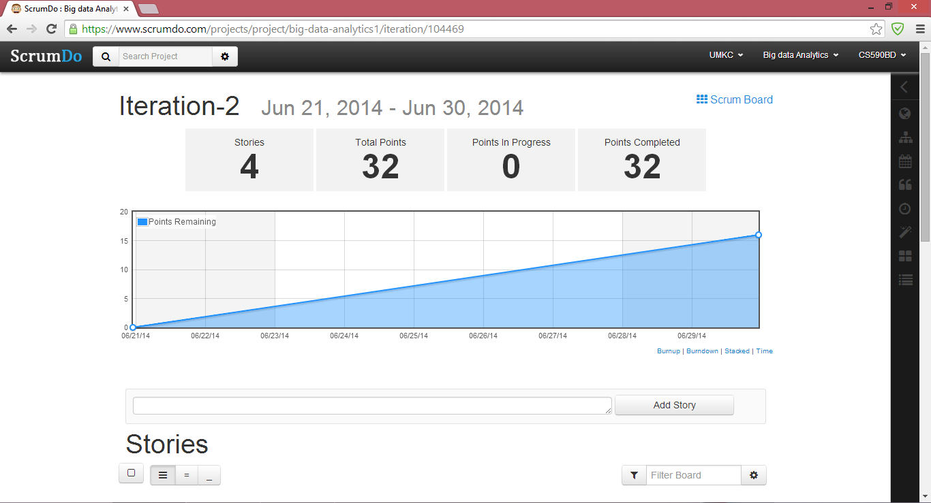

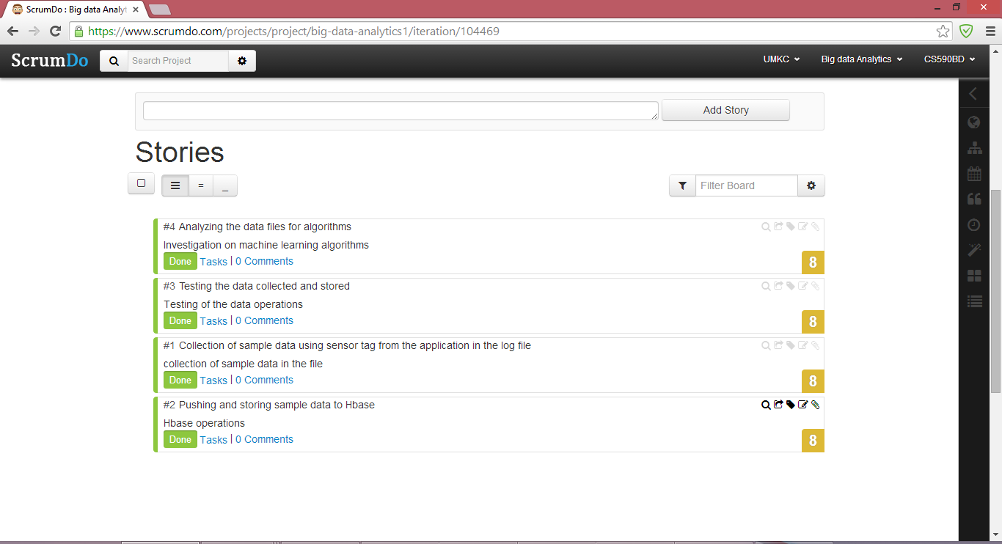

Figure Second Increment

**Third Increment:**

1. Creation of Restful web services. - Swathi
2. Execution of applications for analyzing movements. – Siva Krishna
3. Testing and training the collected data using existing services.- Savya
4. Analyzing collected open source game for development.- BalaKrishna
5. Investigation on the game and sensor connection establishment.- All

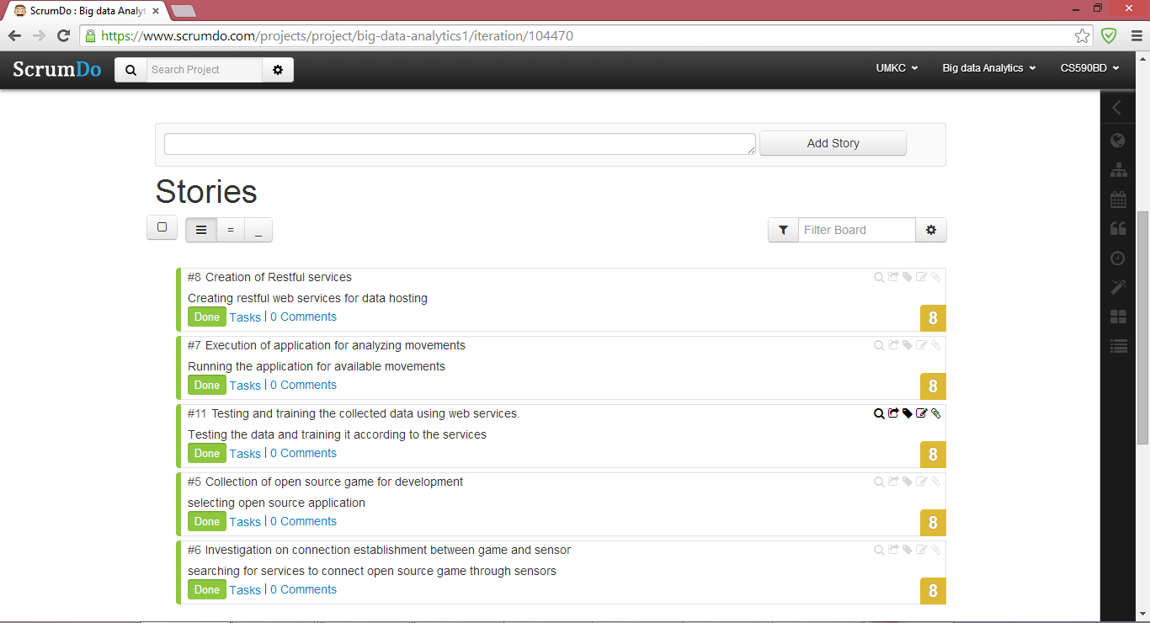

Figure Third Increment

**Fourth Increment:**

1. Modify the existing features of game according to the application development. - BalaKrishna
2. Enhancements for connection between the available open source game and sensor. – Siva Krishna
3. Implementation of graphical reports for analyzed data. – BalaKrishna
4. Activity and motion recognition based on the available data. - Savya
5. Final testing and debugging - Swathi
6. Video production and document production. - All

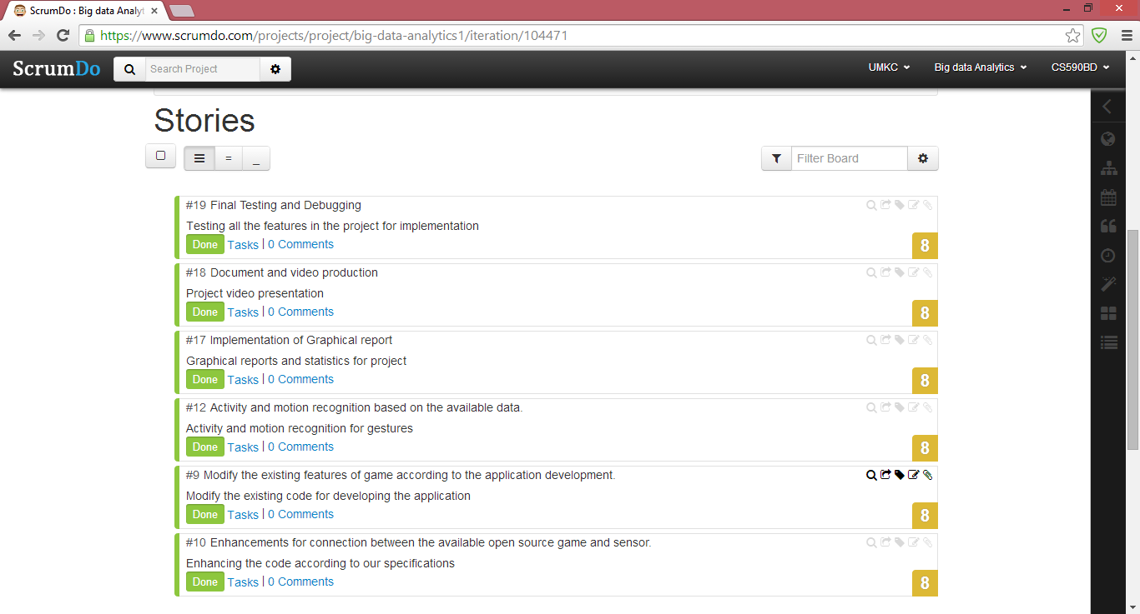

Figure 5Fourth Increment

**Project Summary:**

The entire project summary is shown below with a graph, which reflects the process in project development in each iteration:

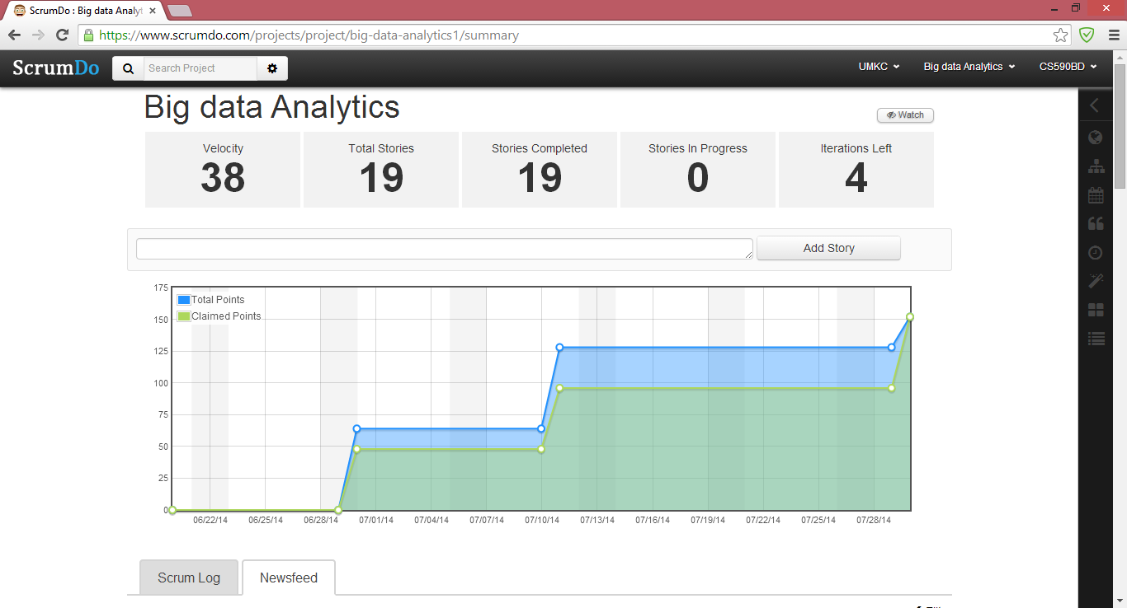

Figure Project Graph

The entire project scrum work and tasks can be viewed in the following link:

* <https://www.scrumdo.com/organization/umkc94/dashboard>