**CS590BD Big Data Analytics and Applications**

**Lab 3 Assignment**

**By**

**Kommineni Siva Krishna**

* **Summary:-**
* Collection of data using the Android application and store it in a file for performing HBase operations – Lab2
* Installation of Glassfish server in eclipse to host the restful web service so that we can perform operations like insert , delete, create and retrieve in HBase with the hosted service.
* File Transfer mechanism from the local system to cloudera using webservices
* Perform the HBase CRUD operations using the web services and develop an Android application.

Data is collected by using the android application developed in Lab-2. We collect the data file and perform all the operations in all the HBase,

* **Creation of Restful web services:-**

First after downloading eclipse juno install Glassfish server in it.

Next create a dynamic web project.

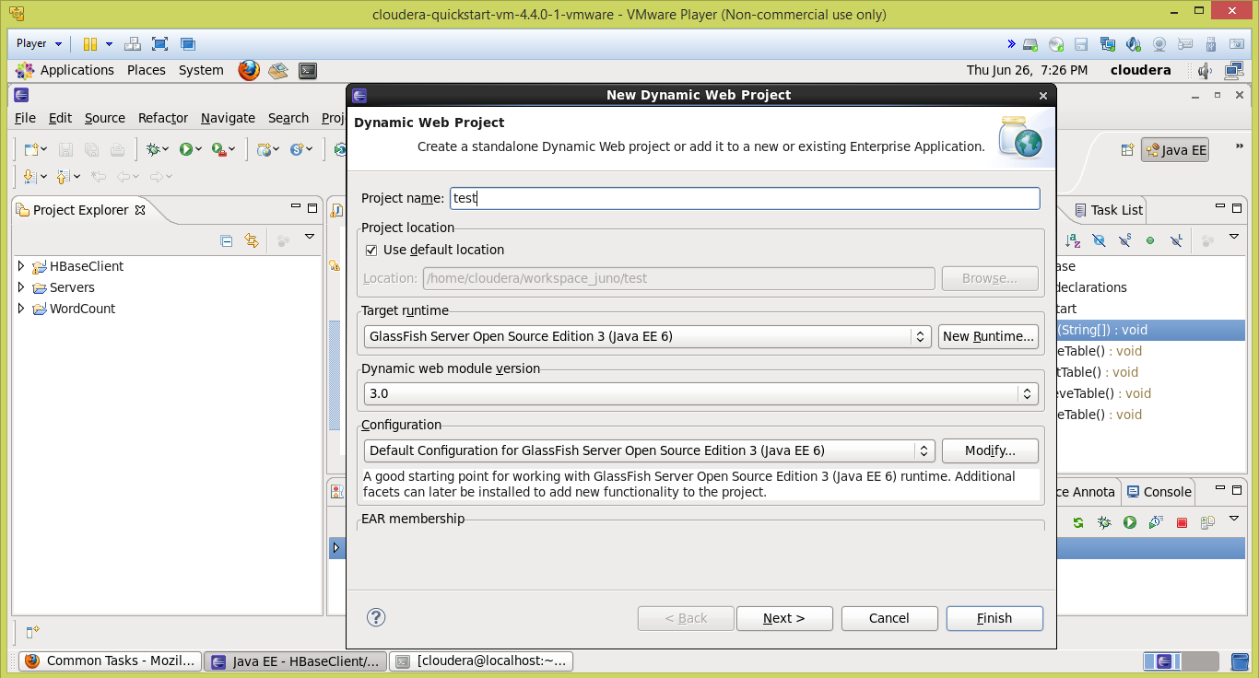

Later include the project facets required as shown below by enabling the Rest services.

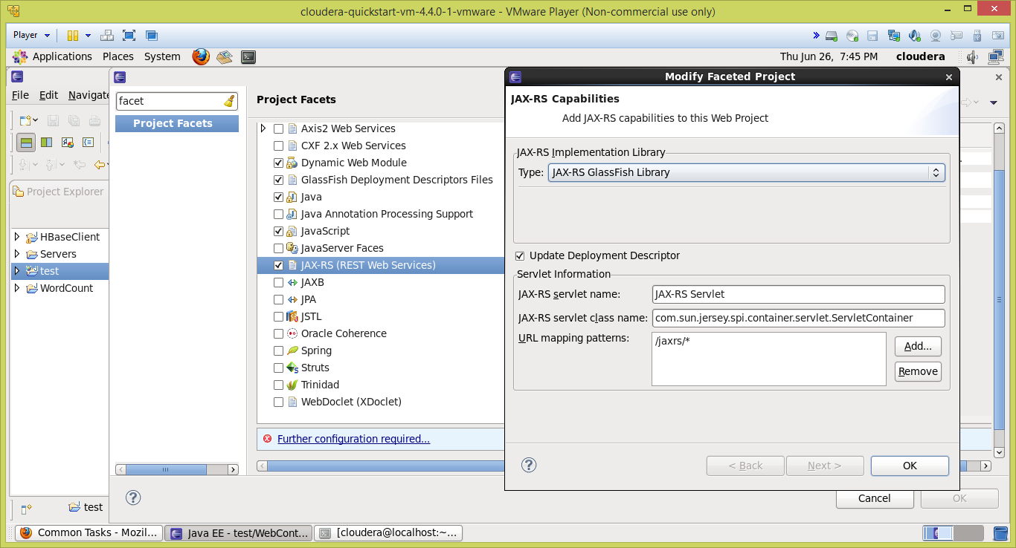

Then click on the project and create a restful application and create a war file.

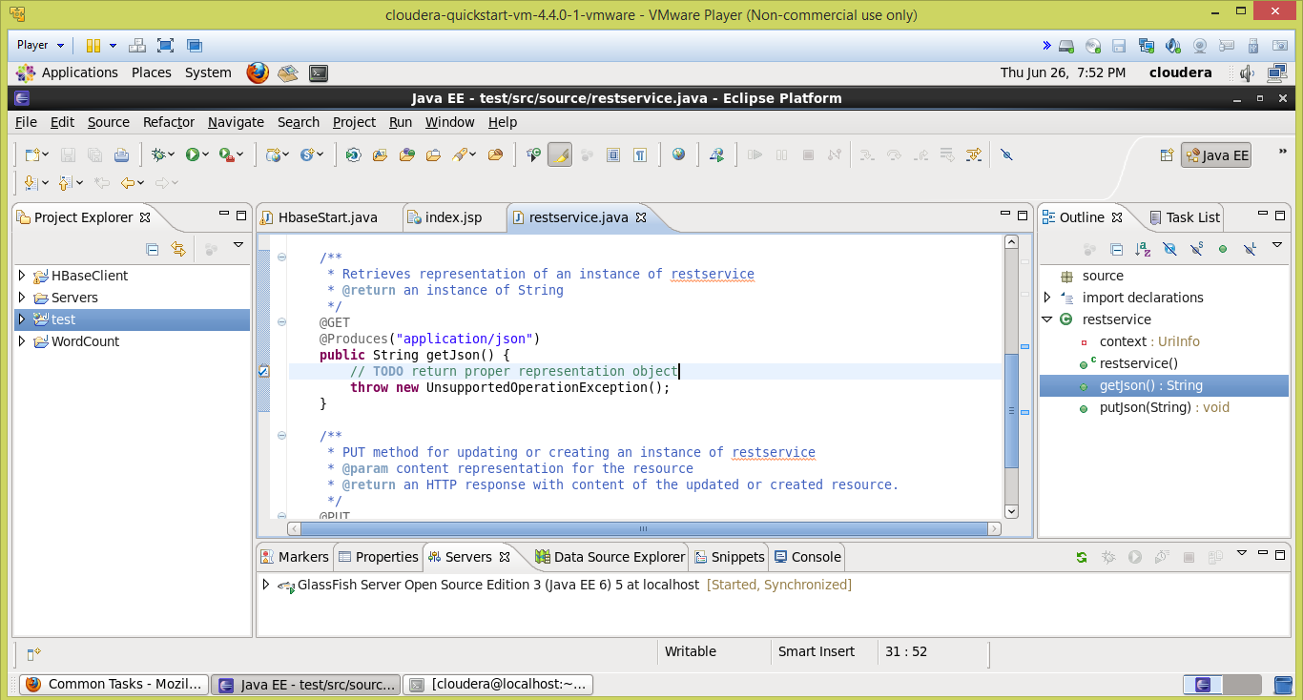

Deploy the war file in a glassfish server and launch it.

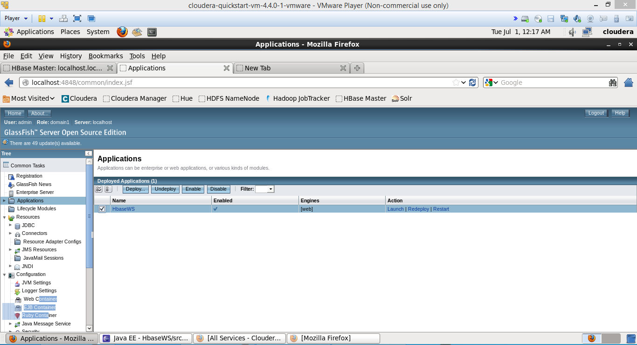

After launching this service we can perform the operations like insert, create , delete, retrieve in HBase based on the data available after collection from the Android application in Lab-2

HBase stores in the column families and we insert the data in the form of tables.

The below screen shots show various operations on HBase using the hosted webservice in cloudera.



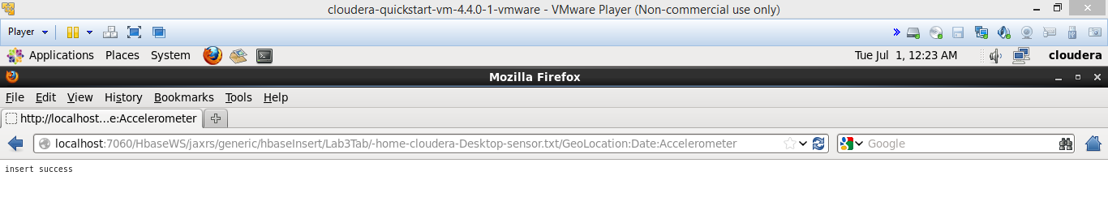

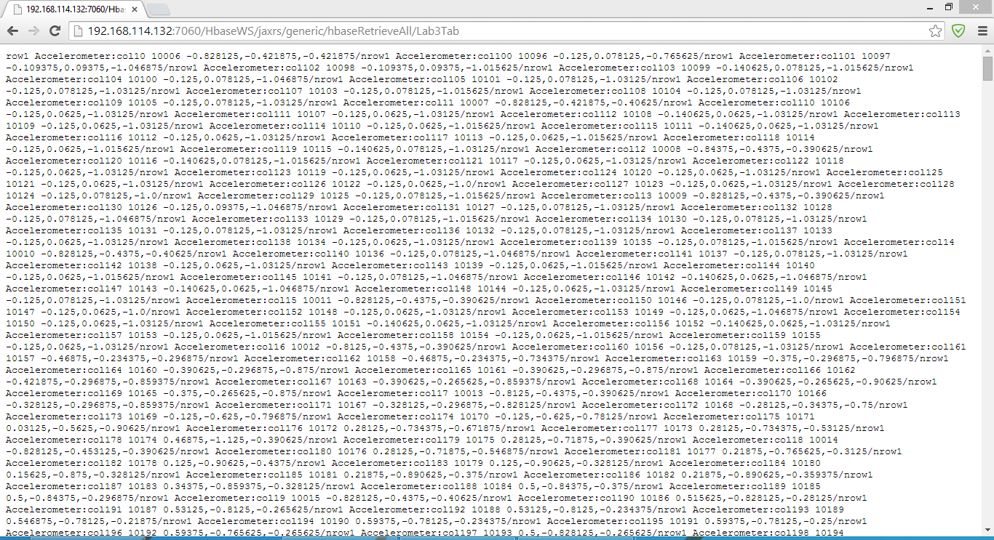

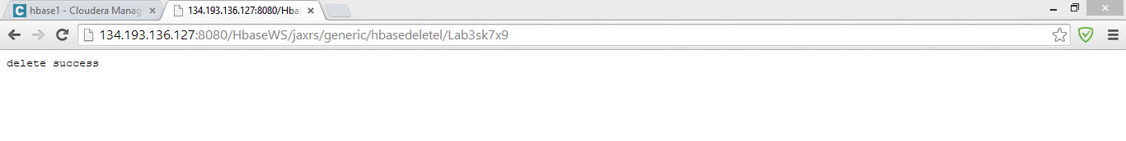

Later we can see the tabular structures formed in HBase local tables as follows based on the columnar structures in data.

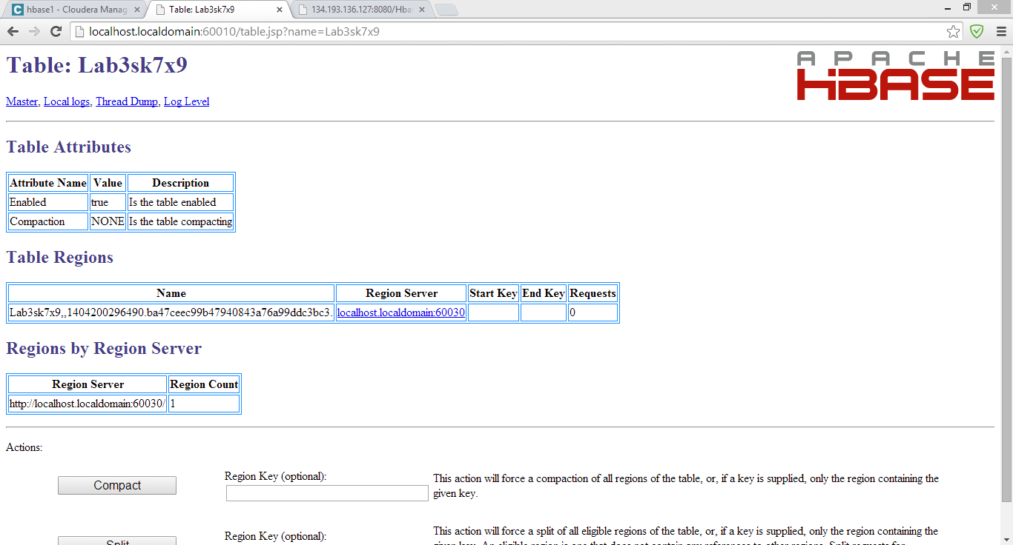

The below shows the tabular structure in the system tables in cloudera and the local HBase.

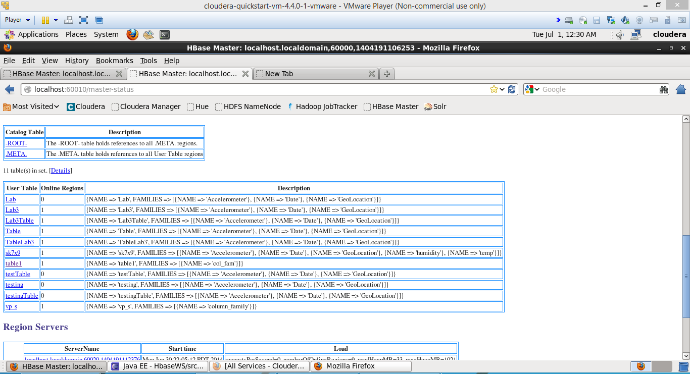

* **File Transfer operations using Web services:-**

The package structure shows the file transfer connection between the local system and the clodera by using the credentials we can transfer the files to the required path.

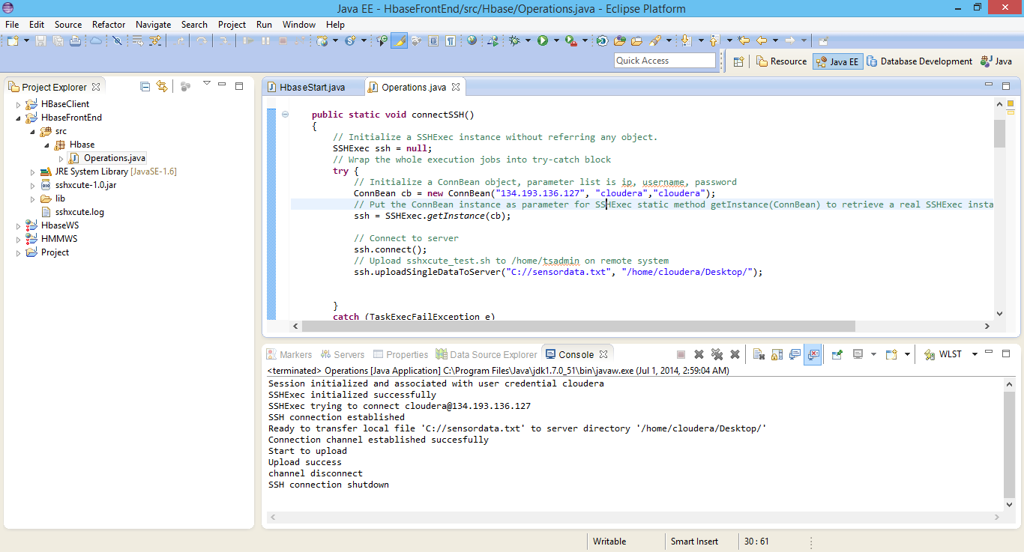

The console shows the establishment of connection and transfer of files as success and later after transferring the file it closes the connection.

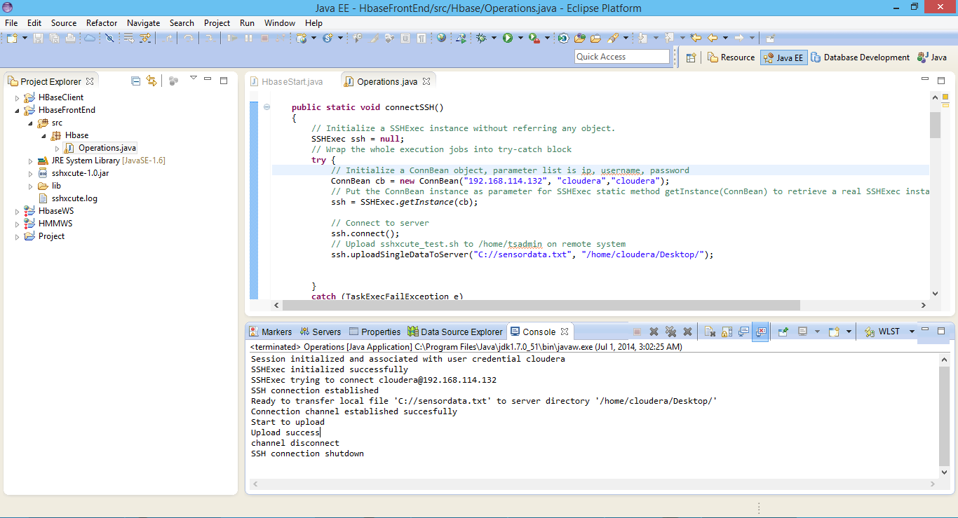

We can perform operations such as insertion, deletion, creation and retrieval of the data. The console shows the creation of tabular structure as success.

* **HBase Crud Operations:-**

Below shows the step by step operations performed in HBase using the webservices.

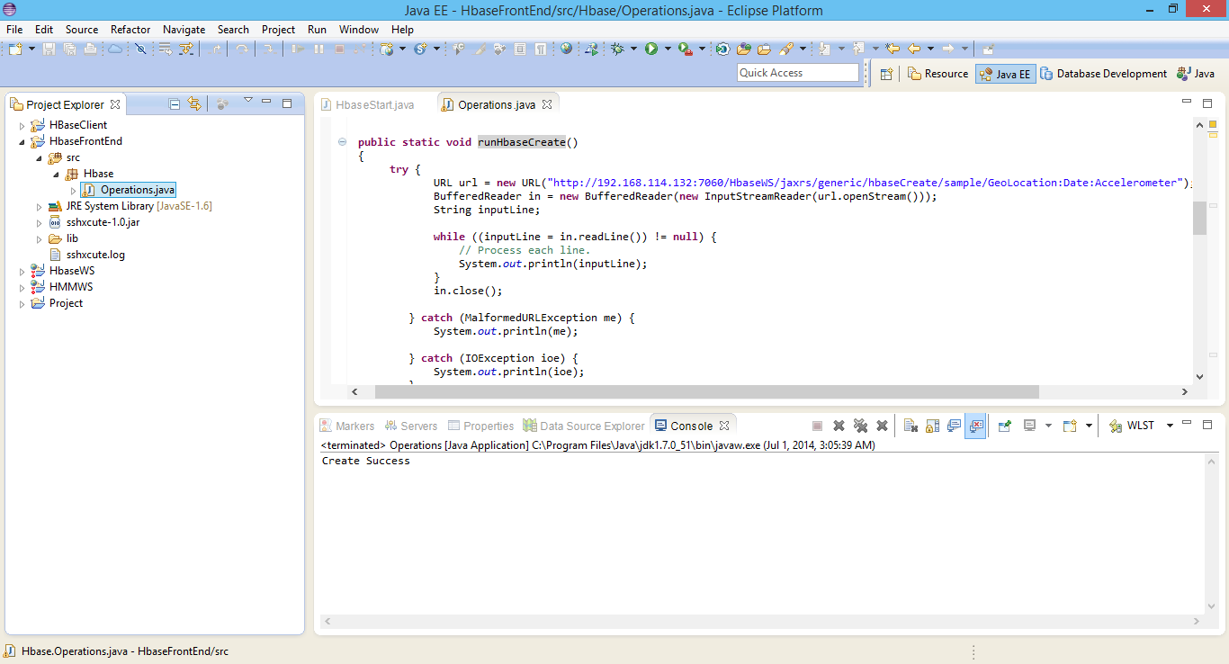

Similarly other operations show in the console shows the success.

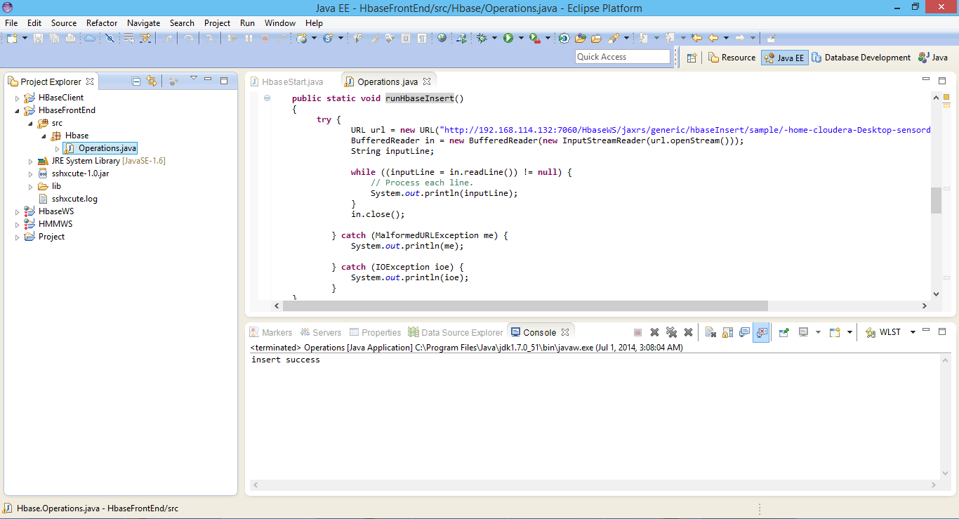

In the same manner we can perform the other HBase operations like retrieval and deletion as shown below.

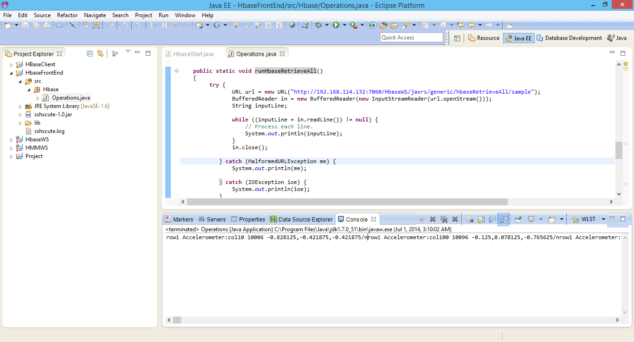

All the operations are performed by using the hosted web services and communicating with them internally.

We establish the tabular structures based on the column families and the data collected from the Android application.

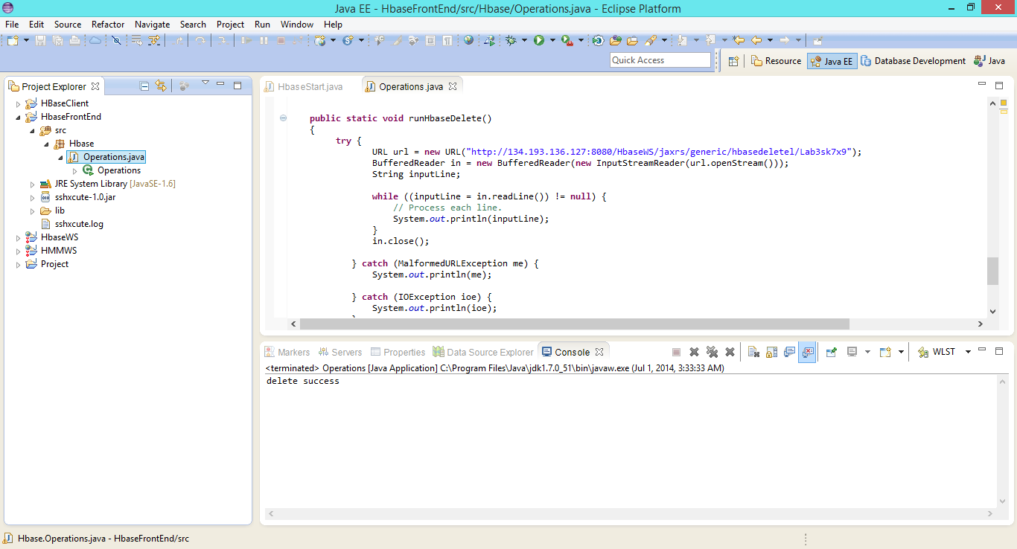

* **Developing Android Application:-**
* Later after performing all the HBase operations using the available web services after hosting them on the Glassfish server.
* Now we are developing an Android application which performs all the operations like creation, insertion, retrieval and deletion of the data and the columnar structures.
* Create a new android application project using the eclipse ADT and select the target SDK.

The UI in the Android ADK is as shown below for the application and shows the emulator launch status.

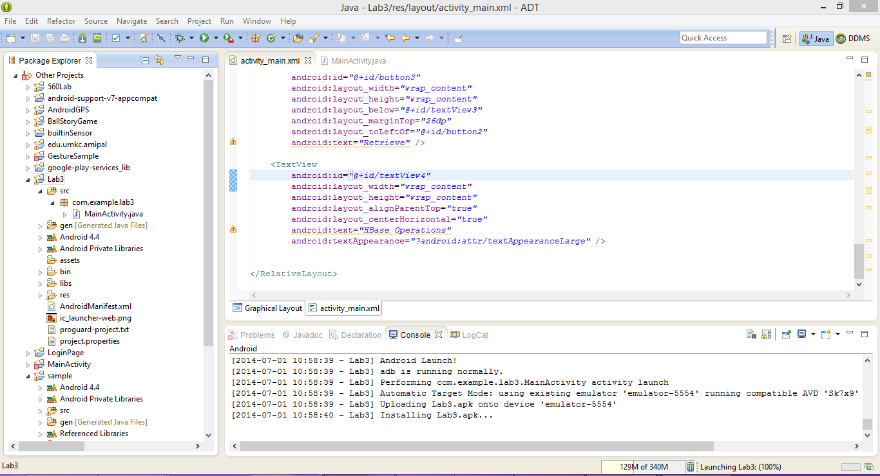

Then run the application on an emulator selected. You can find the screens as follows.

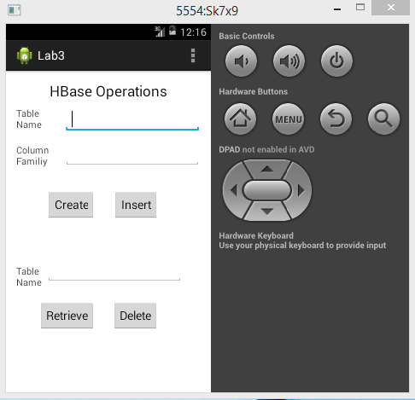

The above screen shows the main page of the application as the available HBase operations like create, insert, delete, and retrieve.

After entering the data in the required column spaces we can perform all the operations accordingly.

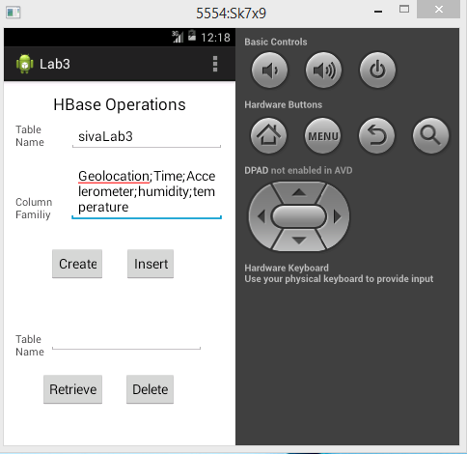

Below screens indicates the operations for the delete and retrieval.

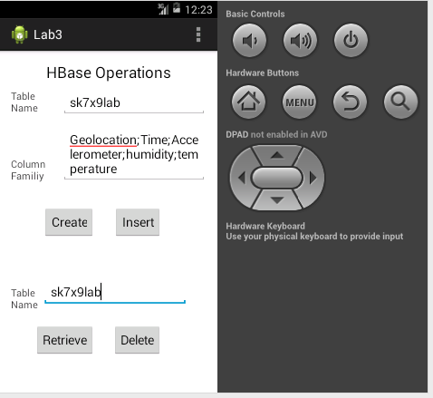

Finally an Android application is developed and HBase Crud operations are performed.