CS560

Knowledge Discovery and Management

Jan. 21 (T), 2013

In-Class Exercise

LAB1 Report

Creation of ER and UML Class Diagrams

By

SIVA KRISHNA KOMMINENI

Student Id - 16104984.

1. **ER Diagram**: Suppose we wish to keep a genealogy. We shall have one entity set, Person. The information we wish to record about persons includes their name (an attribute) and the following relationships: mother, father, and children. Give an E/R diagram involving the Person entity set and all the relationships in which it is involved. Include relationships for mother, father, and children. Extend it with additional relationships such as husband and wife. Do not forget to indicate roles when an entity set is used more than once in a relationship.



The above ER diagram shows the genealogy between family relations.

1. **Class Diagram**: For the given domain (i.e., Family), define UML Class Diagram that specifies classes and their relationships with specific relationships such as inheritance, aggregation, composition, dependence, association, etc.



The above diagram shows the UML Class representation and their relation ship.

**Task 2:**

First we need to sign up for GitHub using the following url:- <https://github.com>



Then join GitHub by creating your own Password.

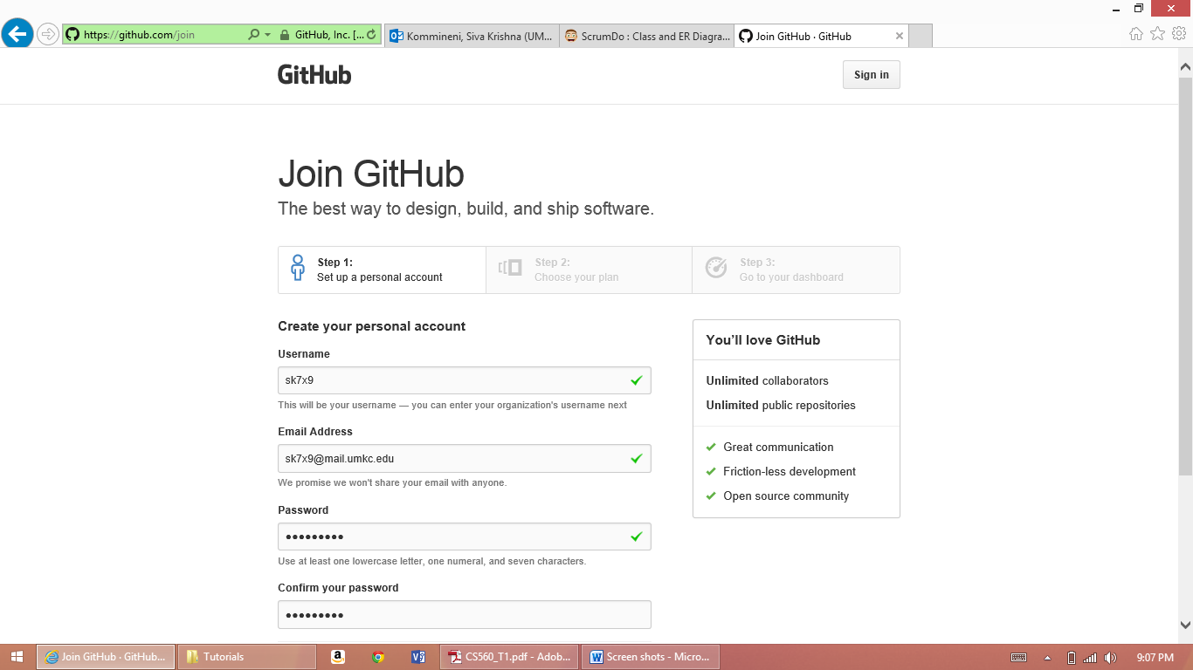

**Task-3:**

Next we need to set up a scrumdo account

Got to the following url <http://www.scrumdo.com>

If you are a new user set up your login information (or) else you can directly login.

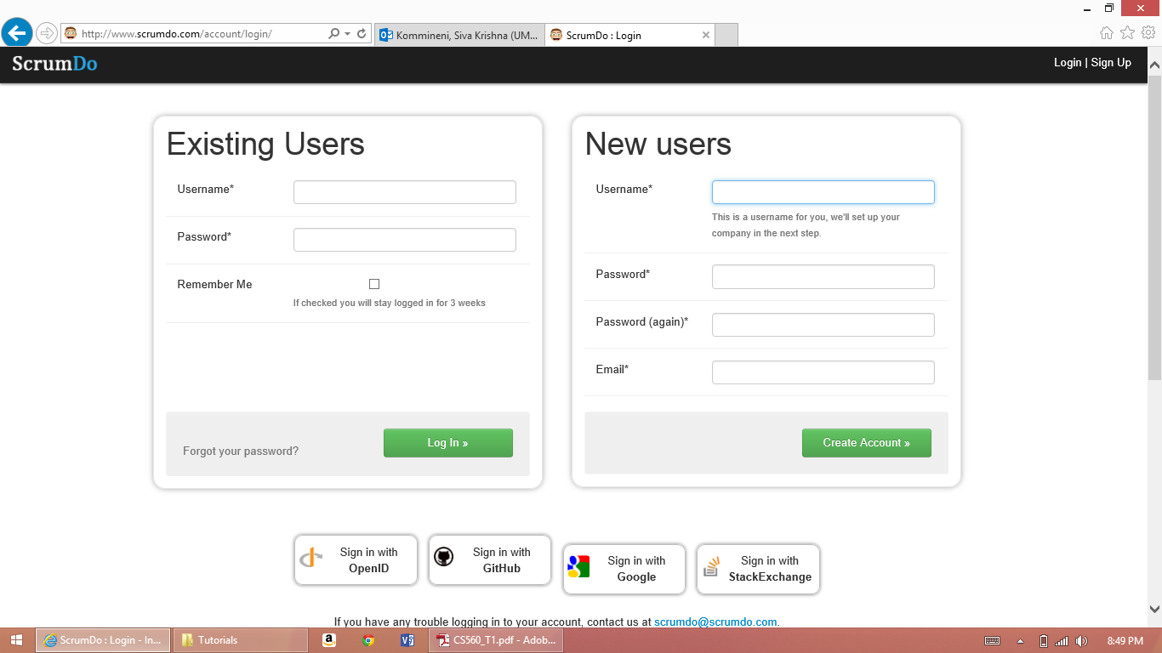

Complete the form and click on Create Account

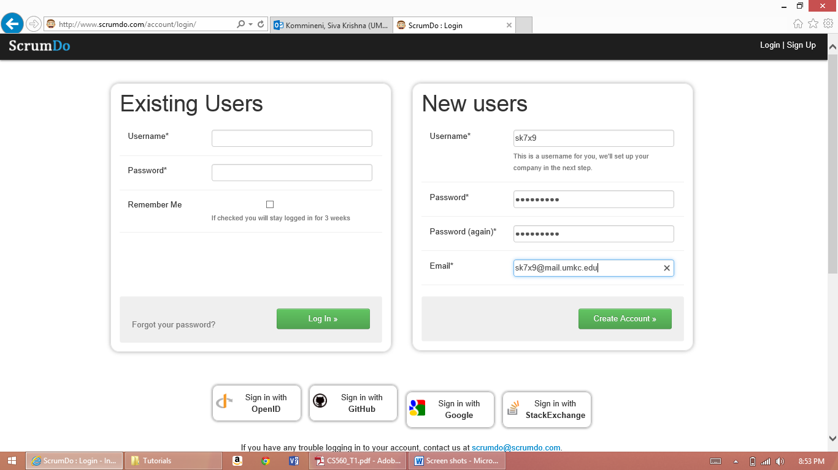

You will be directed to a page as follows after successful creation of your account.

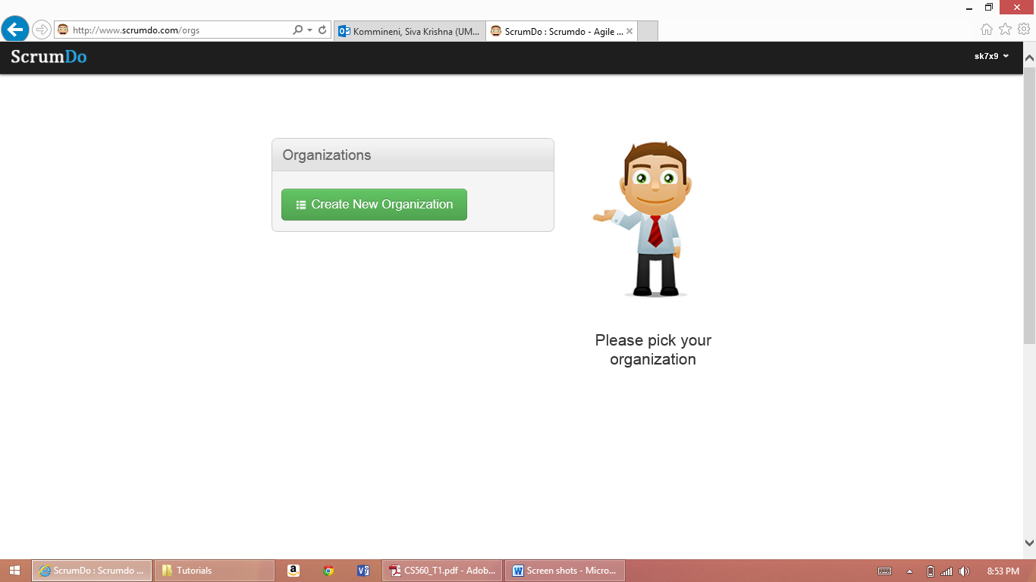

Next Create an Iteration and add a user story to it as follows.

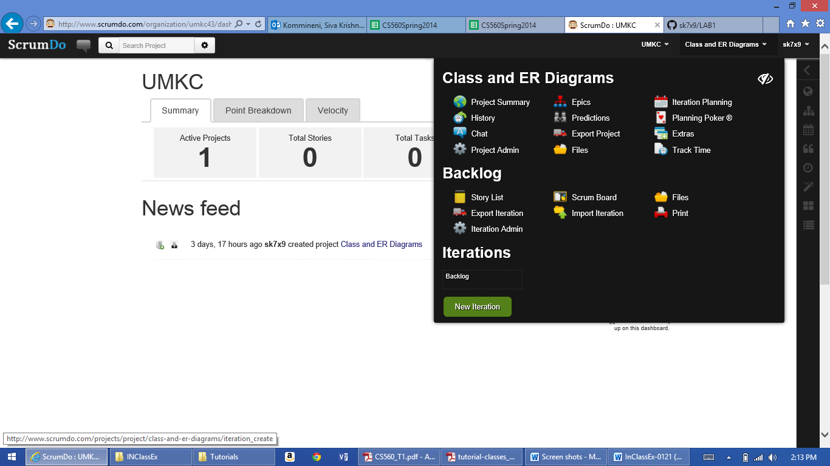

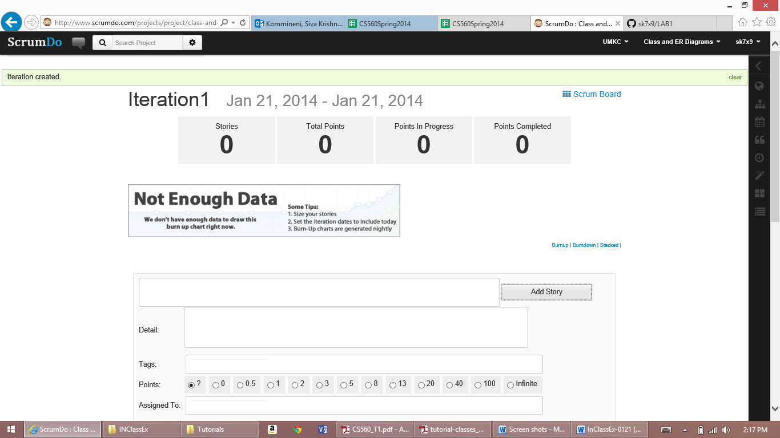

After creation of this add points then you can proceed through various stages as follows in the iteration.

