CS560 Knowledge Discovery and Management

Feb. 4 (T), 2014

**LAB - 2**

**Report on Mobile Client Application Using Web Services**

**BY**

**SIVA KRISHNA KOMMINENI**

**16104984(sk7x9)**

The report describes a mobile client application using Mobile web app technologies. Here existing Google web services is used.

Url is - [https://maps.googleapis.com/maps/api/js?v=3.exp&sensor=true](https://maps.googleapis.com/maps/api/js?v=3.exp&sensor=true%20)

Then we use java script and Html code to design the application which helps in identifying the distance between two places A and B.

First after login into the Jsfiddle the screen appears as follows.

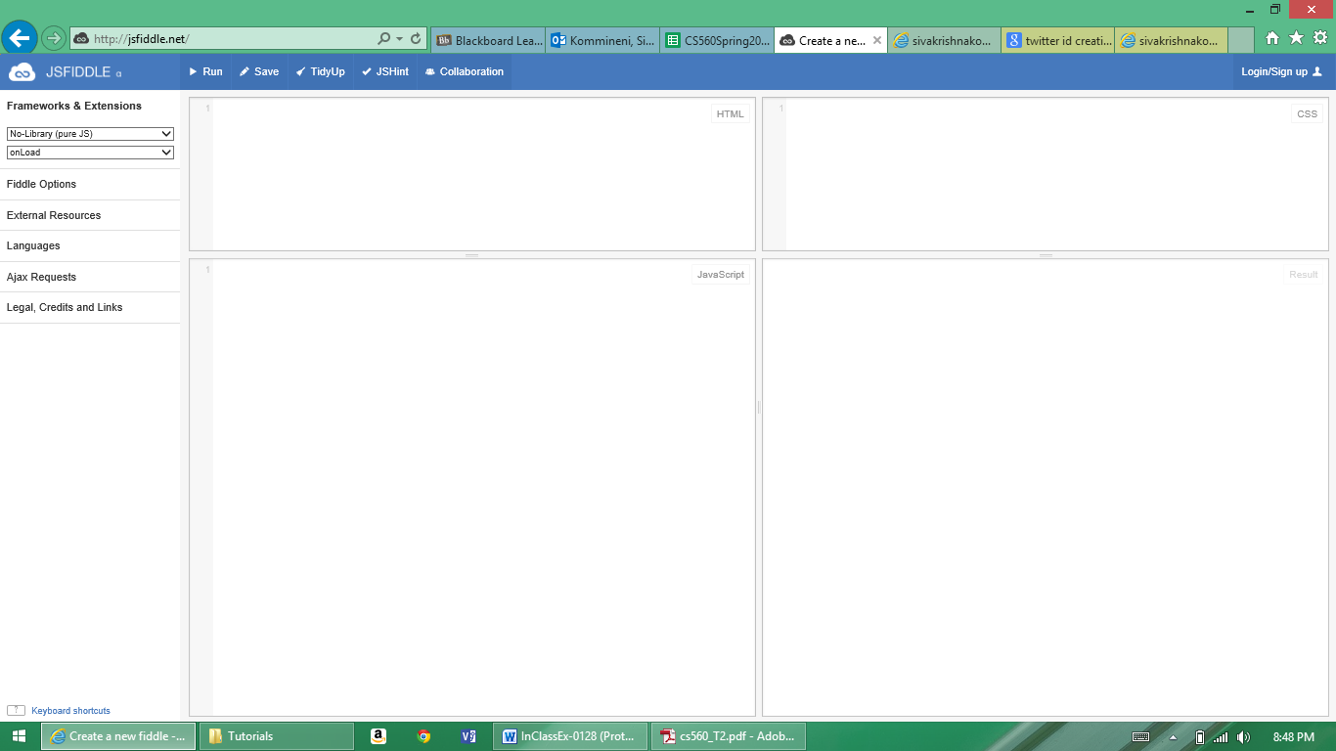

Next after including the javascript and Html code the screen appears as follows.

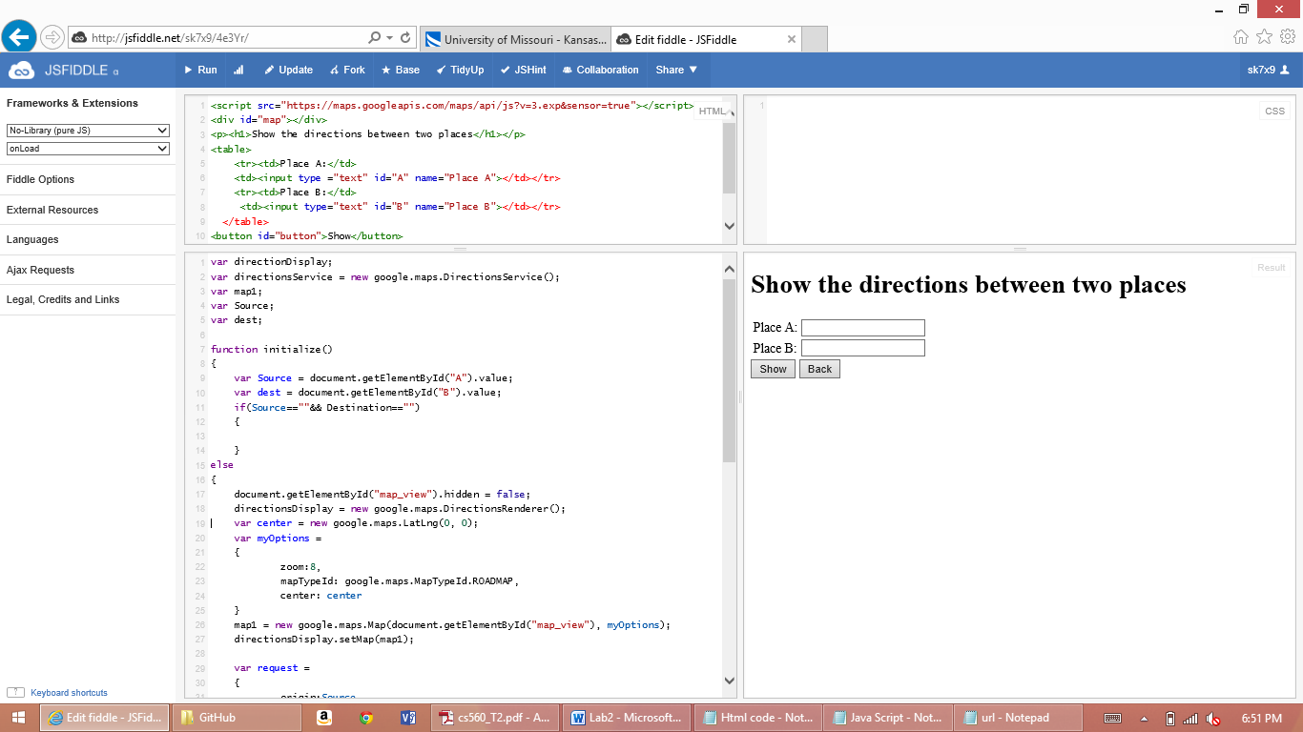

Finally after submitting all the required details the screen shows the map as follows.

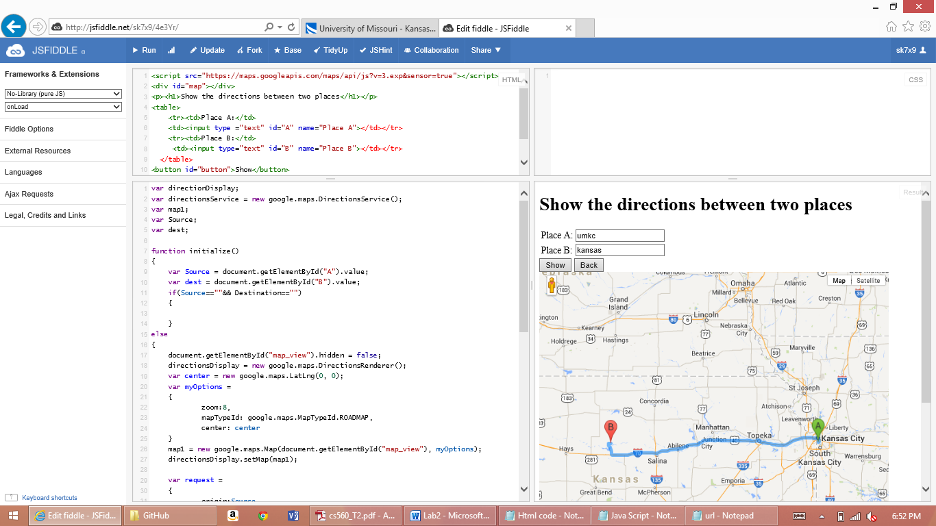**URL of JSfiddle:** Following url shows the page to navigate to the designed application.

<http://jsfiddle.net/sk7x9/4e3Yr/>

**Source Code:** Source code for Html and javascript is enclosed in the folder structure.