Genetic Algorithm UAV Strategy Engine
Artificial Intelligence — Assignment 2 | BSCS Semester 5 | Department of Computer Science
Team of 3: ____________________ / ____________________ / ____________________
Roll Nos: ____________________ / ____________________ / ____________________

1. Problem and objective
Design a strategy engine for a fleet of unmanned aerial vehicles surveying a volatile disaster zone. Decisions include drone deployment positions, ordered waypoint routes, travel speed and sensor activation. Unlike single-objective shortest-path planning, success requires balancing priority coverage, target detection, energy consumption, flight duration and exposure to simulated hazards. This project solves the assigned 50×50-cell version with a seeded, fully synthetic mission.

2. Environment and chromosome representation
The grid stores continuous high-priority weights, normalized hazard intensity, hard no-fly masks and nine simulated target locations. Three UAVs start at separate fixed safe bases. Each individual chromosome represents a complete fleet mission (D = 3 drones, K = 5 waypoint visits per drone):
Segment / gene | Shape and values | Operational meaning
Waypoint coordinates | D × K × 2; real-valued (x,y) | Waypoint 0 is the UAV deployment position; later genes are ordered visits.
Cruise speed | D × K; [1.0, 3.0] | Controls each leg’s travel time and propulsion energy.
Sensor power | D × K; [0, 1] | Continuous on/off intensity, affecting coverage and energy.
Fixed launch bases | D coordinate pairs; not evolved | Flight begins/returns to the assigned base.

The segments stay aligned by UAV and waypoint, so crossover transfers spatial and control genes together. Position repair snaps genes onto legal grid cells and contracts overlong routes toward the base. A* is invoked for segments intersecting blocked cells; obstacle and diagonal corner-cut safety are checked on the routed path.

3. Modeling assumptions
Every sampled sensor observation independently contributes a bounded probability to nearby cells through a Gaussian footprint, with repeated observations combined by saturation (1 − product of non-detection probabilities). The final return leg uses the last speed/power gene. Sensor activity can be reduced toward zero to save energy, but this reduces detection. The system is a planning simulation, not actual drone autopilot software.

4. Multi-objective fitness formulation
All metrics are computed from legal, collision-checked flight routes. We maximize a weighted, normalized scalar fitness:
F = 0.40 C + 0.25 D − 0.15 E − 0.10 T − 0.10 R − P
Term | Exact meaning / why it matters
C | Priority-weighted coverage = Σ(priority_cell × detection_probability_cell) / Σ(priority_cell). Maximizes visits to valuable disaster areas.
D | Mean detection probability across the nine known synthetic target cells. Rewards target localization beyond general coverage.
E | Σ drone energy / (D × battery_budget). Energy = Σ[distance × (0.58 + 0.065 × speed²) + 0.28 × sensor_power × leg_time].
T | Max per-drone flight time / allowed mission time: a parallel-mission makespan that encourages timely fleet completion.
R | Σ(leg_step_distance × hazard_intensity / speed) / (D × allowed mission time); integrates hazard exposure with time.
P | Σ drones [1.5 × max(0, route_distance/max_range − 1) + 1.3 × max(0, energy/battery_budget − 1) + 1.3 × max(0, flight_time/time_limit − 1)].

The weights emphasize C (40%) and D (25%), reflecting the life-critical aim of scanning high-priority disaster zones; E (15%), T (10%) and R (10%) limit operating cost and danger. Violations are penalized separately rather than diluted by objective weights. C and D are in [0, 1], while E, T and R are budget-normalized costs and may exceed 1 for invalid missions.

5. Custom genetic operators and stopping rule
Population initialization draws mission-centered waypoint chains and randomized control profiles. Tournament selection (size 3) chooses parent strategies. Crossover exchanges the waypoint tail AND aligned speed/sensor genes, then geometrically blends the boundary coordinates. Mutation adds Gaussian x/y jitter, independently perturbs speed and sensor power, and occasionally swaps two visits. Elitism retains two top solutions, adaptive mutation rises under stagnation, and random immigrants maintain diversity. After every genetic operation, the strategy is repaired; remaining range/energy/time violations incur P. Stop at generation 38 or 15 stagnant generations.
**Implementation evidence:** `uav_ga/chromosome.py`, `operators.py`, `fitness.py`, `ga.py`, `environment.py`. Recorded best/mean convergence:
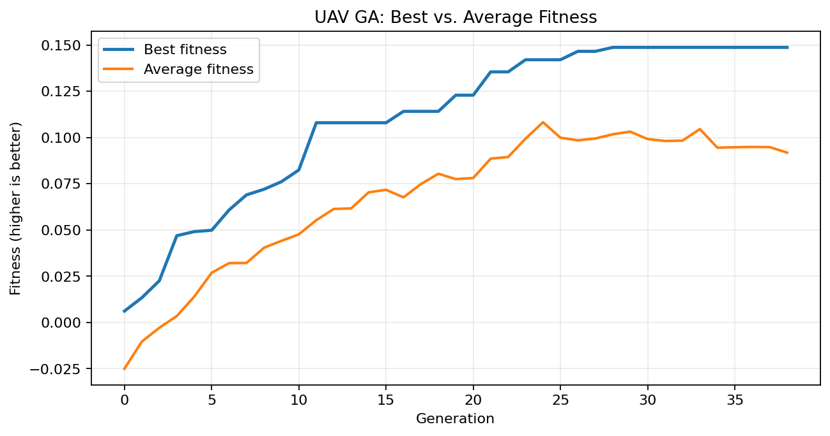

6. Hyperparameter sensitivity study
A one-factor-at-a-time sweep varied the number of individuals, per-gene mutation probability, and tournament size while keeping the same environment and seed (42). Each trial used at most 12 generations, 3 UAVs and 5 waypoints. Reported fitness is the best strategy found in that run. Each population setting uses a different number of evaluations; do not read it as a controlled equal-budget comparison.
Varied parameter | Value | Final best fitness | Evaluations
population size | 16 | 0.07863 | 208
population size | 26 | 0.10430 | 338
population size | 40 | 0.09964 | 520
mutation rate | 0.06 | 0.08312 | 416
mutation rate | 0.19 | 0.10796 | 416
mutation rate | 0.34 | 0.07939 | 416
tournament size | 2 | 0.07834 | 416
tournament size | 3 | 0.10796 | 416
tournament size | 5 | 0.10812 | 416

7. Interpretation of the sweep
Population size: 26 achieved the highest fitness (0.10430) versus 16 (0.07863) and 40 (0.09964). Larger populations evaluated more candidates (208, 338 and 520), so the non-monotonic result reflects both search variation and changing budgets. Mutation rate: 0.19 performed best (0.10796), whereas 0.06 (0.08312) reduced exploration and 0.34 (0.07939) likely disrupted good waypoint structures. Tournament size: 5 (0.10812) slightly exceeded 3 (0.10796), with size 2 lower (0.07834); this modest single-trial difference cannot prove a general improvement. All mutation and tournament runs each used 416 evaluations.
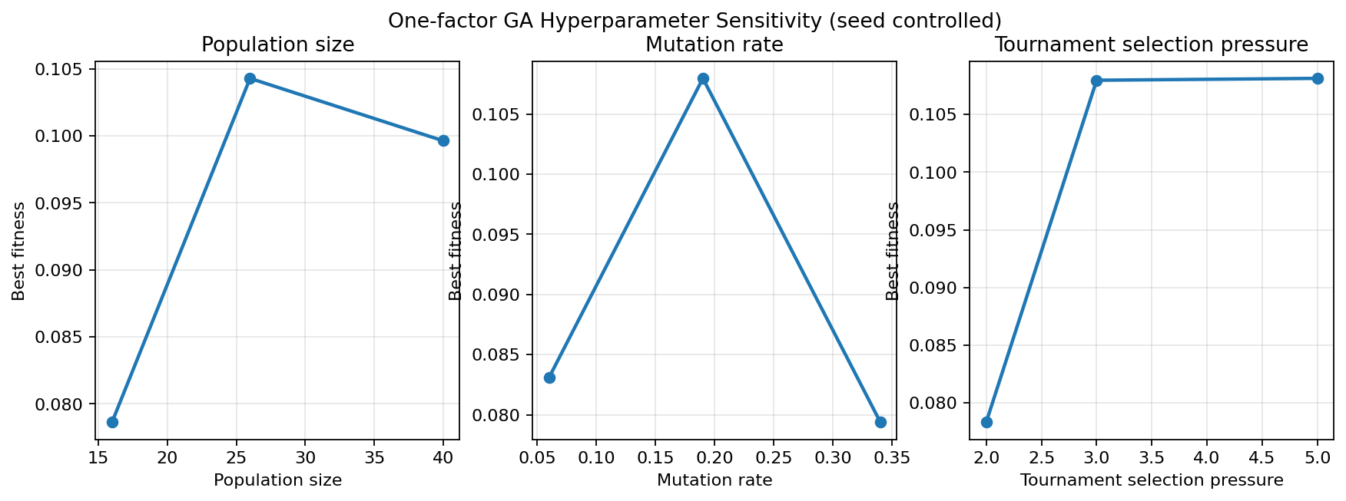
Interpretation caveat: outcomes are illustrative seed-controlled trials, not confidence intervals. Stronger inference would require multiple random seeds, statistical variance estimates and equalized evaluation budgets.

8. Final GA vs. random-search baseline
The final run used the default 32-member population, up to 38 generations, seed 42 and the same 50×50 map. For fairness, random search independently sampled and scored exactly the same number of complete mission chromosomes as the GA. Both methods used the same repair and evaluator. The comparison is a measured result from a single controlled synthetic environment.
Indicator | Genetic Algorithm | Random search
Candidate evaluations | 1,248 | 1,248
Best fitness | 0.14868 | 0.04954
Priority coverage | 0.315 | 0.115
Target detection | 0.639 | 0.323
Normalized energy | 0.541 | 0.280
Normalized flight time | 0.505 | 0.319
Normalized hazard risk | 0.053 | 0.032
Hard-constraint violation | 0.000 | 0.000

Observed GA advantage: +0.09914 fitness units. The evolved solution prioritized longer/higher-power sensing of disaster hot spots: coverage and detection increased substantially, while normalized energy and time also rose. That trade-off is consistent with the chosen priority-heavy weights; it is not a claim that the GA minimizes every metric simultaneously. No-fly paths were legal and all resource penalties were zero in this final solution. All route cells were validated by the simulator.

9. Unique strategy, limitations, and conclusion
The solution is unique to the map geometry, bases, simulated priority peaks, target placement, sensor decay model, speed-dependent energy model and chosen weights. Geometric recombination and local spatial mutation preserve useful partial trajectories that random search cannot explicitly inherit; the GA reaches a better scored configuration with the same evaluation budget in this run. The result is an optimized heuristic, not a mathematically proven global optimum.
Limitations include artificial hazard fields, pre-labeled static targets, planar geometry, constant controls per route leg, simplified energy physics, finite sampled sensor footprints, and a single trial seed. Future work could add stochastic hazard updates, true multi-objective Pareto fronts (e.g., NSGA-II), more realistic UAV dynamics, obstacle clearance margins and repeated-run statistical testing.

10. Reproducibility and submission evidence
From the repository root run: `python -m pip install -r requirements.txt`; `python -m uav_ga simulate`; `python -m uav_ga sensitivity --quick`; `python -m pytest -q`. See `outputs/simulation/` for best/mean convergence, flight paths, coverage heatmap, across-generation evolution, JSON metrics, and CSV fitness history. See `outputs/sensitivity/` for the nine experiment records and chart. The included Colab notebook demonstrates the same modular engine.

