A Data Mining Project
on

Loan Default Prediction

using

Hadoop & Spark

Under the guidance of

Sanjay Ranka
Computer Information Science & Engineering
University of Florida, Gainesville, FL

Submitted on: 25-Apr-2017

By

Sanket Kumar
UFID: 4513-3352
Spring-2017 Semester
Computer Information Science & Engineering
University of Florida, Gainesville, FL

Table of Contents
1. Project Background 4
2. Abstract 5
3. Introduction 6
3a. Description of problem 6
3b. Key Approaches 6
3c. Summary of Results 7
3d. Limitations 9
4. Application Description 10
4a. Problem 10
4b. Data Mining (Classification) 10
4b.1. Data Source 10
4b.2 Data Description 10
4b.3 Data Preparation and Exploration 11
4b.4. Data Upload from local File system to HDFS using Ambari 11
4b.5 RDD, DataFrame, and TempTable using Zeppelin 12
4b.6. Explore Variables one by one using Zeppelin 13
4b.7. Summary Statistics 36
4b.8. Model Building, Scoring, and Evaluation 38
5. Algorithms 45
5a. Hadoop 45
5a.1. Environment Setup 45
5a.2. Run-Time Details of Spark Application 45
5a.3. Zeppelin Code 49
5b. Theoretical Modelling 49
5b.1. Artificial Neural Network 49
5b.2. Logistic Regression model 49
5b.3. Naïve Bayesian Classifier 49
5b.4. Decision Tree 50
6. Experimental Results 51
6a. Datasets 51
6b. Platform Performance 52
6c. Model Results 52
6c.1. Model Evaluation and Comparison 52
6c.2. Major Findings 53
7. Conclusion 54
8. References 55

1. Project Background
This project on Data Mining for predicting Loan Default was completed as part of Spring 2017 course curriculum for MS (Computer Information Science & Engineering) under the guidance of Prof. Sanjay Ranka at University of Florida, Gainesville.
The project focused on leveraging parallel processing of Apache Hadoop and Spark framework as well as applying appropriate statistical algorithms to predict the probable loan defaulters. The accuracy, sensitivity, and specificity were among the parameters for model selection.
It was a huge learning opportunity in multiple areas: the banking industry, Big data platform, current developments and trends in Apache Spark, as well as variety of machine learning techniques.
Prof. Ranka guided me through the initiation, study, development, documentation, and completion of the project through the semester. It was an immense learning!

2. Abstract
Organizations and individuals apply for loans for various reasons. Individuals may apply for loans to buy a house, pay for a purchase etc. Organizations might take a loan to grow their businesses. Banks play crucial role in providing these entities with funds so that the market and society could function properly. The problem is that not every loan application can be approved. In order to make a decision on a loan application, the bank looks at the credit history of these entities. There are a number of parameters to determine if an entity is eligible for a loan. These parameters can be used to predict whether an entity would be suitable for giving a loan or not.
Predicting whether a borrower would default on his/her loan is of vital importance for bankers, as default prediction accuracy will have great impact on their profitability. Previous efforts have been made in this domain using machine learning based on various attributes.
From a Data Mining perspective, the loan default prediction (or credit scoring) can be viewed as a binary classification problem. Due to unequal distribution of data between defaulters and non-defaulters, the data set is usually modified to balance the number of “good” and “bad” cases. Loan defaults data sets are highly skewed, i.e. there are many cases in one class, few in another. This imbalance of data causes many standard learning algorithms perform poorly on the minority class. Duplicating each instance of the minority class multiple times to balance the distribution is an inappropriate technique. This will force the algorithm to overfit to the minority class and the classifier will not work effectively in the real world scenario.
To date, there exists no specialized algorithm to cope up with the imbalances in large data sets for loan default prediction. This project tries to address the problem by using most popular binary classification techniques like Logistic regression and Bayesian network.
The project involves using a set of parameters for each individual to determine if that individual is likely to default on a loan in the future. An effective way of solving this problem will help banks maximize their profits by reducing the number of defaulters.
Data mining on large databases has been a major concern in research community, due to the difficulty of analyzing huge volumes of data using only traditional OLAP tools and RDBMSs. This sort of process implies a lot of computational power, memory and disk I/O, which can only be provided by parallel computers. And, therefore, this data mining project was carried out on Apache Hadoop platform with Spark and other supporting languages like R, Python, and Scala for distributed storage and efficient parallel processing.

3. Introduction

3a. Description of problem
Banks need to make sure that the borrowers don’t default on loan payment. Every borrower should be scored for a loan default at the time of loan application. However, the possibility of default exists even after the loan is granted and some EMIs are paid. This requires a continuous scoring and assessment of all borrowers throughout the loan lifecycle. This score can also be used for upselling and cross-selling.

3b. Key Approaches
- Statistical Approach
The loan default prediction is primarily a binary classification problem. The statistical approach to data mining always starts with data.
- Data selection: The dataset I selected for this project is “cs-training.csv” from kaggle.com (URL: https://www.kaggle.com/c/GiveMeSomeCredit/data). This data set was noisy having NULLS, “NA” in numeric field, high skewness and kurtosis. A statistical handling of data was required including imputing NULLs with median or other techniques, filtering for bad data, under-sampling, and over-sampling etc.
- Platform selection: As the data size was 6.32 MB with 150,000 cases, I decided to use HDFS with SPARK for data exploration and preparation, and R for model building.
- Algorithm selection: I picked models heavily most used supervised learning techniques:
  - Perceptron-based techniques => Artificial Neural Network
  - Generalized linear models => Logistic Regression
  - Statistical learning algorithms => Naive Bayes classifiers, and
  - Logic based algorithms => Decision Tree
- Technical Approach
This project focuses on the following key capabilities and resources:
- HDFS for distributed storage of large volume of data
- Spark for fast processing of data
- Ambari for monitoring and file handling
- Spark History Server UI for event processing analysis
- Spark Livy Server for communication between Spark and Zeppelin Notebook
- Zeppelin Notebook as the front-end for data mining code development
- Scala and Python for data preparation, visualization, and exploration
- R for statistical model building
- Procedural Approach
The objective of this project is to train a classifier that can predict if an individual will experience financial distress in the next two years given the set of attributes listed above. The steps included:
- Data Preparation, Visualization and Exploration
- Analyzing Summary Statistics
- Model Building
- Model Evaluation and Result
- Analysis of back-end process in Spark
- Conclusion
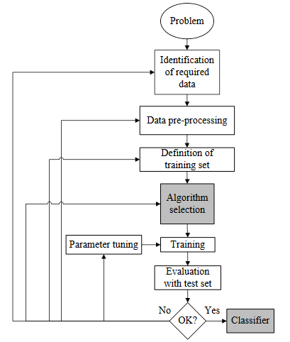

3c. Summary of Results
The original dataset “cs-training.csv” from kaggle.com had 150,000 records. During initial data mining process, I came across multiple issues with the data. I handled it by imputing, recoding and filtering which resulted in 120,269 records. This cleaned dataset was then used with the four selected data mining algorithms (Artificial Neural Network, Logistic Regression, Naïve Bayesian Classifier, and Decision Tree) for development of the predictive models. Two more sampling methods (under sampling and over sampling) were also used to avoid imbalances in the data. The results are shown below:
- Data Preparation
 | Original | Cleaned | All Samples | Under Sampling | Over Sampling
No. of Records | 150,000 | 120,269 | 120,269 | 16,750 | 220,553
- Feature Selection
The initial data mining indicated that one feature “RevUtil” could be dropped based on the p-value in T-test. Since I was building Stepwise Logistic Regression anyways, I decided to carry it forward to confirm the finding. It was indeed dropped by Logistic Regression model in line with the original recommendation.
- Performance of Statistical Models
Sampling | Model | Accuracy | Sensitivity | Specificity | AUC
All Samples | Neural Network | 93.5% | 15.9% | 99.2% | 0.815
All Samples | Logistic Regression | 93.2% | 9.9% | 99.6% | 0.794
All Samples | Naïve Bayesian classifier | 92.5% | 31.6% | 97.0% | 0.795
All Samples | Decision Tree | 93.4% | 16.4% | 99.1% | 0.685
Under Sampling | Neural Network | 73.6% | 65.9% | 81.8% | 0.815
Under Sampling | Logistic Regression | 73.5% | 62.6% | 85.5% | 0.808
Under Sampling | Naïve Bayesian classifier | 79.1% | 81.4% | 76.6% | 0.860
Under Sampling | Decision Tree | 71.3% | 88.8% | 55.1% | 0.796
Over Sampling | Neural Network | 75.4% | 68.1% | 82.6% | 0.820
Over Sampling | Logistic Regression | 73.8% | 60.1% | 87.1% | 0.808
Over Sampling | Naïve Bayesian classifier | 71.2% | 49.3% | 92.2% | 0.799
Over Sampling | Decision Tree | 94.9% | 99.7% | 90.1% | 0.956
The results indicate that the Naïve Bayesian classifier is the best predictor with accuracy as 92.5% and sensitivity as 31.6% on the holdout dataset and with accuracy as 79.1% and sensitivity as 81.4% on the under-sampling dataset. Decision Tree is the best predictor with accuracy 94.9% and sensitivity 99.7% on over-sampling dataset. Performance of logistic regression for any given dataset is not good.

3d. Limitations
- Data Preparation
I had used Spark 1.6 for data preparation tasks. It does not handle SQL sub queries, and as a result, the data exploration and visualization was a bit challenging.
- Platform Capability
I had used Apache software on my laptop, which is limited in its resources. I couldn’t include enough runs specially for ANN with more than 3 nodes in hidden layer due to this limitation.
- Statistical Modeling
My dataset had only 10 independent variables as listed in section 4b.2. Some variables like occupation, education, marital status of borrowers were not present in the dataset, and hence could not be included in this project. I believe that including these variables in statistical modeling would have resulted in better overall performance.

4. Application Description

4a. Problem
Extending credit to individuals is necessary for markets and society to function smoothly. Estimating the probability that an individual would default on their loan, is useful for banks to decide whether to sanction a loan to the individual or not.
For data mining, the first task was to find a representative data set, and then be able to prepare it for consumption by statistical modeling tools. The data is almost always noisy and the balance lies between removal of a feature due to bad data and removal of records to accommodate it. I used summary statistics and t-tests for this purpose.
The data mining software providers have their own way of performing statistical calculations and may give different results even when using the same inputs. Therefore, it was important to use a software that include all the modeling techniques that will be selected for this project, so that the models can be compared against each other for performance.

4b. Data Mining (Classification)

4b.1. Data Source
The data set used for this project is obtained from the competition titled “Give Me Some Credit” in kaggle.com (URL: https://www.kaggle.com/c/GiveMeSomeCredit/data). The file contains various parameters such as Monthly Income, Number of Dependents, age, number of open credit lines and loans etc. It is stored in csv format. Each parameter is briefly described below.

4b.2 Data Description
In this data set there are 150,000 instances. The list of variable is as follows:

Sl.  No | Variable Name  (Original) | Variable Name  (Modified) | Type | Remarks
1 | Instance Number | ID | Numeric | This contains the instance number data
2 | SeriousDlqin2yrs | Dlnq | Binary | Our algorithm is used to predict this. This depicts whether a person experienced 90 days past due delinquency or worse.
3 | RevolvingUtilizationOfUnsecuredLines | RevUtil | Percentage | Total balance on credit cards and personal lines of credit except real estate and no installment debt like car loans divided by the sum of credit limits.
4 | Age | Age | Integer | Contains the age of the borrower in years. This column didn’t contain any missing data.
5 | DebtRatio | DebtRatio | Percentage | It is obtained by dividing the sum of monthly debt payments, alimony, living costs with monthly gross income.
6 | MonthlyIncome | MonthlyInc | Real Number | This column contained the information about the monthly income of an individual.
7 | NumberOfOpenCreditLinesAndLoans | NumOpenCredit | Integer | This column contained information about the number of open loans such as car loans, house loans and lines of credit (ex. Credit card).
8 | NumberRealEstateLoansOrLines | NumREloans | Integer | This column contained information about number of mortgage and real estate loans including home equity lines of credit an individual have taken
9 | NumberOfTime30-59DaysPastDueNotWorse | NumDlnq_30_59 | Integer | This column contains number of times borrower has been 30-59 days past due but no worse in the last 2 years.
10 | NumberOfTime60-89DaysPastDueNotWorse | NumDlnq_60_89 | Integer | This field contains the information about the number of times borrower has been 60-89 days past due but no worse in the last 2 years
11 | NumberOfTimes90DaysLate | NumDlnq_90_Plus | Integer | This column had information about the number of times an individual was late by 90 days or more in paying their bills.
12 | NumberOfDependents | NumDep | Integer | This column contained information about the number of dependents in the family excluding themselves.

4b.3 Data Preparation and Exploration
The data set that was obtained from kaggle.com had 150,000 unique instances. The next step was to prepare data for use with Spark and Scala. The variables were tested for quality of data.
As the ID column in the data sets do not help the algorithm in classifying instances, it was removed from analysis perspective. Since the data was taken from real-world sources, it is expected to contain errors. I tried to identify these errors and fix them. For example, some instances had 0 as the value for Age. Such entries were replaced by the median values.
Some of the quantitative values within the dataset were actually coded values that had qualitative meanings. For example, under the column NumberOfTime30-59DaysPastDueNotWorse, a value of 96 represents “Others”, while a value of 98 represented “Refused to say”. These values needed to be replaced so that their large quantitative values do not skew the entire dataset.
There were some entries in the data set that were listed as ‘NA’. For features where it made sense to impute the data by using the median value (monthly income), this technique was used. For other columns, I had to replace ‘NA’ with ‘’ so that Scala would accept it.
These variables were further studied and transformed.

4b.4. Data Upload from local File system to HDFS using Ambari
The dataset “cs_training_NH.csv” was created from raw data “cs-training.csv” with the following manipulations:
- The columns were re-arranged as per table in section 4b.2
- The ID column was removed
- The Header row was removed
This file was uploaded from local file system to HDFS using Ambari in a directory as shown below:

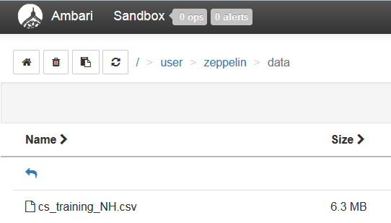
Note: ID column and Header row were removed before upload.

4b.5 RDD, DataFrame, and TempTable using Zeppelin
To create an RDD and DataFrame, and then register a TempTable, I ran the following codes in Apache Zeppelin:

CODE for creating and populating RDD, DataFrame, and TempTable
val sqlContext = new org.apache.spark.sql.SQLContext(sc)
val trngFile = sc.textFile("/resources/data/cs_training_NH.csv")
//val trngFile = sc.textFile("hdfs:///user/zeppelin/data/cs_training_NH.csv")
case class Event(Dlnq: Int,
RevUtil: Double,
Age: Int,
DebtRatio: Double,
MonthlyInc: String,
NumOpenCredit: Int,
NumREloans: Int,
NumDlnq_30_59: Int,
NumDlnq_60_89: Int,
NumDlnq_90_Plus: Int,
NumDep: String)
val eventsRDD = trngFile.map(s => s.split(",")).map(
s => Event( s(0).toInt, //Dlnq
s(1).toDouble, //RevUtil
s(2).toInt, //Age
s(3).toDouble, //DebtRatio
s(4), //MonthlyInc
s(5).toInt, //NumOpenCredit
s(6).toInt, //NumREloans
s(7).toInt, //NumDlnq_30_59
s(8).toInt, //NumDlnq_60_89
s(9).toInt, //NumDlnq_90_Plus
s(10) //NumDep
)
)
eventsRDD.count
val eventsDF = eventsRDD.toDF()
eventsDF.registerTempTable("eventsTable")

4b.6. Explore Variables one by one using Zeppelin

4b.6.1. SeriousDlqin2yrs (Dlnq)

This variable depicts whether a person experienced 90 days past due delinquency or worse. The Analysis, Code and Zeppelin Output are as shown below.

CODE for analysis of variable: Dlnq
%sql
select case when dlnq = 0 then "NonDefaulter" else "Defaulter" end as Type, count(*) as Count, round(100*count(*)/150000,2) as Percentage
from eventsTable
group by case when dlnq = 0 then "NonDefaulter" else "Defaulter" end
order by case when dlnq = 0 then "NonDefaulter" else "Defaulter" end Desc
OUTPUT
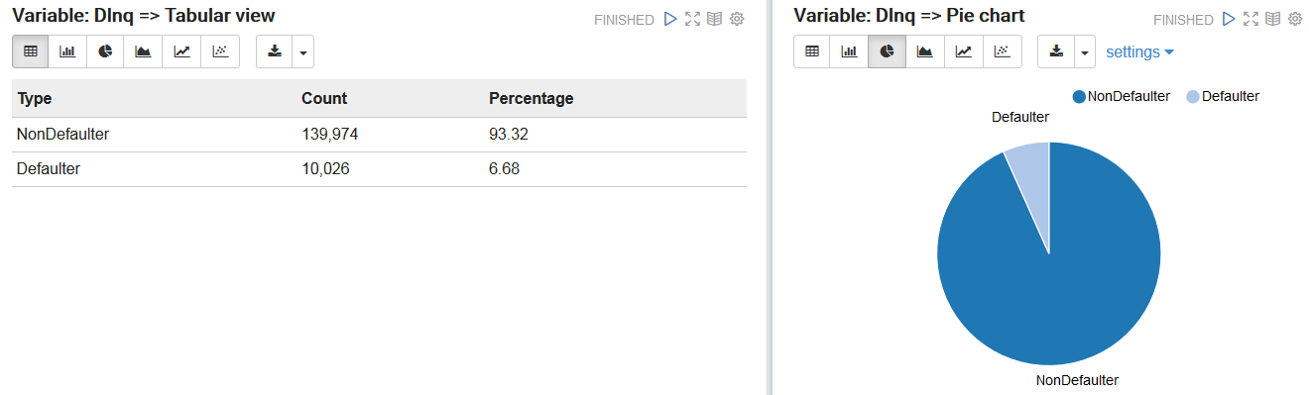

Observations:
- Role: Target
- Data Type: Int, Binary (Only 0 and 1). 0 = Non Defaulter, 1 = Defaulter
- No NULLs
- No. of defaulters = 10,026 (6.68%), No. of Non Defaulters = 139,974 (93.32%)

4b.6.2. RevolvingUtilizationOfUnsecuredLines (RevUtil)

This equals Total balance on credit cards and personal lines of credit except real estate and no-installment debt like car loans divided by the sum of credit limits. I ran the following Spark command to get the basic statistics of this variable:

CODE for descriptive statistics of variable: RevUtil
eventsDF.describe("RevUtil").show()
CODE for Quantile of variable: RevUtil
eventsDF.stat.approxQuantile("RevUtil", Array(0.25), 0.0)
eventsDF.stat.approxQuantile("RevUtil", Array(0.50), 0.0)
eventsDF.stat.approxQuantile("RevUtil", Array(0.75), 0.0)
OUTPUT
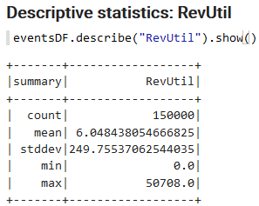 | 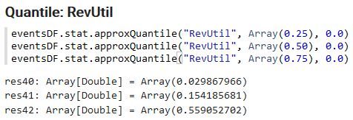

Looking at the mean and max values, it is clear that this variable contains some outliers. Most of the values of this variable lie between 0 and 1 but sometimes it exceeded 1 because some borrowers used more credit than the credit limit. I decided to create 6 categories for better understanding of this variable:
- Less than 0.25
- 0.25 to less than 0.5
- 0.5 to less than 0.75
- 0.75 to less than 1
- 1 to less than 2
- 2 and above
The analysis for this variable is presented here:

CODE for analysis of variable: RevUtil
%sql
select case when RevUtil < 0.25 then '1) less than 0.25'
when RevUtil >= 0.25 and RevUtil < 0.50 then '2) 0.25 to less than 0.5'
when RevUtil >= 0.50 and RevUtil < 0.75 then '3) 0.5 to less than 0.75'
when RevUtil >= 0.75 and RevUtil < 1.00 then '4) 0.75 to less than 1'
when RevUtil >= 1.00 and RevUtil < 2.00 then '5) 1 to less than 2'
else '6) 2 and above' end as RevUtil_Bucket,
count(*) as All_Borrowers,
round(100*count(*)/150000,2) as Perc_All,
sum(case when Dlnq = 1 then 1 else 0 end) as Defaulters,
round(100*sum(case when Dlnq = 1 then 1 else 0 end)/count(*),2) as Perc_Def
from eventsTable
group by case when RevUtil < 0.25 then '1) less than 0.25'
when RevUtil >= 0.25 and RevUtil < 0.50 then '2) 0.25 to less than 0.5'
when RevUtil >= 0.50 and RevUtil < 0.75 then '3) 0.5 to less than 0.75'
when RevUtil >= 0.75 and RevUtil < 1.00 then '4) 0.75 to less than 1'
when RevUtil >= 1.00 and RevUtil < 2.00 then '5) 1 to less than 2'
else '6) 2 and above' end
order by case when RevUtil < 0.25 then '1) less than 0.25'
when RevUtil >= 0.25 and RevUtil < 0.50 then '2) 0.25 to less than 0.5'
when RevUtil >= 0.50 and RevUtil < 0.75 then '3) 0.5 to less than 0.75'
when RevUtil >= 0.75 and RevUtil < 1.00 then '4) 0.75 to less than 1'
when RevUtil >= 1.00 and RevUtil < 2.00 then '5) 1 to less than 2'
else '6) 2 and above' end asc
OUTPUT
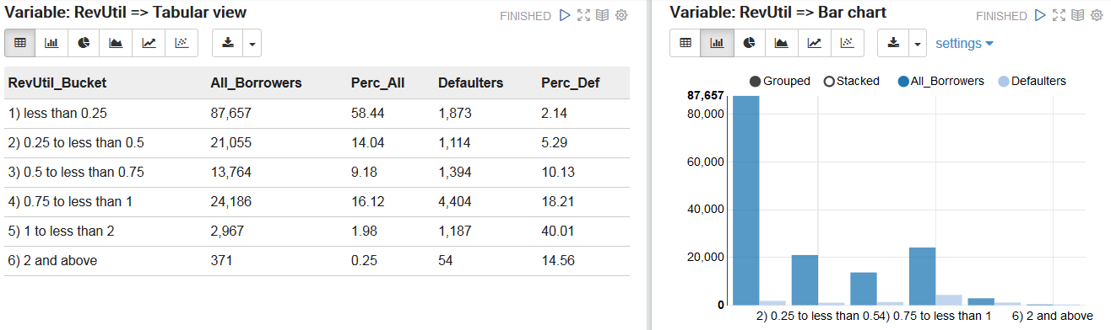

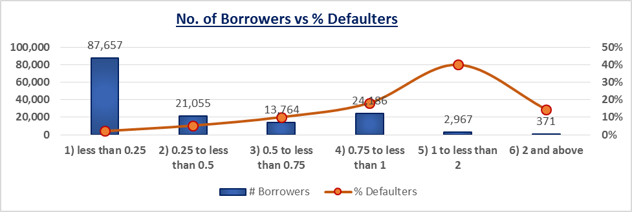

Observations:
- Role: Input
- Data Type: Float, Continuous
- No NULLs
- From the table and chart, it is clear that as the revolving utilization of unsecured lines increases the percentage of defaulters increases. If revolving utilization of unsecured lines is between 1 to 2 then the chances that borrowers will default is very high.

4b.6.3. Age (Age)

This variable contains the age of the borrower in years. The following Spark commands were run to get the basic statistics of this variable:

CODE for descriptive statistics of variable: Age
eventsDF.describe("Age").show()
CODE for Quantile of variable: Age
eventsDF.stat.approxQuantile("Age", Array(0.25), 0.0)
eventsDF.stat.approxQuantile("Age", Array(0.50), 0.0)
eventsDF.stat.approxQuantile("Age", Array(0.75), 0.0)
OUTPUT
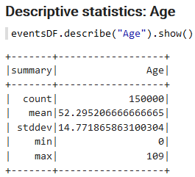 | 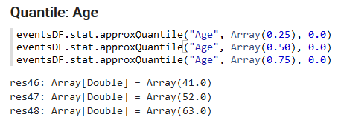

The min = 0 looks pretty abnormal. I created 6 categories for better understanding of this variable:
- 0 to < 26 Yrs
- 26 to < 36 Yrs
- 36 to < 46 Yrs
- 46 to < 56 Yrs
- 56 to < 66 Yrs
- 66 Yrs Plus
The analysis for this variable is presented here:
CODE for analysis of variable: Age
%sql
select case when Age < 26 then '1) 0 to < 26 Yrs'
when Age >= 26 and Age < 36 then '2) 26 to < 36 Yrs'
when Age >= 36 and Age < 46 then '3) 36 to < 46 Yrs'
when Age >= 46 and Age < 56 then '4) 46 to < 56 Yrs'
when Age >= 56 and Age < 66 then '5) 56 to < 66 Yrs'
else '6) 66 Yrs Plus' end as Age_Bucket,
count(*) as All_Borrowers,
round(100*count(*)/150000,2) as Perc_All,
sum(case when Dlnq = 1 then 1 else 0 end) as Defaulters,
round(100*sum(case when Dlnq = 1 then 1 else 0 end)/count(*),2) as Perc_Def
from eventsTable
group by case when Age < 26 then '1) 0 to < 26 Yrs'
when Age >= 26 and Age < 36 then '2) 26 to < 36 Yrs'
when Age >= 36 and Age < 46 then '3) 36 to < 46 Yrs'
when Age >= 46 and Age < 56 then '4) 46 to < 56 Yrs'
when Age >= 56 and Age < 66 then '5) 56 to < 66 Yrs'
else '6) 66 Yrs Plus' end
order by case when Age < 26 then '1) 0 to < 26 Yrs'
when Age >= 26 and Age < 36 then '2) 26 to < 36 Yrs'
when Age >= 36 and Age < 46 then '3) 36 to < 46 Yrs'
when Age >= 46 and Age < 56 then '4) 46 to < 56 Yrs'
when Age >= 56 and Age < 66 then '5) 56 to < 66 Yrs'
else '6) 66 Yrs Plus' end
OUTPUT
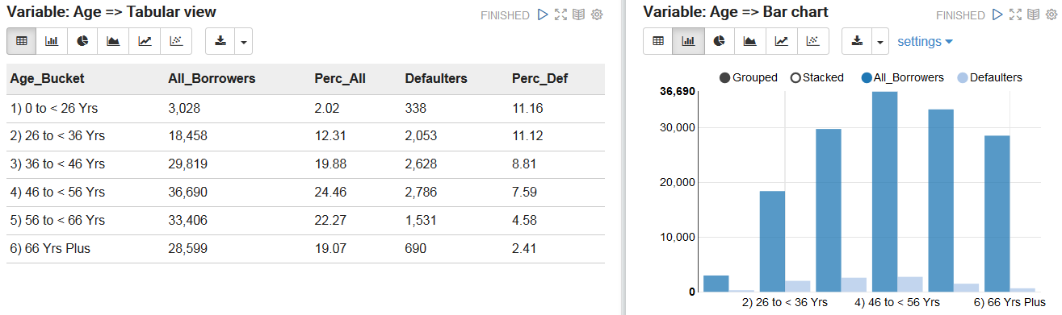

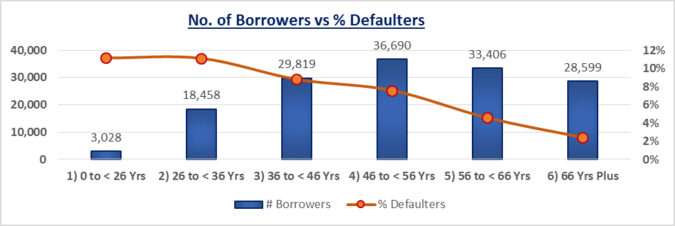
Observations:
- Role: Input
- Data Type: Integer, Continuous
- No NULLs
- From the table we can say that the younger borrowers are most likely to default than the older borrowers. Near about 86% borrowers have age greater than 36 years.

4b.6.4. DebtRatio (DebtRatio)

DebtRatio is obtained by dividing the sum of monthly debt payments, alimony, living costs with monthly gross income. It is the ratio of total debit and total asset. Most of the time it lies between 0 and 1 but sometime it may exceed 1 because total asset may be less than total debit. The following Spark commands were run to get the basic statistics of this variable:

CODE for descriptive statistics of variable: DebtRatio
eventsDF.describe("DebtRatio").show()
CODE for Quantile of variable: DebtRatio
eventsDF.stat.approxQuantile("DebtRatio", Array(0.25), 0.0)
eventsDF.stat.approxQuantile("DebtRatio", Array(0.50), 0.0)
eventsDF.stat.approxQuantile("DebtRatio", Array(0.75), 0.0)
OUTPUT
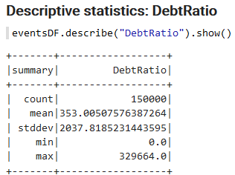 | 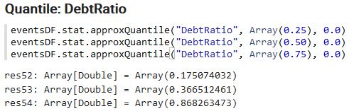

We see that the Std. Deviation is very high. I created 6 categories for better understanding of this variable:
- 0 to < 0.25
- 0.25 to < 0.50
- 0.50 to < 0.75
- 0.75 to < 1.0
- 1.0 to < 2.0
- 2.0 Plus
The analysis for this variable is presented here:

CODE for analysis of variable: DebtRatio
%sql
select case when DebtRatio < 0.25 then '1) 0 to < 0.25'
when DebtRatio >= 0.25 and DebtRatio < 0.50 then '2) 0.25 to < 0.50'
when DebtRatio >= 0.50 and DebtRatio < 0.75 then '3) 0.50 to < 0.75'
when DebtRatio >= 0.75 and DebtRatio < 1.0 then '4) 0.75 to < 1.0'
when DebtRatio >= 1.0 and DebtRatio < 2.0 then '5) 1.0 to < 2.0'
else '6) 2.0 Plus' end as DebtRatio_Bucket,
count(*) as All_Borrowers,
round(100*count(*)/150000,2) as Perc_All,
sum(case when Dlnq = 1 then 1 else 0 end) as Defaulters,
round(100*sum(case when Dlnq = 1 then 1 else 0 end)/count(*),2) as Perc_Def
from eventsTable
group by case when DebtRatio < 0.25 then '1) 0 to < 0.25'
when DebtRatio >= 0.25 and DebtRatio < 0.50 then '2) 0.25 to < 0.50'
when DebtRatio >= 0.50 and DebtRatio < 0.75 then '3) 0.50 to < 0.75'
when DebtRatio >= 0.75 and DebtRatio < 1.0 then '4) 0.75 to < 1.0'
when DebtRatio >= 1.0 and DebtRatio < 2.0 then '5) 1.0 to < 2.0'
else '6) 2.0 Plus' end
order by case when DebtRatio < 0.25 then '1) 0 to < 0.25'
when DebtRatio >= 0.25 and DebtRatio < 0.50 then '2) 0.25 to < 0.50'
when DebtRatio >= 0.50 and DebtRatio < 0.75 then '3) 0.50 to < 0.75'
when DebtRatio >= 0.75 and DebtRatio < 1.0 then '4) 0.75 to < 1.0'
when DebtRatio >= 1.0 and DebtRatio < 2.0 then '5) 1.0 to < 2.0'
else '6) 2.0 Plus' end
OUTPUT
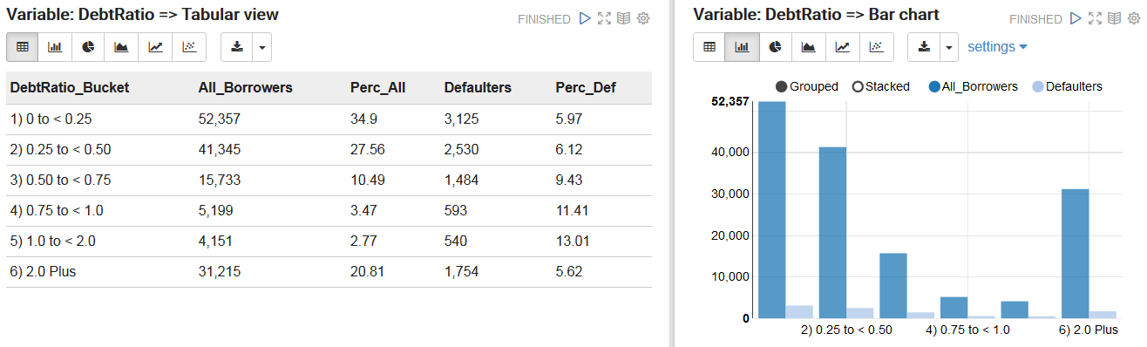

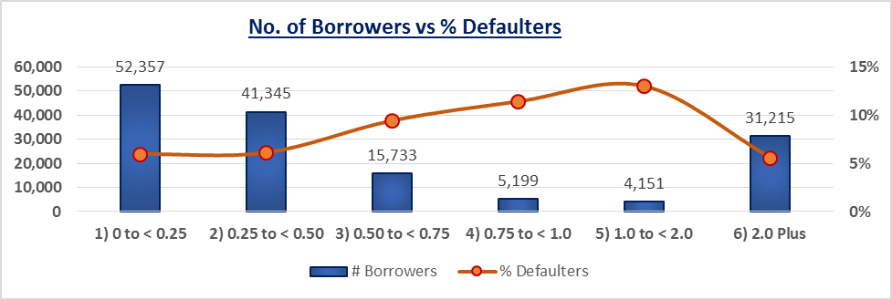

Observations:
- Role: Input
- Data Type: Double, Continuous
- No NULLs
- As we can see, if the DebtRatio increases, the proportion of defaulters also increases. The percentage of defaulters is the highest when debit ratio is in between 1 to 2.

4b.6.5. MonthlyIncome (MonthlyInc)

This column contains information about monthly income of an individual. The unit of income is unknown i.e. we don’t know if the given income is in rupees or dollars. The following Spark commands were run to get the basic statistics of this variable:

CODE for descriptive statistics of variable: MonthlyInc
eventsDF.describe("MonthlyInc").show()
CODE for Quantile of variable: MonthlyInc
//eventsDF.stat.approxQuantile("MonthlyInc", Array(0.25), 0.0)
//eventsDF.stat.approxQuantile("MonthlyInc", Array(0.50), 0.0)
//eventsDF.stat.approxQuantile("MonthlyInc", Array(0.75), 0.0)
Note: Quantile was calculated manually as MonthlyInc contains string entry: “NA”
OUTPUT
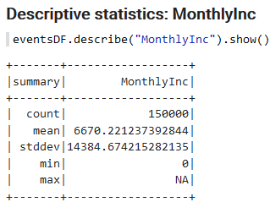

Although this column is expected to be numeric, but it has some non-numeric data as seen in the output above (max = NA). Also, Std. Deviation is very high. To further understand the data, I created 4 categories for this variable:
- 0 to < 5k
- 5k to < 10k
- 10k to < 15k
- 15k Plus
The analysis for this variable is presented here:

CODE for analysis of variable: MonthlyInc
%sql
select case when MonthlyInc < 5000 then '1) 0 to < 5k'
when MonthlyInc >= 5000 and MonthlyInc < 10000 then '2) 5k to < 10k'
when MonthlyInc >= 10000 and MonthlyInc < 15000 then '3) 10k to < 15k'
when MonthlyInc >= 15000 then '4) 15k Plus '
else '5) Bad Data' end as MonthlyInc_Bucket,
count(*) as All_Borrowers,
round(100*count(*)/150000,2) as Perc_All,
sum(case when Dlnq = 1 then 1 else 0 end) as Defaulters,
round(100*sum(case when Dlnq = 1 then 1 else 0 end)/count(*),2) as Perc_Def
from eventsTable
group by case when MonthlyInc < 5000 then '1) 0 to < 5k'
when MonthlyInc >= 5000 and MonthlyInc < 10000 then '2) 5k to < 10k'
when MonthlyInc >= 10000 and MonthlyInc < 15000 then '3) 10k to < 15k'
when MonthlyInc >= 15000 then '4) 15k Plus '
else '5) Bad Data' end
order by case when MonthlyInc < 5000 then '1) 0 to < 5k'
when MonthlyInc >= 5000 and MonthlyInc < 10000 then '2) 5k to < 10k'
when MonthlyInc >= 10000 and MonthlyInc < 15000 then '3) 10k to < 15k'
when MonthlyInc >= 15000 then '4) 15k Plus '
else '5) Bad Data' end
OUTPUT
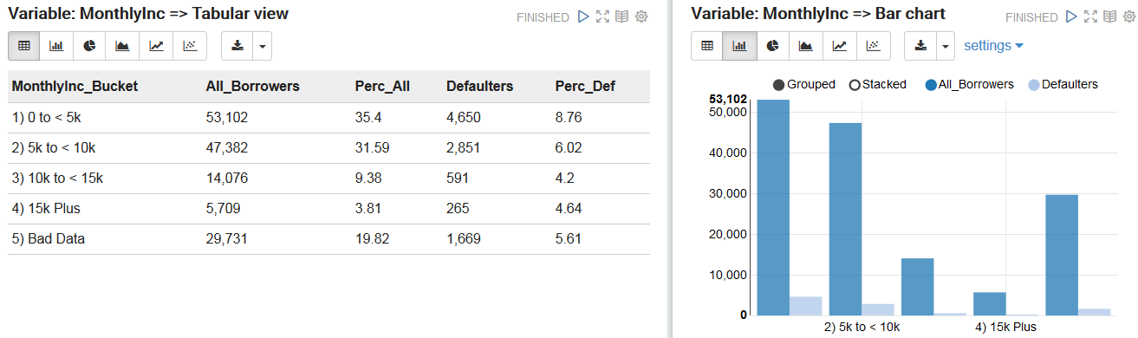

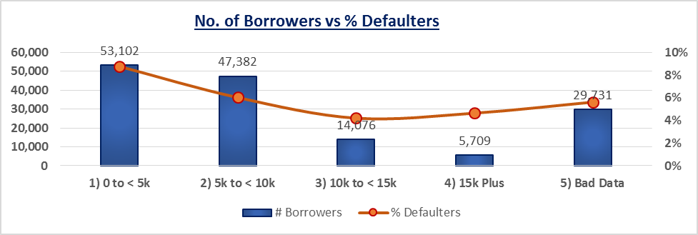

Observations:
- Role: Input
- Data Type: Double, Continuous (In our database, it is string due to “NA” entries)
- NULLs and Bad Data account for 19.82%
- From the table we can say that nearly 67% borrowers have monthly income less than 10k. Proportion of defaulters is significantly higher when income of borrower is below 10k.

4b.6.6. NumberOfOpenCreditLinesAndLoans (NumOpenCredit)
This column contains information about the number of open loans such as car loans, house loans and lines of credit (ex. Credit card). The following Spark commands were run to get the basic statistics of this variable:

CODE for descriptive statistics of variable: NumOpenCredit
eventsDF.describe("NumOpenCredit").show()
CODE for Quantile of variable: NumOpenCredit
eventsDF.stat.approxQuantile("NumOpenCredit", Array(0.25), 0.0)
eventsDF.stat.approxQuantile("NumOpenCredit", Array(0.50), 0.0)
eventsDF.stat.approxQuantile("NumOpenCredit", Array(0.75), 0.0)
OUTPUT
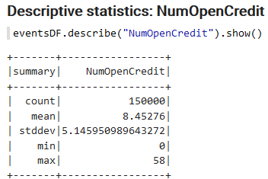 | 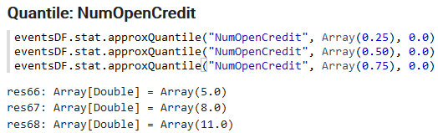

No specific observation on the summary statistics. To understand the data further, I created 7 categories for this variable:
- 0 to < 5
- 5 to < 10
- 10 to < 15
- 15 to <20
- 20 to <25
- 25 to <30
- 30 Plus
The analysis for this variable is presented here:

CODE for analysis of variable: NumOpenCredit
%sql
select case when NumOpenCredit < 5 then '1) 0 to < 5'
when NumOpenCredit >= 5 and NumOpenCredit < 10 then '2) 5 to < 10'
when NumOpenCredit >= 10 and NumOpenCredit < 15 then '3) 10 to < 15'
when NumOpenCredit >= 15 and NumOpenCredit < 20 then '4) 15 to < 20'
when NumOpenCredit >= 20 and NumOpenCredit < 25 then '5) 20 to < 25'
when NumOpenCredit >= 25 and NumOpenCredit < 30 then '6) 25 to < 30'
when NumOpenCredit >= 30 then '7) 30 Plus '
else '8) Bad Data' end as NumOpenCredit_Bucket,
count(*) as All_Borrowers,
round(100*count(*)/150000,2) as Perc_All,
sum(case when Dlnq = 1 then 1 else 0 end) as Defaulters,
round(100*sum(case when Dlnq = 1 then 1 else 0 end)/count(*),2) as Perc_Def
from eventsTable
group by case when NumOpenCredit < 5 then '1) 0 to < 5'
when NumOpenCredit >= 5 and NumOpenCredit < 10 then '2) 5 to < 10'
when NumOpenCredit >= 10 and NumOpenCredit < 15 then '3) 10 to < 15'
when NumOpenCredit >= 15 and NumOpenCredit < 20 then '4) 15 to < 20'
when NumOpenCredit >= 20 and NumOpenCredit < 25 then '5) 20 to < 25'
when NumOpenCredit >= 25 and NumOpenCredit < 30 then '6) 25 to < 30'
when NumOpenCredit >= 30 then '7) 30 Plus '
else '8) Bad Data' end
order by case when NumOpenCredit < 5 then '1) 0 to < 5'
when NumOpenCredit >= 5 and NumOpenCredit < 10 then '2) 5 to < 10'
when NumOpenCredit >= 10 and NumOpenCredit < 15 then '3) 10 to < 15'
when NumOpenCredit >= 15 and NumOpenCredit < 20 then '4) 15 to < 20'
when NumOpenCredit >= 20 and NumOpenCredit < 25 then '5) 20 to < 25'
when NumOpenCredit >= 25 and NumOpenCredit < 30 then '6) 25 to < 30'
when NumOpenCredit >= 30 then '7) 30 Plus '
else '8) Bad Data' end
OUTPUT
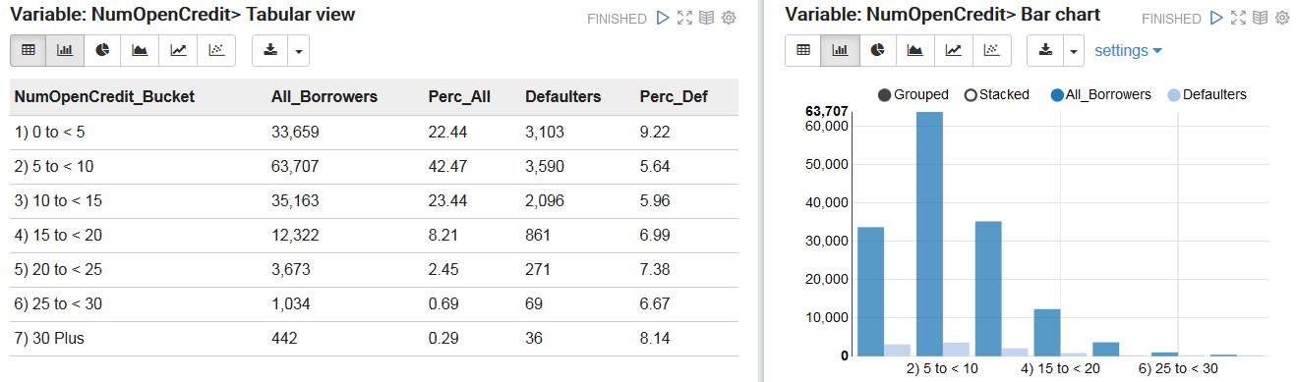

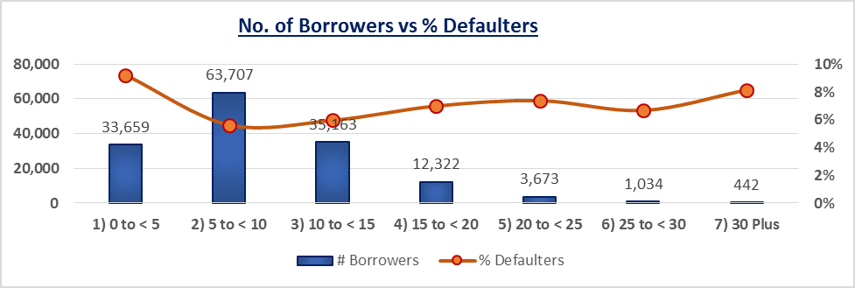

Observations:
- Role: Input
- Data Type: Int, Continuous
- No NULLs
- The table shows that nearly 65% borrowers use less than 10 open credit lines and loans. The proportion of defaulters is almost same across the open credit lines bucket.

4b.6.7. NumberRealEstateLoansOrLines (NumREloans)

This variable contains information about number of mortgages and real estate loans including home equity lines of credit an individual has taken. The following Spark commands were run to get the basic statistics of this variable:

CODE for descriptive statistics of variable: NumREloans
eventsDF.describe("NumREloans").show()
CODE for Quantile of variable: NumREloans
eventsDF.stat.approxQuantile("NumREloans", Array(0.25), 0.0)
eventsDF.stat.approxQuantile("NumREloans", Array(0.50), 0.0)
eventsDF.stat.approxQuantile("NumREloans", Array(0.75), 0.0)
OUTPUT
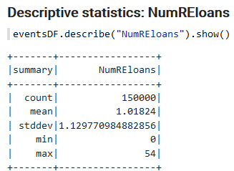 | 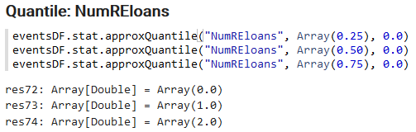

The spread is very high compared to mean, so it indicates an skewed distribution. To understand the data further, I created 5 categories for this variable:
- 0 to < 5
- 5 to < 10
- 10 to < 15
- 15 to <20
- 20 Plus
The analysis for this variable is presented here:

CODE for analysis of variable: NumREloans
%sql
select case when NumREloans < 5 then '1) 0 to < 5'
when NumREloans >= 5 and NumREloans < 10 then '2) 5 to < 10'
when NumREloans >= 10 and NumREloans < 15 then '3) 10 to < 15'
when NumREloans >= 15 and NumREloans < 20 then '4) 15 to < 20'
when NumREloans >= 20 then '5) 20 Plus '
else '6) Bad Data' end as NumREloans_Bucket,
count(*) as All_Borrowers,
round(100*count(*)/150000,2) as Perc_All,
sum(case when Dlnq = 1 then 1 else 0 end) as Defaulters,
round(100*sum(case when Dlnq = 1 then 1 else 0 end)/count(*),2) as Perc_Def
from eventsTable
group by case when NumREloans < 5 then '1) 0 to < 5'
when NumREloans >= 5 and NumREloans < 10 then '2) 5 to < 10'
when NumREloans >= 10 and NumREloans < 15 then '3) 10 to < 15'
when NumREloans >= 15 and NumREloans < 20 then '4) 15 to < 20'
when NumREloans >= 20 then '5) 20 Plus '
else '6) Bad Data' end
order by case when NumREloans < 5 then '1) 0 to < 5'
when NumREloans >= 5 and NumREloans < 10 then '2) 5 to < 10'
when NumREloans >= 10 and NumREloans < 15 then '3) 10 to < 15'
when NumREloans >= 15 and NumREloans < 20 then '4) 15 to < 20'
when NumREloans >= 20 then '5) 20 Plus '
else '6) Bad Data' end
OUTPUT
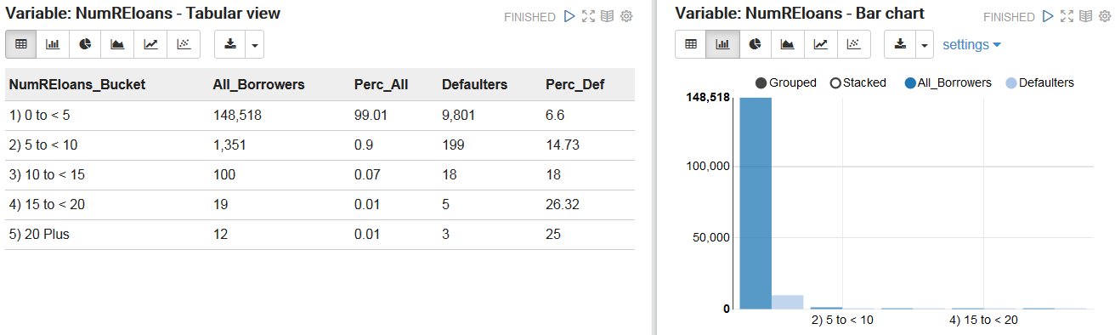

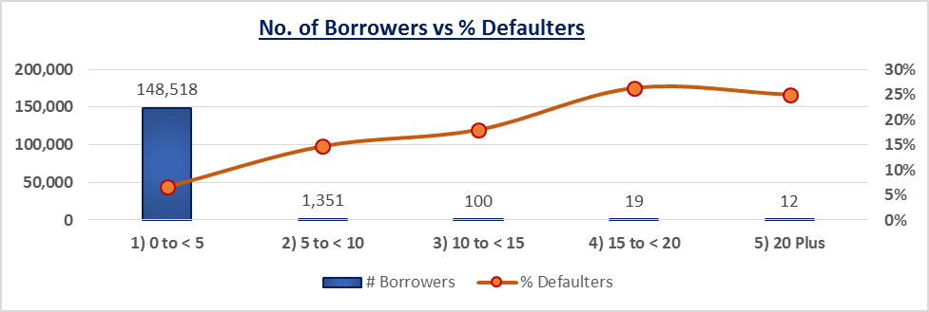

Observations:
- Role: Input
- Data Type: Int, Continuous
- No NULLs
- From the table we can say that almost 99% borrowers have a number of real estate loans which is less than five. But proportion of defaulter borrowers is high when number of real estate loans is greater than 5.

4b.6.8. NumberOfTime30-59DaysPastDueNotWorse (NumDlnq_30_59)

This variable contains number of times borrower has been 30-59 days past due but no worse in the last 2 years. The following Spark commands were run to get the basic statistics of this variable:

CODE for descriptive statistics of variable: NumDlnq_30_59
eventsDF.describe("NumDlnq_30_59").show()
CODE for Quantile: NumDlnq_30_59
eventsDF.stat.approxQuantile("NumDlnq_30_59", Array(0.25), 0.0)
eventsDF.stat.approxQuantile("NumDlnq_30_59", Array(0.50), 0.0)
eventsDF.stat.approxQuantile("NumDlnq_30_59", Array(0.75), 0.0)
OUTPUT
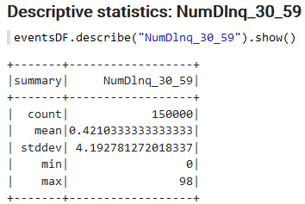 | 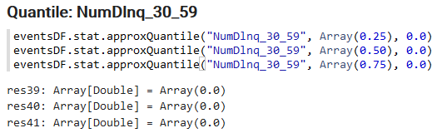

The spread is much higher compared to mean, so it indicates a highly skewed distribution. To understand the data further, I created 9 categories for this variable:
- 0 times
- 1 times
- 2 times
- 3 times
- 4 times
- 5 times
- 6 times
- 7 times
- 8 Plus times
The analysis for this variable is presented here:

CODE for analysis of variable: NumDlnq_30_59
%sql
select case when NumDlnq_30_59 = 0 then '1) 0 times'
when NumDlnq_30_59 = 1 then '2) 1 times'
when NumDlnq_30_59 = 2 then '3) 2 times'
when NumDlnq_30_59 = 3 then '4) 3 times'
when NumDlnq_30_59 = 4 then '5) 4 times'
when NumDlnq_30_59 = 5 then '6) 5 times'
when NumDlnq_30_59 = 6 then '7) 6 times'
when NumDlnq_30_59 = 7 then '8) 7 times'
when NumDlnq_30_59 >= 8 then '9) 8 Plus times'
else '10) Bad Data' end as NumDlnq_30_59_Bucket,
count(*) as All_Borrowers,
round(100*count(*)/150000,2) as Perc_All,
sum(case when Dlnq = 1 then 1 else 0 end) as Defaulters,
round(100*sum(case when Dlnq = 1 then 1 else 0 end)/count(*),2) as Perc_Def
from eventsTable
group by case when NumDlnq_30_59 = 0 then '1) 0 times'
when NumDlnq_30_59 = 1 then '2) 1 times'
when NumDlnq_30_59 = 2 then '3) 2 times'
when NumDlnq_30_59 = 3 then '4) 3 times'
when NumDlnq_30_59 = 4 then '5) 4 times'
when NumDlnq_30_59 = 5 then '6) 5 times'
when NumDlnq_30_59 = 6 then '7) 6 times'
when NumDlnq_30_59 = 7 then '8) 7 times'
when NumDlnq_30_59 >= 8 then '9) 8 Plus times'
else '10) Bad Data' end
order by case when NumDlnq_30_59 = 0 then '1) 0 times'
when NumDlnq_30_59 = 1 then '2) 1 times'
when NumDlnq_30_59 = 2 then '3) 2 times'
when NumDlnq_30_59 = 3 then '4) 3 times'
when NumDlnq_30_59 = 4 then '5) 4 times'
when NumDlnq_30_59 = 5 then '6) 5 times'
when NumDlnq_30_59 = 6 then '7) 6 times'
when NumDlnq_30_59 = 7 then '8) 7 times'
when NumDlnq_30_59 >= 8 then '9) 8 Plus times'
else '10) Bad Data' end
OUTPUT
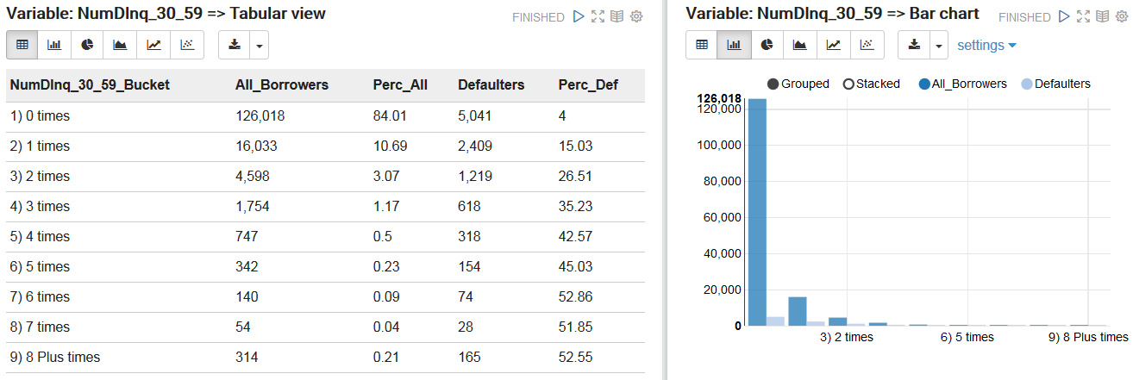

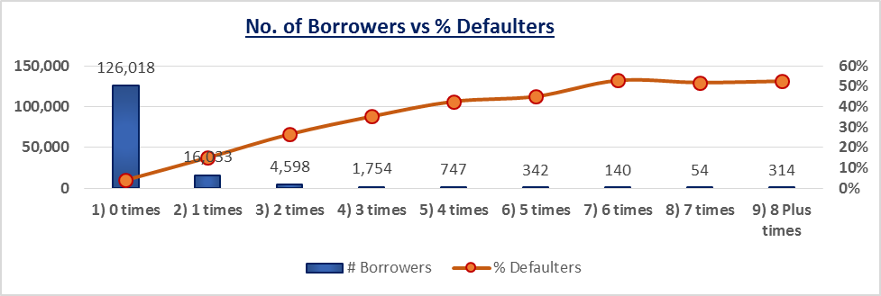
Observations:
- Role: Input
- Data Type: Int, Continuous
- No NULLs
- From the table, it is clear that the percentage of defaulters is high if they are more times late to pay their credit (30-59 days late).

4b.6.9. NumberOfTime60-89DaysPastDueNotWorse (NumDlnq_60_89)

This variable contains the information about the number of times borrower has been 60-89 days past due but no worse in the last 2 years. The following Spark commands were run to get the basic statistics of this variable:

CODE for descriptive statistics of variable: NumDlnq_60_89
eventsDF.describe("NumDlnq_60_89").show()
CODE for Quantile of variable: NumDlnq_60_89
eventsDF.stat.approxQuantile("NumDlnq_60_89", Array(0.25), 0.0)
eventsDF.stat.approxQuantile("NumDlnq_60_89", Array(0.50), 0.0)
eventsDF.stat.approxQuantile("NumDlnq_60_89", Array(0.75), 0.0)
OUTPUT
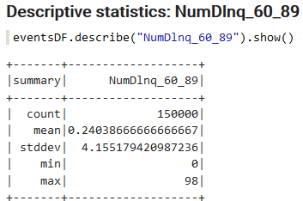 | 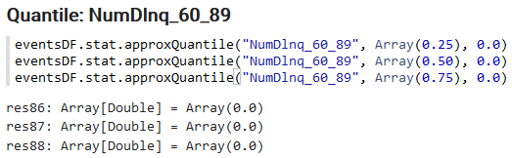
The spread is much higher compared to mean, so it indicates a highly skewed distribution. To understand the data further, I created 7 categories for this variable:
- 0 times
- 1 times
- 2 times
- 3 times
- 4 times
- 5 times
- 6 Plus times
The analysis for this variable is presented here:

CODE for analysis of variable: NumDlnq_60_89
%sql
select case when NumDlnq_60_89 = 0 then '1) 0 times'
when NumDlnq_60_89 = 1 then '2) 1 times'
when NumDlnq_60_89 = 2 then '3) 2 times'
when NumDlnq_60_89 = 3 then '4) 3 times'
when NumDlnq_60_89 = 4 then '5) 4 times'
when NumDlnq_60_89 = 5 then '6) 5 times'
when NumDlnq_60_89 >= 6 then '7) 6 Plus times'
else '8) Bad Data' end as NumDlnq_60_89_Bucket,
count(*) as All_Borrowers,
round(100*count(*)/150000,2) as Perc_All,
sum(case when Dlnq = 1 then 1 else 0 end) as Defaulters,
round(100*sum(case when Dlnq = 1 then 1 else 0 end)/count(*),2) as Perc_Def
from eventsTable
group by case when NumDlnq_60_89 = 0 then '1) 0 times'
when NumDlnq_60_89 = 1 then '2) 1 times'
when NumDlnq_60_89 = 2 then '3) 2 times'
when NumDlnq_60_89 = 3 then '4) 3 times'
when NumDlnq_60_89 = 4 then '5) 4 times'
when NumDlnq_60_89 = 5 then '6) 5 times'
when NumDlnq_60_89 >= 6 then '7) 6 Plus times'
else '8) Bad Data' end
order by case when NumDlnq_60_89 = 0 then '1) 0 times'
when NumDlnq_60_89 = 1 then '2) 1 times'
when NumDlnq_60_89 = 2 then '3) 2 times'
when NumDlnq_60_89 = 3 then '4) 3 times'
when NumDlnq_60_89 = 4 then '5) 4 times'
when NumDlnq_60_89 = 5 then '6) 5 times'
when NumDlnq_60_89 >= 6 then '7) 6 Plus times'
else '8) Bad Data' end
OUTPUT
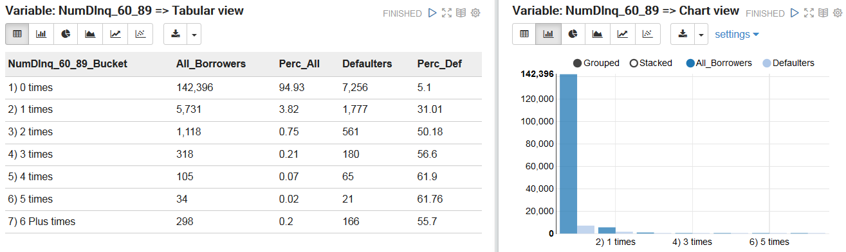

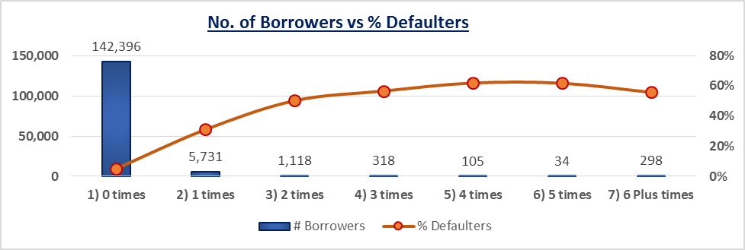
Observations:
- Role: Input
- Data Type: Int, Continuous
- No NULLs
- As like previous table this table also shows that default rate increases as number of times delinquency of borrowers in 60-89 days increases.

4b.6.10. NumberOfTimes90DaysLate (NumDlnq_90_Plus)

This variable has information about the number of times an individual was late by 90 days or more in paying their bills. The following Spark commands were run to get the basic statistics of this variable:

CODE for descriptive statistics of variable: NumDlnq_90_Plus
eventsDF.describe("NumDlnq_90_Plus").show()
CODE for Quantile of variable: NumDlnq_90_Plus
eventsDF.stat.approxQuantile("NumDlnq_90_Plus", Array(0.25), 0.0)
eventsDF.stat.approxQuantile("NumDlnq_90_Plus", Array(0.50), 0.0)
eventsDF.stat.approxQuantile("NumDlnq_90_Plus", Array(0.75), 0.0)
OUTPUT
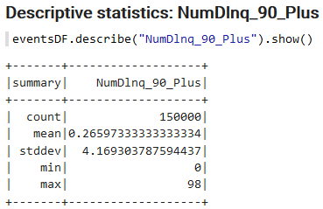 | 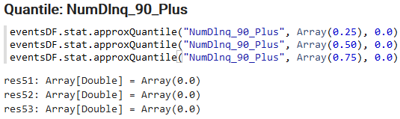

The spread is much higher compared to mean, so it indicates a highly skewed distribution. To understand the data further, I created 7 categories for this variable:
- 0 times
- 1 times
- 2 times
- 3 times
- 4 times
- 5 times
- 6 Plus times
The analysis for this variable is presented here:

CODE for analysis of variable: NumDlnq_90_Plus
%sql
select case when NumDlnq_90_Plus = 0 then '1) 0 times'
when NumDlnq_90_Plus = 1 then '2) 1 times'
when NumDlnq_90_Plus = 2 then '3) 2 times'
when NumDlnq_90_Plus = 3 then '4) 3 times'
when NumDlnq_90_Plus = 4 then '5) 4 times'
when NumDlnq_90_Plus = 5 then '6) 5 times'
when NumDlnq_90_Plus >= 6 then '7) 6 Plus times'
else '8) Bad Data' end as NumDlnq_90_Plus_Bucket,
count(*) as All_Borrowers,
round(100*count(*)/150000,2) as Perc_All,
sum(case when Dlnq = 1 then 1 else 0 end) as Defaulters,
round(100*sum(case when Dlnq = 1 then 1 else 0 end)/count(*),2) as Perc_Def
from eventsTable
group by case when NumDlnq_90_Plus = 0 then '1) 0 times'
when NumDlnq_90_Plus = 1 then '2) 1 times'
when NumDlnq_90_Plus = 2 then '3) 2 times'
when NumDlnq_90_Plus = 3 then '4) 3 times'
when NumDlnq_90_Plus = 4 then '5) 4 times'
when NumDlnq_90_Plus = 5 then '6) 5 times'
when NumDlnq_90_Plus >= 6 then '7) 6 Plus times'
else '8) Bad Data' end
order by case when NumDlnq_90_Plus = 0 then '1) 0 times'
when NumDlnq_90_Plus = 1 then '2) 1 times'
when NumDlnq_90_Plus = 2 then '3) 2 times'
when NumDlnq_90_Plus = 3 then '4) 3 times'
when NumDlnq_90_Plus = 4 then '5) 4 times'
when NumDlnq_90_Plus = 5 then '6) 5 times'
when NumDlnq_90_Plus >= 6 then '7) 6 Plus times'
else '8) Bad Data' end
OUTPUT
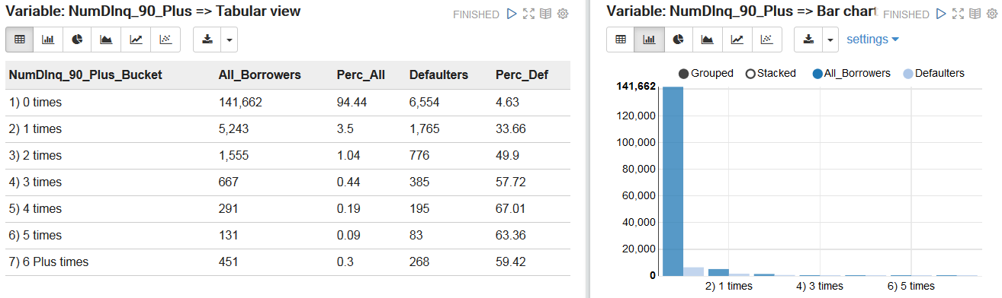

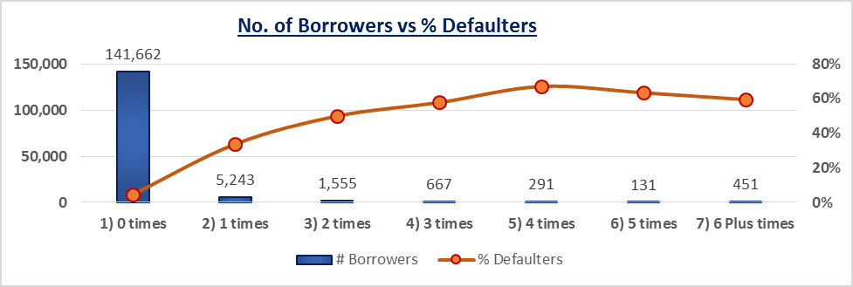

Observations:
- Role: Input
- Data Type: Int, Continuous
- No NULLs
- The proportion of defaulters is high when the no. of times borrower has paid their credit bill late goes high.

4b.6.11. NumberOfDependents (NumDep)

This variable contains information about the number of dependents in the family excluding themselves. The following Spark commands were run to get the basic statistics of this variable:

CODE for descriptive statistics of variable: NumDep
eventsDF.describe("NumDep").show()
CODE for Quantile of variable: NumDep
//eventsDF.stat.approxQuantile("NumDep", Array(0.25), 0.0)
//eventsDF.stat.approxQuantile("NumDep", Array(0.50), 0.0)
//eventsDF.stat.approxQuantile("NumDep", Array(0.75), 0.0)
Note: Quantile was calculated manually as MonthlyInc contains string entry: “NA”
OUTPUT
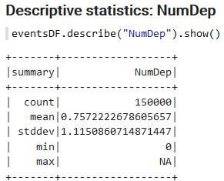

The data is expected to be numeric (Int), but it contains “NA” as seen from the table above. To understand the data further, I created 7 categories for this variable:
- 0
- 1
- 2
- 3
- 4
- 5 Plus
The analysis for this variable is presented here:

CODE for analysis of variable: NumDep
%sql
select case when NumDep = 0 then '1) 0'
when NumDep = 1 then '2) 1'
when NumDep = 2 then '3) 2'
when NumDep = 3 then '4) 3'
when NumDep = 4 then '5) 4'
when NumDep >= 5 then '6) 5 Plus'
else '7) Bad Data' end as NumDep_Bucket,
count(*) as All_Borrowers,
round(100*count(*)/150000,2) as Perc_All,
sum(case when Dlnq = 1 then 1 else 0 end) as Defaulters,
round(100*sum(case when Dlnq = 1 then 1 else 0 end)/count(*),2) as Perc_Def
from eventsTable
group by case when NumDep = 0 then '1) 0'
when NumDep = 1 then '2) 1'
when NumDep = 2 then '3) 2'
when NumDep = 3 then '4) 3'
when NumDep = 4 then '5) 4'
when NumDep >= 5 then '6) 5 Plus'
else '7) Bad Data' end
order by case when NumDep = 0 then '1) 0'
when NumDep = 1 then '2) 1'
when NumDep = 2 then '3) 2'
when NumDep = 3 then '4) 3'
when NumDep = 4 then '5) 4'
when NumDep >= 5 then '6) 5 Plus'
else '7) Bad Data' end
OUTPUT
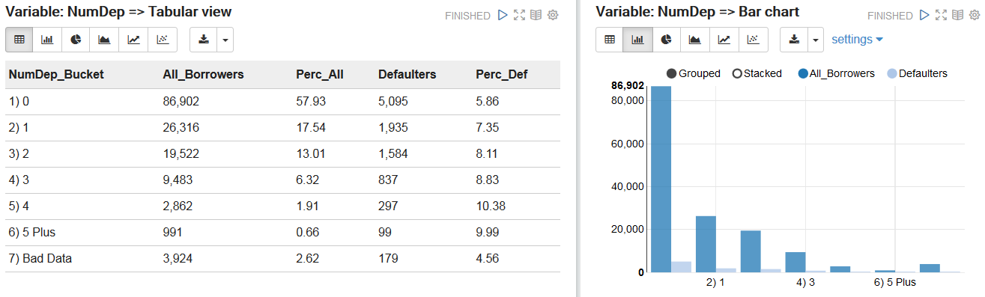

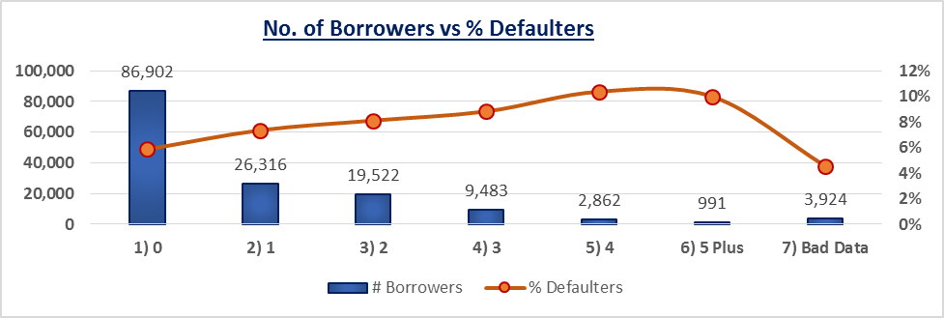

Observations:
- Role: Input
- Data Type: Int, Continuous
- Bad data including NULL and Invalid entries like “NA” (2.62%)
- From the table we can say that most of the individuals i.e. 58% are single (no one is dependent on him/her). The distribution of defaulting borrowers is almost linear with a very small slope if we exclude the bad data.
- Near about 3,924 values of this variable are missing or bad. We will replace all these values by mode of the attribute, which is ‘0’.

4b.7. Summary Statistics
I performed exploratory data analysis using the training dataset. This involved examination of individual descriptive statistics, quality of data, distribution and behavior of the individual variables.

4b.7.1. Descriptive Statistics
- Observation
From the statistics of the individual variable, I am summarizing the same for all the variables:

Sl.  No | Variable Name | Mean | SD | Q1 | Median | Q3 | Min | Max | Missing/  Null Data
1 | RevUtil | 6.05 | 249.76 | 0.0299 | 0.1542 | 0.5590 | 0.0 | 50708.0 | -
2 | Age | 52.30 | 14.77 | 41 | 52 | 63 | 0 | 109 | -
3 | DebtRatio | 353.01 | 2037.82 | 0.1751 | 0.3665 | 0.8683 | 0.0 | 329664.0 | -
4 | MonthlyInc | 6670.22 | 14384.67 | 3400 | 5400 | 8249 | 0 | NA | 19.82%
5 | NumOpenCredit | 8.45 | 5.15 | 5 | 8 | 11 | 0 | 58 | -
6 | NumREloans | 1.02 | 1.13 | 0 | 1 | 2 | 0 | 54 | -
7 | NumDlnq_30_59 | 0.42 | 4.19 | 0 | 0 | 0 | 0 | 98 | -
8 | NumDlnq_60_89 | 0.24 | 4.16 | 0 | 0 | 0 | 0 | 98 | -
9 | NumDlnq_90_Plus | 0.27 | 4.17 | 0 | 0 | 0 | 0 | 98 | -
10 | NumDep | 0.76 | 1.12 | 0 | 0 | 1 | 0 | NA | 2.62%

Note: SD: Standard Deviation, Q1: First quartile, Q3:Third quartile

The following conclusions were drawn from the above exercise:
- Conclusion
  - Average of revolving utilization of unsecured lines of all borrowers is 6.05 with standard deviation 249.76. But 75% borrowers have a revolving utilization less than 0.56.
  - On an average, age of borrowers is nearly equal to 52 and also 50% borrowers have a age below 52 or above.
  - Mean of DebtRatio is 353.01 and 75% borrowers have DebtRatio less than 0.87 means that very few observations have very high DebtRatio which is affected the average of debit ratio.
  - On an average, borrowers have income is 6670.22 unit.

4b.7.2. T-Test of each variable with the response variable
Now we will check the relationship between defaulter variable and all other variables. This will be checked by using the test of equality of means i.e. T-test with unequal variance. Here we will take two groups, one as the defaulter (1) and another, as non-defaulter (0). Also, we will use Welch’s T-test for testing equality of two means.

CODE for creating DataFrame: df
df <- read.csv("C:/SK/SK_DM/data/cs-training-c-h.csv")
CODE for T-Test
lapply(df[2:11], function(x)
t.test(x ~ df$Dlnq, paired = FALSE, na.action = na.pass))
OUTPUT
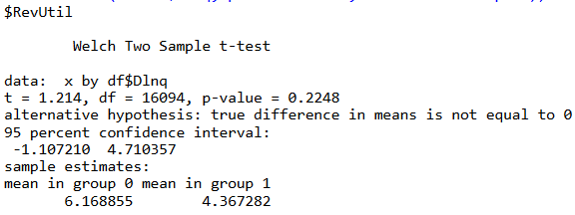 | 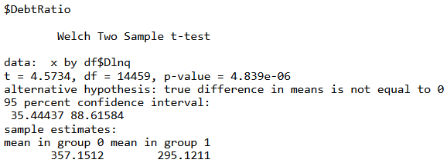
And so on …

The result is presented below in more readable format:

T-Test of each variable with the response variable |  | Mean of each variable
 |  | Serious Delinquent
Sl. No | Variables | 0 (mean) | 1(mean) | P-value
1 | RevUtil | 6.1689 | 4.3673 | 0.2248
2 | Age | 52.7514 | 45.9266 | 0.0001
3 | DebtRatio | 357.1512 | 295.1211 | 0.0001
4 | MonthlyInc | 6747.838 | 5630.826 | 0.0001
5 | NumOpenCredit | 8.493620 | 7.882306 | 0.0001
6 | NumREloans | 1.0203681 | 0.9885298 | 0.0001
7 | NumDlnq_30_59 | 0.2060383 | 1.1430281 | 0.0001
8 | NumDlnq_60_89 | 0.05259548 | 0.58258528 | 0.0001
9 | NumDlnq_90_Plus | 0.06115421 | 0.84590066 | 0.0001
10 | NumDep | 0.7434173 | 0.9482076 | 0.0001

Note: 0 : Non Defaulter, 1 : Defaulter

- Conclusion
  - The sample is okay to proceed with as the variables appear to be good predictors as per the P-value
  - Since RevUtil has P-value > 0.05, we need to understand the behavior of this variable in our models closely
  - The MonthlyInc and NumDep have missing and null data, but are good predictors, I decided to filter the training dataset to get rid of the bad data.

4b.8. Model Building, Scoring, and Evaluation

4b.8.1. Final Data and Dataframe for Model building
First I deleted those observations that contain at least one missing observation. After deleting missing observations, my dataset had 120,269 observations and 11 variables. Among these observations, the defaulting customers were 8,357 (i.e. 6.95%).
As we have seen in the prior section that some variables contains unlikely values, e.g., age variable has value “0”. So the following changes were made to the data,
- “0” value replaced by median of corresponding variable in age variable.
- “98” and “96” were replaced by “13” in the number of delinquent in 30-59 days variable.
- “98” and “96” were replaced by “11” in number of delinquent in 60-89 days variable.
- “98” and “96” were replaced by “17” in 90 days late for paying credit bill.
In all these cases, “96” represented “non-response” and “98” meant “other”.
After the changes were carried out on the dataset, I used artificial neural network, logistic regression, decision trees and naïve Bayesian classifier algorithms. This models were selected for this project because of their popularity in the recent times.

 | Final Data and Dataframe for Model Building
 | # Code for Creating final table for Model Building: “finalTable”
 | sqlContext.sql("create table finalTable as select Dlnq, RevUtil, case Age when 0 then 52 else Age end as Age, DebtRatio, MonthlyInc, NumOpenCredit, NumREloans, case NumDlnq_30_59 when 96 then 13 when 98 then 13 else NumDlnq_30_59 end as NumDlnq_30_59, case NumDlnq_60_89 when 96 then 13 when 98 then 13 else NumDlnq_60_89 end as NumDlnq_60_89, case NumDlnq_90_Plus when 96 then 13 when 98 then 13 else NumDlnq_90_Plus end as NumDlnq_90_Plus, NumDep from eventsTable where MonthlyInc is NOT NULL AND MonthlyInc != 'NA' AND NumDep is NOT NULL AND NumDep != 'NA'")
 | # Create a dataframe from Final Data: “df”
 | df <- read.csv("C:/SK/SK_DM/data/cs-training-cf-h.csv")
 | # Partition the dataset into training and testing sets:
library(caret)
set.seed(500)
indTrain <- createDataPartition(df$Dlnq, p=0.7, list=FALSE)
trainDF <- df[indTrain,]
testDF <- df[-indTrain,]
# Check distribution of Target variable in training and testing data sets:
Code |  | Output
nrow(trainDF)  nrow(testDF)  prop.table(table(trainDF$Dlnq))  prop.table(table(testDF$Dlnq)) |  | 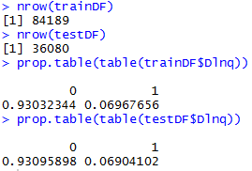

4b.8.2. Setting measures for performance evaluation

I used three performance measures: Accuracy, Sensitivity, Specificity.
- Accuracy = (True Positive +True Negative) /
(True Positive+ False Positive + True Negative + False Negative)
- Sensitivity = (True Positive) / (True Positive + False Negative)
- Specificity = (True Negative) / (True Negative + False Positive)

To develop the models, I partitioned the data into two part: training dataset and testing dataset. First I built the model on training dataset and then check the performance of the model using testing dataset. The methodology and performance of every model is described in the next subsection.

4b.8.3. Artificial Neural Network

Artificial neural network(ANN) are commonly known as biological inspired, sophisticated analytical technique, capable of modeling extremely complex non-linear function. I used a popular ANN architecture called multilayer perceptron (MLP) with back-propagation. The MLP is known to be a powerful function approximator for prediction and classification problems. It is the most commonly used and well-studied ANN architecture. The MLP is essentially the collection of nonlinear neurons organized and connected to each other in a feedforward multilayer structure.
I used sigmoid activation function and six hidden units in hidden layers. By using R software I built the model and corresponding results are as follows:

Building Model: ANN
# Import libraries:
installed.packages("neuralnet")
require(neuralnet)
# Create a dataframe from Final Data:
df <- read.csv("C:/SK/SK_DM/data/cs-training-cf-h.csv")
# Partition the dataset into training and testing sets:
library(caret)
set.seed(500)
indTrain <- createDataPartition(df$Dlnq, p=0.7, list=FALSE)
trainDF <- df[indTrain,]
testDF <- df[-indTrain,]
# Build the Model and analyze:
nnm1 = neuralnet(Dlnq~RevUtil+Age+DebtRatio+MonthlyInc+NumOpenCredit+NumREloans+NumDlnq_30_59+NumDlnq_60_89+NumDlnq_90_Plus+NumDep, data=trainDF, hidden=1, linear.output = FALSE)
#----------------------------
plot(nnm1)
#----------------------------
nnm1$result.matrix
nnm1$weights
# Make prediction using this Model:
nnm1predict <- compute(nnm1,testDF[,2:11], rep=1)
# Analyze the prediction and print Confusion Matrix
table(testDF$Dlnq)
table(nnm1predict$net.result)
#-------decide cut-off based on net.result values-------------
table(testDF$Dlnq, nnm1predict$net.result > 0.0696546761026944)
Weight Matrix and Plots
No. of Nodes in Hidden Layer = 1
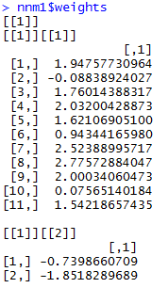 | 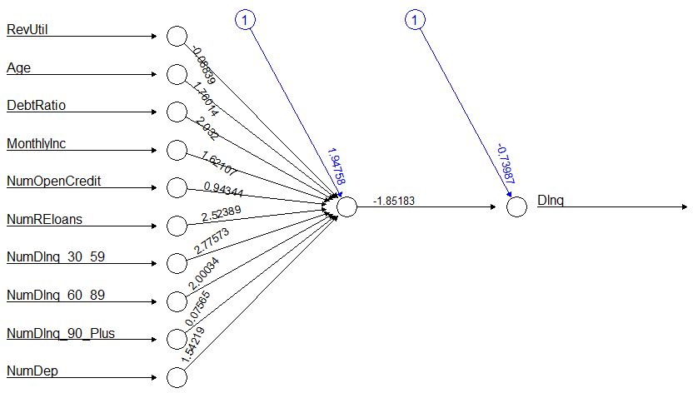
No. of Nodes in Hidden Layer = 2, and so on …
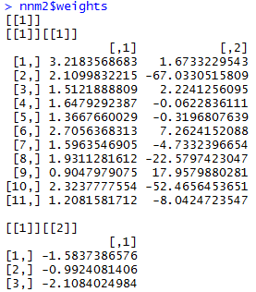 | 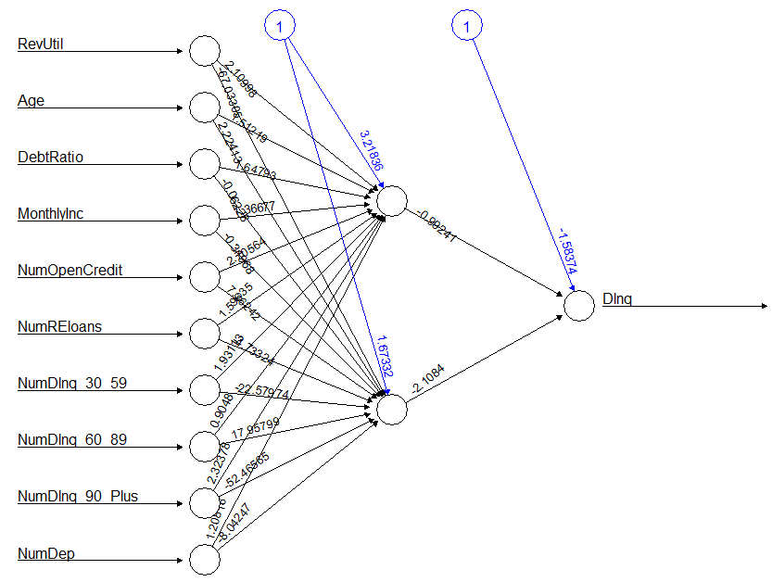
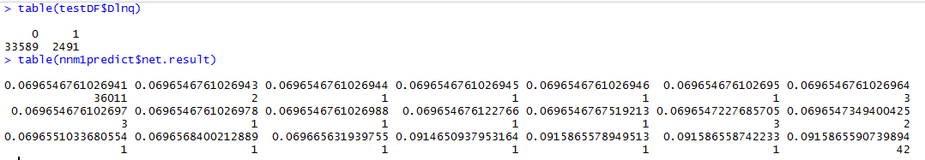
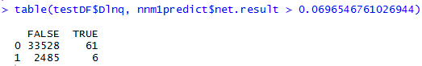

- Final Weight matrix with No of nodes in Hidden Layer = 6:

 | Input layer to Hidden layer
Input Node | node 1 | node 2 | node 3 | node 4 | node 5 | node 6
threshold | -21.03 | -11.01 | -11.69 | -7.48 | -9.77 | -10.55
RevUtil | 18.78 | 8.84 | 10.08 | 6.84 | 9.64 | 9.09
Age | 0.53 | -2.15 | 1.84 | 4.49 | 0.61 | 5.26
DebtRatio | 20.36 | 11.21 | 8.99 | 6.93 | 7.83 | 10.68
MonthlyInc | 29.45 | 16.67 | 19.14 | 12.62 | 12.43 | 16.24
NumOpenCredit | 4.63 | 17.51 | -2.05 | -1.62 | 21.07 | -15.80
NumREloans | -10.25 | 5.11 | -3.04 | -0.04 | -7.67 | -15.18
NumDlnq_30_59 | -20.63 | -20.04 | -2.10 | -1.50 | -14.76 | 0.42
NumDlnq_60_89 | -22.72 | -12.46 | -13.49 | -11.23 | -8.35 | -10.05
NumDlnq_90_Plus | -38.25 | -32.67 | -28.83 | -24.41 | -24.28 | -23.29
NumDep | -2.13 | -4.53 | -2.87 | -4.95 | -10.50 | 6.98
 | Hidden layer to Output layer
Hidden Node | Intercept | node 1 | node 2 | node 3 | node 4 | node 5
defaulter | 1.40 | 1.63 | 0.93 | 0.46 | 1.02 | 0.25
non defaulter | -1.40 | -1.63 | -0.93 | -0.46 | -1.02 | -0.25

The cutoff point of 0.5 was used for the above model. The confusion matrix of testing data is:

Obs.\Pred. | Non def. | Defaulter | Total |  | Accuracy | Sensitivity | Specificity
Non def. | 33,330 | 263 | 33,593 |  | 93.476% | 15.923% | 99.210%
Defaulter | 2,091 | 396 | 2,487
Total | 35,421 | 659 | 36,080

4b.8.4 Logistic Regression

Logistic regression is the generalization of linear regression. It is used primarily for predicting binary or multiclass dependent variables. Because the response variable is discrete, it cannot be modeled directly by linear regression. Therefore, rather than predicting point estimate of the event itself, it builds the model to predict the odds of its occurrence. In two class problem odds greater than 50% would mean that the case is assigned to the class designed as “1” and “0” otherwise. While logistic regression is a powerful modeling tool, it assumes that the response variable is linear in the coefficients of the predictor variable.
I developed a model on training dataset using R. The results is as shown here:

Building Model: Logistic Regression
# Create a dataframe from Final Data:
df <- read.csv("C:/SK/SK_DM/data/cs-training-cf-h.csv")
# Partition the dataset into training and testing sets:
library(caret)
set.seed(500)
indTrain <- createDataPartition(df$Dlnq, p=0.7, list=FALSE)
trainDF <- df[indTrain,]
testDF <- df[-indTrain,]
# Build the Model with “backward” and “forward” directions separately:
lrb <- step(lm (formula = Dlnq~RevUtil+Age+DebtRatio+MonthlyInc+NumOpenCredit+NumREloans+NumDlnq_30_59+NumDlnq_60_89+NumDlnq_90_Plus+NumDep, data = trainDF), direction = "backward")
lrf <- step(lm (formula = Dlnq~1, data = trainDF), direction = "forward", scope =~RevUtil+Age+DebtRatio+MonthlyInc+NumOpenCredit+NumREloans+NumDlnq_30_59+NumDlnq_60_89+NumDlnq_90_Plus+NumDep)
# Note: Both “backward” and “forward” options eliminated same variables: “RevUtil” & “NumOpenCredit”
# Build the Model with remaining 8 variables and analyze:
f = Dlnq~ Age+DebtRatio+MonthlyInc+ NumREloans+NumDlnq_30_59+NumDlnq_60_89+NumDlnq_90_Plus+NumDep
lrm <- glm (formula = f, data = trainDF, family = "binomial")
#----------------------------
lrm
summary(lrm)
# Analyze prediction and print Confusion Matrix:
lrpredict <- ifelse(predict(lrm, data=testDF, type="response")>0.5, TRUE, FALSE)
table(lrpredict, as.logical(lrm$y))

Summary of Stepwise Selection: direction = “forward”
Step | Effect | DF | Score Chi-Square | Wald Chi-Square | Pr > ChiSq
1 | NumDlnq_30_59 | 1 | 5764.7015 | 1407.508 | < 0.0001
2 | NumDlnq_90_Plus | 1 | 1794.1215 | 756.6357 | < 0.0001
3 | Age | 1 | 580.5198 | 448.2811 | < 0.0001
4 | NumDlnq_60_89 | 1 | 230.6534 | 207.9419 | < 0.0001
5 | NumDep | 1 | 22.8346 | 34.2155 | < 0.0001
6 | MonthlyInc | 1 | 15.4233 | 83.9022 | < 0.0001
7 | NumREloans | 1 | 44.5306 | 44.5684 | < 0.0001
8 | DebtRatio | 1 | 4.6635 | 4.9928 | 0.0308

Utilization and number of credit lines variables were removed in stepwise procedure. Estimates of coefficients is:

coefficients | intercept | Age | Debt  Ratio | Monthly  Inc | NumRE  loans | NumDlnq  _30_59 | NumDlnq  _60_89 | NumDlnq_  90_Plus | NumDep
estimate | -1.76 | -0.0241 | -0.00012 | -0.00004 | 0.0833 | 0.5165 | 0.4193 | 0.5488 | 0.0706

- ROC Curve of logistic model

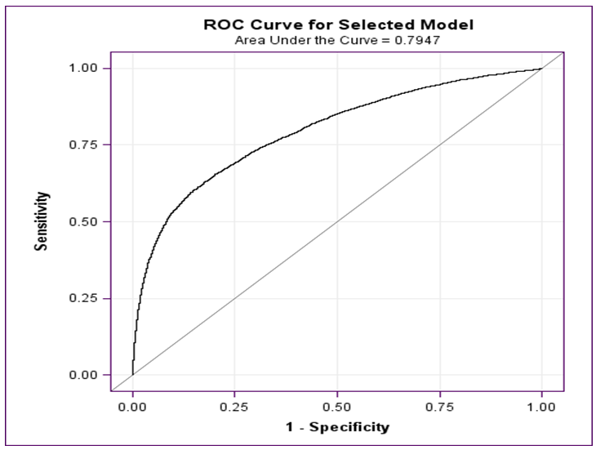

Since area under the curve is 0.7947, our model is appropriate for the given data. With a cut-off point of 0.5, the confusion matrix of testing data is:

Obs.\Pred. | Non def. | Defaulter | Total |  | Accuracy | Sensitivity | Specificity
Non def. | 33,372 | 151 | 33,523 |  | 93.198% | 9.934% | 99.550%
Defaulter | 2,303 | 254 | 2,557
Total | 35,675 | 405 | 36,080

4b.8.5 Naïve Bayesian Classifier
Naive Bayes classifiers are a family of simple probabilistic classifiers based on applying Bayes' theorem with strong (naive) independence assumptions between the features.

Building Model: Naïve Bayesian Classifier
# Import libraries:
library(e1071)
library(rminer)
# Build the Model:
nbm <- naiveBayes(as.factor(Dlnq)~., data=trainDF)
nbm
# Make prediction using this Model:
nbpredict <- predict(nbm, testDF)
# Analyze prediction and print Confusion Matrix:
head(nbpredict, n=5)
table (testDF$Dlnq, nbpredict)

The confusion matrix is as shown below:

Obs.\Pred. | Non def. | Defaulter | Total |  | Accuracy | Sensitivity | Specificity
Non def. | 32,579 | 1,014 | 33,593 |  | 92.478% | 31.645% | 96.982%
Defaulter | 1,700 | 787 | 2,487
Total | 34,279 | 1,801 | 36,080

4b.8.6. Decision Tree
Decision tree builds classification or regression models in the form of a tree structure. It breaks down a dataset into smaller and smaller subsets while at the same time an associated decision tree is incrementally developed. The final result is a tree with decision nodes and leaf nodes.

CODE and Output for model: Decision Tree
# Import libraries:
library(rpart)
library(rpart.plot)
# Build the Model:
dtm <- rpart(Dlnq~., data=trainDF, method="class")
dtm
rpart.plot(dtm, type=4, extra=101)
Output
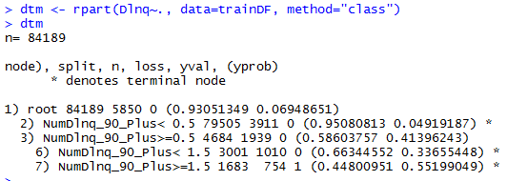 | 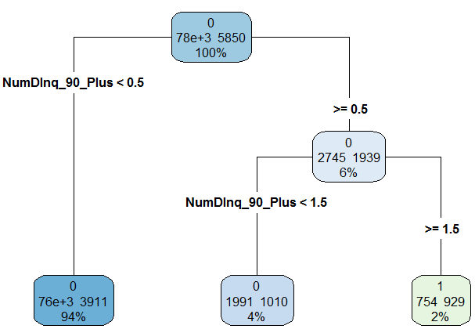
# Make prediction using this Model:
dtpredict <- predict(dtm, testDF, type="class")
# Analyze prediction and print Confusion Matrix:
table (testDF$Dlnq, dtpredict)

The confusion matrix is as shown below:

Obs.\Pred. | Non def. | Defaulter | Total |  | Accuracy | Sensitivity | Specificity
Non def. | 33,284 | 309 | 33,593 |  | 93.381% | 16.405% | 99.080%
Defaulter | 2,079 | 408 | 2,487
Total | 35,363 | 717 | 36,080

5. Algorithms

5a. Hadoop

5a.1. Environment Setup
The code set for this project was developed on Apache Hadoop platform with Spark using Zeppelin notebook with various interpreters like spark, sh, and python.
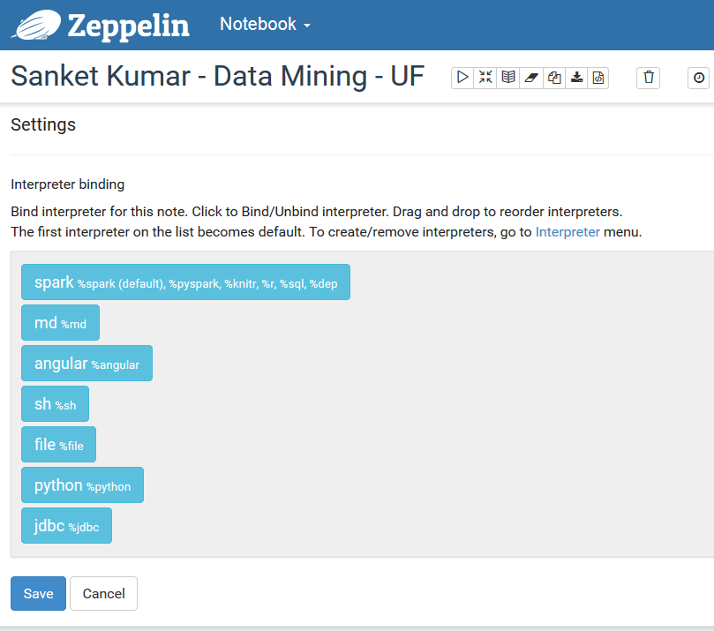

5a.2. Run-Time Details of Spark Application
My application had triggered 15 jobs as shown in the screenshot below. The timing and duration of each job can be analyzed from the event timeline. We can zoom the even to see more detail.
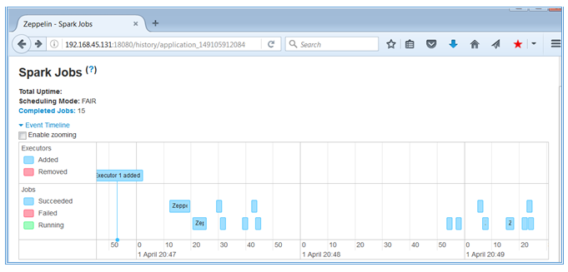
The list of Jobs are also displayed.
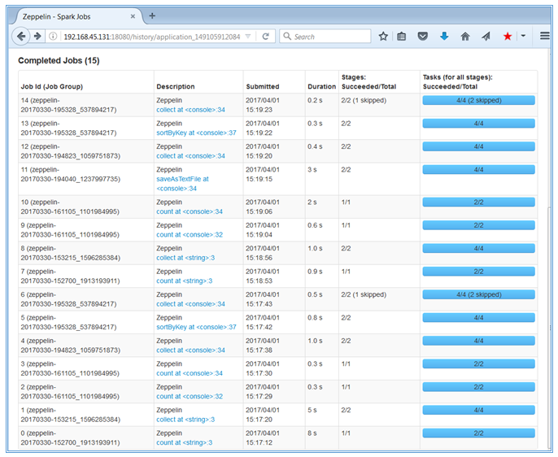
We see that Job # 1 has taken 5s as against other jobs which has taken < 1sec. If we click on the hyperlink “collect at <string>3, we see the following. The DAG (Direct Acyclic Graph) can clearly be seen here. This job has been divided into 2 stages due to “reduceByKey” operation, which requires shuffling across the node.
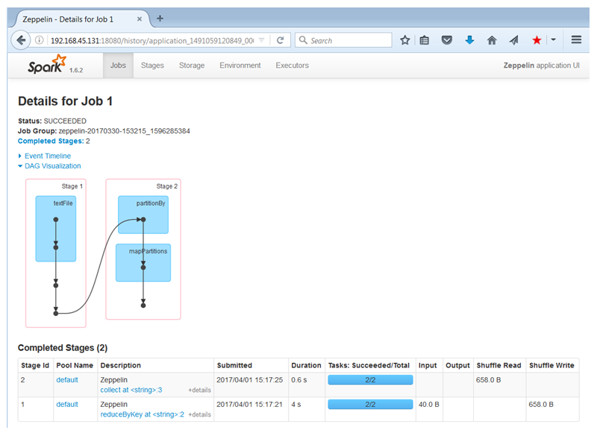

To know more about Stage Id 1 which took 4s of the total 5s, we will click at the hyperlink. We can clearly see the creation of RDDs in the DAG here.

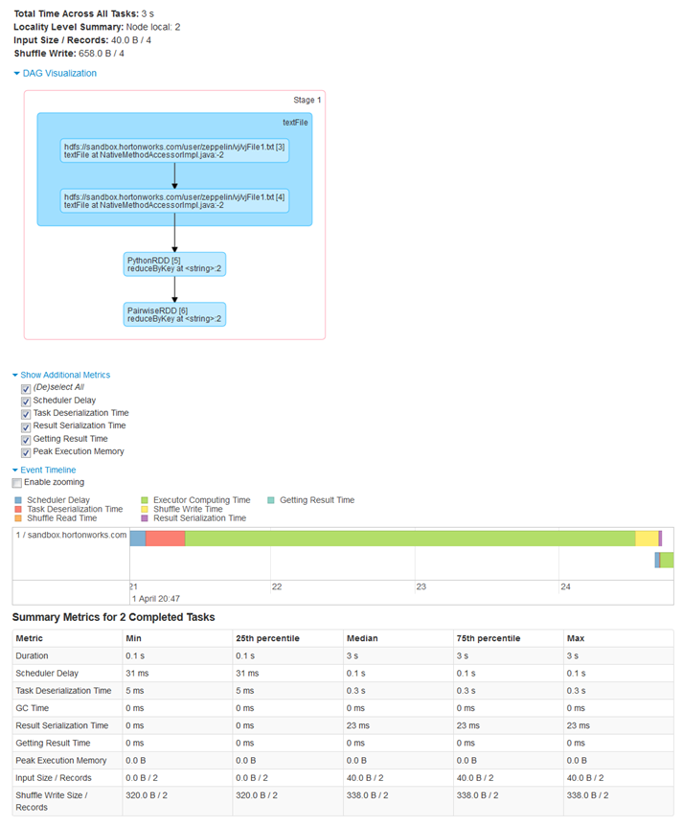

We can also analyze the delays at various resource level.

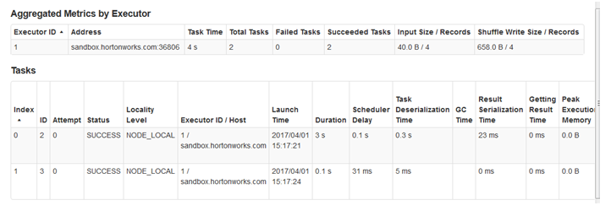

5a.3. Zeppelin Code
The codes run in Zeppelin environment have been included in section 4b (Data Mining Approach)

5b. Theoretical Modelling
We used three popular data mining algorithms (artificial neural network, decision tree and Naïve Bayesian classifier) along with a most commonly used statistical method (logistic regression) to develop the prediction models using a large dataset (150000 instances). Also we used two sampling methods to develop models (under-sampling and oversampling).

5b.1. Artificial Neural Network
Artificial neural network(ANN) is commonly known as biology-inspired, sophisticated analytical technique, capable of modeling extremely complex non-linear functions. We used a popular ANN architecture called multilayer perceptron (MLP) with back-propagation. The MLP is known to be a powerful function approximator for prediction and classification problems. It is the most commonly used and well-studied ANN architecture. The MLP is essentially the collection of nonlinear neurons organized and connected to each other in a feedforward multilayer structure.

5b.2. Logistic Regression model
Logistic regression is the generalization of linear regression. It is used primarily for predicting binary or multiclass dependent variables. Because the response variable is discrete, it cannot be modeled directly by linear regression. Therefore, rather than predicting point estimate of the event itself, it builds the model to predict the odds of its occurrence. In two class problem odds greater than 50% would mean that the case is assigned to the class designed as “1” and “0” otherwise. While logistic regression is a powerful modeling tool, it assumes that the response variable is linear in the coefficients of the predictor variable.

5b.3. Naïve Bayesian Classifier
The Naïve Bayes algorithm is a simple probabilistic classifier that calculates a set of probabilities by counting the frequency and combinations of values in a given dataset. The algorithm uses Bayes theorem and assumes all attributes to be independent given the value of class variable. This conditional independence assumption rarely holds true in real world applications, hence the characterization as Naïve, yet the algorithm tends to perform well and learn rapidly in various supervised classification problems. Naïve Bayes classifier is based on Bayes theorem and the theorem of total probability.
In this classifier we compute the conditional probability P(Cj/X) and assign X to those class Ci having large probability i.e. Xϵ Cj if P(Cj/X)>P(Ci/X) for all i≠j=1,2,….,m

5b.4. Decision Tree
Decision tree are powerful classification algorithm that are becoming increasing more popular with the growth of data mining in the field of information systems. In the literature there are so many popular decision tree algorithms like ID3, C4.5, C5 etc. As the name implies, this technique recursively separates observations in branches to construct a tree for the purpose of improving the prediction accuracy. In doing so, they use mathematical algorithms like information gain, Gini index to identify a variable and corresponding threshold for the variable that splits the input observation into two or more subgroups. This step is repeated at each leaf node until the complete tree is constructed. The objective of the splitting pair that maximizes the homogeneity of the resulting two or more subgroup samples. The most commonly used mathematical algorithm for splitting includes Entropy based information gain used in ID3, C4.5 and C5. Gini index used in CART. In this study I choose to use J48 algorithm as our decision tree method which is a simple C4.5 decision tree for classification.

6. Experimental Results

6a. Datasets
The dataset was sourced from kaggle.com: https://www.kaggle.com/c/GiveMeSomeCredit/data
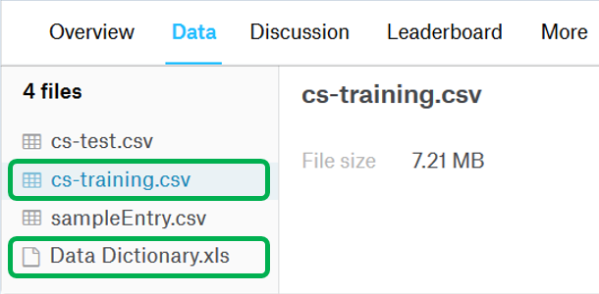
The dataset was handled as shown in the table below:
Type | No. of records |  |  | Percentages |  | Remarks
Type | Total | NonDef | Def | NonDef% | Def% | Remarks
Original | 150,000 | 139,974 | 10,026 | 93.32% | 6.68% | As downloaded “cs-training.csv”
Initial | 150,000 | 139,974 | 10,026 | 93.32% | 6.68% | Columns rearranged. Column “ID” removed. File: “cs_training_NH.csv”
The Data Preparation started with this data set named “cs_training_NH.csv”
Columns handled | 150,000 | 139,974 | 10,026 | 93.32% | 6.68% | After Imputing and Substituting for bad data. File: “cs-training-c-h.csv”
The T-test was done with this data set named “cs-training-c-h.csv” as the initial data had string in numeric field
Columns & Row handled | 120,269 | 111,912 | 8,357 | 93.05% | 6.95% | After filtering rows for bad data. File: “cs-training-cf-h.csv”
The main statistical modeling started with dataset “cs-training-cf-h.csv”
Cleaned | 120,269 | 111,912 | 8,357 | 93.05% | 6.95% | All samples #
--- Train | 84,189 | 78,323 | 5,866 | 93.03% | 6.97% | Training set
--- Test | 36,080 | 33,589 | 2,491 | 93.10% | 6.90% | Test set
Under | 16,750 | 8,393 | 8,357 | 50.11% | 49.89% | Under-sampling
--- Train | 11,725 | 5,875 | 5,850 | 50.11% | 49.89% | Training set
--- Test | 5,025 | 2,518 | 2,507 | 50.11% | 49.89% | Test set
Over | 220,553 | 111,912 | 108,641 | 50.74% | 49.26% | Over-sampling
--- Train | 154,387 | 78,338 | 76,049 | 50.74% | 49.26% | Training set
--- Test | 66,166 | 33,574 | 32,592 | 50.74% | 49.26% | Test set
Note: NonDef = Non Defaulter, Def = Defaulter.
#: This document contains detailed modeling exercise only for this dataset. Summary is presented for all datasets.

6b. Platform Performance
The code performance for Data Preparation on Hadoop platform has been captured here. The starting data was “cs_training_NH.csv” having 150,000 records and 6.31 MB in size.
Steps | Time taken  (1st run) | Time taken  (2nd run)
1. Creating and populating RDD, DataFrame, and TempTable | 3m | 27s
2. Analysis of variable: Dlnq | 1s | 1s
3. Descriptive statistics of variable: RevUtil | <1s | <1s
4. Quantile of variable: RevUtil | 18s | 18s
5. Analysis of variable: RevUtil | 1s | 1s
6. Descriptive statistics of variable: Age | 1s | 1s
7. Quantile of variable: Age | 18s | 18s
8. Analysis of variable: Age | <1s | <1s
9. Descriptive statistics of variable: DebtRatio | 1s | 1s
10. Quantile of variable: DebtRatio | 18s | 18s
11. Analysis of variable: DebtRatio | 1s | 1s
12. Descriptive statistics of variable: MonthlyInc | 1s | 1s
14. Analysis of variable: MonthlyInc | 1s | 1s
15. Descriptive statistics of variable: NumOpenCredit | 1s | 1s
16. Quantile of variable: NumOpenCredit | 18s | 18s
17. Analysis of variable: NumOpenCredit | <1s | <1s
….. and so on
We see a pattern here. Maximum time is taken by first time creation of reading csv file, creating RDD and DataFrame, and registering TempTable.
The 2nd highest time was taken by computation of Quantiles, which calls for a shuffle operation.

6c. Model Results

6c.1. Model Evaluation and Comparison
The four selected models were built and evaluated against 3 types of samples:
- All Samples: All the data from kaggle.com minus bad data
- Under-sampling: All of Default-only data + 7.5% Non-Default-only data
- Over-sampling: All of Non-Default-only data + 13 times Default-only data
The result of model evaluation is shown below for easy comparison against our selection criteria, i.e., Accuracy, Sensitivity, Specificity, and AUC (Area Under Curve)

Sampling | Model | Accuracy | Sensitivity | Specificity | AUC
All Samples | Neural Network | 93.5% | 15.9% | 99.2% | 0.815
All Samples | Logistic Regression | 93.2% | 9.9% | 99.6% | 0.794
All Samples | Naïve Bayesian classifier | 92.5% | 31.6% | 97.0% | 0.795
All Samples | Decision Tree | 93.4% | 16.4% | 99.1% | 0.685
Under Sampling | Neural Network | 73.6% | 65.9% | 81.8% | 0.815
Under Sampling | Logistic Regression | 73.5% | 62.6% | 85.5% | 0.808
Under Sampling | Naïve Bayesian classifier | 79.1% | 81.4% | 76.6% | 0.860
Under Sampling | Decision Tree | 71.3% | 88.8% | 55.1% | 0.796
Over Sampling | Neural Network | 75.4% | 68.1% | 82.6% | 0.820
Over Sampling | Logistic Regression | 73.8% | 60.1% | 87.1% | 0.808
Over Sampling | Naïve Bayesian classifier | 71.2% | 49.3% | 92.2% | 0.799
Over Sampling | Decision Tree | 94.9% | 99.7% | 90.1% | 0.956

6c.2. Major Findings
In accordance with the SEMMA (Sample, Explore, Modify, Model, and Assess) methodology, after obtaining the sample data we started by understanding variables and its relation with defaulting status. Also skewness of the data has significant effect on analysis. In addition, dealing with missing values is an important step of the data cleaning. We further modelled our data using various classification techniques artificial neural network, logistic regression, decision tree and Naïve Bayesian classifier. Then when assessing the various techniques, we used ROC curve, Accuracy, Sensitivity, Specificity etc. to compare the results. ROC values were almost similar for most of the techniques but results were not great in terms of the sensitivity. This was because of the 93:7 Proportion of the events. So by changing the sampling method ( under-sampling and over-sampling) we got better results of about 79% sensitivity using under-sampling method and 99.7% sensitivity using oversampling method.

7. Conclusion
Many traditional approaches to data mining classification problems assume that the target classes share similar prior probabilities. However, in many real world problems, this assumption is grossly violated. Often, it is the case that the ratios of prior probabilities between classes are extremely skewed as with the data set in this project. This situation is known as the imbalanced dataset problem.
We did try to overcome the issue of this imbalance by using both under-sampling and over-sampling. Oversampling seeks to increase the number of minority class members in the training set. The advantage of oversampling is that no information from the original training set is lost since we keep all members from the minority and majority classes. However, the disadvantage is that we greatly increase the size of the training set. Thus, we also increase training time and the amount of memory required to hold the training set. If we do not consider the time taken to resample, under-sampling beats over-sampling in terms of time and memory complexity. Since this is the case, over-sampling needs to be significantly better than under-sampling in terms of classification performance in order to be viable. Past studies have not reached any conclusive results with regards to whether under-sampling or oversampling is best with regards to classification performance. Most likely, conflicting results are due to the combination of different datasets and classification algorithms. In addition, choice of resampling method is probably both domain and problem specific.
In conclusion, we can prove that it is possible to use a superior analytics algorithm through the use of different sampling method to correctly classify customers according to their probability of default. We believe that Naïve Bayesian classifier classifies customer as close to true when data has imbalances but decision tree give better results only when we make the data balanced by using oversampling method.

8. References
- https://www.youtube.com/watch?v=suhHIXHPksk
- https://www.youtube.com/watch?v=JFJIQ0_2ijg
- http://stackoverflow.com/questions/30002013/error-in-confusion-matrix-the-data-and-reference-factors-must-have-the-same-nu
- http://www.ijarcce.com/upload/2016/march-16/IJARCCE%20128.pdf
- http://www.informatica.si/index.php/informatica/article/viewFile/148/140
- https://pdfs.semanticscholar.org/cade/435c88610820f073a0fb61b73dff8f006760.pdf
- Jiawei Han, Micheline Kamber, Jian Pei (2011). Data Mining: Concepts and Techniques, Third Edition.
- Dursun Delen, Glenn Walker, Amit Kadam (2004). Predicting breast cancer survivability: a comparison of thee data mining methods. Artificial Intelligence in Medicine, 34, 113-127.
- Mazurowski M.A., Habas P.A., Zurada J.M., Lo J.Y., Baker J.A., Tourassi G.D. (2008). Training neural network classifiers for medical decision making: The effects of imbalanced dataset on classification performance. Neural Network, 21, 427-436.

