**Java Script**

**SYLLABUS :**

**1.** Variables and data types

2. Operators

3. Conditional statements

4. Loops and Strings

5. Arrays

6. Functions

7. Objects

8. DOM and Events

9. API calls

JavaScript has become the **go-to language** for building interactive, responsive, and efficient web applications. Its versatility, rich ecosystem, and ability to handle both front-end and back-end tasks make it an essential tool for modern developers. Whether you are building simple websites, complex web apps, or mobile applications, JavaScript is indispensable in today’s tech landscape.

**KeyWords :**

• **let**: Block-scoped, reassignable, modern choice for variable declaration.

• **const**: Block-scoped, non-reassignable, used for values that should not change (including object references).

• **var**: Function-scoped, reassignable, **legacy** (avoid in modern JavaScript as it has confusing scoping behavior).

**Data Types :**

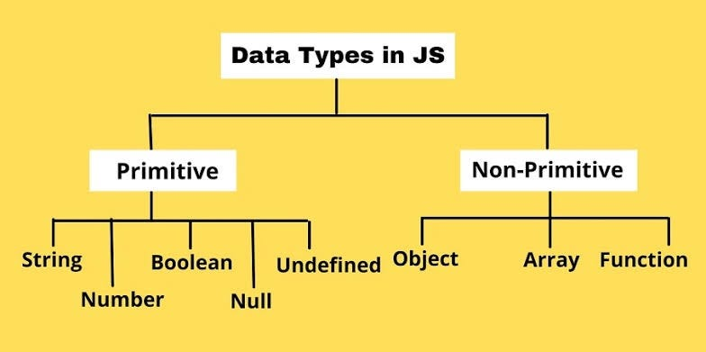

Additional Primitive data types :

1.BigInt

2.Symbol