**Operators :**

**What is an Operator?**

An **operator** is a special symbol used to perform operations on values or variables. For example: +, -, *, /, etc.

**Types :**

1. **Arithmetic Operators**
2. **Assignment Operators**
3. **Comparison Operators**
4. **Logical Operators**
5. **Ternary Operators**

##### **6. Bitwise Operators** (Optional if advanced)

* **&, |, ^, ~, <<, >>**

7. **Optional: Nullish Coalescing (??) & Optional Chaining (?.)**

**1. Arithmetic Operators**

Used to perform mathematical operations.

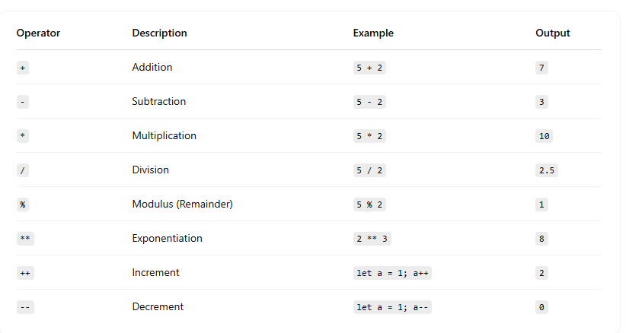

**2. Comparison Operators**

Used to compare two values.

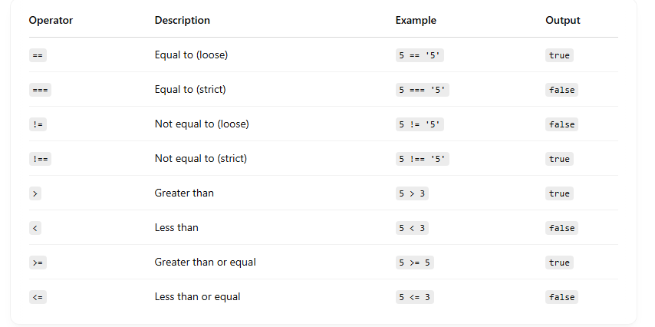

**3. Logical Operators**

Used to combine or invert boolean values.

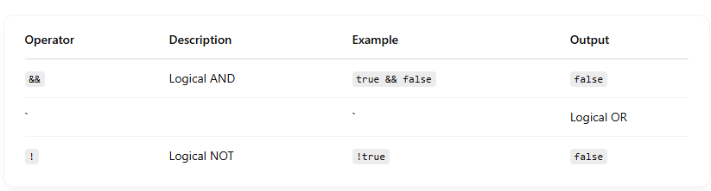

**4. Assignment Operators**

Used to assign values to variables.

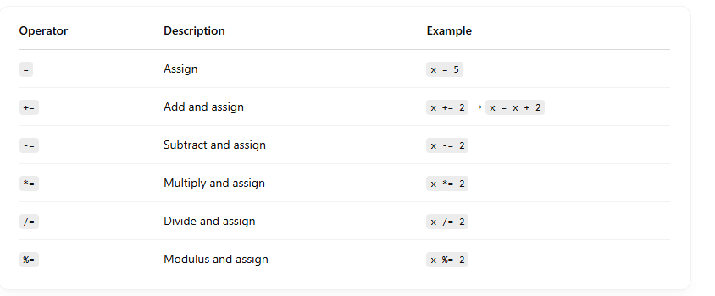

**5. Ternary Operators :**

**Syntax :**

**condition ? expression_if_true : expression_if_false;**