1.Why do we use programming language
Programming languages are essential tools for creating software and applications. They act as a bridge between humans and machines, enabling us to instruct computers in a way they can understand.

Reason:

1. Communication with Computers
- Computers operate using binary code (1s and 0s), which is difficult for humans to understand and write.
- Programming languages provide a higher-level abstraction that allows us to communicate with machines in a more human-readable and logical manner.

2. Development of Applications
- Programming languages are used to build software applications, websites, mobile apps, games, and more.

3. Solving Problems
- Programming enables logical problem-solving through algorithms.
- Example: Writing a program to sort a list of numbers or analyze large datasets.

Applications:

1. Desktop GUI Applications
Java provides frameworks such as Swing, JavaFX, and AWT for creating graphical user interfaces.
Examples:
  - Media players
  - Graphic design tools
  - Text editors (e.g., NetBeans IDE)

2. Web Applications
Java Enterprise Edition (Java EE) provides APIs like Servlets, JSP, and frameworks like Spring, Struts, and Hibernate for developing web-based applications.
Examples:
  - E-commerce platforms
  - Online banking portals

3. Mobile Applications
Java is the backbone for developing Android apps using the Android SDK.
Examples:
  - Android games
  - Productivity tools
  - Social media apps

4. Enterprise Applications
Java is commonly used for developing large-scale, distributed, and secure enterprise systems.
Examples:
  - Enterprise Resource Planning (ERP) systems
  - Customer Relationship Management (CRM) software
  - Billing and inventory management systems

6. Gaming Applications
Java is used for developing 2D and 3D games, leveraging frameworks like LibGDX and jMonkeyEngine.
Examples:
  - Mobile and desktop games
  - Browser-based games

7. Artificial Intelligence (AI) and Machine Learning
Java provides libraries like Weka, Deep Java Library (DJL), and integration with Python frameworks for AI and ML tasks.
Examples:
Predictive analytics
  - Natural language processing (NLP)

8. Financial Services
Java is widely used in the banking and financial sector for creating secure, high-performance applications.
Examples:
  - Trading platforms
  - Risk management systems
  - Payment gateways

Editions:
SUN Microsystem (now Oracle corp.) divided Java concepts into four categories for easy maintenance and easy distribution to all types of domains like mobile, desktop, and internet applications. In Java, a category is called Edition. So, Java concepts are divided into four editions.
- Java SE (Java Platform Standard Edition)
- Java EE (Java Platform Enterprise Edition)
- Java ME (Java Platform Micro Edition)
- Java FX (Java platform Effects)

Java SE (Java Platform Standard Edition):- It has concepts for developing software for Desktop based (standalone) CUI (command user interface) and GUI (graphical user interface) applications, applets, database Interaction application, distributed application, and XML parsing applications.
Java EE (Java Platform Enterprise Edition):- It has concepts to develop software for Web applications, Enterprise applications, and Interoperable applications. These applications are called high-scale applications. Some examples are:- banking and insurance-based applications.

Java ME (Java Platform Micro Edition):- It has concepts to develop software for consumer electronic devices means embedded systems, like mobile and electronic level applications. Java ME was popular for developing mobile gaming applications. This edition was called micro because these edition programs are embedded in small chips. The program embedded in the chip is called micro (small).

Java FX (Java platform Effects):- Java FX stands for Java platform Effects (Eff=F, ects=X). It provides concepts for developing rich internet applications with more graphics and animations.

Features of Java
The primary objective of Java programming language creation was to make it portable, simple and secure programming language. Apart from this, there are also some excellent features which play an important role in the popularity of this language. The features of Java are also known as Java buzzwords.
A list of the most important features of the Java language is given below.
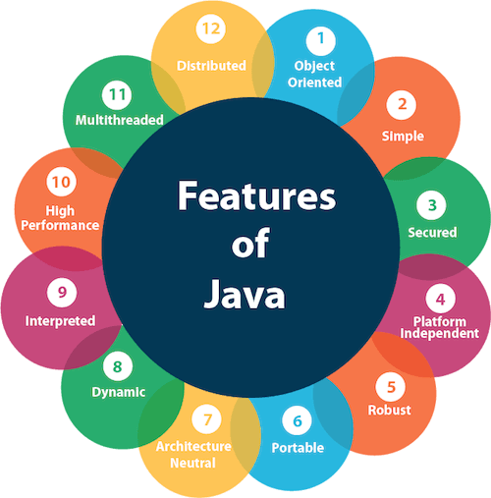
- Simple
- Object-Oriented
- Portable
- Platform independent
- Secured
- Robust
- Architecture neutral
- High Performance
- Multithreaded
- Distributed
- Dynamic

1. Simple
- Java's syntax is easy to learn and similar to C++ but eliminates complex features like pointers, operator overloading, and explicit memory management.

2. Object-Oriented
- Java is fully object-oriented, supporting key concepts like inheritance, encapsulation, polymorphism, and abstraction.
- Almost everything in Java is treated as an object.
Object-oriented programming (OOPs) is a methodology that simplifies software development and maintenance by providing some rules.
Basic concepts of OOPs are:
- Object
- Class
- Inheritance
- Polymorphism
- Abstraction
- Encapsulation

3.Portable
Java is portable because it facilitates you to carry the Java bytecode to any platform. It doesn't require any implementation.

4. Platform-Independent
- Java uses the "Write Once, Run Anywhere" (WORA) principle.
- Java code is compiled into bytecode, which can run on any platform with a Java Virtual Machine (JVM).
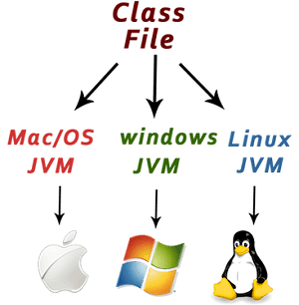

5. Secure
- Java provides a secure environment by avoiding explicit pointer usage and running applications inside a sandbox.
- It has built-in security features like bytecode verification, classloader, and security manager.
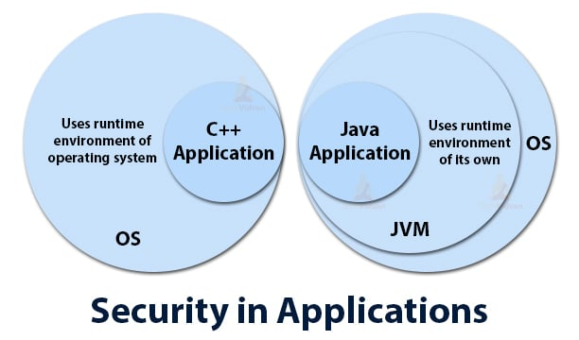

6. Robust
- Java emphasizes strong memory management, exception handling, and type-checking mechanisms.
- It minimizes errors by catching compile-time and runtime errors effectively.

7.Architecture-neutral
Java is architecture neutral because there are no implementation dependent features, for example, the size of primitive types is fixed.
In C programming, int data type occupies 2 bytes of memory for 32-bit architecture and 4 bytes of memory for 64-bit architecture. However, it occupies 4 bytes of memory for both 32 and 64-bit architectures in Java.

8. High-performance
Java is faster than other traditional interpreted programming languages because Java bytecode is "close" to native code. It is still a little bit slower than a compiled language (e.g., C++). Java is an interpreted language that is why it is slower than compiled languages, e.g., C, C++, etc.

9. Multithreaded
Java has built-in support for multithreading, enabling the development of applications that can perform multiple tasks simultaneously

10.Distributed

Java is distributed because it facilitates users to create distributed applications in Java. RMI and EJB are used for creating distributed applications. This feature of Java makes us able to access files by calling the methods from any machine on the internet.

11. Dynamic and Extensible
- Java supports dynamic linking of classes and allows updates to libraries without recompiling the entire application.
- It integrates easily with other technologies, such as Java Native Interface (JNI).

JDK / JRE / JVM:

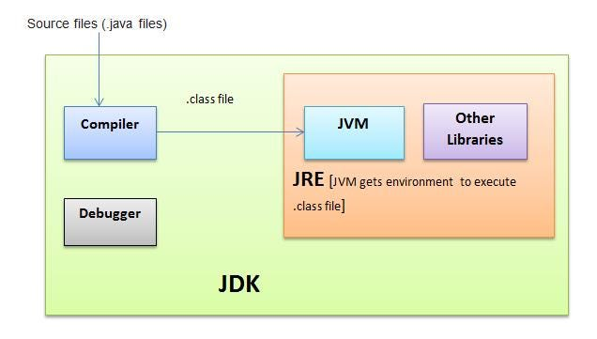

. 1. JDK (Java Development Kit)
- Purpose: Provides tools to develop and compile Java applications.
- Components: Includes JRE, compiler (javac), debugger, and other development tools.
- For Developers: Required to write, compile, and run Java programs.

2. JRE (Java Runtime Environment)
- Purpose: Provides the environment to run Java applications.
- Components: Includes JVM and core libraries.
- For End Users: Required to execute Java applications but cannot be used for development.

3. JVM (Java Virtual Machine)
- Purpose: Executes Java bytecode, providing platform independence.
- Functionality: Converts bytecode to machine-specific instructions and handles memory management (garbage collection).
- Part of JRE: JVM is the core of the Java runtime system.

To download JDK SE 8 verison:
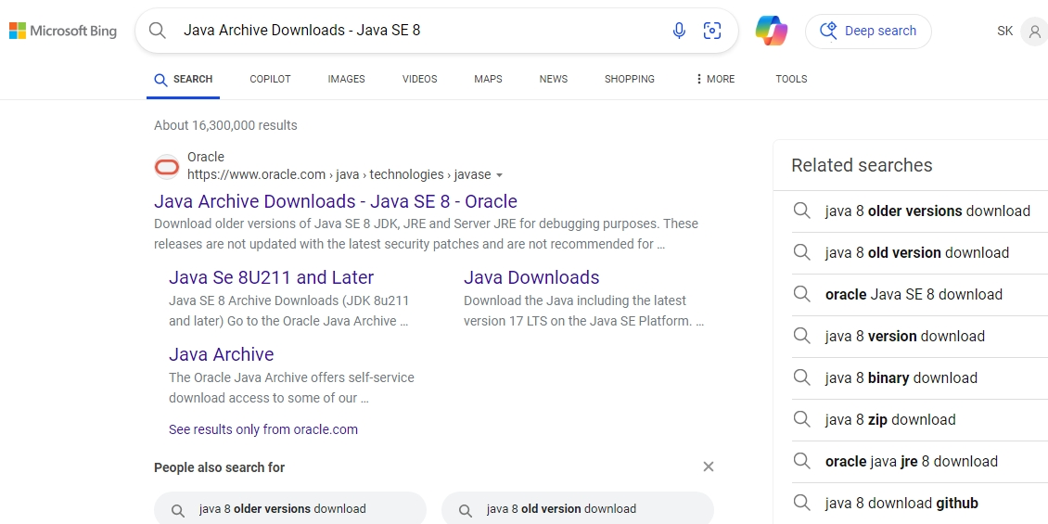

  - Click on first link

Java SE Development Kit 8u202 [ you can see main heading ]

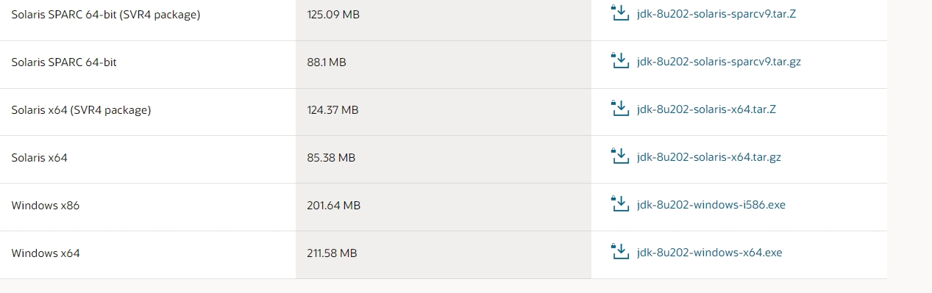
3.Downlaod according to your operating system type;

Example: If you are using window operating system them download
[window X64 ] size – 211.58MB

