1.Why do we use programming language
Programming languages are essential tools for creating software and applications. They act as a bridge between humans and machines, enabling us to instruct computers in a way they can understand.

Reason:

1. Communication with Computers
- Computers operate using binary code (1s and 0s), which is difficult for humans to understand and write.
- Programming languages provide a higher-level abstraction that allows us to communicate with machines in a more human-readable and logical manner.

2. Development of Applications
- Programming languages are used to build software applications, websites, mobile apps, games, and more.

3. Solving Problems
- Programming enables logical problem-solving through algorithms.
- Example: Writing a program to sort a list of numbers or analyze large datasets.

Applications:

1. Desktop GUI Applications
Java provides frameworks such as Swing, JavaFX, and AWT for creating graphical user interfaces.
Examples:
  - Media players
  - Graphic design tools
  - Text editors (e.g., NetBeans IDE)

2. Web Applications
Java Enterprise Edition (Java EE) provides APIs like Servlets, JSP, and frameworks like Spring, Struts, and Hibernate for developing web-based applications.
Examples:
  - E-commerce platforms
  - Online banking portals

3. Mobile Applications
Java is the backbone for developing Android apps using the Android SDK.
Examples:
  - Android games
  - Productivity tools
  - Social media apps

4. Enterprise Applications
Java is commonly used for developing large-scale, distributed, and secure enterprise systems.
Examples:
  - Enterprise Resource Planning (ERP) systems
  - Customer Relationship Management (CRM) software
  - Billing and inventory management systems

6. Gaming Applications
Java is used for developing 2D and 3D games, leveraging frameworks like LibGDX and jMonkeyEngine.
Examples:
  - Mobile and desktop games
  - Browser-based games

7. Artificial Intelligence (AI) and Machine Learning
Java provides libraries like Weka, Deep Java Library (DJL), and integration with Python frameworks for AI and ML tasks.
Examples:
Predictive analytics
  - Natural language processing (NLP)

8. Financial Services
Java is widely used in the banking and financial sector for creating secure, high-performance applications.
Examples:
  - Trading platforms
  - Risk management systems
  - Payment gateways

Editions:
SUN Microsystem (now Oracle corp.) divided Java concepts into four categories for easy maintenance and easy distribution to all types of domains like mobile, desktop, and internet applications. In Java, a category is called Edition. So, Java concepts are divided into four editions.
- Java SE (Java Platform Standard Edition)
- Java EE (Java Platform Enterprise Edition)
- Java ME (Java Platform Micro Edition)
- Java FX (Java platform Effects)

Java SE (Java Platform Standard Edition):- It has concepts for developing software for Desktop based (standalone) CUI (command user interface) and GUI (graphical user interface) applications, applets, database Interaction application, distributed application, and XML parsing applications.
Java EE (Java Platform Enterprise Edition):- It has concepts to develop software for Web applications, Enterprise applications, and Interoperable applications. These applications are called high-scale applications. Some examples are:- banking and insurance-based applications.

Java ME (Java Platform Micro Edition):- It has concepts to develop software for consumer electronic devices means embedded systems, like mobile and electronic level applications. Java ME was popular for developing mobile gaming applications. This edition was called micro because these edition programs are embedded in small chips. The program embedded in the chip is called micro (small).

Java FX (Java platform Effects):- Java FX stands for Java platform Effects (Eff=F, ects=X). It provides concepts for developing rich internet applications with more graphics and animations.

Features of Java
The primary objective of Java programming language creation was to make it portable, simple and secure programming language. Apart from this, there are also some excellent features which play an important role in the popularity of this language. The features of Java are also known as Java buzzwords.
A list of the most important features of the Java language is given below.
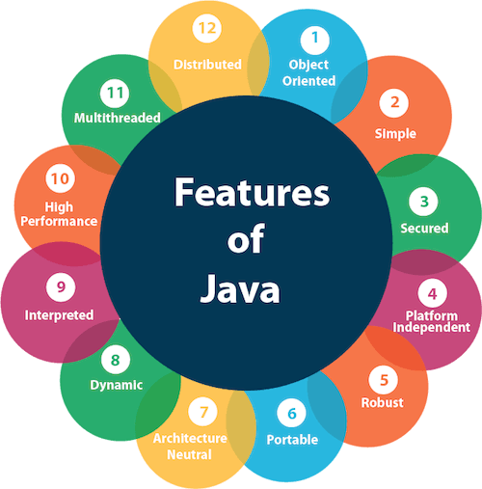
- Simple
- Object-Oriented
- Portable
- Platform independent
- Secured
- Robust
- Architecture neutral
- High Performance
- Multithreaded
- Distributed
- Dynamic

1. Simple
- Java's syntax is easy to learn and similar to C++ but eliminates complex features like pointers, operator overloading, and explicit memory management.

2. Object-Oriented
- Java is fully object-oriented, supporting key concepts like inheritance, encapsulation, polymorphism, and abstraction.
- Almost everything in Java is treated as an object.
Object-oriented programming (OOPs) is a methodology that simplifies software development and maintenance by providing some rules.
Basic concepts of OOPs are:
- Object
- Class
- Inheritance
- Polymorphism
- Abstraction
- Encapsulation

3.Portable
Java is portable because it facilitates you to carry the Java bytecode to any platform. It doesn't require any implementation.

4. Platform-Independent
- Java uses the "Write Once, Run Anywhere" (WORA) principle.
- Java code is compiled into bytecode, which can run on any platform with a Java Virtual Machine (JVM).
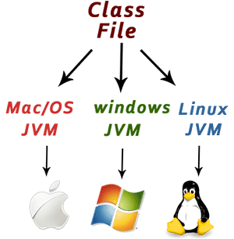

5. Secure
- Java provides a secure environment by avoiding explicit pointer usage and running applications inside a sandbox.
- It has built-in security features like bytecode verification, classloader, and security manager.
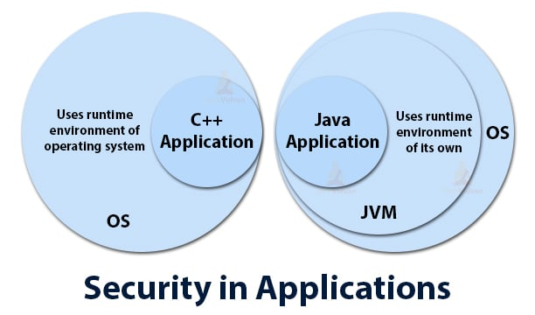

6. Robust
- Java emphasizes strong memory management, exception handling, and type-checking mechanisms.
- It minimizes errors by catching compile-time and runtime errors effectively.

7.Architecture-neutral
Java is architecture neutral because there are no implementation dependent features, for example, the size of primitive types is fixed.
In C programming, int data type occupies 2 bytes of memory for 32-bit architecture and 4 bytes of memory for 64-bit architecture. However, it occupies 4 bytes of memory for both 32 and 64-bit architectures in Java.

8. High-performance
Java is faster than other traditional interpreted programming languages because Java bytecode is "close" to native code. It is still a little bit slower than a compiled language (e.g., C++). Java is an interpreted language that is why it is slower than compiled languages, e.g., C, C++, etc.

9. Multithreaded
Java has built-in support for multithreading, enabling the development of applications that can perform multiple tasks simultaneously

10.Distributed

Java is distributed because it facilitates users to create distributed applications in Java. RMI and EJB are used for creating distributed applications. This feature of Java makes us able to access files by calling the methods from any machine on the internet.

11. Dynamic and Extensible
- Java supports dynamic linking of classes and allows updates to libraries without recompiling the entire application.
- It integrates easily with other technologies, such as Java Native Interface (JNI).

JDK / JRE / JVM:

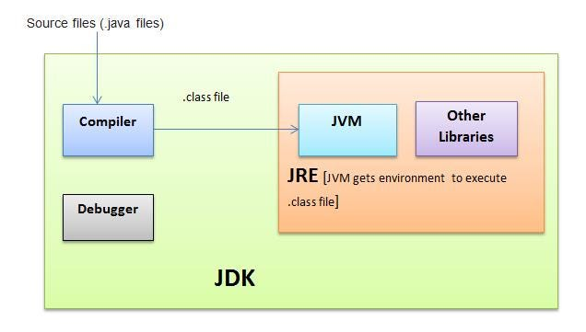

. 1. JDK (Java Development Kit)
- Purpose: Provides tools to develop and compile Java applications.
- Components: Includes JRE, compiler (javac), debugger, and other development tools.
- For Developers: Required to write, compile, and run Java programs.

2. JRE (Java Runtime Environment)
- Purpose: Provides the environment to run Java applications.
- Components: Includes JVM and core libraries.
- For End Users: Required to execute Java applications but cannot be used for development.

3. JVM (Java Virtual Machine)
- Purpose: Executes Java bytecode, providing platform independence.
- Functionality: Converts bytecode to machine-specific instructions and handles memory management (garbage collection).
- Part of JRE: JVM is the core of the Java runtime system.

To download JDK SE 8 verison:
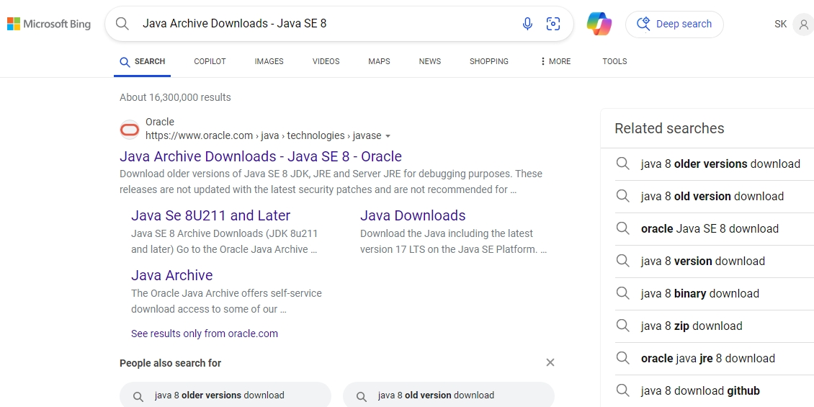

  - Click on first link

Java SE Development Kit 8u202 [ you can see main heading ]

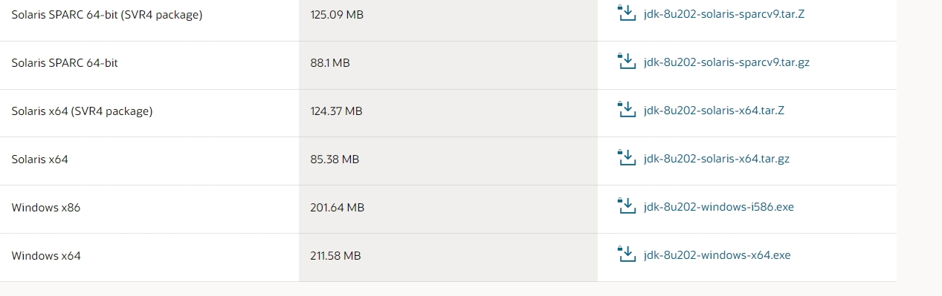
3.Downlaod according to your operating system type;

Example: If you are using window operating system them download
[window X64 ] size – 211.58MB
Data types:
A data type in Java specifies the type of data a variable can hold. It defines the size, memory allocation, and operations that can be performed on the data.
Java has two categories of data types: Primitive and Non-Primitive (Reference) data types.
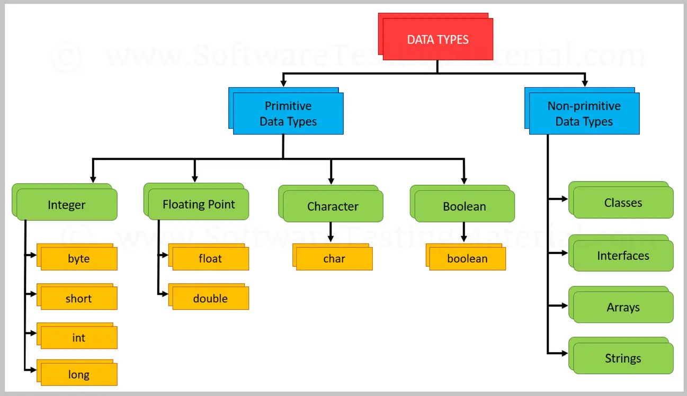

1. Primitive Data Types
These are the basic, built-in data types in Java. They are simple values and are not objects.

Definition:
Primitive data types are the most basic type of data type, directly supported by the Java programming language. They are not objects and hold their values in memory.
Data Type | Size | Default Value | Description
byte | 1 byte | 0 | Stores integers from -128 to 127
short | 2 bytes | 0 | Stores integers from -32,768 to 32,767
int | 4 bytes | 0 | Stores integers from -2^31 to 2^31-1
long | 8 bytes | 0L | Stores larger integers (bigger than int)
float | 4 bytes | 0.0f | Stores decimal values (single precision)
double | 8 bytes | 0.0d | Stores decimal values (double precision)
char | 2 bytes | '\u0000' | Stores a single character (Unicode)
boolean | 1 bit | false | Stores true or false

2. Non-Primitive (Reference) Data Types
These types are more complex and are defined by the user or come from built-in Java libraries. They store references to memory locations where the actual data is stored, rather than holding the data itself.

Definition:
Non-primitive data types, also called reference types, are used to store more complex data, like collections or objects. They do not contain the actual value but rather a reference (or address) to where the data is located in memory.
Data Type | Description
String | A sequence of characters. Example: "Hello"
Arrays | A collection of values of the same data type. Example: int[] numbers = {1, 2, 3};
Classes | User-defined data types that represent objects.
Interfaces | Used to define a contract that other classes can implement.
Example Code on data type :
class Main {
public static void main(String[] args) {
boolean flag = true;
byte a = 127;
int id = 10;
short s = 100;
long l = 2000;
float f = 3.14444f;
double d = 3.1123333;
char ch = 'a';

System.out.println(flag);
System.out.println(a);
System.out.println(id);
System.out.println(f);
System.out.println(d);
System.out.println(ch);
System.out.println(s);
System.out.println(l);

}
}
Output :
true
127
10
3.14444
3.1123333
a
100
2000

Variables in Java
A variable in Java is a container used to store data values. It has a name and a data type which defines the kind of data it holds. Variables are essential in programming as they allow you to store and manipulate data.

Types of Variables in Java
There are three main types of variables in Java:
- Local Variables
- Instance Variables
- Class/Static Variables

1. Local Variables

Definition:
- A local variable is declared within a method, constructor, or block of code.
- It is only accessible within that method, constructor, or block.
- The variable must be initialized before use.

Characteristics:
- Scope: The scope is limited to the method or block in which it is declared.
- Lifetime: Exists only while the method or block is executing.
- Default Value: Local variables are not assigned a default value, and must be explicitly
- initialized before use.
1.Local variable :
import java.io.*;
class Hello {
public static void main(String[] args)
{
// Declared a Local Variable
int var = 10;
// This variable is local to this main method only
System.out.println("Local Variable: " + var);
}
}
Output:
10

2. Instance Variables

Definition:
- An instance variable is declared inside a class but outside any method or constructor.
- It represents the state or properties of an object created from the class.
- Each object of the class has its own copy of the instance variable.

Characteristics:
- Scope: Available to all methods, constructors, and blocks in the class.
- Lifetime: Exists as long as the object is alive.
- Default Value: Instance variables are initialized to default values (e.g., 0 for int, null for objects, false for boolean).
2.Instance variables:
Example 1 :
class Main {
int id=101; //Instance variable
String name = "Aakhib"; //Instance variable
double sal = 2000000.27; //Instance variable
public static void main(String[] args)
{
Main obj = new Main(); // creating object for class
System.out.println(obj.id);
System.out.println(obj.name);
System.out.println(obj.sal);
}
}
Output:
101
Aakhib
2000000.27

Example 2 :
class Main{
int id=101; //Instance variable
String name = "Aakhib"; //Instance variable
double sal = 2000000.27; //Instance variable
public static void main(String[] args) {
Main obj = new Main();
}
{ // Non static block
System.out.println(id);
System.out.println(name);
System.out.println(sal);
} // Non static block
}
Output:
101
Aakhib
2000000.27

3. Class/Static Variables

Definition:
- A class variable is declared with the static keyword inside a class but outside any method.
- Class variables are shared among all instances (objects) of the class.
- There is only one copy of the class variable, no matter how many objects are created.

Characteristics:
- Scope: Available to all methods, constructors, and blocks in the class.
- Lifetime: Exists as long as the class is loaded into memory.
- Default Value: Like instance variables, static variables are initialized to default values.
- Memory: Shared by all instances of the class.

3.Static variables :

class Main{
static int id=101; //static variable
static String name = "Aakhib"; //static variable
static double sal = 2000000.27; //static variable
public static void main(String[] args)
{
System.out.println(id);
System.out.println(name);
System.out.println(sal);
}
}
Output:
101
Aakhib
2000000.27 Table
Type | Declaration | Scope | Lifetime | Default Value

Local Variable | Inside a method/block | Limited to the method/block | Exists only during execution | Not assigned (must be initialized)

Instance Variable | Inside a class (not static) | Available to methods in the class | Exists as long as object exists | Initialized to default values

Class Variable | Inside a class (static) | Available to all instances of the class | Exists as long as class is loaded | Initialized to default values

Identifiers in Java

Definition

Identifiers are the names used for variables, methods, classes, packages, and interfaces in Java. They help in uniquely identifying these programming elements.

Rules for Naming Identifiers
- Allowed Characters: Identifiers can contain letters (A-Z, a-z), digits (0-9), underscores (_), and dollar signs ($).
  - ✅ myVariable, student_name, _counter, $amount
  - ❌ 123name (Cannot start with a digit)
- Cannot be a Keyword: Java keywords (like int, class, static) cannot be used as identifiers.
  - ❌ int = 5; (Invalid, because int is a keyword)
- Case Sensitivity: Java is case-sensitive, meaning MyVariable and myvariable are different identifiers.
  - ✅ StudentName
  - ✅ studentname (Different from StudentName)
- Cannot Contain Spaces: Identifiers cannot have spaces between words.
  - ❌ student name = "John"; (Invalid)
  - ✅ studentName = "John"; (Valid)
- Must Begin with a Letter, Underscore, or Dollar Sign: Identifiers cannot start with a digit.
  - ✅ _myVariable, $value, age
  - ❌ 2count (Invalid)
- Should be Meaningful: Always use meaningful names for readability.
  - ✅ totalMarks, employeeSalary
  - ❌ a, xyz (Not meaningful)

Examples of Valid and Invalid Identifiers
Valid Identifiers | Invalid Identifiers
studentAge | 123name (Starts with a digit)
_result | void (Java keyword)
$salary | total marks (Contains space)
employeeName | @value (Special character not allowed)

Best Practices for Naming Identifiers
- Follow Camel Case for Variables and Methods
  - Example: studentName, calculateSalary()
- Use Pascal Case for Class Names
  - Example: StudentDetails, BankAccount
- Use Uppercase for Constants
  - Example: PI = 3.14;, MAX_VALUE = 100;
- Use Meaningful Names
  - Instead of int x;, use int studentCount;

Keywords in Java

Definition:
Keywords are predefined reserved words in Java that have special meanings and cannot be used as identifiers (variable names, class names, method names, etc.).
abstract continue for new switch
assert default goto package synchronized
boolean do if private this
break double implements protected throw
byte else import public throws
case enum instanceof return transient
catch extends int short try
char final interface static void
class finally long strictfp volatile
const float native super while

List of Java Keywords
Java keywords can be categorized based on their usage:

1. Data Type Keywords
Used to declare variables of specific types:
byte, short, int, long, float, double, char, boolean

2. Control Flow Keywords
Used for decision-making and loops:
if, else, switch, case, default, for, while, do, break, continue, return, yield

3. Exception Handling Keywords
Used for handling exceptions:
try, catch, finally, throw, throws

4. Class and Object Keywords
Used for defining classes and objects:
class, interface, extends, implements, this, super, new, instanceof, abstract, final

5. Access Modifiers
Used to define the visibility of classes, methods, and variables:
public, private, protected

6. Modifiers & Non-Access Modifiers
Used for modifying the behavior of variables, methods, and classes:
static, volatile, synchronized, transient, strictfp, native, default, sealed, non-sealed, permits

7. Object-Oriented Programming (OOP) Keywords
Related to OOP concepts:
this, super

8. Package & Import Keywords
Used for importing classes and defining packages:
package, import

9. Variable and Method Declaration Keywords
var, void

10. Concurrency Keywords (Multithreading)
volatile, synchronized

11. Return Type Keywords
void, return, yield

12. Miscellaneous Keywords
assert, enum, record, module, exports, requires, opens, uses, provides, with, to, transitive

Important Points About Keywords
- Keywords are case-sensitive – Must be written in lowercase.
  - ✅ public, static
  - ❌ Public, STATIC (Invalid)
- Cannot be used as variable names
  - ❌ int class = 5; (Invalid, class is a keyword)
  - ✅ int studentClass = 5; (Valid)
- Some keywords are unused in Java (but reserved for future use)
  - goto, const (Not used in Java)
- Some keywords are introduced in newer versions
  - sealed, permits, record (Java 14+)

Operators in Java

Definition:
Operators in Java are symbols that perform operations on variables and values. Java provides various types of operators to handle mathematical computations, logical decisions, and value manipulations.
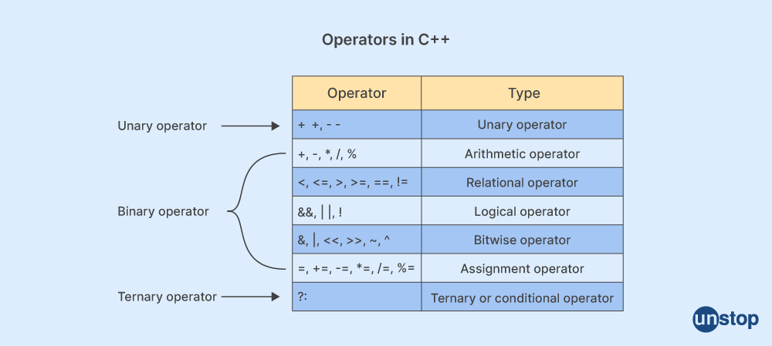

1. Arithmetic Operators
Used for performing basic mathematical operations
int a = 10, b = 5;
System.out.println(a + b); // Output: 15
System.out.println(a - b); // Output: 5
System.out.println(a * b); // Output: 50
System.out.println(a / b); // Output: 2
System.out.println(a % b); // Output: 0

2. Relational (Comparison) Operators
Used to compare two values and return a boolean (true or false).
int x = 10, y = 5;
System.out.println(x == y); // false
System.out.println(x != y); // true
System.out.println(x > y); // true
System.out.println(x < y); // false
System.out.println(x >= y); // true
System.out.println(x <= y); // false

3. Logical Operators
Used for combining multiple conditions.
int a = 10, b = 5;
System.out.println((a > 5) && (b < 10)); // true
System.out.println((a < 5) || (b < 10)); // true
System.out.println(!(a > 5)); // false

4. Bitwise Operators
Used for bit-level operations.
int a = 5, b = 3;
System.out.println(a & b); // Output: 1
System.out.println(a | b); // Output: 7
System.out.println(a ^ b); // Output: 6
System.out.println(~a); // Output: -6
System.out.println(a << 2); // Output: 20
System.out.println(a >> 1); // Output: 2

5. Assignment Operators
Used to assign values to variables.
int x = 10;
x += 5; // x = x + 5 → x = 15
x -= 3; // x = x - 3 → x = 12
x *= 2; // x = x * 2 → x = 24
System.out.println(x);

6. Unary Operators
Operate on a single operand.
int a = 5;
System.out.println(++a); // 6 (Pre-increment)
System.out.println(a--); // 6 (Post-decrement, prints first then decreases)
System.out.println(a); // 5

7. Ternary Operator
Short-hand for if-else conditions.
int a = 10, b = 20;
int max = (a > b) ? a : b;
System.out.println(max); // Output: 20

8. Instanceof Operator
Checks if an object belongs to a specific class.
String name = "Java";
System.out.println(name instanceof String); // true

Java Operators: Precedence and Associativity
In Java, operator precedence and associativity define the order in which operations are performed in an expression.

1. Operator Precedence
Operator precedence determines the order in which operators are evaluated when there are multiple operators in an expression. Operators with higher precedence are evaluated first.
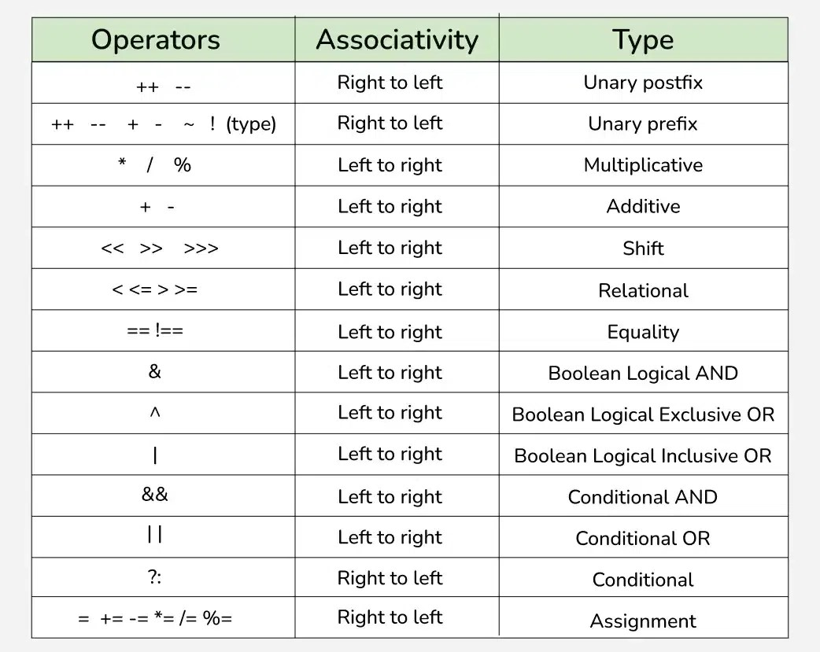

Type Casting in Java
Type casting in Java refers to converting one data type to another. This is often necessary when working with different data types, especially when performing arithmetic operations or dealing with variables that require a specific type.
There are two types of type casting in Java:
- Implicit Type Casting (Widening)
- Explicit Type Casting (Narrowing)

1. Implicit Type Casting (Widening)
Implicit type casting occurs when Java automatically converts a smaller data type to a larger data type. This happens automatically because there is no risk of data loss.

Rules:
- Java automatically converts lower data types (e.g., int, char) to higher data types (e.g., long, float, double).
- This is known as widening, where the range of values is increased.
- No explicit casting is required.
Example:
int num = 50;
long bigNum = num; // Implicit casting from int to long
System.out.println(bigNum); // 50
float floatNum = 10.5f;
double doubleNum = floatNum; // Implicit casting from float to double
System.out.println(doubleNum); // 10.5

2. Explicit Type Casting (Narrowing)
Explicit type casting occurs when you convert a larger data type to a smaller one. Since there is a potential loss of data (e.g., truncating decimals, or losing precision), you need to explicitly tell Java to do this.

Rules:
- You must explicitly cast the variable to the desired type using casting syntax.
- This is known as narrowing, where the range of values is decreased, and there is a risk of data loss.
Example:
double price = 45.99;
int wholePrice = (int) price; // Explicit casting from double to int (decimal part is lost)
System.out.println(wholePrice); // 45
long largeNum = 123456789L;
int smallNum = (int) largeNum; // Explicit casting from long to int (possible data loss)
System.out.println(smallNum); // Data loss: largeNum can't be fully represented in int

Scanner Class in Java

Definition:
The Scanner class in Java is used to take input from the user. It is part of the java.util package and can be used to read input from various sources like the keyboard (System.in), files, or strings.

Importing the Scanner Class
Before using the Scanner class, we must import it:
import java.util.Scanner;

Creating a Scanner Object
To use the Scanner class, we need to create an object of it:
Scanner sc = new Scanner(System.in);

Commonly Used Scanner Methods
The Scanner class provides several methods to read different types of inputs.
Method | Description | Example

next() | Reads a single word (stops at space) | sc.next();

nextLine() | Reads a full line (until Enter) | sc.nextLine();

nextInt() | Reads an integer | sc.nextInt();

nextDouble() | Reads a double (decimal number) | sc.nextDouble();

nextFloat() | Reads a float | sc.nextFloat();

nextLong() | Reads a long integer | sc.nextLong();

nextBoolean() | Reads a boolean value (true/false) | sc.nextBoolean();

nextByte() | Reads a byte value | sc.nextByte();

nextShort() | Reads a short integer | sc.nextShort();

import java.util.Scanner;
public class ScannerExample {
public static void main(String[] args) {
Scanner sc = new Scanner(System.in);
// Taking integer input
System.out.print("Enter an integer: ");
int num = sc.nextInt();
System.out.println("You entered: " + num);
// Taking double input
System.out.print("Enter a decimal number: ");
double decimal = sc.nextDouble();
System.out.println("You entered: " + decimal);
// Taking string input (single word)
System.out.print("Enter a word: ");
String word = sc.next();
System.out.println("You entered: " + word);
// Clearing the buffer
sc.nextLine();
// Taking full line input
System.out.print("Enter a full sentence: ");
String sentence = sc.nextLine();
System.out.println("You entered: " + sentence);
// Taking boolean input
System.out.print("Enter true or false: ");
boolean boolValue = sc.nextBoolean();
System.out.println("You entered: " + boolValue);
// Closing the scanner
sc.close();
}
}

Output:
Enter an integer: 10
You entered: 10
Enter a decimal number: 22.34
You entered: 22.34
Enter a word: Aakhib
You entered: Aakhib
Enter a full sentence: Java is easy language
You entered: Java is easy language
Enter true or false: true
You entered: true

Important Points
- Use sc.nextLine() carefully after sc.nextInt() or other next() methods
  - nextInt() or next() does not read the newline character (\n) after the input.
  - To avoid issues, add sc.nextLine() after calling nextInt(), nextDouble(), etc.
- Close the Scanner
  - Always call sc.close(); when input is no longer needed to prevent memory
  - leaks.

Example: Handling nextInt() and nextLine() Issue :
Scanner sc = new Scanner(System.in);
System.out.print("Enter your age: ");
int age = sc.nextInt();
sc.nextLine(); // Clears the buffer
System.out.print("Enter your name: ");
String name = sc.nextLine();
System.out.println("Name: " + name + ", Age: " + age);

Output:
Enter your age: 60
Enter your name: sandhya
Name: sandhya, Age: 60

WithOut nextline() :
import java.util.Scanner;
public class Main
{
public static void main(String[] args) {
Scanner sc = new Scanner(System.in);
System.out.print("Enter your age: ");
int age = sc.nextInt();
System.out.print("Enter your name: ");
String name = sc.nextLine();
System.out.println("Name: " + name + ", Age: " + age);
}
}
Output:
Enter your age: 60
Enter your name: Name: , Age: 60

ASCII Values in Java

What is ASCII?
- ASCII (American Standard Code for Information Interchange) is a character encoding standard that represents text in computers.
- Each character (letters, digits, symbols) has a unique numeric value (0 to 127 in standard ASCII).
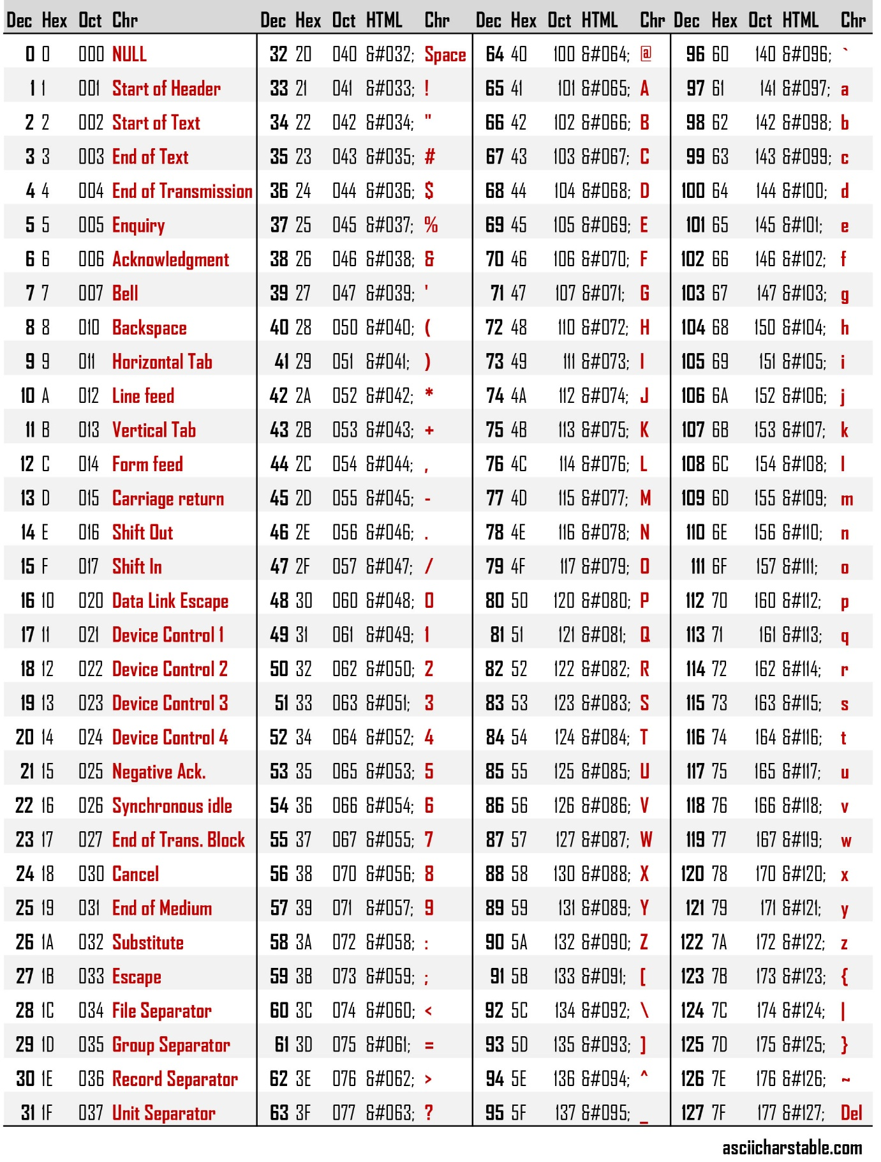

Important ranges :
1.[A-Z] ----65-90
2. [a-z] --- 97-122
3.[0-9]----48-57

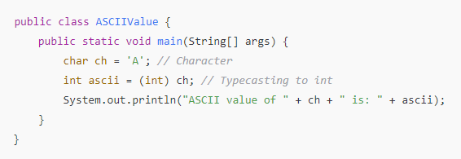
Output:
ASCII value of A is: 65

Control Flow Statements in Java

1. Introduction
Control flow statements in Java determine the order in which statements are executed. They are classified into:
- Decision-Making Statements (if, if-else, switch)
- Looping Statements (for, while, do-while)
- Jump Statements (break, continue, return)
Decision-Making Statements:
Decision-making statements help in executing a block of code based on conditions. Java provides the following decision-making statements:
- if Statement
- if-else Statement
- if-else-if Ladder
- switch Statement

1). if Statement
The if statement executes a block of code only if the given condition is true.
Syntax:
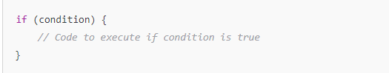
Example:
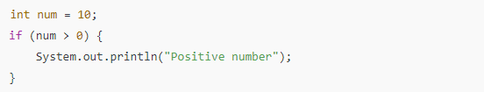
Output:
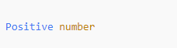

2). if-else Statement
The if-else statement executes one block if the condition is true, otherwise, it executes another block.
Syntax:
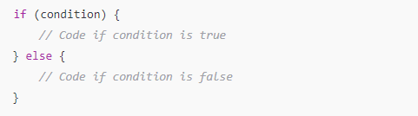
Example:
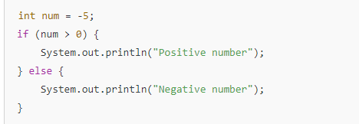
Output:


3. if-else-if Ladder
The if-else-if ladder is used when multiple conditions need to be checked one after another.
Syntax:
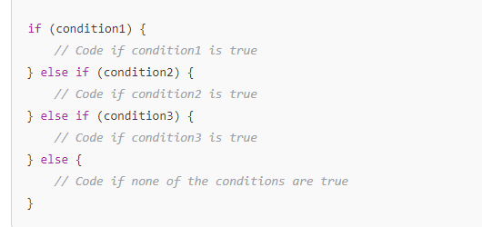

Example:
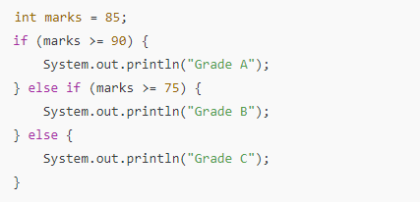
Output:


4. switch Statement
The switch statement is used when a variable is compared with multiple values (cases).
Syntax:
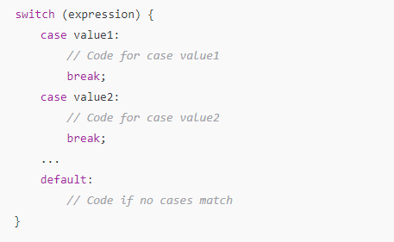

Example:
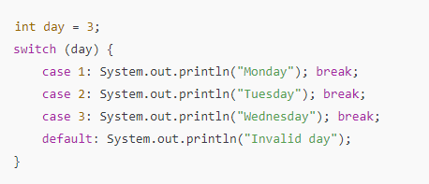
Output:


Loops in Java

Introduction
Loops in Java are used to execute a block of code repeatedly until a specific condition is met. Java provides three types of loops:
- for loop – Used when the number of iterations is known.
- while loop – Used when the number of iterations is unknown but depends on a condition.
- do-while loop – Similar to while, but executes at least once before checking the condition.

1. for Loop
The for loop is used when the number of iterations is known beforehand.
Syntax:
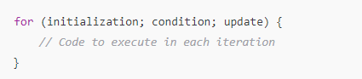

Example:
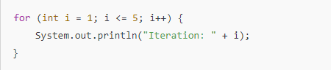
Output:
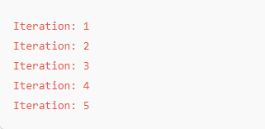

Enhanced for Loop (for-each Loop)
Used to iterate over arrays and collections.
Syntax:
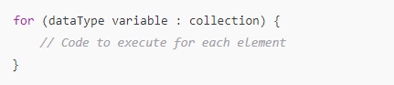
Example:
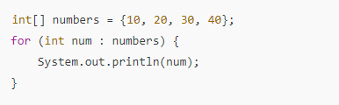

Output:
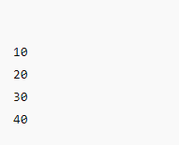

2. while Loop
The while loop executes as long as the given condition is true.
Syntax:
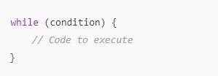
Example:
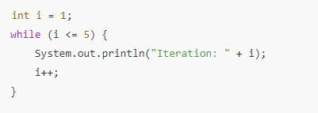

Output:
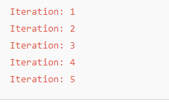

3. do-while Loop
The do-while loop executes at least once, then checks the condition.
Syntax:
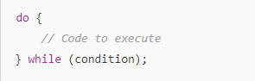
Example:
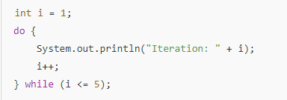
Output:
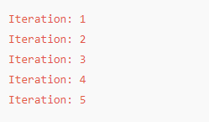

Nested Loops in Java

Introduction
A nested loop is a loop inside another loop. Java allows placing one loop inside another, which is useful for working with multi-dimensional structures like matrices or patterns.
Syntax of Nested for Loops :
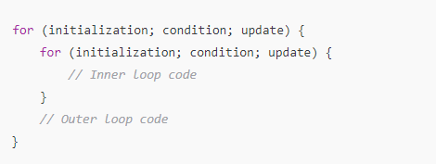
Examples:

1. Left Angle Triangle Pattern
Example:
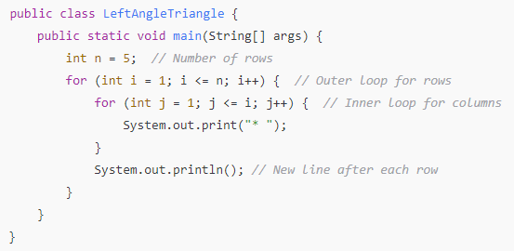
Output:


2. Left Angle Triangle Pattern (Inverted)
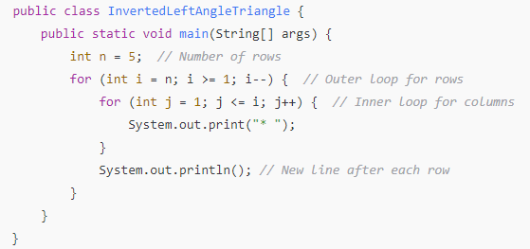
Output:
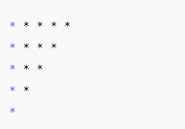
3. Right Angle Triangle Pattern
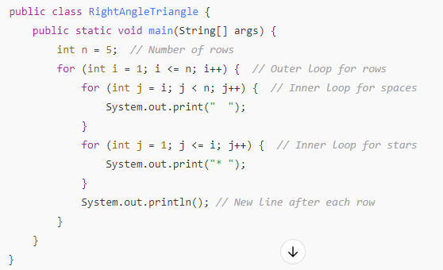
Output:

4. Right Angle Triangle Pattern (Inverted)
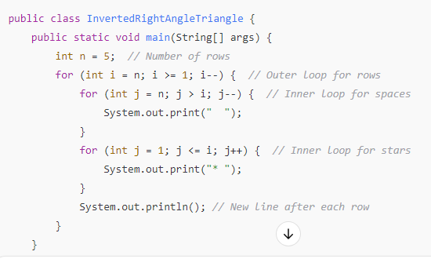
Output:


Jump Statements:
(break, continue, return):

a) break Statement
Exits the loop or switch case immediately.
Example:
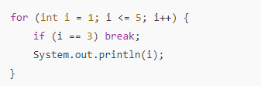
Output:


b) continue Statement
Skips the current iteration and continues with the next.
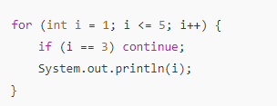
Output:
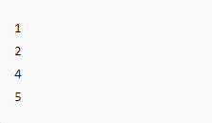

c) return Statement
The return statement in Java is used to exit from a method and optionally return a value to the caller. It is classified into two types:
- Non-return type method (void method) – Uses return; but does not return any value.
- Return type method – Uses return value; to return a specific data type.

1. Example: Non-Return Type (void)
In a method with void return type, return; is optional but can be used to exit the method early.
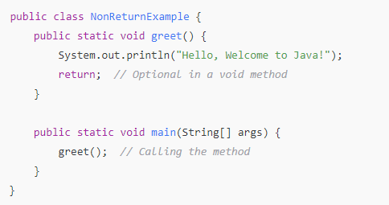
Output:
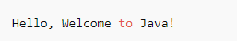

2. Example: Return Type Method
A method that returns a value must specify a return type and use return value;.
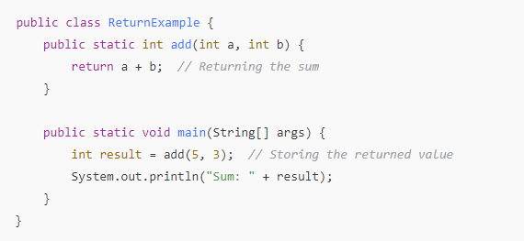
Output:

- Example: Using return in Conditional Statements
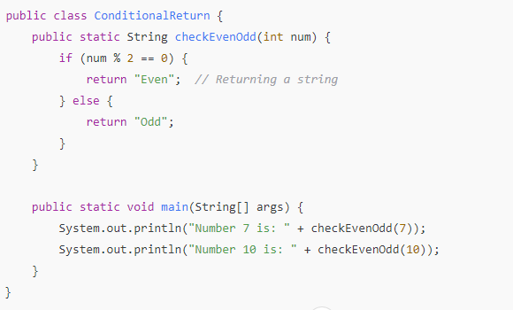
Output:
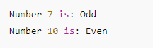
Table:
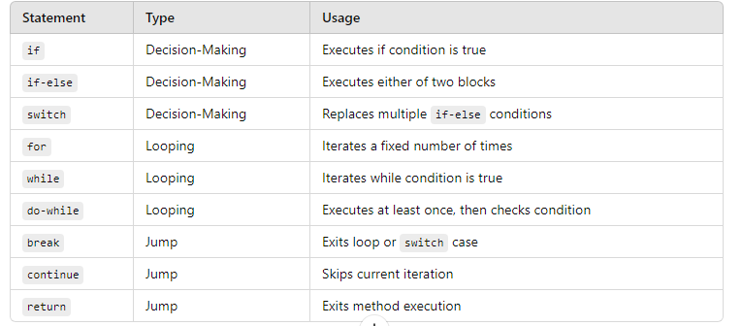

Tasks on flow control statements:
1.Write a java program to find out max and min of four numbers using if-else
2.Write a java program to simulate a calculator using switch case
3.Write a java program to find out given year is leap year or not
4.Find the factorial of given number using any loop
5.Find the given number is prime number or not
6.Checking a number is palindrome or not
7.Construct a pyramid of numbers using nested for loop
8.Find out second largest value and second smallest value
9.Find out given number is armStrong number or not [Require knowledge of number crunching concept]
10.Find out given number is magic number or not .

Methods in Java:
A method in Java is a block of code that performs a specific task. It allows code reusability and improves readability.

1. Types of Methods in Java
Java methods can be classified into two main categories:
- Predefined Methods (Built-in) – Methods provided by Java (e.g., Math.sqrt(), System.out.println()).
- User-Defined Methods – Methods created by the programmer.
Method Syntax:
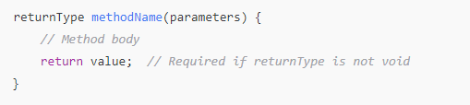
Example: Creating and Calling a Method :
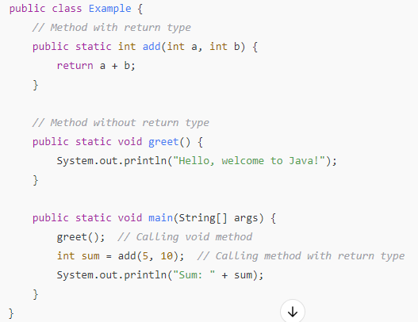

Output:
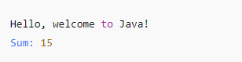

1. Method Overloading (Multiple Methods with Same Name)
Method overloading allows defining multiple methods with the same name but different parameters.
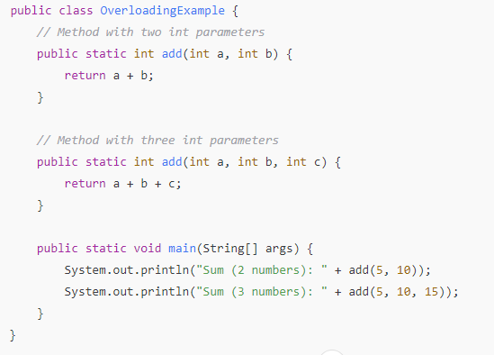
Output:
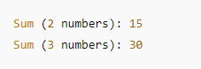
2. Static vs. Non-Static Methods

Static Method
- Declared with static keyword.
- Can be called without creating an object.
- Example: main() method in Java.
Example:
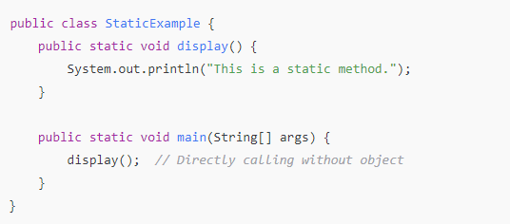
Output:

Non-Static Method
- Requires an object to be called.
Example:
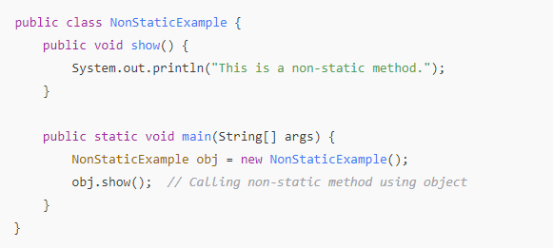
Output:
3.Calling a Method Inside Another Method in the Same Class
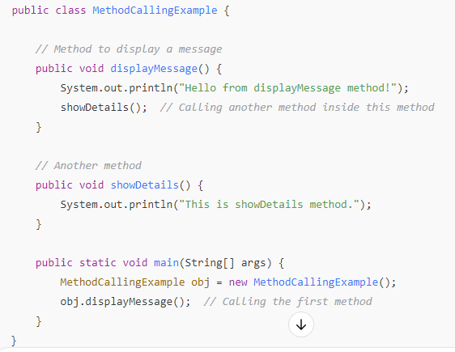
Output:
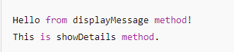
4: Calling a Method Inside Another Method in Another Class
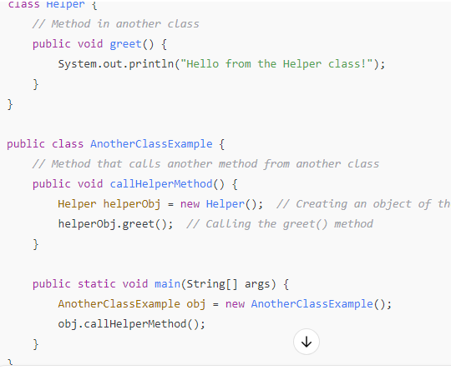
Output:
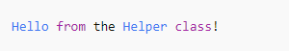
5: Calling a Method Inside Another Method Using this Keyword
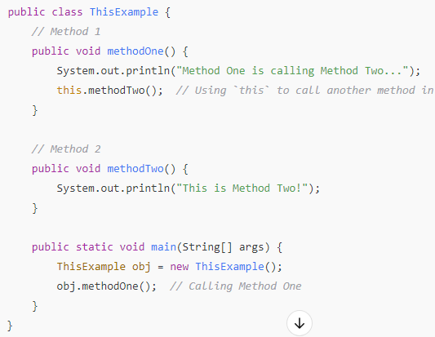
Output:
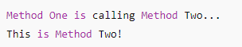
6: Calling a Static Method Inside Another Static Method
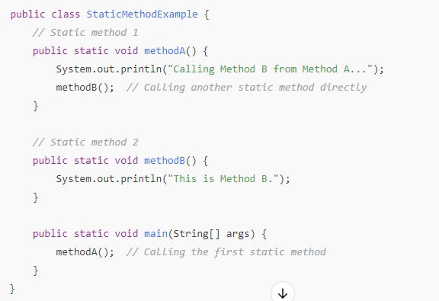
Output:
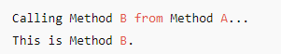

Constructors in Java:
Constructors are special methods in Java that are called when an object is created. They are used to initialize an object. The constructor name must match the class name, and it does not have a return type.

1. Parameterless (Default) Constructor
A default constructor does not take any parameters. It is used to initialize an object with default values.
Example:
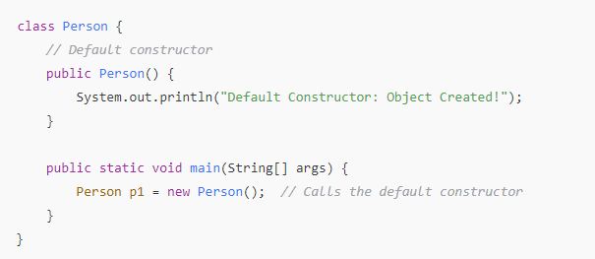
Output:
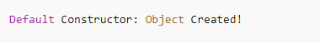

2. Parameterized Constructor
A parameterized constructor takes arguments and initializes object properties dynamically.
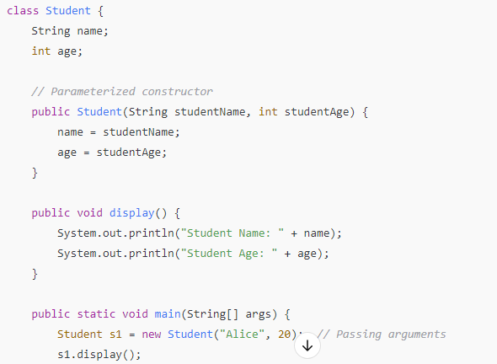
}
}
Output:
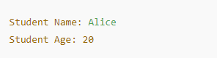

3. Constructor Chaining
Constructor chaining is calling one constructor from another constructor within the same class using this() or from a superclass using super().
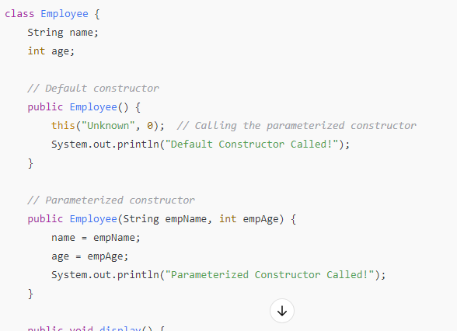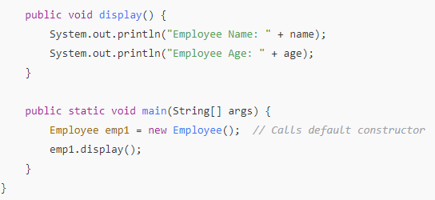
Output:
