Java Script
SYLLABUS :
1. Variables and data types
2. Operators
3. Conditional statements
4. Loops and Strings
5. Arrays
6. Functions
7. Objects
8. DOM and Events
9. API calls

JavaScript has become the go-to language for building interactive, responsive, and efficient web applications. Its versatility, rich ecosystem, and ability to handle both front-end and back-end tasks make it an essential tool for modern developers. Whether you are building simple websites, complex web apps, or mobile applications, JavaScript is indispensable in today’s tech landscape.

KeyWords :
• let: Block-scoped, reassignable, modern choice for variable declaration.
• const: Block-scoped, non-reassignable, used for values that should not change (including object references).
• var: Function-scoped, reassignable, legacy (avoid in modern JavaScript as it has confusing scoping behavior).

Data Types :
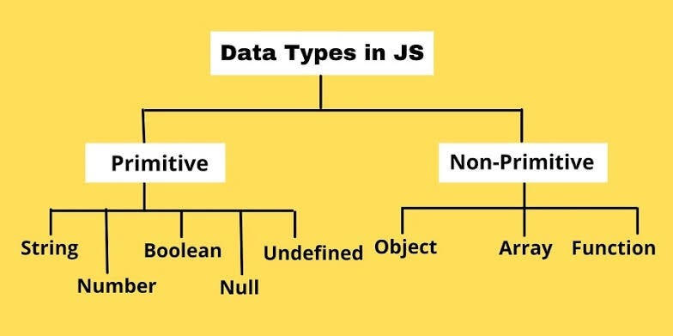
Additional Primitive data types :
1.BigInt
2.Symbol

Objects Methods :
- Object.keys()
- Object.Values()
- Object.entries()
- Object.Freeze()
- Object.seal()
- Object.Assign()

Nested Objects :

