Operators :

What is an Operator?
An operator is a special symbol used to perform operations on values or variables. For example: +, -, *, /, etc.
Types :
- Arithmetic Operators
- Assignment Operators
- Comparison Operators
- Logical Operators
- Ternary Operators

6. Bitwise Operators (Optional if advanced)
- &, |, ^, ~, <<, >>
7. Optional: Nullish Coalescing (??) & Optional Chaining (?.)

1. Arithmetic Operators
Used to perform mathematical operations.
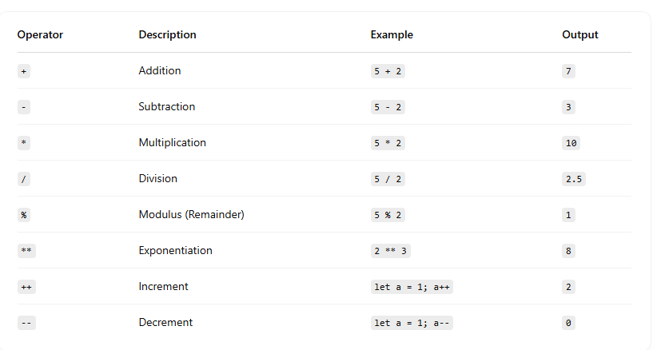

2. Comparison Operators
Used to compare two values.
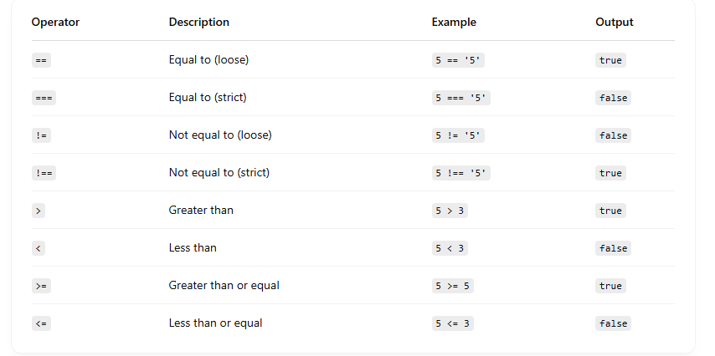

3. Logical Operators
Used to combine or invert boolean values.
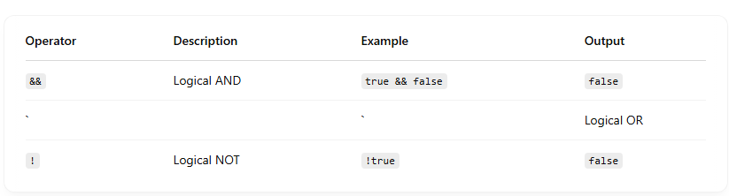

4. Assignment Operators
Used to assign values to variables.
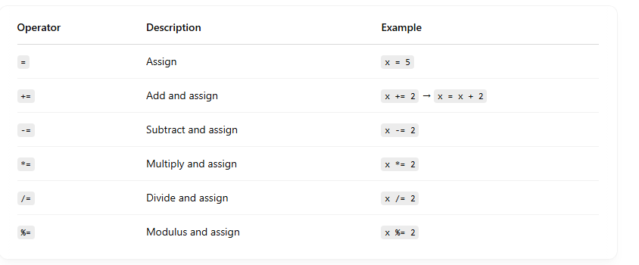
5. Ternary Operators :
Syntax :
condition ? expression_if_true : expression_if_false;

