MILESTONE 1
Development of an AI-Based
Startup Idea Validator with
Market Analysis Assistance
Complete Documentation for Tasks 1–5
Prepared for: Project Mentor and Team
Submission deadline: Monday, 12 October 2026
Team Member(s): __1. Shaik Thaheer___________________________
Team / Section: _______team-4_______________________

Document Overview
This document covers all five Milestone 1 tasks: project understanding and startup validation, multi-agent AI systems, system architecture, startup idea submission module, and web search API integration. It includes a sample startup idea, agent responsibilities, diagrams, a UI wireframe, structured JSON, Python test code, expected output format, and a GitHub checklist.
Task | Main deliverable
Task 1 | Project understanding notes and one sample startup idea with validation plan
Task 2 | Definitions and responsibilities of six specialized agents
Task 3 | Architecture diagram, component roles, and end-to-end information flow
Task 4 | Submission form wireframe, LLM prompt, and structured JSON example
Task 5 | Tavily API setup, Python request code, readable result display, and troubleshooting

Project Summary
The proposed system helps founders make an evidence-informed first assessment of a startup idea. A user submits an idea through a web form. The backend uses an LLM to convert the description into structured data, searches the web for relevant market and competitor information, coordinates specialized agents, and presents a report containing opportunities, risks, competitor observations, and an MVP recommendation.
Important limitation: an AI-generated report is preliminary decision support, not a guarantee of commercial success. Search snippets can be incomplete or outdated, and market demand should be validated with customer interviews, surveys, prototype testing, and reliable sources.

TASK 1 — Understand the Project and Startup Validation

1.1 Project objective
The objective is to develop an AI-based system that assists entrepreneurs in evaluating startup ideas before investing significant time and money. The system organizes the idea, gathers public web information, analyzes the market and competitors, identifies strengths and risks, recommends a minimum viable product (MVP), and generates a readable validation report.

1.2 Why startup validation is important
- Checks whether a real customer problem exists and whether people are interested in a proposed solution.
- Helps identify target users and understand their needs, budgets, and buying behavior.
- Shows what competing products already offer and where gaps may exist.
- Helps estimate development effort, operating costs, possible revenue, and other feasibility concerns.
- Reduces avoidable risk by testing assumptions before building a complete product.
- Supports a practical decision: continue, revise, test further, or stop.

1.3 Key concepts
Concept | Meaning | Example evidence
Market demand | The level of need or interest for a product or service. | Customer interviews, surveys, search trends, pilot sign-ups
Target customers | The people or organizations most likely to use or pay for the product. | Age/role, institution type, needs, budget, usage context
Competitor analysis | Reviewing existing alternatives, features, pricing, and positioning. | Official product pages, pricing pages, reviews, comparison tables
Business feasibility | Whether the idea can realistically be built, operated, and sustained. | Cost estimates, technical skills, revenue assumptions, regulations
SWOT analysis | Strengths, Weaknesses, Opportunities, and Threats. | Internal capabilities and external market conditions
MVP | Minimum Viable Product: the smallest version that can test the core value proposition. | A simple prototype with only essential features

1.4 Sample startup idea
Name: AI-Powered Personalized Learning Plans for College Students
Description: A platform that asks students about their learning goals, available study time, current knowledge, and quiz performance. It then recommends a personalized study schedule, relevant learning resources, and topics to revise. Recommendations can be updated as students complete activities and quizzes.
Item | Details
Problem | Students may struggle to plan study time, prioritize topics, and identify knowledge gaps.
Proposed solution | An AI-supported learning planner that creates and adjusts study plans.
Target customers | College students; later, colleges and online learning providers.
Industry | Education Technology (EdTech).
Possible revenue model | Freemium access with optional paid features or institutional subscriptions.
Key assumption | Students find personalized study planning useful enough to return to the platform.
Main risks | Competition, low engagement, inaccurate recommendations, privacy concerns, and content licensing.

1.5 How to validate the sample idea
- Customer discovery: interview or survey a varied group of college students about how they currently plan study and revise topics.
- Problem validation: determine how frequently the problem occurs and which students experience it most strongly.
- Web research: search for existing study planners, adaptive learning systems, and AI tutoring platforms.
- Competitor comparison: compare core features, pricing, target audiences, strengths, and reported limitations using dated sources.
- Feasibility review: estimate the cost and effort of a basic planner, quiz tracking, and recommendation feature.
- MVP test: build a simple prototype and invite a small group of students to use it for a short pilot.
- Measure outcomes: track activation, repeat usage, completion of recommended study tasks, user feedback, and willingness to pay.
- Decision: improve, continue, or reconsider the idea based on observed evidence rather than AI opinion alone.

1.6 Initial validation questions
- Do students already use a planner, calendar, AI tutor, or other tool to organize learning?
- What is frustrating or missing in their current approach?
- Would they follow a study plan generated from their goals and quiz performance?
- Which features are essential for a first version?
- Would students or institutions pay for any premium features?
- What privacy and data-protection expectations apply to student information?

TASK 2 — Study Multi-Agent AI Systems

2.1 What is an AI agent?
An AI agent is a software component assigned a specific goal. It may use an LLM, instructions, tools, and data to perform a task and return a result. In this project, agents are specialized components coordinated by the backend.

2.2 What is a Large Language Model (LLM)?
A Large Language Model is an AI model trained to understand and generate language. It can extract fields from a startup description, summarize web content, compare alternatives, classify risks, and draft reports. Its outputs can be incorrect, so important claims must be checked against sources.

2.3 Why use multiple agents?
- Specialization: each agent focuses on one clear responsibility.
- Modularity: individual agents can be improved or replaced independently.
- Traceability: separate outputs make it easier to see where a finding came from.
- Coordination: the backend can run independent analyses in parallel and then combine them.
- Quality control: results can be checked for missing evidence, contradictions, and unsupported claims.

2.4 Agent responsibilities
Agent | Responsibilities | Typical output
Web Search Agent | Creates search queries; calls the search API; retrieves titles, snippets, URLs, and dates where available; removes duplicates and irrelevant results. | A list of relevant sources with snippets and URLs
Market Analysis Agent | Uses retrieved evidence to summarize demand signals, customer segments, trends, opportunities, and market limitations; distinguishes facts from assumptions. | Market findings, evidence, uncertainties, and questions for further research
Competitor Analysis Agent | Identifies direct and indirect alternatives; compares features, audience, pricing where verified, positioning, and possible gaps. | Competitor comparison table with source URLs
SWOT and Risk Analysis Agent | Identifies strengths, weaknesses, opportunities, threats, and technical, business, operational, privacy, or regulatory risks. | SWOT matrix, risk list, impact/likelihood, mitigations
MVP Recommendation Agent | Selects the smallest feature set needed to test the main customer value proposition; recommends a pilot and success metrics. | MVP scope, excluded features, test plan, metrics
Report Generation Agent | Combines agent outputs, removes repetition, cites sources, flags uncertainty, and creates a structured report for the user. | Readable startup validation report

2.5 Multi-agent workflow
+-----------------------+
| User's Startup Idea |
+-----------+-----------+
|
v
+-----------------------+
| LLM Idea Structuring |
+-----------+-----------+
|
v
+-----------------------+
| Web Search Agent |
+-----------+-----------+
|
+-----------+-----------+
| |
v v
+----------------+ +--------------------+
| Market Analysis| | Competitor Analysis|
+--------+-------+ +----------+---------+
| |
+------------+------------+
v
+-----------------------+
| SWOT & Risk Analysis |
+-----------+-----------+
v
+-----------------------+
| MVP Recommendation |
+-----------+-----------+
v
+-----------------------+
| Report Generation |
+-----------+-----------+
v
+-----------------------+
| Final Validation Report|
+-----------------------+

2.6 Coordination and quality rules
- Use a consistent JSON schema between the backend and agents.
- Attach source URLs to market and competitor claims wherever possible.
- Record retrieval dates and avoid presenting old results as current.
- Mark unsupported values as unknown instead of inventing statistics or prices.
- Handle API failures and empty search results gracefully.
- Review for contradictory findings before producing the final report.

TASK 3 — Design the System Architecture

3.1 Architecture diagram

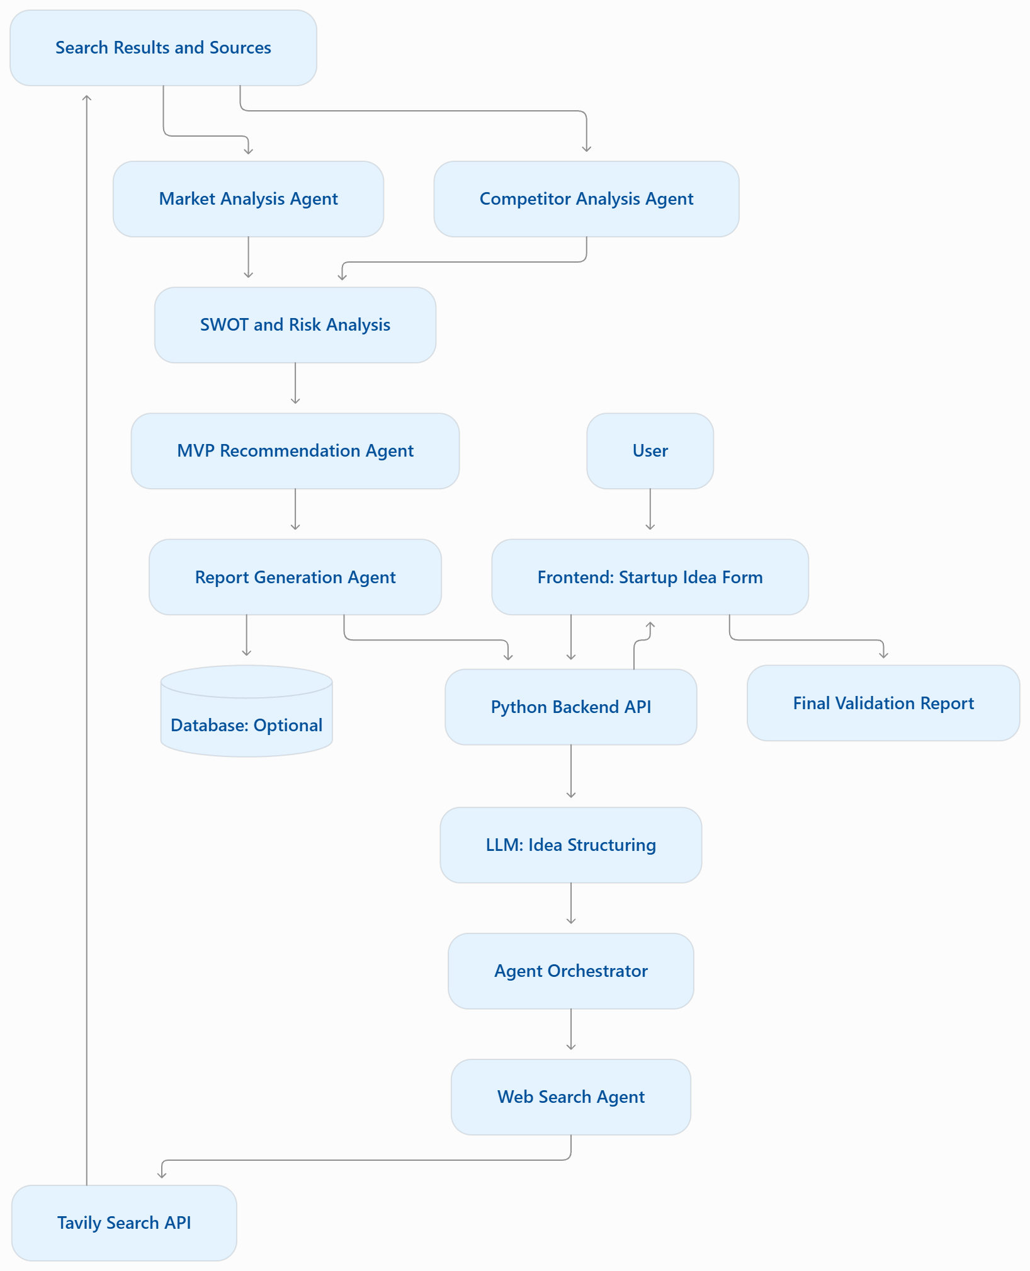

3.2 Component roles
Component | Role
User interface (frontend) | Provides fields for idea submission, shows validation status, and presents the final report.
Backend API | Validates user input, protects secrets, coordinates calls, manages errors/timeouts, and combines outputs.
LLM | Converts free text into a structured startup idea and supports analysis tasks.
Web search API | Retrieves public web results relevant to the idea, market, and competitors.
Specialized agents | Perform market, competitor, SWOT/risk, MVP, and report tasks.
Optional database | Stores submissions, source records, and reports with appropriate access controls.
Report dashboard | Displays summary, evidence, competitor comparison, risks, recommendations, and source links.

3.3 End-to-end information flow
- The user fills in the startup idea submission form.
- The frontend sends the form data to the backend over HTTPS.
- The backend validates required fields and sends the description to the LLM with a JSON-output instruction.
- The backend checks the structured response and records missing fields.
- The Web Search Agent uses the search API to retrieve relevant pages and source URLs.
- The Market Analysis and Competitor Analysis Agents review the relevant evidence.
- The SWOT and Risk Agent combines the analysis and identifies uncertainties and mitigations.
- The MVP Recommendation Agent proposes a limited first version and a test plan.
- The Report Generation Agent combines findings and source references into a report.
- The backend returns the report to the frontend and may save it to a database.

3.4 Basic non-functional requirements
- Security: keep API keys on the server, use environment variables, and never expose secrets in frontend code.
- Privacy: collect only required user data and define retention/access rules before storing submissions.
- Reliability: handle timeouts, rate limits, invalid JSON, and failed agent calls.
- Transparency: show source links, dates when available, assumptions, and confidence limitations.
- Maintainability: keep agents in separate modules and document API request/response formats.
- Usability: use clear form labels, validation messages, and a readable report layout.

TASK 4 — Design the Startup Idea Submission Module

4.1 Basic UI wireframe
+--------------------------------------------------------------+
| STARTUP IDEA VALIDATOR |
| Submit your idea to begin preliminary validation. |
+--------------------------------------------------------------+
| Startup idea name (optional): [___________________________] |
| |
| Startup idea description: |
| [________________________________________________________] |
| [________________________________________________________] |
| |
| Target customers: [______________________________________] |
| Industry: [Select industry v______________________] |
| Customer problem: [______________________________________] |
| Proposed solution:[______________________________________] |
| Revenue model: [Freemium / Subscription / Other v_____] |
| Initial budget: [Low / Medium / High / Not decided v___] |
| Location/market (optional): [____________________________] |
| Additional notes (optional): [____________________________] |
| |
| [ Validate Startup Idea ] |
+--------------------------------------------------------------+
| Results: market evidence | competitors | SWOT | MVP | report |
+--------------------------------------------------------------+
The wireframe is a planning design. The form is not a deployed application and must be implemented in the team's frontend framework before it can submit data to a backend.

4.2 Suggested fields
Field | Required? | Purpose
Startup idea description | Yes | Explains the idea and proposed value.
Target customers | Yes | Identifies intended users or buyers.
Industry | Yes | Helps generate relevant search queries.
Customer problem | Recommended | Explains the problem being addressed.
Proposed solution | Recommended | Describes how the product addresses the problem.
Revenue model | Optional | Captures how the business may earn revenue.
Initial budget | Optional | Supports preliminary feasibility discussion.
Location or target market | Optional | Narrows market and competitor research.
Additional notes | Optional | Allows users to add constraints or context.

4.3 LLM structuring process
- Receive form values in the backend.
- Validate required fields and limit input length.
- Send the text and a clear extraction instruction to the LLM.
- Request JSON only, following a defined schema.
- Parse and validate the returned JSON in the backend.
- If the response is invalid, retry safely or return a clear error.
- Pass the structured idea to the search and analysis workflow.

4.4 Example LLM prompt
Convert the user's startup submission into valid JSON.
Extract:
- startup_name
- industry
- idea_description
- target_customers (array)
- customer_problem
- proposed_solution
- revenue_model
- initial_budget
- location_or_target_market
- additional_notes
- validation_requirements (array)
Rules:
1. Preserve the meaning of the submitted information.
2. Use null for missing scalar values and [] for missing arrays.
3. Do not invent market statistics, competitor facts, or customer evidence.
4. Return valid JSON only, without Markdown fences.

4.5 Sample structured output
{
"startup_name": "AI Personalized Learning Planner",
"industry": "Education Technology",
"idea_description": "An AI platform that creates personalized study plans.",
"target_customers": [
"College students",
"Educational institutions"
],
"customer_problem": "Students struggle to organize study time and identify knowledge gaps.",
"proposed_solution": "Generate adaptive study plans using goals and quiz performance.",
"revenue_model": "Freemium subscription",
"initial_budget": "Low initial budget",
"location_or_target_market": null,
"additional_notes": null,
"validation_requirements": [
"Measure student demand",
"Research existing competitors",
"Estimate development costs",
"Test a prototype with students"
]
}

4.6 Example backend validation checks
- Confirm that the description, target customers, and industry are present.
- Confirm that the LLM response parses as JSON and contains expected keys.
- Treat user input and web content as untrusted data; do not follow instructions embedded in retrieved pages.
- Keep the API key in a server-side environment variable.
- Show users that AI conclusions are preliminary and source-dependent.

TASK 5 — Explore Web Search API Integration

5.1 Purpose of a web search API
A web search API lets an application retrieve public web pages and snippets programmatically. In this project, it helps discover market trends, existing products, competitor pages, pricing information, and other potentially useful evidence. Results must be reviewed and dated where possible; search snippets alone do not prove demand or business viability.

5.2 Explore Tavily
Tavily is one possible web search API designed for applications that use search results in AI workflows.
- Documentation: https://docs.tavily.com/
- Website/dashboard: https://tavily.com/
Setup: create an account, obtain an API key from the provider dashboard, review current API and usage limits, and save the key in an environment variable. Do not paste a real key into documentation or commit it to GitHub.

5.3 Install dependency
python -m pip install requests

5.4 Set the API key
Windows PowerShell (for the current terminal session):
$env:TAVILY_API_KEY="your_actual_api_key"
Linux/macOS shell (for the current terminal session):
export TAVILY_API_KEY="your_actual_api_key"
Replace the placeholder with your own key. Avoid writing the real key into the Python source file.

5.5 Python test request
import os
import requests
API_KEY = os.getenv("TAVILY_API_KEY")
if not API_KEY:
raise ValueError("Set the TAVILY_API_KEY environment variable.")
url = "https://api.tavily.com/search"
payload = {
"api_key": API_KEY,
"query": (
"AI personalized learning platforms for college students "
"competitors and market trends"
),
"search_depth": "basic",
"max_results": 5,
"include_answer": True
}
response = requests.post(url, json=payload, timeout=30)
response.raise_for_status()
data = response.json()
print("\nSEARCH SUMMARY\n")
print(data.get("answer", "No summary returned."))
print("\nSEARCH RESULTS\n")
for index, result in enumerate(data.get("results", []), start=1):
print(f"{index}. {result.get('title', 'Untitled')}")
print(f" URL: {result.get('url', 'N/A')}")
snippet = result.get("content", "N/A")
print(f" Content: {snippet[:400]}")
print()

5.6 Run the test
Save the code as tavily_test.py and run:
python tavily_test.py

5.7 Example of readable output format
The following is an illustrative format only. It is not a real search response. Run the script with a valid API key to retrieve actual results.
SEARCH SUMMARY
A summary of information retrieved from relevant web pages.
SEARCH RESULTS
1. Example page title
URL: https://example.com/page
Content: A snippet retrieved from the page.
2. Another example page
URL: https://example.com/another-page
Content: A second retrieved snippet.

5.8 Troubleshooting
Problem | Possible action
Missing API key | Set TAVILY_API_KEY in the same terminal session used to run Python.
HTTP 401 or 403 | Check the key, account access, and current API permissions.
HTTP 429 | Check usage limits and rate limits; wait and retry if appropriate.
Connection timeout | Check internet access and retry with a reasonable timeout.
No useful results | Try a more focused or broader query and inspect the returned titles and URLs.
JSON or parsing issue | Print the response status and response body safely; do not print the API key.

5.9 Expected evidence for submission
- A screenshot or copied terminal output showing the test request ran successfully.
- Three to five actual search results with title, URL, and a short content snippet.
- A short note explaining why each result may be relevant to the startup idea.
- A note stating that results were retrieved on the actual test date and may change over time.
Important: this document contains the working test code and expected output format, but it cannot contain genuine live results from your account. Run the script with your API key and replace the illustrative output with the real results before submission.

GitHub Repository Structure
startup-idea-validator/
├── README.md
├── docs/
│ ├── task1_project_understanding.md
│ ├── task2_agent_responsibilities.md
│ ├── task3_system_architecture.md
│ └── task4_submission_module.md
├── backend/
│ ├── tavily_test.py
│ └── requirements.txt
├── frontend/
│ └── startup_form_wireframe.md
└── .gitignore

GitHub safety checklist
- Add .env and other secret files to .gitignore.
- Use a .env.example file containing placeholder values only, if needed.
- Document setup steps in README.md.
- Commit code and documentation in small, understandable changes.
- Do not upload API keys, passwords, or private user data.
- Ask a teammate to clone the repository and follow the README to verify setup.

Final Deliverables Checklist
No. | Deliverable | Completion evidence
1 | Project understanding and sample startup idea | Notes and a documented validation plan
2 | Agent responsibilities | Descriptions and workflow for six agents
3 | System architecture | Architecture diagram and component roles
4 | Submission module | UI wireframe, LLM prompt, sample JSON
5 | Web search API integration | Python test plus actual retrieved results
6 | GitHub repository | Committed documentation and code with secrets excluded

Conclusion
Milestone 1 establishes the foundation for the AI-Based Startup Idea Validator with Market Analysis Assistance. The project combines structured user input, LLM-based extraction, web research, specialized analysis agents, and report generation. The next implementation step is to build the submission form and backend, run the Tavily API test with a private API key, save actual results, and integrate the agent workflow. Startup decisions should rely on credible evidence and direct customer validation, not on AI-generated conclusions alone.

