CO2 -AT1
SHAIK THAHEER
192425347
SIMATS ENGINEERING
ASSESSMENT TOOL 1: Analytical Problem Solving

COURSE NAME: Cloud Computing and
Big Data Analytics COURSE CODE: CSA15
________________________________________________________________
COURSE OUTCOME COVERED
CO2: Analyze virtualization architectures to identify performance and security issues in cloud computing environments. (BL3)
Assessment Tool Weightage: 40%
Dave’s Taxonomy: Manipulation (Level 2)
Question Count: 5 Total Marks: 50
________________________________________________________________
Code of Conduct
I ___SHAIK THAHEER(192425347)_ (Name / Reg No) certify that this submission is my original work and that I have adhered to the guidelines specified for this assessment.
I understand that any violation of academic integrity rules will result in disciplinary action.
Signature of the student: __SHAIK THAHEER____

1. Compare Type-1 and Type-2 Hypervisors for a Cloud Datacenter Hosting Mission-Critical Applications
Introduction
A hypervisor is a virtualization software layer that creates, runs, and manages multiple virtual machines (VMs) on a physical computer. It allocates hardware resources such as CPU, memory, storage, and network interfaces to virtual machines.
There are two main types of hypervisors: Type-1 (bare-metal) and Type-2 (hosted). For a cloud datacenter hosting mission-critical applications, selecting the appropriate hypervisor is essential for performance, security, reliability, and manageability.
Criteria | Type-1 Hypervisor | Type-2 Hypervisor
Architecture | Runs directly on physical hardware | Runs on top of a host operating system
Performance | High performance with lower virtualization overhead | Additional overhead due to the host OS
Security | Smaller software stack between VMs and hardware | Depends on the security of both the host OS and hypervisor
Resource management | Directly manages hardware resources | Accesses hardware through the host OS
Reliability | Designed for enterprise workloads and continuous operation | Host OS failures can affect all hosted VMs
Manageability | Supports centralized management and automation | Generally easier for desktop use and development
Scalability | Suitable for large cloud environments | Less suitable for large-scale production datacenters
Examples | VMware ESXi, Xen, Microsoft Hyper-V | Oracle VirtualBox, VMware Workstation
Comparison of Type-1 and Type-2 Hypervisors
Analytical Discussion
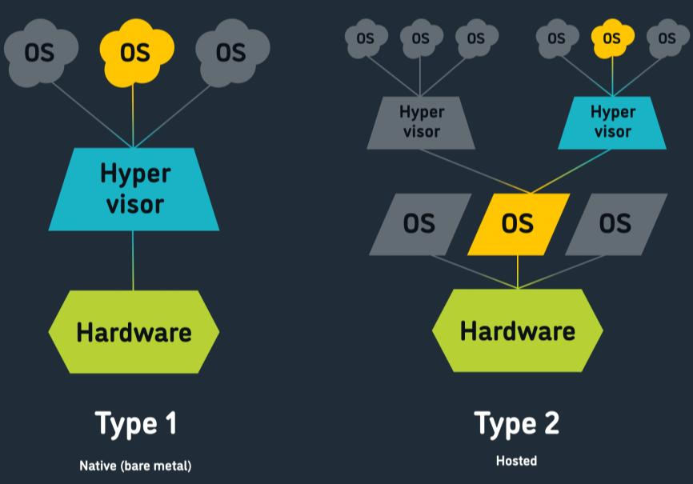
1. Performance
Type-1 hypervisors interact directly with the physical hardware, allowing efficient allocation of CPU, memory, storage, and networking resources. They are suitable for high-volume applications such as online banking, hospital management systems, and enterprise databases.
Type-2 hypervisors depend on a host operating system, which introduces an additional software layer. This may increase resource overhead and affect performance under heavy workloads.
Therefore, Type-1 hypervisors are generally preferable for mission-critical applications that require consistent performance.
2. Security
Type-1 hypervisors have a smaller general-purpose software stack between the virtual machines and the hardware. This can reduce the attack surface, although the hypervisor and its management interfaces must still be secured.
Type-2 hypervisors inherit security risks from the host operating system. If the host OS is compromised, the attacker may gain access to the hosted virtualization environment.
For sensitive applications, both types require security updates, access control, network isolation, and monitoring. However, a properly hardened Type-1 deployment is generally the stronger architectural choice for a production cloud datacenter.
3. Manageability
Type-1 hypervisors are designed for enterprise environments. They support centralized administration, automated provisioning, resource scheduling, monitoring, and live migration where supported.
Type-2 hypervisors are convenient for individual developers, testing environments, and educational purposes. Managing a large number of production VMs using desktop-oriented tools is less practical.
Justification
For example, consider a cloud provider hosting a hospital's patient records and an online banking application. These applications require continuous availability, secure data processing, and reliable resource allocation.
A Type-1 hypervisor can support enterprise monitoring, workload balancing, and high-availability configurations. If a physical host becomes overloaded, VMs may be migrated to another compatible host, provided the infrastructure supports this capability.
Conclusion
A Type-1 hypervisor is the better choice for a cloud datacenter hosting mission-critical applications because it offers efficient hardware resource management, enterprise-level administration, and a smaller general-purpose software stack. Type-2 hypervisors are more appropriate for development, testing, and desktop virtualization.

2. Workload Isolation for Finance, Healthcare, and Student Portals on Shared Hardware
Introduction
Cloud providers often host multiple customers or applications on the same physical server to improve resource utilization and reduce infrastructure costs. However, finance, healthcare, and student portal applications process different types of sensitive information.
Finance applications handle financial transactions, healthcare applications process patient information, and student portals maintain academic and personal records. Therefore, the provider must ensure that one workload cannot access another workload's data or resources without authorization.
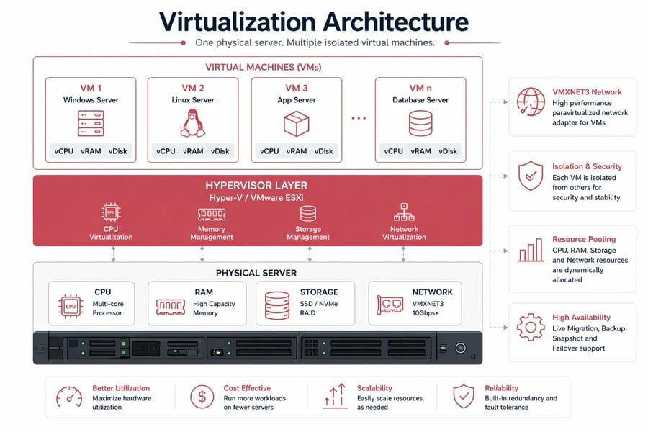
How Virtualization Architecture Supports Isolation
Virtualization divides a physical server into multiple virtual machines using a hypervisor. Each VM operates as an independent computing environment with its own operating system, applications, virtual disks, and network configuration.
Physical Hardware
CPU, RAM, storage and network interfaces
Type-1 Hypervisor
VM creation, resource allocation and isolation
Finance VM
Transactions
Private network
Healthcare VM
Patient records
Private network
Student VM
Academic records
Private network
Each workload receives separate logical resources and controlled access to shared physical infrastructure.
Isolation Mechanisms
1. Compute isolation
The hypervisor assigns virtual CPUs and memory to individual VMs. CPU scheduling and resource limits help prevent one workload from monopolizing the server. Memory isolation prevents a VM from directly reading another VM's memory through normal operation.
2. Storage isolation
Each VM can use separate virtual disks and storage volumes. Access-control policies and encryption prevent unauthorized applications from accessing confidential data.
For example, the student portal should not be able to read the database files belonging to the finance application.
3. Network isolation
Virtual LANs (VLANs), software-defined networks, firewalls, and security groups separate traffic between workloads. Only explicitly permitted communication should be allowed.
4. Identity and access isolation
Role-based access control (RBAC), multi-factor authentication (MFA), and least-privilege policies restrict users and administrators to authorized resources.
Two Major Attack Surfaces
Attack Surface 1: Hypervisor and VM escape vulnerabilities
The hypervisor manages the boundary between virtual machines and physical hardware. A vulnerability in this layer may allow a malicious VM to escape its isolation and access the host or other VMs.
For example, an attacker who compromises a VM running the student portal may attempt to exploit a hypervisor vulnerability to access the finance VM.

Mitigation measures:
- Apply regular hypervisor security patches.
- Use secure configurations and disable unnecessary services.
- Restrict administrative access to the hypervisor.
- Monitor suspicious VM and host activity.
- Separate highly sensitive workloads onto dedicated hosts when risk requirements justify it.
Attack Surface 2: Virtual networks and management interfaces
Misconfigured virtual networks, exposed management interfaces, weak credentials, or overly permissive firewall rules may allow attackers to intercept traffic or access unauthorized workloads.
For example, a firewall misconfiguration might permit the healthcare VM to communicate with the finance database even though that communication is unnecessary.
Mitigation measures:
- Implement network segmentation.
- Apply default-deny firewall rules and explicit allowlists.
- Protect management interfaces with MFA and restricted administrative networks.
- Encrypt network traffic and audit configuration changes.
Conclusion
Virtualization enables finance, healthcare, and student portal applications to share physical hardware while maintaining logical isolation. However, isolation is not automatic or absolute.
3. Analyze VM Host Utilization and Recommend Corrective Actions
Problem Statement
A cloud provider observes the following VM host utilization values:
Parameter | Observed value
CPU utilization | 92%
Memory utilization | 88%
Storage I/O latency | 35 ms
Average VM boot time | 170 seconds
The provider must identify the likely performance bottlenecks and recommend corrective actions.
Analysis of the Utilization Snapshot
1. CPU utilization — 92%
CPU utilization of 92% indicates that the host is operating close to its available processing capacity. During peak workloads, virtual machines may compete for CPU time.
Likely effects include:
- Slow application response.
- Delayed VM scheduling.
- Increased processing time.
- Longer VM startup time.
A high CPU value alone does not prove a CPU bottleneck, so CPU ready time, processor saturation, and workload patterns should also be examined.
Corrective actions:
- Identify VMs consuming excessive CPU resources.
- Migrate workloads to less-utilized hosts.
- Add CPU capacity or additional hosts if demand remains high.
- Right-size VM vCPU allocations.
- Use load balancing to distribute workloads.
2. Memory utilization — 88%
Memory utilization of 88% indicates limited free RAM. If the host cannot satisfy memory demands, it may use memory reclamation, ballooning, compression, or swapping, depending on the virtualization platform.
Excessive swapping can reduce performance significantly.
Likely effects include:
- Increased memory-access latency.
- Slower applications.
- Higher storage activity.
- Reduced capacity for starting additional VMs.
Corrective actions:
- Identify VMs with unnecessarily large memory allocations.
- Increase physical RAM if required.
- Migrate some VMs to hosts with available memory.
- Investigate swapping, ballooning, and memory pressure.
- Avoid excessive memory overcommitment for critical workloads.
3. Storage I/O latency — 35 ms
Storage I/O latency measures the time taken to complete a storage operation. A latency of 35 ms can be problematic for latency-sensitive databases and transactional workloads, although acceptable latency depends on the storage technology and application requirements.
Possible causes include:
- High disk I/O demand.
- Storage array or disk saturation.
- Excessive queue depth.
- Contention between VMs sharing the same storage.
- Slow underlying disks or network-storage delays.
Corrective actions:
- Measure read/write latency, IOPS, throughput, and queue depth.
- Identify VMs generating excessive I/O.
- Move latency-sensitive workloads to faster storage where appropriate.
- Distribute workloads across storage devices or volumes.
- Optimize storage configuration and eliminate unnecessary I/O.
4. Average VM boot time — 170 seconds
An average boot time of 170 seconds means that VM startup takes approximately 2 minutes and 50 seconds.
This may be caused by CPU contention, memory pressure, storage delays, operating-system startup services, or simultaneous boot requests.
The VM boot time should be compared with the provider's service-level target and historical baseline before deciding how severe the issue is.
Corrective actions:
- Measure boot time separately for virtual hardware initialization, disk activity, operating-system startup, and application initialization.
- Stagger mass VM startup operations.
- Improve storage performance.
- Remove unnecessary startup services.
- Preconfigure VM templates and optimize initialization scripts.
Priority-Based Corrective Action Plan
Priority | Action | Reason
1 | Investigate storage latency and memory pressure | Both can create major delays and affect many VMs
2 | Rebalance CPU and memory workloads | Reduce resource contention
3 | Optimize VM boot processes | Reduce startup delays
4 | Expand host or storage capacity if necessary | Provide sufficient long-term resources
5 | Configure continuous monitoring and alerts | Prevent recurring performance issues
Conclusion
The host is under substantial resource pressure, with CPU utilization at 92% and memory utilization at 88%. Storage latency of 35 ms may be contributing to slow VM startup, while operating-system initialization may also be involved.
The provider should first identify the actual bottlenecks using CPU scheduling, memory pressure, and storage performance metrics. Workload migration, resource right-sizing, storage optimization, and capacity expansion can then improve overall performance and reduce the average VM boot time.

4. Analyze How Software-Defined Datacenter Architecture Improves Agility
Introduction
A Software-Defined Datacenter (SDDC) is a datacenter architecture in which compute, storage, and networking resources are virtualized and managed through software. Automation and centralized control allow administrators to provision and modify resources without manually configuring every hardware component.
In a traditional datacenter, resources often depend on separate hardware systems and manual configuration procedures. This can slow deployment, scaling, and infrastructure changes.
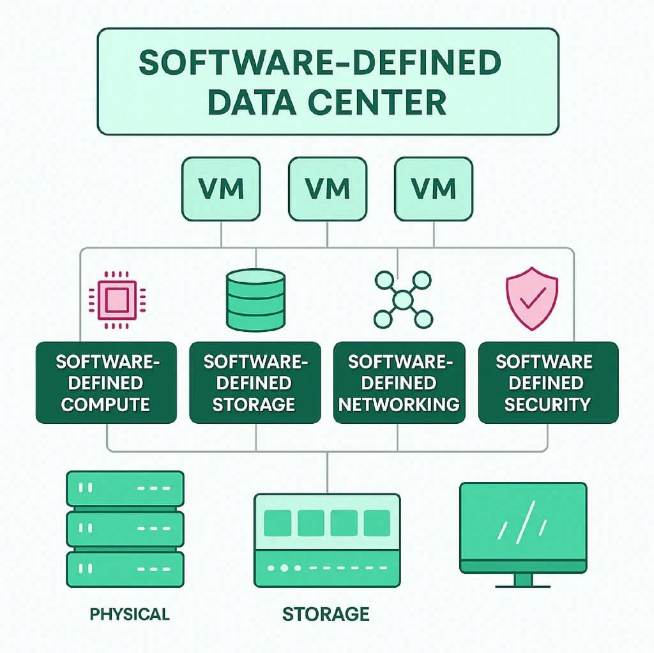
Traditional Datacenter vs SDDC
Feature | Traditional Datacenter | Software-Defined Datacenter
Compute management | Physical server provisioning | VM-based and software-controlled provisioning
Storage management | Separate storage devices and manual allocation | Pooled storage managed through software
Network management | Manual switch and router configuration | Programmable virtual networks
Deployment speed | Often slower | Faster through automation
Scalability | May require extensive manual configuration | Resources can be provisioned dynamically
Management | Multiple hardware-specific tools | Centralized management and orchestration
Flexibility | More dependent on fixed hardware configurations | Workloads can be reassigned more easily
How SDDC Improves Agility
1. Compute virtualization
Compute virtualization allows multiple VMs to run on physical servers. Administrators can create VMs from templates, change resource allocations, and move workloads between compatible hosts.
For example, an organization can deploy additional application VMs during periods of high demand rather than purchasing and configuring a separate physical server for every new instance.
Benefits:
- Faster server provisioning.
- Improved hardware utilization.
- Flexible workload placement.
- Easier workload recovery and migration.
2. Storage virtualization
Storage virtualization combines storage capacity from multiple physical devices into logical pools. Software-defined storage systems can allocate capacity according to workload needs and automate certain storage-management tasks.
For example, a database requiring high performance can be assigned to an appropriate high-performance storage tier, while archival data can use lower-cost storage.
Benefits:
- Flexible capacity allocation.
- Simplified storage administration.
- Better utilization of available capacity.
- Easier expansion and policy-based placement.
3. Network virtualization
Network virtualization creates logical networks independently of the underlying physical network topology. Software-defined networking (SDN) enables administrators to manage routing, traffic policies, segmentation, and connectivity through software.
For example, a newly deployed healthcare application can be placed in a dedicated virtual network with restricted access to patient records.
Benefits:
- Faster network provisioning.
- Automated security policies.
- Better workload isolation.
- Easier implementation of network changes.
4. Automation and orchestration
SDDC platforms can use automation tools to coordinate compute, storage, and network provisioning. Instead of configuring each component separately, administrators can deploy a complete application environment through predefined templates and policies.
This reduces manual work, configuration errors, and deployment time.
In an SDDC:
- Monitoring detects an increase in application demand.
- Automation provisions additional application instances.
- Storage resources are allocated according to policy.
- Virtual network rules are applied automatically.
- Load balancing distributes traffic among the available instances.
These operations depend on the capabilities and configuration of the SDDC platform, but they demonstrate how software control can accelerate infrastructure changes.
Conclusion
SDDC improves agility through compute virtualization, storage pooling, programmable networking, and automation. It enables faster provisioning, easier scaling, centralized management, and more consistent security policies. Compared with a traditional datacenter, it allows organizations to respond more quickly to changing business requirements while using infrastructure resources more efficiently.

5. Multi-Cloud Federation Failure Due to Identity Mismatches
Introduction
Multi-cloud federation allows organizations to use services from multiple cloud providers while enabling controlled access between their environments. Federation is particularly useful when an organization distributes applications and data across different cloud platforms.
However, a federation project may fail if the providers use incompatible identity systems, authentication protocols, user identifiers, or authorization policies.
Analysis of the Identity Mismatch Problem
Suppose an organization uses three cloud providers:
- Cloud A hosts financial applications.
- Cloud B hosts healthcare applications.
- Cloud C hosts student services.
A user authenticates successfully with Cloud A but cannot access an authorized resource in Cloud B because the providers interpret the user's identity or permissions differently.
Common causes include:
1. Different identity formats
One provider may identify users using an email address, while another uses a unique subject identifier or tenant-specific user ID. The same person may therefore appear as different identities.
2. Incompatible authentication protocols
Providers may use different authentication mechanisms. If the federation layer cannot exchange or validate identity assertions correctly, authentication fails.
3. Inconsistent authorization policies
A role such as Data Analyst may have different permissions across providers. Directly copying roles from one cloud to another may grant excessive privileges or deny legitimate access.
4. Incorrect trust configuration
Incorrect issuer identifiers, audience values, signing certificates, token expiry settings, or metadata configuration may cause the receiving provider to reject identity assertions.
Proposed Secure Identity and Privacy Design
A secure solution should use a trusted identity provider, standardized federation protocols, consistent identity mapping, and cloud-specific authorization policies.
User
Requests access to a cloud application
Trusted Identity Provider (IdP)
Authentication, MFA and identity verification
Federation Protocol
SAML 2.0 or OpenID Connect (OIDC)
Cloud A
Validate and authorize
Cloud B
Validate and authorize
Cloud C
Validate and authorize
Each cloud validates the trusted identity information and enforces its own permissions.
Step-by-Step Secure Design
Step 1: Establish a trusted identity provider
Use a centralized or otherwise trusted identity provider to authenticate users. The identity provider should support MFA, account lifecycle management, and secure authentication policies.
Centralized authentication does not require giving the identity provider unrestricted access to every cloud resource.
Step 2: Standardize federation protocols
Use established standards such as:
- SAML 2.0: Commonly used for exchanging authentication assertions between identity providers and enterprise applications.
- OpenID Connect (OIDC): Provides an identity layer over OAuth 2.0 and supports token-based authentication.
The selected protocol must be supported and correctly configured by the participating providers.
Step 3: Map identities consistently
Define a stable identity-mapping scheme that distinguishes users across tenants and providers. Map external identities to the appropriate local accounts or principals without relying solely on mutable attributes such as email addresses.
For example, the same authenticated user may be mapped to a restricted finance role in Cloud A and a read-only reporting role in Cloud B.
Step 4: Implement role-based access control
Each provider should map trusted identity attributes to its own local permissions. Apply least privilege so that authentication in one cloud does not automatically grant administrative access in another.
For example:
- Finance employees can access approved financial resources.
- Healthcare staff can access authorized patient records.
- Students can access their own academic information.
Step 5: Secure identity assertions and tokens
Validate token signatures, issuer, audience, expiry, and other required claims. Protect signing keys and certificates, use secure transport, and prevent token leakage or replay through appropriate protocol controls.
Step 6: Protect privacy
Share only the identity attributes required for the requested service. Avoid transferring unnecessary personal, financial, or medical information between providers.
Where possible, use pseudonymous identifiers and keep sensitive data within the cloud environment responsible for processing it.
Step 7: Monitor and audit federation activity
Record authentication events, permission changes, failed access attempts, and administrative actions. Establish procedures to revoke sessions and remove access when users leave the organization or change roles.
Conclusion
The multi-cloud federation project failed because the participating cloud providers could not consistently interpret and trust user identities and permissions. The solution is to implement a secure federation architecture using a trusted identity provider, SAML 2.0 or OIDC, stable identity mapping, role-based authorization, and privacy-preserving attribute sharing.
This design improves interoperability while maintaining security and privacy across all participating cloud environments.

