Heater Logic Module Description

 | Organisatie / Organization | Datum / Date
Auteur(s) / Author(s):
Eric Kooistra | ASTRON
Controle / Checked:
Andre Gunst | ASTRON
Goedkeuring / Approval:
Andre Gunst | ASTRON
Autorisatie / Authorisation:
Handtekening / Signature  Andre Gunst | ASTRON
© ASTRON 2008
All rights are reserved. Reproduction in whole or in part is
prohibited without written consent of the copyright owner.

Distribution list:

Group: | Others:
Andre Gunst (AG, ASTRON)  Daniel van der Schuur (DS, ASTRON)  Rajan Raj Thilak (RT, ASTRON)  Arpad Szomoru (JIVE)  Jonathan Hargreaves (JH, JIVE)  Salvatore Pirruccio (SP, JIVE) | Gijs Schoonderbeek (GS, ASTRON)  Sjouke Zwier (SZ, ASTRON)

Document history:

Revision | Date | Author | Modification / Change
0.1 | 2010-11-09 | Eric Kooistra | Creation.
0.2 | 2010-11-10 | Eric Kooistra | Improved the order of the sections.
0.3 | 2010-11-15 | Eric Kooistra | Added util_logic.
0.4 | 2010-11-30 | Eric Kooistra | Updated after review on Nov 25, 2010 with EK, DS, JH, SP.  Refer to ASTRON-RP-426 for basic node design features.
0.5 | 2010-12-01 | Eric Kooistra | Moved clock domain section to hardware interface chapter.  Used tables to list the files in the appendix.
1.0 | 2011-02-03 | Eric Kooistra | Added known issues section to fit the template.

Table of contents:

1 Introduction 5
1.1 Purpose 5
1.2 Module overview 5
2 Software interface 6
2.1 Operation 6
2.2 MM registers 6
2.2.1 Heater register 6
2.3 Software functions 7
3 Hardware interface 8
3.1 Clock domains 8
3.2 Parameters 8
3.3 MM interface 8
3.4 ST interface 9
3.5 Other interfaces 9
4 Application 10
4.1 SOPC design 10
4.2 Synthesis 10
4.2.1 Design 10
4.2.2 Module 11
4.3 Software main 11
4.4 Known issues 11
5 Design 12
5.1 Architecture 12
6 Implementation 13
6.1 Control 13
6.2 Heater element 13
7 Verification 14
7.1 Simulation 14
7.1.1 Test bench for the heater module 14
7.1.2 Test bench for the unb_base SOPC design with the heater module 14
7.2 Target hardware 14
8 Appendix: List of files 15
8.1 Firmware VHDL 15
8.1.1 Heater module 15
8.1.2 Heater example design 15
8.2 Software C, H 15
8.2.1 Module 15
8.2.2 Main 15
8.3 Simulation 16
8.4 Synthesis 16

Terminology:

DP Data Path
DSP Digital Signal Processing
DUT Device Under Test
FF Flip Flop (clocked or registered logic)
FIFO First In First Out
FPGA Field Programmable Gate Array
GUI Graphical User Interface
HDL Hardware Description Language
IO Input Output
IP Intellectual Property
LUT Look Up Table (combinatorial logic)
MAC Multiply and Accumulate
MAS Master
MISO Master In Slave Out
MM Memory-Mapped
MOSI Master Out Slave In
Nof Number of
PHY Physical layer
PIO Parallel IO
PRSG Pseudo Random Sequence Generator
RAM Random Access Memory
ROM Read Only Memory
RTL Register Transfer Level
SLA Slave
SISO Source In Sink Out
SOPC System On a Programmable Chip (Altera)
SOSI Source Out Sink In
ST Streaming
UNB Path to UniBoard Firmware directory
UTIL Utility
WDI Watchdog Interrupt

References:

- www.altera.com, stratix4_handbook.pdf
- www.altera.com, quartusii_handbook.pdf
- www.altera.com, mnl_avalon_spec.pdf
- https://svn.astron.nl/UniBoard_FP7/UniBoard/trunk, the UniBoard FP7 SVN repository, see below.
- “Common Library Memory and Register Component Descriptions”, ASTRON-RP-415, E. Kooistra
- “UNB_Common Module Description”, ASTRON-RP-426, Eric Kooistra

Relevant directories in the UniBoard FP7 SVN repository:

$UNB: Firmware/doc/howto/ → How to descriptions
$UNB: Firmware/modules/ → HDL modules
$UNB: Firmware/designs/ → FPGA HDL designs
$UNB: Firmware/software/modules/src/ → C, H modules
$UNB: Firmware/software/apps/ → C main applications

Introduction

Purpose
This document is a user guide and a description of the heater VHDL module.

The purpose of the heater module is to provide an easy way to use almost all of the internal resources on an FPGA; meaning logic, multipliers and RAM. The heater module has no functional purpose. Instead the heater module can be used to verify power consumption of the internal resources of the FPGA and to verify the performance of the FPGA IO like DDR3 access and transceiver links at higher temperatures.

Section 2 describes the software interface of the module and contains sufficient information for on chip microprocessor software development.

Section 3 describes the hardware interface of the module and contains sufficient information for using the module in an SOPC Builder system or for instantiating it manually in a VHDL design.

Section 4 describes an example application and contains sufficient information for synthesizing the module in a design and to run a software main() application.

The subsequent sections describe the VHDL design, implementation and verification of the heater module and its internal details. These sections contain sufficient information for maintaining the module.

Module overview
Figure 1 shows the interfaces of the heater module. On the application side the heater module is a MM slave with one register that allows dynamically control of switching more or less of the internal resources on or off. The streaming interface only consists of a ST clock and reset input that are used to clock and reset the internal streaming resources. The used internal resources are logic (LUTs and FFs), DSP multipliers (*) and block RAM. The heater module has no streaming data IO, because it implements a dummy function.

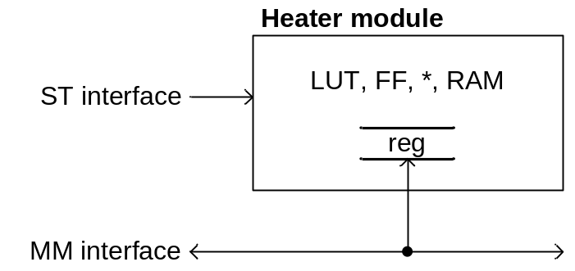
Figure 1: Heater module interfaces

Software interface

Operation
The heater module is a MM slave with only one MM register and no interrupt. The heater module consists of a number of identical elements. The total amount of available elements in an instance of the heater module is fixed and defined by g_nof_mac4 in the HDL. At run time the clock enable for each element can be set on or off via a bit in the MM heater register. When the clock enable is on then the corresponding element runs on the ST clock and dissipates power. When the clock enable is switched off then the corresponding element does not change state so then it dissipates almost no power.

MM registers
The Nios II architecture is little endian. Words and half words are stored in memory with the more-significant bytes at higher addresses. Bit 31 indicates the MSBit and bit 0 indicates the LSBit of a word. The heater module MM interface has to be accessed per word. Access per byte is not supported. The heater register is little endian. Table 1 lists the registers (only one) that are available in the heater module.

Name | Address  (words) | Size  (words) | Read/  Write | Description
Heater | 0 | 16 | RW | Enable heater elements
Table 1: Heater module registers

Heater register
Table 2 defines the bits in the heater register for a maximum of 352 mac4 elements. The maximum number of effective bits is equal to g_nof_mac4. The remaining bits and words in the heater register are empty. Setting a bit to ‘1’ enables the element and setting it to ‘0’ disables the element. Reading a bit yields a varying and undefined result when the element is enabled and a stable result when the element is disabled.

Offset (bytes) | Bits 31:0
0 | HEATER_ELEMENT_EN[31:0]
4 | HEATER_ELEMENT_EN[63:32]
8 | HEATER_ELEMENT_EN[95:64]
12 | HEATER_ELEMENT_EN[127:96]
16 | HEATER_ELEMENT_EN[159:128]
20 | HEATER_ELEMENT_EN[191:160]
24 | HEATER_ELEMENT_EN[223:192]
28 | HEATER_ELEMENT_EN[255:224]
32 | HEATER_ELEMENT_EN[287:256]
36 | HEATER_ELEMENT_EN[319:288]
40 | HEATER_ELEMENT_EN[351:320]
44 | -
48 | -
52 | -
56 | -
60 | -
Table 2: Heater register (g_nof_mac4 = 352)

Each mac4 element uses 4 18x18 multipliers. The Stratix IV GX230 has 1288 18x18 multipliers, so in total it can fit maximally 322 mac4 elements. For the heater register this implies the maximum that can be used for g_nof_mac4 = 322 and that the register bits [351:322] are then void. The heater register has 352/32 = 11 words. This implies that the register address width is 4 bit and that the words at [15:11] do not exist.

Software functions
The heater module software consists of avs_util_heater.c/h and avs_util_heater_regs.h and provides a public function to control the heater peripheral. Table 3 lists the software functions that are available for controlling the heater peripheral.

Function | Description
UTIL_HEATER_Control() | Specify the number of heater elements that need to be switched on. Specifying 0 causes all elements to be switched off. Switching on a specific element is not supported, because all elements are equivalent.
Table 3: Heater functions in the avs_util_heater.c/h software module

Hardware interface

Clock domains
Figure 2 shows the two clock domains that are used by the heater module:

- mm_clk = MM clock for the memory-mapped bus with the NIOS II processor
- st_clk = ST clock for the heater module elements

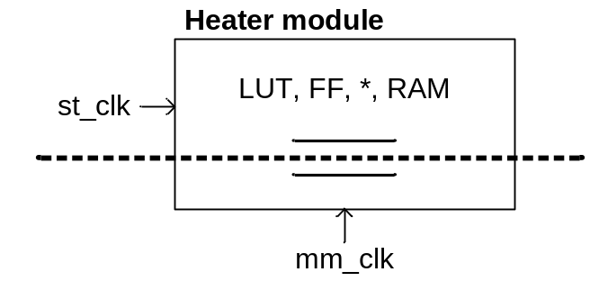
Figure 2: Clock domains of the heater module

Parameters

Table 4 lists the VHDL generics that can be when the heater module is instantiated in another HDL design or in an SOPC system.

Generic | Type | Description
g_nof_mac4 | NATURAL | >= 1, number of multiply 18x18 and accumulate 4 elements in the heater <= c_util_heater_nof_mac4_max = 352. Use this to define the number of heater elements in the heater instance.
g_pipeline | NATURAL | >= 0, number of pipelining register stages. Use this to define the amount of logic (FFs or RAM dependent on the synthesis) that is used per heater element.
g_nof_ram | NATURAL | >= 0, number of 1 kByte RAM blocks. Use this to define the amount of RAM that is used per heater element
g_nof_logic | NATURAL | >= 0, number of logic register stages. Use this to define the amount of logic (LUTs and FFs) that is used per heater element.
Table 4: Heater module parameters

The Stratix4 GX230 PFGA has 1288 multipliers, so it can fit maximum g_nof_mac4 = 322. The maximum values for RAM and logic also depend on the size of the FPGA.

MM interface
Table 5 defines the clock and reset for the MM interface.

Signal | Type | Description
mm_clk | CLOCK | Clock input for the MM interface side of the heater module
mm_rst | RESET | Reset input for the MM interface side of the heater module
Table 5: Heater MM interface clock and reset

Table 6 defines the interface signals for the heater MM slave register of Table 2.

Signal | Type | Description
sla_out.rddata[31:0] | MISO | Read data word, valid 1 clock cycle after rd
sla_in.address[3:0] | MOSI | Word address range to fit the module registers of Table 1
sla_in.wrdata[31:0] | MOSI | Write data word, must be valid with wr
sla_in.wr | MOSI | Write strobe
sla_in.rd | MOSI | Read strobe
Table 6: Heater MM register interface

In an SOPC system the MM interface signals from Table 5 and Table 6 get connected automatically.

ST interface
Table 5 defines the clock and reset for the ST interface.

Signal | Type | Description
st_clk | CLOCK | Clock input for the ST interface side of the heater module
st_rst | RESET | Reset input for the ST interface side of the heater module
Table 7: Heater ST interface clock and reset

The ST interface clock and reset are used for running the heater elements. The ST interface of the heater does not source or sink external data.

In an SOPC system the ST interface signals from Table 7 can be connected to an internal clock (e.g. from a PLL in the SOPC system) or via conduit [3] input pins.

Other interfaces
The heater module has no other interfaces than MM or ST.

Application

SOPC design
Thanks to a VHDL wrapper component and a hardware description TCL file, see Appendix 8, the heater module is also available within SOPC Builder [2]. Figure 3 shows the heater module called avs_util_heater in an SOPC system. From the SOPC Builder GUI it is possible to set the heater module parameters that were described in section 3.2.

The example sopc_base SOPC system is instantiated in the unb_base.vhd node design. For more information on instantiating an SOPC system in a UniBoard node design see [6].

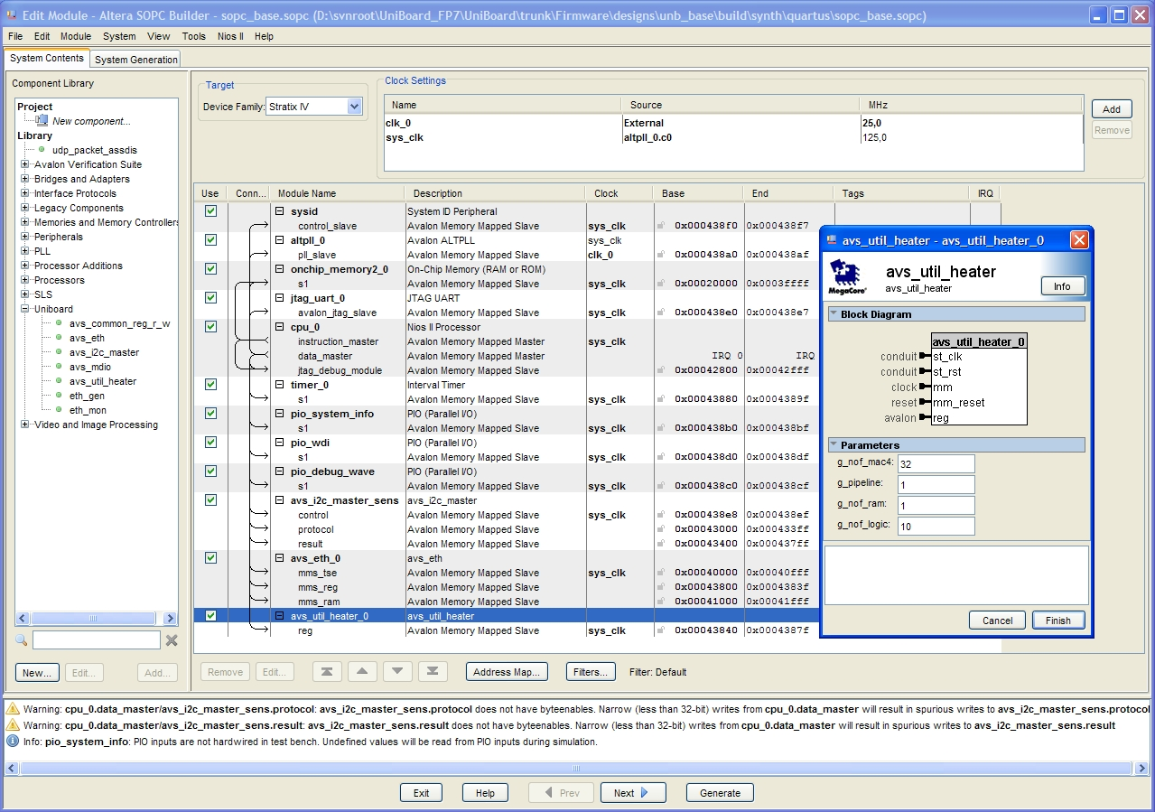
Figure 3: SOPC Builder system sopc_base with the heater module

Synthesis

Design
The example unb_base design with the sopc_base SOPC system including the heater can run on all of the 8 FPGA nodes of the UniBoard. Appendix 8 list the Quartus II project and settings files for synthesizing the unb_base design.

Module
There is also a Quartus II project for synthesizing the avs_util_heater.vhd without pin assignments. This is useful to quickly verify the effect of the generics on the synthesis result.

Software main
The sopc_base SOPC Builder system of Figure 3 also contains a Nios II microprocessor. Therefore the software that runs on the Nios II determines how the unb_base example design behaves. The unb_base_heater/main() example from Appendix 8 can run on the design. Other software can also run on the design, it is not necessary to synthesize the logic again when the software has changed. The compiled software image is loaded into the on chip memory component that is connected to the Nios II in Figure 3.

Known issues
There are no known issues with the heater module.

Design

Architecture
Figure 4 shows the block diagram of the heater module. Each MAC4 heater element contains 4 multipliers that get their input from a set of PRSG sources. The output of the heater element is narrowed down to a single bit signal that can be read via the MM register. Using the output ensures that the heater element will not get optimized away by synthesis.
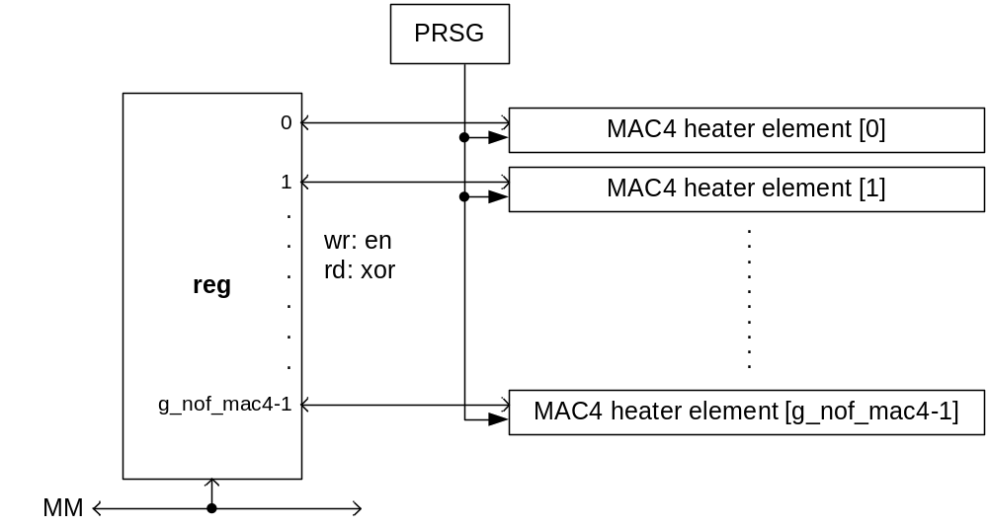
Figure 4: Top level block diagram of the heater module

Implementation

Control
The control register in Figure 4 uses the common_reg_r_w.vhd component from the $UNB common library [4].

The enable bits written to the control register are put across the mm_clk domain to the st_clk domain shown in Figure 2 by passing each bit via a common_async.vhd synchronization component. Similar the corresponding XOR bits that can be read via the control register are put across from the st_clk domain to the mm_clk domain via a common_async.vhd synchronization component. It is not necessary to use common_reg_cross_domain.vhd, see [5], because the register bits are used independently (i.e. not interpreted as numbers > 1).

Heater element
Figure 5 shows the block diagram of a heater element as used in Figure 4. The MAC4 uses 4 18x18 multipliers, the pipeline uses flip flops (or RAM blocks), the FIFO uses RAM blocks and the logic uses LUTs and flip flops, so together with the number of heater elements this allows the heater module to use an arbitrary mix of internal FPGA resources. The configuration is done via generics as defined in Table 4.

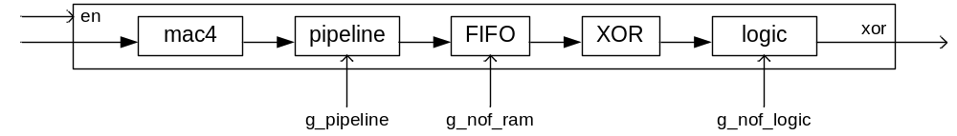
Figure 5: Block diagram of the heater element

The MAC4 block uses the RTL implementation of common_mult_add4.vhd. The generics for the common_mult_add4 are set such that the MAC4 maps efficiently on the Stratix IV DSP blocks [1]. The pipeline block uses the common_pipeline.vhd. For larger g_pipeline settings the synthesis tool may implement this logic in RAM blocks. The FIFO block uses the common_fifo_sc.vhd, Typically g_nof_ram should be a power of 2, possibly because of the internal (Gray-encoded) addressing in the FIFO. The logic block uses util_logic.vhd. The difference between common_pipeline and util_logic is that in util_logic each register stage input is the XOR of its own feed back output and the output from the preceding register stage. This is necessary to avoid that the synthesis tool may implement the logic in RAM blocks. The final XOR is used to reduce the multi-bit vector signal into a single bit element output signal and is available as a function in the common(pkg).vhd. The common components come from the common library [4].

Verification

Simulation

Test bench for the heater module
The tb_util_heater is a VHDL test bench to verify the util_heater module in Modelsim. The test bench uses the procedures listed in Table 8 to more easily access the MM register in the heater module.

Item | Description
proc_mm_access() | Used by proc_util_heater_wr() and proc_util_heater_rd() to do the low level control for a write or a read access.
proc_util_heater_wr() | Write a word to an address in the heater register.
proc_util_heater_rd() | Read a word from an address in the heater register.
Table 8: Heater register access procedures

The p_mm_stimuli process in the VHDL test bench of Figure 6 uses the procedures from Table 8 to access the MM register in the heater module. The test bench is not self checking. The proper behaviour of the internal heater elements needs to be observed in the Modelsim Wave window.

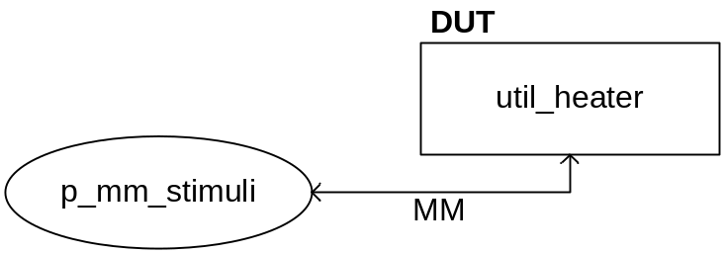
Figure 6: Architecture of tb_util_heater to verify the heater module

Test bench for the unb_base SOPC design with the heater module
By running the unb_base_heater/main.c program from Appendix 8 on the Nios II it is possible to run a design with the heater module as Nios II peripheral in simulation. This main() program calls the heater control function from Table 3 to switch the heater elements on or off at regular intervals. The VHDL test bench tb_unb_base can be used to verify the unb_base design in simulation, see [6] for more information.

Target hardware
By enabling more or less heater elements in a design that runs on the 8 FPGAs of the UniBoard it is possible to verify the power consumption for different loads. By changing the ST clock frequency (≤ the maximum clock frequency constraint that was set for synthesis, see Appendix 8) it is possible to verify the power consumption in relation to the clock frequency.

The power consumption can be derived from the voltage and current readings of the 48 V power supply or by reading the measurements from the I²C hot swap controller sensor via UniBoard back node 3.

Appendix: List of files

Not all files for the heater module and the unb_base example design in the SVN repository [4] are listed in this section, only the top level files, packages, test benches and the project files. For more general information on how to use the files see [6].

Firmware VHDL

Heater module
The heater module hardware files are kept at: $UNB/Firmware/modules/util

File | Description
util_heater.vhd | Heater module implementation of Figure 4 and Figure 5
tb_util_heater.vhd | Test bench of Figure 6 to verify the heater module in the Modelsim Wave window
avs_util_heater.vhd | Heater module wrapper for standard Avalon Interface IO [3].
avs_util_heater_hw.tcl | Hardware description file to make the module available in SOPC builder
Table 9: Source files for the heater module

Heater example design
The unb_base design serves as example design for the heater module and is kept at:

$UNB/Firmware/designs/unb_base/

File | Description
sopc_base.sopc | SOPC Builder system of Figure 3
unb_base.vhd | Example SOPC design with the heater module
tb_unb_base.vhd | VHDL test bench for unb_base.vhd.
Table 10: Source files for the unb_base example design that uses the heater module

Software C, H

Module
The heater module software files are kept at: $UNB/Firmware/software/modules/src

File | Description
avs_util_heater_regs.h | Constants and macros to MM access the heater module.
avs_util_heater.h | Public functions to control the heater module.
avs_util_heater.c | Implements for avs_util_heater.h
Table 11: Module software C, H files

Main
The heater module software main files are kept at: $UNB/Firmware/software/apps

File | Description
unb_base_heater/main.c | Enable or disable the heater elements.
Table 12: Application software main C files

Simulation
The simulation project files are located in:

$UNB/Firmware/modules/util/build/sim/modelsim/ → for heater module util_lib library.
$UNB/Firmware/designs/unb_base/build/synth/quartus/sopc_base_sim/ → for the unb_base design.

File | Description
util.mpf | Modelsim project file that builds the util_lib module library and provides the simulation configurations for the heater module test benches of Table 9.
unb_base.mpf | Modelsim project file for the unb_base design. Builds the unb_base work library and provides the simulation configurations for the test bench.
Table 13: Simulation project files

Synthesis
The synthesis files are kept at:

$UNB/Firmware/modules/util/build/synth/quartus → for heater module.
$UNB/Firmware/designs/unb_base/build/synth/quartus/ → for the unb_base design.

File | Description
avs_util_heater.qpf, qsf | Quartus II Project and Settings File for avs_util_heater.
unb_base.qpf, qsf | Quartus II Project and Settings File for unb_base
Table 14: Synthesis project and settings files

