1Gb Ethernet Module Description

 | Organisatie / Organization | Datum / Date
Auteur(s) / Author(s):
Eric Kooistra | ASTRON
Controle / Checked:
Andre Gunst | ASTRON
Goedkeuring / Approval:
Andre Gunst | ASTRON
Autorisatie / Authorisation:
Handtekening / Signature | ASTRON
© ASTRON 2010
All rights are reserved. Reproduction in whole or in part is
prohibited without written consent of the copyright owner.

Distribution list:

Group: | Others:
Andre Gunst (AG, ASTRON)  Eric Kooistra (EK, ASTRON)  Daniel van der Schuur (DS, ASTRON)  Arpad Szomoru (AS, JIVE)  Harro Verkouter (HV, JIVE)  Jonathan Hargreaves (JH, JIVE)  Salvatore Pirruccio (SP, JIVE) | Gijs Schoonderbeek (GS, ASTRON)  Sjouke Zwier (SZ, ASTRON)

Document history:

Revision | Date | Author | Modification / Change
0.1 | 2010-07-14 | Eric Kooistra | Draft in progress.
0.2 | 2010-09-10 | Eric Kooistra | Draft in progress.
0.3 | 2010-09-22 | Eric Kooistra | Added SW view of HW control state machine.
0.4 | 2010-09-28 | Eric Kooistra | Described Tx IP header checksum support.  Added section on ETH module memory usage.
0.5 | 2010-10-01 | Eric Kooistra | Use continue reg wr access instead on control reg wr.
0.6 | 2010-11-03 | Eric Kooistra | Separate interface section into SW section and HW section.  Force DST MAC to this node MAC for Tx response header.  Changed Rx, Tx packet register to big endian.  Made VHDL implementation more basic, e.g. showing more clearly how eth_hdr is reused.
0.7 | 2010-12-01 | Eric Kooistra | Reordered sections to avoid forward references.  Added sections on software functions and module generics.
1.0 | 2010-02-02 | Eric Kooistra | Updated after review on Dec 8, 2010 with EK, DS, JH, SP.  Corrected PCS control by keeping auto negotiate enabled.

Table of contents:
1 Introduction 7
1.1 Purpose 7
1.2 Module overview 7
1.2.1 Compatibility with 10GbE 8
2 Software interface 9
2.1 Node control operation 9
2.1.1 Multiple hosts 9
2.1.2 Frame support 9
2.2 HW – SW interaction 9
2.2.1 MM ETH interrupt 11
2.2.2 Status polling 11
2.2.3 Endianess 11
2.3 MM ETH registers 11
2.3.1 Demux 11
2.3.2 Config 12
2.3.3 Control 12
2.3.4 Frame 13
2.3.5 Status 13
2.3.6 Continue 14
2.4 MM ETH packet buffer 14
2.4.1 Packet length 14
2.4.2 Response Tx header support 15
2.5 MM TSE IP registers and settings 15
2.6 Software functions 15
3 Hardware interface 16
3.1 Clock domains 16
3.2 Parameters 16
3.3 MM interface 16
3.4 ST interface 17
3.5 PHY interface 17
4 Application 18
4.1 SOPC design 18
4.2 Synthesis 19
4.3 Software main 19
4.4 Known issues 19
5 Design 20
5.1 Architecture 20
5.2 Packet buffering 20
6 Implementation 22
6.1 TSE IP wrapper 22
6.2 Header handling 22
6.3 CRC handling 23
6.4 UDP off-load 23
6.5 Rx buffer 23
6.6 Control 24
6.7 MM registers 24
6.8 MM packet buffer 25
7 Verification 26
7.1 Simulation 26
7.1.1 Test bench for TSE IP 26
7.1.2 Test bench for ETH module 27
7.1.3 Test benches for a UniBoard SOPC design with ETH module 27
7.2 Target hardware 28
8 Appendix: Ethernet protocols 29
8.1 Ethernet frame 29
8.2 IPv4 header 29
8.3 ARP header 29
8.4 ICMP header 30
8.5 UDP header 30
9 Appendix: TSE IP 31
9.1 Generics 31
9.2 PCS control registers 31
9.3 MAC control registers 32
9.3.1 COMMAND_CONFIG register bits 32
9.3.2 FIFO control 33
10 Appendix: List of files 34
10.1 Firmware VHDL 34
10.1.1 TSE IP 34
10.1.2 ETH module 34
10.1.3 UNB_TSE design 35
10.2 Software C, H 35
10.2.1 Module 35
10.2.2 Main 35
10.3 Simulation 36
10.4 Synthesis 36

References:

- www.altera.com, “Triple Speed Ethernet MegaCore, Function User Guide”, ug_ethernet.pdf
- www.altera.com, “Avalon Interface Specifications”, mnl_avalon_spec.pdf
- http://en.wikipedia.org
- https://svn.astron.nl/UniBoard_FP7/UniBoard/trunk, the UniBoard FP7 SVN repository ($UNB)
- “Specification for module interfaces using VHDL records”, ASTRON-RP-380, Eric Kooistra
- “DP Streaming Module Description (The ready signal of the streaming interface)”, ASTRON-RP-382, Eric Kooistra
- “Common Library Memory and Register Component Descriptions”, ASTRON-RP-415, Eric Kooistra
- “UNB_Common Module Description”, ASTRON-RP-426, Eric Kooistra

Terminology:

ARP Address Resolution Protocol (to link an IP address to a MAC address)
AVS Avalon interface Slave (Avalon slave wrapper of a MM slave peripheral)
CRC Cyclic Redundancy Check
DHCP Dynamic Host Configuration Protocol (for IP address assignment)
DMA Direct Memory Access
DP Data Path
DSP Digital Signal Processing
DST Destination
DUT Device Under Test
eof End Of Frame
eop End Of Packet
err Error signal
FIFO First In First Out
Firmware Digital logic
FPGA Field Programmable Gate Array
GbE Gigabit Ethernet
GMII Gigabit MII
GUI Graphical User Interface
HDL Hardware Description Language
HW Hardware
ICMP Internet Control Message Protocol (for ping)
ISR Interrupt Service Routine
HDL Hardware Description Language (typically VHDL or Verilog)
IC Intergrated Circuit
I/O Input/Output
IP Internet Protocol, Intellectual Property
ISR Interrupt Service Routine
LLC Logical Link Control
LOFAR Low Frequency Array
LS Least Significant
LVDS Low-Voltage Differential Signaling
M9K Altera RAM block unit of size 1 kByte
MAC Media Access Control
MDIO Management Data Input/Output
MII Media Independent Interface
MISO Master In Slave Out
MM Memory Mapped interface (part of Altera Avalon interface)
MMS MM Slave
MOSI Master Out Slave In
MS Most Significant
Nof Number of
OSI Open System Interconnection
PCS Physical Coding Sub-layer
PHY Physical layer (PMA and PCS)
PMA Physical Medium Attachment
RO Read Only
RTL Register Transfer Level
RW Read Write
SDC Synopsys Design Constraint
SHA Sender Hardware Address
SGMII Serial GMII
SISO Source In Sink Out
SPA Sender Protocol Address
SRC Source
SFD Start of Frame Delimiter
sof Start Of Frame
Software Software embedded on the Nios II microprocessor or on software on a PC host
sop Start Of Packet
SOPC System On a Programmable Chip (Altera firmware system builder tool)
SOSI Source Out Sink In
ST Streaming interface (part Altera Avalon interface)
SW Software
TBD To Be Done/Decided
THA Target Hardware Address
TPA Target Protocol Address
TSE Triple Speed Ethernet (Altera GbE interface IP)
UDP User Datagram Protocol
UNB https://svn.astron.nl/UniBoard_FP7/UniBoard/trunk
VHDL Very High Speed IC HDL
WDI Watchdog Interrupt

Introduction

Purpose
This document is a user guide and a description of the 1 Giga bit per second Ethernet (ETH) module [3].

The ETH module connects the 1GbE port of an FPGA node to an on chip microprocessor soft core. The ETH module is intended for the UniBoard using Stratix IV FPGA, Nios II soft core microprocessor and the Triple Speed Ethernet (TSE) MAC IP from Altera. However the module architecture is generic so it can easily be adapted to fit other Ethernet MAC IP.

Section 2 describes the software interface of the ETH module and contains sufficient information for on chip microprocessor software development. The subsequent sections describe the hardware interface, application, design, implementation and verification of the ETH module and its internal details.

Module overview
Figure 1 shows the interfaces of the ETH module. On the line side the ETH module uses the TSE IP from Altera [1] to receive and transmit Ethernet packets to and from the PHY interface. On the application side the ETH module provides a memory mapped (MM) slave interface to receive and transmit control packets and an UDP streaming (ST) interface for direct data path access. The MM interface also serves to set up the TSE IP registers and the registers of the ETH module. On the UniBoard the MM master is typically the Nios II soft core microprocessor.

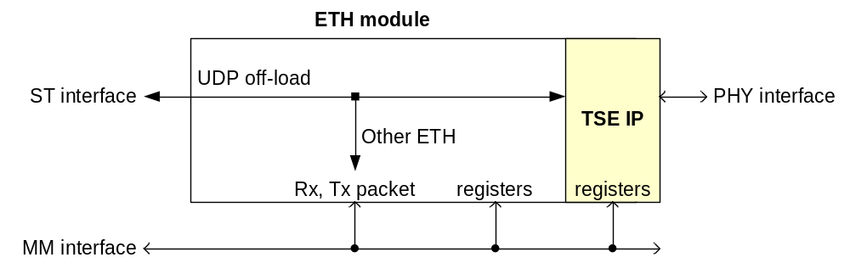
Figure 1: ETH module interfaces

The purpose of the ETH module is to present the received frames to the microprocessor and to transmit frames when enabled to do so by the microprocessor. Typically the main task of a soft core microprocessor in a UniBoard FPGA node is to handle Ethernet packets from the control computer. The real time processing performance of a soft core microprocessor is limited though. Therefore the ETH module offers several features to minimize the processing load for the microprocessor:

- Off-load UDP packets for direct data path access
- Buffer the other ETH packets via an input FIFO while the microprocessor is busy
- Provide status information on the received packet
- Prepare the header of the response packet
- Calculate the IP header checksum for received and transmitted IP packets

Compatibility with 10GbE
The architecture of this 1GbE ETH module also suits 10GbE, because the Ethernet protocol is independent of the speed. However there is at least one issue, because the 1Gb ETH module internally works with 32 bit words @ 125 MHz whereas the 10GbE MAC uses 64 bit long words @ 156.25 MHz. Furthermore for 10GbE the UDP off-load port would be the main usage. The micro processor interface would only need to be used to handle ping and ARP, DHCP to set up the UDP/IP link.

Software interface

Node control operation
All received packets that are not for the streaming UDP off-load ports will be presented to the microprocessor via the Rx packet register. The control computer communicates with a node via UDP/IP using IPv4. The control computer sends a request and then the node sends a response. The microprocessor in the node interprets the packet header and handles the packet payload. For light control tasks like reporting status on temperature and voltages the payload can be handled entirely in software. For heavy control tasks like setting a block of data path coefficients or reporting data path statistics the software typically sets up a DMA transfer between the packet register and the addressed data path component. The DMA component is not part of the ETH module, but could easily be added in an SOPC builder design. The microprocessor then instructs the DMA component to do the data transfer between the addressed data component and the Rx or Tx packet payload. Alternatively for streaming data path IO the ETH module can be set up with one or more dedicated UDP ports to off-load these packets completely from the microprocessor.

Multiple hosts
With the default Rx-Tx, request-response operation the control computer will typically not send the next request packet until it has received a response from the node. However the node must have sufficient packet buffer memory to cope with multiple Rx frames because it is connected to a network and because it can have multiple PC hosts. Via the network broadcast messages will also appear at the node. Using more than one host can be useful to have one PC host to control the node and use another PC host to monitor some node status.

Frame support
The ETH module firmware provides extra support for ARP, IP, ICMP, UDP and DHCP frames, see Appendix 8 for their packet structure [3]. ARP is used for informing routers about what MAC address belongs to what IP address. IP is the Internet Protocol for communicating packets across a network. ICMP/IP is used for ping. UDP/IP is used for node control and for data path UDP off-load ports. DHCP/UDP/IP is used for dynamic IP address assignment.

The ETH module prepares the header of the response Tx frame based on the header of the Rx frame. The Tx frame payload is undefined. The last header details and the payload of the Tx frame need to be filled in by software on the microprocessor. For IP the ETH module calculates the IP header checksum.

HW – SW interaction
Figure 2 shows the control state machine of the ETH module from a software point of view. The state machine is a Mealy-type state machine. For example, the state machine goes from state RECEIVE to state PENDING when done is active (i.e. NOT busy) and then it sets RX_AVAIL to 1 and issues the IRQ. Else when busy is active, then the state machine remains in state RECEIVE. A reset causes the state machine to start in state IDLE.
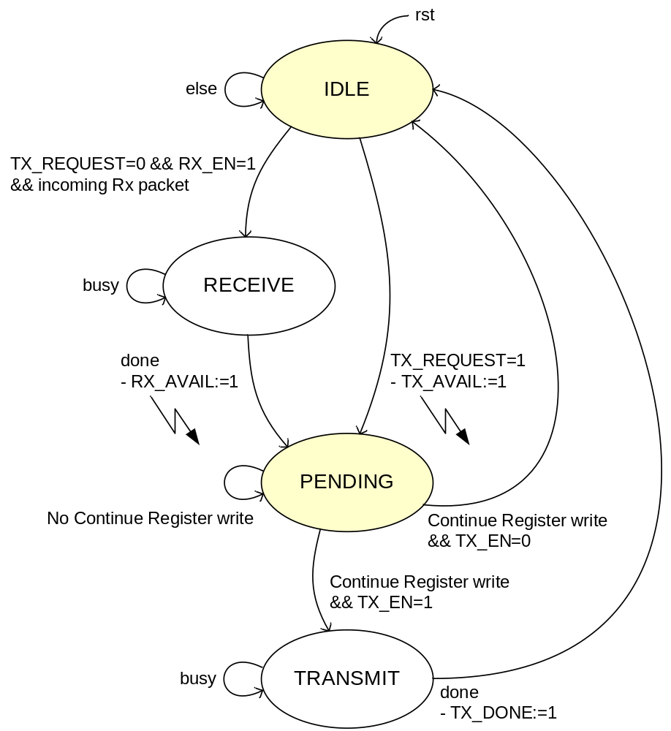
Figure 2: Software view of the ETH control state machine

The ETH module has two modes:

- Rx-Tx operation
- Tx insert

The ETH module does not start a transmission by itself. Therefore it interrupts the microprocessor when a new frame is available in the Rx buffer or to acknowledge a transmit insert request. There can only be one interrupt cause at a time and the SW can find out which by reading the status register. To let the HW continue the SW needs to write the continue register. Typically the HW will then transmit the frame, but it is also allowed to continue without transmit.

It is allowed to operate the ETH module in separate Rx and Tx operation, meaning that the software can receive multiple packets before it sends their response packets. This requires that the Rx packet buffer is copied to processor memory and implies that the Tx frame header response support can not be used directly. A frame transmit is then always issued via a transmit insert request.

MM ETH interrupt
The ETH module issues an interrupt when RX_AVAIL or TX_AVAIL in the status register is ‘1’. The ETH module removes the interrupt when the microprocessor does a (dummy) write access to the status register. As a minimum an ETH interrupt service routine (ISR) should read the status register and then write the status register to acknowledge the interrupt request (IRQ). Before returning the ISR must keep on reading the status register until it is zero, to ensure that the ETH module has removed the IRQ.

The ETH module software (Appendix 10.2) provides an ISR that reads the status register and clears the ETH interrupt. The read data is available via an ISR function argument for further processing in a task. In this way the ISR is as short as possible. Thanks to the handshake handling of Figure 2 the SW and HW remain in phase without the need to (temporarily) disable the interrupts.

Status polling
Status register polling instead of using interrupts is not preferred, but it is allowed. Status register polling can also be useful to monitor TX_DONE. When polling is used in combination with interrupts care must be taken that the ETH control state machine remains in a known state, because otherwise the polling loop could cause the SW to hang. This could happen for example when the ISR clears the status register after a new receive, because RX_EN was set too soon, while the task with the polling loop has not yet seen TX_DONE active from the previous transmit.

Endianess
The Nios II architecture is little endian. Words and half words are stored in memory with the more-significant bytes at higher addresses. Bit 31 indicates the MSBit and bit 0 indicates the LSBit of a word.

The ETH module MM interface has to be accessed per word. Access per byte is not supported. The ETH registers are little endian. The TSE IP registers are little endian, except for the MAC_0,1 register which are big endian. The Rx and Tx packet register is big endian to suit the network order.

MM ETH registers
Table 1 lists the MM registers that are available in the ETH module. The number of demux ports for UDP off-load streams is 2, but can be changed by regenerating the ETH module.

Name | Address  (words) | Size  (words) | Read/  Write | Description
Demux | 0 | 2 | RW | UDP demux ports
Config | 2 = nof UDP ports + 0 | 4 | RW | ETH module configuration
Control | 6 = nof UDP ports + 4 | 1 | RW | Rx control and Tx control
Frame | 7 = nof UDP ports + 5 | 1 | R | Rx packet information
Status | 8 = nof UDP ports + 6 | 1 | R | Rx status and Tx status
Continue | 9 = nof UDP ports + 7 | 1 | W | ETH module continue
Table 1: ETH module registers

Demux
The demux register defines 2 UDP ports for data path off-load streams, see Table 2. The UDP_PORT_# bits are defined in Table 3.

Offset (words) | Bits 31:0
0 | UDP_PORT_0
1 | UDP_PORT_1
Table 2: Demux register

Bits | Field name | Description
[31:17] | RSVD | -
[16] | UDP_PORT_EN | When ‘1’ then the UDP port is enabled to off-load traffic else not used
[15:0] | UDP_PORT_NR | If a received frame matches an enabled UDP port number then it is passed on to that the ST UDP off-load interface. Otherwise the received frame is kept inside the ETH module and passed on for further analysis.
Table 3: Demux register bits for UDP off-load port control

Config
The config register defines the Ethernet MAC and IPv4 addresses of this node and the UDP port number for node control, see Table 4.

Offset (words) | Bits 31:0
2 | MAC_ADDRESS_LO
3 | MAC_ADDRESS_HI
4 | IP_ADDRESS
5 | UDP_CTRL_PORT
Table 4: Config register
The MAC_ADDRESS_LO and MAC_ADDRESS_HI fields are defined in Table 5.

MAC word | Node MAC address bits
MAC_ADDRESS_LO[31:0] | MAC_ADDRESS[31:0]
MAC_ADDRESS_HI[15:0] | MAC_ADDRESS[47:32]
MAC_ADDRESS_HI[31:16] | RSVD
Table 5: MAC address definition
For example MAC_ADDRESS [47:0] = 0x123456789ABC corresponds to MAC address 12-34-56-78-9A-BC. For example IP_ADDRESS[31:0] = 0x05060708 corresponds to IP address 5:6:7:8.

The UDP_CTRL_PORT bits are defined in Table 6.

Bits | Field name | Description
[31:16] | RSVD | -
[15:0] | UDP_CTRL_PORT | Defines the UDP port number that is used for node control. Only used to report IS_UDP_CTRL_PORT in the Frame register (see Table 9)
Table 6: UDP control port

Control
The control register provides the microprocessor means to control the access to the Rx and Tx buffer, see Table 7. The CONTROL bits are defined in Table 8.

Offset (words) | Bits 31:0
6 | CONTROL
Table 7: Control register

Bits | Field name | Description
[31:30] | RSVD | -
[29:18] | TX_NOF_WORDS | Number of words in the Tx frame, including the word align field (see Figure 16) and excluding the CRC.
[17:16] | TX_EMPTY | Number of LS octets in the last word of the Tx frame that are not valid.
[15:3] | RSVD | -
[2] | TX_REQUEST | Request to insert an extra Tx frame.
[1] | TX_EN | Enable the ETH Tx to send out frames from the Tx frame buffer.
[0] | RX_EN | Enable the ETH Rx to pass on frames to the Rx frame buffer.
Table 8: Control register bits

Frame
The frame register provides information on the received frame in the Rx buffer, see Table 9. The FRAME bits are defined in Table 10.

Offset (words) | Bits 31:0
7 | FRAME
Table 9: Frame register

Bits | Field name | Description
[31:15] | RSVD | -
[14] | IS_UDP_CTRL_PORT | When ‘1’ then IS_UDP=’1’ and the UDP port number matches the UDP_CTRL_PORT
[13] | IS_UDP | When ‘1’ then IS_IP=’1’ and the IPv4 protocol type indicates UDP
[12] | IS_ICMP | When ‘1’ then IS_IP=’1’ and the IPv4 protocol type indicates ICMP
[11] | IP_ADDRESS_MATCH | When ‘1’ then IS_IP=’1’ and the IPv4 address matches this node IP_ADDRESS
[10] | IP_CHECKSUM_OK | When ‘1’ then IS_IP=’1’ and the IPv4 header checksum is OK
[9] | IS_IP | When ‘1’ then the Ethernet type indicates IPv4
[8] | IS_ARP | When ‘1’ then the Ethernet type indicates ARP
[7] | MAC_ADDRESS_MATCH | When ‘1’ then the DST_MAC address matches this node MAC_ADDRESS
[6] | RSVD | -
[5:0] | ETH_MAC_ERROR | When ‘0’ then OK, else TSE IP error indication:  [5] = collision error (can only occur in half duplex mode)  [4] = PHY error on GMII  [3] = receive frame truncated due to FIFO overflow  [2] = CRC-32 error  [1] = invalid length  [0] = OR of [1:5]
Table 10: Frame register bits

Status
The status register provides the microprocessor status information on the Rx and Tx buffer, see Table 11. The STATUS bits are defined in Table 12.

Offset (words) | Bits 31:0
8 | STATUS
Table 11: Status register

Bits | Field name | Description
[31:30] | RSVD | -
[29:18] | RX_NOF_WORDS | Number of words in the Rx frame, including the word align field (see Figure 16) and including the CRC (because CRC_FWD=1, see Table 26).
[17:16] | RX_EMPTY | Number of octets in the last word of the Rx frame that are not valid.
[15:3] | RSVD | -
[2] | TX_AVAIL | When ‘1’ then the Tx buffer is available for inserting a Tx frame.
[1] | TX_DONE | When ‘1’ then the Tx frame in the Tx buffer has been send.
[0] | RX_AVAIL | When ‘1’ then there is a new Rx frame available in the Rx buffer.
Table 12: Status register bits

Continue
A write access to the continue register triggers the ETH module to act upon the new control data. This will cause the state machine in Figure 2 to leave the PENDING state. The continue register has no contents, see Table 13.

Offset (words) | Bits 31:0
9 | void
Table 13: Continue register

Note: It is not possible to use a control register write access to make the ETH module continue, because then a control register write access to set the TX_REQUEST bit can cause the ETH module to leave the PENDING state before the software tasks loop has taken care of it. Using a control register read access is also not suitable, because a control register read access can be necessary in a read-modify-write sequence. Therefore if a register like the control register has multiple purposes, then it is necessary to define a separate event register like the continue register.

MM ETH packet buffer
Table 14 shows the MM Rx packet buffer and the MM Tx packet buffer that are available in the ETH module.

Name | Address  (words) | Size  (words) | Read/  Write | Description
Rx packet | 0 | 0x800 | RW | Rx packet buffer 2 kBytes to fit a 1520 octet frame
Tx packet | 0x800 | 0x800 | RW | Tx packet buffer 2 kBytes to fit a 1520 octet frame
Table 14: ETH module Rx and Tx packet buffers

Rx and Tx frames shorter than 11 words are not supported and get discarded.

For an ETH/IP Tx packet the ETH module will calculate and overwrite the IP header checksum field. The ETH module does not calculate and overwrite the UDP checksum.

Packet length
The packet length includes the word align field (2), DST_MAC (6), SRC_MAC (6), Ethernet Type (2), payload (max. 1500, or max. 9000 for jumbo frames) and CRC (4), so in total 1520 or 9020 bytes.

If jumbo frames are supported then the packet buffer sizes become 8 kByte or 9 kByte and the Tx packet base address becomes 8*1024 or 9*1024 dependent on the maximum jumbo frame size compile parameter setting in the ETH module VHDL (see section 5.2).

To use jumbo frames requires regeneration of the ETH module logic. The TX_NOF_WORDS field in the control register and the RX_NOF_WORDS field in the status register are 14 bit, so they already suit jumbo frame sizes. For more details on the Rx and Tx packet buffer sizes see section 5.2.

Response Tx header support
When a new frame is available in the Rx packet buffer, then the ETH module has also prepared the header for the response packet in the Tx packet buffer. The Tx header is a copy of the Rx header except for the modifications listed in Table 15.

Protocol | Reference | Modification
ETH | Figure 16 | Use SRC MAC for DST MAC address.  Force SRC MAC to this node MAC address as set in config register (Table 4).
ETH/ARP | Figure 18 | Force the operation field to ARP reply = 2.  Force SHA field to this node MAC address as set in config register (Table 4).  Force SPA field to this node IP address as set in config register (Table 4).  Use Rx SHA for THA.  Use Rx SPA for TPA.
ETH/IP | Figure 17 | Force IP header checksum field to 0.  Swap IP DST address and IP SRC address.
ETH/IP/ICMP | Figure 19 | Force type field to ICMP reply = 0.  Force ICMP checksum field to 0.
ETH/IP/UDP | Figure 20 | Swap UDP DST port and UDP SRC port.  Force UDP checksum field to 0.
Table 15: Tx response header modifications

MM TSE IP registers and settings
The TSE IP has been generated without statistic counts, no supplementary MACs and no multi cast hash table. Appendix 9.1 lists the parameter settings of the TSE IP.

The PCS and MAC registers in the TSE IP need to be written to operate the TSE IP for the ETH module in a UniBoard node. Appendix 9.2 and 9.3 lists the programmable settings for the TSE IP. The ETH registers should have been set before the TSE IP Rx and Tx are enabled.

Software functions
The ETH module software consists of avs_eth.c/h and avs_eth_regs.h and provides public variables and public functions and macros to control the ETH module peripheral. Table 16 lists the software functions that are available.

Function | Modification
ETH_Init() | Init the ETH device peripheral by hooking a default or a custom ISR.
ETH_Setup | Setup the ETH module with a MAC address and other IP and UDP properties. It also calls the private TSE_Setup() function which takes care of the TSE IP setting conform appendix 9.
Table 16: Public ETH functions in the avs_eth.c/h software module

Hardware interface

Clock domains
Figure 3 shows the three clock domains that are used by the ETH module:

- eth_clk = PHY 125 MHz reference clock for the TSE IP
- mm_clk = MM clock for the memory-mapped bus with the NIOS II processor
- st_clk = ST clock for the streaming UDP off-load interface

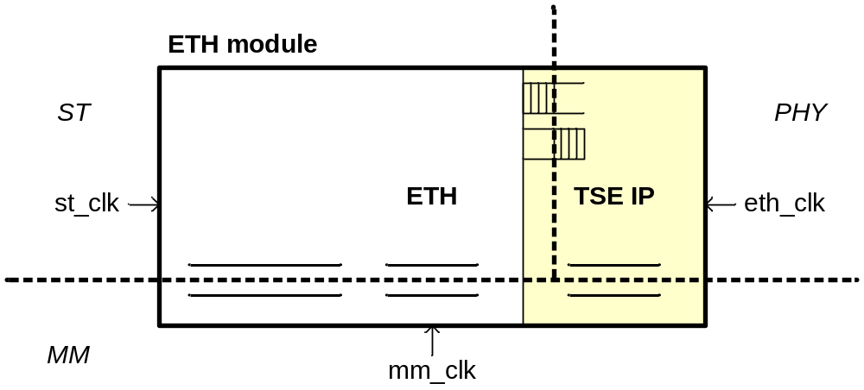
Figure 3: Clock domains of the ETH module

Parameters
Table 17 lists the VHDL generics that can be changed when the ETH module is instantiated in another HDL design or in an SOPC system.

Generic | Type | Description
g_cross_clock_domain | Boolean | Default TRUE. Use FALSE, when the mm_clk and st_clk (see Figure 3) are the same, else use TRUE, to ensure that the MM register information reliably crosses the clock domain.
Table 17: ETH module parameters

MM interface
Table 18 defines the interface signals for the MM ETH registers.

Signal | Type | Description
rddata[31:0] | MISO | Read data word, valid 1 clock cycle after rd
address[3:0] | MOSI | Word address range to fit the ETH registers of Table 1
wrdata[31:0] | MOSI | Write data word, must be valid with wr
wr | MOSI | Write strobe
rd | MOSI | Read strobe
Table 18: MM ETH registers interface signals

Table 19 defines the interface signals for the MM ETH packet register.

Signal | Type | Description
rddata[31:0] | MISO | Read data word, valid 2 clock cycles after rd.
address[11:0] | MOSI | Word address range to fit an Rx packet and a Tx packet.
wrdata[31:0] | MOSI | Write data word, must be valid with wr.
Wr | MOSI | Write strobe.
Rd | MOSI | Read strobe.
Table 19: MM ETH packet register interface signals

For the MM interface definition of the MM TSE IP registers see [1].

ST interface
Table 20 shows the UDP off-load interface ST signals.

Signal | Type | Description
ready | SISO | Backpressure flow control signal. The ready latency is RL = 1.
data[31:0] | SOSI | Data word, byte [31:24] is the MSByte and is transmitted or received first.
empty[1:0] | SOSI | Indicates the number of invalid bytes in the last data word marked by eop.
valid | SOSI | Data valid strobe.
sop | SOSI | Start of packet strobe.
eop | SOSI | End of packet strobe.
channel | SOSI | Support two UDP off-load channels 0 or 1.
Table 20: MM ETH packet register interface signals

PHY interface
The TSE IP is configured for 1000BASE-X via two 1.25 Gbps LVDS lines, one for Tx and one for Rx. In an SOPC system these IO signals appear as conduit interface signals.

Application

SOPC design
Thanks to an AVS wrapper component and a hardware description TCL file the ETH module is also available within SOPC builder, see Appendix 10.1. Figure 4 shows the ETH module called avs_eth in the sopc_tse.sopc SOPC system. The avs_eth does not (yet) present the UDP off-load ST interface in the GUI.

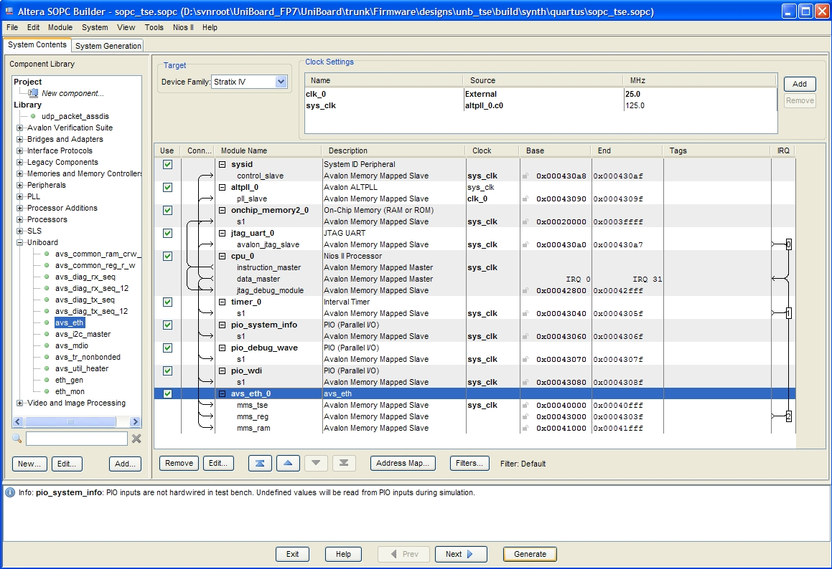
Figure 4: SOPC builder system sopc_tse.sopc with the ETH module

The SOPC Builder tool generates the sopc_tse.vhd VHDL file from the system defined by sopc_tse.sopc in Figure 4. Figure 5 shows the unb_tse design that instantiates this sopc_tse system. The unb_tse design uses the unb_node_ctrl and unb_system_info components from the unb_common library [8] to support the sopc_tse system in a design that can run on any of the 8 nodes of the UniBoard.
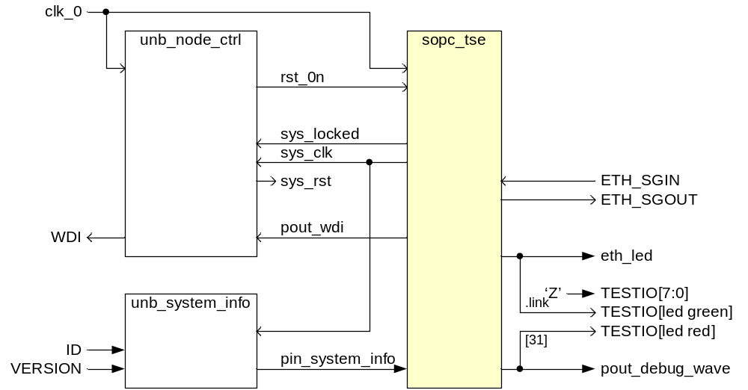
Figure 5: Block diagram of the unb_tse design on an UniBoard FPGA

The IO signals of unb_tse design in Figure 5 are connected to pins of the FPGA or they are left open for monitoring in simulation only. The clk_0 connects to the 25 MHz input ETH_CLK pin of each UniBoard FPGA node and is used as reference for the PLL in the sopc_tse system. The sys_clk is 125 MHz and in this unb_tse example designs it is used for the mm_clk, eth_clk and for the st_clk in Figure 3.

Synthesis
The unb_tse design can run on all 8 FPGA nodes of the UniBoard, see Appendix 10.4.

Software main
The ETH applications software contains some main() example functions on how to use them, see Appendix 10.2. The software determines how the unb_tse design behaves. It is not necessary to synthesize the logic again when the software has changed.

Known issues
The readme.txt in $UNB/Firmware/MegaWizard//tse_sgmii_lvds/doc contains a list of known issues regarding the ETH module.

Design

Architecture
Figure 6 shows the block diagram of the ETH module. The packet transfer is done via ST interface components. The ETH control component handles the interface between the ST components and the MM packet register. The MM packet register provides the access for a microprocessor to the Rx packet and Tx packet. Via the ETH and TSE IP registers a microprocessor can control and monitor the ETH module.

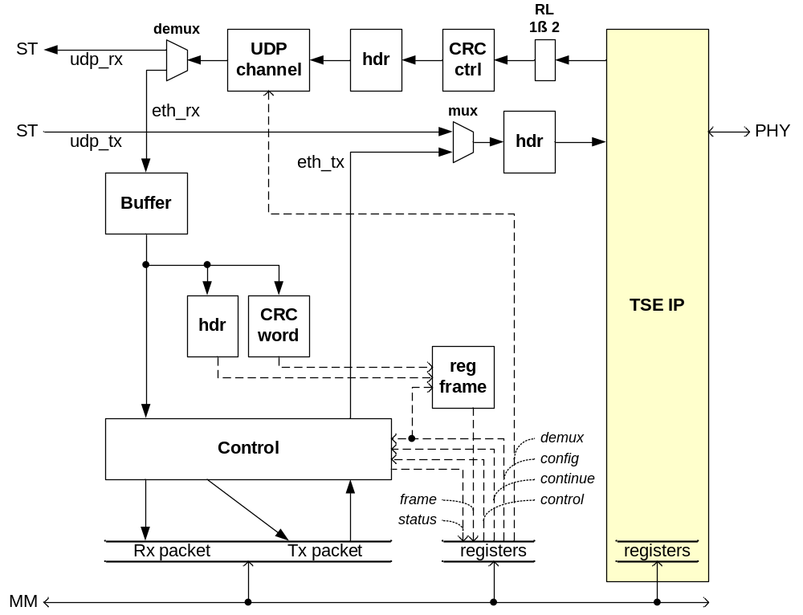
Figure 6: Top level block diagram of the ETH module

Packet buffering
The TSE IP contains Rx and Tx FIFOs to allow the data to reliably cross the ETH clock domain and the ST clock domain. These FIFOs are 256 x 32b-words deep, because that just fits in 1 M9K RAM block = 1 kByte, so using less words does not save memory resources (note that the maximum data width for a M9K RAM block is 36 bit).

The Rx buffer contains a FIFO to buffer received frames that can not yet be handled by the software. If the Rx packet register is available then a received frame gets passed on with minimal latency otherwise a new frame gets buffered. Dependent on the expected throughput for this node the FIFO buffer typically needs to be able to store at least one maximum size frame. It may be a requirement to have FIFO depth that is a power of 2, because the Altera MegaWizard does not show intermediate sizes. Therefore use a depth of 2 (or even 4) kByte rather than 1.5 kByte for default Ethernet frames and a depth of 16 (or even 32) kByte rather than 9 kByte if jumbo frames need to be supported.

The Rx packet register and the Tx Packet register both have to be able to store one maximum size frame. These MM memories do not have to have a size that is a power of 2. The Rx and Tx packet are stored in a single buffer, so it is possible to choose 1.5 kByte bytes for default Ethernet which results in 2*1.5=3 M9K RAM blocks. However it is fine to spend one more M9K and use 2 kBytes for the Rx and Tx packet, so 4 M9K RAM blocks (the reason is that this avoids the simulation warnings for addresses that are outside the available RAM range which occur also when the MM slave is not selected). For jumbo frames one can use 9 kByte, so 2*9=18 M9K RAM blocks.

The other functions in the ETH module have no frame buffering. Table 21 summarizes the memory usage of the ETH module. Whether jumbo frames are supported depends on a compile constant in eth(pkg).vhd. Use c_eth_frame_sz=2 kByte for default Ethernet frame size and use c_eth_frame_sz=9 kByte for jumbo frame support.

Function | Buffer | Nof kBytes = nof M9K RAM
TSE IP | Rx FIFO  Tx FIFO | 1  1
Rx buffer | Buffer FIFO | 2 (16)
Rx packet  Tx packet | MM register  MM register | 2 (9)  2 (9)
Total | ETH module | 8 (36 kByte)
Table 21: ETH module memory usage overview (values for jumbo frames in brackets)

Implementation

This chapter describes the HDL implementation of the ETH module. The sections follow the functions in the top level block diagram of Figure 6. The ST mux, demux and RL adapter come from the DP library [6].

TSE IP wrapper
The ETH module is written in generic VHDL. Hence it can be used on any platform. The TSE IP component is Altera specific, but typically such a component will be available on other platforms as well. Therefore the TSE IP component is wrapped by a generic TSE component to clearly separate it from the rest of the ETH module HDL, see Appendix 10.1.

The Rx output from the TSE IP has ready latency RL = 2 so first a DP latency adapter is used to adapt the RL to 1.

Header handling
The eth_hdr component shown in Figure 7 provides a uniform means for handling Ethernet frame headers and is reused throughout the ETH module.

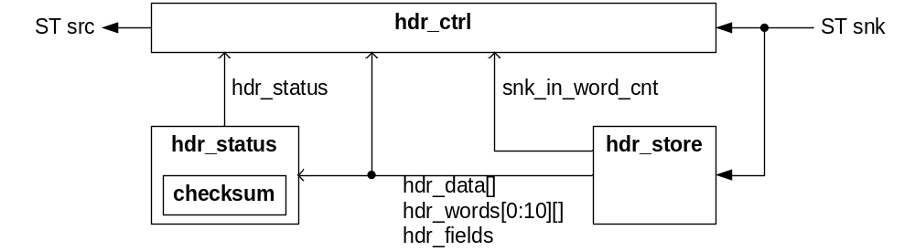
Figure 7: Block diagram for uniform Ethernet header handling

The header of all supported Ethernet protocols (ARP, IP/UDP and IP/ICMP, see Appendix 8) fits into exactly 11 words. Therefore eth_hdr_store extracts the first 11 words from an Ethernet packet and makes them available as a word array and as record fields. The component has three output formats:

- hdr_data[31:0], the currently active header word
- hdr_words[0:11][31:0], the 11 word header store
- hdr_fields, combinatorial mapping of the 11 word header store to various Ethernet packet header fields

Which format to use depends on the application. The logic for words or header fields that are not used, will get optimized away during synthesis.

The eth_hdr_status interprets the header fields and determines the status information from the Ethernet header after every asserted sop. This concerns status information like is it an ARP frame, is it an UDP frame, the UDP port number, etc. The eth_hdr_status calculates the IP header checksum using eth_checksum or it reads the IP header checksum from the frame.

The eth_hdr_ctrl outputs the stored header and the rest of the payload. Frames shorter than 11 words are discarded by eth_hdr_ctrl. For IP frames eth_hdr_ctrl uses the calculated IP header checksum value to replace it in the frame. For receive this checksum will be 0 when OK and indicate an IP header error otherwise. For transmit this checksum is the required IP header checksum.

CRC handling
The eth_crc_crl component uses DP shiftreg to replace the true CRC frame word by the ST error field information. This avoids the need for the ST error field in subsequent blocks. Hence after the eth_crc_ctrl the CRC word in a frame carries an enumerated value, 0=OK and >0 to indicate the TSE IP error code (same as ETH_MAC_ERROR field defined in Table 10).

The eth_crc_word component extracts the CRC word from the Ethernet frame tail. The eth_crc_word acts as a stream monitor, but it can be in the stream because it connects its sink to its source. Dependent on snk_in.empty the CRC word is in the last tail word or straddled in the last two tail words. This component does not distinguish on whether the CRC word is the true CRC word or the enumerated CRC derivative from eth_crc_ctrl.

UDP off-load
If UDP off-load is enabled then eth_channel maps the UDP port to the appropriate ST channel value dependent on the MM demux register settings described in section 2.3.1. The DP demultiplexer and DP multiplexer are used to separate and combine the UDP off-load traffic and the other ETH traffic.

Rx buffer
Figure 8 shows a block diagram of eth_buffer that is used for the Rx buffer. All frames that are not for UDP off-load are stored by the input FIFO in eth_buffer. Via some source control signals a frame can be requested from the FIFO. These source control signals act like the SISO ready signal, but instead of operating per data word they operate per entire frame. The input FIFO needs to be able to hold at least one frame, to allow the microprocessor to handle the current Rx frame. If the input FIFO gets almost full, then the first frame in the FIFO will be flushed to maintain integrity of the frames in the FIFO.

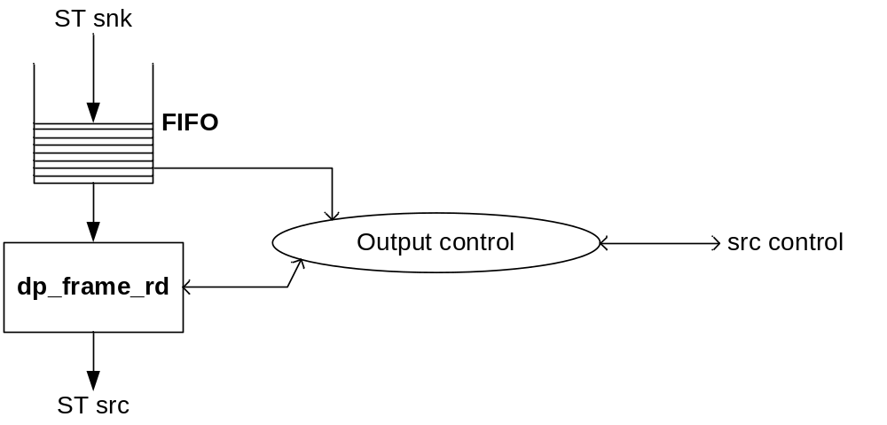
Figure 8: Block diagram for eth_buffer

When the frame is output then the status of this frame is presented in the frame register (see section 2.3.4), via eth_hdr and eth_mm_reg_frame as shown in Figure 6.

Control
Figure 9 shows a block diagram of ETH control. The ovals indicate combinatorial or clocked processes in VHDL, and are typically named with prefix ‘p_’. The ETH control takes care of access to the Rx packet and Tx packet buffer and handles the handshake control with the software conform the state machine of Figure 2. The ETH control can request a frame from the Rx buffer via the receive control signals and it can transmit a frame when enabled to do so by the microprocessor.

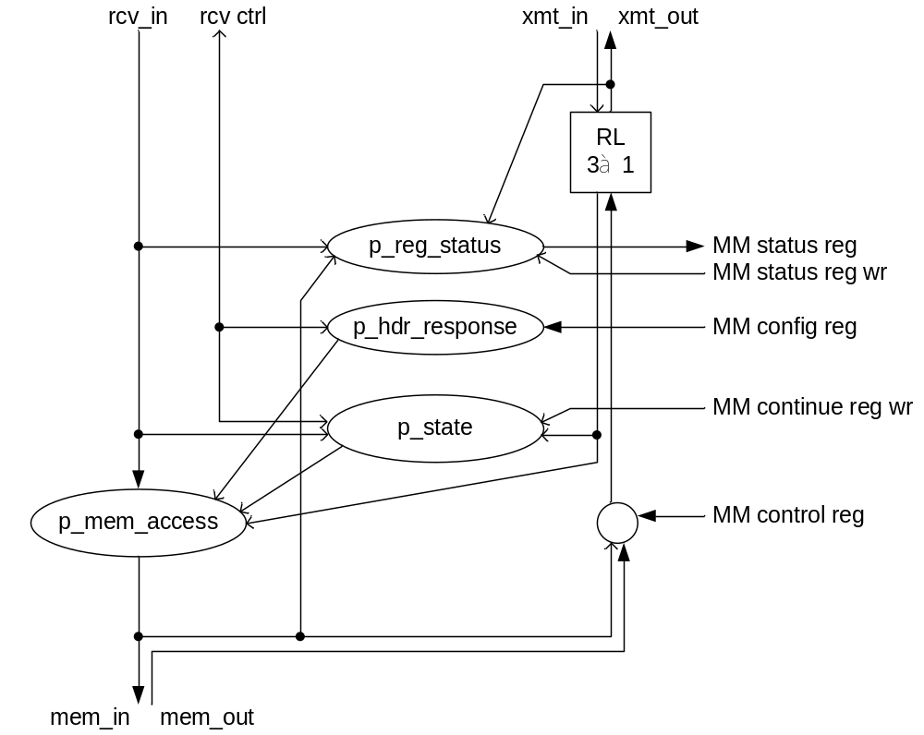
Figure 9: Block diagram for eth_control

MM registers
Figure 10 shows the block diagram for memory-mapped (MM) registers of the ETH module. The MM registers are defined in section 2.3. The MM registers of the TSE IP are not shown, because they have a dedicated MM slave interface. If the MM clock domain differs from the ST clock domain then the clock domain crossing logic has to be inserted via the generic g_cross_clock_domain [7]. The representation of the status register in the MM clock domain provides the RX_AVAIL and TX_AVAIL fields that are used to create the ETH interrupt described in section 2.2.1.
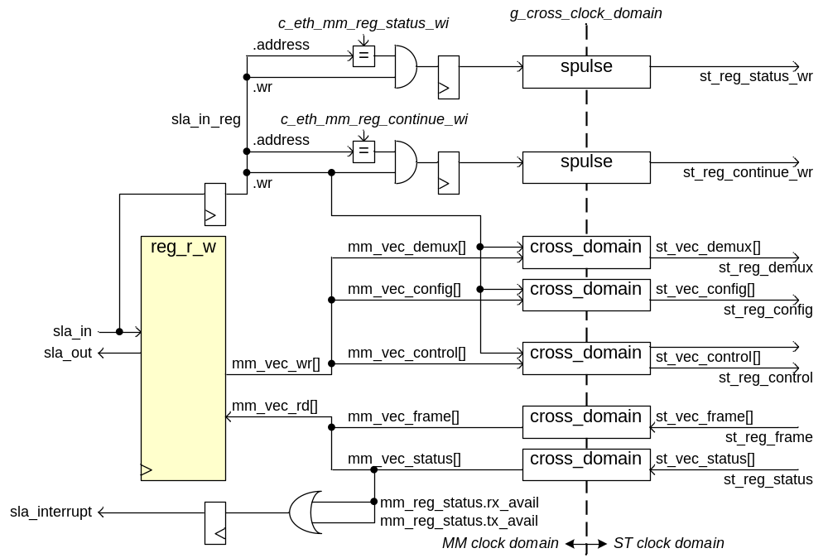
Figure 10: Block diagram for eth_mm_registers

MM packet buffer
The MM packet buffer is defined in section 2.4 and contains sufficient RAM to store an Rx packet and a Tx packet. The RAM is a dual port RAM with separate clocks, so any clock domain crossing between the MM clock domain and the ST clock domain is taken care of by default if necessary.

Verification

Simulation
The verification of the ETH module is done in a step by step approach. First the test bench generated by the MegaWizard was run to have a reference. Then a more compact test bench was made to verify and understand the TSE IP (section 7.1.1). After that another test bench was made to verify the ETH module with the TSE IP inside and also another instance of the TSE IP to ease interfacing a model of the control computer (section 7.1.2). Finally a test bench for a UniBoard design using the ETH module was made (section 7.1.3). This design includes the ETH module in an SOPC Builder system with a Nios II, so it can also verify the software.

Test bench for TSE IP
The tb_tse is a VHDL test bench to experiment and verify the TSE IP. The tb_tse test bench is much more concise than the test bench that gets generated for the TSE IP by the MegaWizard. Furthermore the tb_tse uses procedures from the tb_tse_pkg package to more easily stimulate and verify the TSE IP DUT.

Item | Description
proc_tse_setup() | Initializes the PCS registers according to Table 24.  Initializes the MAC registers according to Table 25 and Table 26.
proc_tse_tx_packet() | Transmit a packet to the DUT. Supported types: ETH, ARP, ICMP, UDP. Supported payload data: byte count or word count.
proc_tse_rx_packet() | Receive and verify a packet
Table 22: tb_tse_pkg

Table 22 list the main items in the tb_tse_pkg. The packet procedures also handle the stream empty field in case the number of octets in the payload is not a multiple of 4, with 4 octets per word.

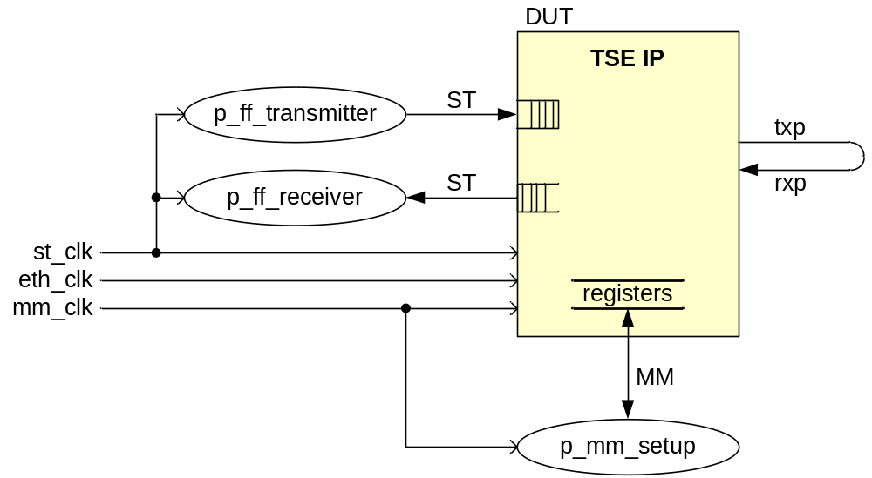
Figure 11: Architecture of tb_tse to verify the TSE IP

Figure 11 shows how the TSE IP is tested. The transmitter process uses the proc_tse_tx_packet() procedure to send packets to the DUT. The PHY of the TSE IP is connected as loopback, so the transmitted packets also get received by this DUT. The receiver process receives these packets from the DUT and verifies the payload. The receiver process continually loops and calls proc_tse_rx_packet().

Test bench for ETH module
The tb_eth is a VHDL test bench to experiment and verify the entire ETH module. The tb_eth uses the procedures from the tb_tse_pkg package to set up the TSE IP and to transmit to the DUT and receive packets from the DUT.

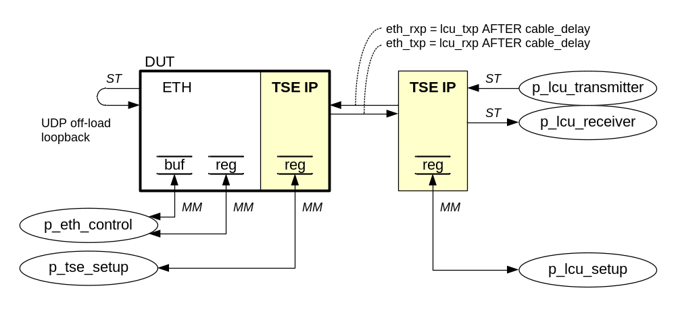
Figure 12: Architecture of tb_eth to verify the ETH module

Figure 12 shows how the ETH DUT is tested using another TSE IP instance to provide a MM interface for the control computer or local control unit (LCU). The LCU behaviour is modelled via the p_lcu_transmitter and p_lcu_receiver VHDL processes. The behaviour of the on chip microprocessor soft core is modelled by the p_eth_control VHDL process.

Test benches for a UniBoard SOPC design with ETH module
Figure 13 shows how the unb_tse design of Figure 5 is tested using similar stimuli as with tb_eth of Figure 12. Note that the behaviour of the unb_tse design is determined partly by the main() software function that runs on the NIos II inside the sopc_tse system.
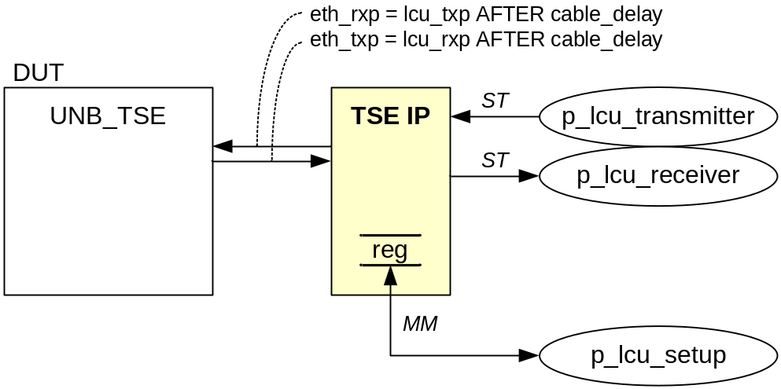
Figure 13: Architecture of tb_unb_tse to verify the ETH module in a design

Figure 14 shows how the unb_tse design of Figure 5 is tested for multiple nodes like with UniBoard. The behaviour of the Ethernet switch that connects the nodes is modelled by simply connecting the Ethernet links in a ring. For the purpose of letting each node sent to its neighbour node this limited model of the Ethernet switch is sufficient.

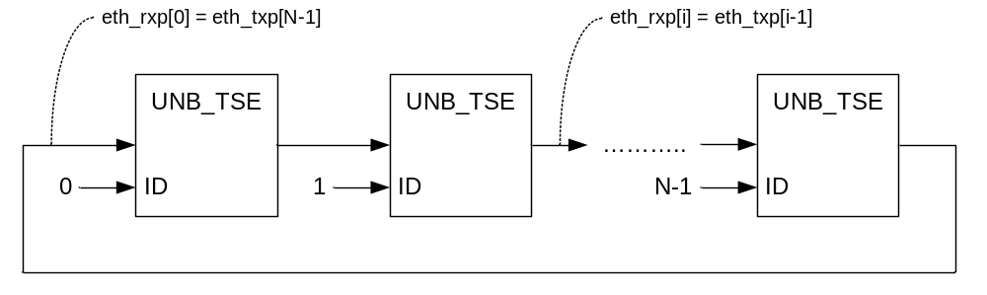
Figure 14: Architecture of tb_unb_tse_board to verify multiple nodes

Figure 15 shows how the unb_tse design of Figure 5 is tested for one node. The external loopback connection can be disconnected to verify internal TSE MAC IP loopback.

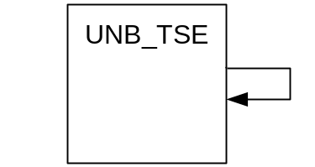
Figure 15: Architecture of tb_unb_tse_loopback to verify one node

Target hardware
The unb_tse design can run on all nodes of the UniBoard. If the Nios II runs the program with the main() function selected by ETH_MAIN_TX_RX (see Appendix 10.2) with NOF_NODES=8, then each node will transmit a frame to its neighbour every second.

Appendix: Ethernet protocols

Ethernet frame
0 15 16 31 wi
|----------------------------------------------------------------------|
| Word Align | Destination MAC Address | 0
|----------------------------------- |
| | 1
|----------------------------------------------------------------------|
| Source MAC Address | 2
| ------------------------------------|
| | EtherType | 3
|----------------------------------|-----------------------------------|
| |
| Ethernet Payload |
| |
|------------------------------------------------------------ // ------|
| Frame Check Sequence |
|------------------------------------------------------------ // ------|
Figure 16: Ethernet frame format (with payload word alignment)

IPv4 header
IPv4 is the Internet Protocol. The Ethernet type for IP v4 is EtherType 0x800.

0 3 4 7 8 15 16 18 19 31 wi
|----------------------------------------------------------------------|
| Version | HLEN | Services | Total Length | 4
|----------------------------------------------------------------------|
| Identification | Flags | Fragment Offset | 5
|----------------------------------------------------------------------|
| TTL | Protocol | Header Checksum | 6
|----------------------------------------------------------------------|
| Source IP Address | 7
|----------------------------------------------------------------------|
| Destination IP Address | 8
|----------------------------------------------------------------------|
| |
| IP Payload |
| |
|------------------------------------------------------------ // ------|
Figure 17: IPv4 header format

ARP header
ARP is the Address Resolution Protocol. The Ethernet type for ARP is EtherType 0x806.

0 7 8 15 16 31 wi
|----------------------------------------------------------------------|
| Hardware Type | Protocol Type | 4
|----------------------------------------------------------------------|
| HW Addr Len | Prot Addr Len | Operation | 5
|----------------------------------------------------------------------|
| Sender Hardware Address | 6
| ------------------------------------|
| | | 7
|---------------------------------/ /----------------------------------|
| Sender Protocol Address | | 8
|----------------------------------- |
| Target Hardware Address | 9
|----------------------------------------------------------------------|
| Target Protocol Address | 10
|----------------------------------------------------------------------|
Figure 18: ARP header format

ICMP header

ICMP is Internet Control Message Protocol for ping. The IP protocol for ICMP is 1.

0 7 8 15 16 31 wi
|----------------------------------------------------------------------|
| Type | Code | Checksum | 9
|----------------------------------------------------------------------|
| ID | Sequence | 10
|----------------------------------------------------------------------|
| |
| ICMP Payload (padding data) |
| |
|------------------------------------------------------------ // ------|
Figure 19: ICMP header format

UDP header

UDP is the User Datagram Protocol. The IP protocol for ICMP is 17.

0 15 16 31 wi
|----------------------------------------------------------------------|
| Source Port | Destination Port | 9
|----------------------------------------------------------------------|
| Total Length | Checksum | 10
|----------------------------------------------------------------------|
| |
| UDP Payload |
| |
|----------------------------------------------------------- // -------|
Figure 20: UDP header format

Appendix: TSE IP

The TSE IP MegaCore from Altera [1] provides the MAC and PHY for accessing Ethernet at 1000BASE-X. On UniBoard the PHY interface uses one LVDS line for Tx and one for Rx.

Generics
The TSE IP needs to be regenerated if its parameters in Table 23 are changed.

Parameter | Setting | Comment
ENABLE_SHIFT16 | 1 | Align packet headers to 32 bit, useful for Nios II data handling.
ENABLE_SUP_ADDR | 0 | An extra MAC addresses can e.g. be used as service MAC for tests.
ENA_HASH | 0 | A multi cast hash table can be used to address all nodes at once.
STAT_CNT_ENA | 0 | PHY statistics counts are useful for monitoring, but not really needed.
EG_FIFO | 256 | Egress TX_FIFO_DEPTH in nof 32 bit words (256 fits 1 M9K).
ING_FIFO | 256 | Ingress RX_FIFO_DEPTH in nof 32 bit words (256 fits 1 M9K).
ENABLE_SGMII | 0 | Use 1000BASE-X direct mode for PHY interface.
Table 23: TSE IP generic settings

PCS control registers
Register | Address | Access | Value | Comment
REV | 0x22 | R | 0x0901 | PCS IP version number 9.1
IF_MODE | 0x28 | W | 0x0008 | Enable 1000BASE-X gigabit mode and gigabit speed
CONTROL | 0x00 | R | 0x1140 | Gigabit speed and full duplex (RO), auto-negotiation enabled (RW)
STATUS | 0x02 | R | 0x000D | Link status bit 2 = ‘1’ indicates that a valid link has been established
CONTROL | 0x00 | W | 0x1140 | Keep auto negotiate enabled (is reset default)
Table 24: TSE IP PCS control register values

MAC control registers
Register | Address | Access | Value | Comment
REV | 0x000 | R | 0x00000901 | ETH module version 0x0000 and TSE IP version 0x0901
COMMAND_CONFIG | 0x008 | W | 0x0100004B | See Table 26
MAC_0 | 0x00C | W | 0x78563412 | E.g. MAC address 12-34-56-78-9A-BC.  The MAC address for the TSE IP needs to be in big endian.
MAC_1 | 0x010 | W | 0x0000BC9A | E.g. MAC address 12-34-56-78-9A-BC.
TX_IPG_LENGTH | 0x05C | W | 0x0000000C | Inter packet gap 12 bytes
FRM_LENGTH | 0x014 | W | 0x000005EE | Receive max frame length typical 1518
RX_SECTION_EMPTY | 0x01C | W | 0x00000F0 | Default Rx FIFO depth - 16, >3
RX_SECTION_FULL | 0x020 | W | 0x0000010 | Default 16
TX_SECTION_EMPTY | 0x024 | W | 0x00000F0 | Default Tx FIFO depth - 16, >3
TX_SECTION_FULL | 0x028 | W | 0x0000010 | Default 16, > about 8 otherwise no Tx
RX_ALMOST_EMPTY | 0x02C | W | 0x0000008 | Default 8
RX_ALMOST_FULL | 0x030 | W | 0x0000008 | Default 8
TX_ALMOST_EMPTY | 0x034 | W | 0x0000008 | Default 8
TX_ALMOST_FULL | 0x038 | W | 0x0000003 | Default TX_READY_LATENCY + 3 = 3
TX_CMD_STAT | 0x0E8 | R | 0x00040000 | [18]=1 TX_SHIFT16, [17]=0 OMIT_CRC
RX_CMD_STAT | 0x0EC | R | 0x02000000 | [25]=1 RX_SHIFT16
Table 25: TSE IP MAC control register values

COMMAND_CONFIG register bits
Table 26 explains the COMMAND_CONFIG register bits that are relevant to the UniBoard.

Bit | Name | Value | Description
0 | TX_ENA | 1 | Enable tx data path
1 | RX_ENA | 1 | Enable rx data path
2 | XON_GEN | 0 | -
3 | ETH_SPEED | 1 | Enable 1GbE operation
4 | PROMIS_EN | 0 | When 1 then receive all frames
5 | PAD_EN | 0 | When 1 enable receive padding removal (requires Ethernet Type = payload length)
6 | CRC_FWD | 1 | Enable receive CRC forward
7 | PAUSE_FWD | 0 | -
8 | PAUSE_IGNORE | 0 | -
9 | TX_ADDR_INS | 0 | When 1 then the TSE IP overwrites Tx SRC_MAC with MAC_0,1 or one of the supplemental MAC.
[10] | HD_ENA | 0 | -
[11] | EXCESS_COL | 0 | -
[12] | LATE_COL | 0 | -
[13] | SW_RESET | 0 | When 1 then the TSE IP disables Tx and Rx, clear statistics and flushes the receive FIFO.
[14] | MHAS_SEL | 0 | When 1 then select multicast address resolutions hash-code mode.
[15] | LOOP_ENA | 0 | -
[18:16] | TX_ADDR_SEL[2:0] | 0 | TX_ADDR_INS insert MAC_0,1 or one of the supplemental MAC.
[19] | MAGIC_EN | 0 | -
[20] | SLEEP | 0 | -
[21] | WAKEUP | 0 | -
[22] | XOFF_GEN | 0 | -
[23] | CNT_FRM_ENA | 0 | -
[24] | NO_LGTH_CHECK | 1 | When 0 then check payload length of received frames (requires Ethernet Type = payload length).
[25] | ENA_10 | 0 | -
[26] | RX_ERR_DISC | 0 | When 1 then discard erroneous frames (requires store and forward mode, so rx_section_full=0). When 0 then pass on with rx_err[0]=1
[27] | DISABLE_RD_TIMEOUT | 0
[30:28] | RSVD | 0
[31] | CNT_RESET | 0 | When 1 clear statistics.
Table 26: TSE IP MAC COMMAND_CONFIG register bits

FIFO control
Table 27 explains the meaning of the FIFO fill level settings. The section full and empty levels operate at application level and indicate whether there is enough data in the FIFO to start reading a packet from it or whether there is enough space in it to continue writing a packet to it. The almost full and empty levels operate at somewhat lower level and are used to ensure that overflow and underflow are handled correctly.

Term | Description
TX_SECTION_FULL | There is enough data in the FIFO to start reading it, when 0 then store and forward.
RX_SECTION_FULL | There is enough data in the FIFO to start reading it, when 0 then store and forward.
TX_SECTION_EMPTY | There is not much empty space anymore in the FIFO, warn user via signal ff_tx_septy.
RX_SECTION_EMPTY | There is not much empty space anymore in the FIFO, inform remote device via XOFF flow control.
TX_ALMOST_FULL | Assert signal ff_tx_a_full and deassert signal ff_tx_rdy. Furthermore TX_ALMOST_FULL = TX_READY_LATENCY+3.
RX_ALMOST_FULL | Assert signal ff_rx_a_full and if the user is not ready indicated by signal ff_rx_rdy then break off the reception with an error to avoid FIFO overflow.
TX_ALMOST_EMPTY | Assert signal ff_tx_a_empty and if the FIFO does not contain an eop yet then break off the transmission with an error to avoid FIFO underflow.
RX_ALMOST_EMPTY | Assert signal ff_rx_a_empty.
Table 27: FIFO terminology

Typical FIFO settings:

TX_SECTION_FULL = 16 > 8 = TX_ALMOST_EMPTY
RX_SECTION_FULL = 16 > 8 = RX_ALMOST_EMPTY
TX_SECTION_EMPTY = D-16 < D-3 = TX_FIFO_DEPTH - TX_ALMOST_FULL
RX_SECTION_EMPTY = D-16 < D-8 = RX_FIFO_DEPTH - RX_ALMOST_FULL

TX_FIFO_DEPTH = 1 M9K = 256*32b = 1k * 8b is sufficient when the Tx user respects signal ff_tx_rdy. To store a complete ETH packet would require 1518 byte, so 2 M9K = 2k * 8b. RX_FIFO_DEPTH = 1 M9K = 256*32b = 1k * 8b is sufficient when the Rx user signal ff_rx_rdy is sufficiently active.

Appendix: List of files

Not all files for the ETH module and the unb_tse example design in the SVN repository [4] are listed in this section, only the top level files, packages, test benches and the project files. For more general information on how to use the files see [7].

Firmware VHDL

TSE IP
The TSE IP component is generated with the Altera MegaWizard and kept at:

$UNB/Firmware/modules/MegaWizard/tse_sgmii_lvds

File | Description
tse_sgmii_lvds.vhd | TSE IP MegaWizard top level component for synthesis.
tse_sgmii_lvds.vho | TSE IP MegaWizard top level component for simulation.
Table 28: TSE IP VHDL source and test bench files
The tse_sgmii_lvds.vhd in Table 28 defines the MegaWizard file that can generate the TSE IP files that are needed for simulation and synthesis. These generated files are also kept in SVN, so it is not necessary to run the MegaWizard to recreate them.

ETH module
The ETH module hardware files are kept at: $UNB/Firmware/modules/tse

Table 29 lists the TSE IP wrapper files. By using a wrapper component the TSE IP from Altera is clearly distinguished from the generic HDL of the rest of the ETH module. If another TSE IP would be used then typically only the wrapper component will need to be adapted, all other ETH module HDL can remain the same.

File | Description
tse(pkg).vhd | TSE IP wrapper IO record definitions.
tse(stratix4).vhd | TSE IP wrapper for tse_sgmii_lvds.
tse.vhd | General TSE component with wrapper using IO records [5]
Table 29: Wrapper files for the TSE IP

Table 30 lists the ETH module package and top level entity files for Figure 6.

File | Description
eth_layers(pkg).vhd | General ETH, ARP, IPv4, ICMP, UDP and DHCP definitions (see Appendix 8).
eth(pkg).vhd | ETH module specific definitions
eth.vhd | ETH module top level of Figure 6
Table 30: Source files for the ETH module

The ETH module in eth.vhd uses ST and MM record types [5]. To make the ETH module available in SOPC Builder it is necessary to use standard logic interface signal types. Therefore the AVS_ETH wrapper component shown in Table 31 is needed.

File | Description
avs_eth.vhd | ETH module wrapper for standard Avalon Interface IO.
avs_eth_hw.tcl | Hardware description file to make the ETH module available in SOPC Builder
Table 31: Wrapper files for the AVS_ETH module

File | Description
tb_tse(pkg).vhd | Procedures to set up the TSE IP and to Tx and Rx a packet
tb_eth(pkg).vhd | Procedures to access the ETH registers and packet buffer via the MM interface
tb_tse.vhd | Test bench to verify the TSE IP via tse.vhd (Figure 11)
tb_eth.vhd | Test bench to verify ETH module via eth.vhd (Figure 12)
tb_tb_eth.vhd | Test bench to run multiple settings of tb_eth.vhd (Figure 12)
tb_eth_checksum.vhd | Test bench to verify the IP header checksum calculation in eth_checksum.vhd
Table 32: Test bench files for ETH module

UNB_TSE design
The files for the unb_tse example design with the ETH module are kept at: $UNB/Firmware/designs/unb_tse.

File | Description
sopc_tse.sopc | SOPC Builder design file of Figure 4.
unb_tse.vhd | Node design of Figure 5 that includes the sopc_tse system with the AVS_ETH module inside and that is suitable for all UniBoard modes.
Table 33: Source files for unb_tse design

File | Description
tb_unb_tse.vhd | Test bench of Figure 13 with LCU that transmits packets to the unb_tse.
tb_unb_tse_board.vhd | Test bench of Figure 14 with one or more unb_tse that are connected in a ring
tb_unb_tse_loopback.vhd | Test bench of Figure 15 with one the unb_tse and external loopback
Table 34: Test bench files for unb_tse design

Software C, H

Module
The UniBoard software modules are stored at: $UNB/Firmware/software/modules/src.

File | Description
avs_eth_regs.h | Constants and macros to MM access the ETH module.
avs_eth.h | Public functions to set up the ETH module and to hook the ISR
avs_eth.c | Implements for avs_eth.h
Table 35: Module software C, H files

Main
The UniBoard software applications with main() examples for the modules are stored at:

$UNB/Firmware/software/apps

Table 36 lists the main() function examples that are available for the ETH module.

Main() | Description
ETH_MAIN | Report received frame and reply using the default header and same length. Modelsim simulate by sending e.g. 1 frame with tb_unb_tse.vhd.
ETH_MAIN_TX_RX | Node transmits raw Ethernet frames to next node. Report received frames. Modelsim simulate using tb_unb_tse_board.vhd for ≥ 1 nodes or tb_unb_tse_loopback.vhd for 1 node.
ETH_MAIN_TSE | Read some PCS and MAC registers and report. Modelsim simulate using tb_unb_tse.vhd.
Table 36: Application software main C files

All these ETH main() report results via the JTAG UART using printf(). On target hardware the JTAG UART output can be observed in a Nios II Command Shell. In Modelsim simulation the JTAG UART output appears in the Modelsim transcript window. In simulation the main() functions also provide program status information in the Wave window via the debug wave parallel output (signal pout_debug_wave in Figure 5).

Simulation
The simulation project files are located in:

$UNB/Firmware/modules/tse/build/sim/modelsim/ → for ETH module tse_lib library.
$UNB/Firmware/designs/unb_tse/build/synth/quartus/sopc_tse_sim/ → for the unb_tse design.

File | Description
tse.mpf | Modelsim project file that builds the tse_lib module library and provides the simulation configurations for the ETH module test benches of Table 32.
setup_sim.do | Modelsim simulation do-file generated by SOPC Builder for sopc_tse.sopc, only used as an example. For simulation use unb_tse.mpf.
unb_tse.mpf | Modelsim project file for the unb_tse design. Builds the unb_tse work library and provides the simulation configurations for the unb_tse test benches of Table 34.
Table 37: Simulation project files

Synthesis
The synthesis files are kept at: $UNB/Firmware/designs/unb_tse/build/synth/quartus

File | Description
unb_tse.qsf | Quartus II Project File.
unb_tse.qsf | Quartus II Settings File, lists all source files
unb_tse.sdc | Synopsys Design Constraint file, constraints the clock
Table 38: Synthesis project and settings files

