**Domination of Cashless Economy: A Study on Delhi and Madhya Pradesh Region**

**INTRODUCTION**

The ‘*Cashless Economy*’ refers to the term where the physical flow of currency notes and coins are replaced with digital flow of money. It is also referred as *less cash economy* which mainly aims at minimizing the use of physical currency (i.e., proper currency) which includes use of plastic money, digital means and over the net transaction (i.e., Electronic payment modes). ‘*Physical money’* means the paper currency notes and coins issued by the government as legal tender. ‘*Plastic money*’ involves the use of plastic cards such as debit cards, credit cards, pre-paid cards, contact less cards etc and the ‘*Electronic payment modes’* include all kinds of mobile wallets and payments have done through smart phones, laptops etc.

In the primitive age of human history, at that time the barter system came into existence, where goods and services were being exchanged. Whatever one needed would be provided by the other person in exchange of the goods and services that the other person would need. That was a content life, followed by the metallic age.

When the coins started to be minted, people realized the importance of the shiny golden coins. Currency notes were introduced by China in the 7th century and thereafter these were used all over the world. People no longer needed to carry heavy bags of grains in case they needed a pair of shoes. They simply had to pay a few coins and notes. After the evolution of a banking system, for many decades, coins, notes and cheques were the key instruments for money transactions among customers and companies (Akinola, 2012). Usually, customers kept these physical currencies in their wallet, although sometimes it was not feasible to keep all the money in their possession for an expensive purchase. Gradually money became a measure for everything. Capitalism crept in and people started becoming a rich man’s opportunity. Also, with physical currency (coins and notes), several evils arose (Burglery, robbery, bribery and fraud). We are all moving fast in the direction of a digital generation where ‘paper’ work will be obsolete. Oman is a good example of this, where more than 66.6 percent of data is available online (United Nations, 2014). Here, every sort of organization, big or small, is keenly motivating everybody to move towards living without cash.

In terms of goods and services, Papadopoulos (2007) proposes that cash is treated as a form of goods, whereas Cole (2012) expresses that carrying hard cash is a thing of the past. Infrastructure is being developed and markets are preparing themselves to accept and adopt ‘cashlessness’ around the world (Thomas, 2013). Following these modernization steps, Oman has established Master Card Internet Gateway Service (MiGS) in collaboration with Master Card (Baqer, 2012). MiGS would provide government and private sectors with an e-environment for faster and secure public services for citizens of Oman. The present generation, which has witnessed a significant technological change from pen-paper to touch screen era, is motivated by government, banking and retail sectors to shift from cash to cashless transactions. Oman, where 71.2 percent male and 59.8 percent female are using the internet, is moving fast towards a cashless society (ITU, 2015).

Fundamentally, e-government is a natural feature of a cashless society. For an effective and efficient cashless society, the government needs to identify the basic requirements of its citizens and then use the features of a cashless society to motivate citizens to adopt e-government. The concept of a cashless society is based on e-transaction. Generally, these cashless transactions are linked with a bank and the banks have adequate control over the transactions. The first cashless payment was introduced in the 1950s, since then, various e-payment instruments have been introduced. SMS payment, Plastic Cards, e-transfer, Internet Banking, Virtual Wallet (Google Wallet) and Virtual Currency (Bitcoin) are the key innovations of the past few decades. Rapid enhancement of smartphones, 3G/4G networks, Wi-Fi, NFC and QR code are speeding up the flow of information around the globe. This flow of information is not only becoming faster, easier and safer but also substantially cheaper. Now people may live anywhere around the world, but when a family needs cash, money will reach them. The real sense of a cashless society means that transactions not only of large amounts but also of small amounts will be performed. Oman is also showing its strong presence in the cashless environment, having secured its place among the top 50 performers on e-participation with index 0.7059 and Online Service Index (OSI) 0.7323 (United Nations, 2014). Much of research study conducted in others countries has also shown positive results in this respective for intense, Cole (2012) highlights that 73 percent of Americans have accepted that they are moving towards a cashless state, from cash-based transactions. Moody’s Analytics (2013), studying the impact of card usage on GDP of 51 countries, found that electronic card usage added USD 1.1 trillion in real dollars to private consumption and GDP from 2003 to 2008. The study found that a 1% increase in card transaction volume would increase consumption each year by 0.039% and GDP growth by 0.024%. Many countries, such as Canada and the U.S., have successfully reduced the production expenditure of coins and currency. Similar benefits are expected for India as well.

In this progression, the Prime Minister of India, on 8th November, 2016 has launched a campaign "*Digital India*" along with demonetization in order to make the governments services available to citizens of our country by online modes and by increasing internet connectivity to make the country digital empowered in the field of technology. The main aim of this step was aimed to attack on counterfeit currency, currency used for terrorist financing, black money and corruption. This project "*Digital India*" has motivated people to make transactions by mobile cashless plastic money, online modes of payments such as mobile app, like PAYTM, Google Pay, and Phone-Pay etc.

In order to achieve the goal of "*Digital India*" many initiative have been taken by the government, such as:

* 100 **Digi Dhan Melas** held in 100 cities.
* 15000 institutions have gone cashless.
* 75 less-cash townships to generate over 1.5 lakh digital transactions/day.
* Rs 258 crore awarded to 16 lakh lucky winners for using digital payments

which resulted as, number of e-transactions jumps 23 times to 63,80,000 for a value of 2,425 crore. Further, peoples moves to e-transactions from cash payment.

LITERATURE REVIEW :

The People Research on India’s Consumer Economy (PRICE) conducted a cash survey in 2014 to identify reasons for cash usage in India. The survey was administered to 1,005 respondents who belonged to a varied population. It was found that the primary source of cash was employment and business. However, a meager seven percent of respondents owned a credit card, while 55 percent relied on both cash and debit cards for transactions, where debit cards were mostly used for withdrawing cash. The remaining 38 percent relied on cash alone. Therefore, about 92 percent of the respondents were dependent on cash-based transactions. Among those who owned credit cards, 57 percent were regular salaried individuals and about 33percent were self-employed. The category of credit card owners did not include a single casual laborer. On the other hand, about 55 percent of those who relied exclusively on cash were unpaid household women workers and casual laborers.

In 2015 report by Price Water House Coopers, India’s unbanked population was at 233 million. Even for people with access to banking, the ability to use their debit or credit card is limited because there are only about 1.46 million points of sale which accept payments through cards. In 2016 report, cash is still expected to remain a significant payment method in the near future. However, services based on immediate payments are more efficient than cash and are expected to accelerate the move to digital payments.

In December 2016, S&P Global Ratings [decreased its estimated economic growth rate](http://economictimes.indiatimes.com/articleshow/55975757.cms?utm_source=contentofinterest&utm_medium=text&utm_campaign=cppst) for 2016-17 by one full percentage point to 6.9% to reflect the disruption. However, Dharmakirti Joshi, Chief Economist of Crisil, a subsidiary of S&P Global, noted that, “We expect lower private consumption in fiscal 2017, but expect demand to revive and growth to rebound in fiscal 2018. India should shortly revert back to an 8% annual growth trajectory”. The Wall street Journal similarly comments that while GDP growth slowed as a result of the demonetization policy, “India is expected to [remain one of the world’s fastest-growing large economies](https://www.wsj.com/articles/indian-gdp-growth-hurt-by-new-delhis-cash-crackdown-1488291164)”.

Dhanda and Arora (2017), Genesis of cashless society: A study on growing acceptability towards plastic money. This paper is aimed towards studying the factors responsible for the rapid increase in acceptability of plastic card in the recent years. After the study was conducted it was seen that use of plastic cards is a matter of great pride among teenagers and is considered safe and free from any frauds.

Kousalya and Shankar (2018), Cashless economy/transaction. The paper was focused towards understanding the impact of cashless economy and its importance in India. After the research conducted it was seen that the introduction of cashless economy in India will bring about a positive impact on the financial sector and will help in modernization of the payment system in India. In 2020, According to National Payments Corporation of India (NPCI) data, payments on Unified Payments Interface (UPI) in June hit an all-time high of 1.34 billion in terms of volume with transactions worth nearly Rs 2.62 lakh crore. The Cashless Economy can be helpful in the crisis such as COVID-19 as it can be spread through cash also.

In this study, there are two major issues we address: the share of cashless -both in terms of transactions as well as value and the factors that affect them most. This provides a roadmap to increasing the share of cashless transactions in the economy. Going cashless may lead to higher tax collection as well. To the existing body of the literature, our contribution is developing an insight both at a micro level (households and retailers), as well as to what sectors are likely to implement more cashless payments than others. Insights from our findings will be invaluable towards developing a roadmap for promoting cashless payments. To the best of our knowledge, such analysis at a disaggregated level has not been done at country level, as the focus of literature has been on estimating cashless payments, its macro-economic effects, instruments, and regulations that can promote cashless payments.

## ADVANTAGES OF CASHLESS PAYMENTS

There are both direct as well as indirect benefits of going cashless for India. We list them below such as

1. **Direct Benefits:**

***(a) Costs:*** According to the Reserve Bank of India (RBI), the provisional estimates of the amount of currency in circulation (as of June 2016) stand at INR 16.61 trillions, out of which only 5% of the currency is with the bank. From April 1994 to June 2016, currency has shown a yearly growth rate of 17%, while the share of bank currency has remained around 5%. It was estimated that, for 2009–2010, RBI incurred an annual cost of INR 2800 Crores for printing currency notes (Das and Agarwal 2010). This is 0.4% of the total currency in circulation. This cost does not include the cost of storage, transportation, security, detection of counterfeits, etc. In addition to the printing cost, if we were to add the cost of storage and maintaining these currencies through ATMs alone, the cost of printing and distributing cash constitutes about 0.2% of India’s GDP. Given these costs, moderate growth of cashless transactions by 5% a year will save more than INR 500 Crores annually.

***(b) Financial records and tax collections:*** As a prevention strategy, the Government has recently announced an immediate demonetization of all high-value currencies. Schneider (2006) estimates the size of India’s black money economy between 23% and 26% of the GDP. Some recent estimates consider it between 40% and 75% of the GDP. In addition, India is among the low tax collection countries. Economic Index of Freedom data estimates the tax burden in India at only at 17.6%, which is lower than the global average of above 25%. While the direct tax rate is 30.9% in India, as opposed to a global average of 35.6%, only 1% of the total population in India pays income tax. The effort is therefore to increase indirect tax collection. With cashless transactions, all transactions would leave digital footprints. A system that encourages and incentivizes the “buyer” to pay through cashless instruments (increasing use of bank-to-bank transactions without involving physical currency) will have higher financial transparency. This is perhaps the most direct way of battling issues of corruption and black money in India.

1. **Indirect benefits:**

***(a) Financial inclusion:*** The percentage of population covered by the banking system is still low in India (slightly above 60%), despite recent improvements. The push towards financial inclusion in India has emanated from the Pradhan Mantri JanDhan Yojana in August 2014. As of July 2016, approximately 228 million accounts have been opened under the PMJDY scheme (a quarter of them are zero-balance accounts). The biggest challenge to financial inclusion is that the accounts opened under such schemes mostly lie latent. Various models have tried to activate the accounts with mixed results. India has tried the banking correspondence model, drawing upon the experiences of Latin American countries such as Brazil and Mexico. Mobile banking is perhaps best suited to solve the problem of connecting to users to the banks. Most previous models in India have focused on how to make it easier for the individuals to access cash. The focus should be on how efficiently they can carry forth their financial transactions.

***(b) Stopping leakages:*** A cashless economy could stop leakages. In 2009, the Planning commission estimated that only 27% of Public Distribution System expenditure reached the targeted low income groups. Computerized platforms are used to keep record of all transactions pertaining to government-to-person (G2P) payments can have a significant impact on the economy as a whole in terms of efficiency, safety, and transparency. It also brings previously unbanked beneficiaries into the fold of formal financial services by channeling a regular flow of money into their accounts. Evidence from other countries (such as South Africa, Brazil, Mexico) shows this to be already in operation. G2P payments comprised less than 10% of total transfers for India. We now present a theoretical model that addresses the direct benefits of going cashless.

OBJECTIVES OF THE STUDY:

* To study consumer awareness on cashless transactions in two areas Delhi and M.P.
* To study the benefits of cashless economy.
* To understand the factors influencing the customer moving towards cashless economy.
* To find difficulties and challenges faced by people for adoption of cashless economy.
* Suggestions to face challenges to improve cashless transaction system in cashless economy.

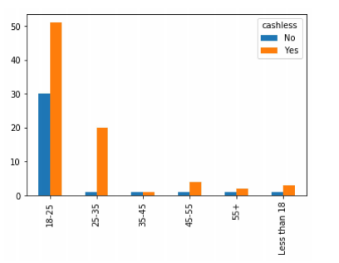RESEARCH METHODOLOGY:

The methodology of this study included these following points as

***Data :***

Data are characteristics or information, usually numerical, that are collected through observation, about one or more persons or objects. It could be like

***Sample/Research Design:***

For this study qualitative and quantitative both research methods are used. Data for study was collected from primary as well secondary sources.

***Primary Data:***

Primary data for research is collected through structured questionnaire.

***Secondary Data:***

Secondary data was gathered from various sources viz: books, reports, journals, published papers.

**Size of Sample:**

The study has been conducted by using sample of 116 out of which 59 from Delhi and the rest 57 from M.P.

***Frequency Distribution:***

It is a list, table or graph that displays the frequency or count of the occurred of values within a particular group or interval.

***Contingency Table:***

A table showing the distribution of one variable in rows and another in columns, used to study the correction between the two variables. It is also known as cross tabulation or crosstab.

***χ2 - statistics:***

A chi-square (*χ*2) statistic is a test that measures how a model compares to actual observed data. It is commonly used for testing relationships between categorical variates.

***p- value:***

A p – value is the probability of obtaining test results at least as extreme as the results actually observed, under the assumption that the null hypothesis is correct. If the p- value is less than significance level, we can’t accept null hypothesis.

***Level of significance:***

Level of significance is the probability of reject null hypothesis when it is true.

***Statistical Hypothesis:***

A Statistical hypothesis is an assumption about a population parameter. This assumption may or may not be true. It is of two types.

***Null Hypothesis:***  It is the hypothesis which is tested for possible rejection under the assumption that it is true. It is denoted by H0.

***Alternative Hypothesis:***  Any hypothesis complementary to the null hypothesis is called an alternative hypothesis. It is denoted by H1.

***Bar Chart:***

A diagram that uses narrow bands of different heights to show different amounts so that they can be compared.

INTERPRETATION & ANALYSIS OF THE STUDY:

## Response Rate

The Data is of two states Delhi and Madhya Pradesh in which 50.8 % data is of Delhi and total observation of data is 116. It consists of 60.34 % of Female and 39.65 % of Male. Majority of the responder are from the age group 18-25 year old of people in which major of them are students.

## Hypothesis Testing

### Hypothesis:

* There is no significant difference in cashless transaction with respect to location i.e. in Delhi and Madhya Pradesh.
* There is no significant difference in cashless transaction gender wise.
* There is no significant relationship between employment status and cashless transaction.

### Hypothesis-1:

* H0: There is no significant difference in cashless transaction with respect to location i.e. in Delhi and Madhya Pradesh.
* H1: There is significant difference in cashless transaction with respect to location i.e. in Delhi and Madhya Pradesh.

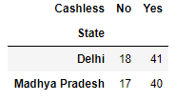

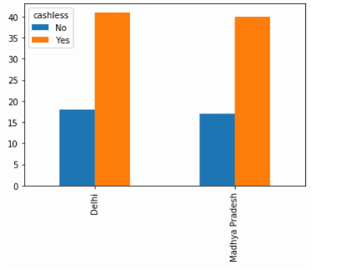

This table shows the relationship of cashless transaction in two states.

From the table, you can see that 15.5 % in a case study not using cashless transaction in Delhi and 14.6% in Madhya Pradesh while 35.3% use cashless transaction in Delhi and 34.4% in Madhya Pradesh.

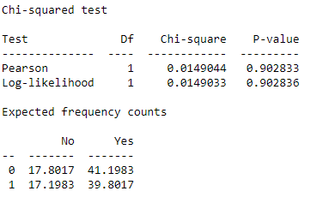

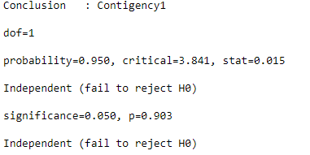

Since the chi-square value is less than the critical value at 5% level of significance which not statistically significant and indicates strong evidence for the null hypothesis. So, we fail to reject the null hypothesis. Further, there is significant difference in cashless transaction with respect to location i.e. in Delhi and Madhya Pradesh (In simple words we can say that the variation in cashless transaction affected by the location of the city).

### Hypothesis-2:

* H0: There is no significant difference in cashless transaction gender wise.
* H1: There is significant difference in cashless transaction gender wise.

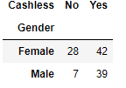

This table shows the relationship of male and female using cashless transaction.

From the table, you can see that 24.13 % Female and 6.03% Male in a case study not using cashless transaction while 36.20% Female and 33.62% Male using cashless transaction.

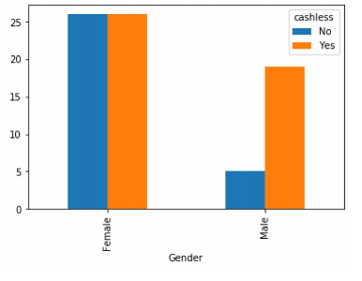

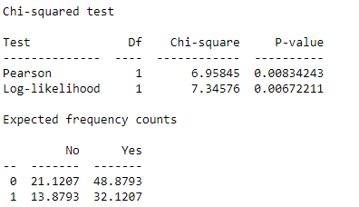

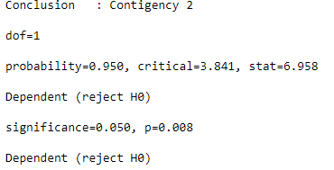

Since the chi-square value is greater than the critical value at 5% level of significance. It indicates strong evidence against the null hypothesis, as there is less than a 5% probability the null is correct (and the results are random). So, we reject the null hypothesis and accept the alternate hypothesis. Therefore, results shows that there is significant difference in cashless transaction by gender wise

### Hypothesis-3:

* There is no significant relationship between employment status and cashless transaction.
* There is significant relationship between employment status and cashless transaction.

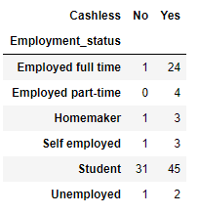

This table shows the relationship of cashless transaction with employment status

From the table, you can see that 20.6% employed workers, 38.7% student and rest 10% other in a case study using cashless transaction while 26.7% student and rest 3% are not using it.

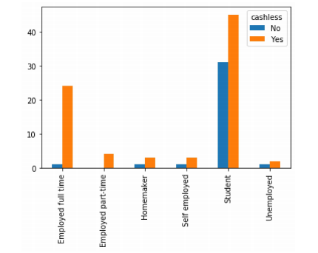

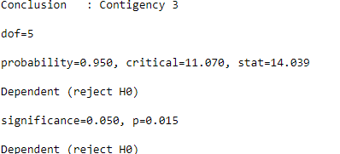

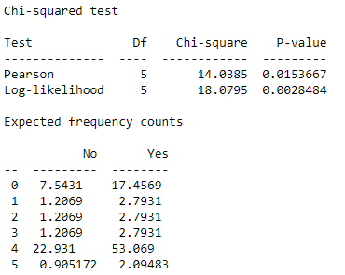

Since the chi-square value is greater than the critical value at 5% level of significance. It indicates strong evidence against the null hypothesis. So, we reject the null hypothesis and accept the alternate hypothesis.

1. **Cashless Economy in near future -**

It can be interpreted from the graph that the youth’s perception for Delhi and M.P. is a less cash economy, where all the major transactions will be through cashless transactions. It can also be seen that the older generation, also have a changed mindset and are anticipating a movement towards a less cash economy. This indicates that people are ready to see and accept a change in the near future.

1. **Mode of Transaction used for day-to-day transaction-**

From the graph, we can evaluate the most of the sample population do not use physical money i.e., cash. The trend towards use of cards and online payments modes are mainly due to the raise in the number of mobile applications after the Demonetizing of currency in India, during the month of November 2016.

**3) Mobile Payments Apps used-**

**4) Reason** **for the adoption of cashless transaction**-

Not only financial inclusion is a reason to shift from a cash-based system to electronic (online) payments, but there are other reasons as well. The above graphs indicate that the convenience of using mobile apps is not only reason for the adoption of online transaction. But the promotion and discount plays a very important role in it. Also the online transaction saves a lot of time.

**5) Consumers’ biggest concern around cashless payments-**

Many consumers would move towards the cashless society, but due to security of application, internet connection, loss of cards/mobile, hacker activity and lack of technology knowledge they still resist cashless transactions.

**6) Indian Economy-**

92.2% respondents are in the support of the cashless India. While 25% and 50.8% respondents are strongly agree and agree respectively that cashless economy help in making India a developed country from a developing country. And rest of them some disagree and some are neutral.

**7) Cashless is tough in India or not-**

10.3% respondents strongly agree that cashless is tough in India, while 48.2% agree the same fact. Only 18.1% respondents disagree the fact. Consumers are also increasingly resorting to cashless methods but India still has a long way to go to before it can become a major cashless economy.

LIMITATIONS OF THE STUDY:

Despite of all efforts and dedication towards this study there are some limitations to this study which are as follows:

* ***Sample Size:*** The sample size considered for this study is very small to represent both the states.
* ***Method of Primary Data:*** Primary data obtained through questionnaire, there is possibility of personal bias or due to any other reason respondent not provided true data.
* The time taken for research also acts as a restrain for the study.

CONCLUSION:

From the interpretation and analysis of this study we may conclude that India is far away from being a cashless economy.

Factor like illiteracy, E-illiteracy, financial unstably rural life style, lack of awareness, internet availability electronic gadgets are some of the major barriers in making India a cashless economy. Due to these barriers we can also say that the dream of making digital India seems difficult to achieve. The government of India trying its best to overcome these barriers and to switch people to cashless modes of transaction.

But government alone cannot do anything, contribution of each and every individual is required. The dream project “Digital India” may be difficult but is not impossible if the government and people of our nation will support each other, in adopting a cashless economy.

Cashless economy is one of the major aspect of digital India and “Digital India “ is a big step for India, as it will not help India to be developed but will also help in economy growth as well as bring a lot of opportunities and prosperity with it.

KEY SUGGESTIONS:

Make people aware about cashless transaction and their advantages, as they can pay money and make purchases anything and anywhere.

* Minimization of convenience charges of e-payments.
* Availability of low cost electronic gadgets like mobile, etc.
* Proper internet facilities and affordable charges.
* Use of promotions and cash back offers to convince people to switch to online transactions.
* Teach people handling of internet banking, mobile banking In order to reduce E-illiteracy.
* Security assurance by providing completely secured applications, so that, there is negligible chances for cybercrime.

REFERENCES:

Jain, V. and Jain, P., 2017. A journey towards a cashless society. *Banking Sector In Oman: Strategic Issues, Challenges And Future Scenarios*, pp.61-72.

Garg, P. and Panchal, M., 2017. Study on Introduction of Cashless Economy in India 2016: Benefits & Challenge’s. *IOSR Journal of Business and Management*, *19*(4), pp.116-120.

Dhanda and Arora (2017), Genesis of cashless society: A study on growing acceptability towards plastic money

Richa Goel, Seema Sahai, Anita Vinaik, Vikas Garg, Moving From Cash to Cashless Economy: - A Study of Consumer Perception Towards Digital Transactions, *International Journal of Recent Technology and Engineering (IJRTE).*

Mukhopadhyay, B., 2016. Understanding cashless payments in India. *Financial Innovation*, *2*(1), pp.1-26.

Kousalya and Shankar(2018), Cashless economy/transaction

<https://vikaspedia.in/e-governance/digital-payment/policies-and-schemes/news-updates-on-digital-payment-promotion>

Gupta Sc and V. K. Kapoor, Fundamentals of Mathematical Statistics.

QUESTIONAIRE:

**Cashless Economy**

This survey is a part of my academic research project aimed at finding out whether consumers in Delhi or Madhya Pradesh are slowly moving away from cash payments. This research hopes to establish an understanding to the people of knowing what cashless system of payment is.

**Person Information**

1. Name

|  |
| --- |
|  |

2. Age

Mark only one.

* Less than 18
* 18-25 years old
* 25-35 years old
* 35-45 years old
* 45-55 years old
* 55+ years old

3. Gender

Mark only one.

* Female
* Male
* Others

4. State

Mark only one.

* Delhi
* Madhya Pradesh

5. What is your current employment status?

Mark only one

* Employed full time
* Employed part-time
* Self employed
* Unemployed
* Homemaker
* Retired
* Student
* Other

**General Information**

6. Are you a cashless transaction user?

Mark only one.

* Yes
* No

7. If, yes why do you use this kind of payment system?

|  |
| --- |
|  |

8. How do you prefer to make payments of your monthly bills?

Mark only one.

* Cash
* Debit/Credit Cards
* Mobile Banking
* Mobile Wallets
* Other

9. How much cash do you prefer to have in hand?

Mark only one.

* Less than 1000
* Between 1000-5000
* Between 5000-10000
* Above 10000

10. Which mobile payment apps do you use?(multiple option can be selected also).

* Google Pay
* Phone Pay
* Paytm
* Mobikiwik
* BHIM
* UPI
* Amazon Pay
* None
* Other

11. How frequently do you use online banking(transaction)?

Mark only one.

* More than once a week
* Once a week
* Once or twice a month
* Less than twice a month
* None

12. Would you consider making payments using mobile phones in future.

Mark only one.

* Strongly Agree
* Agree
* Neutral
* Disagree

13. Do you believe that mobile payments apps or cards are more convenient than bringing cash.

Mark only one.

* Strongly Agree
* Agree
* Neutral
* Disagree

14. Promotions and discount play a substantial role on online transaction.

Mark only one.

* Strongly Agree
* Agree
* Neutral
* Disagree

**Indian Economy**

15. Do you think cashless is tough in India ?

Mark only one.

* Strongly Agree
* Agree
* Neutral
* Disagree

16. Do you support cashless India?

Mark only one.

* Support
* Not Support

17. Can cashless economy help in making India a developed country from a developing country.

Mark only one.

* Strongly Agree
* Agree
* Neutral
* Disagree

**Additional Information**

18. Does online transaction save time?

Mark only one.

* Yes
* No

19. What worries more to switch into cashless transaction.(more than one option can be selected also).

* Security of Application
* Internet Connection
* Loss of Cards/Mobile
* Hackers Activity
* Lack of Technology Knowledge
* Other

20. What can you suggest for the improvement of cashless system of payment in India?