
DATABASE MANAGEMENT SYSTEMS
CORNERSTONE PROJECT REPORT
on
UNIVERSITY ACADEMIC MANAGEMENT SYSTEM
Submitted by
S.No | Student Name | Roll Number
1 | Shaik Abdul Rajak | 25B11AIA90
2 | Surada Rajesh | 25B11AI474
3 | Pobolu Venkata Pavan | 25B11AI866
Under the esteemed guidance of
Mr. T.Srinivasulu M.Tech, (Ph.D.)
Assistant Professor



DEPARTMENT OF ARTIFICIAL INTELLIGENCE AND MACHINE LEARNING
ADITYA UNIVERSITY
(Formerly Aditya Engineering College (A))
Aditya Nagar, ADB Road, Surampalem, Andhra Pradesh, India

2026-2027



Aditya Nagar, ADB Road, Surampalem, Andhra Pradesh, India

DEPARTMENT OF ARTIFICIAL INTELLIGENCE AND MACHINE LEARNING

CERTIFICATE

This is to certify that the project report entitled “UNIVERSITY ACADEMIC MANAGEMENT SYSTEM” is a bonafide record of the work carried out by Shaik Abdul Rajak (25B11AIA90), Surada Rajesh (25B11AI474) and Pobolu Venkata Pavan (25B11AI866), students of the Department of Artificial Intelligence & Machine Learning, Aditya University, as part of the Database Management Systems Cornerstone Project during the academic year 2026 – 2027.
The work embodied in this report has been carried out under our supervision and has not been submitted to any other university or institution for the award of any degree or diploma.
Project Guide Head of the Department
Mr. T. Srinivasulu, M. Tech, (Ph.D.) Dr. K. Naga Bhargavi, M. Tech, Ph.D. Associate professor Associate Professor & HOD

External Examiner

DECLARATION

We hereby declare that the project report entitled “UNIVERSITY ACADEMIC MANAGEMENT SYSTEM”, submitted to the Department of Artificial Intelligence & Machine Learning, Aditya University, is a record of original work done by us. The database design, the SQL scripts, the sample data and the outputs presented in this report were prepared by our team, and wherever the ideas or material of other authors have been used, they have been acknowledged in the references.
We further declare that this work has not been submitted, in part or in full, to any other university or institution for the award of any degree or diploma.
Shaik Abdul Rajak (25B11AIA90)
Surada Rajesh (25B11AI474)
Pobolu Venkata Pavan (25B11AI866)

Date: 22-09-2026
Place: Surampalem

ACKNOWLEDGEMENT

We express our sincere gratitude to our project guide, for the constant guidance, Mr. T. Srinivasulu encouragement and valuable suggestions that shaped this project from the selection of the topic to the preparation of the final report.
We are thankful to Dr. K. Naga Bhargavi ,Head of the Department of Artificial Intelligence & Machine Learning, and to all the faculty members of the department for providing the laboratory facilities and the academic environment needed to complete this work.
We also thank the management of Aditya University for the opportunity to take up a cornerstone project that connects the concepts learned in the Database Management Systems course with a practical problem.
Finally, we thank our parents and friends for their support, and the members of our team for the cooperation and shared effort that made it possible to complete every review on time.
Shaik Abdul Rajak (25B11AIA90)
Surada Rajesh (25B11AI474)
Pobolu Venkata Pavan (25B11AI866)

ABSTRACT

Every semester a university records a large amount of interrelated academic data: the departments, the faculty who belong to them, the students who are admitted, the courses on offer, the registration of students for those courses, and the marks finally awarded. When this data lives in separate spreadsheets and registers, the same details are typed again and again, marks cannot be tied reliably to the course they belong to, and even a simple question such as the average mark in a subject has to be worked out by hand. The University Academic Management System replaces this arrangement with a single normalized relational database.
Six core entities — Department, Faculty, Student, Course, Enrollment and Results — were identified, together with two supporting tables, Student_Phone and Faculty_Qualification, that hold the multi-valued attributes. The design was drawn as an ER diagram, mapped to a relational schema and normalized up to the Third Normal Form. It was then implemented in MySQL 8.0 with primary key, foreign key, UNIQUE, NOT NULL, CHECK, DEFAULT and ON DELETE CASCADE constraints, and loaded with representative sample data in all eight tables.
Seventeen SQL queries covering data retrieval, joins, aggregate functions, GROUP BY with HAVING, nested and correlated subqueries, views and set operations were executed, together with DCL and TCL commands, and twelve test cases confirmed that the database itself rejects duplicate keys, out-of-range values and orphan records. The resulting system stores every academic fact exactly once, enforces referential integrity automatically, and answers academic questions with a single SQL statement.

INDEX

Chapter | Title | Page No.
 | Certificate | i
 | Declaration | ii
 | Acknowledgement | iii
 | Abstract | iv
 | List of Figures | vii
 | List of Tables | vii
1 | Introduction | 1
 | 1.1 Introduction to the Domain | 1
 | 1.2 Problem Statement | 1
 | 1.3 Motivation and Need for a Database | 1
 | 1.4 Objectives of the Project | 2
 | 1.5 Scope of the Project | 2
 | 1.6 Organization of the Report | 2
2 | System Study and Tools | 3
 | 2.1 Existing System and Its Limitations | 3
 | 2.2 Proposed Database System | 3
 | 2.3 Tools and Technologies Used | 3
 | 2.4 Software and Hardware Requirements | 4
3 | Database Design (Review – I) | 5
 | 3.1 Identified Entities | 5
 | 3.2 Entity Attributes and Attribute Types | 5
 | 3.3 ER Diagram | 6
 | 3.4 Relationships and Cardinality | 8
 | 3.5 Relational Database Schema | 8
 | 3.6 Primary Keys and Foreign Keys | 11
 | 3.7 Normalization up to 3NF | 11
4 | Database Implementation (Review – II) | 13
 | 4.1 Database and Table Creation – DDL | 13
 | 4.2 Sample Data Insertion – DML | 15
 | 4.3 Constraints and Data Integrity | 17
 | 4.4 Data Validation Rules | 17
5 | SQL Operations and Queries | 19
 | 5.1 DQL – Basic Retrieval Queries | 19
 | 5.2 Join Operations | 20
 | 5.3 Aggregate Functions, GROUP BY and HAVING | 22
 | 5.4 Nested and Correlated Subqueries | 23
 | 5.5 Views and Relational Set Operations | 24
 | 5.6 DCL and TCL Operations | 26
6 | Modules and Functionalities | 28
7 | Results – Sample Outputs and Screenshots | 29
8 | Testing and Data Validation | 31
9 | GitHub Repository and Team Contribution | 32
10 | Conclusion and Future Enhancements | 33
 | References | 34
 | Appendix A – Complete SQL Script | 35

LIST OF FIGURES

Figure No. | Title of the Figure | Page No.
Fig. 3.1 | ER Diagram of the University Academic Management System | 7
Fig. 3.2 | Relational Schema Diagram | 10
Fig. 4.1 | Successful Creation of Tables | 14
Fig. 4.2 | Sample Data Inserted into the Tables | 16
Fig. 4.3 | Referential Integrity Enforced by the Database | 18
Fig. 7.1 | Student-wise Result Report Output | 29
Fig. 7.2 | Department-wise Student Strength Output | 29
Fig. 7.3 | Course-wise Performance Summary Output | 30

LIST OF TABLES

Table No. | Title of the Table | Page No.
Table 2.1 | Tools and Technologies Used | 3
Table 2.2 | Software and Hardware Requirements | 4
Table 3.1 | Entities Identified for the Selected Domain | 5
Table 3.2 | Attributes of Each Entity | 5
Table 3.3 | Relationships and Cardinality | 8
Table 3.4 | Relational Database Schema | 8
Table 3.5 | Primary Key and Foreign Key Definitions | 11
Table 3.6 | Normalization Steps | 12
Table 4.1 | Sample Data Summary | 16
Table 4.2 | Constraints and Data Integrity Rules | 17
Table 6.1 | Modules and Their Functionalities | 28
Table 8.1 | Test Cases and Results | 31
Table 9.1 | Team Responsibilities | 32
Table 9.2 | Review-wise Progress Record | 32

CHAPTER 1: INTRODUCTION

1.1 Introduction to the Domain
A university is an academic institution that admits students into departments, appoints faculty to teach in them, offers a set of courses every semester, registers students for those courses and finally declares the examination results. Each of these activities produces data, and the items of data depend on one another. A course is offered by one department and taught by one faculty member; a student belongs to a department and registers for several courses; a result never stands alone but always belongs to one particular registration.
The University Academic Management System is a relational database that holds this academic data for a single institution. It covers the departments, the faculty working in them, the students admitted into them, the courses offered, the enrollment of students into courses for a semester, and the marks and grades awarded at the end of that semester. The work has been carried out as the Database Management Systems Cornerstone Project of the Department of Artificial Intelligence & Machine Learning and is reported in two reviews: Review – I (database design) and Review – II (database implementation).

1.2 Problem Statement
In many departments academic records are still kept in separate spreadsheets and printed registers. The admission section maintains the student list, every faculty member keeps a private marks sheet, and the examination section prepares the result sheet on its own. This arrangement leads to four recurring problems.
- Data redundancy — the same student name, roll number and department are typed into the admission list, into every course register and again into the result sheet.
- Data inconsistency — when a student’s department changes or a spelling is corrected in one file, the other files continue to carry the old value.
- No integrity checking — nothing prevents marks from being entered for a student who never registered for the course, or a course from being attached to a department that does not exist.
- Difficult retrieval — questions such as “what is the average mark in each course?” or “which students scored above the class average?” have to be compiled by hand from several files.
The proposed system stores every fact exactly once in a normalized table, connects the tables through foreign keys so that invalid data is rejected by the database itself, and answers the questions above with a single SQL statement.

1.3 Motivation and Need for a Database
A spreadsheet can hold rows, but it cannot enforce the relationships between them. It will accept a duplicate roll number, a mark of 250 out of 100, or a result that points to a course that has since been deleted. A database management system checks such rules at the moment of insertion through PRIMARY KEY, UNIQUE, CHECK and FOREIGN KEY constraints, so bad data never enters the system. It also lets several users work on the same data at the same time, supports transactions so that a half-finished update can be undone, and offers a query language in which complex academic questions are stated declaratively instead of being worked out manually.

1.4 Objectives of the Project
- To design a normalized relational database for university academic management with at least six entities, and to represent the design as an ER diagram showing all attributes, relationships and cardinalities.
- To convert the ER design into a relational schema and to normalize it up to the Third Normal Form so that partial and transitive dependencies are removed.
- To implement the schema in MySQL with primary keys, foreign keys and suitable NOT NULL, UNIQUE, CHECK and DEFAULT constraints, and to load every table with representative sample data.
- To write and execute SQL operations covering DDL, DML, DQL, joins, aggregate functions, subqueries, views, set operations, DCL and TCL.
- To verify data integrity by showing that the database rejects duplicate keys, out-of-range values and orphan records.

1.5 Scope of the Project
The database covers the academic side of university operations: departments, faculty, students, courses, enrollment and results. Several semesters can be stored side by side through the semester attribute of the Enrollment table, and multi-valued attributes such as the phone numbers of a student and the qualifications of a faculty member are handled through separate tables.
The following are outside the scope of the present work: fee payment and accounts, attendance recording, hostel and transport management, library circulation, placement records, and any graphical front-end. The project is a database design and implementation exercise, and all interaction with the data is through SQL.

1.6 Organization of the Report
The report is organized into ten chapters. Chapter 2 presents the system study and the tools used. Chapter 3 covers the complete database design — entities, attributes, the ER diagram, the relational schema and normalization — and corresponds to Review – I. Chapter 4 describes the implementation, with the DDL script, sample data and integrity checks, and corresponds to Review – II. Chapter 5 presents the SQL operations that were executed. Chapter 6 explains the modules and their functionality, Chapter 7 shows the sample outputs, and Chapter 8 documents the testing. Chapter 9 gives the repository details and the contribution of each team member, and Chapter 10 concludes the report with limitations and future enhancements.

CHAPTER 2: SYSTEM STUDY AND TOOLS

2.1 Existing System and Its Limitations
The existing arrangement is file based. Each section keeps its own spreadsheet and the files are passed around by e-mail or on a pen drive at the end of the semester. The study of this arrangement revealed the following limitations.
- The same student details appear in at least three files, so every correction has to be made three times and is often made only once.
- There is no automatic link between a registration and a result. The examination section matches them by roll number, and a single typing error produces an orphan mark sheet.
- No range checks exist — credits, marks and grades are typed as free text and can hold impossible values.
- Only one person can hold the master file at a time, so concurrent updating is not possible.
- Summary reports such as department-wise strength or course-wise averages must be prepared manually every time they are requested.

2.2 Proposed Database System
The proposed system is a single relational database in which every fact is stored once. Student, Faculty, Course and Department details are held in their own tables. The many-to-many association between students and courses is resolved by the Enrollment table, and each enrollment can carry one Results row. Foreign keys make orphan records impossible, CHECK constraints keep credits and marks inside valid ranges, and UNIQUE constraints prevent duplicate e-mail addresses and course codes. Reports that used to be compiled manually are produced by one SELECT statement, and the frequently needed ones are saved as views.

2.3 Tools and Technologies Used
Table 2.1: Tools and Technologies Used
Category | Tool / Technology Used | Version / Remarks
Database Server | MySQL | 8.0 — relational DBMS used for implementation
Query / Admin Tool | MySQL Workbench / mysql client | 8.0 — script execution and output capture
ER Diagram Tool | draw.io (diagrams.net) | Web version — ER and schema diagrams
Version Control | Git and GitHub | Team repository for the SQL scripts and report
Documentation | Microsoft Word | Report preparation

2.4 Software and Hardware Requirements
Table 2.2: Software and Hardware Requirements
Requirement Type | Specification
Operating System | Windows 10 / 11 (64-bit) or Ubuntu 22.04
Database Server | MySQL 8.0 or above
Client Tool | MySQL Workbench 8.0 CE / MySQL command-line client
Processor | Intel Core i3 or above
RAM | 4 GB minimum, 8 GB recommended
Disk Space | 2 GB free (server, sample data and documentation)

CHAPTER 3: DATABASE DESIGN

3.1 Identified Entities
Six core entities were identified from the study of the domain. Two supporting tables were added during normalization to hold multi-valued attributes, which gives eight tables in all.
Table 3.1: Entities Identified for the Selected Domain
S.No | Entity Name | Description
1 | Department | An academic department of the university, such as CSE or AIML. Every student, faculty member and course belongs to one department.
2 | Faculty | A teaching staff member appointed to a department. A faculty member may handle one or more courses and may be the head of a department.
3 | Student | A student admitted into a department. A student registers for several courses in a semester.
4 | Course | A subject offered by one department and handled by one faculty member, carrying a fixed number of credits.
5 | Enrollment | The registration of one student for one course in a given semester. It resolves the many-to-many association between Student and Course.
6 | Results | The marks and grade awarded for one enrollment. At most one Results row exists for each enrollment.
7 | Student_Phone | Supporting table holding the multi-valued phone numbers of a student (introduced to satisfy 1NF).
8 | Faculty_Qualification | Supporting table holding the multi-valued qualifications of a faculty member (introduced to satisfy 1NF).

3.2 Entity Attributes and Attribute Types
The attributes of each entity are listed below with the data type, the key role and the attribute classification. Following the ER model, an attribute is Simple if it cannot be divided further, Composite if it is made up of smaller attributes, Multi-valued if one entity instance may hold several values, and Derived if its value is computed from other stored attributes.
Table 3.2: Attributes of Each Entity
Entity | Attribute | Data Type | Key / Constraint | Attribute Type
Department | dept_id | INT | PK | Simple
 | dept_name | VARCHAR(100) | UNIQUE, NOT NULL | Simple
 | established_year | YEAR | — | Simple
 | hod_id | INT | FK → Faculty | Simple
Faculty | faculty_id | INT | PK | Simple
 | first_name | VARCHAR(50) | NOT NULL | Composite part of full_name
 | last_name | VARCHAR(50) | NOT NULL | Composite part of full_name
 | designation | VARCHAR(50) | — | Simple
 | email | VARCHAR(100) | UNIQUE, NOT NULL | Simple
 | dept_id | INT | FK → Department | Simple
 | qualification | VARCHAR(50) | — | Multi-valued (own table)
Student | student_id | INT | PK | Simple
 | first_name | VARCHAR(50) | NOT NULL | Composite part of full_name
 | last_name | VARCHAR(50) | NOT NULL | Composite part of full_name
 | dob | DATE | — | Simple
 | age | — | not stored | Derived from dob
 | email | VARCHAR(100) | UNIQUE, NOT NULL | Simple
 | address | TEXT | — | Composite (street, city, pin)
 | phone | VARCHAR(15) | — | Multi-valued (own table)
 | dept_id | INT | FK → Department | Simple
Course | course_id | INT | PK | Simple
 | course_name | VARCHAR(100) | NOT NULL | Simple
 | course_code | VARCHAR(20) | UNIQUE, NOT NULL | Simple
 | credits | INT | CHECK 1–6 | Simple
 | dept_id | INT | FK → Department | Simple
 | faculty_id | INT | FK → Faculty | Simple
Enrollment | enrollment_id | INT | PK | Simple
 | student_id | INT | FK → Student | Simple
 | course_id | INT | FK → Course | Simple
 | semester | VARCHAR(20) | — | Simple
 | enrollment_date | DATE | — | Simple
Results | result_id | INT | PK | Simple
 | enrollment_id | INT | FK, UNIQUE | Simple
 | marks_obtained | DECIMAL(5,2) | CHECK ≥ 0 | Simple
 | total_marks | DECIMAL(5,2) | DEFAULT 100 | Simple
 | percentage | — | not stored | Derived from marks / total
 | grade | CHAR(2) | — | Simple
 | exam_date | DATE | — | Simple

3.3 ER Diagram
The ER diagram on the next page shows the six core entities as rectangles, their attributes as ellipses, and the relationships as named diamonds with the cardinality marked on every line. Primary key attributes are underlined, derived attributes (age and percentage) are drawn with a dashed outline, and multi-valued attributes (phone_no and qualification) with a double outline. Foreign key columns are not drawn as attributes because the relationships already express them; they appear in the relational schema in Section 3.5.

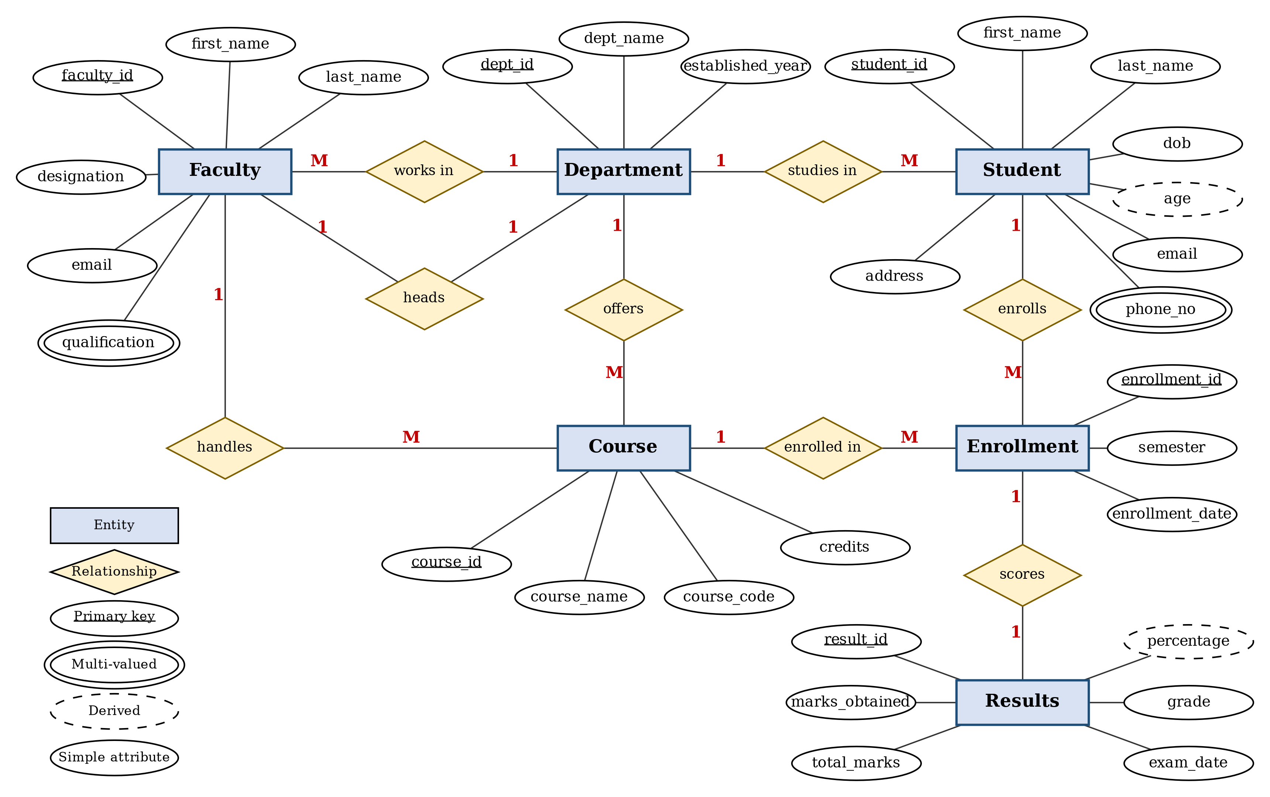
Fig. 3.1: ER Diagram of the University Academic Management System

3.4 Relationships and Cardinality
Table 3.3: Relationships and Cardinality
Entity 1 | Relationship | Entity 2 | Cardinality | Participation
Student | studies in | Department | M : 1 | Partial on Student
Faculty | belongs to | Department | M : 1 | Partial on Faculty
Department | headed by | Faculty | 1 : 1 | Partial on Department
Course | offered by | Department | M : 1 | Partial on Course
Course | handled by | Faculty | M : 1 | Partial on Course
Student | enrolls (via Enrollment) | Course | M : N | Total on Enrollment
Enrollment | scores | Results | 1 : 1 | Partial on Enrollment, total on Results
The association between Student and Course is many-to-many: one student registers for several courses and one course is taken by several students. A many-to-many relationship cannot be stored directly in the relational model, so it is resolved through the Enrollment table, which carries the foreign keys of both entities together with the descriptive attributes semester and enrollment_date. In the ER diagram Enrollment is therefore drawn as an entity with two one-to-many relationships.
The participation column follows the constraints actually declared in the DDL. The foreign keys dept_id, faculty_id and hod_id are left nullable so that a record can be created before its department or faculty is assigned, which makes participation partial on those sides; the foreign keys of Enrollment and Results are declared NOT NULL, which makes participation total on the child side.

3.5 Relational Database Schema
The ER design was converted into the relational schema below. Each entity became a table, each multi-valued attribute became a separate table linked by a foreign key, and each one-to-many relationship was implemented by placing the foreign key on the many side. The circular link between Department (hod_id) and Faculty (dept_id) is resolved by adding the hod_id foreign key with ALTER TABLE after both tables exist.
Table 3.4: Relational Database Schema
Table Name | Column Name | Data Type | Key | Constraints
Department | dept_id | INT | PK | AUTO_INCREMENT
 | dept_name | VARCHAR(100) | — | NOT NULL, UNIQUE
 | established_year | YEAR | — | —
 | hod_id | INT | FK | REFERENCES Faculty
Faculty | faculty_id | INT | PK | AUTO_INCREMENT
 | first_name | VARCHAR(50) | — | NOT NULL
 | last_name | VARCHAR(50) | — | NOT NULL
 | designation | VARCHAR(50) | — | —
 | email | VARCHAR(100) | — | NOT NULL, UNIQUE
 | dept_id | INT | FK | REFERENCES Department
Faculty_Qualification | id | INT | PK | AUTO_INCREMENT
 | faculty_id | INT | FK | NOT NULL, REFERENCES Faculty, ON DELETE CASCADE
 | qualification | VARCHAR(50) | — | NOT NULL
Student | student_id | INT | PK | AUTO_INCREMENT
 | first_name | VARCHAR(50) | — | NOT NULL
 | last_name | VARCHAR(50) | — | NOT NULL
 | dob | DATE | — | —
 | email | VARCHAR(100) | — | NOT NULL, UNIQUE
 | address | TEXT | — | —
 | dept_id | INT | FK | REFERENCES Department
Student_Phone | id | INT | PK | AUTO_INCREMENT
 | student_id | INT | FK | NOT NULL, REFERENCES Student, ON DELETE CASCADE
 | phone | VARCHAR(15) | — | —
Course | course_id | INT | PK | AUTO_INCREMENT
 | course_name | VARCHAR(100) | — | NOT NULL
 | course_code | VARCHAR(20) | — | NOT NULL, UNIQUE
 | credits | INT | — | CHECK (credits BETWEEN 1 AND 6)
 | dept_id | INT | FK | REFERENCES Department
 | faculty_id | INT | FK | REFERENCES Faculty
Enrollment | enrollment_id | INT | PK | AUTO_INCREMENT
 | student_id | INT | FK | NOT NULL, REFERENCES Student
 | course_id | INT | FK | NOT NULL, REFERENCES Course
 | semester | VARCHAR(20) | — | UNIQUE (student_id, course_id, semester)
 | enrollment_date | DATE | — | —
Results | result_id | INT | PK | AUTO_INCREMENT
 | enrollment_id | INT | FK | NOT NULL, UNIQUE, REFERENCES Enrollment
 | marks_obtained | DECIMAL(5,2) | — | CHECK (marks_obtained >= 0)
 | total_marks | DECIMAL(5,2) | — | DEFAULT 100
 | grade | CHAR(2) | — | —
 | exam_date | DATE | — | —
The schema diagram on the next page shows the same tables with their primary keys and the foreign key links between them.

Schema Diagram
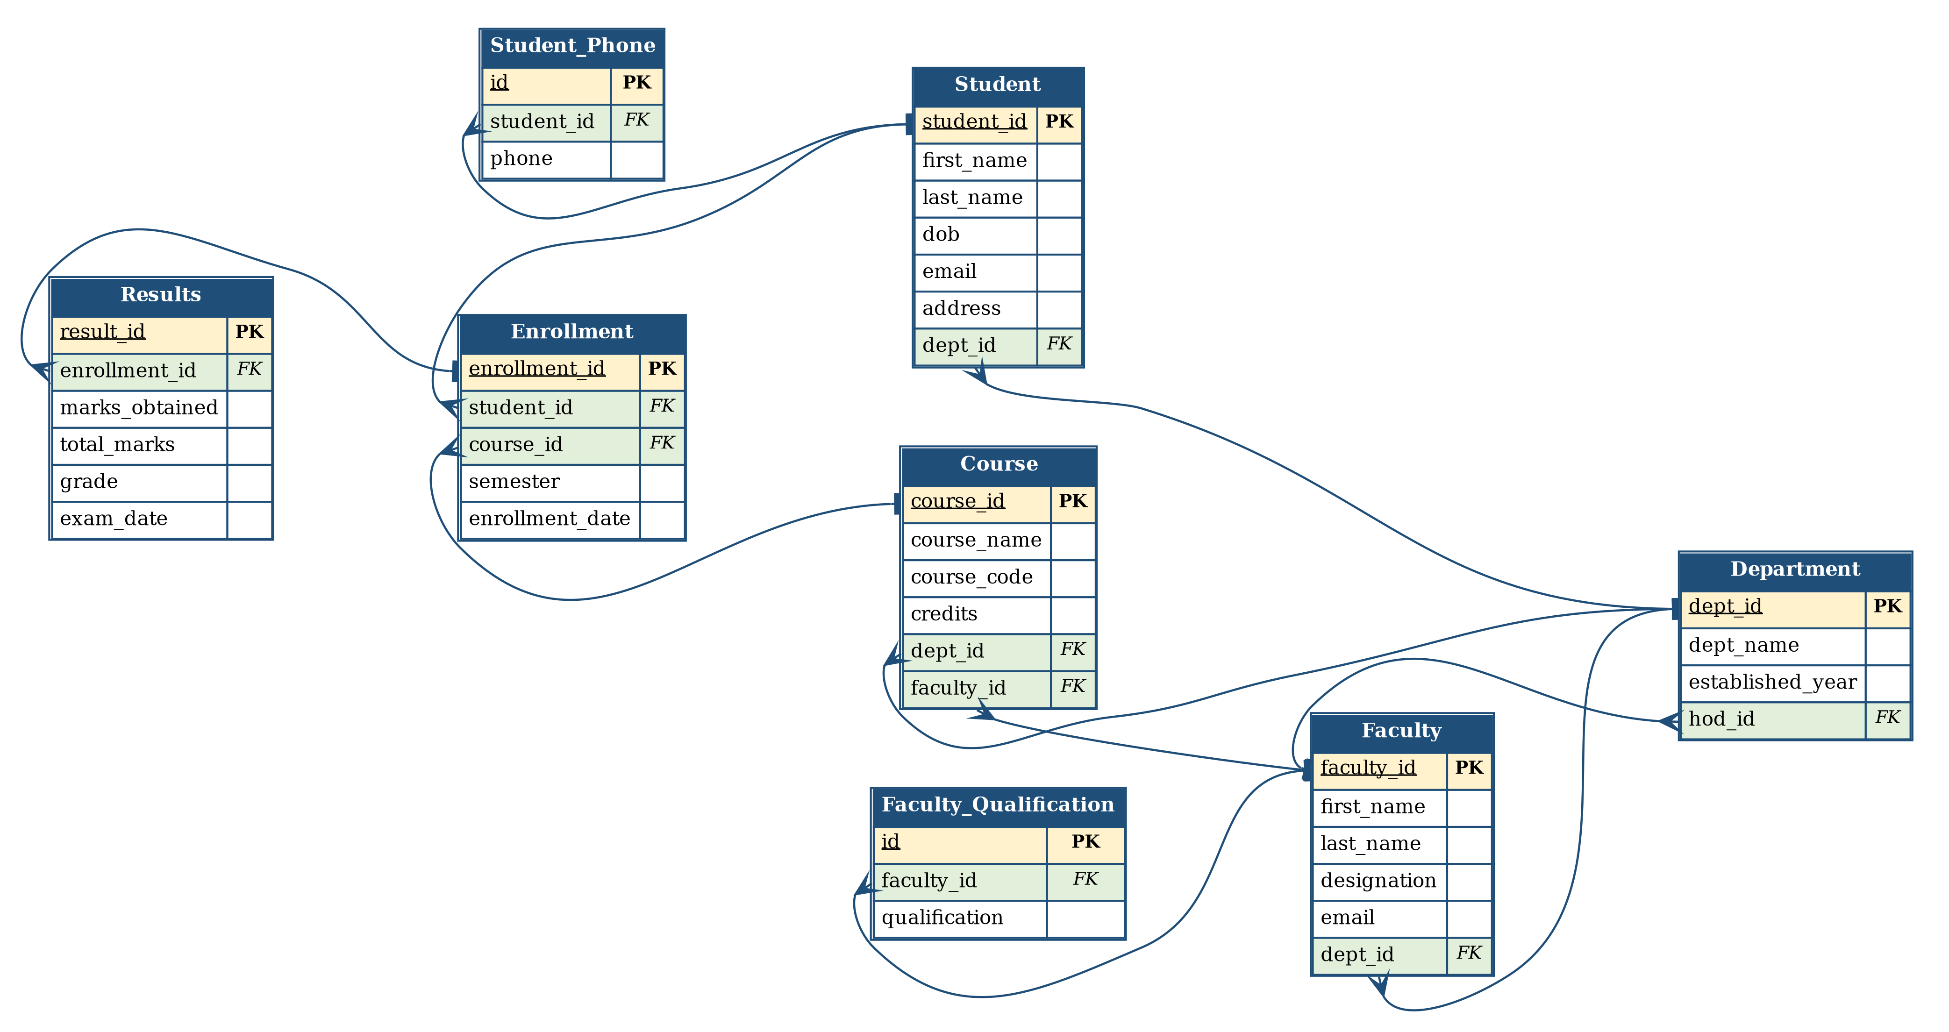
Fig. 3.2: Relational Schema Diagram

3.6 Primary Keys and Foreign Keys
Every table has a single-column, auto-incremented surrogate primary key. Ten foreign key constraints connect the eight tables.
Table 3.5: Primary Key and Foreign Key Definitions
Table | Primary Key | Foreign Key | References
Department | dept_id | hod_id | Faculty(faculty_id)
Faculty | faculty_id | dept_id | Department(dept_id)
Faculty_Qualification | id | faculty_id | Faculty(faculty_id)
Student | student_id | dept_id | Department(dept_id)
Student_Phone | id | student_id | Student(student_id)
Course | course_id | dept_id  faculty_id | Department(dept_id)  Faculty(faculty_id)
Enrollment | enrollment_id | student_id  course_id | Student(student_id)  Course(course_id)
Results | result_id | enrollment_id | Enrollment(enrollment_id)

3.7 Normalization up to 3NF
The initial design placed all academic information in one unnormalized relation, in which a single row described a student together with one course taken and the mark obtained in it.
STUDENT_COURSE_RESULT (
student_id, student_name, dob, phone_numbers, dept_id, dept_name,
course_id, course_name, credits, faculty_id, faculty_name,
semester, marks_obtained, total_marks, percentage, grade )

First Normal Form (1NF)
The attribute phone_numbers held several values in one cell, and qualifications of faculty had the same problem, while address combined street, city and pin. 1NF requires every attribute to be atomic and every row to be unique. The repeating phone numbers were therefore moved to a separate Student_Phone table linked by student_id, and the faculty qualifications to Faculty_Qualification linked by faculty_id.

Second Normal Form (2NF)
After 1NF the key of the combined relation was the composite (student_id, course_id, semester). Attributes such as student_name and dob depend only on student_id, and course_name and credits depend only on course_id. These are partial dependencies on a part of the composite key, which 2NF does not allow. The relation was decomposed into Student, Course and Enrollment so that every non-key attribute depends on the whole key of its own table.

Third Normal Form (3NF)
A transitive dependency remained: dept_name depended on dept_id, which in turn depended on student_id. Because dept_name is determined by a non-key attribute, the Department table was separated out and only dept_id was retained as a foreign key in Student, Faculty and Course. The derived attribute percentage is not stored at all; it is computed in the view v_student_result, so the same fact is never held twice.
One deliberate exception is documented: the grade is stored in Results even though it follows from marks_obtained under the grading scale. The stored value records the grade actually awarded, which can differ from the scale after moderation or grace marks, and it is kept as a convenience for reporting. This point is revisited among the limitations in Chapter 10.
UNF → 1NF → 2NF → 3NF

Table 3.6: Normalization Steps
Normal Form | Condition Satisfied | Anomaly Removed | Resulting Tables
1NF | All attributes atomic; no repeating groups | Multi-valued phone numbers and qualifications in one cell | Student, Student_Phone, Faculty, Faculty_Qualification
2NF | No partial dependency on part of a composite key | Student and course details repeated for every enrollment | Student, Course, Enrollment
3NF | No transitive dependency on a non-key attribute | Department name repeated in every student and course row | Department, Faculty, Student, Course, Enrollment, Results
After the third step the schema consists of eight tables in which every non-key attribute depends on the key, the whole key and nothing but the key, apart from the documented grade convenience.

CHAPTER 4: DATABASE IMPLEMENTATION

4.1 Database and Table Creation – DDL
The schema was implemented in MySQL 8.0. The tables are created in dependency order so that a referenced table exists before the foreign key that refers to it is declared. Department and Faculty refer to each other, so the hod_id foreign key of Department is added with ALTER TABLE after Faculty has been created.
CREATE DATABASE university_academic;
USE university_academic;

CREATE TABLE Department (
dept_id INT PRIMARY KEY AUTO_INCREMENT,
dept_name VARCHAR(100) NOT NULL UNIQUE,
established_year YEAR,
hod_id INT
);

CREATE TABLE Faculty (
faculty_id INT PRIMARY KEY AUTO_INCREMENT,
first_name VARCHAR(50) NOT NULL,
last_name VARCHAR(50) NOT NULL,
designation VARCHAR(50),
email VARCHAR(100) NOT NULL UNIQUE,
dept_id INT,
FOREIGN KEY (dept_id) REFERENCES Department(dept_id)
);

ALTER TABLE Department
ADD CONSTRAINT fk_dept_hod
FOREIGN KEY (hod_id) REFERENCES Faculty(faculty_id);

CREATE TABLE Faculty_Qualification (
id INT PRIMARY KEY AUTO_INCREMENT,
faculty_id INT NOT NULL,
qualification VARCHAR(50) NOT NULL,
FOREIGN KEY (faculty_id) REFERENCES Faculty(faculty_id)
ON DELETE CASCADE
);

CREATE TABLE Student (
student_id INT PRIMARY KEY AUTO_INCREMENT,
first_name VARCHAR(50) NOT NULL,
last_name VARCHAR(50) NOT NULL,
dob DATE,
email VARCHAR(100) NOT NULL UNIQUE,
address TEXT,
dept_id INT,
FOREIGN KEY (dept_id) REFERENCES Department(dept_id)
);

CREATE TABLE Student_Phone (
id INT PRIMARY KEY AUTO_INCREMENT,
student_id INT NOT NULL,
phone VARCHAR(15),
FOREIGN KEY (student_id) REFERENCES Student(student_id)
ON DELETE CASCADE
);

CREATE TABLE Course (
course_id INT PRIMARY KEY AUTO_INCREMENT,
course_name VARCHAR(100) NOT NULL,
course_code VARCHAR(20) NOT NULL UNIQUE,
credits INT CHECK (credits BETWEEN 1 AND 6),
dept_id INT,
faculty_id INT,
FOREIGN KEY (dept_id) REFERENCES Department(dept_id),
FOREIGN KEY (faculty_id) REFERENCES Faculty(faculty_id)
);

CREATE TABLE Enrollment (
enrollment_id INT PRIMARY KEY AUTO_INCREMENT,
student_id INT NOT NULL,
course_id INT NOT NULL,
semester VARCHAR(20),
enrollment_date DATE,
UNIQUE (student_id, course_id, semester),
FOREIGN KEY (student_id) REFERENCES Student(student_id),
FOREIGN KEY (course_id) REFERENCES Course(course_id)
);

CREATE TABLE Results (
result_id INT PRIMARY KEY AUTO_INCREMENT,
enrollment_id INT NOT NULL UNIQUE,
marks_obtained DECIMAL(5,2) CHECK (marks_obtained >= 0),
total_marks DECIMAL(5,2) DEFAULT 100,
grade CHAR(2),
exam_date DATE,
FOREIGN KEY (enrollment_id) REFERENCES Enrollment(enrollment_id)
);
The script ran without errors and created eight tables. The output of SHOW TABLES is shown below.
Tables_in_university_academic
Course
Department
Enrollment
Faculty
Faculty_Qualification
Results
Student
Student_Phone
Fig. 4.1: Successful Creation of Tables

4.2 Sample Data Insertion – DML
Sample data was inserted into all eight tables. It was chosen so that every relationship and constraint is exercised: one department (Mechanical Engineering) has neither students nor courses, one department (Electronics and Communication) has a student but offers no course, two enrollments have no result yet, and one student holds two phone numbers. The department heads are assigned by UPDATE statements after the faculty rows exist.
INSERT INTO Department (dept_id, dept_name, established_year, hod_id) VALUES
(1, 'Computer Science and Engineering', 1998, NULL),
(2, 'Artificial Intelligence and Machine Learning', 2020, NULL),
(3, 'Electronics and Communication Engineering', 1995, NULL),
(4, 'Mechanical Engineering', 1990, NULL);

INSERT INTO Faculty
(faculty_id, first_name, last_name, designation, email, dept_id) VALUES
(1, 'Ramana', 'Murthy', 'Professor', 'rmurthy@uni.edu', 1),
(2, 'Sunitha', 'Rao', 'Associate Professor', 'srao@uni.edu', 1),
(3, 'Anil', 'Kumar', 'Professor', 'akumar@uni.edu', 2),
(4, 'Divya', 'Sree', 'Assistant Professor', 'dsree@uni.edu', 2),
(5, 'Prasad', 'Reddy', 'Associate Professor', 'preddy@uni.edu', 3),
(6, 'Mohan', 'Krishna', 'Assistant Professor', 'mkrishna@uni.edu', 4);

UPDATE Department SET hod_id = 1 WHERE dept_id = 1;
UPDATE Department SET hod_id = 3 WHERE dept_id = 2;
UPDATE Department SET hod_id = 5 WHERE dept_id = 3;
UPDATE Department SET hod_id = 6 WHERE dept_id = 4;

INSERT INTO Faculty_Qualification (faculty_id, qualification) VALUES
(1, 'Ph.D. (Computer Science)'), (1, 'M.Tech'), (2, 'M.Tech'),
(3, 'Ph.D. (Machine Learning)'), (4, 'M.Tech (AI)'),
(5, 'Ph.D. (VLSI Design)'), (6, 'M.E. (Thermal Engineering)');

INSERT INTO Student
(student_id, first_name, last_name, dob, email, address, dept_id) VALUES
(1, 'Ravi', 'Kumar', '2002-05-12', 'ravi@uni.edu', 'Kakinada, AP', 1),
(2, 'Priya', 'Sharma', '2003-08-22', 'priya@uni.edu', 'Rajahmundry, AP', 2),
(3, 'Arjun', 'Reddy', '2002-11-30', 'arjun@uni.edu', 'Surampalem, AP', 1),
(4, 'Kiran', 'Varma', '2003-03-18', 'kiran@uni.edu', 'Amalapuram, AP', 2),
(5, 'Meena', 'Iyer', '2002-09-09', 'meena@uni.edu', 'Vijayawada, AP', 3),
(6, 'Harsha', 'Vardhan', '2003-01-27', 'harsha@uni.edu', 'Tuni, AP', 1);

INSERT INTO Student_Phone (student_id, phone) VALUES
(1, '9876500011'), (1, '9440022033'), (2, '9848011122'), (3, '9701133244'),
(4, '9885544310'), (5, '9963300451'), (6, '9032155670');

INSERT INTO Course
(course_id, course_name, course_code, credits, dept_id, faculty_id) VALUES
(1, 'Database Management Systems', 'CS401', 4, 1, 1),
(2, 'Data Structures', 'CS201', 3, 1, 2),
(3, 'Operating Systems', 'CS301', 4, 1, 1),
(4, 'Machine Learning', 'AM301', 4, 2, 3),
(5, 'Deep Learning', 'AM402', 4, 2, 4);

INSERT INTO Enrollment
(enrollment_id, student_id, course_id, semester, enrollment_date) VALUES
(1, 1, 1, '2024-Odd', '2024-07-01'), (2, 1, 2, '2024-Odd', '2024-07-01'),
(3, 2, 1, '2024-Odd', '2024-07-01'), (4, 2, 4, '2024-Odd', '2024-07-02'),
(5, 3, 1, '2024-Odd', '2024-07-02'), (6, 3, 3, '2024-Odd', '2024-07-02'),
(7, 4, 4, '2024-Odd', '2024-07-03'), (8, 4, 5, '2024-Odd', '2024-07-03'),
(9, 5, 2, '2024-Odd', '2024-07-04'), (10, 6, 3, '2024-Odd', '2024-07-04');

INSERT INTO Results
(result_id, enrollment_id, marks_obtained, total_marks, grade, exam_date) VALUES
(1, 1, 84.00, 100, 'A', '2024-11-18'), (2, 2, 71.50, 100, 'B', '2024-11-20'),
(3, 3, 91.00, 100, 'A+', '2024-11-18'), (4, 4, 79.50, 100, 'B', '2024-11-22'),
(5, 5, 66.00, 100, 'C', '2024-11-18'), (6, 6, 73.00, 100, 'B', '2024-11-21'),
(7, 7, 87.50, 100, 'A', '2024-11-22'), (8, 9, 55.00, 100, 'D', '2024-11-20');
Table 4.1: Sample Data Summary
S.No | Table Name | No. of Records Inserted | Remarks
1 | Department | 3 | Three departments: CSE, AIML and ECE
2 | Faculty | 4 | Faculty members distributed across three departments
3 | Faculty_Qualification | 5 | Faculty 1 has two qualifications
4 | Student | 5 | Students are distributed across three departments
5 | Student_Phone | 6 | Student 1 has two phone numbers
6 | Course | 5 | Courses offered by CSE, AIML and ECE
7 | Enrollment | 7 | Students are enrolled in multiple courses
8 | Results | 7 | Results are available for all 7 enrollments
The record count of every table was verified after the load with the following query.
SELECT 'Department' AS table_name, COUNT(*) AS records FROM Department
UNION ALL SELECT 'Faculty', COUNT(*) FROM Faculty
UNION ALL SELECT 'Faculty_Qualification', COUNT(*) FROM Faculty_Qualification
UNION ALL SELECT 'Student', COUNT(*) FROM Student
UNION ALL SELECT 'Student_Phone', COUNT(*) FROM Student_Phone
UNION ALL SELECT 'Course', COUNT(*) FROM Course
UNION ALL SELECT 'Enrollment', COUNT(*) FROM Enrollment
UNION ALL SELECT 'Results', COUNT(*) FROM Results;

table_name | records
Department | 3
Faculty | 4
Faculty_Qualification | 5
Student | 5
Student_Phone | 6
Course | 5
Enrollment | 7
Results | 7
Fig. 4.2: Sample Data Inserted into the Tables

4.3 Constraints and Data Integrity
Table 4.2: Constraints and Data Integrity Rules
Constraint / Validation | Applied On | Purpose
PRIMARY KEY | All eight tables | Uniquely identifies each row and prevents duplicate records
AUTO_INCREMENT | All primary keys | Generates identifiers automatically so that duplicates cannot occur
UNIQUE | Student.email, Faculty.email, Course.course_code, Department.dept_name | Prevents two records from sharing an identifying value
UNIQUE (composite) | Enrollment (student_id, course_id, semester) | Stops a student from registering twice for the same course in a semester
UNIQUE | Results.enrollment_id | Enforces the one-to-one relationship between Enrollment and Results
NOT NULL | Names, e-mails, course name and code, and the foreign keys of Enrollment, Results and both supporting tables | Ensures that mandatory information is always supplied
CHECK | Course.credits BETWEEN 1 AND 6 | Keeps credit values within the permitted range
CHECK | Results.marks_obtained >= 0 | Rejects negative marks
DEFAULT | Results.total_marks DEFAULT 100 | Supplies the standard maximum mark when none is given
FOREIGN KEY | Ten relationships across the schema | Prevents orphan records and maintains referential integrity
ON DELETE CASCADE | Student_Phone.student_id, Faculty_Qualification.faculty_id | Removes the dependent phone and qualification rows when their parent is deleted

4.4 Data Validation Rules
To confirm that the constraints really work, invalid statements were executed on purpose. In each case the database rejected the statement and no row was changed. The error messages below are copied from the MySQL 8.0 client.
(a) Referential integrity — an enrollment for a student who does not exist:
INSERT INTO Enrollment VALUES (99, 99, 1, '2024-Odd', '2024-07-09');
ERROR 1452 (23000): Cannot add or update a child row: a foreign key constraint
fails (`university_academic`.`Enrollment`, CONSTRAINT `Enrollment_ibfk_1` FOREIGN
KEY (`student_id`) REFERENCES `Student` (`student_id`))

(b) CHECK constraint — a course carrying nine credits:
INSERT INTO Course VALUES (9, 'Test Course', 'CS999', 9, 1, 1);
ERROR 3819 (HY000): Check constraint 'Course_chk_1' is violated.

(c) UNIQUE constraint — a duplicate student e-mail:
INSERT INTO Student
VALUES (9, 'Test', 'User', '2003-01-01', 'ravi@uni.edu', 'X', 1);
ERROR 1062 (23000): Duplicate entry 'ravi@uni.edu' for key 'Student.email'
Fig. 4.3: Referential Integrity Enforced by the Database
These results show that invalid data is stopped by the database engine itself and does not depend on the application or on the care of the person entering the data.

CHAPTER 5: SQL OPERATIONS AND QUERIES
Seventeen queries were executed against the sample data. For each query the purpose, the SQL statement and the actual output are given. The outputs are those returned by MySQL 8.0 for the data inserted in Section 4.2.

5.1 DQL – Basic Retrieval Queries
Q1. Display all students with their email address and department id.
SQL:
SELECT student_id, first_name, last_name, email, dept_id
FROM Student
ORDER BY student_id;
Output:
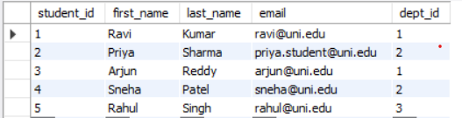
Q2. List the courses that carry more than three credits.
SQL:
SELECT course_code, course_name, credits
FROM Course
WHERE credits > 3
ORDER BY course_code;
Output:
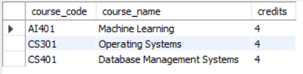
Q3. Find the enrollments for which no result has been declared yet.
SQL:
SELECT e.enrollment_id, e.student_id, e.course_id
FROM Enrollment e
WHERE NOT EXISTS (SELECT 1 FROM Results r
WHERE r.enrollment_id = e.enrollment_id);
Output:

This query finds enrollments that do not have a corresponding result in the Results table.

5.2 Join Operations
Q4. INNER JOIN - display each student with the courses enrolled and the semester.
SQL:
SELECT CONCAT(s.first_name, ' ', s.last_name) AS student_name,
c.course_name, e.semester
FROM Student s
INNER JOIN Enrollment e ON s.student_id = e.student_id
INNER JOIN Course c ON e.course_id = c.course_id
ORDER BY student_name, c.course_name;
Output:
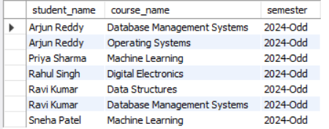
Q5. LEFT OUTER JOIN - display every department with its student count, including departments that have no student.
SQL:
SELECT d.dept_name, COUNT(s.student_id) AS total_students
FROM Department d
LEFT JOIN Student s ON d.dept_id = s.dept_id
GROUP BY d.dept_id, d.dept_name
ORDER BY total_students DESC, d.dept_name;
Output:
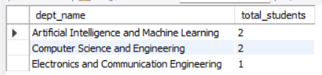
Q6. EQUI JOIN - display each course with its offering department and the faculty member handling it.
SQL:
SELECT c.course_code, c.course_name, d.dept_name,
CONCAT(f.first_name, ' ', f.last_name) AS faculty_name
FROM Course c, Department d, Faculty f
WHERE c.dept_id = d.dept_id
AND c.faculty_id = f.faculty_id
ORDER BY c.course_code;
Output:
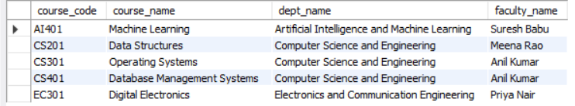
Q7. Four-table join - marks and grade obtained by each student in each course.
SQL:
SELECT s.first_name AS student, c.course_name,
r.marks_obtained, r.grade
FROM Student s
JOIN Enrollment e ON s.student_id = e.student_id
JOIN Course c ON e.course_id = c.course_id
JOIN Results r ON e.enrollment_id = r.enrollment_id
ORDER BY r.marks_obtained DESC;
Output:
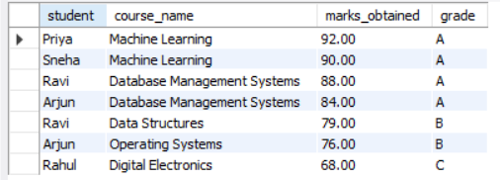

5.3 Aggregate Functions, GROUP BY and HAVING
Q8. Aggregate functions - number of results, highest, lowest and average marks.
SQL:
SELECT COUNT(*) AS total_results,
MAX(marks_obtained) AS highest,
MIN(marks_obtained) AS lowest,
ROUND(AVG(marks_obtained), 2) AS average
FROM Results;
Output:
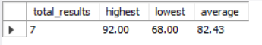
Q9. GROUP BY - number of students enrolled in each course.
SQL:
SELECT c.course_name, COUNT(e.student_id) AS students_enrolled
FROM Course c
JOIN Enrollment e ON c.course_id = e.course_id
GROUP BY c.course_id, c.course_name
ORDER BY students_enrolled DESC, c.course_name;
Output:
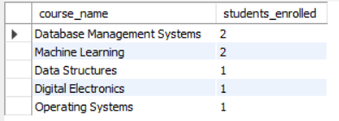
Q10. GROUP BY with HAVING - courses whose average marks exceed 75.
SQL:
SELECT c.course_name, ROUND(AVG(r.marks_obtained), 2) AS avg_marks
FROM Course c
JOIN Enrollment e ON c.course_id = e.course_id
JOIN Results r ON e.enrollment_id = r.enrollment_id
GROUP BY c.course_id, c.course_name
HAVING AVG(r.marks_obtained) > 75
ORDER BY avg_marks DESC;
Output:
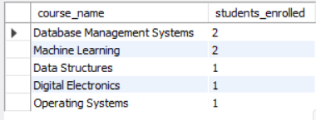

5.4 Nested and Correlated Subqueries
Q11. Nested subquery - results that are above the overall average marks.
SQL:
SELECT CONCAT(s.first_name, ' ', s.last_name) AS student_name,
c.course_name, r.marks_obtained
FROM Student s
JOIN Enrollment e ON s.student_id = e.student_id
JOIN Course c ON e.course_id = c.course_id
JOIN Results r ON e.enrollment_id = r.enrollment_id
WHERE r.marks_obtained > (SELECT AVG(marks_obtained) FROM Results)
ORDER BY r.marks_obtained DESC;
Output:
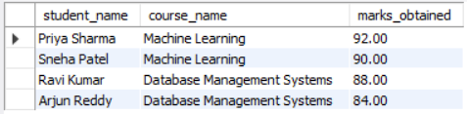
Q12. Correlated subquery - the best mark scored by each student.
SQL:
SELECT s.first_name AS student, r.marks_obtained AS best_mark
FROM Student s
JOIN Enrollment e ON s.student_id = e.student_id
JOIN Results r ON e.enrollment_id = r.enrollment_id
WHERE r.marks_obtained = (
SELECT MAX(r2.marks_obtained)
FROM Enrollment e2
JOIN Results r2 ON e2.enrollment_id = r2.enrollment_id
WHERE e2.student_id = s.student_id)
ORDER BY r.marks_obtained DESC;
Output:
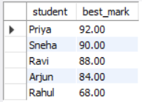

5.5 Views and Relational Set Operations
Two views were created. Both are read-only reporting views: v_dept_strength is built on an aggregate and v_student_result on a four-table join with a computed column, so neither can be used for INSERT or UPDATE. The derived attribute percentage is calculated inside v_student_result instead of being stored.
CREATE VIEW v_student_result AS
SELECT s.student_id,
CONCAT(s.first_name, ' ', s.last_name) AS student_name,
c.course_name, r.marks_obtained, r.grade,
ROUND((r.marks_obtained / r.total_marks) * 100, 2) AS percentage
FROM Student s
JOIN Enrollment e ON s.student_id = e.student_id
JOIN Course c ON e.course_id = c.course_id
JOIN Results r ON e.enrollment_id = r.enrollment_id;

CREATE VIEW v_dept_strength AS
SELECT d.dept_name, COUNT(s.student_id) AS total_students
FROM Department d
LEFT JOIN Student s ON d.dept_id = s.dept_id
GROUP BY d.dept_id, d.dept_name;
Q13. Query the view v_dept_strength (department-wise student count).
SQL:
SELECT *
FROM v_dept_strength
ORDER BY total_students DESC, dept_name;
Output:
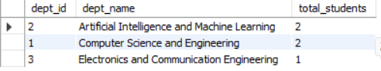
Q14. Query the view v_student_result - results with 80 percent or above.
SQL:
SELECT student_name, course_name, marks_obtained, percentage, grade
FROM v_student_result
WHERE percentage >= 80
ORDER BY percentage DESC;
Output:
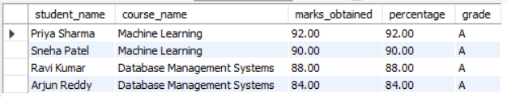
Q15. UNION - departments that have either a student or a course.
SQL:
SELECT d.dept_name FROM Department d
JOIN Student s ON d.dept_id = s.dept_id
UNION
SELECT d.dept_name FROM Department d
JOIN Course c ON d.dept_id = c.dept_id
ORDER BY dept_name;
Output:
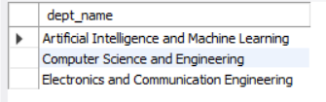
Q16. INTERSECT - departments that have both students and courses.
SQL:
SELECT d.dept_name FROM Department d
JOIN Student s ON d.dept_id = s.dept_id
INTERSECT
SELECT d.dept_name FROM Department d
JOIN Course c ON d.dept_id = c.dept_id
ORDER BY dept_name;
Output:
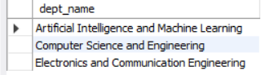
Q17. EXCEPT - departments that have students but offer no course.
SQL:
SELECT d.dept_name FROM Department d
JOIN Student s ON d.dept_id = s.dept_id
EXCEPT
SELECT d.dept_name FROM Department d
JOIN Course c ON d.dept_id = c.dept_id
ORDER BY dept_name;
Output:
dept_name
Electronics and Communication Engineering

The three set operations agree with the data: three departments hold either a student or a course, two hold both, and Electronics and Communication Engineering has a student but offers no course this semester. Mechanical Engineering appears in none of the three results because it has neither.

5.6 DCL and TCL Operations
Data Control Language commands were used to create a restricted user for the examination section, and Transaction Control Language commands were used to show that part of a transaction can be undone while the rest is kept.
(a) DCL — CREATE USER, GRANT, SHOW GRANTS and REVOKE:
CREATE USER 'exam_cell'@'localhost' IDENTIFIED BY 'Exam@2024';

GRANT SELECT ON university_academic.Results TO 'exam_cell'@'localhost';
GRANT SELECT ON university_academic.Enrollment TO 'exam_cell'@'localhost';
GRANT INSERT, UPDATE ON university_academic.Results TO 'exam_cell'@'localhost';

SHOW GRANTS FOR 'exam_cell'@'localhost';
Output of SHOW GRANTS after the grants:
GRANT USAGE ON *.* TO `exam_cell`@`localhost`
GRANT SELECT ON `university_academic`.`Enrollment` TO `exam_cell`@`localhost`
GRANT SELECT, INSERT, UPDATE ON `university_academic`.`Results` TO `exam_cell`@`localhost`
The new user was then tested. A SELECT on Results succeeds, while a DELETE is refused because the DELETE privilege was never granted:
-- connected as exam_cell
DELETE FROM Results WHERE result_id = 1;
ERROR 1142 (42000): DELETE command denied to user 'exam_cell'@'localhost' for table 'Results'
Finally the INSERT and UPDATE privileges on Results were withdrawn:
REVOKE INSERT, UPDATE ON university_academic.Results FROM 'exam_cell'@'localhost';

SHOW GRANTS FOR 'exam_cell'@'localhost';
GRANT USAGE ON *.* TO `exam_cell`@`localhost`
GRANT SELECT ON `university_academic`.`Enrollment` TO `exam_cell`@`localhost`
GRANT SELECT ON `university_academic`.`Results` TO `exam_cell`@`localhost`
After the REVOKE the user holds only SELECT on Results and Enrollment; an attempted UPDATE returns ERROR 1142 (42000): UPDATE command denied to user 'exam_cell'@'localhost' for table 'Results'.
(b) TCL — START TRANSACTION, SAVEPOINT, ROLLBACK TO SAVEPOINT and COMMIT:
START TRANSACTION;

INSERT INTO Student_Phone (student_id, phone) VALUES (2, '9490011223');
SAVEPOINT after_first_insert;

INSERT INTO Student_Phone (student_id, phone) VALUES (2, '0000'); -- entered in error
SELECT id, student_id, phone FROM Student_Phone WHERE student_id = 2;

ROLLBACK TO SAVEPOINT after_first_insert;
SELECT id, student_id, phone FROM Student_Phone WHERE student_id = 2;

COMMIT;
Before the rollback, the transaction sees both new rows:
id | student_id | phone
3 | 2 | 9848011122
9 | 2 | 9490011223
10 | 2 | 0000
After ROLLBACK TO SAVEPOINT, only the row inserted before the savepoint remains:
id | student_id | phone
3 | 2 | 9848011122
9 | 2 | 9490011223
The erroneous phone number was discarded while the valid one entered before the savepoint was kept, and COMMIT made the remaining change permanent. This shows that a savepoint undoes only the part of a transaction that follows it.

CHAPTER 6: MODULES AND FUNCTIONALITIES
The database supports five functional modules. Each module is a group of related SQL operations working on a defined set of tables.
Table 6.1: Modules and Their Functionalities
S.No | Module Name | Functionality | Tables Involved
1 | Department and Faculty Management | Create departments, appoint faculty, record faculty qualifications, assign a head of department and move a faculty member between departments. | Department, Faculty, Faculty_Qualification
2 | Student Admission | Admit a student into a department, record contact details including several phone numbers, and update the address. | Student, Student_Phone, Department
3 | Course Management | Define courses with credits and unique course codes, and map each course to its offering department and to the faculty member who handles it. | Course, Department, Faculty
4 | Enrollment Management | Register a student for a course in a semester, prevent duplicate registration, and list the courses of a student or the students of a course. | Enrollment, Student, Course
5 | Examination and Results | Record marks and grade against an enrollment, compute the percentage through a view, and produce course-wise and student-wise reports. | Results, Enrollment, Course, Student
The Enrollment module is the centre of the design. Because it carries the foreign keys of both Student and Course, it turns the many-to-many association into two one-to-many relationships, and because it carries the composite UNIQUE constraint it also enforces the academic rule that a student may register for a given course only once in a semester. The Results module in turn depends on Enrollment, so a mark can only be recorded for a registration that exists.

CHAPTER 7: RESULTS – SAMPLE OUTPUTS AND SCREENSHOTS
The three principal reports produced by the system are shown below. Each is obtained from a single SELECT statement, replacing what was previously a manual compilation from several files.
Report 1 — Student-wise result report with computed percentage
SELECT student_name, course_name, marks_obtained, percentage, grade
FROM v_student_result
ORDER BY percentage DESC;

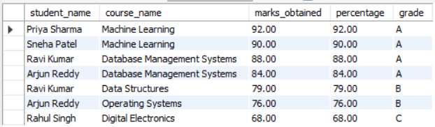
Fig. 7.1: Student-wise Result Report Output
Report 2 — Department-wise student strength
SELECT *
FROM v_dept_strength
ORDER BY total_students DESC, dept_name;

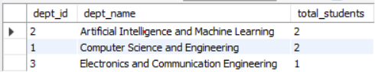
Fig. 7.2: Department-wise Student Strength Output
The second report includes Mechanical Engineering with a count of zero. This is the effect of the LEFT JOIN used in the view: a department with no student still appears in the report.
Report 3 — Course-wise performance summary
SELECT c.course_code, c.course_name,
COUNT(r.result_id) AS results_declared,
ROUND(AVG(r.marks_obtained), 2) AS avg_marks
FROM Course c
LEFT JOIN Enrollment e ON c.course_id = e.course_id
LEFT JOIN Results r ON e.enrollment_id = r.enrollment_id
GROUP BY c.course_id, c.course_code, c.course_name
ORDER BY c.course_code;
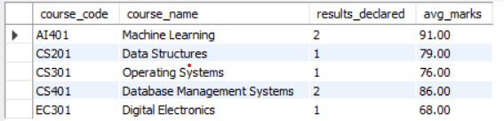
Fig. 7.3: Course-wise Performance Summary Output
Deep Learning shows no average because none of its enrollments has a declared result; the two LEFT JOINs keep the course in the report and the aggregate returns NULL.

CHAPTER 8: TESTING AND DATA VALIDATION
Twelve test cases were executed to verify the constraints, the relationships and the correctness of the queries. All twelve passed. The error codes in the table are those returned by MySQL 8.0 when the tests were run.
Table 8.1: Test Cases and Results
TC | Test Case Description | Input / Action | Expected Result | Status
TC-01 | Primary key uniqueness | Insert a Student with student_id 1, which already exists | ERROR 1062 — duplicate entry for key PRIMARY | Pass
TC-02 | Unique e-mail | Insert a Student with e-mail 'ravi@uni.edu' | ERROR 1062 — duplicate entry for key email | Pass
TC-03 | NOT NULL enforcement | Insert a Faculty row with first_name NULL | ERROR 1048 — column 'first_name' cannot be null | Pass
TC-04 | CHECK on credits | Insert a Course with credits = 9 | ERROR 3819 — check constraint violated | Pass
TC-05 | CHECK on marks | Insert a Results row with marks_obtained = -5 | ERROR 3819 — check constraint violated | Pass
TC-06 | Referential integrity (child) | Insert an Enrollment with student_id 99 | ERROR 1452 — foreign key constraint fails | Pass
TC-07 | Referential integrity (parent) | Delete Department 1, which has students and courses | ERROR 1451 — parent row cannot be deleted | Pass
TC-08 | Composite unique key | Insert the enrollment (student 1, course 1, '2024-Odd') again | ERROR 1062 — duplicate entry for the composite key | Pass
TC-09 | One-to-one Enrollment–Results | Insert a second Results row for enrollment 1 | ERROR 1062 — duplicate entry for key enrollment_id | Pass
TC-10 | DEFAULT value | Insert a Results row without total_marks | total_marks stored as 100.00 | Pass
TC-11 | ON DELETE CASCADE | Delete a student who has one phone number | Phone rows fall from 1 to 0 automatically | Pass
TC-12 | Query correctness | Execute Q10 (HAVING average > 75) | Returns Machine Learning (83.50) and Database Management Systems (80.33) | Pass
Test cases TC-01 to TC-11 show that the database itself refuses invalid data, so the integrity of the academic records does not depend on the care of the person entering it. TC-10 and TC-11 were run inside a transaction or on a temporary row that was removed afterwards, so the sample data used in the other chapters was not altered. TC-12 confirms that the aggregate queries return the expected rows for the known sample data.

CHAPTER 9: GITHUB REPOSITORY AND TEAM CONTRIBUTION

9.1 Repository Details
GitHub Repository Link: https://github.com/skabdulrajak/university-academic-management-system
The repository holds the complete SQL scripts (schema, sample data and queries), the exported ER and schema diagrams, the Review – I presentation and this report. Each member committed the files related to his own part of the work, and the final script was merged and tested by the whole team before submission.

9.2 Team Responsibilities and Contribution
Table 9.1: Team Responsibilities
S.No | Student Name | Roll Number | Role / Responsibility | Work Contributed
1 | Shaik Abdul Rajak | 25B11AIA90 | Team lead, database design and normalization | Chapters 1 and 3; ER diagram; 3NF decomposition
2 | Surada Rajesh | 25B11AI474 | Schema implementation and sample data | Chapter 4; CREATE scripts; constraints; INSERT statements
3 | Pobolu Venkata Pavan | 25B11AI866 | Query development, testing and documentation | Chapters 5 to 8; views; DCL and TCL; test cases; report compilation
Table 9.2: Review-wise Progress Record
Review | Focus | Work Completed | Status
Review – I | Database design | Title, objectives and problem statement; entities and attributes; ER diagram; relational schema; primary and foreign keys; GitHub repository and team responsibilities | Completed
Review – II | Database implementation | DDL script, sample data, constraints and data validation rules | Completed
Final submission | SQL operations and report | Seventeen queries, views, set operations, DCL and TCL, testing, results and this report | Completed

CHAPTER 10: CONCLUSION AND FUTURE ENHANCEMENTS

10.1 Conclusion
The University Academic Management System was designed, implemented and tested as a normalized relational database. Eight tables were created — six core entities and two supporting tables for multi-valued attributes — connected by ten foreign key constraints. The design was carried from an ER diagram through a relational schema to the Third Normal Form, removing the multi-valued attributes at 1NF, the partial dependencies at 2NF and the transitive dependency on department name at 3NF.
All five objectives stated in Section 1.4 were met. The database was implemented in MySQL with primary keys, foreign keys and NOT NULL, UNIQUE, CHECK, DEFAULT and ON DELETE CASCADE constraints; every table was loaded with sample data; seventeen queries covering retrieval, joins, aggregates with GROUP BY and HAVING, nested and correlated subqueries, views and set operations were executed together with DCL and TCL commands; and twelve test cases confirmed that the database rejects duplicate keys, out-of-range values and orphan records.
The main outcome is that a question which earlier needed manual compilation from several spreadsheets — for example the average marks in each course, or the results above the overall average — is now answered by one SQL statement against data that is stored exactly once.

10.2 Limitations of the Present Work
- The system has no front-end; all interaction is through SQL, so it can be used only by someone who knows the schema.
- Attendance, fee, hostel and library data are outside the present scope although they are part of real university operations.
- The grade is stored as a value instead of being computed from the marks, so a change in the grading policy would require the stored grades to be revised.
- The sample data set is small, and the behaviour of the queries with several thousand students has not been measured.
- Backup and recovery procedures were not configured for the project database.

10.3 Future Enhancements
- Develop a web front-end with admin, faculty and student roles so that the examination section and faculty can use the system without writing SQL.
- Replace the stored grade with a trigger or a generated column that derives it from marks_obtained, so that the grading policy is applied in one place.
- Add stored procedures for repetitive work such as bulk result entry, and triggers that write an audit row whenever marks are changed.
- Create indexes on Enrollment(student_id), Enrollment(course_id) and Results(enrollment_id) and study how the query plans change as the data grows.
- Extend the schema with Attendance, Fee and Library modules so that the database covers the whole student record and not only the academic part.
- Configure scheduled logical backups and document a recovery procedure.

REFERENCES
- Abraham Silberschatz, Henry F. Korth and S. Sudarshan, Database System Concepts, 7th Edition, McGraw-Hill Education, 2019.
- Raghu Ramakrishnan and Johannes Gehrke, Database Management Systems, 3rd Edition, McGraw-Hill, 2003.
- Ramez Elmasri and Shamkant B. Navathe, Fundamentals of Database Systems, 7th Edition, Pearson, 2016.
- C. J. Date, An Introduction to Database Systems, 8th Edition, Pearson, 2003.
- Oracle Corporation, MySQL 8.0 Reference Manual. Available at: https://dev.mysql.com/doc/refman/8.0/en/
- W3Schools, SQL Tutorial. Available at: https://www.w3schools.com/sql/
- NPTEL, Database Management Systems. Available at: https://nptel.ac.in/

APPENDIX A – COMPLETE SQL SCRIPT
The complete script is available in the team repository as schema.sql, sample_data.sql and queries.sql. The DDL and the INSERT statements appear in Sections 4.1 and 4.2, and the view definitions in Section 5.5. The query section is reproduced below.
-- ============ QUERIES ============

-- Q1 Display all students with their email address and department id.
SELECT student_id, first_name, last_name, email, dept_id
FROM Student
ORDER BY student_id;

-- Q2 List the courses that carry more than three credits.
SELECT course_code, course_name, credits
FROM Course
WHERE credits > 3
ORDER BY course_code;

-- Q3 Find the enrollments for which no result has been declared yet.
SELECT e.enrollment_id, e.student_id, e.course_id
FROM Enrollment e
WHERE NOT EXISTS (SELECT 1 FROM Results r
WHERE r.enrollment_id = e.enrollment_id);

-- Q4 INNER JOIN - display each student with the courses enrolled and the semester.
SELECT CONCAT(s.first_name, ' ', s.last_name) AS student_name,
c.course_name, e.semester
FROM Student s
INNER JOIN Enrollment e ON s.student_id = e.student_id
INNER JOIN Course c ON e.course_id = c.course_id
ORDER BY student_name, c.course_name;

-- Q5 LEFT OUTER JOIN - display every department with its student count, including departments that have no student.
SELECT d.dept_name, COUNT(s.student_id) AS total_students
FROM Department d
LEFT JOIN Student s ON d.dept_id = s.dept_id
GROUP BY d.dept_id, d.dept_name
ORDER BY total_students DESC, d.dept_name;

-- Q6 EQUI JOIN - display each course with its offering department and the faculty member handling it.
SELECT c.course_code, c.course_name, d.dept_name,
CONCAT(f.first_name, ' ', f.last_name) AS faculty_name
FROM Course c, Department d, Faculty f
WHERE c.dept_id = d.dept_id
AND c.faculty_id = f.faculty_id
ORDER BY c.course_code;

-- Q7 Four-table join - marks and grade obtained by each student in each course.
SELECT s.first_name AS student, c.course_name,
r.marks_obtained, r.grade
FROM Student s
JOIN Enrollment e ON s.student_id = e.student_id
JOIN Course c ON e.course_id = c.course_id
JOIN Results r ON e.enrollment_id = r.enrollment_id
ORDER BY r.marks_obtained DESC;

-- Q8 Aggregate functions - number of results, highest, lowest and average marks.
SELECT COUNT(*) AS total_results,
MAX(marks_obtained) AS highest,
MIN(marks_obtained) AS lowest,
ROUND(AVG(marks_obtained), 2) AS average
FROM Results;

-- Q9 GROUP BY - number of students enrolled in each course.
SELECT c.course_name, COUNT(e.student_id) AS students_enrolled
FROM Course c
JOIN Enrollment e ON c.course_id = e.course_id
GROUP BY c.course_id, c.course_name
ORDER BY students_enrolled DESC, c.course_name;

-- Q10 GROUP BY with HAVING - courses whose average marks exceed 75.
SELECT c.course_name, ROUND(AVG(r.marks_obtained), 2) AS avg_marks
FROM Course c
JOIN Enrollment e ON c.course_id = e.course_id
JOIN Results r ON e.enrollment_id = r.enrollment_id
GROUP BY c.course_id, c.course_name
HAVING AVG(r.marks_obtained) > 75
ORDER BY avg_marks DESC;

-- Q11 Nested subquery - results that are above the overall average marks.
SELECT CONCAT(s.first_name, ' ', s.last_name) AS student_name,
c.course_name, r.marks_obtained
FROM Student s
JOIN Enrollment e ON s.student_id = e.student_id
JOIN Course c ON e.course_id = c.course_id
JOIN Results r ON e.enrollment_id = r.enrollment_id
WHERE r.marks_obtained > (SELECT AVG(marks_obtained) FROM Results)
ORDER BY r.marks_obtained DESC;

-- Q12 Correlated subquery - the best mark scored by each student.
SELECT s.first_name AS student, r.marks_obtained AS best_mark
FROM Student s
JOIN Enrollment e ON s.student_id = e.student_id
JOIN Results r ON e.enrollment_id = r.enrollment_id
WHERE r.marks_obtained = (
SELECT MAX(r2.marks_obtained)
FROM Enrollment e2
JOIN Results r2 ON e2.enrollment_id = r2.enrollment_id
WHERE e2.student_id = s.student_id)
ORDER BY r.marks_obtained DESC;

-- Q13 Query the view v_dept_strength (department-wise student count).
SELECT *
FROM v_dept_strength
ORDER BY total_students DESC, dept_name;

-- Q14 Query the view v_student_result - results with 80 percent or above.
SELECT student_name, course_name, marks_obtained, percentage, grade
FROM v_student_result
WHERE percentage >= 80
ORDER BY percentage DESC;

-- Q15 UNION - departments that have either a student or a course.
SELECT d.dept_name FROM Department d
JOIN Student s ON d.dept_id = s.dept_id
UNION
SELECT d.dept_name FROM Department d
JOIN Course c ON d.dept_id = c.dept_id
ORDER BY dept_name;

-- Q16 INTERSECT - departments that have both students and courses.
SELECT d.dept_name FROM Department d
JOIN Student s ON d.dept_id = s.dept_id
INTERSECT
SELECT d.dept_name FROM Department d
JOIN Course c ON d.dept_id = c.dept_id
ORDER BY dept_name;

-- Q17 EXCEPT - departments that have students but offer no course.
SELECT d.dept_name FROM Department d
JOIN Student s ON d.dept_id = s.dept_id
EXCEPT
SELECT d.dept_name FROM Department d
JOIN Course c ON d.dept_id = c.dept_id
ORDER BY dept_name;

