GitHub Auto Resynchronization Tool

Introduction:

GitHub has become a central hub for collaborative software development, but managing repositories and keeping local copies synchronized can be a manual and time-consuming task. To streamline this process, we've developed the GitHub Auto Resynchronization Tool, a Python-based tool that automates the download and synchronization of GitHub repositories.

The GitHub Auto Resynchronization Tool is designed to simplify the process of downloading and updating files or entire repositories from GitHub. Whether you're working on a team project or need to maintain local backups of repositories, this tool automates repetitive tasks, making your workflow more efficient.

Purpose of GitHub Auto Resynchronization Tool:

GitHub has become the backbone of collaborative software development, hosting millions of repositories across a myriad of projects. However, as projects evolve and repositories grow, keeping local copies synchronized with the latest changes becomes a challenging task. This is especially true for developers working on multiple machines or teams collaborating across different time zones.

The GitHub Auto Resynchronization Tool is designed with a singular purpose: to simplify and automate the process of managing GitHub repositories. Let's delve into the key purposes this tool serves:

* **Efficient Repository Synchronization**: -

Manually downloading and updating repositories can be a cumbersome process, especially when dealing with numerous files or large projects. This tool automates the synchronization process, ensuring that your local copies are always up to date without the need for manual intervention.

* **Flexible File and Repository Exploration**: -

Whether you need to download a specific file or clone an entire repository, the tool adapts to your requirements. It dynamically fetches available branches and tags, allowing users to select the precise version they want to download. This flexibility is particularly valuable when dealing with projects that have multiple release versions or branches.

* **Time-Saving Parallel Downloading**: -

For repositories with a substantial number of files, parallel downloading can significantly reduce synchronization times. The tool supports concurrent downloading of files, making the process faster and more efficient.

In essence, the GitHub Auto Resynchronization Tool is crafted to empower developers and teams by automating the mundane aspects of repository management.

Tool Requirements:

* **Python3**
* **Git**
* **GitHub Account**
* **GitHub personal access token:** Make sure Your Personal access token is active and had at least read access to that Repository. You can create a Personal access token [Personal Access Tokens (conti.de)](https://github-am.geo.conti.de/settings/tokens) ([Settings](https://github-am.geo.conti.de/settings/profile) ->[Developer settings](https://github-am.geo.conti.de/settings/tokens) -> Generate new token) here.

Features:

**User-Friendly GUI**

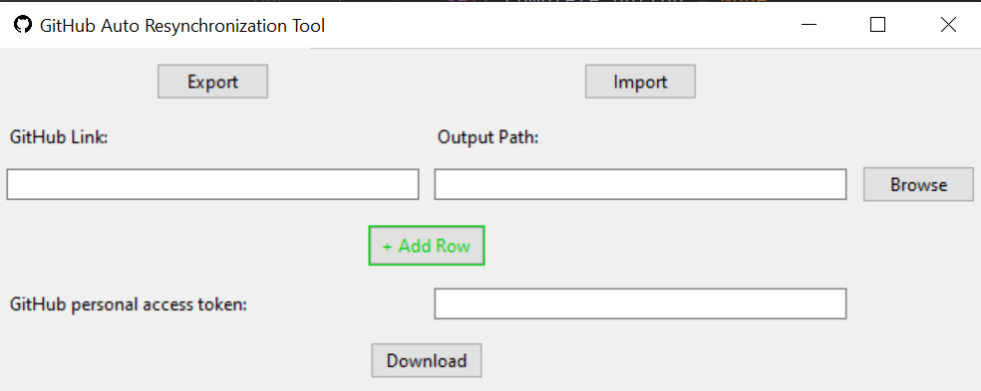

1. GitHub link entries: - paste your GitHub link of the file or folder of a certain branch you want to download.

2. Output Path entries: - paste your local path where you want to download

3. Browse button: - Instead of pasting local path you can browse your local path using this button

4. Add row button: - clicking the add row button will add new row (GitHub Link Output Path entries and browse button), so that user can provide more GitHub link, Output Path for **Parallel Downloading.**

5. GitHub personal access token: - Provide your GitHub personal access token here for authentication purpose.

6. Download button: - **Click it only when all the other fields are filled**. After clicking it download will start don’t close the GUI until all downloads are completed. After completing single download, it will show the status (Completed/Failed). You will get a pop-up notification after the whole process.

7. Export Button: - Select a json file, it will save all your entries in json format, so that later user can import the saved json file using import button.

8. Import Button: - Select the exported json configuration it will populate all the entries.

9. Report: - Get total information of the status of individual download as mentioned below.

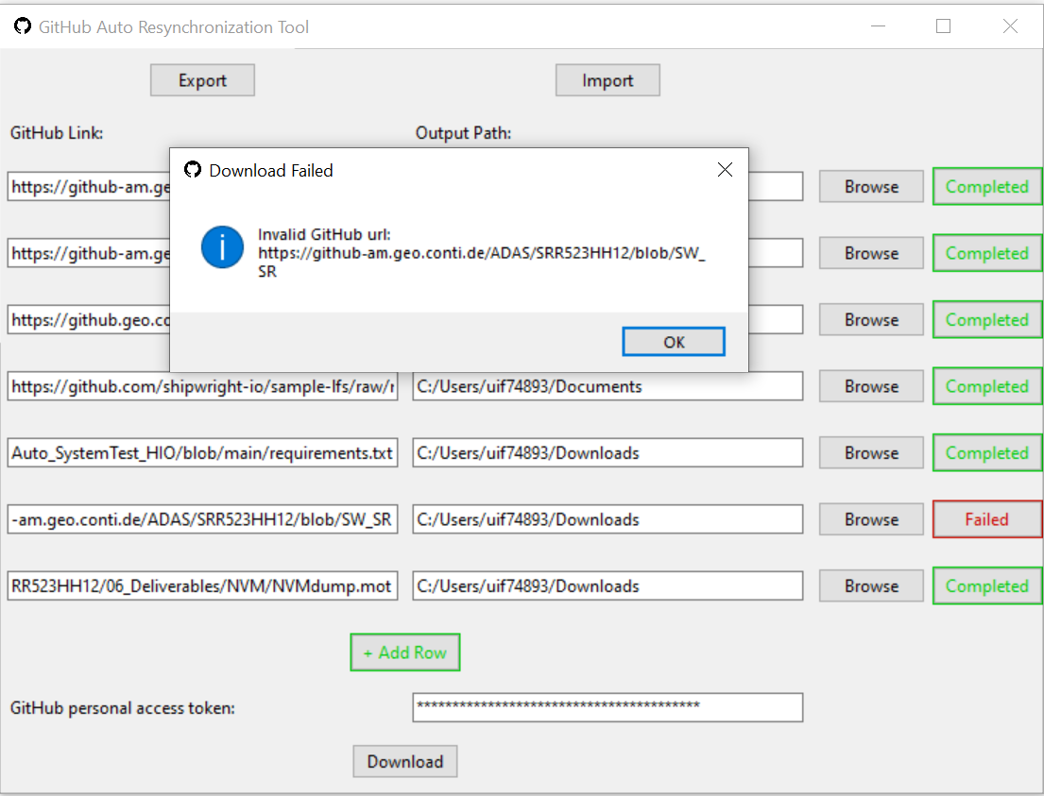

**Dynamic Repository Exploration: -**

Users can explore and download specific files or entire repositories. The tool dynamically populates the available branches and tags, enabling users to select the version they want to download.

**GitHub Token Integration: -**

To access private repositories or increase API request limits, the tool supports GitHub personal access tokens. Users can conveniently input their token in the GUI.

**Parallel Downloading: -**

The tool supports concurrent downloading of files, significantly reducing the time required for synchronizing repositories with a large number of files.

**Export and Import Configuration: -**

Users can export their configuration, including repository details, to a JSON file. This allows for easy backup and sharing of configuration settings. The tool also features an import functionality that can import multiple exported json files, simplifying the setup process when switching machines or sharing configurations.

Comparison GitHub API and GitHub Desktop:

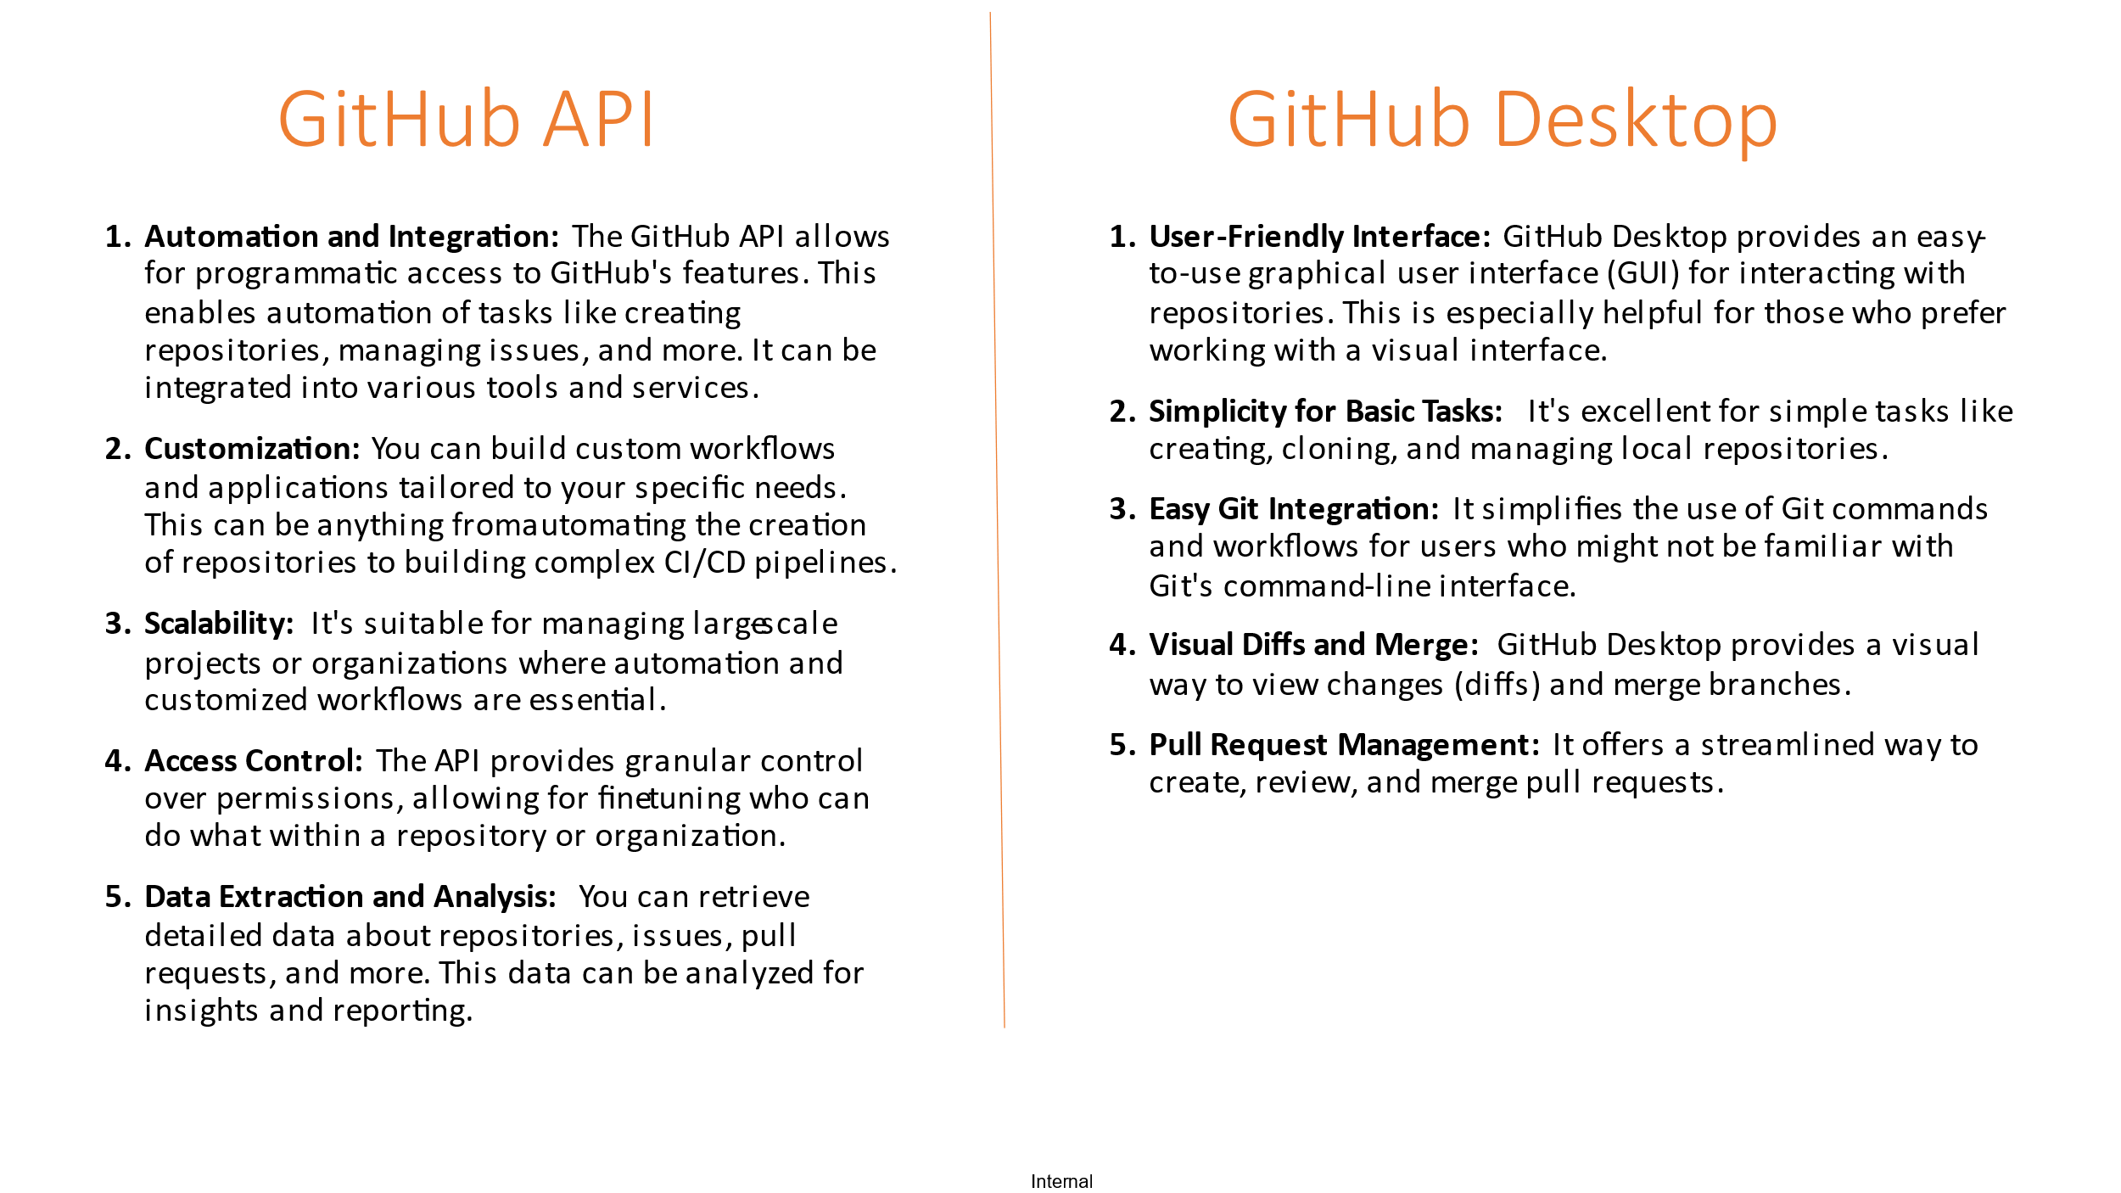

Advantages:

* Integrate with automated testing and continuous integration tools for efficient development.
* Efficient usages of space and time using resynchronization instead of cloning.
* Automation of repetitive git commands
* No need to clone the entire repository; you can simply download specific files or folders that you need. This way, we can save a significant amount of space by avoiding unnecessary files and folders, as well as time.

Future Scope:

* Integrating GitHub API with External Applications
* Retrieving repository information
* Managing issues and pull requests programmatically.
* Exploring user and organization management capabilities
* Utilize version control effectively to track changes and manage codebase.

Conclusion:

The GitHub Auto Resynchronization Tool provides a convenient and efficient way to manage GitHub repositories. Its user-friendly GUI, dynamic repository exploration, GitHub token integration, parallel downloading, and configuration export/import features make it an asset for developers and teams working with GitHub.

By automating the synchronization process, this tool empowers developers to focus more on coding and less on manual repository management. Whether you're a solo developer or part of a larger team, consider integrating the GitHub Auto Resynchronization Tool into your workflow for a more seamless and productive experience.

Feel free to contribute to the project on GitHub and let us know your thoughts and suggestions!