**Earthmap Application**

This application is based on FourSuare API’s to perform the below operation:

* Get the location information by name
* Get the Categories information
* Create the use define preferred list

**Limitations:**

* This application is not using the all FourSquare API’s

1. **GET location by name**

URL: GET <http://localhost:8080/foursquare/search/pune>

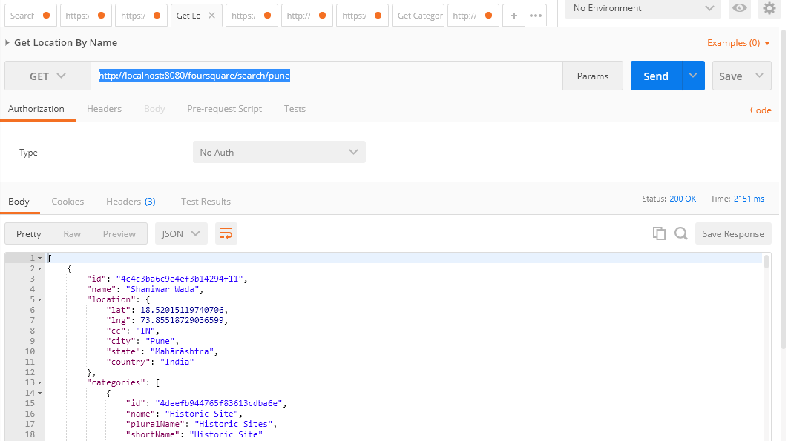

1. **GET the Categories**

**URL:** GET <http://localhost:8080/foursquare/categories>

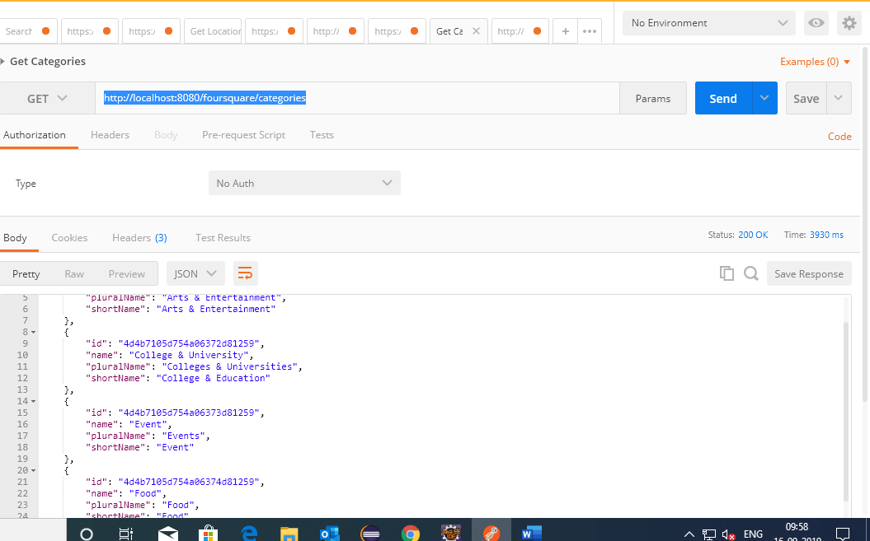

1. **Create the List**

**URL: POST** <http://localhost:8080/foursquare/createlist>

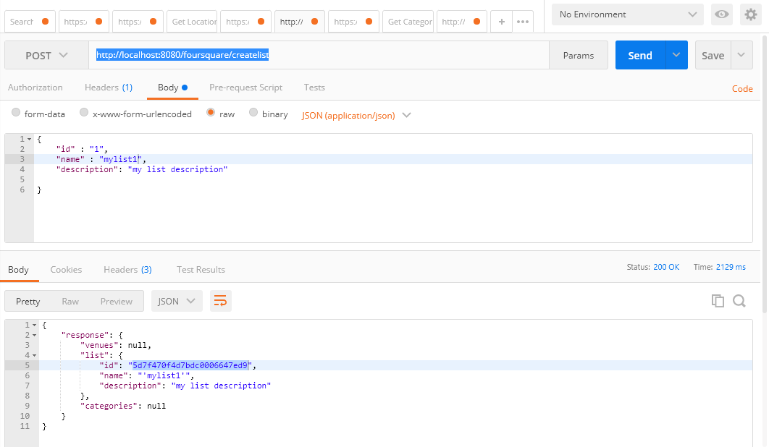

**Can see the user defined list. Please find below screenshot for more information**

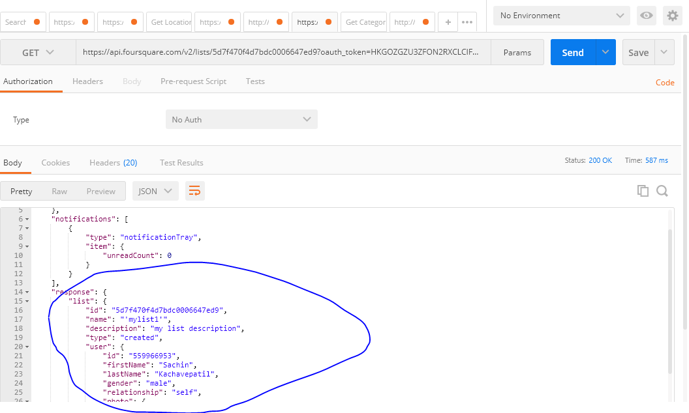

1. **Add the place under created list**

**URL: POST** <http://localhost:8080/foursquare/placesunderlist>

Where:

"id":"5d7f7e38af505800076cf48e" 🡪 List created by User

"venueId": "550d201c498e3f36752cf7a0" 🡪 Vh1 Supersonic (Venue name under “Pune” city)

