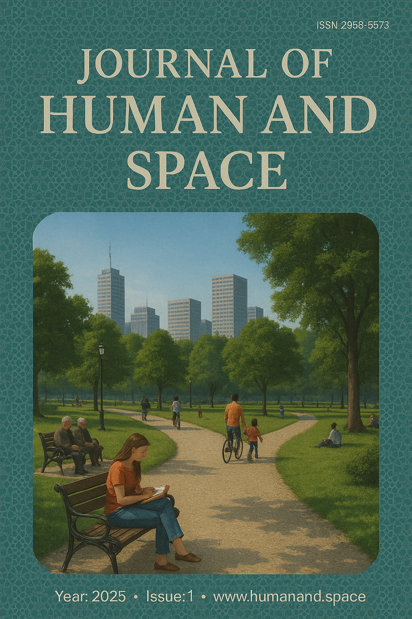

# Dedication

To the veterans of Azeroth—those who braved Molten Cores, drank in moonlit lore, and still find time to help a new adventurer answer the eternal question, “Where is the bank in Stormwind?” Your stories lit the path this book now follows.

“The arcane is not a candle to be lit—it is a sun to be wielded. Wield lightly, and beware the shadows it casts.”

—Medivh, Last Guardian of Tirisfal

# Preface

You hold in your hands a chronicle of craft and cosmos: a collection of essays that ventures beyond patch notes to uncover the beating mythos behind each class in *World of Warcraft*. Here, mechanics meet narrative; tooltips tango with prophecy. Whether you are a veteran raid leader parsing logs or a lore‑lover tracing the lineage of Quel’thalas, this volume aims to deepen your appreciation of the spell‑slinging, glaive‑whirling tapestry that has kept Azeroth alive for over two decades.

The chapters that follow are deliberately concise—a hearth‑stone you can flip through between queues—yet each was written with scholarly care. We sought voices from PvP enthusiasts, role‑players, and theorycrafters alike, blending their perspectives into a unified exploration of class identity. Within these pages you will find not just strategies, but stories: the sacrificial ethos of Warlocks, the measured fury of Demon Hunters, the crystalline discipline of Mages, and many more.

May these words ignite fresh curiosity, spark thoughtful debate, and perhaps inspire you to roll an alt whose storyline you have never walked. Azeroth, after all, is most vibrant when its heroes cross paths—each carrying echoes of their unique covenant with power.

Safe travels, reader. Turn the page, summon your courage, and step once more into a world where legends are only ever one spellcast away.

**Table of Contents**

**1.** Article 111: Mage *(case_study, s. N/A)*

*Authors:* Author 9, Author 11

*Abstract:* TR Abstract for article 111 exploring important aspects of the subject matter with detailed methodology and findings.

**2.** Article 112: Demon Hunter *(research, s. 127-132)*

*Authors:* Author 7

*Abstract:* TR Abstract for article 112 exploring important aspects of the subject matter with detailed methodology and findings.

**3.** Article 110: Warlock *(research, s. 12-41)*

*Authors:* Author 9

*Abstract:* TR Abstract for article 110 exploring important aspects of the subject matter with detailed methodology and findings.

# From the Editor

Dear Reader,

When we first conceived this volume, the goal was deceptively simple: capture the spirit of *World of Warcraft* classes in a form that could sit as comfortably on a coffee table as it could in the backpack of a Mythic raider. Yet, as any Adventurer of Azeroth knows, even "simple" quests tend to unfold into sprawling epics. Drafts multiplied, perspectives diverged, and the hardest fight turned out to be picking which stories to leave untold.

I approached this project much like a raid leader approaching a new tier: outline the strategy, assemble a balanced roster of contributors, and hope that when the enrage timer loomed, inspiration—rather than panic—would surge. Over countless late‑night editing sessions, I watched chapters transform from raw damage logs into narrative crits—moments where mechanics met myth in that sweet spot Blizzard themselves call "gameplay first." The authors, artists, and proofreaders all channeled their inner class fantasy. Our resident Warlock insisted on emerald‑green footnotes; the Mage lobbied for more portals (to skip the boring parts, naturally); and the Demon Hunter advocated for a double‑jump cut that kept the pacing airborne. My job was to weave these fel‑fueled threads into a coherent tapestry.

As you turn these pages, you will notice an intentional balance between depth and brevity. Each article aims to invite reflection without demanding encyclopedic commitment. Whether you main an Arcane battlemage or an affable Brewmaster, I hope you find insights that resonate with your own journey through Azeroth.

Of course, no tome about Warcraft would be complete without acknowledging the community that keeps the world alive. The theorycrafters who spreadsheet into the small hours, the role‑players who flesh out every tavern rumor, the addon authors who automate everything except friendship—this book is as much theirs as it is ours. To readers who find errors (you will), I invite you to treat them as a weekly reset: an opportunity to push deeper, learn faster, and maybe send a kindly worded bug report my way.

Finally, a word on sustainability. The printing of this edition follows eco‑friendly standards; inks are soy‑based and pages sourced from responsibly managed forests. Warcraft’s worlds remind us that careless extraction breeds fel corruption—let us prove the opposite can be true outside the game.

Thank you for choosing to spend a portion of your real‑world cooldowns with us. May your hearthstones always cast instantly, your loot rolls defy probability, and your IRL coffee never go cold before the queue pops.

With gratitude and a pinch of Arcane Intellect,

—The Editor

# Arcane Ascendancy: A Brief Treatise on Warcraft Mages

When the first spell‑addled scholars of Azshara’s court bent light into lances, they birthed the archetype that would become the modern Mage. In Azeroth’s history, few institutions loom larger than the Kirin Tor of Dalaran—a floating city of violet spires whose very streets hum with ley‑line resonance. From these crystalline halls, Mages have served as both archivists and artillery, sifting through dusty grimoires one moment and shattering siege engines with cosmic fire the next.

Contemporary practice divides their craft into three schools: **Arcane**, **Fire**, and **Frost**. Arcane Mages are rhythm gamers wielding raw mana as both fuel and ticking bomb; their rotation is a dance of ebbing power, culminating in *Arcane Surge* that turns progress bars into purple streaks across damage meters. Fire Mages play roulette with combustion—banking critical mass before unleashing a *Pyroblast* chain that can erase boss health if timed with trinket procs. Frost, ever the tactician, slows time itself: *Icy Veins* accelerates casts while enemies shiver under permanent chill, making Frost a control class disguised as a DPS spec.

Utility is the Mage’s quiet superpower. *Polymorph* can neutralize any beast, humanoid, or critter into hapless sheep—an eternal meme among dungeon leaders drafting crowd‑control assignments. *Time Warp* (and its Horde cousin, *Bloodlust*) defines raid pacing; few moments raise pulse rates faster than the ritual countdown to "Lust!" on voice chat. Meanwhile, *Alter Time* lets savvy players rewind fatal mistakes, reinforcing the class fantasy of temporal mastery.

Yet the Mage’s greatest strength might be cultural rather than mechanical. They symbolize potential—the notion that knowledge, once mastered, can bend reality. From Jaina Proudmoore’s tidal fury to Khadgar’s cosmic teleportation, Warcraft narratives hinge on Mages opening literal portals to new eras. In gameplay, their high skill ceiling rewards those who relish planning 15 seconds ahead while reacting in 0.5 seconds flat.

In the delicate balance between scholarly restraint and apocalyptic spectacle, Mages stand as a reminder: the arcane is neither good nor evil—it is merely power shaped by will. Handle with care, cast with flair, and always keep one hearthstone set to Dalaran, just in case the ley lines start humming.

# Warglaives and Wargames: A Three‑Page Chronicle of the Warcraft Demon Hunter

## I. Born of Betrayal

Few classes in Azeroth’s martial tapestry inspire the same blend of awe and unease as the Demon Hunter. They are the paradoxical offspring of Illidan Stormrage’s defiance—a legion‑slayer who drank fel to wield fel. In lore, their initiation is half ritual, half suicide mission: aspirants carve out their own eyes, binding a demon’s essence within themselves, then don an enchanted blindfold to cage the inferno now raging behind their empty sockets. The reward is spectral sight—vision that pierces shadows and deceptions the way Warglaives cleave through chitin.

This tragic origin sets Demon Hunters apart from Azeroth’s conventional heroes. Where paladins bear holy symbols, Illidari brand themselves with runes of imprisonment. They are both prisoner and warden, walking contradictions who must continually prove—to themselves most of all—that the cost of their power was not too high. Storylines in Legion and Dragonflight repeatedly confront the class with that tension: the demons they hunt recognize them as kin, taunting, "We share the same blood."

From a stylistic standpoint, Blizzard has always positioned Demon Hunters as the ‘anime protagonist’ of *World of Warcraft*. Double jumps, gliding wings, and crimson fel scars evoke cinematic flourish seldom afforded to other classes. Players who choose Demon Hunter often cite the power fantasy of mobility: whirling into combat, exploding outward in a Metamorphosis shockwave, then soaring above the fray with Infernal Strike. It’s an adrenaline loop more akin to an action platformer than a traditional MMO rotation.

## II. Fel‑Forged Toolkit

Modern Demon Hunter gameplay divides cleanly between the **Havoc** and **Vengeance** specializations. Havoc is the frenetic DPS spec—muscle memory distilled into three impulses: generate Fury, spend Fury, keep moving. *Blade Dance* and *Chaos Strike* form the rhythm section, while cooldowns like *Metamorphosis* and *Eye Beam* provide the guitar solo. In Mythic+ dungeons, a properly timed Eye Beam—buffed by *Essence Break*—can erase pulls in a flash of chart‑topping damage.

Vengeance, by contrast, reimagines tanking as a low‑altitude bombing run. Its defensive layers are active and aggressive: *Fel Devastation* heals while hurting, *Demon Spikes* thorns back melee hits, and *Fiery Brand* turns the scariest add into a kitten for eight seconds. The spec emphasizes self‑sustain—an essential trait in pickup‑group PUG culture where healers may be preoccupied (or perished).

Utility is the Demon Hunter’s unsung melody. *Spectral Sight* trivializes stealth gimmicks in PvP; *Chaos Nova* offers AoE crowd control; *Darkness* provides a party‑wide 20% chance to dodge lethal mechanics—the mythic raider’s coin toss between wipe and win. And then there is mobility: double leap plus glide forms a platforming kit that can cheese environmental hazards, skip dungeon corridors, or simply let you save face after misjudging a Knockback mechanic.

Dragonflight’s talent overhaul allowed Demon Hunters to reclaim some Warlords of Draenor nostalgia—*The Hunt* returns as a gap‑closing execute; *Fodder to the Flame* adds a thematic mini‑boss that combusts into a Fury piñata. Meanwhile, Vengeance gained *Frailty* stacks that reward proactive mitigation with damage conversion, transforming tank uptime into raid DPS contribution.

Beneath the spreadsheets, the class retains a visceral identity: every button press crackles with fel energy, every animation punctuates a narrative of barely contained rage. When a Havoc DH pops Metamorphosis, horns burst forth and wings flare—visual shorthand for the internal demon taking the driver’s seat.

## III. Cultural Impact and Future Flight

Since their debut in the 2016 *Legion* expansion, Demon Hunters have reshaped community expectations around class design. They proved that fewer buttons can coexist with high skill expression: positioning, timing, and encounter foresight separate the great from the merely adequate. In esports, their mobility has redefined PvP engagements—map geometry matters more when someone can glide onto a pillar or triple‑jump out of *Ring of Frost*.

Lorewise, Illidan’s absence post‑Antorus leaves an existential question: what does an Illidari fight for once the Legion is over? Dragonflight’s storyline offers a partial answer: demonic remnants still lurk in the Nether, and the Black Dragonflight’s experiments hint at new threats worthy of glaive and grudge. Blizzard seems content to keep Demon Hunters relevant through cameo arcs and renewed fel incursions—because where there are demons, there will always be hunters.

Speculation for *The Last Titan* expansion points to Void corruption as the next cosmic antagonist. Designers have teased glyph customization that could recolor fel green into void purple, perhaps heralding a "Void Hunter" sub‑class. The prospect excites theorycrafters: imagine *Void Beam* that drains Sanity instead of Health, or *Shadow Wings* granting brief phasing through terrain. Whether these ideas manifest or not, Demon Hunters exemplify Blizzard’s willingness to break the mold—and then shatter the shards for effect.

Ultimately, the class’s popularity rests on a simple equation: high ceiling, low floor, maximum swagger. If Warcraft is a stage, Demon Hunters are the acrobats who light themselves on fire mid‑flip. They embody Illidan’s creed—"we are prepared"—not as a boast, but as a tacit promise: the moment darkness gathers, glaives will sing, wings will spread, and the sky itself will burn with green fire and violet vacuum.

And so the Chronicle closes with a challenge: should you feel the itch for speed, spectacle, and strategic depth, take up the blindfold. Let the world blur into motion lines as you dive blades‑first into the unknown. May your jumps be true, your Fury unending, and your inner demon forever on a tight leash.

# Shadow and Flame: A Brief Treatise on the Warcraft Warlock

## Origins and Dark Design

Long before the first portal tore across the sky of Azeroth, the craft now known as warlock magic was already whispered about in a dozen doomed worlds. At its core lies the communion with the Burning Legion’s fel energies—fiery, viridian streams of chaotic power best described as a corruption of life’s own spark. Early eredar sorcerers on Argus called it ‘the Great Exchange’: one’s purity for limitless might. When Sargeras recruited them, the pact cemented a discipline that would leap across time and space, eventually finding fertile ground among the desperate or the ambitious on Azeroth.

It is precisely this bargain—strength against sacrifice—that shapes every Warlock. In the heat of battle, a Warlock’s silhouette is a paradoxical blend of scholarly calm and infernal pyrotechnics. Robes swirl, quills and grimoires float around them, yet all restraint is discarded when green fire ignites in their palms. Players drawn to the class often cite this duality: a mastermind who eagerly unleashes raw destruction while still planning three moves ahead, like a fel‑infused chess player who rigs the board to explode.

From a gameplay standpoint, Blizzard Entertainment has leaned into that fantasy since the original *World of Warcraft* launched in 2004. Early Warlocks were notorious duelists thanks to the ‘SL/SL’ (Siphon Life + Soul Link) build—a near‑unkillable drain tank that frustrated rogues for years. Modern design, by contrast, pushes Warlocks toward clear specializations: **Affliction** suffocates foes with stacking curses, **Demonology** orchestrates a demonic menagerie, and **Destruction** embodies the fireworks factory, hurling bolts that could level Stormwind’s harbor.

Yet numbers on a tooltip tell only half the story. Warlock flavor is inseparable from the minions they bind. There is sociopathic beauty in the way a seasoned player cycles through *Summon Imp* for ranged harassment, *Voidwalker* for tanking, and *Felhunter* for mage‑snacking spell locks. Each demon is both tool and narrative device—a reflection of the master’s intent. In Warcraft’s lore, these creatures are not mindless pets but grudging partners stitched together by arcane contracts older than some continents.

Consider the Coven of Shivarra on Argus, who view Azerothian practitioners as blasphemous upstarts, or the Black Harvest—an elite conclave of mortal Warlocks founded after the Cataclysm. Their members raid tombs, trade Nether shards, and occasionally tutor bright‑eyed mages who think a fel ember is just ‘green fire’. Warlocks cultivate legends because power loves an audience, and audiences love whispered danger.

## Battlefield Mechanics and Modern Meta

In contemporary Mythic+ dungeons, Affliction’s strength lies in ‘ramp windows.’ A well‑timed *Darkglare* coupled with triple‑stacked *Seed of Corruption* can liquefy entire trash packs. The class has become a lesson in delayed gratification: invest your global cooldowns early, watch timers bloom, and erupt in soul‑shredding damage fifteen seconds later. It rewards encounter knowledge, rewarding patience rather than frantic key‑smashing.

Destruction, meanwhile, is the crowd‑pleaser. *Chaos Bolt* remains Warcraft’s most screenshot‑worthy spell effect—an emerald meteor wrapped in violet fractals. In PvP, good ‘Destro’ players weaponize that visual threat: opponents waste interrupts in panic, paving the way for the real kill setup. With the shard economy simplified in Dragonflight, Destruction regained a rhythm closer to its Mists of Pandaria heyday: build, burst, cackle, repeat.

Demonology’s renaissance might be the expansion’s most pleasant surprise. After years as the ‘mad science spec,’ it now channels a Legion commander fantasy. The rotation is a board meeting chaired by the Warlock: *Hand of Gul’dan* summons interns (Wild Imps); *Dreadstalker* calls middle management; *Tyrant* arrives to audit everyone’s performance, amplifying all demonic damage. Watching thirty entities swarm a raid boss evokes a real‑time strategy game compressed into twelve seconds.

One cannot discuss Warlocks without acknowledging their utility toolkit. *Healthstones* have saved more raids than recount logs will ever admit. *Soulstone* provides combat resurrection, making the class a lifeline rather than mere DPS meter. And of course, the infamous *Ritual of Summoning*—responsible for legions of ‘lock taxi’ jokes—continues to dictate which raid members can afford to be late to trash pulls.

Perhaps the greatest testament to the Warlock’s design is its cultural staying power. Across expansions, nerfs, and redesigns, veteran players rarely delete their Warlock mains. They are custodians of a dark tradition that balances on the knife‑edge of temptation: wield fel energy, but do not let it consume you. Whether you are dot‑juggling Affliction, minion‑micromanaging Demonology, or pyroclastic Destruction, the contract remains the same—power at a price. Sign in blood, summon in style, and leave a trail of green‑lit craters as your signature.