1. Check your working directory by typing : pwd

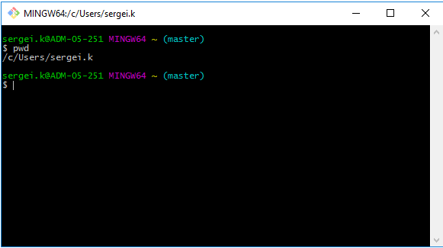

1. You can use ls (to check what files are inside) if needed
2. Now we need to clone the URL that teacher has provided by using command: git clone (you can past link by right click-paste. Note ctrl+c and ctrl+v are not working in bash

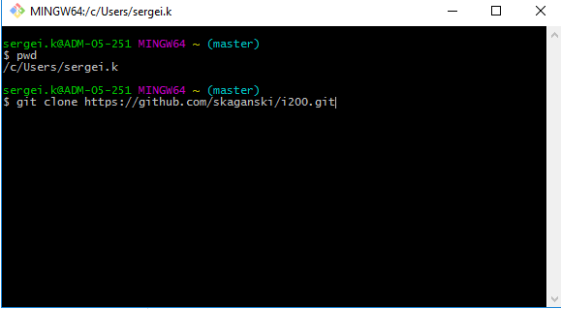

1. Now, by clicking pwd, you will discover that you are still in the same directory but we need to get into new folder with cloned files. For that you should go to the folder, where your project is and copy the link

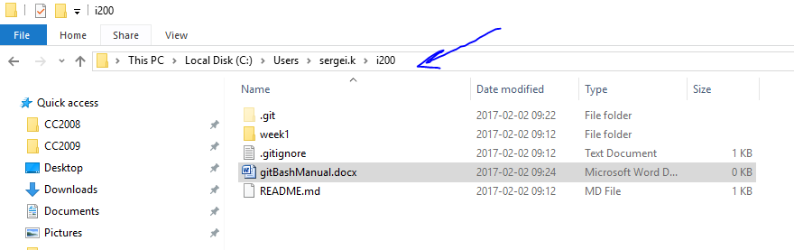

1. Now we need to make some changes on link C:\Users\sergei.k\i200. Again, for inserting, use right click and paste. After that change \ to /, delete : and instead of C type small c, pay attention, that you need to type before c -> cd and before c you should add also /. For navigation use arrowKeys. On picture below is the final result. Now you are inside your project.

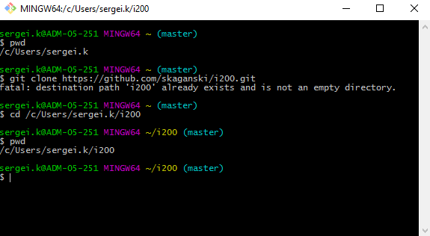

1. You can use git status to check, whats going on right now with your git

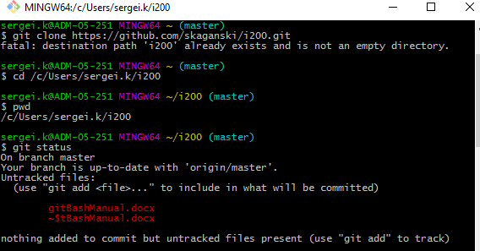

1. Now you can use git add –A to add all files

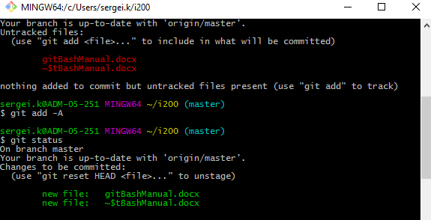

1. Now you just need commit : git commit –m”typeYourMessageHere”
2. And push all files back : git push
3. Done!