**COMPUDISTRIBUTOR PORTFOLIO APPLICATION**

**Introduction**

2018 is clearly best known for the online shopping business. We have decided to base our project in this field. We are proposing to make a computer distributor portfolio application for Algonquin College students that shows most types of laptops with their specifications and a match it with the proper program.

Our application will present to the user a detailed view of their recommended laptop for the program as well as will allow students to buy/sell brand-new or used laptops. Our application will target only Algonquin college student as they can only sign up with their Algonquin email which will you keep the market secured.

Team Members:

Hasan Skaiky – 040 672 444

Brandon Fournier– 040 779 289

Seyar Azim – 040 811 874

Agneese Saini– 040 851 885

**Application Overview**

**Login Page**

* Header
  + Login
  + Create Account
  + Main navigation bar

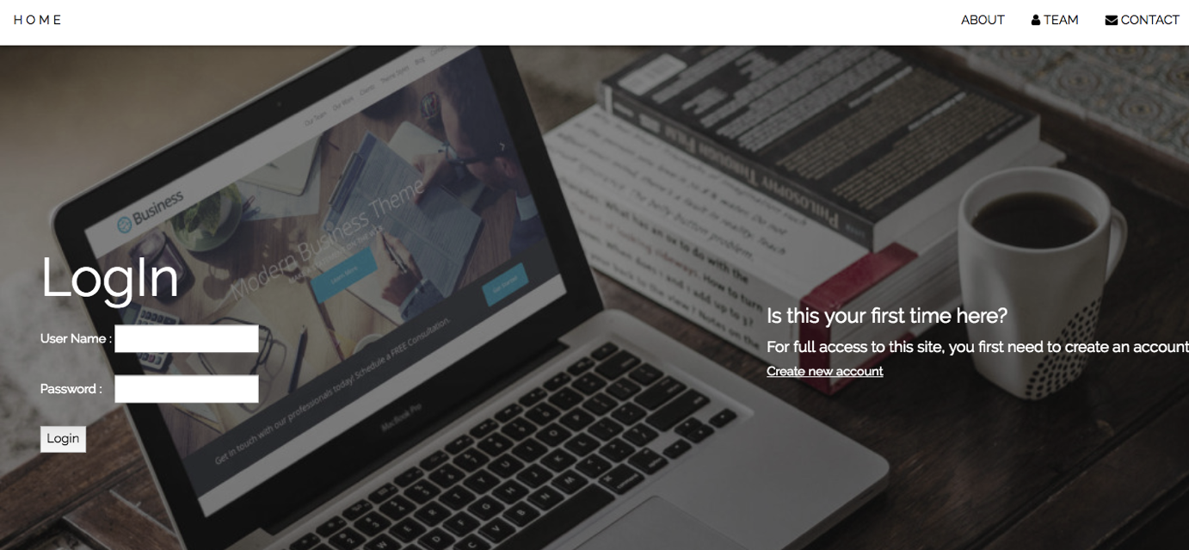

* Overview
  + Small description detailing the purpose of the application
* Features Description
  + List of all the features the application provides
* Team Members
  + Display the pictures and the contact details of all the team members involved in the making of the application
  + Contact feature allows user to open up their email client and send an email to the team members

**Listing Page**

* Header
  + Welcome user name
  + Drop Down Menu to navigate
  + Ability to add Listing
  + Ability to View Listing
  + Ability to Change Account Settings

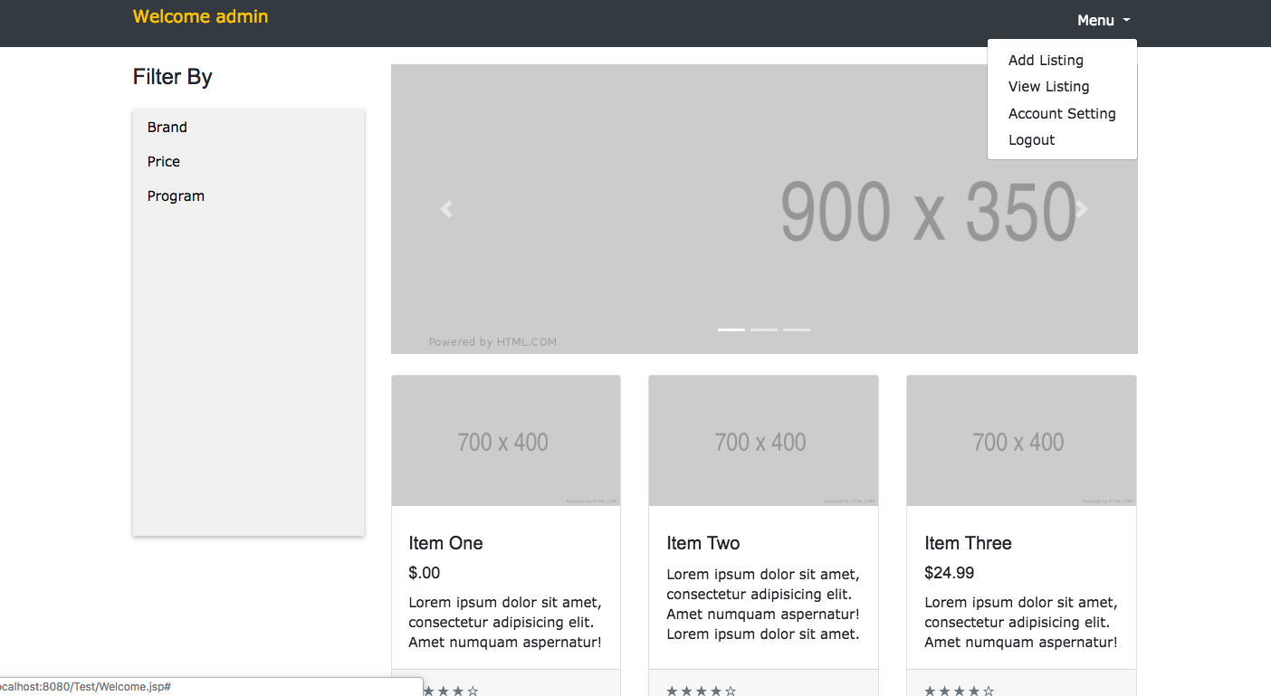

* Footer
  + Footer Copy rights



**My Account Page.**

* Header
  + Title
  + Main navigation bar
* My Details
  + User can update and change details pertaining to their account
  + User can delete their account
* Footer
  + Footer Copy rights

Not Completed

**Admin Page**

* Header
  + Title
  + Main navigation bar
* Admin Info
  + Admin can see a list of users
  + Admin can delete a user
  + Admin can edit user information
* Footer
  + Footer Copy rights

Not Completed

**Login, Logout and Account Creation Pages**

* Standard login, logout and account creation pages
  + User password is encrypted using hash tables
  + User can choose their language preference when they login

**Other**

* User password is encrypted
* Internationalization between English and French
* Security using realms and security constraints
* Ajax to support web forms

Not Completed

**Application Architecture:**

* Data Aspect

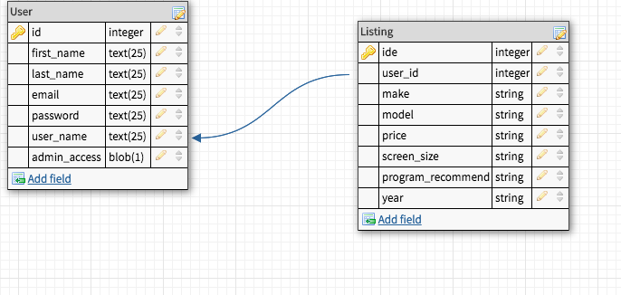

* Function Aspect
  + Administrative Functionality
    - Standard database manipulation (create/delete/update tables)
    - Ability to read usernames and emails
    - Ability to delete accounts from user database
    - Ability to delete/edit listing from database
  + User Functionality
    - Ability to edit accounts / delete accounts from database
    - Ability to delete/edit user listing from database
  + General Functionality
    - * User account creation
      * User can delete their account
      * User can edit account related information
      * User can Contact Us via email
* Additional Features
  + Multi-language-support (English and French)
  + Passwords to be encrypted before storage
  + Provide Ajax to web form pages
  + Add security constrains using realms

**Project Plan**

· Version 0.1

**Back-end:**

o Design (as entity-relationship diagrams) and placeholder values for the following database elements: User Portfolio Table, Listing Table)

o **Middle-level:**

o Establishing communication channels between front-to-back components

o Implementation of means of storage of user account data

o Establishing application logic

**Front-end:**

o Rough implementation of login and account creation pages

o Rough implementation of main Portfolio page

· Version 0.2

**Back-end:**

o Add the listing table to the database and testing random data

o Edit the userPortfolio table (hide admin rights from the menu, so user doesn’t have an option to choose)

o Restrict email creation to @algonquinlive.com

o Adding Password class for (hashing the password)-thinking of security aspect

**Middle-level:**

o Add a listing to the listing table through the front end

o Obtain information from listing table to display

o adding functionality to drop down menu in the catalogue page ex.(Add listing, show listing, account setting, logout)

o Obtain more testing on the catalogue page and drop down menu to avoid any crashes

**Front-end:**

o Create catalogue view to display the listings (including images of laptops or tablets)

o Create Header view (Drop down Menu, where user can add listing, edit listing, account setting to edit his account info, and logout which will take him to the home page).

O Add footer to the main page and listing page

O Obtain a responsive UI to make the site applicable with different screen sizes

**Estimation time for version 0.2**

Back-end: estimating 5 hours in total of creating the hash password class, adding a table to the database, and adding restrictions of email creations. Possible will take more than that for adding some testing or if we ever ran into a bug, and troubleshooting.

Middle-level: estimating 5 hours total for obtaining information from the listing table, adding listings to listing table (possible of fake data entry for testing purposes, and adding functionality to the drop down menu. Possible will take more than that for adding some testing or if we ever ran into a bug, and troubleshooting.

Front-end: estimating 6 hours, as creating a responsive UI for listing catalogue (menubar(will have a username label and dropdown menu), sidebar(for filtering the products), context(displaying the products with their specs),footer(copyright label, img&link to our github repo) with different colours. Possible will take more than that for adding some testing or if we ever ran into a bug, and troubleshooting.

· Version 0.3

**Back-end**

o Address security

**Middle-level**

o Establishing application logic and calculations

**Front-end**

o Internationalization/localization

* Version 1.0

Items to be touched up and Completed:

**Back-end**

* + Database reorganization
  + Created Historical entry table

**Middle-level**

* + Established application logic for Admin and My Account pages
  + Established application logic
  + Established application logic for contact us feature (email)
  + Bugs and fixes

**Front-end**

* + Designing My-Account page, Admin page
  + Design cleanup
  + Internationalization
  + Ajax
  + Security
  + Password Encryption

**Application Code Breakdown as of V-1.0:**

* Web Pages
  + Create.xhtml
  + Edit.xhtml
  + List.xhtml
  + View.xhtml
  + Login.xhtml
  + Index.html
  + Loginerror.xhtml
  + Welcome.xhtml
  + Admin.xhtml
  + User.xhtml
* Look and Feel
  + main.css
  + font-awesome.css
  + main.css
  + images
* Servlets
  + Login.java
  + Logout.java
  + MyAccount.java
* Java Beans
  + LogoutBean.java
  + HashedPasswordgenerator
* DataBase
  + Data Aspect of the Architecture stated implemented using MySQL and MariaDB

**Roles**

Agneese – Front-end

60% - Design web pages, registration system

20% - Adding Ajax support to web forms

10% - Aiding Seyar with middle-level

10% - Overall contribution to other areas of the project

Seyar – Middle-level (client-to-server and server-to-client liaison)

60% - Intermediary between front- and back-end elements; application logic and calculations (Mainly admin and user page)

30% - Aiding Agneese

10% - Overall contribution to other areas of the project

Brandon – Back-end (database design/management)

60% - Internationalization

30% - Aiding Hasan (with Database UML, implementation)

10% - Overall contribution to other areas of the project

Hasan – Back-end (database design/management)

60% - Implementing database elements (UML, Relations, tables, queries)

20% - establishing security using realms

10% - Aiding Brandon

10% - Overall contribution to other areas of the project

**Scope**

Currently we have a well-rounded project, as of right now most of the features we had described before have been or are mostly completed, the current scope as of version 0.3 to the final are as follows:

* Ajax functionality for user registration page
* Internationalization, for listings
* Security functionality
* Backend database management
* Administration functionality

**Estimation Time for Version 0.3 to Final Version**

Back-end: estimating between 15-20 hours, most of the work in the current scope has at least part of their components in the backend like the database management, security, administration, etc. The reason the estimate is high, is due to the fact that all of these needs to be tested with the middle level and front end, which could cause some issues that we would need to fix, basically giving us some leeway for bug fixes.

Middle-level: estimating around 12 hours, since we already have most of the functionality already implemented, the main thing is to test internationalization for the listings as well as adding admin functionality so that they can edit/delete listings properly, this area also connects both with the front and the back end. If admin deletes a user’s ad, it needs to update on the front-end and needs to update the users listing in the back-end.

Front-end: estimating around 8 hours, this section is virtually complete for us, we have already designed our webpage and have listings working. The main part that’s left for this section is making sure that all the features we do add in the back/middle part work properly on the front end. This means that this can’t be started till one of the other pieces is completed.

**Team Statement**

We are all happy with the contributions of all teammates, their communication and commitment during planning and execution, and the release Version 1.0 of our product.