#1 Site of Bantu Languages
Zanzibar · Tanzania · Kenya · D.R. Congo · Afrika Mashariki

KISWAHILI ? HAKUNA MATATA !
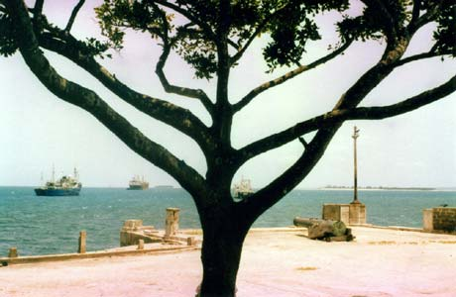
Zanzibar, Forodhani seafront

A New Swahili Learning Method
for Beginner Students

INTRODUCTION
Swahili in the world Swahili is at the 7th rank of the most widely spoken languages in the world, with somewhere between 45 and 100 million people that use it as their first or second language. Swahili, which means "the coast", is at first the mother tongue of the peoples that live on the East coast of Africa, that stretches from the South of Somalia to the North of Mozambique, via the islands of Pate, Lamu, Pemba, Zanzibar and Mafia. From East to West, the area of influence of Swahili extends from Tanzania and Kenya through the interior of Congo (ex-Zaïre), up to Uganda, Burundi, Zambia and Malawi.
What is Swahili ? Swahili belongs to the large family of Bantu languages, spoken in all the southern half of the African continent. However, it distinguishes itself from the other Bantu languages by its vocabulary of mixed Bantu and Arabic origins.
Language of contact and communication between the men that came from the outside, explorers, merchants, slave traders, colonizers, missionaries, etc. and the populations of the coast and of the inside of the continent, it developped as a lingua franca, and while preserving its Bantu grammatical structure characterized by a system of nominal classes and an agglutinative verbal construction, it managed to appropriate quantity of foreign words, for the greater part of Persan and Arabic origins, but also some Portuguese, German and mostly English words.
Development of Swahili Swahili, which was first transcribed in Arabic characters by Moslem men of letters on the islands along the East coast from as early as the XIIth through the XIXth century, took a new expansion with the arrival of the English missionnaries at the end of the XIXth century, who transcribed it in latin characters, and used it to propagate the teaching of the Christian faith to hundreds of peoples that each possessed their own tribal language. The first works of Swahili standardization were begun by the English missionnaries and the governors of Zanzibar at the beginning of the XXth century.
At the time of the independence of Tanganyika, Swahili naturally imposed itself as a medium of political propaganda and was seen as the language of liberation from the colonial yoke and as an instrument of unity between the local populations : indeed, Swahili was nobody's particular language and it wasn't tainted with tribalism.
In 1974, Tanzania took a further step when making Swahili its official and national language, spoken in the parliament and in the government. Overnight, its leaders imposed the eradication of all the English names from the streets and the buildings by renaming them with Swahili names, thus erasing all written traces of the colonial era from its districts, avenues, schools, businesses, banks, hotels, cooperatives and all other official and private amenities.
In the educative system, Tanzanian pupils and students begin their primary schooling in Swahili, and are only gradually exposed to English, which has henceforth the status of first foreign language, just before French.
Learning Swahili Swahili is certainly one of the easiest African languages to learn, for it doesn't contain any unpronounceable sounds for westerners, no "tones" as in Lingala, the other lingua franca of Africa. Its grammar, puzzling at first, works like a linguistic "meccano", and has made the delights of professional linguists since long. As for its vocabulary, there lies the only true difficulty of Swahili, for everything is new and must be memorized by heart, apart from a few words of English origin.
We advise our students to dedicate an average daily hour to learning the grammar and memorizing the vocabulary, and guarantee that this effort will produce its first fruit after only six months' learning.
Therefore, on the threshold of your apprenticeship we have the pleasure to wish you :
ALL THE BEST AND GOOD LUCK !

