The Syntax of Allocutivity in Arabic
Preprint – Draft.
SALEEM ABDEL HADY
This study presents evidence of the use of allocutive markers in Arabic. The study examines allocutive markers in three functionally analogs constructions: complementizer phrases, determiner phrases, and demonstrative phrases. The study supports the existence of speech act projections as the topmost c-commanding functional head. In addition, the study shows the impact of allocutive markers on categories. Allocutive markers have a pragmatic effect on commands, proximity, and pronominality. Determiners, addressee pronouns, names of verbs, and the double use of yous support the syntactic-pragmatic status of these markers.
Keywords: allocutive markers, speech act projections, morphosyntax

Introduction
Allocutive agreement refers to representing the gender of an addressee in utterances (Haddican, 2018; Kaur, 2018; Miyagawa, 2017). Allocutivity is extensively studied across languages: Punjabi (Kaur, 2018), Glician (Riobóo, 1995), Japanese (Miyagawa, 2017), Jingpo (Zu, 2013), and Basque (Haddican, 2018). The following examples illustrate the phenomenon.
- Amaia n-a-u-k.
Amaia ABS.1SG-PRES-have-ALL.MASC
I am Amaia (to a male addressee, speaking informally)
- Amaia n-a-u-n.
Amaia ABS.1SG-PRES-have-ALL.FEM
I am Amaia (to a female addressee, speaking informally)
Allocutive agreement appears in how speech participants show agreement with the addressee. In ‎(1), the marker -k depicts a male addressee. However, if the addressee is a female, the -n appears instead ‎(2). Allocativity appears in various constructions in the Arabic language and its spoken varieties. We often observe instances of multiple agreement patterns with the addressee. Agentive addressee and non-agentive ones in religious transcripts ‎(3).

- ʔa-raʔay-ta-ka hā-ḏā ʔal-laḏi karram-ta ʕalā-yya?
q.part-saw-2m.sg-2m.sg part-dem def-that prefered-2sg on-1sg.acc
‘Did you YOU see the person that you preferred over me?’
(Holy Quran)
- ʔa-raʔay-tu-kum ʔin ʔatā-kum ʕaḏāb-u Allah-i
Q.PART-saw-2M.PL-2M.PL if came-2M.PL.ACC torture-NOM God-GEN
baġta?
suddenly
‘Did you YOU see if God’s torture besieged you suddenly.’
(Holy Quran)
Two morphemes depict the addressee in the examples above. In ‎(3), -ta and -ka are second person singular morphemes. The structure of these morphemes is sensitive to the gender and number of the second person; in ‎(4), they change to reflect a plural second person. Despite its importance, none of the studies has examined allocutivity in the Arabic language. There are two reasons for ignoring this phenomenon. First, allocutivity is often depicted through multifunctional exponents; that is, allocutive morphemes perform more than one function, depending on their syntactic context. Without a contextual-functional analysis (Wiltschko, 2014), it is impossible to arrive at allocutive patterns. Second, in functional categories, allocutivity appears as bounded affixes; they are inseparable from the interpretation of their host; without a thoughtful scrutinization, it is tempting to submerge allocativity within the structure of such categories. The case resembles that of Basque (Haddican, 2018).
- Hi-k egin-go d-u-k/-n.
you-ERG do-IRR EXPL-ROOT-2SG.FAM.ERG.MASC/FEM
‘You (familiar) will do it.’
- Hi-ri eman-go d-i-a/na-t.
you-DAT give-IRR EXPL-ROOT-2SG.FAM.MASC/FEM.DAT-1SG.ERG
‘I will give it to you.’
The bottom-line that sets allocutivity apart from other functions is that allocutive exponents refrain from having thematic roles; they, instead, show pragmatic roles (Speas & Tenny, 2003). In this paper, we show that this is exactly what goes in the Arabic language. Second person exponents are two types: exponents that show thematic roles and exponents that show pragmatic roles. We provide evidence that the former exists in thematic domains while the latter shows up in speech act domains.
Even though the literature (Aoun et al., 1994; Benmamoun, 2011; Fehri, 2012, among others), examine -ak as a pronominal suffix that competes for genitive, oblique and accusative case, depending on the category it attaches to, the study highlights several cases in which the suffix cannot be treated according to previous treatments. The following table illustrates Benmamoun (2011) classification of -k.
Table 1 The Classification of -k in Benmamoun's (2011, p. 145-146) analysis
Second Person | Category | Singular | Dual | Plural
object clitics  in perfective | Verbs | ʃakara-ka | ʃakara-kumaa | ʃakara-kum
object clitics in imperfective | Verbs | ya- ʃakara-ka | ya- ʃakara-kumaa | ya- ʃakara-kum
genitive clitics | Nouns | kitābu-ka | kitābu-kumaa | kitābu-kum
oblique clitics | Prepositions | maʕa-ka | maʕa-kumaa | maʕa-kum

The classification above deals with how the marker -k is defined relative to verb, nouns, and prepositions. Thus, -k is viewed, based on these contexts, as a pronominal suffix. Benmamoun (2011) classification characterizes -k behavior in well-known contexts. He (2011, p.146) claims that “object clitics are not sensitive to the category type and to aspectual or temporal properties of the head that hosts them.” However, the classification above overlooks other contexts - the contexts in which -k serves as an allocutive marker.
The discussion is organized as follows. Section two provides a brief introduction to allocativity and speech act projections. Section three describes the multifunctionality of allocutive morphemes in Arabic and how they challenge agreement approaches (e.g., Benmamoun, 2011; Fassi Fehri, 2012). Section four proposes an analysis of these markers as bound morphemes that are merged in a speech act projection. Section five extends the analysis to capture analogs patterns at the morphosyntactic level: DPs and DemPs. We show the decomposition of the pronominal system in Arabic.

Background

The development in syntactic theories has shown that there are two ways in which the addressee interacts with syntactic structures: agentive and non-agentive addresses (Antonov, 2015). The non-agentive addressee is present by a class of morphemes that are called allocutive markers (Haddican, 2018). In Basque, speakers may use allocutivity with finite verbs in two occasions: familiarity and politeness. Based on that, there are two allocutive pronouns in the language hi and zu. Both pronouns feature a second person; nevertheless, hi shows familiarity, and zu expresses respect (Antonov, 2015, p. 56).
- Bilbo-ra n-oa
Bilbao-ALL 1.S-go
‘I am going to Bilbao.’

- Bilbo-ra n-oa-k
Bilbao-ALL 1.S-go-ALLOC:M
‘I am going to Bilbao.’ [male addressee]

- Bilbo-ra n-oa-n.
Bilbao-ALL 1.S-go-ALLOC:F
‘I am going to Bilbao.’ [female addressee]

- etʃe-a banu-sy.
house-ALL 1.S.go-ALLOC:RSP
‘I am going to the house.’ [respected addressee]
(Antonov, 2015, pp. 57–58)

According to Antonov (2015), the allocutive markers, -k ‎(8) and -n ‎(9), show that the speaker is familiar with addressee. In ‎(10), the speaker uses the allocutive morpheme -sy as a politeness strategy to code respect for the addressee.
Recently, researchers have proposed models for understanding how the language faculty generates allocutivity. The new models necessitate creating syntactic projections that can assign pragmatic roles. Reviving Ross' (1970) performative hypothesis, Speas and Tenny (2003) show that, in addition to including thematic domains, syntactic projections have domains for assigning pragmatic roles. Addressees may function as arguments if they are generated in thematic domains; they may lose this function if they are generated in the pragmatic domain. The basic insight has led to a further articulation of complementizer phrases; according to their view, pragmatic domains must c-command thematic ones; that is, speech act projections must be the maximal projection for complementizer phrases.
Speech Act Phrase (SAP)

Complementizer Phrase (CP)

Inflectional Phrase (IP)

Aspectual Phrase (AspP)

Verb Phrase (vP)

Speech act projections work on the basis of two layers to capture speech participants: the speaker layer and the hearer layer (Haegeman & Hill, 2013; Hill, 2007b, 2013a). Haegeman and Hill (2013) show how the speech act zone impacts particles and vocatives, Alcazar and Saltarelli (2013) create a link between this zone and imperatives, Gutzmann (2019) draws similar conclusions on its impact on expressivity and Wiltschko and Heim (2016) confirms its existence by looking at its role in grounding. The most agreed-upon pattern is seen in ‎(12) below.

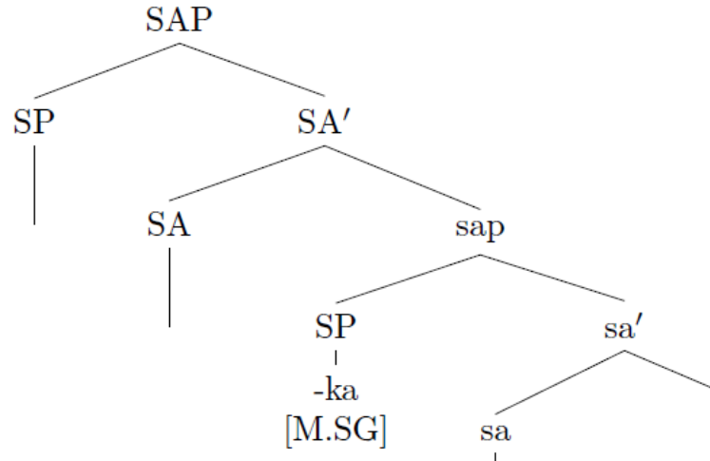
Among the many syntactic patterns that can relate to the speech act zone, allocutivity is related to how the hearer is depicted in syntactic derivations such as CPs (Haegeman & Hill, 2013), DPs (Ritter & Wiltschko, 2018), DemPs (Bliss & Wiltschko, 2014) and others.

Analysis

Cross-linguistically, allocutivity includes a second person feature and resembles second person pronouns; however, they do not appear in argument positions. To establish the foundation of allocutivity in the Arabic language and its spoken varieties, we present a comparative approach that highlights the role of allocutive markers in CPs, DPs, DemP, and PartPs. We present that in all these constructions, allocutivity serves pragmatic functions such as establishing emphasis, imperative force, exposing proximity relations, and others. The comparison shows that in these constructions, the second person marker does not have any argument position; that is, it does not function as a subject or object.

Allocutive Markers above CPs

The analysis shows that there is a need to distinguish between addressee at two syntactic levels. The first level predicts that the addressee has the thematic role of an agent, whereas the second level indicates that the addressee has the pragmatic role of a hearer. The prediction supports the contrasts of spelling out two specifiers. We provide a clear case where the specifier positions from the lowest part of the syntactic derivations, vP up to the highest-level, SAP. Consider the following example.
- ʔa-raʔay-ta-ka hā-ḏā ʔal-laḏi karram-ta ʕalā-yya?
q.part-saw-2m.sg-2m.sg part-dem def-that prefered-2sg on-1sg.acc
‘Did you YOU see the person that you preferred over me?’
(Holy Quran)

- ʔa-raʔay-tu-kum ʔin ʔatā-kum ʕaḏāb-u Allah-i baġta?
q.part-saw-2m.pl-2m.pl if came-2m.pl.acc torture-nom God-gen suddenly
‘Did you YOU see if God’s torture besieged you suddenly.’
(Holy Quran)
The question in ‎(13) shows a complex representation of the addressee that can be decoded only at the syntactic-pragmatic interface. The verb raʔay-ta-ka ‘you show’ is suffixed by two markers of you, -ta and -ka; the two markers, nevertheless, refer to the same addressee. The only difference is that the first marker, -ta is an articulation of the covert agent, while the second marker -ka does not function as an agent. The order of morphemes shows that they are syntactically governed; the suffix -ta must come before the suffix -ka
- a. ʔa-raʔay-ta-ka
b.*ʔa-raʔay-ka-ta
- a. ʔa-raʔay-tu-kum
b.*ʔa-raʔay-kum-tu
The syntactic difference pours out naturally from their hierarchical order; the agentive you (-ta/-tu) is closer to the verb than the non-agentive you (-ka/-kum). This entails where thematic and pragmatic roles are realized in syntactic structures.
The first stage, in deriving the structure of you YOU, begins with deriving the CP structure. The verb merges with its specifier. After the verb moves to T, it gets its past interpretation. Then, the verb moves to C to be associated with the interrogative force; C is specified by the interrogative particles ʔa. The derivation below clarifies the first stage.

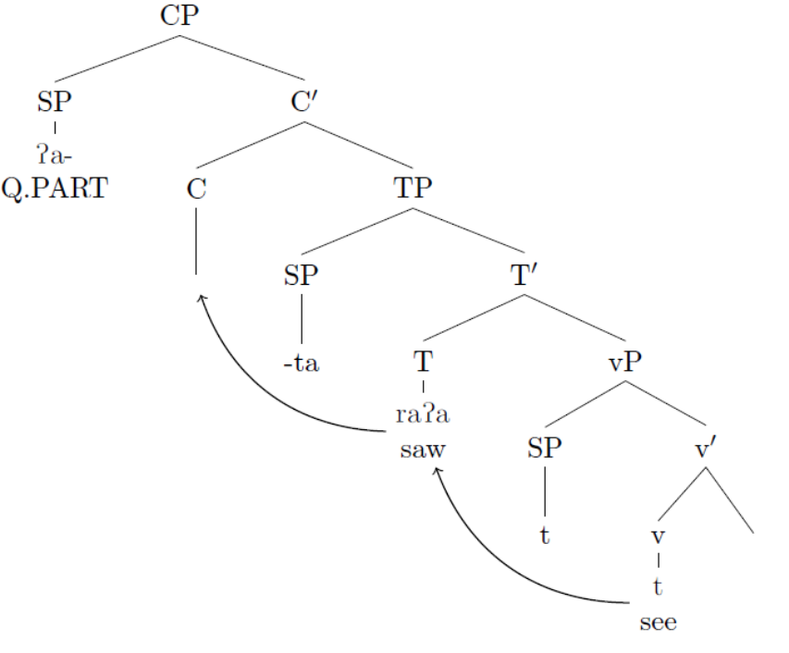
The same mechanism applies to moving the agentive -ta after associating it with its thematic role in the VP position. -ta moves to occupy the specifier position of little v before moving to the specifier position of T to satisfy the EPP feature in T. -ta is blocked from further movements because the interrogative particle occupies the next landing target, spec-c. The movement can be illustrated in ‎(18) below.

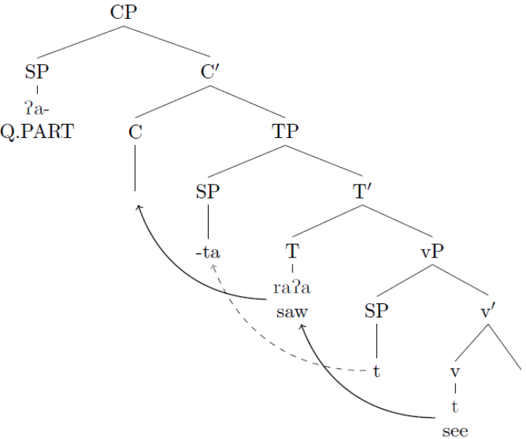
The second stage in the derivation is to account for the non-agentive -ka. Assuming that -ka represents the hearer and arguing that -ka is disassociated from any thematic roles and is associated with pragmatic roles instead confirms its status in SAPs; that is, -ka occupies the specifier position of the hearer projection ‎(19).

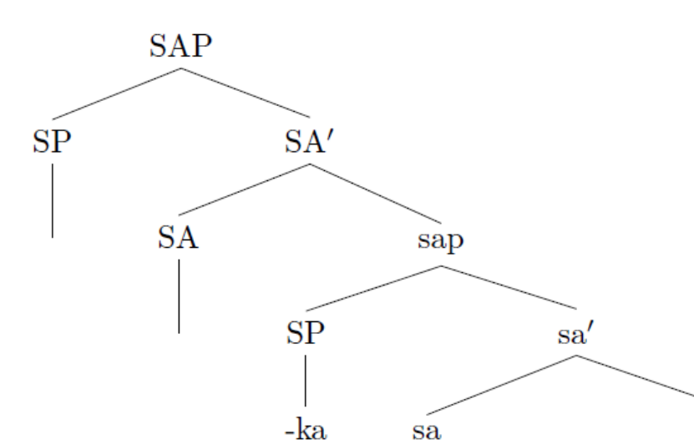
The -ka appears in a c-commanding position higher than the CP. Therefore, -ka cannot get any thematic roles, yet it exists in a position where a second-person feature is present (Hill, 2007b, 2013a).

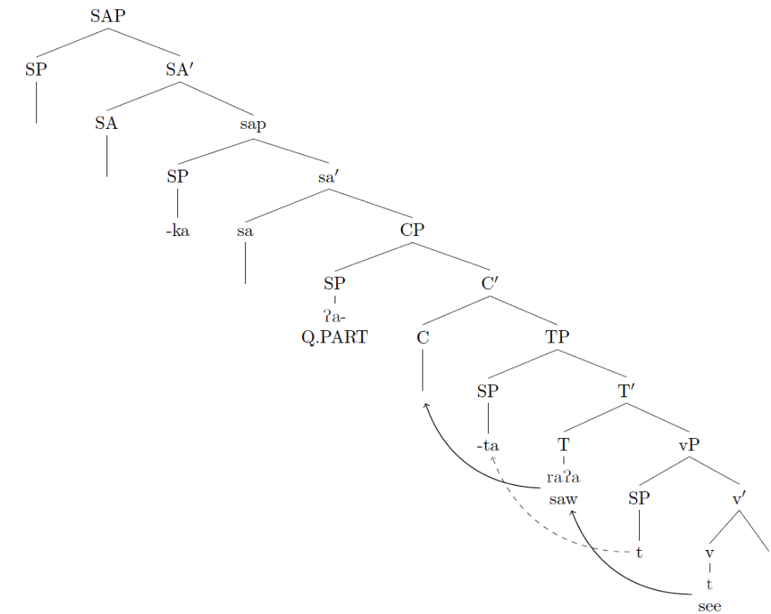
This fact explains why only -ka appears in this position but not any corresponding third-person markers, such as -hu. Notice that using -hu as an addressee is not permissible; instead, the grammatical role of -hu in ‎(21) is the direct object. Therefore, since the verb see is a monotransitive verb, using -hu along with another object yields to ungrammatical construction‎(22).
- a. *ʔa-raʔay-ta-hu [intended for an addressee]
b. ʔa-raʔay-ta-hu [-hu is the direct object]

- *ʔa-raʔay-ta-hu hā-ḏā ʔal-laḏi karram-ta ʕalā-yya?
q.part-saw-2m.sg-3m.sg.acc part-dem def-that prefered-2sg on-1sg.acc
‘Did you YOU see the person that you preferred over me?’

If -ak is in a c-commanding position, the derivation in ‎(20) would fail to account for the right word order. Since the interrogative particle is directed by a speaker and as the specifier position of the speaker is still vacant, we argue that the CP moves to spec-sap, yielding the following outcome.

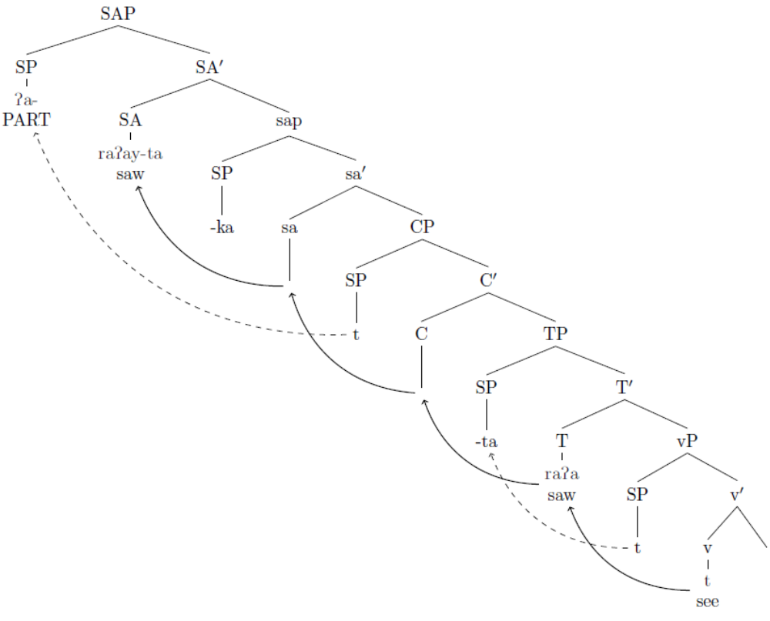
The outcome is that -ka ends in the rightmost position after the verb and its agentive suffix -ta and object, without having any thematic roles. The allocutive agreement, in Japanese, provides ample evidence for such movement (Miyagawa, 2017). The prediction can be generalized to support the existence of allocutive markers/agreement in Arabic and its spoken varieties, a matter that is overlooked in all previous treatments (e.g., Benmamoun, 2003, 2011; Fassi Fehri, 2012, among others). The pragmatic motivation for using you YOU is to establish an emphasis that is integrated with an imperative reminder for the addressee. The question is a rhetorical question; that is, the speaker does not wait for the addressee to answer his inquiry; instead, he is emphasizing and highlighting the speech act of reprimand on his behalf. We, therefore, argue that rhetorical questions are questions established when the specifier of C moves to the specifier of the position of the speaker's head. The conclusion has fruitful outcomes; information-seeking questions differ from rhetorical ones in that the latter involves more emphasis on the addressee; while the force of both types is established in C, C does not have any further impact on their interpretations.

Allocutive Markers in DemPs

If the syntax of SAPs is well-established in Classical Arabic, we should observe its impact on the structure of CPs, DemPs, and DPs. While we illustrate the former, we provide further evidence to its structure in DemPs and DPs. In Classical Arabic, the interpretation of demonstratives is opaque. The demonstrative ðalika, for instance, is often glossed as ‘that’. However, the demonstrative is not always interpreted as a distal marker; decomposing the demonstrative shows an interaction with the addressee marker -ak. The impact of the addressee marker reverses the commonly held view that the demonstrative should point to distal objects; instead, its use entails proximity ‎(24).
- ðālika ʔal-kitab lā raybba fī-hi …
this def-book no doubt in-it.gen
‘This book is undoubtful.” (Holy Quran)

I attribute the proximity of the interpretation to the structure of the demonstrative itself ‎(25); ðalika may be decomposed into three parts: ða-li-ka [DEM-li-2m.sg]. Because of the addressee marker, I argue that ða [DEM] depicts proximity. The speaker is not only pointing toward the book but also implying a command for a nearby addressee. The book is far from the speaker, indicated by -li, but it is close to the hearer. The decomposition may provide further evidence for the impact of speech acts at the morphosyntactic level (Marantz, 1997), confirming the similarity between CPs, DPs, and DEMPs (Bliss & Wiltschko, 2014, 2018; Clark et al., 1983; Wiltschko, 2014c).

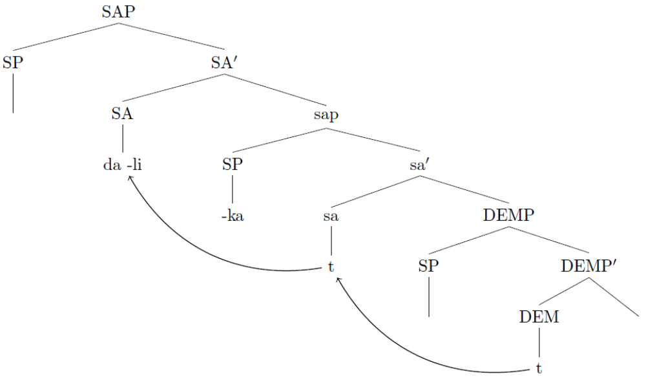
It is observed that, in some languages such as Punjabi (Kaur, 2018), the allocutive marker is realized as the cogwheel of the imperative interpretation. In DEMPs, the allocutive marker changes the spatial deictic interpretation. The behavior of other closely related demonstratives such as haðak ‘that’ provides a full articulation of the specifier position of the speaker; the demonstrative may be decomposed into three elements [ha-DEM-2.SG]. ha- represents a marker through which the speaker is drawing the hearer’s attention ‎(26).

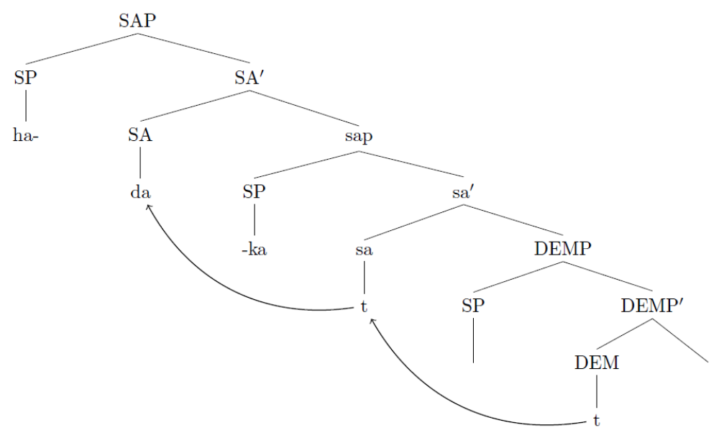
In line with the finding, a potential area of research is to explore the impact of the allocutive marker on other demonstratives and opaque categories and figure out its influence on their interpretation.

Allocutive Markers in DPs
Abney (1987) shows that there is a parallel between CPs and DPs. Ritter and Wiltschko (2018) argue that SAPs are not limited to CPs, but they can also be found in DPs. The analysis of -ak as an allocutive morpheme in Arabic supports their conclusions. The following example is illustrative.
- ʔiyyaka naʕbd-u wa ʔiyyāka nastʕīn.
indef.pro:2m.sg.acc worship.1pl-pres and indef.pro:2m.sg.acc seek-help.1pl
‘It is You we worship, and it is You we ask for help.’
We depart from previous treatments of ʔiyaka as a pronoun that consists of one unit. -ka only represents the second person specifications, while ʔiya itself does not. Both affixes are inseparable; they are bound morphemes. Therefore, in this domain -ka cannot have any thematic roles of its own. However, we notice that as one-unit, ʔiyaka is having the accusative case and acts as the grammatical object of its c-commanding verbs ‎(28).
- [focp iyyaka [foc [cp …[vp pro [v naʕbd-u DP[iyaka]]
Our prediction suggests that the pronoun is breakable, yet it is inseparable. This suggests that DP is morphosyntactically complex; it is c-commanded by a SAP. Our initial analysis can be presented as follows.

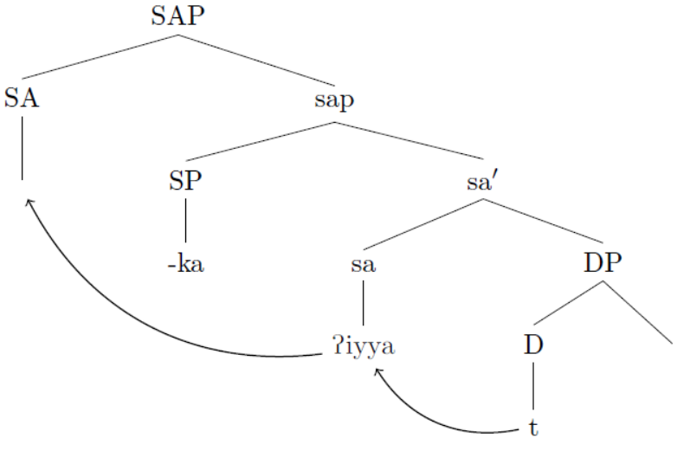
In (17), the indefinite pronoun originates in the D position; however, since the DP is related to the addressee, it moves to a position to be specified by the allocutive marker (via an agreement with addressee or via affixation to the allocutive morpheme). Based on the analysis, the indefinite interpretation is clarified by specifying the gender and number of the addressee. The pronoun is used to emphasize the addressed entity.
The suggested idea highlights another puzzle. The Arabic pronominal system classifies ʔiyaka as an accusative pronoun and lists another functional akin pronoun as an agentive one. Thus, the system differentiates two pronouns that stand for the second person: ʔiyaka and ʔanta and their derivatives as follows.
- ʾiyāka [m.sg] ʾiyāki [f.sg], ʾiyākumā [n.du], ʾiyākum [m.pl], ʾiyākun [f.pl]
- ʾanta [m.sg], ʾanti [f.sg], ʾantumā [n.du], ʾantum [m.pl], ʾantuna [f.pl]
The pronouns show sharp contrast at two levels. The first level is that the pronouns in ‎(30) can have an imperative force when they are used by themselves, while the pronouns in ‎(31) cannot.
- ʾiayāka w al-kaḏib.
2m.sg.imp and def-lie
‘you must not to lie.’
‘I warn you not to lie.’
Another contrast appears with how ʾiyyā can detach from -ka. ʾiyyā can attach with third-person bound pronouns. Once they detach from their second person markers, they behave differently. They lose the ability to imply imperative force. Besides, ʾiyyaā can show the speaker.
- ʾiyyāhu [m.sg], ʾiyāhā [f.sg], ʾiyāhmā [n.du], ʾiyāhm [m.pl], ʾiyāhn [f.pl]
- ʾiyāya [sg], ʾiyānā [pl]
We assume that ʾiyyā is a DP by itself. The difference lies in how the DP depicts its internal structure. -ka represents the articulation of the hearer specification ‎(30)and -ya and -na ‎(34) depicts the specification of the speaker. The third person patterns confirm the agentive specifications ‎(33). The logical patterns confirm the status of ʾiyyā as a unit of language that has its own boundary.
We argue that these pronouns consist of internal structure. As I illustrated earlier, ʔiyyaka consists of the indefinite marker, ʔiyya, and the allocutive marker -ka. As it stands the ʔiyyaka cannot appear in the agentive position; we attribute the reason to the fact that -ka does not have any thematic roles. By analogy, ʔanta and its derivatives ‎(31) consist of two bound morphemes: ʔan and -ta. The prediction highlights why ʔanta albeit specified with a second person feature like ʔiyyaka it must always appear in the agentive position. Our analysis predicts that ʔan is formed in a similar way like ʔiyyaka; however, it is specified by the agentive -ta which associates with ʔan at an earlier stage. The stage is akin to the specifier position of the VP, where thematic roles are assigned. Thus, ʔanta is derived as follows.

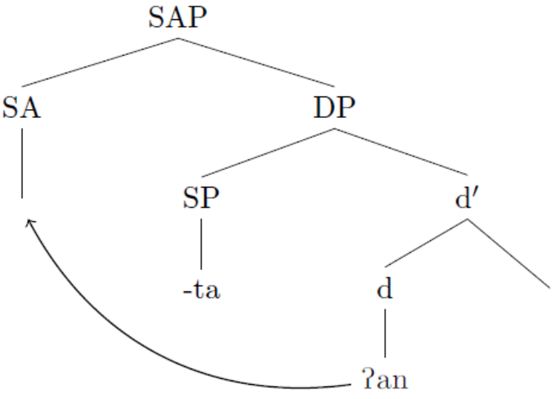
The analysis shows that the system of the Arabic language consists of three major categories: nouns, verbs and particles. What originates in the d position and gets new interpretations are, in fact, particles; the functional head defines the particles. Their specification with agentive and non-agentive addressee markers define their use and position. Thus, those particles that originate in the d position and are c-commanded by the hearer never appear in the agentive position, but those that are associated with the agentive markers can appear as agents.

Allocutive Markers in Imperative NoVs

We push the prediction that the Arabic language has only particles and show how particles can be disguised in ʔisim ʔal-fiʕil ‘Names of Verbs’. In the Arabic language, prepositions can appear to function as verbs, and they withhold commands for their hearers.
- haaka al-kitaab-a.
part:2m.sg def-book-acc.
‘Take the book.’
- dūnka al-qalam.
part:2m.sg def-pen
‘take the pen.’
We argue that the derivation of this category follows from the same principle; the particle in the V position acts as a verb and may end up like verbs. However, once the particle moves to the speech act zone; it behaves differently; in that position, the particle internally merges with a specifier that does not have a thematic role; that is, the particle gets specified by a hearer. The representation below illustrates a shortcut for the movement process.

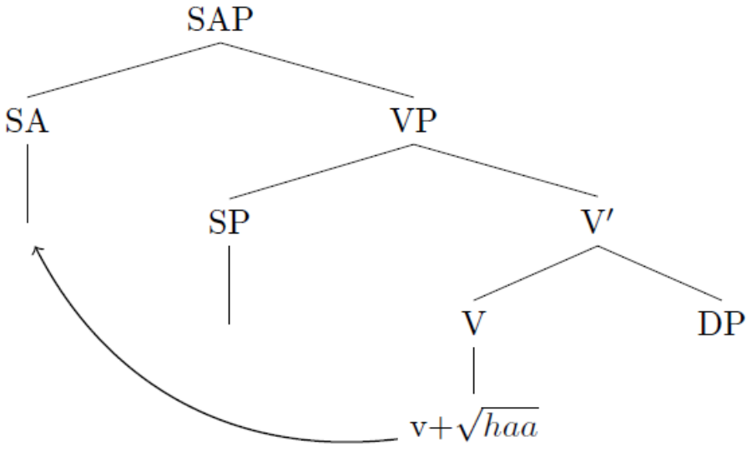
Pragmatic reasons, more specifically emphasis, trigger the movement of the particle; in its original position the particle will move the C position for generating the imperative force; like in English, the C position is specified by a generic you; the generic you cannot specify precisely the entity addressed. Therefore, the particle moves higher up to a position that enables a more accurate interpretation of the imperative force; the new landing site should confirm the gender and number of the hearer. The SAP singles the hearer out and specifies its gender and number by the allocutive marker -ka and its derivatives.

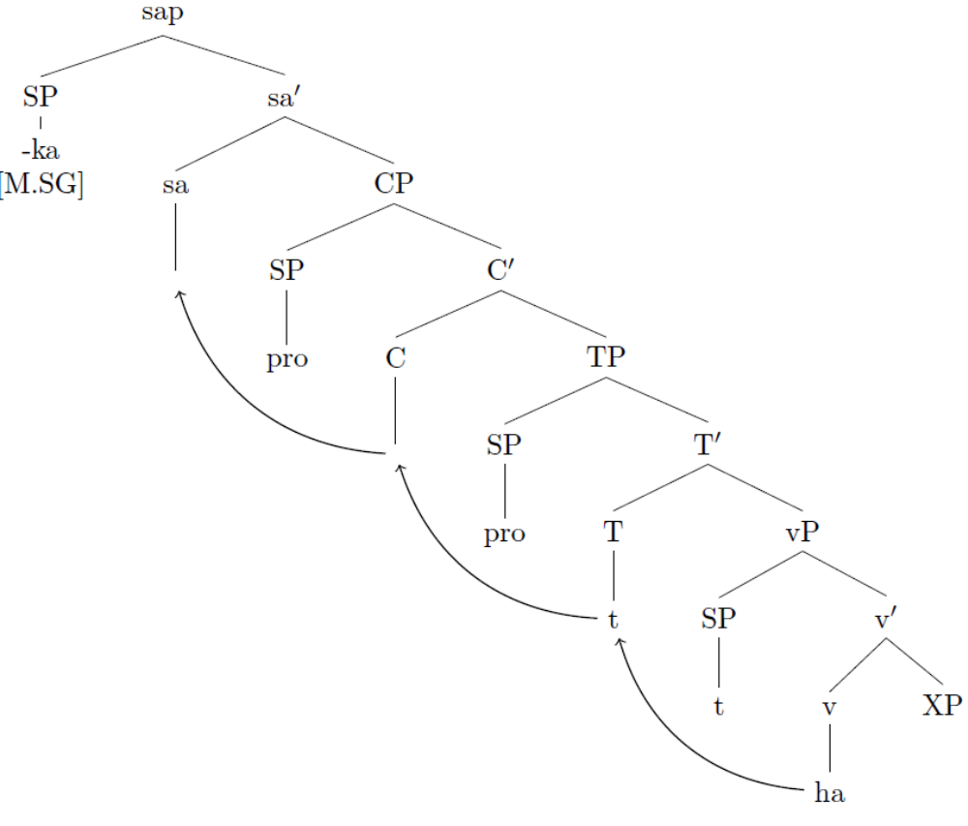
The prediction provides evidence for the role of allocutive markers in imperative interpretations. Kaur (2018) shows that Punjabi, an Indo-Aryan language, deploys allocutive markers, such as -je, with declarative verbs for endowing such verbs with imperative force.
- (tuu/tussi) bacce-nuu vekh-Ø/vekh-o.
(2.sg/2.pl) child-acc see.imp-2.sg/see.imp-2.pl
‘Look after/see the child.’
- (tussi) bacce-nuu vekhyaa-je
(2.pl) child-acc see.perf.m.sg-alloc
‘Look after/see the child!’
Kaur (2018) shows that allocativity is the primary source for the impetrative interpretation in ‎(41). We also conclude that what endows particles and DPs with imperative force is their association with allocutive markers.

Allocutive Markers in Imperative Calls

One of the most recent areas in syntactic literature has focused on the syntactic structure and the functional composition of call constructions (Hill, 2007a, 2013b, 2017). Across languages, establishing a call on addressee is mostly done by vocative particles (Hill, 2007a) or by intonation (Heim et al., 2016). In the Arabic language, vocatives are not exceptional. According to (Moutaouakil, 1989, among others), there are eight vocative particles: ʔa, ʔaj, jā, ʔaja, haja, ʔaj, ʔa, and wa. Most particles appear along with an addressee. Most studies have focused on dealing with calls established by using the particle jā (Shormani & Ali Qarabesh, 2018). Most recent generative treatments of vocatives predict that a vocative construction consists of an optional vocative particle that occupies the specifier position of a vocative head (Espinal, 2011; Hill, 2007, 2013a), schematized in (233) below. Soltan (2016) shows the applicability of this model in generating vocatives in Arabic.

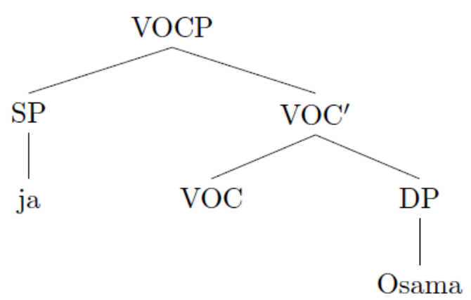

According to Soltan (2016), in Egyptian Arabic, the vocative particle is obligatory with nouns and adjectives and is prohibited with second-person pronouns and definite DPs. The distribution of the vocative particle, in Egyptian Arabic, shows that vocative particles cannot be used with pronouns.

- *jā ʔinta.
voc you
‘hey, you.’

However, in spoken varieties of Arabic, such as Omani Arabic, speakers create a call by using the call particle ja along with the second person; more specifically, in Omani Arabic, speakers use jaak [ vocative particle + second person] to establish a warning call on addressee (Lutz & Jong, 2011). The pattern suggests that the vocative particle gets an imperative force once the allocutive marker attaches to it. See the following example.

- jāk wī ʔil-lis.
part.2m.sg part def-thief (Omani Arabic)
‘watch out for the thief!’ (Lutz & Jong, 2011, p. 486)

The prediction shows a neat interaction between syntactic outputs and pragmatic motivations. When a call is established in typical situations, it is fully-fledged with a vocative particle and an addressee. Strong calls are more urgent and direct. We conclude that what enables the imperative interpretation of calls is their association with allocutive markers.

Conclusion
This research presents data in favor of allocativity in Arabic. We have highlighted contexts in which second person markers do not have an agentive role; instead, they show pragmatic ones. The pragmatic roles of the second person markers qualify them to be interpreted as allocutive morphemes. The first pattern appears where agentive and non-agentive markers are used in one domain; the appearance of the two markers highlighted the syntactic position and role of allocativity in Arabic. We extended the analysis to capture allocativity at the morphosyntactic compositions of DPs, DemPs, PartPs and VocPs. The remarkable behavior of allocativity confirms the views that SAPs are the topmost c-commanding layer of nominal projections(Ritter & Wiltschko, 2018) and demonstrative phrases (Bliss & Wiltschko, 2014), which gives direct support for the Universal Spine Hypothesis (Wiltschko, 2014). The study also finds that allocativity in Arabic serves several pragmatic functions: it can establish imperative force, emphasis, and proximity. The principle that governs allocutive markers is how functional heads attach to roots and their level of association.

Works Cited
Abney, S. P. (1987). The English noun phrase in its sentential aspect [Ph.D.]. MIT.
Alcazar, A., & Saltarelli, M. (2013). The Syntax of Imperatives. Cambridge University Press. https://doi.org/10.1017/CBO9780511794391
Antonov, A. (2015). Verbal allocutivity in a crosslinguistic perspective. Linguistic Typology, 19(1), 55–85. https://doi.org/10.1515/lingty-2015-0002
Aoun, J., Benmamoun, E., & Sportiche, D. (1994). Agreement, Word Order, and Conjunction in Some Varieties of Arabic. Linguistic Inquiry, 25(2), 195–220. JSTOR.
Benmamoun, E. (2003). Agreement parallelism between sentences and noun phrases: A historical sketch. Lingua, 113(8), 747–764. https://doi.org/10.1016/S0024-3841(02)00127-4
Benmamoun, E. (2011). Agreement and Cliticization in Arabic Varieties from Diachronic and Synchronic Perspectives. Al-’Arabiyya, 44/45, 137–150. JSTOR.
Bliss, H., & Wiltschko, M. (2014, October 23). The Syntactic Composition of Blackfoot Demonstratives—Google Search.
Bliss, H., & Wiltschko, M. (2018). Stsíkiistsi ki stsíkiistsi: The ubiquity of Blackfoot demonstratives in discourse [Workshop]. Discourse Functions of Demonstratives, UiO UiO Department of Linguistics and Nordic Studies.
Clark, H. H., Schreuder, R., & Buttrick, S. (1983). Common ground at the understanding of demonstrative reference. Journal of Verbal Learning and Verbal Behavior, 22(2), 245–258. https://doi.org/10.1016/S0022-5371(83)90189-5
Espinal, T. (2011). Pragmatic particles at the syntax-cognition interface. In L. Payrató & J. M. Cots (Eds.), The Pragmatics of Catalan (pp. 49–80). Walter de Gruyter.
Fassi Fehri, A. F. (2012). Key Features and Parameters in Arabic Grammar. John Benjamins Publishing.
Gutzmann, D. (2019). The Grammar of Expressivity. Oxford University Press.
Haddican, B. (2018). The syntax of Basque allocutive clitics. Glossa: A Journal of General Linguistics, 3(1), 101. https://doi.org/10.5334/gjgl.471
Haegeman, L., & Hill, V. (2013). The syntacticization of discourse. Syntax and Its Limits, 370–390.
Heim, J., Keupdjio, H., Lam, Z. W.-M., Osa-Gómez, A., Thoma, S., & Wiltschko, M. (2016). Intonation and Particles as Speech Act Modifiers: A Syntactic Analysis. Studies in Chinese Linguistics, 37(2).
Hill, V. (2007a). Vocatives and the pragmatics–syntax interface. Lingua, 117(12), 2077–2105. https://doi.org/10.1016/j.lingua.2007.01.002
Hill, V. (2013a). Vocatives: How Syntax meets with Pragmatics. Brill. https://brill.com/view/title/20550
Hill, V. (2017). Vocatives in the Balkans. Revista Letras, 96. https://doi.org/10.5380/rel.v96i0.50145
Kaur, G. (2018). Adresee Agrement as the Locus of Imperative Syntax. North East Linguistics Society 2018, Cornell University.
Lutz, E., & Jong, R. (Eds.). (2011). Encyclopedia of Arabic Language and Linguistics. BRILL. https://referenceworks.brillonline.com/browse/encyclopedia-of-arabic-language-and-linguistics
Marantz, A. (1997). No Escape from Syntax: Don’t Try Morphological Analysis in the Privacy of Your Own Lexicon. University of Pennsylvania Working Papers in Linguistics, 27.
Miyagawa, S. (2017). Agreement Beyond Phi. MIT Press.
Moutaouakil, A. (1989). Pragmatic functions in a functional grammar of Arabic. Foris Publications.
Riobóo, M. de la S. C. (1995). Ethical datives and solidarity clitics in Galician. University of Kansas, Linguistics.
Ritter, E., & Wiltschko, M. (2018). Nominal speech act structure: Evidence from the structural deficiency of impersonal pronouns. e
Ross, J. (1970). On Declarative Sentences. In R. Jacobs & P. Rosenbaum, Readings in English Transformational Grammar (pp. 22–227). Ginn and Company.
Shormani, M. Q., & Ali Qarabesh, M. (2018). Vocatives: Correlating the syntax and discourse at the interface. Cogent Arts & Humanities, 5(1). https://doi.org/10.1080/23311983.2018.1469388
Soltan, U. (2016). The syntax of vocatives in Egyptian Arabic. http://www4.uwm.edu/letsci/conferences/asal29/abstracts/apr10-930am-Soltan-syntax%20of%20vocatives%20in%20Egyptian%20Arabic.pdf
Speas, P., & Tenny, C. L. (2003). Configurational properties of point of view roles. In A. M. Di Sciullo (Ed.), Linguistik Aktuell/Linguistics Today (Vol. 57, pp. 315–344). John Benjamins Publishing Company. https://doi.org/10.1075/la.57.15spe
Wiltschko, M. (2014, July). The Universal Structure of Categories: Towards a Formal Typology. Cambridge Core. https://doi.org/10.1017/CBO9781139833899
Wiltschko, M., & Heim, J. (2016). The syntax of confirmationals: A neo-performative analysis. In G. Kaltenböck, E. Keizer, & A. Lohmann (Eds.), Studies in Language Companion Series (Vol. 178, pp. 305–340). John Benjamins Publishing Company. https://doi.org/10.1075/slcs.178.11wil
Zu, V. (2013). Probing for conversation participants: The case of Jingpo. Proceedings of the Annual Regional Meeting of the Chicago Linguistic Society, 379–389.

© Memorial University of Newfoundland.
While some examples are cited from Classical Arabic, they are important for grounding the phenomenon in everyday use of the language; using a language covers the ability of its native speakers to decode messages. We extend the analysis to everyday language throughout the study.
I refrain from presenting pro-drop for clarity of the argument; nevertheless, we think that -ak and -ta may represent agreement markers with hidden pros in the same positions.

