**SQL Queries in PostgreSQL**

**Creating Tables of CSV files:**

1. Create Medals table

CREATE TABLE medals (

"Rank" INT,

Country_Name varchar(50),

Gold INT,

Silver INT,

Bronze INT,

Total INT,

"Rank by Total" INT

);

2. Create Athletes table

CREATE TABLE athletes (

athlete_name varchar(50),

country varchar(50),

discipline varchar(50)

);

3. Create Coaches table

CREATE TABLE coaches (

coach_name varchar(50),

country varchar(50),

discipline varchar(50),

“event” varchar(50)

);

4. Create EntriesGender table

CREATE TABLE entriesgender (

discipline varchar(50),

female INT,

male INT,

total INT

);

5. Create Teams table

CREATE TABLE teams (

country_name varchar(50),

discipline varchar(50),

country varchar(50),

“event” varchar(50)

);

**Load Data from CSV to PostgreSQL database:**

Copy athletes

FROM 'D:\Sahil\OTHERS\Masters\HOF\Power BI\Azure\Data\Athletes.csv'

DELIMITER ','

CSV HEADER

Output:

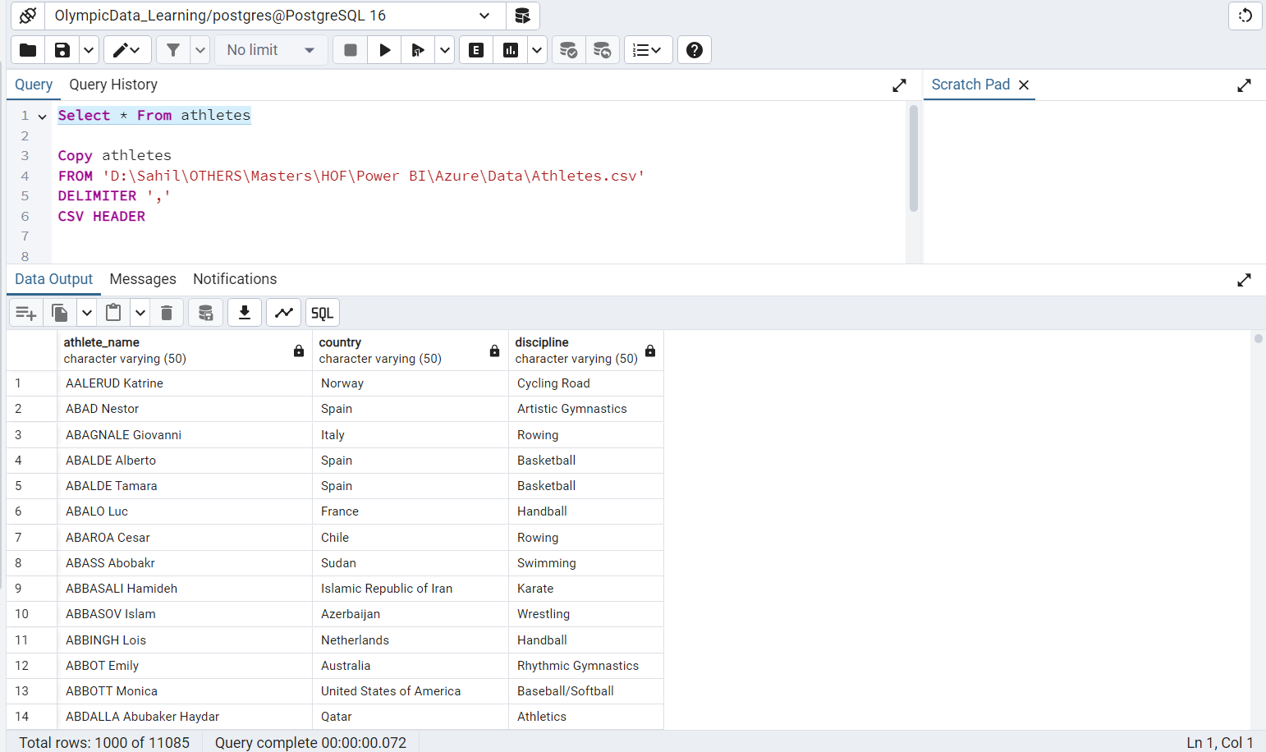

Copy entriesgender

FROM 'D:\Sahil\OTHERS\Masters\HOF\Power BI\Azure\Data\EntriesGender.csv'

DELIMITER ','

CSV HEADER

Output:

Copy coaches

FROM 'D:\Sahil\OTHERS\Masters\HOF\Power BI\Azure\Data\Coaches.csv'

DELIMITER ','

CSV HEADER

Output:

Copy medals

FROM 'D:\Sahil\OTHERS\Masters\HOF\Power BI\Azure\Data\Medals.csv'

DELIMITER ','

CSV HEADER

Output:

Copy teams

FROM 'D:\Sahil\OTHERS\Masters\HOF\Power BI\Azure\Data\Teams.csv'

DELIMITER ','

CSV HEADER

Output:

