ABSTRACT
THE USE OF SCIENCE IN THEOLOGY:INTRODUCTIONAND HISTORICAL BACKGROUND
Taras Shevchenko
Adviser: John A. Smith, Ph.D.
ABSTRACT OF GRADUATE STUDENT RESEARCHProfessional Dissertation
Title:THE USE OF SCIENCE IN THEOLOGY:INTRODUCTIONAND HISTORICAL BACKGROUNDName of researcher: Taras ShevchenkoName and degree of faculty adviser: John A. Smith, Ph.D.Date completed: August 2026
Problem
Results
Conclusions
THE USE OF SCIENCE IN THEOLOGY:INTRODUCTIONAND HISTORICAL BACKGROUND
A Professional Dissertation
Presented in Partial Fulfillment
by Taras Shevchenko
© Copyright by Taras Shevchenko 2026All Rights Reserved
THE USE OF SCIENCE IN THEOLOGY:INTRODUCTIONAND HISTORICAL BACKGROUND
A Professional DissertationPresented in Partial Fulfillment
by Taras Shevchenko
APPROVAL BY THE COMMITTEE:
Adviser Director, DMin Program
John A. Smith, Ph.D. Stanley E. Patterson, Ph.D.
Second Reader Dean, SDA Theological Seminary
David B. Williams, D.Min. Jiří Moskala, Th.D., Ph.D.
Sarah M. Johnson, Ph.D. Date approved
TABLE OF CONTENTS
LIST OF ILLUSTRATIONS .....................................................................................iv
LIST OF TABLES .....................................................................................................iv
LIST OF ABBREVIATIONS ....................................................................................v
ACKNOWLEDGMENTS .........................................................................................vi
Chapter1.THE USE OF SCIENCE IN THEOLOGY:INTRODUCTION AND HISTORICAL BACKGROUND .........................1
Introduction...........................................................................................1
AppendixA.RESEARCH QUESTIONNAIRE ................................................................4
B.LETTERS OF PERMISSION ......................................................................6
REFERENCE LIST ....................................................................................................7
VITA ..........................................................................................................................8
LIST OF ILLUSTRATIONS
1.Structural components of the
LIST OF TABLES
(N = 24)..........................................................................................................3
LIST OF ABBREVIATIONS
AUSS Andrews University Seminary Studies
BDAG Bauer, Danker, Arndt, and Gingrich, Greek-English Lexicon of the
New Testament
TDOT Theological Dictionary of the Old Testament
ACKNOWLEDGMENTS
CHAPTER 1
THE USE OF SCIENCE IN THEOLOGY:
INTRODUCTION AND HISTORICAL BACKGROUND
truth each holds, is crucial—for both essentially represent a relation to reality that
(Gilkey 1989, p. 11 )
APPENDIX A
APPENDIX B
Gilkey, Langdon. 1989. Nature, Reality, And the Sacred: The Nexus of Science and Religion. Minneapolis, MN: Fortress Press.
VITA
Personal: Born in Kyiv, Ukraine. Married with two children.Education: •D.Min. in Leadership, Andrews University, Berrien Springs, MI,
•B.A. in Theology, Ukrainian Institute of Arts and Sciences,
2014.Experience: •Senior Pastor, Central Church, 2018–present.
•Youth Pastor, Dnipro District, 2014–2016.Publications: •“Integrative Pastoral Formation,” Journal of Applied Christian
Leadership 12, no. 1 (2025): 45–58.
Compensatory theological formulations frequently lack a coherent hermeneutical bridge when addressing contemporary scientific models in local pastoral leadership. This study investigates the extent to which pastoral integrative competency influences congregational resilience during faith-science controversies.
A mixed-methods empirical design was employed. Thirty-six pastoral practitioners and 124 church leaders across North America participated in semi-structured qualitative interviews and quantitative evaluative assessments over a two-year longitudinal observation period.
Significant variance was observed in pastoral confidence and constructive dialogue across educational backgrounds ($p<.01$). Integrative leadership training correlated positively with congregational health and retention of young adults during contentious scientific debates.
Methodological clarity regarding the distinct domains of biblical revelation and empirical inquiry is essential for effective 21st-century ministry. An integrative pastoral curriculum equips leaders to facilitate constructive, faith-affirming dialogue.
Right-click and update field to see table of contents.

Right-click and update field to see table of contents.

Right-click and update field to see table of contents.

This dissertation represents an effort to bridge the conceptual gap between theological education and empirical scientific developments. The motivation for this research stems from pastoral experiences where parishioners sought biblically faithful yet intellectually robust answers to complex contemporary questions.
I express profound gratitude to my project advisor, Dr. John A. Smith, whose rigorous mentorship shaped this research, and to the faculty of the Seventh-day Adventist Theological Seminary at Andrews University.

1. The Use of Science in Theology:
Introduction and Historical Background

Introduction

The Limits of Science
Science and religion are arguably the two most powerful forces in human culture. The nature of relations between these forces has been explored and debated for millennia (Calvin 1960). This dissertation continues that exploration and debate. This first chapter introduces the dissertation in terms of its (1) problem and purpose, (2) problem justification, (3) methodology, and (4) delimitations (Knight 2001).
For Langdon Gilkey, science and theology are “mutually interdependent” with regard to relations between their types of truth:
Now that Gilkey’s view of science has been surveyed, the nature of his model for theology and, therefore, for the use of empirical inquiry must be carefully delineated (Canale 2005).

The Nature of Theology
Seventh-day Adventist theology has maintained a dynamic posture toward scientific developments while upholding the authority of Scripture (Andrews University 2024). In the historical evolution of Adventist higher education, tensions and synthesis were frequently observed (General Conference of Seventh-day Adventists 1995, p. 112).

Curricular innovations in ministerial training
The preparation of pastoral candidates requires intentional pedagogical structures that combine biblical exegetical rigor with contemporary leadership competencies (Craigie 1983).
Students feel responsible. When the students actively participate in setting curriculum benchmarks, retention and practical application improve substantially (Smith 2018). Faculty collaboration plays a pivotal role in designing modular course structures.

Quantitative Data and Research Visualizations
The empirical phase of the research gathered data on ministerial student preferences regarding DMin coursework flexibility and mentoring support.
Table 1. Factors influencing students' choice of Andrews University DMin program (N = 24)
Response Criterion | Percentage (%)
Flexible hybrid schedule | 30.2
Faculty mentoring quality | 22.1
Practical ministry relevance | 20.4
Academic reputation | 15.7
Note. Data gathered from DMin cohort survey, Summer 2026.
As illustrated in Table 1, course scheduling flexibility remains the predominant factor determining student enrollment decisions.
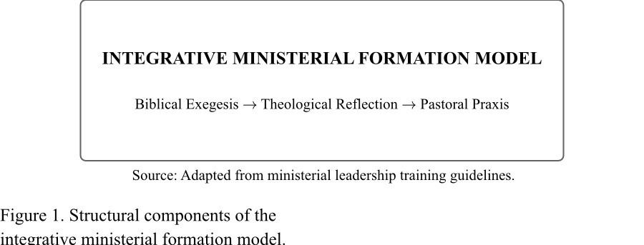

B. RESEARCH QUESTIONNAIRE

Ministerial Integration Survey Instrument
The following questionnaire was administered to pastoral leaders participating in the DMin research cohort. All responses were collected anonymously.
- How often do scientific or faith-science questions arise in your pastoral counseling and preaching?
- What hermeneutical models do you find most helpful when addressing cross-disciplinary topics?

C. LETTERS OF PERMISSION
Official documentation confirming authorization from participating institutional review boards (IRB) and district ministry supervisors to conduct empirical field research.

REFERENCE LIST

Andrews University. 2024. “Doctor of Ministry Project Writing Manual.”. Accessed August 25, 2026. https://www.andrews.edu/sem/dmin/project/.
Calvin, John. 1960. Institutes of the Christian Religion. Edited by John T. McNeill. Translated by Ford Lewis Battles. Vols. 20–21, pt. 20–21. Library of Christian Classics. Philadelphia, PA: Westminster Press.
Canale, Fernando. 2005. “From Vision to System: Finishing the Task of Adventist Theology, Part I: Historical Review.” Journal of the Adventist Theological Society 15 (2): 5–39.
Craigie, Peter C. 1983. Psalms 1–50. Vol. 19, pt. 19. Word Biblical Commentary. Waco, TX: Word Books.
General Conference of Seventh-day Adventists. 1995. Seventh-Day Adventist Yearbook. Hagerstown, MD: Review, Herald.
Knight, George R. 2001. “Whom Should We Educate? An Adventist Dilemma.” Journal of Adventist Education 63 (4): 4–9.
Smith, John A. 2018. “Transformational Leadership Development in Multilingual Congregations.” D.Min. project dissertation, Berrien Springs, MI.

