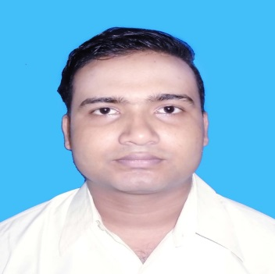

**RESUME**

|  |  |  |  |  |  |  |  |
| --- | --- | --- | --- | --- | --- | --- | --- |
| Name | | :: | | **SK AKSHAM ALI** | | | |
| Present Address | | :: | | C/o – Sk. ABUL FOIEZ  Vill. – Santipur,  P.O. – Mecheda ,  P.S. – Kolaghat,  Dist. – Purba Medinipur,  Pin.- 721137  8945911833 | | | |
| **Educational Qualification** | | **::** | |  | | | |
| Sl. No. | Degree | | Year | | Board | Remarks |
| 1 | 10th | | 2014 | | W.B.B.S.E. | Pass |
| 2 | 12th | | 2016 | | W.B.S.C.V.E.T. | Pass |

**Professional Qualification ::**

|  |  |  |
| --- | --- | --- |
| Course | Year of Passing | Institute |
| CNC Turning | 2019 | MSME TOOL ROOM KOLKATA |

Experience :: 2 years experience in Fitter

**Personal Details :-**

Date of Birth :: 21 / 08 / 1996

Father’s Name :: Sk. Abul foiez

Sex :: Male

Marital Status :: Single

Nationality :: Indian

Religion :: Islam

Languages Known :: Bengali, Hindi, English

**Declaration**

I hereby Declare that the all information furnished above are true to the best of my knowledge.

Place : ……………………………………

Date : Signature of the candidate