

|  |
| --- |
| Business Template  **Subject areas** |
| **Logo / Image** |

Contents

1 Business Description 3

1.1 Business background 3

1.2 Problems. Current Situation 3

1.3 The benefits of implementing a database. Project Vision 3

2 Model description 3

2.1 Definitions & Acronyms 3

2.2 Logical Scheme 3

2.3 Objects 3

# 

# Business Description

## Business background

The mountaineering club manages numerous aspects of climbing expeditions, including climbers, routes, guides, equipment, bookings, and payments. Currently, records are maintained in an unstructured format, such as paper logs or spreadsheets, leading to inefficiencies in data management and operational oversight.

## Problems. Current Situation

## Unstructured Data - Difficulty in tracking climber details, climb history, and equipment usage.

## Safety Concerns - Lack of historical records on climber experience and incidents.

## Inefficient Logistics - Managing bookings, payments, and equipment rentals is challenging.

## Limited Data Insights - No centralized way to analyze climb success rates, route difficulty trends, or guide performance.

## the Benefits of implementing a database. Project Vision

Implementing a structured database will:

* Streamline Data Management - Centralized storage of all climb-related data.
* Enhance Safety Measures - Better tracking of climber experience, emergency contacts, and past incidents.
* Optimize Logistics - Improved scheduling of climbs, guide assignments, and equipment rentals.
* Enable Data Analytics - Generate insights for performance tracking and decision-making.

# Model description

## Definitions & Acronyms

## Climb - A recorded ascent of a mountain route.

## Climber - An individual participating in a climb.

## Club - An organization that climbers join to participate in activities.

## Guide - A certified individual leading a climb.

## Equipment - Gear necessary for climbing expeditions.

## Booking - A reservation for a climbing service.

## Payment - A financial transaction related to services or rentals.

## Logical Scheme

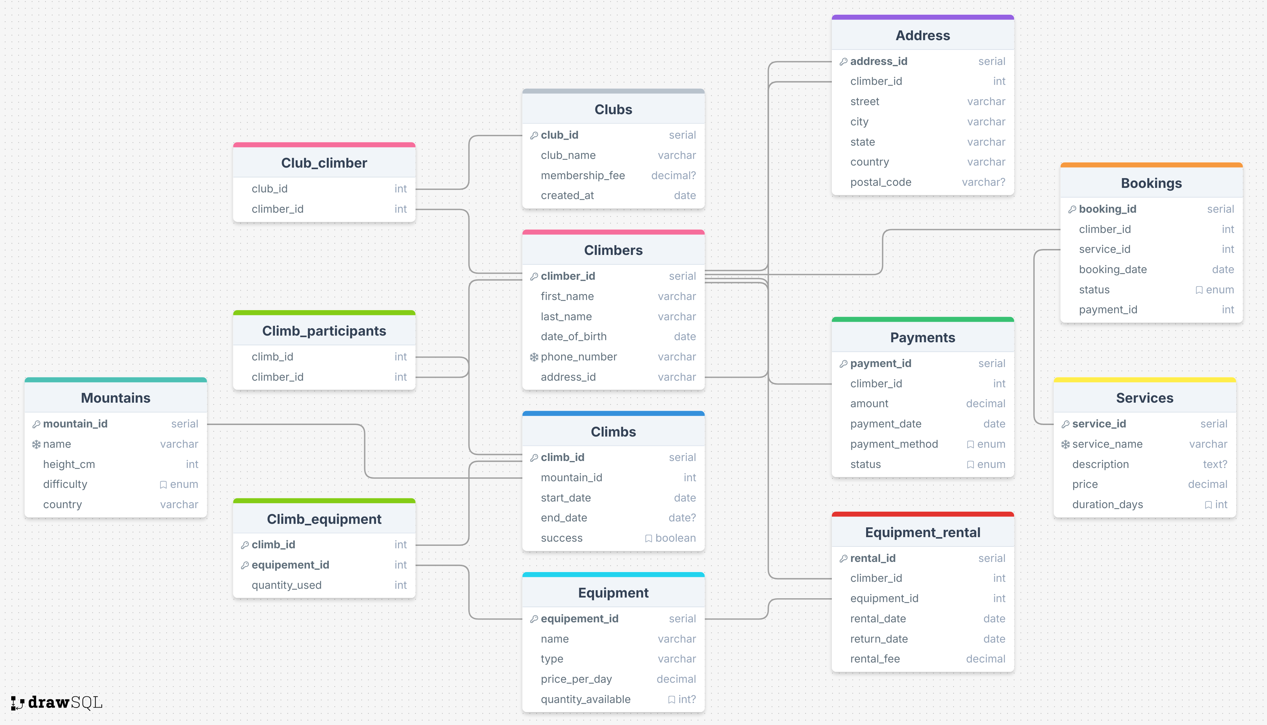

## Objects

Table Description

|  |  |  |  |
| --- | --- | --- | --- |
| Table Name | Field name | Field Description | Data Type |
| Climbers | climber_id | Unique ID for climber (PK) | Serial |
| first_name | Climber's first name | Varchar |
| last_name | Climber's last name | Varchar |
| date_of_birth | Climber's birth date | Date |
| phone_number | Contact number | Varchar |
| address_id | Foreign key to Address | Int |
| Table Name | Field name | Field Description | Data Type |
| Address | address_id | Unique address ID (PK) | Serial |
| climber_id | Foreign key to Climber | Int |
| street | Street name | Varchar |
| city | City name | Varchar |
| state | State name | Varchar |
| country | Country name | Varchar |
| postal_code | Postal code | Varchar |
| Table Name | Field name | Field Description | Data Type |
| Clubs | club_id | Unique club ID (PK) | Serial |
| club_name | Name of the club | Varchar |
| membership_fee | Annual membership fee | Decimal |
| created_at | Date of club creation | Date |
| Table Name | Field name | Field Description | Data Type |
| Club Climber | club_id | Foreign key to Climbs | Int |
| climber_id | Foreign key to Climbers | Int |
| Table Name | Field name | Field Description | Data Type |
| Climbs | climb_id | Unique climb ID (PK) | Serial |
| mountain_id | Foreign key to Mountains | Int |
| start_date | Climb start date | Date |
| end_date | Climb end date | Date |
| success | Whether climb was successful | Boolean |
| Table Name | Field name | Field Description | Data Type |
| Climb Participant | climb_id | Unique climb ID (PK) | Serial |
| climber_id | Foreign key to Mountains | Int |
| Table Name | Field name | Field Description | Data Type |
| Mountains | mountain_id | Unique mountain ID (PK) | Serial |
| name | Mountain name | Varchar |
| height_cm | Height in centimeters | Int |
| difficulty | Difficulty rating | Enum |
| country | Country of location | Varchar |
| Table Name | Field name | Field Description | Data Type |
| Equipment | equipment_id | Unique equipment ID (PK) | Serial |
| name | Equipment name | Varchar |
| type | Type of equipment | Varchar |
| price_per_day | Rental price per day | Decimal |
| quantity_available | Foreign key to Address | Int |
| Table Name | Field name | Field Description | Data Type |
| Climb Equipment | climb_id | Foreign key to Climbs | Int |
| equipment_id | Foreign key to Equipment | Int |
| quantity_used | Amount of equipment used | Int |
| Table Name | Field name | Field Description | Data Type |
| Equipment Rental | rental_id | Unique rental ID (PK) | Serial |
| climber_id | Foreign key to Climber | Int |
| equipment_id | Foreign key to Equipment | Int |
| rental_date | Date of rental | Date |
| return_date | Expected return date | Date |
| rental_fee | Total rental fee | Decimal |
| Table Name | Field name | Field Description | Data Type |
| Payments | payment_id | Unique payment ID (PK) | Serial |
| climber_id | Foreign key to Climber | Int |
| amount | Payment amount | Decimal |
| payment_date | Date of payment | Date |
| payment_method | Payment method | Enum |
| status | Payment status | Enum |
| Table Name | Field name | Field Description | Data Type |
| Service | service_id | Unique service ID (PK) | Serial |
| service_name | Name of the service | Varchar |
| description | Description of the service | Text |
| price | Cost of the service | Decimal |
| duration_days | Duration of the service | Int |
| Table Name | Field name | Field Description | Data Type |
| Bookings | booking_id | Unique booking ID (PK) | Serial |
| climber_id | Foreign key to Climber | Int |
| service_id | Foreign key to Services | Int |
| booking_date | Date of booking | Date |
| status | Booking status | Enum |
| payment_id | Foreign key to Payments | Int |

* **Climbers and Address**: One-to-One relationship.
* **Climbers and Clubs**: Many-to-Many relationship (through Club_Climber).
* **Climbers and Climbs**: Many-to-Many relationship (through Climb_Participants).
* **Climbers and Equipment Rentals**: One-to-Many relationship.
* **Bookings and Payments**: One-to-One relationship.
* **Mountains and Climbs**: One-to-Many relationship.

Example with data

|  |  |  |  |  |  |
| --- | --- | --- | --- | --- | --- |
| Climber_id | First_name | Last_name | Date_of_birth | Phone_number | Address_id |
| 1 | Jack | Clinton | 12.02.12 | +37493121212 | 1 |