

|  |
| --- |
| Business Template  **Subject areas** |
| **Logo / Image** |

Contents

1 Business Description 3

1.1 Business background 3

1.2 Problems. Current Situation 3

1.3 The benefits of implementing a database. Project Vision 3

2 Model description 3

2.1 Definitions & Acronyms 3

2.2 Logical Scheme 3

2.3 Objects 3

# 

# Business Description

## Business background

The mountaineering club manages numerous aspects of climbing expeditions, including climbers, routes, guides, equipment, bookings, and payments. Currently, records are maintained in an unstructured format, such as paper logs or spreadsheets, leading to inefficiencies in data management and operational oversight.

## Problems. Current Situation

## Unstructured Data - Difficulty in tracking climber details, climb history, and equipment usage.

## Safety Concerns - Lack of historical records on climber experience and incidents.

## Inefficient Logistics - Managing bookings, payments, and equipment rentals is challenging.

## Limited Data Insights - No centralized way to analyze climb success rates, route difficulty trends, or guide performance.

## the Benefits of implementing a database. Project Vision

Implementing a structured database will:

* Streamline Data Management - Centralized storage of all climb-related data.
* Enhance Safety Measures - Better tracking of climber experience, emergency contacts, and past incidents.
* Optimize Logistics - Improved scheduling of climbs, guide assignments, and equipment rentals.
* Enable Data Analytics - Generate insights for performance tracking and decision-making.

# Model description

## Definitions & Acronyms

## Climb - A recorded ascent of a mountain route.

## Climber - An individual participating in a climb.

## Club - An organization that climbers join to participate in activities.

## Guide - A certified individual leading a climb.

## Equipment - Gear necessary for climbing expeditions.

## Booking - A reservation for a climbing service.

## Payment - A financial transaction related to services or rentals.

## Logical Scheme

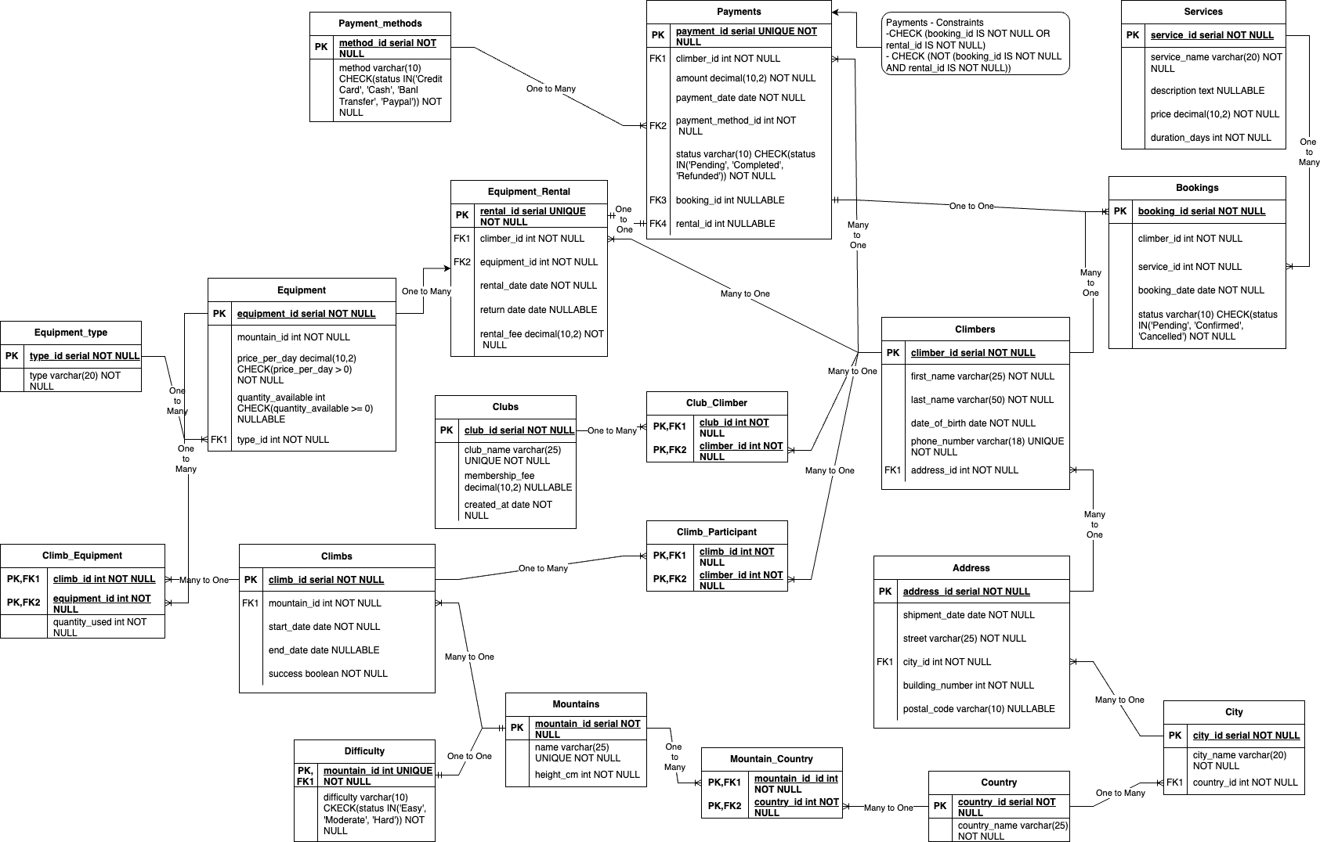

## Objects

Table Description

|  |  |  |  |
| --- | --- | --- | --- |
| Table Name | Field name | Field Description | Data Type |
| Climbers | climber_id | Unique ID for climber (PK) | Serial |
| first_name | Climber's first name | Varchar(25) NOT NULL |
| last_name | Climber's last name | Varchar(50) NOT NULL |
| date_of_birth | Climber's birth date | Date NOT NULL |
| phone_number | Contact number | Varchar(18) UNIQUE NOT NULL |
| address_id | Foreign key to Address | Int NOT NULL |
| Table Name | Field name | Field Description | Data Type |
| Address | address_id | Unique address ID (PK) | Serial |
| street | Street name | Varchar(25) NOT NULL |
| city_id | Foreign key to City | Int NOT NULL |
| building_number | Number of the building | Int NOT NULL |
| postal_code | Postal code | Varchar(10) NULLABLE |
| Table Name | Field name | Field Description | Data Type |
| City | city_id | Unique city ID (PK) | Serial |
| city_name | City name | Varchar(20) NOT NULL |
| country_id | Foreign key to Country | Int NOT NULL |
| Table Name | Field name | Field Description | Data Type |
| Country | country_id | Unique country ID (PK) | Serial |
| country_name | Country name | Varchar(25) NOT NULL |
| Table Name | Field name | Field Description | Data Type |
| Clubs | club_id | Unique club ID (PK) | Serial |
| club_name | Name of the club | Varchar(25) UNIQUE NOT NULL |
| membership_fee | Annual membership fee | Decimal(10,2) NULLABLE |
| created_at | Date of club creation | Date NOT NULL |
| Table Name | Field name | Field Description | Data Type |
| Club Climber | club_id | Composite PK, Foreign key to Climbs | Int NOT NULL |
| climber_id | Composite PK, Foreign key to Climbers | Int NOT NULL |
| Table Name | Field name | Field Description | Data Type |
| Climbs | climb_id | Unique climb ID (PK) | Serial |
| mountain_id | Foreign key to Mountains | Int NOT NULL |
| start_date | Climb start date | Date NOT NULL |
| end_date | Climb end date | Date NULLABLE |
| success | Whether climb was successful | Boolean NOT NULL |
| Table Name | Field name | Field Description | Data Type |
| Climb Participant | climb_id | Unique climb ID (PK), Foreign key to Climbs | Int NOT NULL |
| climber_id | Unique climber ID (PK), Foreign key to Climbers | Int NOT NULL |
| Table Name | Field name | Field Description | Data Type |
| Mountains | mountain_id | Unique mountain ID (PK) | Serial |
| name | Mountain name | Varchar(25) UNIQUE NOT NULL |
| height_cm | Height in centimeters | Int NOT NULL |
| Table Name | Field name | Field Description | Data Type |
| Mountain Country | mountain_id | Unique mountain ID (PK), Foreign key to Mountains | Int NOT NULL |
| country_id | Unique country ID (PK), Foreign key to Country | Int NOT NULL |
| Table Name | Field name | Field Description | Data Type |
| Difficulty | mountain_id | Unique mountain ID (PK), Foreign key to Mountains | Int NOT NULL |
| difficulty | Difficulty level | Varchar(10) - CHECK(status IN('Easy', 'Moderate', 'Hard') NOT NULL |
| Table Name | Field name | Field Description | Data Type |
| Equipment | equipment_id | Unique equipment ID (PK) | Serial |
| name | Equipment name | Varchar(20) NOT NULL |
| price_per_day | Rental price per day | Decimal, CHECK (price_per_day > 0), NOT NULL |
| quantity_available | Quantity of equipment that is available | Int, CHECK (quantity_available >= 0), NULLABLE |
| type_id | Foreign key to equipment type | Int NOT NULL |
| Table Name | Field name | Field Description | Data Type |
| Equipment Type | type_id | Unique type ID (PK) | Serial |
| type | Type of equipment | Varchar(20) NOT NULL |
| Table Name | Field name | Field Description | Data Type |
| Climb Equipment | climb_id | Composite PK, Foreign key to Climbs | Int NOT NULL |
| equipment_id | Composite PK, Foreign key to Equipment | Int NOT NULL |
| quantity_used | Amount of equipment used | Int NOT NULL |
| Table Name | Field name | Field Description | Data Type |
| Equipment Rental | rental_id | Unique rental ID (PK) | Serial |
| climber_id | Foreign key to Climber | Int NOT NULL |
| equipment_id | Foreign key to Equipment | Int NOT NULL |
| rental_date | Date of rental | Date NOT NULL |
| return_date | Expected return date | Date NULLABLE |
| rental_fee | Total rental fee | Decimal(10,2) NOT NULL |
| Table Name | Field name | Field Description | Data Type |
| Payments | payment_id | Unique payment ID (PK) | Serial |
| climber_id | Foreign key to Climber | Int NOT NULL |
| amount | Payment amount | Decimal(10,2) NOT NULL |
| payment_date | Date of payment | Date NOT NULL |
| payment_method_id | Foreign key to Payment Methods | Int NOT NULL |
| status | Payment status | Varchar(10) - CHECK(status IN(‘Pending’,‘Completed’,‘Refunded’)) NOT NULL |
| booking_id | Foreign key to Bookings | Int NULLABLE |
| rental_id | Foreign key to equipment rental | Int NULLABLE |
| Constraints | CHECK (booking_id IS NOT NULL OR rental_id IS NOT NULL) | |
| CHECK (NOT (booking_id IS NOT NULL AND rental_id IS NOT NULL)) | |
| Table Name | Field name | Field Description | Data Type |
| Payment Methods | method_id | Unique method ID (PK) | Serial |
| method | Method of the Payment | Varchar(10) - CHECK(status IN(‘Credit Card’,‘Cash’,‘Bank Transfer’,‘PayPal’) NOT NULL |
| Table Name | Field name | Field Description | Data Type |
| Service | service_id | Unique service ID (PK) | Serial |
| service_name | Name of the service | Varchar(20) NOT NULL |
| description | Description of the service | Text NULLABLE |
| price | Cost of the service | Decimal(10,2) NOT NULL |
| duration_days | Duration of the service | Int NOT NULL |
| Table Name | Field name | Field Description | Data Type |
| Bookings | booking_id | Unique booking ID (PK) | Serial |
| climber_id | Foreign key to Climber | Int NOT NULL |
| service_id | Foreign key to Services | Int NOT NULL |
| booking_date | Date of booking | Date NOT NULL |
| status | Booking status | Varchar(10) - CHECK(status IN(‘Pending’,‘Confirmed’,‘Cancelled’)) NOT NULL |

* **Climbers and Address**: One-to-Many relationship.
* **Climbers and Clubs**: Many-to-Many relationship (through Club_Climber).
* **Climbers and Climbs**: Many-to-Many relationship (through Climb_Participants).
* **Climbers and Equipment Rentals**: One-to-Many relationship.
* **Bookings and Payments**: One-to-One relationship.
* **Mountains and Climbs**: One-to-Many relationship.

Example with data

1. Climbers

|  |  |  |  |  |  |
| --- | --- | --- | --- | --- | --- |
| Climber_id | First_name | Last_name | Date_of_birth | Phone_number | Address_id |
| 1 | Jack | Clinton | 12.02.92 | +37493121212 | 1 |

1. Addresses

|  |  |  |  |  |
| --- | --- | --- | --- | --- |
| Address_id | Street | City_id | Building_number | Postal_code |
| 1 | 5th Avenue | 24 | 23 | 07008 |

1. City

|  |  |  |
| --- | --- | --- |
| City_id | City_name | Country_id |
| 24 | New York | 2 |

1. Country

|  |  |
| --- | --- |
| Country_id | Country_name |
| 2 | USA |
| 7 | Nepal |

1. Clubs

|  |  |  |  |
| --- | --- | --- | --- |
| Club_id | Club_name | Membership_fee | Created_at |
| 3 | Everest Bound Club | 100.00 | 10.02.2000 |

1. Club Climber

|  |  |
| --- | --- |
| Club_id | Climber_id |
| 3 | 1 |

1. Climbs

|  |  |  |  |  |
| --- | --- | --- | --- | --- |
| Climb_id | Mountain_id | Start_date | End_date | Success |
| 5 | 4 | 30.06.2014 | 31.07.2014 | True |

1. Climb Participant

|  |  |
| --- | --- |
| Climb_id | Climber_id |
| 5 | 1 |

1. Mountain

|  |  |  |
| --- | --- | --- |
| Mountain_id | Name | Height_cm |
| 4 | Everest | 884900 |

1. Mountain Country

|  |  |
| --- | --- |
| Mountain_id | Country_id |
| 5 | 7 |

1. Difficulty

|  |  |
| --- | --- |
| Mountain_id | Difficulty |
| 4 | Hard |

1. Equipment

|  |  |  |  |
| --- | --- | --- | --- |
| Equipment_id | Name | Price_per_day | Quantity_available |
| 8 | Headlamp | 10.00 | 100 |

1. Equipment Type

|  |  |  |
| --- | --- | --- |
| Type_id | Type | Equipment_id |
| 5 | Lamp | 8 |

1. Climb Equipment

|  |  |  |
| --- | --- | --- |
| Climb_id | Equipment_id | Quantity_used |
| 5 | 8 | 23 |

1. Equipment Rental

|  |  |  |  |  |  |
| --- | --- | --- | --- | --- | --- |
| Rental_id | Climber_id | Equipment_id | Rental_date | Return_date | Rental_fee |
| 12 | 1 | 8 | 28.06.2014 | 03.08.2014 | 370.00 |

1. Payments

|  |  |  |  |  |  |  |  |
| --- | --- | --- | --- | --- | --- | --- | --- |
| Payment_id | Climber_id | Amount | Payment_date | Payment_method_id | Status | Rental_id | Booking_id |
| 12 | 1 | 370.00 | 01.06.2014 | 9 | Pending | NULL | 10 |
| 13 | 1 |  |  |  | Completed | 12 | NULL |

1. Payment Methods

|  |  |
| --- | --- |
| Method_id | Method |
| 9 | Paypal |

1. Services

|  |  |  |  |  |
| --- | --- | --- | --- | --- |
| Service_id | Service_name | Description | Price | Duration_days |
| 6 | High-Altitude Acclimatization Program | Helps climbers adjust to high elevations before a major climb | 190.00 | 14 |

1. Bookings

|  |  |  |  |  |
| --- | --- | --- | --- | --- |
| Booking_id | Climber_id | Service_id | Booking_date | Status |
| 10 | 1 | 6 | 01.06.2014 | Confirmed |