Sreya Kalyan
April 26, 2024
Prof. Keith Paarporn
CS 2160 – Mon/Wed (12:15pm)
Homework 6

Problem 1

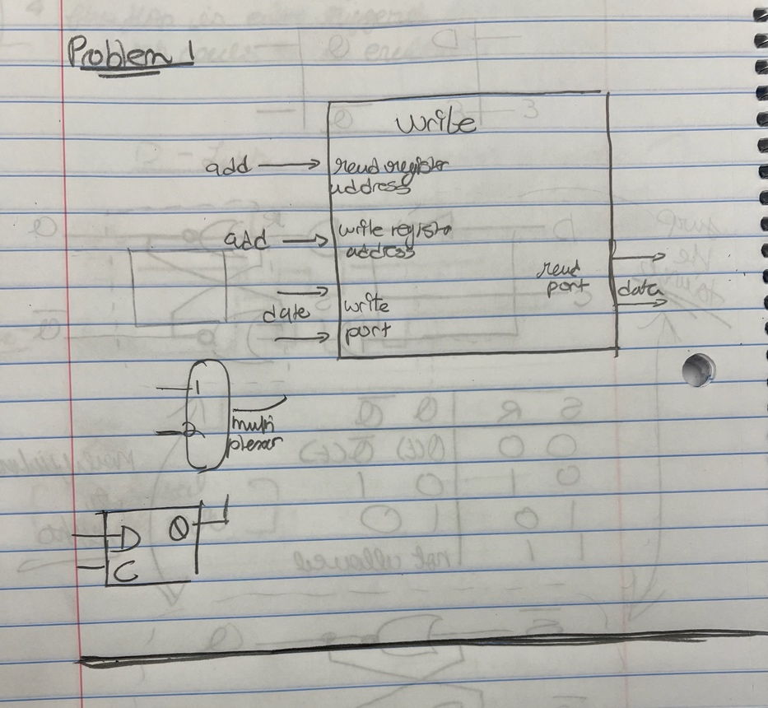

Problem 2

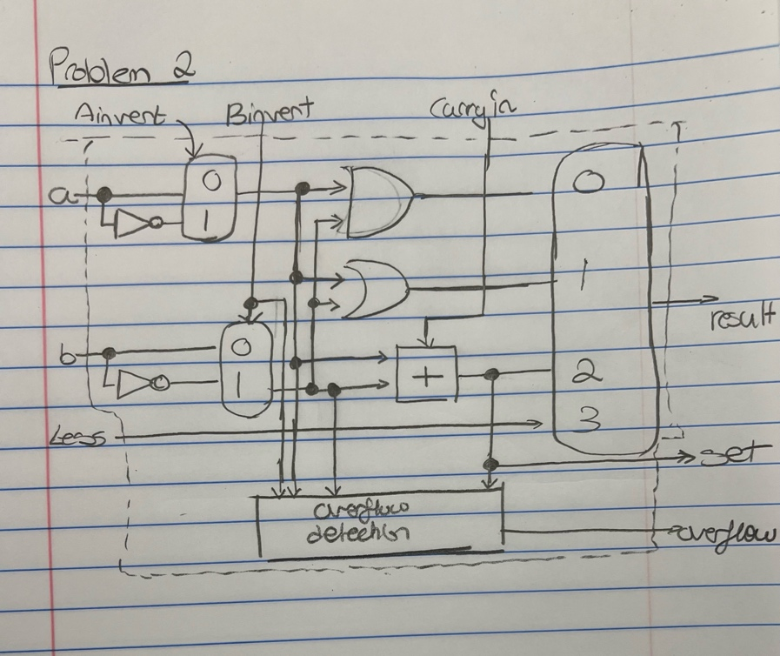
Problem 3

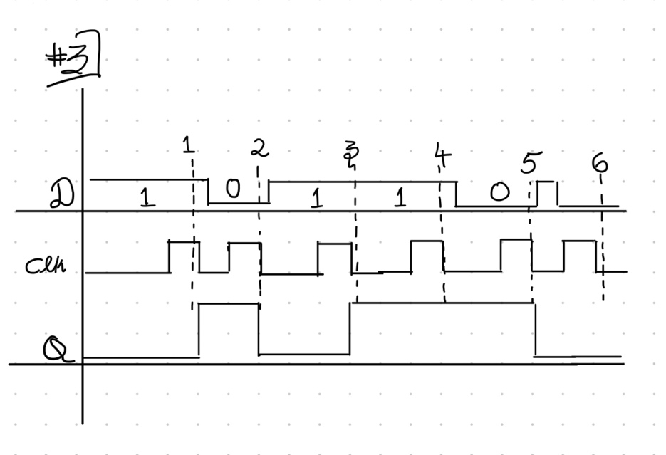

Problem 4 (Bonus Problem)

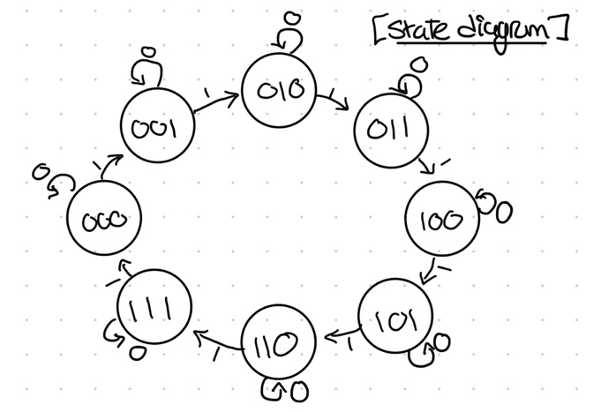

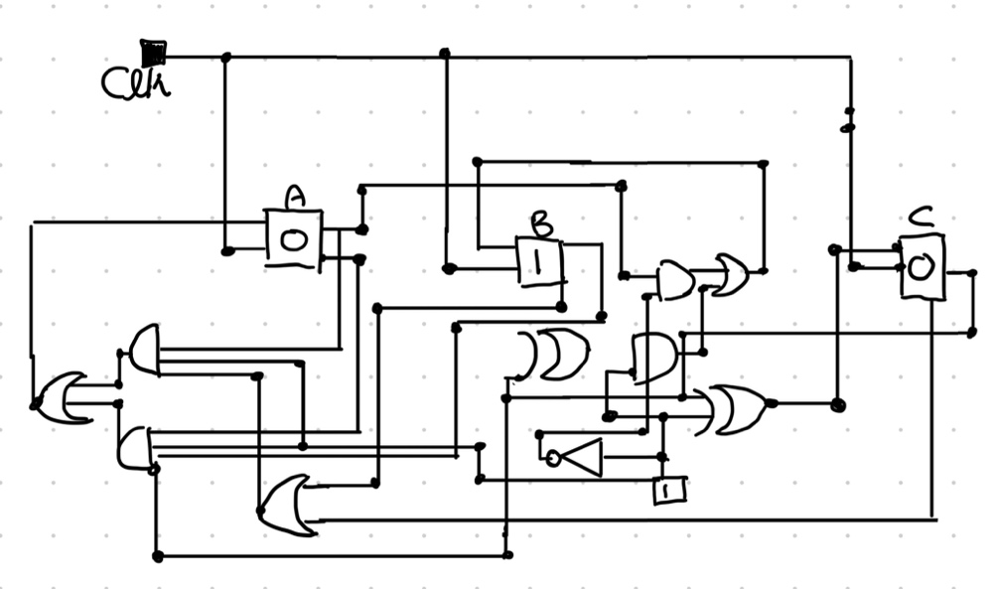
Truth Table

Input | A | B | C | A+ | B+ | C+
0 | 0 | 0 | 0 | 0 | 0 | 0
0 | 0 | 0 | 1 | 0 | 0 | 1
0 | 0 | 1 | 0 | 0 | 0 | 0
0 | 0 | 1 | 1 | 0 | 0 | 1
0 | 1 | 0 | 0 | 0 | 1 | 0
0 | 1 | 0 | 1 | 0 | 1 | 1
0 | 1 | 1 | 0 | 0 | 1 | 0
0 | 1 | 1 | 1 | 0 | 1 | 1
1 | 0 | 0 | 0 | 0 | 0 | 1
1 | 0 | 0 | 1 | 0 | 1 | 0
1 | 0 | 1 | 0 | 0 | 1 | 1
1 | 0 | 1 | 1 | 1 | 0 | 0
1 | 1 | 0 | 0 | 1 | 0 | 1
1 | 1 | 0 | 1 | 1 | 1 | 0
1 | 1 | 1 | 0 | 1 | 1 | 1
1 | 1 | 1 | 1 | 0 | 0 | 0

