## DR.SIVANTHI ADITANAR COLLEGE OF ENGINEERING

**PROJECT TITLE:** ENVIRONMENTAL MONITORING SYSTEMS (IOT_PHASE4) **BATCH MEMBERS**: KAMALESH KUMAR,MOHAN RAM,SYED AHMED,MOHAMMED ARIF,HARESHVISHAL.

**DEPARTMENT:** B.Tech – Information Technology

**MENTOR NAME:** RAMYA

# Environmental Monitoring System

**Building a comprehensive environmental monitoring platform, complemented by a mobile app, for IoT-based environmental assessment with a particular emphasis on noise data, encompasses the following steps:**

# Environmental Monitoring Platform:

### Research and Requirement Analysis:

* Understand the specific environmental parameters you wish to monitor beyond just noise (e.g., air quality, temperature, humidity).
* Define the scope: Understand the geographical regions you want to cover and the depth of data you want to capture.

### Database Setup:

* **Selection:** Choose between relational databases like PostgreSQL and MySQL or NoSQL databases like MongoDB based on the kind of data you anticipate.
* **Schema Design**: Build a detailed database schema considering various environmental parameters, their historical values, timestamp, sensor metadata, and more.
* **Optimization:** Regularly index and optimize your database to ensure efficient retrieval of data, especially when dealing with large datasets from IoT devices.

### Backend Development:

* **Framework Selection:** Depending on the scalability requirement, choose frameworks like Flask, Django, or Node.js.
* **API Development**: Create RESTful APIs to manage incoming data. Consider rate-limiting and secure endpoints to manage high influxes.
* **Security:** Add layers of security using tools like JWT for authentication, HTTPS for encrypted data transfer, and proper validation and sanitization of incoming data.

### Data Analysis & Processing:

* **Processing Algorithms:** Implement algorithms that filter and process raw data, transforming it into actionable insights.
* **Machine Learning:** If needed, integrate machine learning models to predict trends and anomalies in the data.
* **Reporting:** Automate report generation for daily, weekly, or monthly environmental trends.

### Web Dashboard:

* **Design:** Aesthetically showcase data. Consider dark and light themes, easy toggling between parameters, and perhaps even a night mode.
* **Real-time Display:** Use WebSocket or similar tech for real-time data display.
* **Customizability**: Let users customize their views — let them choose parameters, set their thresholds, and even set geographical preferences.

**Define Project Objectives:**

Clearly outline the goals and objectives of your environmental monitoring system. Understand what you aim to achieve and the specific parameters you want to measure.

## Select IoT Sensors:

Choose appropriate noise sensors and IoT devices capable of collecting noise data. Consider factors like accuracy, connectivity, and power requirements.

## Data Collection and Transmission:

Set up the infrastructure for collecting data from sensors. This might involve using IoT protocols like MQTT or HTTP to transmit data to a central server.

## Data Collection and Transmission:

Set up the infrastructure for collecting data from sensors. This might involve using IoT protocols like MQTT or HTTP to transmit data to a central server.

## Data Processing:

Develop algorithms and software to process the incoming noise data. This could involve filtering, aggregating, and analyzing the data for insights.

## Database Setup:

Create a database to store the processed data. You may use databases like MySQL, PostgreSQL, or NoSQL databases depending on your requirements.

# Mobile App Development:

## Web Platform Development:

Build a web-based interface for accessing environmental data. Users should be able to view real-time noise levels, historical data, and insights. Utilize web development technologies like HTML, CSS, and JavaScript.

## Mobile App Development:

Develop a mobile app for iOS and Android platforms. This app should enable users to access noise data on the go, receive notifications, and set preferences.

.

## User Authentication and Security:

Implement robust user authentication mechanisms to ensure data security and privacy. Use encryption for data transmission and storage.

## Visualization:

Create meaningful visualizations, such as charts and graphs, to present noise data in an understandable and actionable way.

## Alerting and Notifications:

Set up alerting mechanisms to notify users when noise levels exceed predefined thresholds. This could be through the app or email/SMS notifications.

## Testing and Quality Assurance:

Thoroughly test the system for bugs and issues. Ensure that the data accuracy and system performance meet the desired standards.

## Deployment:

Deploy the system on servers or cloud platforms, and publish the mobile app on app stores.

## User Training and Documentation:

Provide training materials and documentation for users on how to use the platform and app effectively.

## Maintenance and Updates:

Continuously monitor the system's performance, apply updates, and make improvements based on user feedback and changing environmental conditions.

## Compliance and Regulations:

Ensure that your system complies with environmental regulations and data privacy laws.

## Data Analysis and Reporting:

If needed, integrate data analysis tools to generate reports and insights from the collected noise data.

## Scalability and Expansion:

Plan for future expansion and scalability of your system as the need for more sensors or additional environmental parameters arises.

Remember to engage with environmental experts, software developers, and IoT specialists as needed to build a robust and accurate environmental monitoring system and mobile app.

**Certainly! Here's a step-by-step guide for creating a web platform that displays real-time noise level data using HTML, CSS, JavaScript for the front-end, and Node.js with Express for the back-end with WebSocket for real-time updates:**

## Set Up Your Development Environment:

Install Node.js, npm (Node Package Manager), and a code editor like Visual Studio Code.

## Create a New Node.js Project:

Initialize a new Node.js project using npm init and follow the setup prompts.

## Install Dependencies:

Install the necessary packages for your project, including Express.js, WebSocket library (e.g., Socket.io), and any other required libraries.

## Backend Server using Node.js and Express:

This will handle incoming data from IoT sensors and serve it to the frontend.

## server.js:

const express = require('express');

const bodyParser = require('body-parser');

const app = express(); app.use(bodyParser.json());

const PORT = 3000;

let environmentalData = [];

app.post('/data', (req, res) => {

environmentalData.push(req.body);

res.status(200).send('Data received');

});

app.get('/data', (req, res) => {

res.json(environmentalData);

});

app.listen(PORT, () => {

console.log(`Server running on port ${PORT}`);

});

## Database Setup using MongoDB:

To store and retrieve environmental data.

Using mongoose for **MongoDB**:

const mongoose = require('mongoose');

mongoose.connect('mongodb://localhost:27017/environmentalDB', {useNewUrlParser: true, useUnifiedTopology: true});

const dataSchema = new mongoose.Schema({

temperature: Number,

humidity: Number,

noise: Number,

timestamp: Date

});

const Data = mongoose.model('Data', dataSchema);

## Frontend using HTML & JavaScript:

To display the latest data.

**index.html:**

<!DOCTYPE html>

<html>

<head>

<title>Environmental Monitoring System</title>

<script src="script.js" defer></script>

</head>

<body>

<h1>Latest Data</h1>

<p>Temperature: <span id="temp"></span>°C</p>

<p>Humidity: <span id="humidity"></span>%</p>

<p>Noise Level: <span id="noise"></span>dB</p>

</body>

</html>

## script.js:

document.addEventListener('DOMContentLoaded', () => {

fetch('/data')

.then(res => res.json())

.then(data => {

const latestData = data[data.length - 1];

document.getElementById('temp').textContent = latestData.temperature;

document.getElementById('humidity').textContent = latestData.humidity;

document.getElementById('noise').textContent = latestData.noise;

});

});

## Mobile App:

Building a mobile app would typically require a platform like Flutter, React Native, or native development with Swift (iOS) or Kotlin (Android). Here's a basic Flutter implementation to fetch and display data:

import 'package:flutter/material.dart'; import 'package:http/http.dart' as http; import 'dart:convert';

void main() => runApp(App());

class App extends StatelessWidget {

@override

Widget build(BuildContext context) {

return MaterialApp(

title: 'Environmental Monitor',

home: DataDisplay(),

);

}

}

class DataDisplay extends StatefulWidget {

@override

_DataDisplayState createState() => _DataDisplayState();

}

class _DataDisplayState extends State<DataDisplay> {

var data;

@override

void initState() {

super.initState();

fetchData();

}

fetchData() async {

final response = await http.get('http://YOUR_SERVER_IP:3000/data');

setState(() {

data = json.decode(response.body);

});

}

@override

Widget build(BuildContext context) {

return Scaffold(

appBar: AppBar(title: Text('Environmental Data')),

body: data == null

? CircularProgressIndicator()

: Text('Temperature: ${data['temperature']}'),

// Add other data points as needed

);

}

}

## Testing:

Thoroughly test your web platform, including the real-time data updates, WebSocket communication, and responsiveness of the interface.

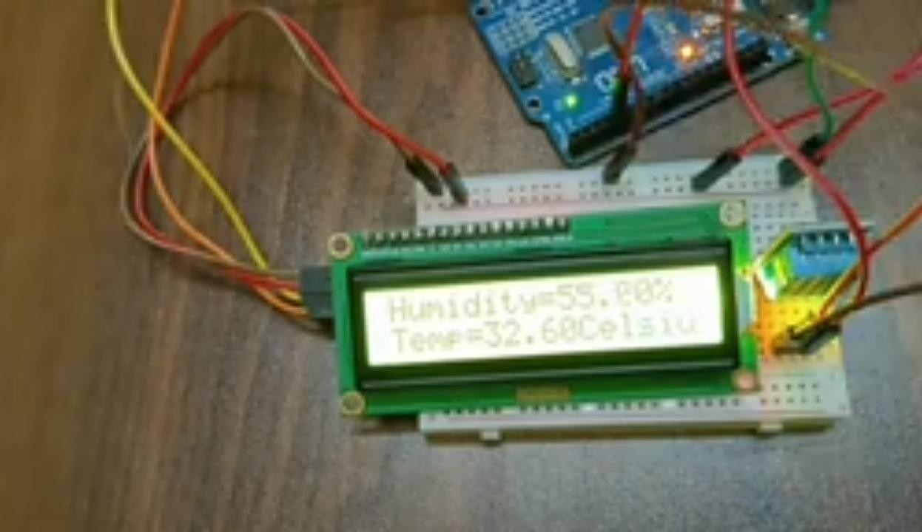

## User Training and Documentation:

Provide training materials and documentation for users on how to use the platform and app effectively.

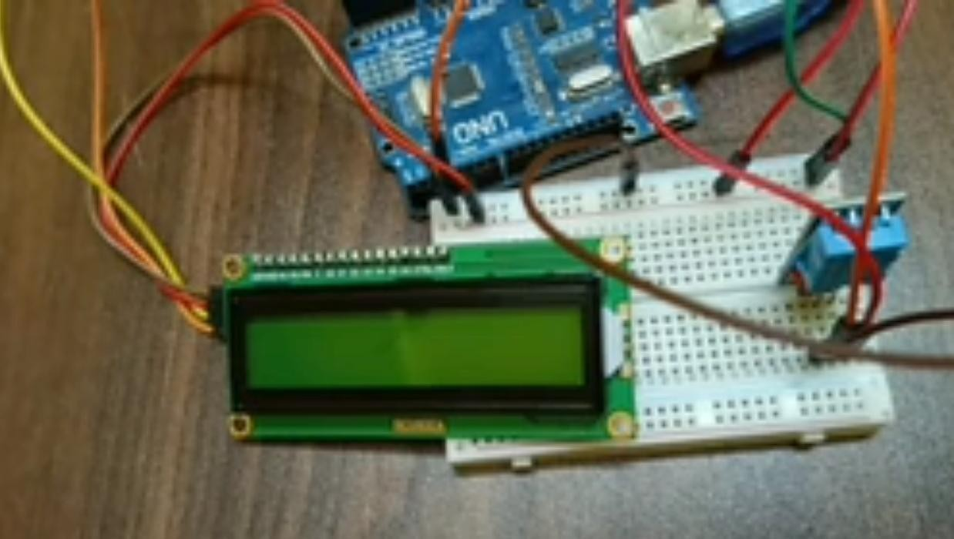

## Integration:

* **IoT and Platform Sync:** Ensure real-time data sync between IoT devices, the main platform, and mobile apps. Consider MQTT or similar protocols for efficient IoT communication.
* **Third-party Integrations:** If integrating with other services (like weather platforms), ensure robust and fail-safe API interactions.

## Deployment & Scaling:

* Choose cloud providers like AWS, Azure, or Google Cloud for scalability.
* Implement a CI/CD pipeline for seamless deployment and updates.

## Training & Documentation:

* **User Manual:** Create comprehensive user documentation detailing all platform features.
* **Workshops:** Conduct workshops for local bodies, educational institutions, and communities, showcasing how to interpret the data effectively.

## Feedback & Iteration:

* Collect user feedback continuously.
* Regularly update the platform and app based on feedback and technological advancements.

By meticulously following these enriched steps, your Environmental Monitoring System will not only serve as a pivotal tool for understanding environmental trends but also act as a cornerstone for community awareness, education, and action. Remember, the value of such a system multiplies when its data is accessible and interpretable by both experts and the general public.

This comprehensive breakdown should give you a clearer path forward. Adjustments can be made based on the specific technologies you prefer or based on the development cycle you follow.