DR.SIVANTHI ADITANAR COLLEGE OF ENGINEERING

Projecttitle:Environmentalmonitoringsystem.

Batchmember:KAMALESH KUMAR,HARESVISHAL,MAR

SYED AHMED,MOHAMMED ARIF,MOHANRAM. Department: B.TECH-INFORMATION TECHNOLOGY

Mentorname:RAMYA.

Describetheproject'sobjectives,IoTsensordeployment,platformandmobileapp development, and code implementation:

**Projectobjectives:**

1. AssessingEnvironmentalQuality:Monitoringtodeterminethestateofenvironmental parameters such as air and water quality, soil conditions, and biodiversity.
2. DetectingPollution:Identifyingandquantifyingpollutantstoensurecompliancewith environmental regulations and standards.
3. EarlyWarning:Providingearlywarningofenvironmentalthreatssuchas naturaldisastersor industrial accidents.

**Iotsensor deployment:**

1. SelectSensors:ChooseappropriateIoTsensorsbasedonyourobjectives.Ensuretheycan collect and transmit data reliably in the target environment.
2. Sensor Placement: Position sensors strategically inthe target locations to capture relevant dataaccurately.Considerfactorslikealtitude,proximitytopollutionsources,orareasproneto environmental changes.
3. PowerSupply:Ensuresensorshaveastablepowersource,whichcouldbebatteries,solar panels, or energy harvesting methods, depending on the location.
4. DataAnalysis:Implementdataanalyticsandvisualizationtoolstoprocessthecollecteddata. This allows for real-time monitoring and historical analysis.

# Platformdevelopment:

1. ArchitectureDesign:Planthesoftwarearchitecture.Decideifitwillbeacloud-basedplatform or an on-premises solution. Consider the scalability, data storage, and processing components.
2. SensorIntegration:DevelopAPIsorprotocolstoconnectwithIoTsensorsandcollectdata. Ensure compatibility with various sensor types and communication protocols.
3. DataIngestion:Createadataingestionpipelinetocollectdatafromsensors.Thismight involve real-time streaming or batch data collection, depending on the use case.
4. DataStorage:Designadatabaseschemaorstoragesolutiontostorecollecteddatasecurely and efficiently. Consider factors like data retention policies and disaster recovery.

# Mobileappdevelopment:

1. Feature Set: Define the core features of the app, which may include real-time data visualization,historicaldataaccess,customizablealerts,mapintegration,andusernotifications.
2. AlertsandNotifications:Implementasystemforcustomizablealertsandnotifications, allowing users to set thresholds for specific environmental parameters.
3. PrivacyandDataSecurity:Implementrobustdatasecuritymeasurestoprotectsensitive environmental data and user information.

# Codeimplementation:

SensorDataCollection:

InterfacewithIoTsensorstocollectdata.

Implementprotocols(e.g.,MQTT,HTTP,LoRa)forsensorcommunication. Ensure real-time or periodic data collection as needed.

DataProcessing:

Developalgorithmsfordatacleaningandpreprocessing.

Applystatisticalormachinelearningtechniquesfordataanalysis. Calculate averages, outliers, and trends in environmental data.

DataStorage:

Designadatabaseschemaorchooseappropriatedatastoragesolutions(e.g.,SQLdatabases, NoSQL databases, or time-series databases).

Storecollecteddatasecurelyandefficiently.

Implementdataretentionpoliciesforhistoricaldata.

**Includediagrams,schematics,andscreenshotsoftheloTsensors, environmentalmonitoring information Platform, and mobile app interfaces:**

1. **Mappingforenvironmentalmonitoring:**

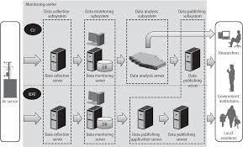

1. **enviornmentalmonitoringsystem:**

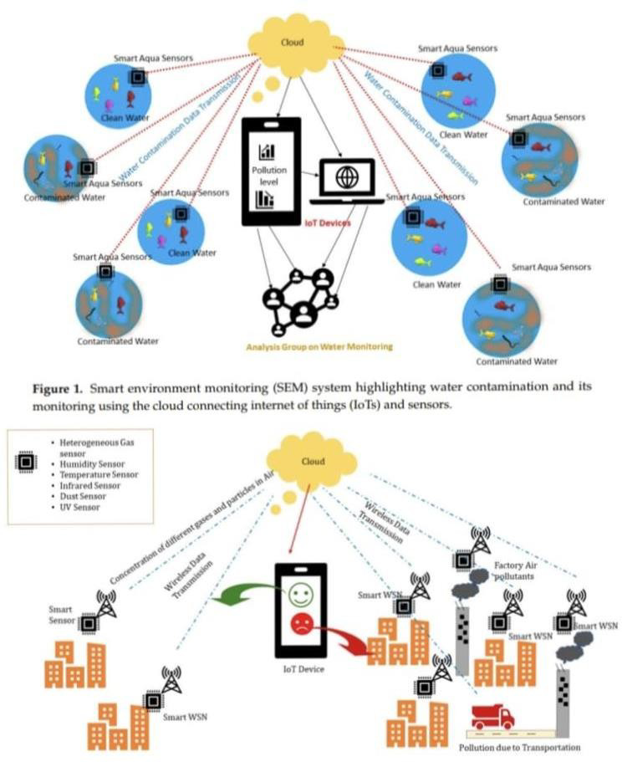

1. **Overcomesforenvironmentalmonitoringsystems**

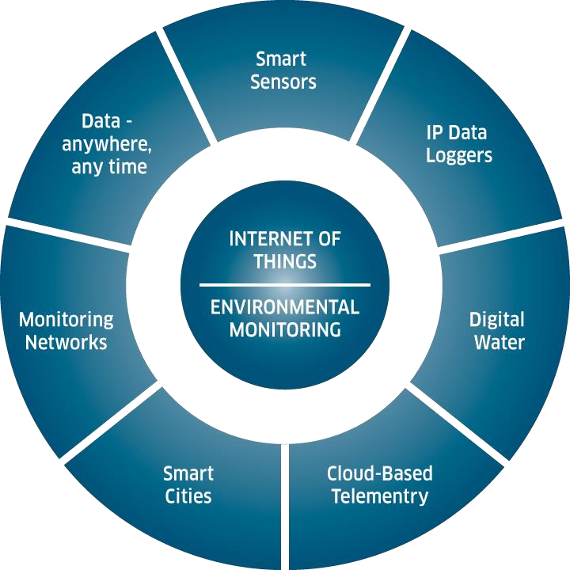

**IoTSensorsDeploymentSchematic:**

IoTSensors:Thesearethephysicaldevicesthatcollectenvironmentaldata.Specifythetypesof sensors you plan to use (e.g.,temperature, humidity, air quality, waterquality, etc.).

SensorNodes:Theseareoftenequippedwithmicrocontrollersandwirelesscommunication modules. Show how sensor nodes are distributed across the monitored area.

CloudPlatform:Datareceivedfromthegatewayisstoredandprocessedinthecloud.Visualize the cloud platform and data storage.

UserInterface:Thiscanbeawebapplicationoramobileapp.Showhowuserswillinteractwith the system to access real-time and historical data.

# EnvironmentalmonitoringsystemInformationPlatformDiagram:

DataSources:Startwithiconsorsymbolsrepresentingthevariousenvironmentalsensors collecting data.

DataProcessing:Representdataprocessingcomponentslikeservers,algorithms,andanalytics tools within the cloud platform.

# MobileAppUserInterfaceScreenshots:

1. Capturescreenshotsofthemobileapp’suserinterfacetoshowcaseitsfunctionalityand design.
2. Includescreensdisplayingreal-timedata,historicaldata,locationfiltering,andnotifications. 3.Highlight the app’s user-friendly features and visual elements.

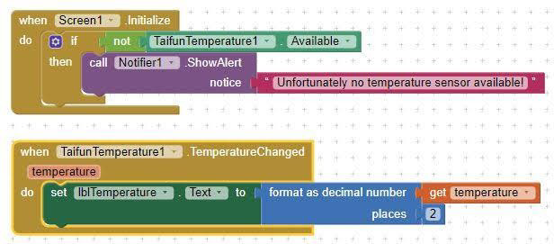

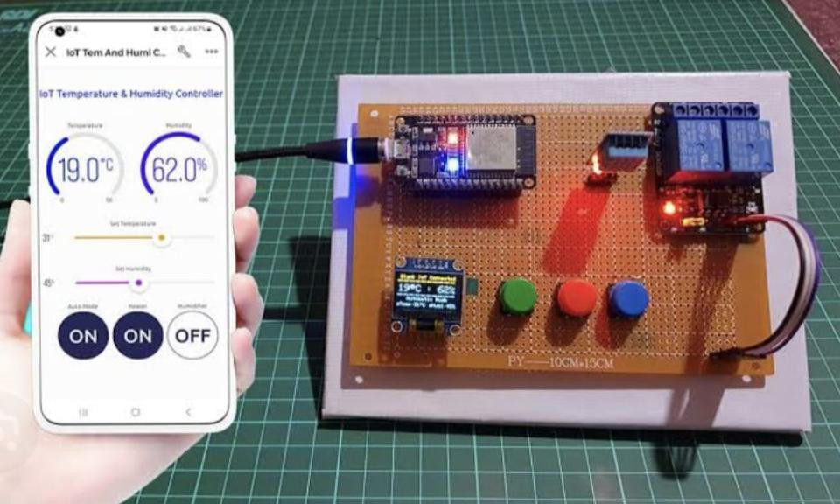

# Explainhowthereal-timeenvironmentalmonitoringsystempromotespublic awareness and contributes to temperature and humidity levelmitigation:

**DataAccessibility:**Byprovidingreal-timedataontemperatureandhumiditylevels,thesystem allowsthepublictoaccessup-to-dateinformation.Thisinformationempowersindividualsand communities to make informed decisions about their activities and adapt to current

environmentalconditions.

**PublicAlerts:**Themonitoringsystemcanissuealertswhenextremetemperatureorhumidity conditionsaredetected.Thesealertscanbesenttomobiledevicesordisplayedonwebsites, helping people take precautionary measures to stay safe and comfortable.

**Education**:Thesystemcanserveasaneducationaltoolbyprovidinginformationontheimpacts of temperature and humidity levels on health, agriculture, and the environment. This can increase public understanding and awareness of these issues.

**BehavioralChanges:**Real-timedatacaninfluencepublicbehavior.Forexample,whenpeople

areawareofhightemperatures,theymayreduceenergyconsumptionbyusingairconditioning more efficiently, conserving water, or limiting outdoor activities during peak heat.

**EnergyEfficiency**:Awarenessoftemperatureandhumiditylevelscanencouragethepublicto use energy-efficient appliances and practices, which can reduce energy consumption and, in turn, lower greenhouse gas emissions contributing to temperature rise.

**Urban Planning**: City officials and urban planners can use the data to make informed decisions regardingurbandevelopmentandgreeninfrastructure.Thiscanincludedesigninggreenspaces, planting trees, and improving city layouts to mitigate temperature and humidity effects.

**Mitigation Strategies:** Public awareness of environmental data can drive the adoption of mitigationstrategies,suchasimplementingcoolroofprograms,urbanforestryinitiatives,or water conservation measures to combat high temperatures and humidity.

**CommunityEngagement:**Real-timeenvironmentaldatacanfostercommunityengagementand collaborative efforts to address temperature and humidity-related challenges. Local organizationsandresidentscanworktogethertoimplementsolutionsandsharebestpractices.

# PositiveImpactonQualityofLife:

Environmentalmonitoringsystemshavefar-reachingpositiveimpacts,fromprotectinghuman healthandecosystemstomitigatingclimatechangeandpromotingsustainabledevelopment. They are vital tools for a healthier, more sustainable planet.

# Wowkistimilation:

<Wowkionlinestimulationsforcustomtypetemperaturesensorin environmental monitoring systems>

