Samuel C. Tyler
STA 271 – HW 9/3
#1.101-1.106, 1.117, 1.121, 1.123, 1.129, 1.139, 1.140, 1.146

1.101.)

N(572,51)

1.102.)
N(572,51)
This is a negative number because the score is lower than the mean. The deviation is to the left of mean.

1.103.)

X < 600

So those who got higher than 600 were 12%.
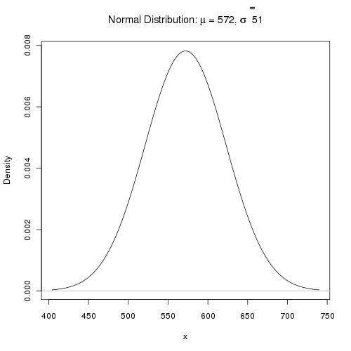

1.104.)
600 < X < 650

So those who got higher than 600 and less than 650 were in between 61% and 88%, or 27%.
.

1.105.) top 5% of scores in N(572,51)?
Z=1.65

1.106.)
z=-0.20

1.117,) Heights of women. The heights of women aged 20 to 29 are approximately Normal with mean 64 inches and standard deviation 2.7 inches. Men the same age have mean height 69.3 inches with standard deviation 2.8 inches. What are the z-scores for a woman 6 feet tall and a man 6 feet tall? What information do the z-scores give that the actual heights do not?

1.121,) Find more proportions. Using either Table A or your calculator or software, find the proportion of observations from a standard Normal distribution for each of the following events. In each case, sketch a standard Normal curve and shade the area representing the proportion.
(a) Z ≤ −1.9
(b) Z ≥ −1.9
(c) Z > 1.55
(d) −1.9 < Z < 1.55

1.123,) Find more values of z. The variable Z has a standard Normal distribution.
(a) Find the number z that has cumulative proportion 0.85.
(b) Find the number z such that the event Z > z has proportion 0.40.

1.129,) Find the SAT equivalent. Maria scores 29 (out of 36 possible) on the ACT. Assuming that both tests measure the same thing, what score on the SAT (1600? or 2400?) is equivalent to Maria’s ACT score?

1.139,) Length of pregnancies. The length of human pregnancies from conception to birth varies according to a distribution that is approximately Normal with mean 266 days and standard deviation 16 days.
(a) What percent of pregnancies last less than 240 days (that’s about 8 months)?
(b) What percent of pregnancies last between 240 and 270 days (roughly between 8 months and 9 months)?
(c) How long do the longest 20% of pregnancies last?

1.140,) Quartiles for Normal distributions. The quartiles of any distribution are the values with cumulative proportions 0.25 and 0.75.
(a) What are the quartiles of the standard Normal distribution?
-0.67, 0.67
(b) Using your numerical values from (a), write an equation that gives the quartiles of the N(μ, σ) distribution in terms of and σ.
[I don't understand the question – (X-0.67)/1 ?]
(c) The length of human pregnancies from conception to birth varies according to a distribution that is approximately Normal with mean 266 days and standard deviation 16 days. Apply your result from (b): what are the quartiles of the distribution of lengths of human pregnancies?

1.146.)
(a). 2
(b). 1. It is an even distribution
(c). 4.
(d). 3

