Samuel C. Tyler
STA 271 HW 4

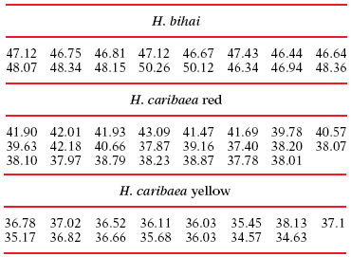

1.79 Compare the three varieties of flowers. The biologists who collected the flower length data in the previous exercise compared the three Heliconia varieties using statistical methods based on and s.
(a) Find and s for each variety.

H. bihai H.caribaea red H.caribaea yellow
47.59750 39.71130 36.29071
s 1.2128781 1.7987630 0.9090778

b) Make a stemplot of each set of flower lengths. Do the distributions appear suitable for use of and s as summaries?
leaf unit: 0.1
H. bihai:
2 46 | 34
7 46 | 66789
(3) 47 | 114
47 |
6 48 | 0133
48 |
49 |
49 |
2 50 | 12
H. caribaea red:
1 37 | 4
4 37 | 789
9 38 | 00122
11 38 | 78
(1) 39 | 1
11 39 | 67
40 |
9 40 | 56
7 41 | 4
6 41 | 699
3 42 | 01
42 |
1 43 | 0
H. caribaea yellow:
2 34 | 56
4 35 | 14
5 35 | 6
(3) 36 | 001
7 36 | 5678
3 37 | 01
37 |
1 38 | 1
Yes, the distributions seem to match up to the graph.

1.93 Compare three varieties of flowers. Exercise 1.78 reports data on the lengths in millimeters of flowers of three varieties of Heliconia. In Exercise 1.79 you found the mean and standard deviation for each variety. Starting from the − and s-values in millimeters, find the means and standard deviations in inches. (A millimeter is 1/1000 of a meter. A meter is 39.37 inches.) (So a mm is 0.03937in.)
H. bihai H.caribaea red H.caribaea yellow
1.873913575 1.563433881 1.428765253
s 0.047751011 0.070817299 0.035790393

1.99 Test scores. Many states have programs for assessing the skills of students in various grades. The Indiana Statewide Testing for Educational Progress (ISTEP) is one such program.³⁵ In a recent year 76,531 tenth-grade Indiana students took the English/language arts exam. The mean score was 572 and the standard deviation was 51. Assuming that these scores are approximately Normally distributed, N(572, 51), use the 68–95–99.7 rule to give a range of scores that includes 95% of these students.
(68% : 572+/-51 = (572-51) - (572+51) = 521 - 623)
95% : 572+/-102 = (572-102) - (572+102) = 470 - 674

1.100 Use the 68–95–99.7 rule. Refer to the previous exercise. Use the 68–95–99.7 rule to give a range of scores that includes 99.7% of these students.
99.7%: 572+/-153 = (572-153) - (572+153) = 419 - 752

1.109 Use a different range for the uniform distribution. Many random number generators allow users to specify the range of the random numbers to be produced. Suppose that you specify that the outcomes are to be distributed uniformly between 0 and 4. Then the density curve of the outcomes has constant height between 0 and 4, and height 0 elsewhere.
(a) What is the height of the density curve between 0 and 4? Draw a graph of the density curve.

6 |
5 |
4 |__________
3 | |
2 | |
1 | |
|__________|________
1 2 3 4 5 6

(b) Use your graph from (a) and the fact that areas under the curve are proportions of outcomes to find the proportion of outcomes that are less than 1.
4/16 = ¼ = 25%
(c) Find the proportion of outcomes that lie between 0.5 and 2.5.
8/16 = 1/2 = 50%

1.111 Three density curves. Figure 1.38 displays three density curves, each with three points marked on it. At which of these points on each curve do the mean and the median fall?
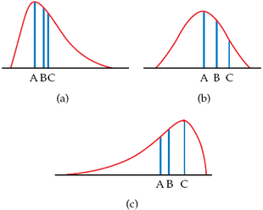
FIGURE 1.38 Three density curves, for Exercise 1.111.

(a). mean: A, median: B
(b). mean: A, median: A
(c). mean: B, median: A

1.115 Horse pregnancies are longer. Bigger animals tend to carry their young longer before birth. The length of horse pregnancies from conception to birth varies according to a roughly Normal distribution with mean 336 days and standard deviation 3 days. Use the 68–95–99.7 rule to answer the following questions.
(a) Almost all (99.7%) horse pregnancies fall in what range of lengths?

(68% : 336+/-3 = (336-3) - (336+3) = 333 - 339
95% : 336+/-6 = (336-6) - (336+6) = 330 - 342)
99.7%: 336+/-9 = (336-9) - (336+9) = 327 - 345

(b) What percent of horse pregnancies are longer than 339 days?
32%

