Please install folwoing tools and resources

1. Install XAMPP

<https://www.apachefriends.org/download.html>

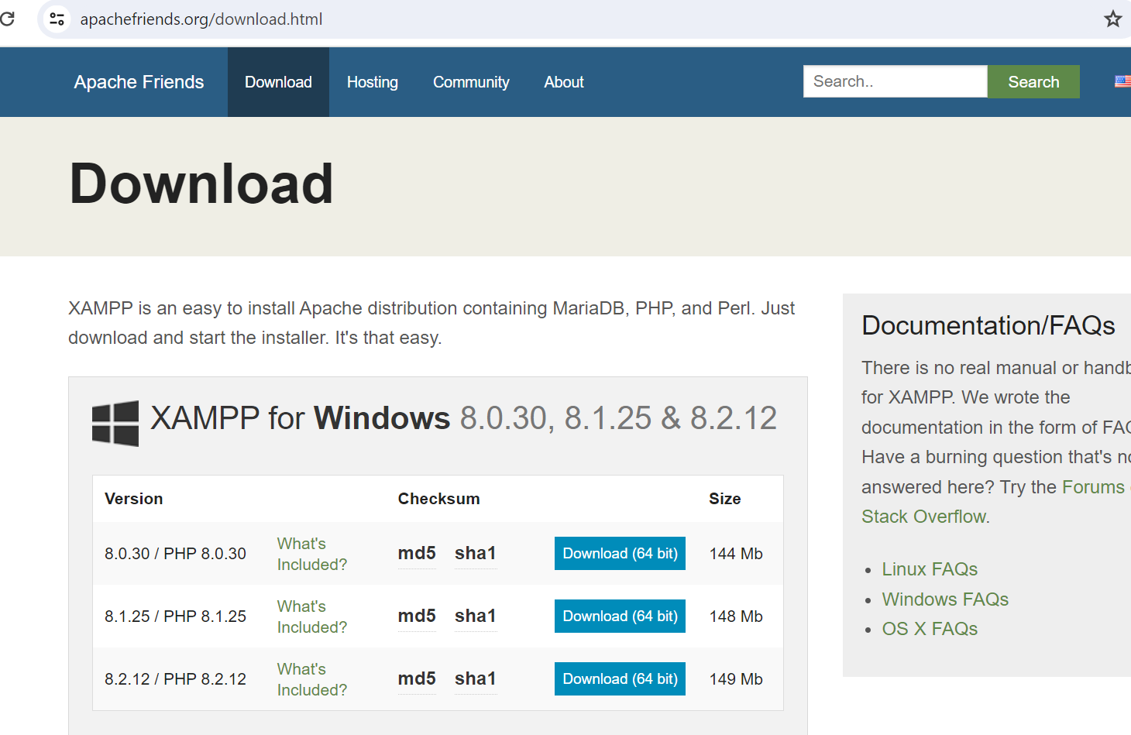

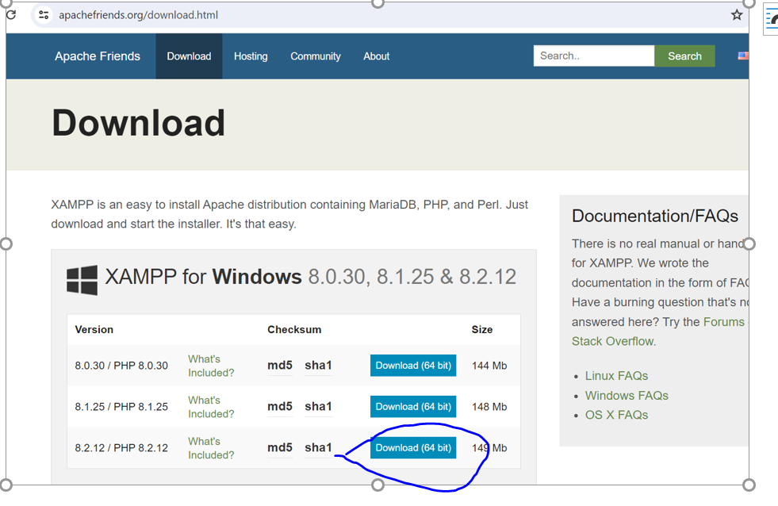

2. Install Java

<https://codebun.com/java-web-project-configuration/>

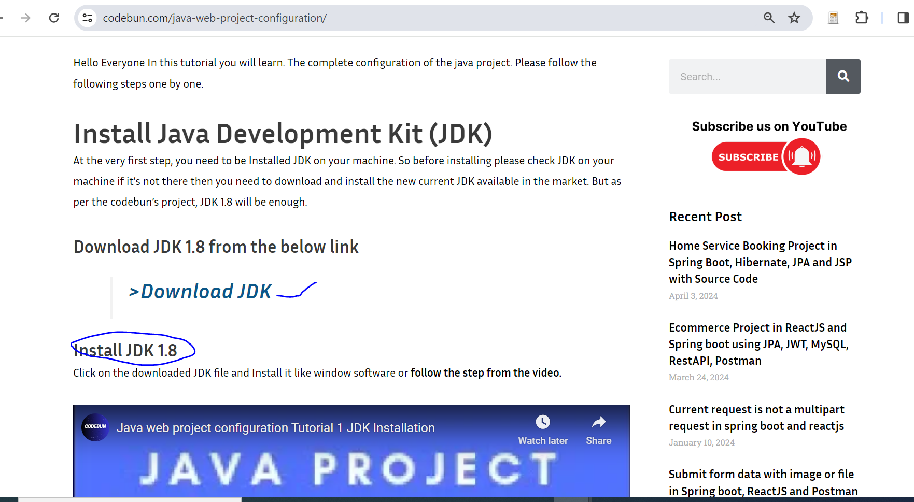

3. Install Apache Tomcat Server

<https://codebun.com/java-web-project-configuration/>

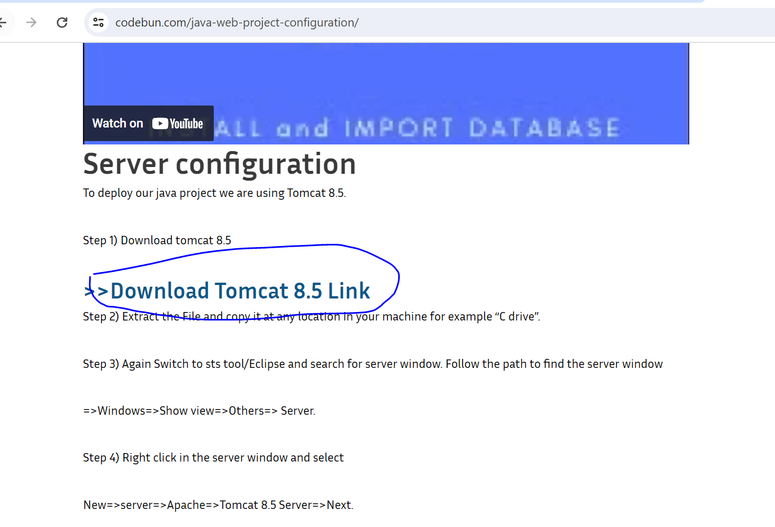

**4. Install notepad+++**

**5. down load your zip file and extract it**

**6. copy OR MOVE YOUR PROJECT FOLDER NOT ZIP ONLY EXTRACTED folder into XampS’S WEB APPS FOLDER**

Look at the path

Local C:\xampp\tomcat\webapps

Local c🡪 XAMPP-> TOMCAT🡪 -> WEBAPPS

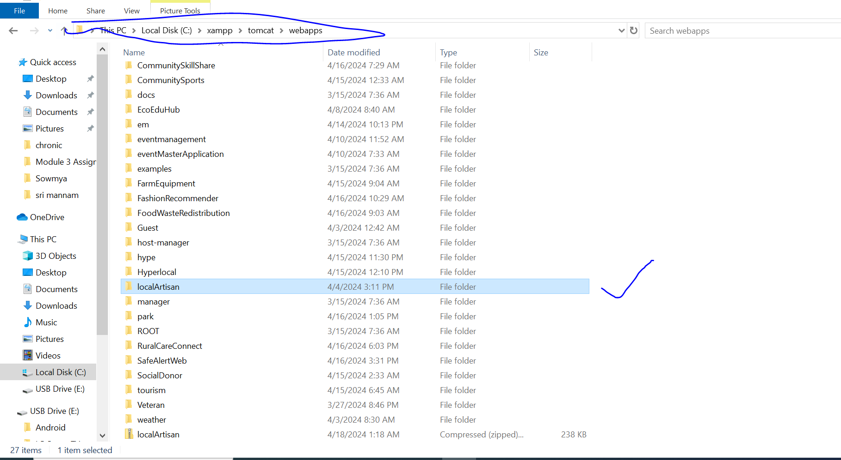

7. OPEN XAMPP AND RUN XAMPP, CLICK WINDOWS START BUTTONA ND SEARC XAMPP, CLICK IT WILL OEPN LIKE THIS

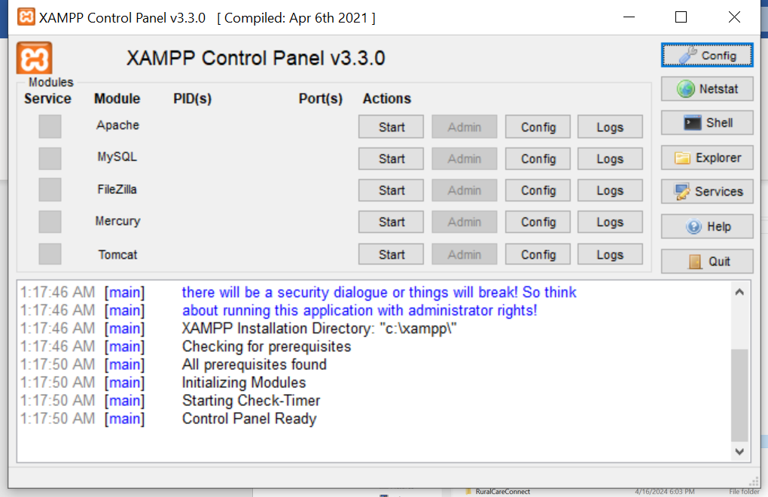

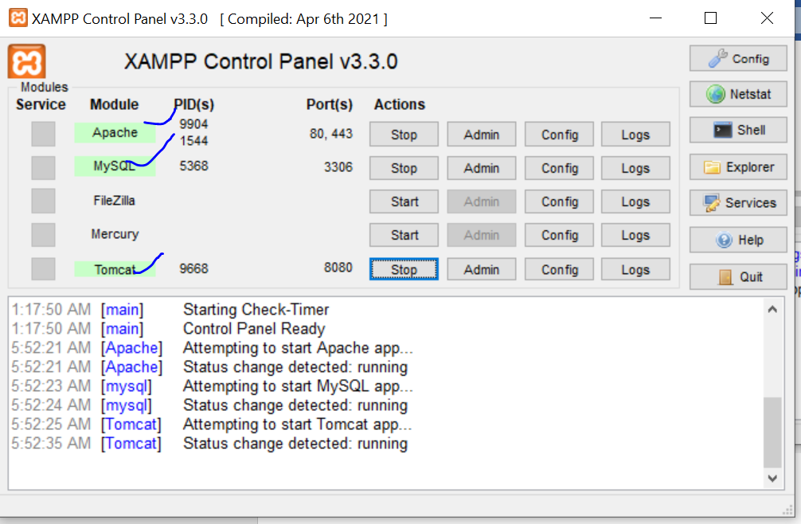

NOW CLICK ADMIN OPTION AT TOMACT OPTION NEXT TO THE STOP BUTTON

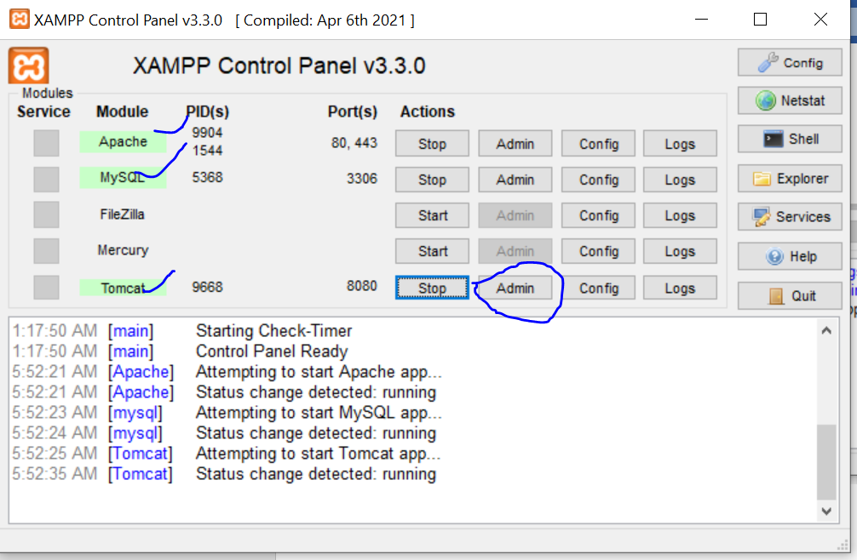

8. Local host server will be opened as shown in below

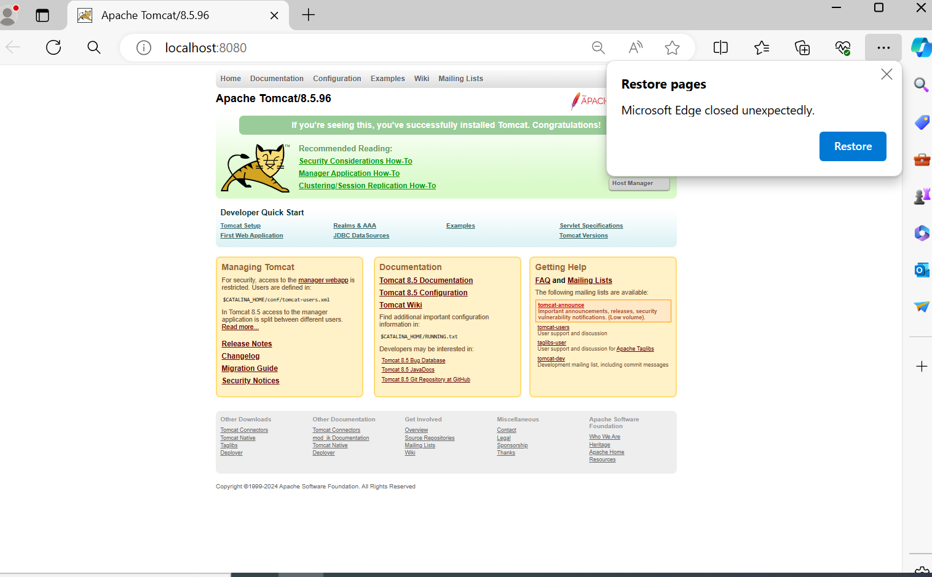

9. RUN YOUR PROJECT

TO RUN YOUR PROJECT JUST COPY OR TYPE THE FOLDER NAME, FOR example your folder name is localArtisan

Type /loaclArtisan after the localhost:8080

For exmael “”

