CMS Version 2.0

- Introduction:

Contact Management System (CMS) is design to manage member information writhen an organization and manage organization business. The system has designed with high level of user security.

Member
Organization
Business

At this stage the system has the following models build in

    - Members Information
    - Member’s children Information
    - Member Payments
    - Collections and any type of income
    - Invoice and Receipt model
    - Cash flow model

The system is using Access database with Crystal report to generate reports

CMS
Access Database
Crystal Report

- Requirement:
The program has been tested in Windows XP operating system and office 2000.

- Installation:
By the default the system will be installed in CMS folder under program files directory. Database will be saved in DATA directory in CMS folder. Reports will be saved in reports directory in CMS folder.

- User menu:

  - Reference Data

If you open the database in MS-Access the following tables are reference data you can edit your own reference data

- PaymentType table : is used for payment model

ID | Payment
1 | Baptism
2 | Building
3 | Donation
4 | Membership
5 | Memorial
6 | Wedding
7 | Other

    - Collection Type : is used for collection model the default items are

ID | Collection_Type
1 | CANDLES
2 | CANTEEN
3 | COLLECTION
4 | GIFT SHOP
5 | FUNCTION
6 | RUFFLES
7 | SCHOOL FUND RAISING
8 | SCHOLL RENT
9 | REFAND FROM HALL
10 | DONATION
11 | MEMORIAL
12 | WEDDING
13 | BAPTISM
14 | BUILDING
15 | OTHER

  - Type Table : Used in payment Model

ID | Payment_type
1 | Cash
2 | Cheque

  - WordAmount : used for Payment model
ID | AmountInWord
1 | FIFTY DOLLARS ONLY.
2 | TEN DOLLARS ONLY .
3 | FIFTEEN DOLLARS ONLY.
4 | TWENTY DOLLARS ONLY .
5 | THIRTY DOLLARS ONLY.
6 | FOURTY DOLLARS ONLY .
7 | FIFTY DOLLARS ONLY.
8 | SIXTY DOLLARS ONLY .
9 | EIGHTY DOLLARS ONLY .
10 | ONE HUNDRED DOLLARS ONLY .

  - Term Table: Used for Invoice model

ID | TermName
1 | 7 Days
2 | 14 Days
3 | 28 Days

  - InvoiceItemType Table : is used in Invoice item model .

ID | Descriprtion | ItemCode | Gst
1 | Hall Rent | INV_1 | 0.1

  - System user setup
When you log in for the first time the default user log in is CHURCH and password is WELCOME.
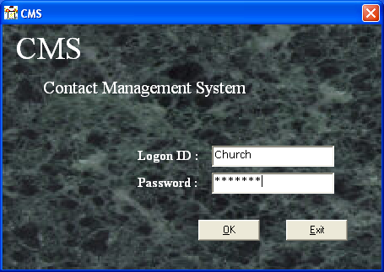

The system will ask you to change your password for the first time you log in to the system and after each 30 days, in the same time you can change your password at any time you like from the file menu
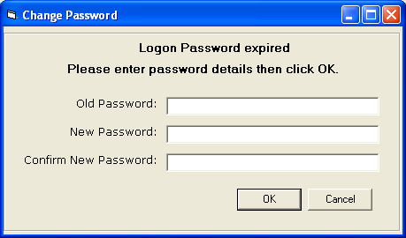

To add new user to the system you have to log in as system manager. By the default the church user is system manager.
From file menu select system setting

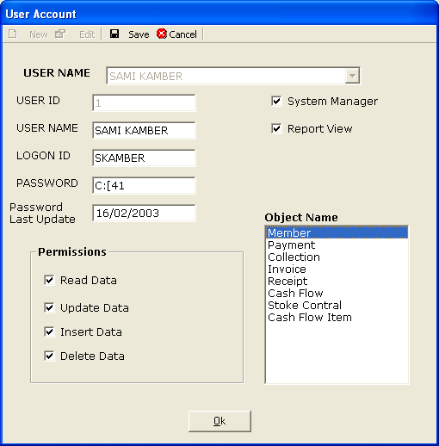

Fields Name :
- User Name : Full user name
- Logon ID : User log on ID
- Password : User Password . The password is incepted to reset the password you set the password to WELCOME. To log the user to use the system set the password to LOCKED. The system will lock the user to use the system if the user failed to log on three times.
- System Manager : User which is able to change user setting
- Report View : User which can generate reports
- Object Name : all models in the system
- Permissions : user permissions per model. . Set all the time read data, Update data and Insert data per model. Do not give any delete permission for user it is very danger permission

.

