- Login to WLS console as admin (http://localhost:7001/console)
- Click Lock and Edit button
- Add a new Machine by clicking on Machines hyperlink under Environment. Click New button
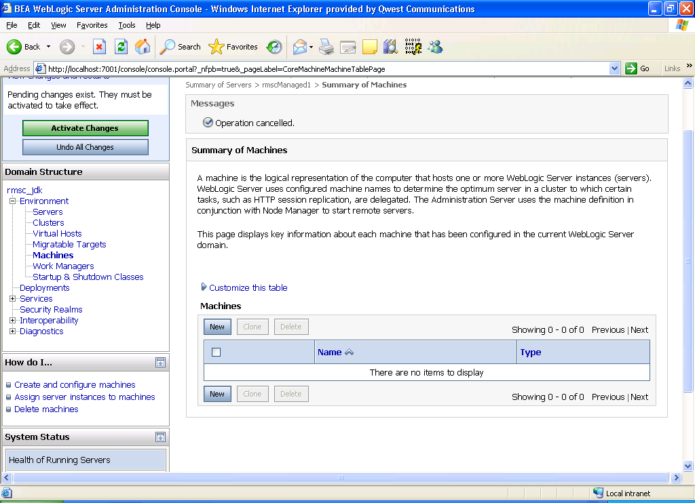

- Fill in machine name. Choose OS as other (since your desktop is windows os). Click OK.
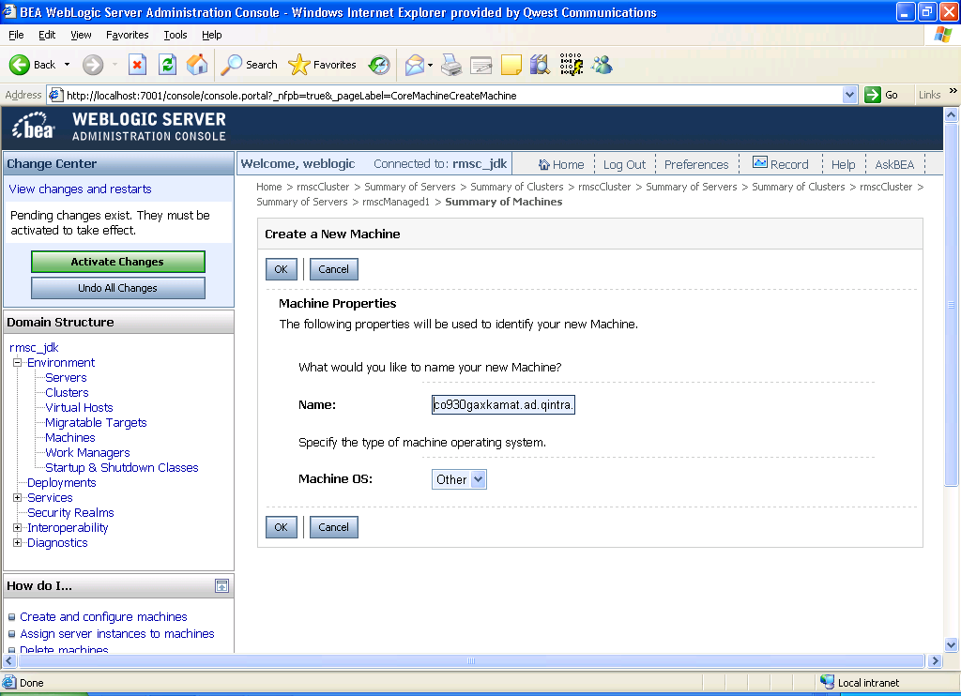

- Machine is now created:
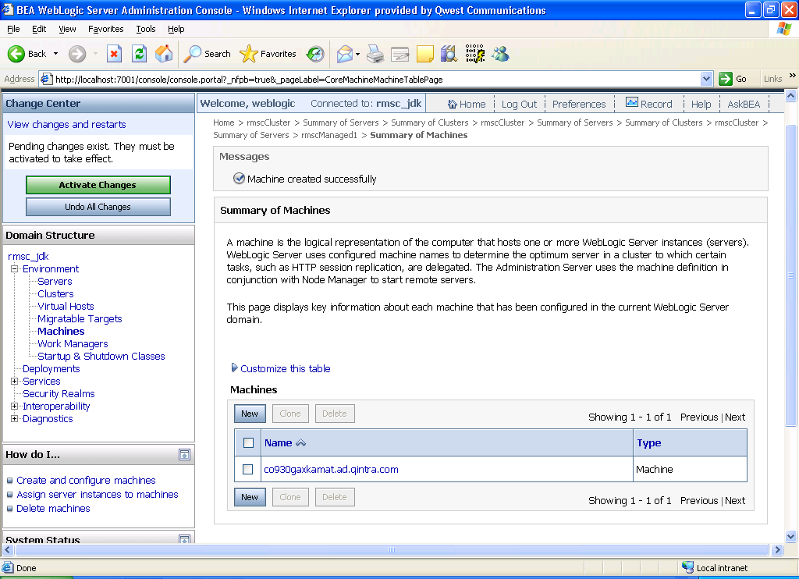
co930gaxkamat.ad.qintra.com
- Expand Environment and click on Clusters
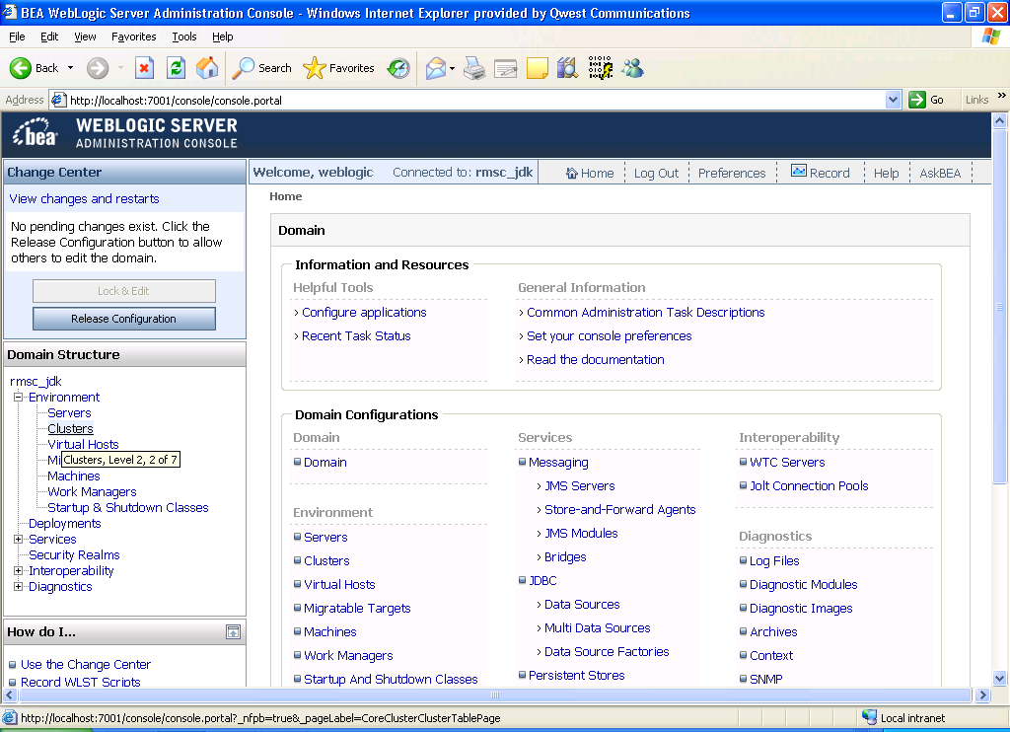

- Click the New button
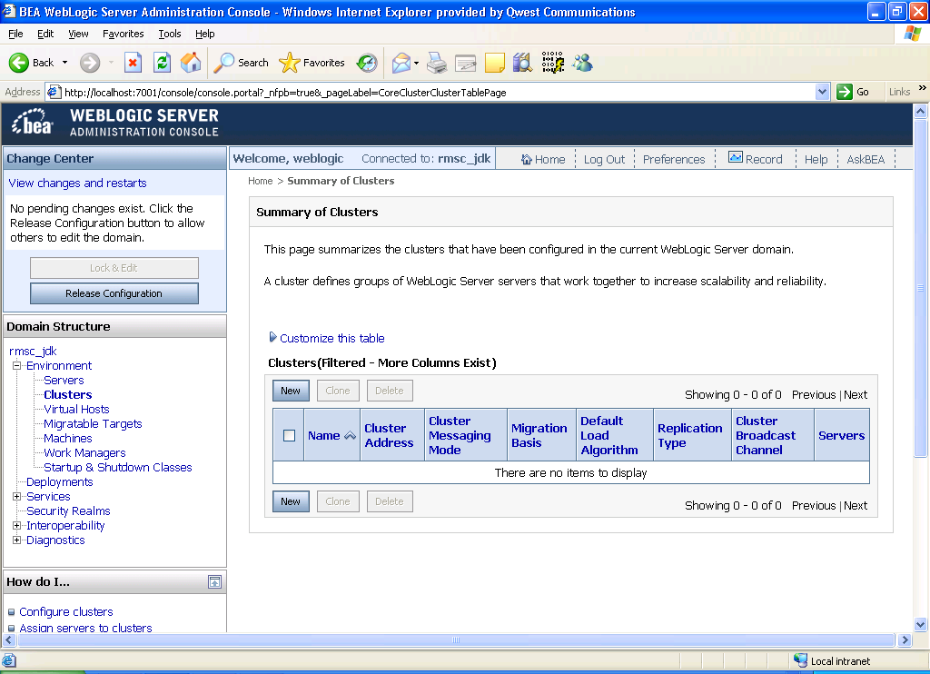

- Name the cluster. Select Multicast as Messaging Mode. Leave muticast address and port as default for dev environment.
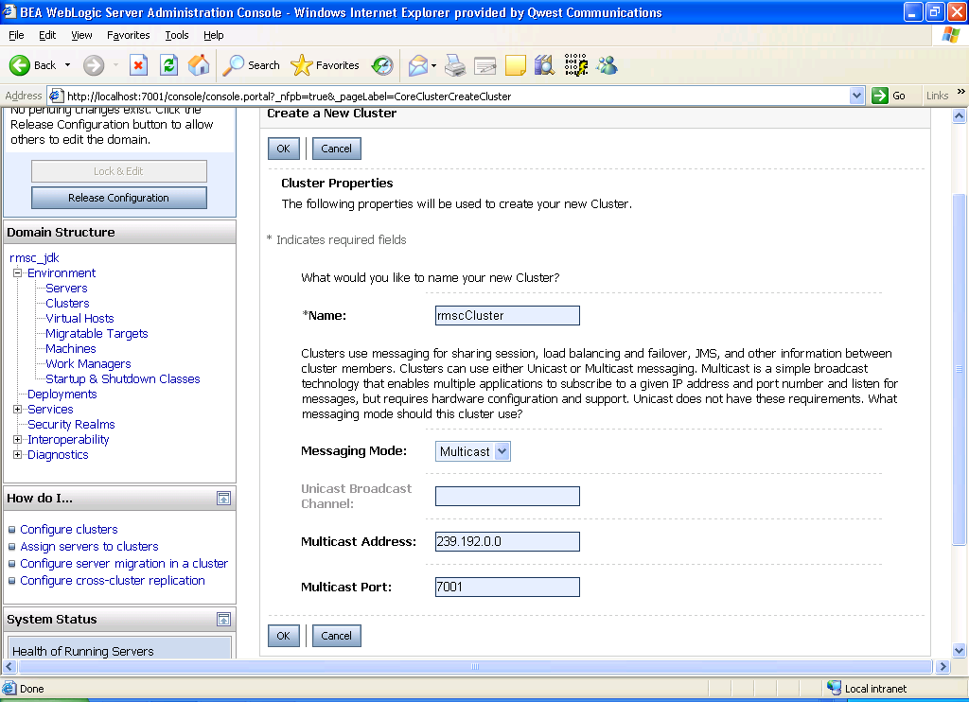

- Cluster created as shown in below screen.

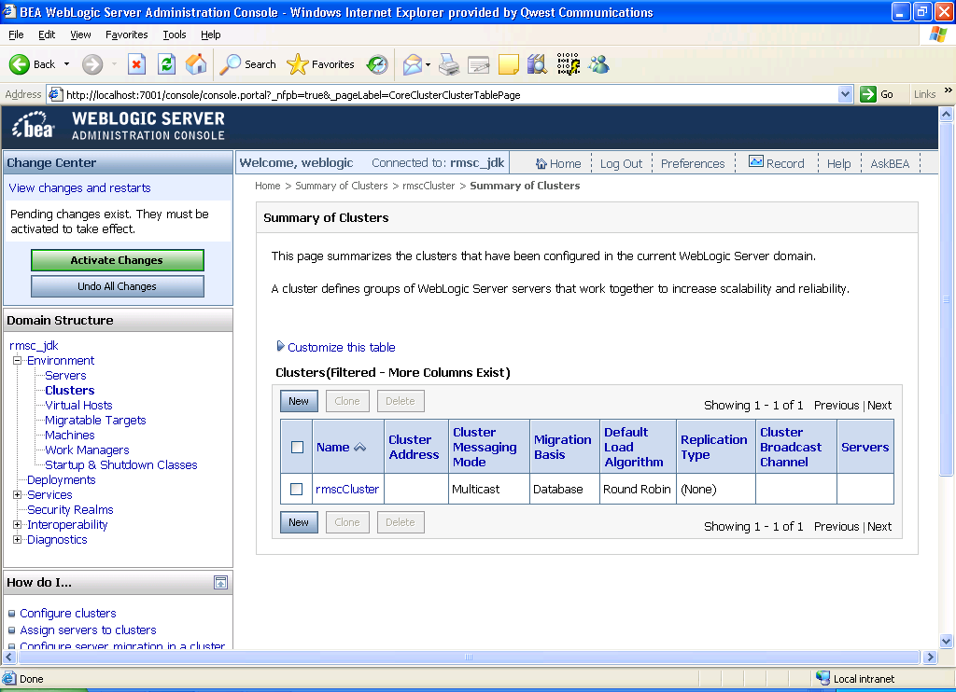

Note: You can request muticast address and port from http://dns/requests/multicast-add.html (Need to do this for full fledged test and prod environments and shared dev environment)

- Create a new Server: Click on Servers link under Environment:

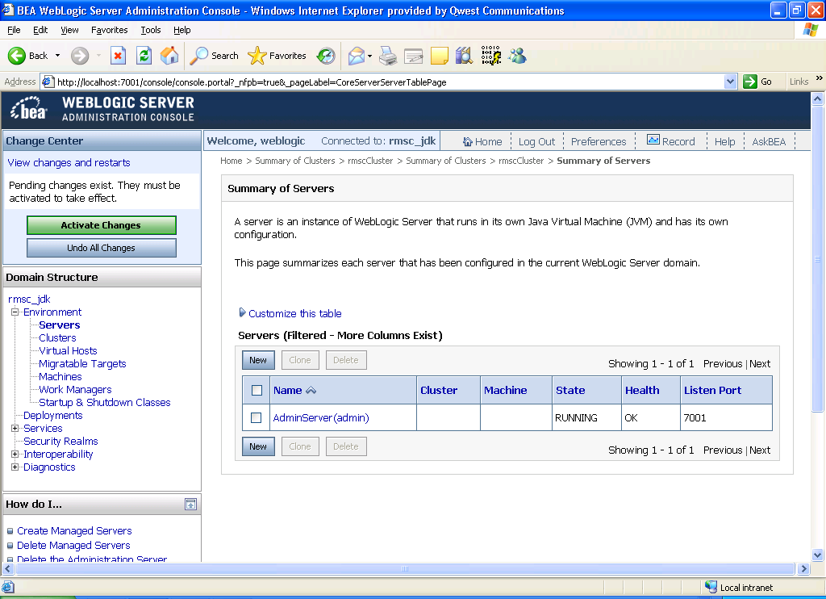

- Click New button to create a managed server.

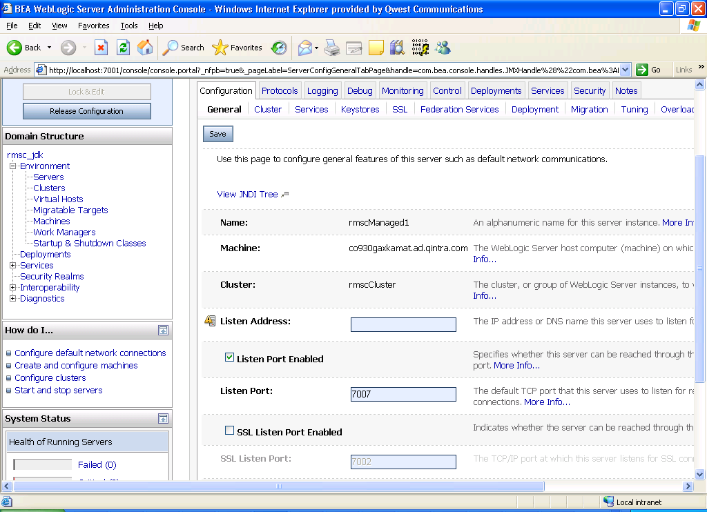

Enter server name, listen address and port. Select cluster.

- Now server is created and part of cluster.

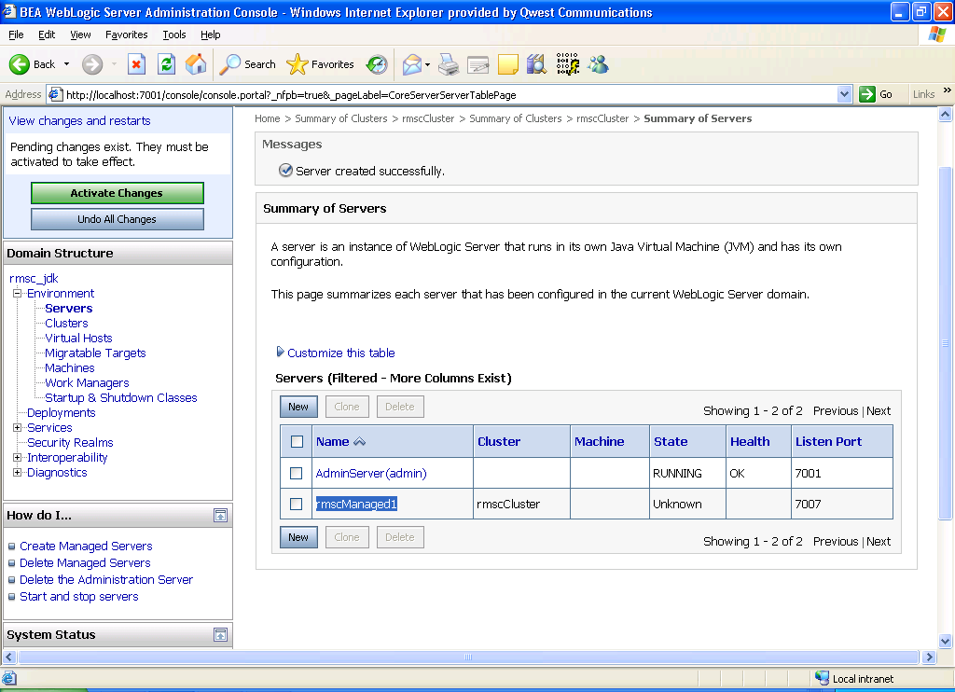

- Click on rmscManaged1 and select co930gaxkamat for machine. Click Save.

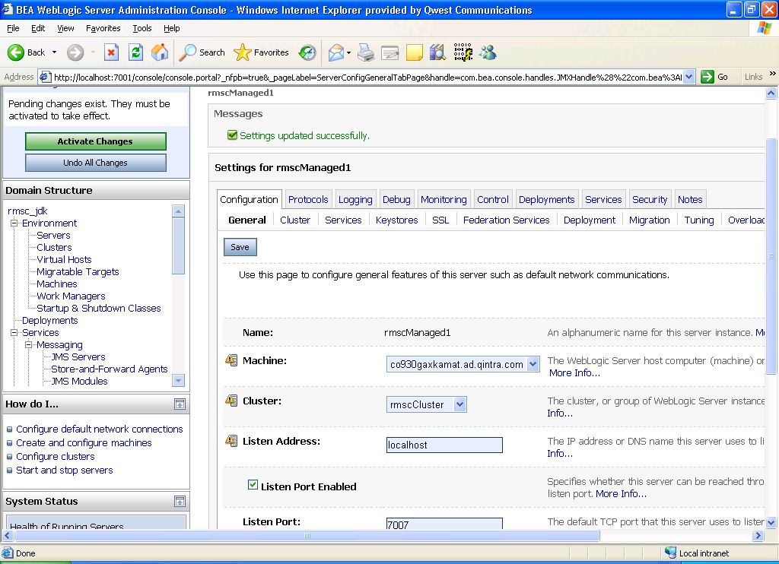

- Click Activate Changes to save the config changes

Create JDBC Connection pool

- Login to WLS console as admin (http://localhost:7001/console)
- Click Lock and Edit button
- Expand Services and underneath services expand JDBC. Click Data Sources. Click the New button to create a new datasource as shown below:
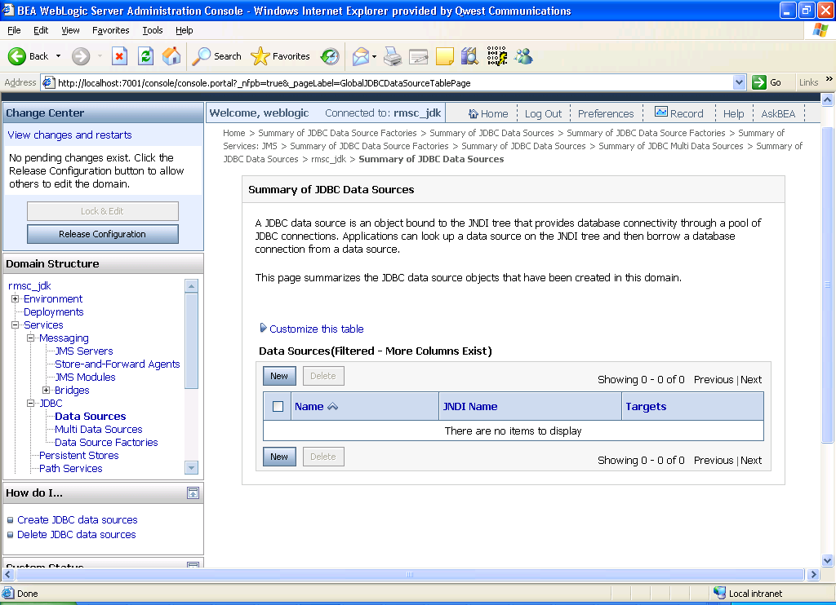

- Select the following values in the ‘Create a New JDBC Data Source’ screen:
Name: rmscDataSource
JNDI Name: rmscDataSource
Database Type: Oracle
Database Driver: Oracle’s Driver (Thin) Versions 9.0.1, 9.2.0, 10

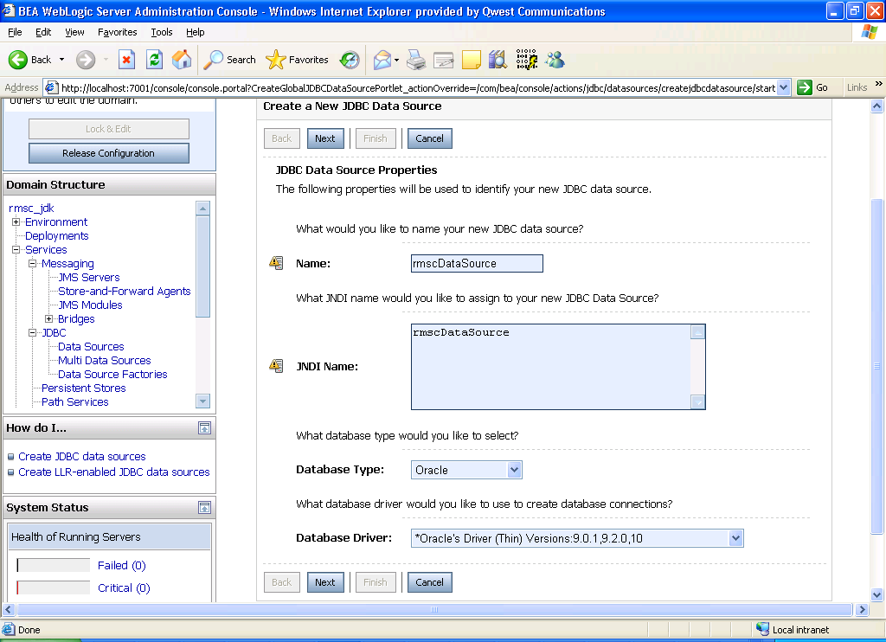

Click Next.

- Uncheck ‘Supports Global Transactions’ check box. Click Next.
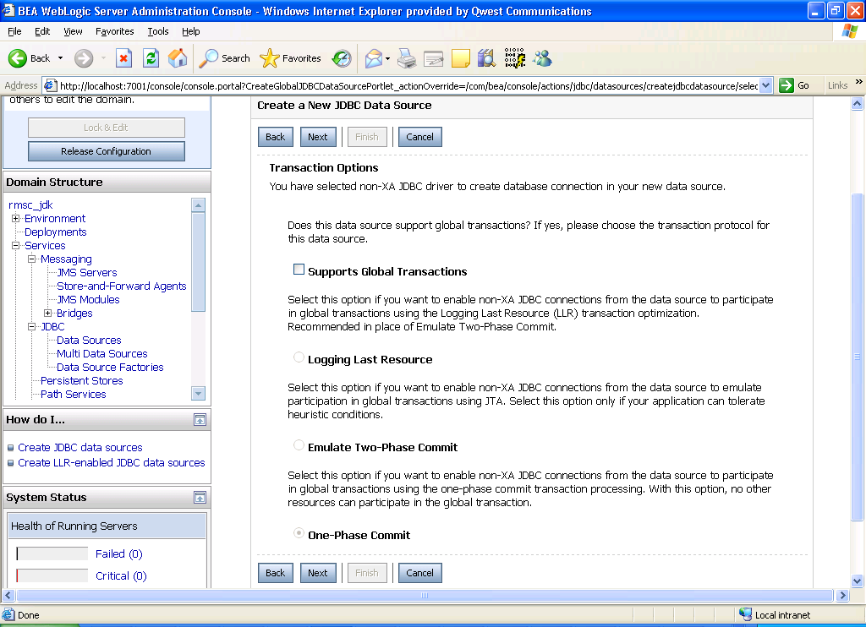

- In the ‘Create a New JDBC Data Source’ screen fill the following for system test RMSC database:
Database Name: uromss00
Host Name: romsdevdb.qintra.com
Port: 1528
Database User Name: rmscapp
Password and Confirm Password: ppacsmr

Dev data base information.

HOST=romsdev_db.dev.qintra.com
PORT=1560
SERVICE_NAME=uromsd00
userid :ROMS
pwd :ROMSDEV
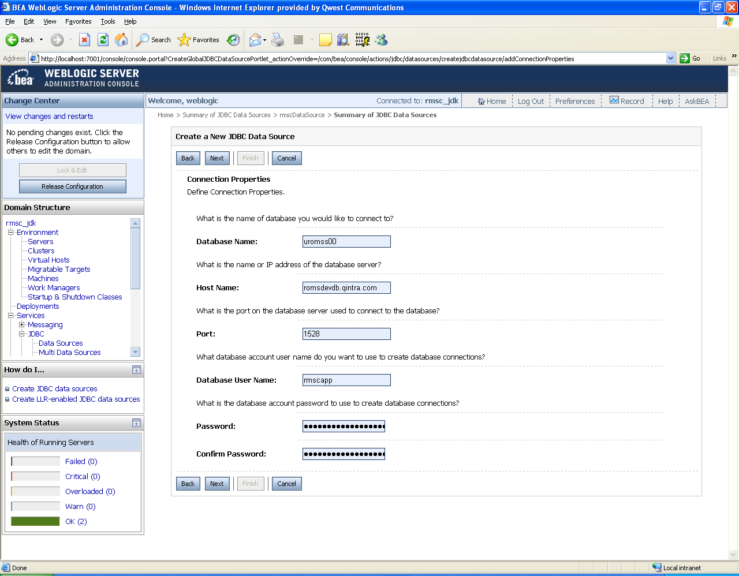

- Click ‘Test Configuration’ button and make sure the Connection succeeds
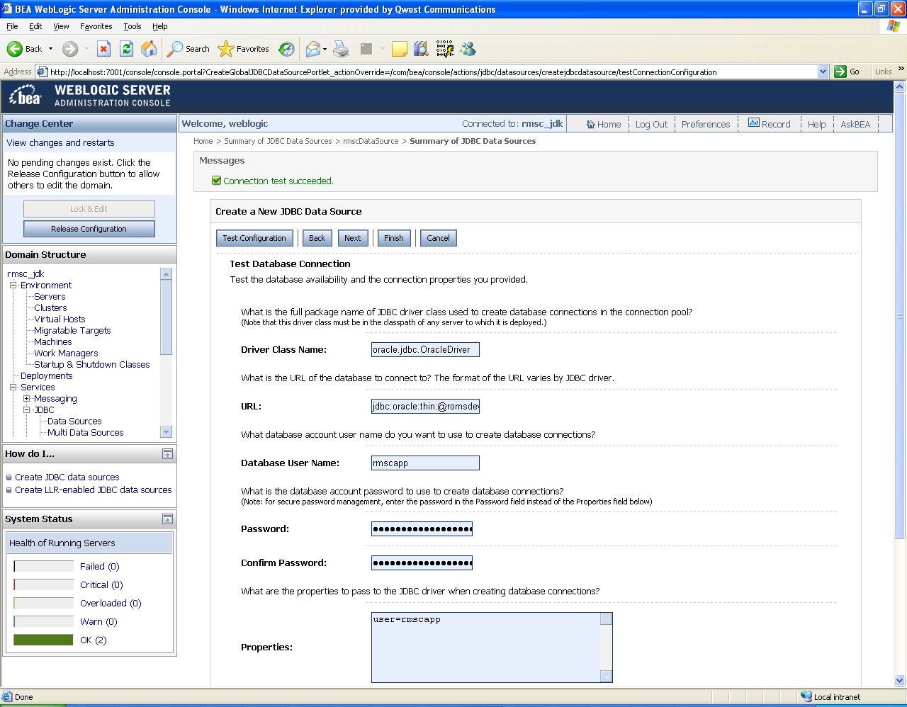

- Select rmscCluster. Click Finish.

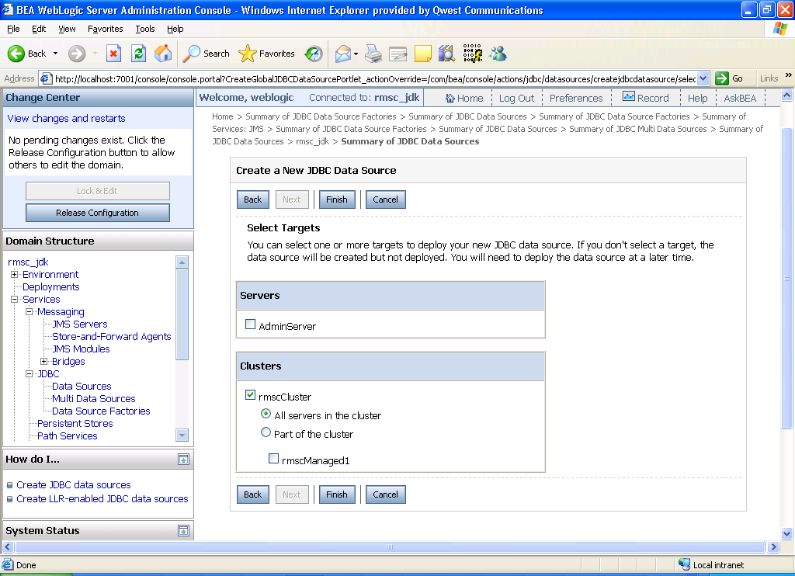

- Click ‘Activate Changes’ button.

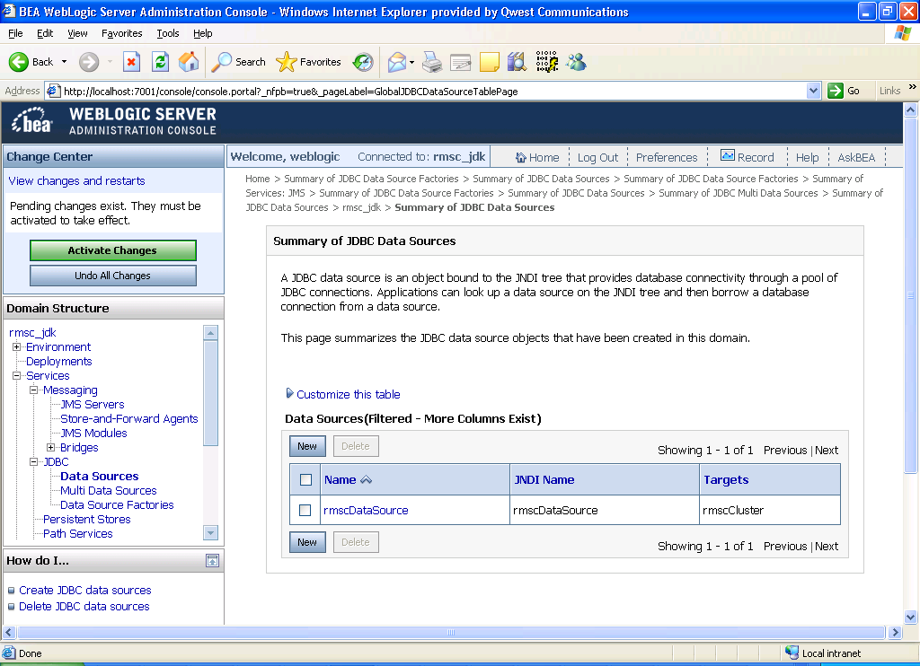

Setting JTA Timeout
In domain structure tree, migrate to Service > JTA. Click the Lock & Edit button. Edit Timeout Seconds to 3600. Enter Save button. Enter Release Configuration button.

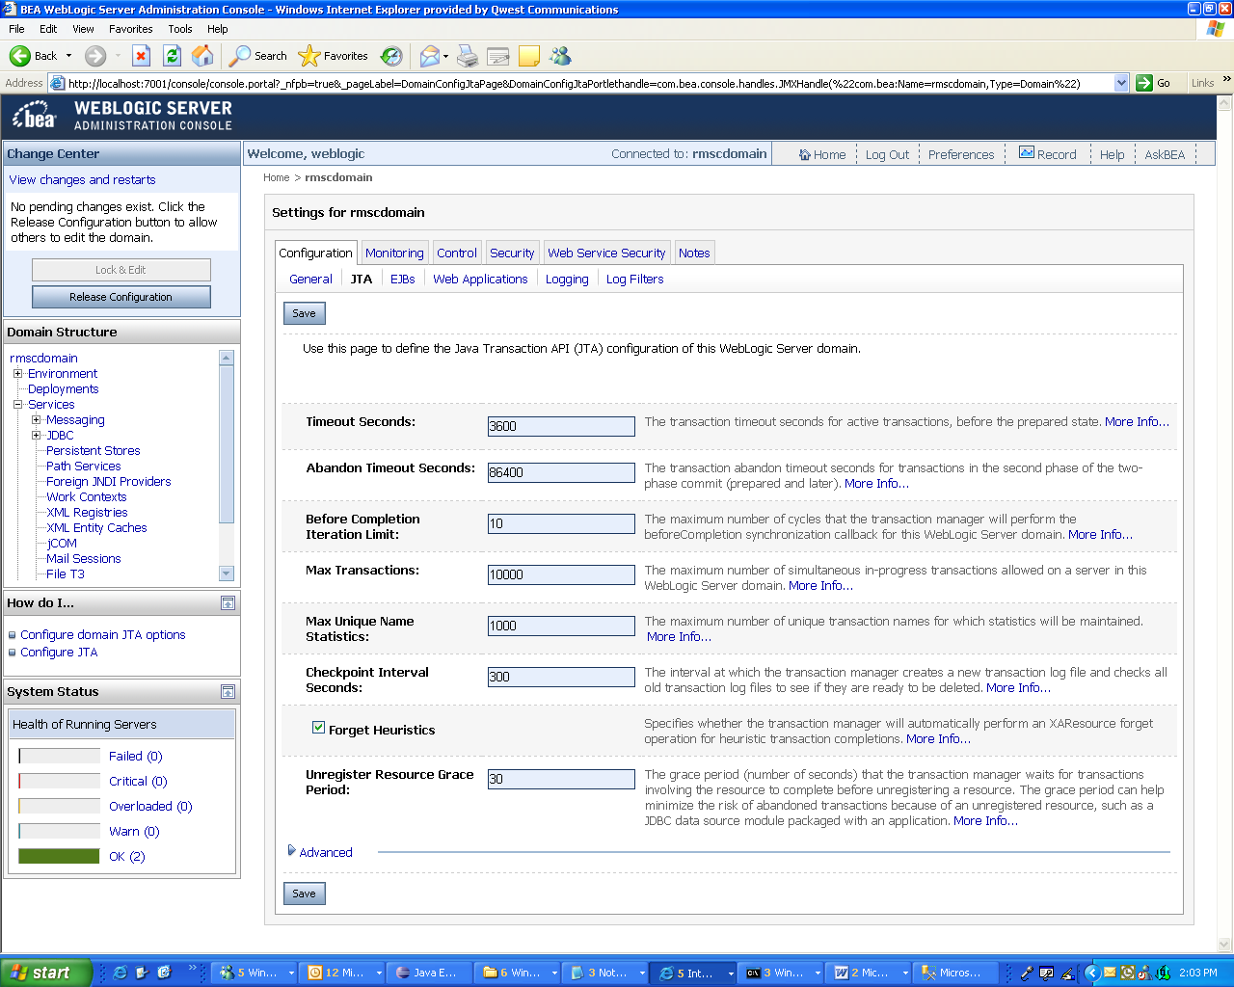

Deploying the Application

- Click Deployments 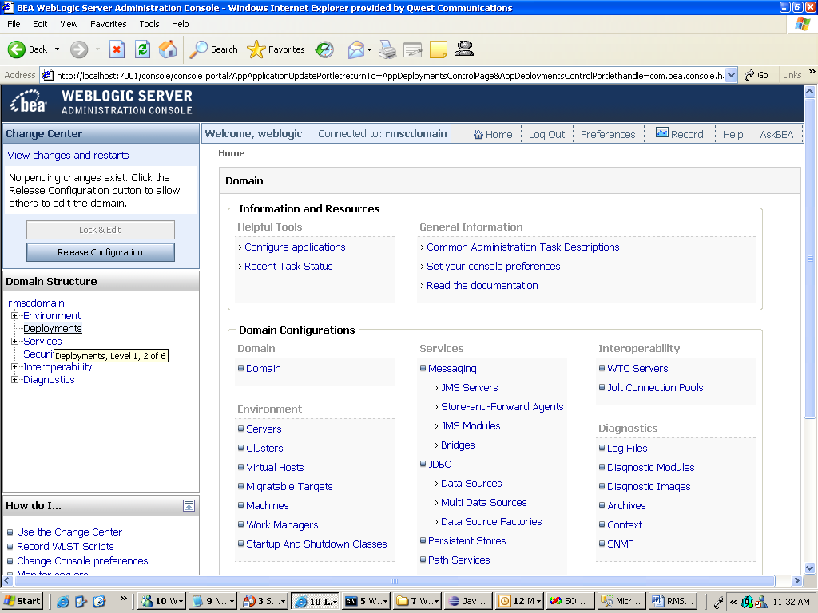

- select RMSC checkbox and click Update: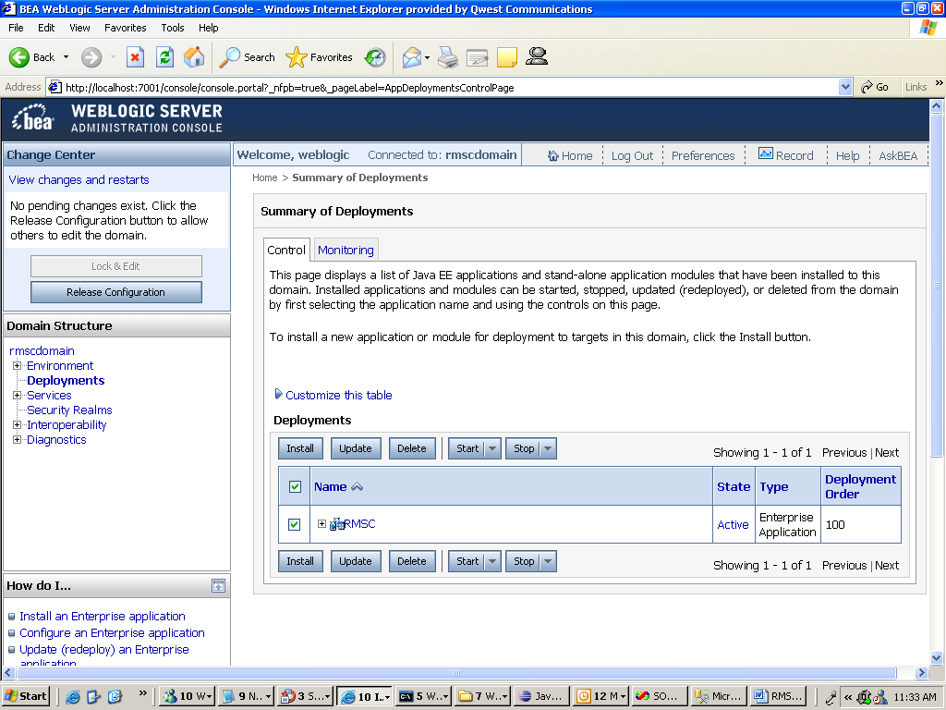

- verify new deployment source path and enter next

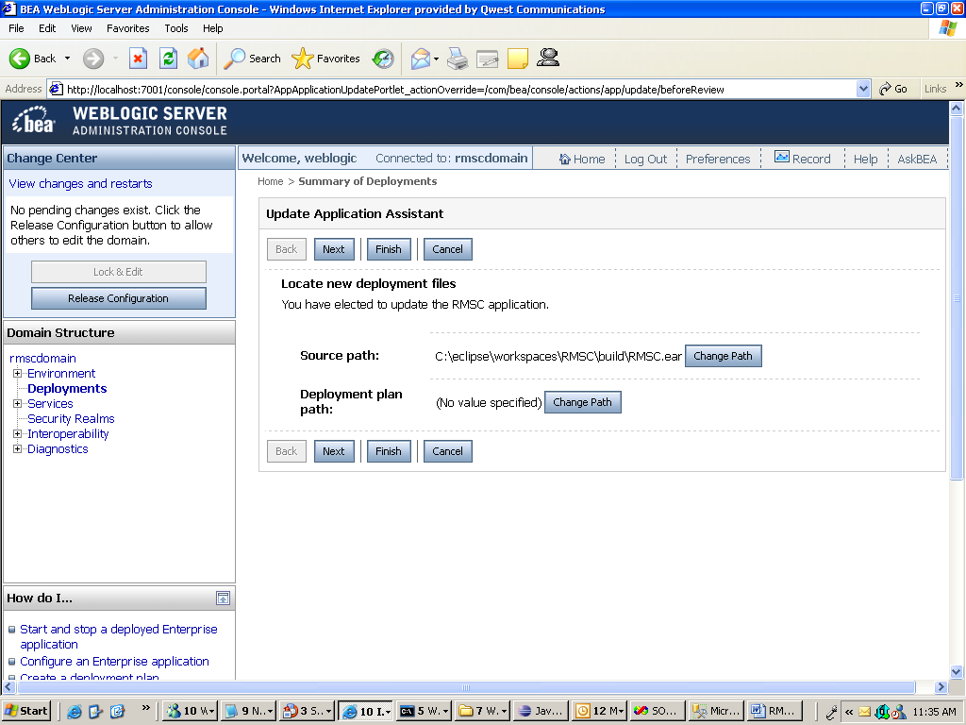

- enter Finish
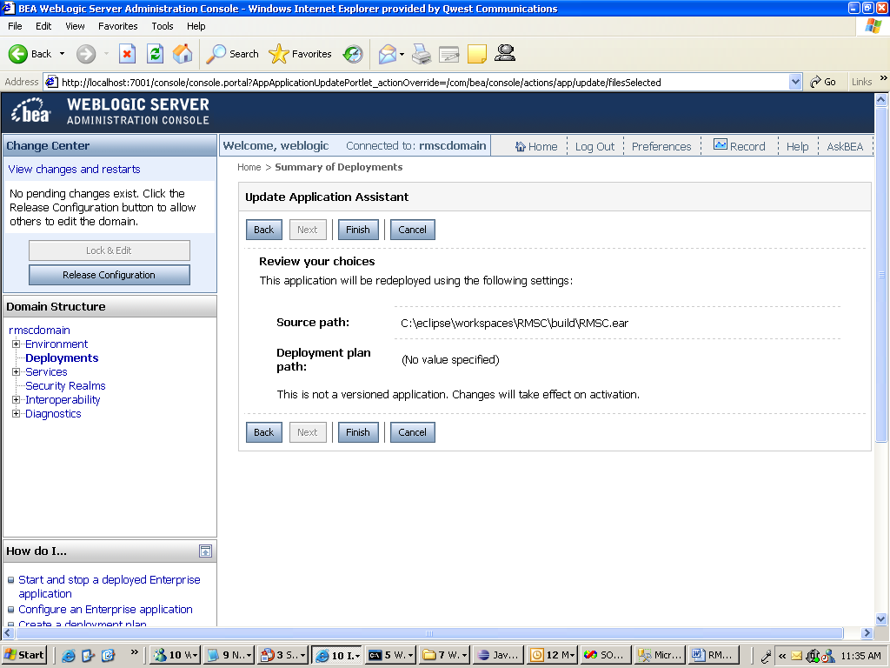

- enter Activate Changes button
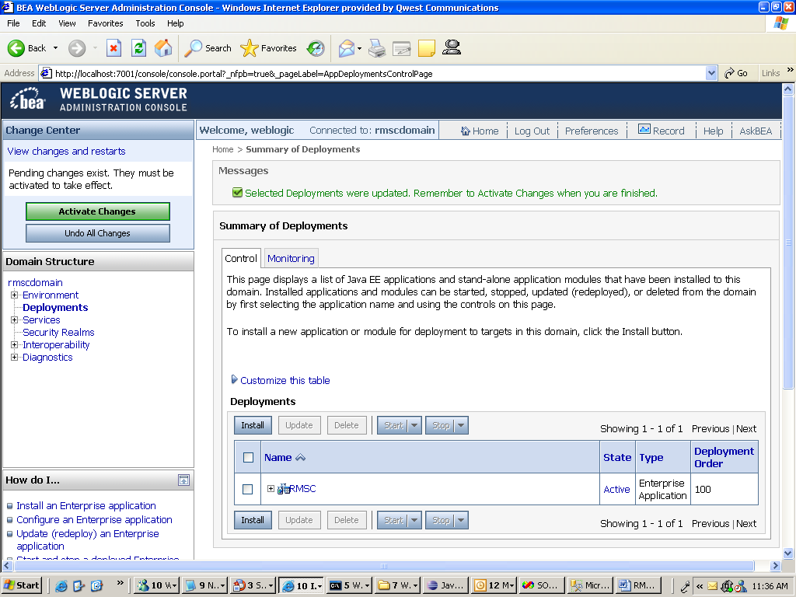

- select RMSC checkbox. Highlight Start button and select Servicing All Requests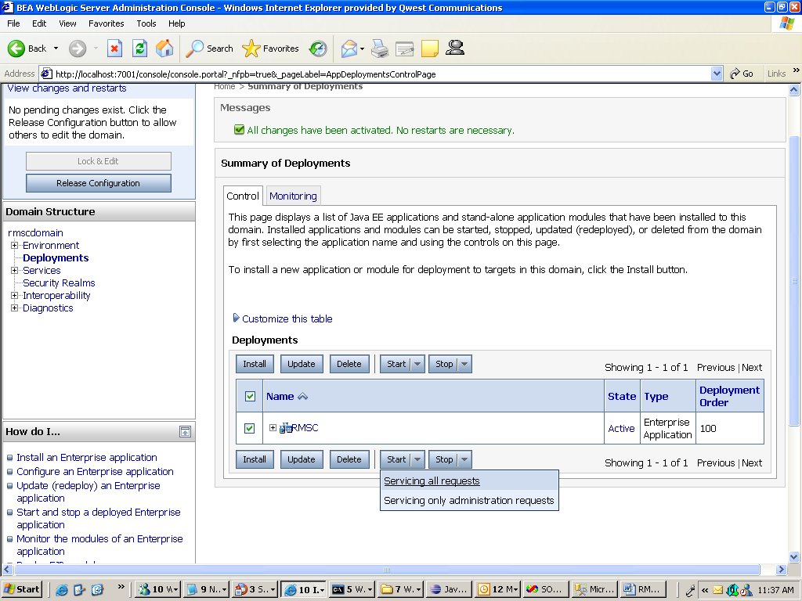

- Select Yes
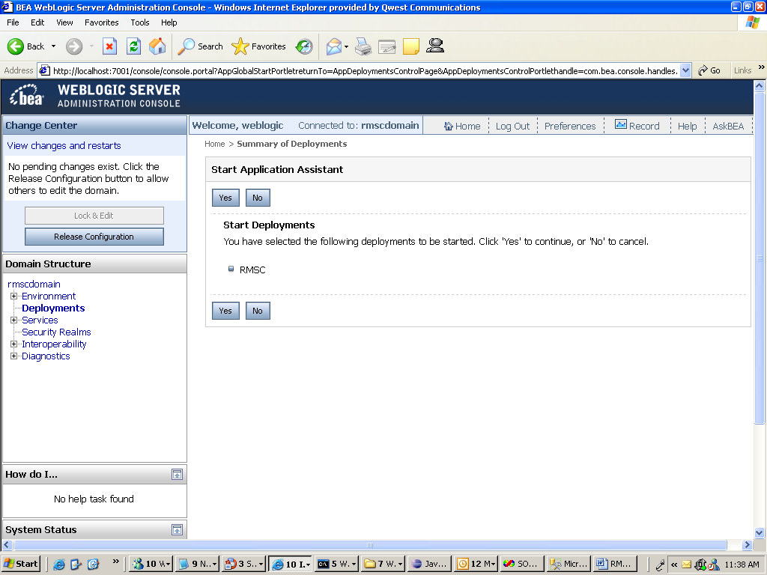

8. Add the CT configs to the JAVA_OPTIONS of C:\bea102\user_projects\domains\rmscdomain\bin\startManagedWebLogic.cmd
set JAVA_OPTIONS=-Dweblogic.security.SSL.trustedCAKeyStore="C:\bea102\wlserver_10.0\server\lib\cacerts" -Dcom.qwest.appsec.CTECOMFilterConfigFilePath=C:/bea102/user_projects/domains/rmscdomain/Qwest/config/CTECOMFilter.config -Dcom.qwest.appsec.CTAPPFilterConfigFilePath=C:/bea102/user_projects/domains/rmscdomain/Qwest/config/CTAPPFilter.config -Dcom.qwest.appsec.actrl.userCfg=C:/bea102/user_projects/domains/rmscdomain/Qwest/config/CTProperties.config %JAVA_OPTIONS%

9. Go to cmd prompt and enter below to start managed server: C:\bea102\user_projects\domains\rmscdomain\bin>startManagedWebLogic.cmd rmscManaged1 http://localhost:7001

10. enter weblogic userid and password:
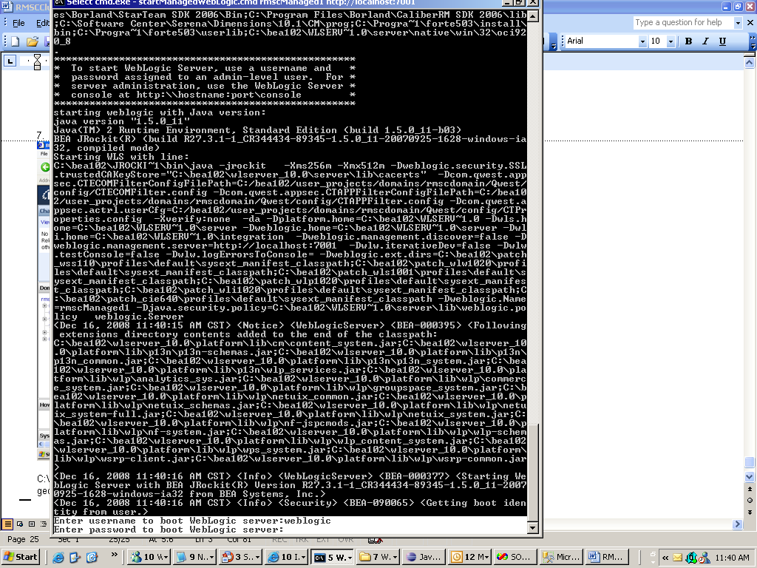

- Open a browser window and test app: http://aiomt992.dev.qintra.com:9000/CTLogin.jsp

http://localhost:7007/CTLogin.jsp

http://localhost:7007/Login.jsp

MISCELLANEOUS:
If you see this error after Deploy ear/Activate changes… ensure managed server is not in shutdown status and is running!
