Sandeep Kumar
sandeepkambham1992@gmail.com
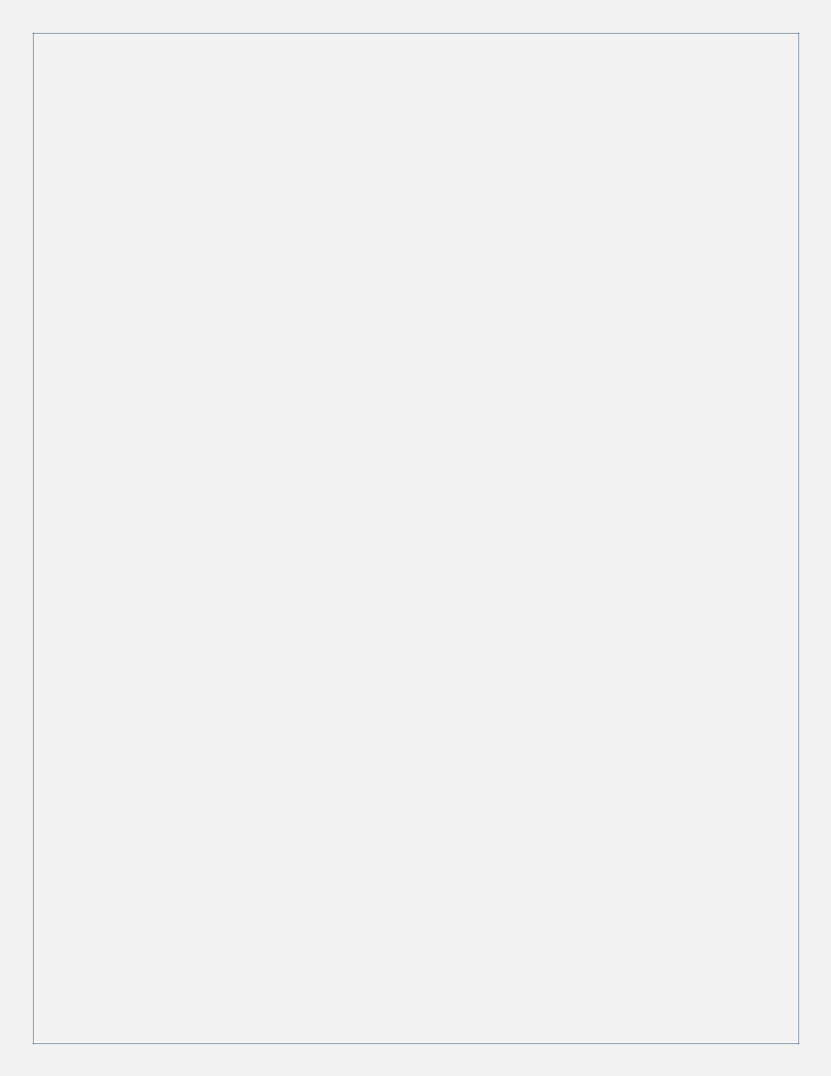
+91 - 9885334237

Objective

Having over 6+ years of substantial IT experience with expertise in DevOps technologies, Linux Administration, Cloud Infrastructure, I am looking a challenging position in an esteemed organization where my experience, technical and analytical skills are utilized for continuous growth and advancement of the company. I am a person with positive attitude, have sincerity towards my work and ability to perform under pressure.

Professional Summary

- Having 2+ year of working experience in Linux system Administrator. Also having 3+ years of experience of Build/Release and DevOps methodologies and setting up and maintaining CI & CD pipelines and delivering releases for multiple Applications running on Linux based distributed Infrastructure.

- Expertise in supporting multiple projects during builds and release process. Hands on experience with version control tool GIT and GITHUB.

- Good understanding in Helm charts, good understanding and experience in writing Deployment, Service, Ingress, Configmaps and Secrets in Kubernetes.

- Hands on Experience with Build Tool Maven to generate project Artifacts. Hands on Experience in automating build process using JENKINS CI Tool. Written Groovy script for pipeline project.

- Good experience in deploying the files in Tomcat Server. Worked on ticketing tool like JIRA.
- Good experience in Groovy.

- Integration, deployment, and administration of Java Application servers – Tomcat Application Server across Linux platforms.

- Experience in integrating Code Quality Analysis Tools like SonarQube.

- Having good knowledge in Amazon EC2 technologies EC2, S3, EBS, Auto scaling and ELB. Managing PaaS platform hosted on AWS running with 99.99% uptime using Auto scaling. Experience in using Nexus, Artifactory Repository Managers for Maven builds.
- Integrating Nexus with Jenkins to store artifacts.

- Experience in writing Ansible playbooks for configuration management. Experience in creating Ansible Roles.

- Docker installation and image setup. Creating custom image from a Docker File.

Sandeep Kumar
sandeepkambham1992@gmail.com
+91 - 9885334237

- Expertise in creating Docker Images and maintaining it in private Artifactory repository Nexus Hands on experience in Container Orchestration by using Kubernetes. Good experience in writing Dockerfiles.

Skill Set

Version control system | Git, GitHub
Operating Systems | Linux, Windows
Scripting | Shell Scripting and Groovy -
 | Manageable
Build Tools | Maven, Ant and Gradle
Application Server | Apache Tomcat, Nginx
Artifact repository Manager | Nexus
Quality code Management Tool | SonarQube
Continuous Integration Tools | Jenkins (CI)
Cloud Environment | AWS
Containerization Tool | Docker
Container Orchestration | Kubernetes.
Ticketing Tool | ServiceNow, Jira

Education:

Bachelor of Electronics and Communication Engineering from JNTU-A in 2013.

Work Experince

Organization | Duration
Century Link (Lumen) | May 2021 to till date
Wipro Technologies | Dec 2018 to May 2021
Innominds Software Pvt Ltd | April 2016 to Nov 2018

Sandeep Kumar
sandeepkambham1992@gmail.com
+91 - 9885334237

Work Experience in detail

Current Organization: Lumen (Formerly CenturyLink)

Duration: 12th May2021 – Till date

Designation: Senior Software Consultant II

Project: Internal

Skills used: GitHub, Docker, Maven, nexus, Kubernetes, Helm, and Jenkins.

Roles and responsibilities

- Administration of GITHUB includes creating branches, tagging. Maintaining source code in GITHUB repository

- Used Maven scripts to build the source code Automated build scripts using Maven and Shell Scripts.

- Involved in installing Jenkins on a Linux Machine. And creating a Master and Slave configuration to implement multiple parallel builds through a build.

- Installing and configuring the GIT, Maven, Sonar, Nexus, Docker, and Kubernetes with Jenkins for CICD.

- Used Helm charts and Deployment templates to generate Kubernetes Manifest and deployed in k8’s cluster.

- Configured Jenkins CI tool for project and setup Nightly Builds Using Build Periodically. Automated the code deployment process in each environment (development, QA, Staging, Production).

- Create the Kubernetes cluster by using kubeadm. Responsible for writing the Manifest and Service files.

- Involved in the release process and Deployed applications in Kubernetes Cluster. Creating the Kubernetes cluster and writing the manifest files and Service files. Involved in the release process and Deployed applications in Kubernetes Cluster.

- Configured a continuous integration process and interface with the operations team to ensure project Artefacts are deployed automatically to various environments using Jenkins.

Sandeep Kumar
sandeepkambham1992@gmail.com
+91 - 9885334237

- Explaining teams about the pipeline and deployment setup, clearing their towards DevOps process.

- Worked on debugging issues, whenever there is a failure in deployment.

- Creating services and maintaining their endpoints.

- Creating ingress as per the dev requirement and making sure application is accessible from in/out of the network.

Previous Organization: Wipro Technologies

Duration: Dec,2018 – May 2021

Designation: DevOps Engineer

Project: Cisco

Skills used: GitHub, Jenkins, Docker, Ansible, Kubernetes, AWS (EC2, VPC, IAM, EKS, Cloud Front, SNS, Cloud watch, S3, ELB and EBS), Linux, Nagios and AppDynamics and Service Now.

Description: CP (Customer Portal) is a Cisco Application used by the cisco customers to check the details about their contract with cisco and upload details. This application processes the device data in the form of upload and make it available at cisco. As of now these applications are hosted on VM’s on on-premises. We moved all the application environment to containerization platform and to EKS as well.

Roles and Responsibilities

- Environment setup and writing Jenkins jobs and pipelines.

- Containerized the applications using Docker file

- Worked on EKS for Kubernetes on cloud.

- Writing ansible playbooks to pull the containers from the antifactory and deploy it in respective environments.
- Responsible for writing the Kubernetes objects.

- Responsible for 24/7 end to end infrastructure health monitoring.

- Support includes monitoring, finding issue, debugging, and troubleshooting the issue, finding rca for the same, involving application related teams to find the bug.

- Creating War rooms and sending communication to end customers if there is any failure/downtime in the application they are using.

- Working closely with all/any required times to bring application up in failovers.

- Giving KT to new joiners and helping them to resolve minor issues.

Sandeep Kumar
sandeepkambham1992@gmail.com
+91 - 9885334237

- Worked on sql db to fetch data by using sql quires through toad.

- Making sure the application is always up and running.

- Worked on Incident management, collecting critical incidents and giving hand over among the shifts.
- Writing Jenkins files to create a multi branch pipeline with multiple stages.

- Clearing log files and taking back up in case of exceeding resource limits.

Previous Organization: Innominds Software Pvt Ltd

Duration: April,2016 – Nov,2018

Designation: Jr DevOps Engineer

Project: Samsung

Skills used: Docker, Linux, Nginx, Prometheus, Docker, Ansible and ELK.

Responsibilities:

- Performing end-to-end deployments for different applications in all the stacks (DEV, QA, PROD)
- Providing Infra Related Support to developers and track the issue through Jira

- Creating/terminating instances based on requirements and deploy Docker container on that.

- Working with Jenkins build (creating/deploying/maintaining/resolving) to support all requests.

- Working with Dockers, Git, AWS, Linux, Jenkins, MySQL as part of OPS related tasks.

- Launching Amazon instances by using customized AMIs, performing administration and monitoring using Amazon Cloud Watch.

- Working in Managing deployment, maintenance, support and upgrade of servers, hardware, software, operating systems in Server Environment.

- Expertise in using Linux servers and Configuration Management tools like Ansible.

- Create Docker files to deploy application and build it through image.

- Create Ansible playbooks based on requirement.

- Working with Jira to track issues and create ticket to track issue and working with Atlassian to make documents for reference.

- Creating Document to track all issues for future reference.

- Experienced in Logstash, Kibana and Elastic search.

