**M. C. E Society’s**

**Allana Institute of Management Sciences, Pune**

**Project Report**

**on**

**VEHICLE PARKING MANAGEMENT SYSTEM**

**ITC21: Mini Project**

**By**

***SHAIKH AMMAR LIYKAT***

**MCA I**

**Roll No 92**

**Seat No 967**

**Academic Year 2022-24**

**Guide Name**

**Prof. Tabassum Shaikh**

**Introduction**

**Introduction:-**

Vehicle Parking Management system is a web-based technology that will manage the records of the incoming and outgoing vehicles in an parking house. It’s an easy for Admin to retrieve the data if the vehicle has been visited through number he can get that data. Vehicle parking management system is an automatic system which delivers data processing in very high speed in systematic manner.

In VPMS we use PHP and MySQL database. This is the project which keeps records of the vehicle which is going to park in the parking area. VPMS has two module admin and user.

**ADMIN**

**Dashboard**: In this sections, admin can briefly view the number of vehicle entries in a particular period.

**Category**: In this section, admin can manage category (add/update/delete).

**Add Vehicle**: In this section, admin add vehicle which is going to park.

**Manage Vehicle**: In this section, admin can manage incoming and outgoing vehicle and admin can also add parking charges and his/her remarks.

**Reports**: In this section admin can generate vehicle entries reports between two dates.

**Search**: In this section, admin can search a particular vehicle by parking number.

Admin can also update his profile, change the password and recover the password.

**USERS**

**Dashboard**: It is welcome page for an users.

**View Vehicle:** In this section, users view the details of vehicle parking which is parked by him/her.

Users can also update his profile, change the password and recover the password.

**Purpose:-**

The purpose of developing vehicle parking management system is to computerized the tradition way of parking. Another purpose for developing this application is to generate the report automatically.

**Scope:-**

In the modern age. Many people have vehicles. Vehicle is now a basic need. Every place is under the process of urbanization. There are many corporate offices and shopping centers etc. There are many recreational places where people used to go for refreshment. So, all these places need a parking space where people can park their vehicles safely and easily. Every parking area needs a system that records the detail of vehicles to give the facility. With the help of this system we can deliver a good service to customer who wants to park their vehicle into the any organization’s premises.

**Requirement Specification**

**Hardware Configuration :**

**Client Side:**

|  |  |
| --- | --- |
| **RAM RAMfgdfRA RAM** | 512 MB |
|  |  |
| **Hard disk** | 10 GB |
|  |  |
| **Processor** | 1.0 GHz |
|  |  |

**Server side:**

|  |  |
| --- | --- |
| **RAM** | **1 GB** |
| **Hard disk** | **20 GB** |
| **Processor** | **2.0 GHz** |

**Software Requirement:**

**Client Side:**

|  |  |
| --- | --- |
| **Web Browser** | Google Chrome or any compatible browser |
| **Operating System** | Windows or any equivalent OS |

**Server Side:**

|  |  |
| --- | --- |
| **Web Server** | APACHE |
| **Server side Language** | PHP5.6 or above version |
| **Database Server** | MYSQL |
| **Web Browser** | Google Chrome or any compatible browser |
| **Operating System** | Windows or any equivalent OS |

**APACHE**

The Apache HTTP Server Project is an effort to develop and maintain an open-source HTTP server for modern operating systems including UNIX and Windows. The goal of this project is to provide a secure, efficient and extensible server that provides HTTP services in sync with the current HTTP standards.

The Apache HTTP Server ("httpd") was launched in 1995 and it has been the most popular web server on the Internet since April 1996. It has celebrated its 20th birthday as a project in February 2015.

**PHP**

* PHP stands for PHP: Hypertext Preprocessor.
* PHP is a server-side scripting language, like ASP.
* PHP scripts are executed on the server.
* PHP supports many databases (MYSQL, Informix, Oracle, Sybase, Solid, Generic ODBC, etc.).
* PHP is an open source software .
* PHP is free to download and use.

**MYSQL**

* MYSQL is a database server
* MYSQL is ideal for both small and large applications
* MYSQL supports standard SQL
* MYSQL compiles on a number of platforms
* MYSQL is free to download and use
* How to access MySQL: <http://localhost/phpmyadmin>

**Analysis and Design**

**Analysis:**

In present all visitors parking work done on the paper. The whole year visitor parking record is stored in the registers. We can’t generate reports as per our requirements because its take more time to calculate the visitors parking report.

**Disadvantage of present system:**

* **Not user friendly:** The present system not user friendly because data is not stored in structure and proper format.
* **Manual Control:** All report calculation is done manually so there is a chance of error.
* **Lots of paper work:** Visitors maintain in the register so lots of paper require storing details.
* **Time consuming**

**Design Introduction:**

Design is the first step in the development phase for any techniques and principles for the purpose of defining a device, a process or system in sufficient detail to permit its physical realization.Once the software requirements have been analyzed and specified the software design involves three technical activities - design, coding, implementation and testing that are required to build and verify the software.

The design activities are of main importance in this phase, because in this activity, decisions ultimately affecting the success of the software implementation and its ease of maintenance are made. These decisions have the final bearing upon reliability and maintainability of the system. Design is the only way to accurately translate the customer’s requirements into finished software or a system.

Design is the place where quality is fostered in development. Software design is a process through which requirements are translated into a representation of software. Software design is conducted in two steps. Preliminary design is concerned with the transformation of requirements into data

UML Diagrams:

Actor:  
 A coherent set of roles that users of use cases play when interacting with the use `cases.

Use case: A description of sequence of actions, including variants, that a system performs that yields an observable result of value of an actor.

UML stands for Unified Modeling Language. UML is a language for specifying, visualizing and documenting the system. This is the step while developing any product after analysis. The goal from this is to produce a model of the entities involved in the project which later need to be built. The representation of the entities that are to be used in the product being developed need to be designed.

**USECASE DIAGRAMS:**

Use case diagrams model behavior within a system and helps the developers understand of what the user require. The stick man represents what’s called an actor.

Use case diagram can be useful for getting an overall view of the system and clarifying who can do and more importantly what they can’t do.

Use case diagram consists of use cases and actors and shows the interaction between the use case and actors.

* The purpose is to show the interactions between the use case and actor.
* To represent the system requirements from user’s perspective.
* An actor could be the end-user of the system or an external system.

**USECASE DIAGRAM:** A Use case is a description of set of sequence of actions. Graphically it is rendered as an ellipse with solid line including only its name. Use case diagram is a behavioral diagram that shows a set of use cases and actors and their relationship. It is an association between the use cases and actors. An actor represents a real-world object. Primary Actor – Sender, Secondary Actor Receiver.

**Use Case Diagrams:**

**Admin**

Sign in

Add Vehicle Category

Dashboard

Manage Vehicle Category

(Update Details)

Ad

Add Vehicle

Manage Vehicle(Update Details)

View Reg Users

Generate Reports

Update Profile

Change Password

Password Recovery

Search

**Users**

Signup

Sign in

Dashboard

View Vehicle

Update Profile

Change Password

Password Recovery

**Class Diagram:**

A description of set of objects that share the same attributes operations, relationships, and semantics

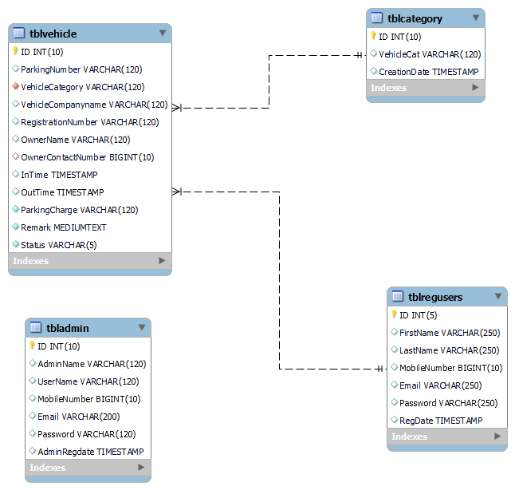

**ER Diagram:**

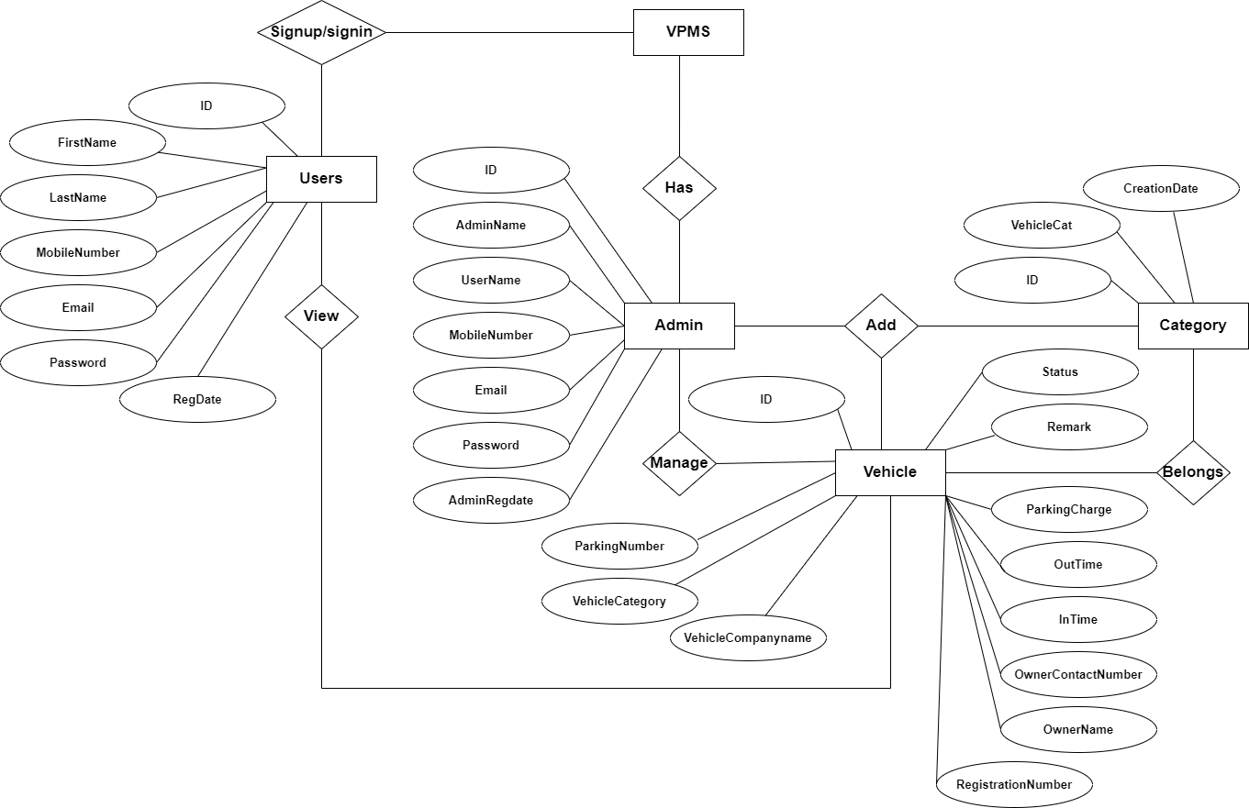

**Data Flow Diagram**

**Zero Level DFD**

**Password Management**

**Vehicle Category Management**

**Login Management**

**Outgoing Vehicle Management**

**User Management**

**Incoming Vehicle Management**

**VPMS**

**Vehicle Management**

**Administrator Management**

**First Level DFD**

**Incoming Vehicle Management**

**Login Management**

**Administrator Management**

**User Management**

**VPMS**

**Vehicle Management**

**Password Management**

**Generate Vehicle Report**

**Vehicle Category Management**

**Password Recovery Management**

**Outgoing Vehicle Management**

**Second Level DFD**

**Check Roles of access**

**Login to system**

**Admin**

**Manage Vehicle Category**

**Add Vehicle**

**Check Credential**

**Forgot Password**

**Manage incoming vehicle**

**Manage Modules**

**Manage outgoing vehicle**

**Generate vehicle report**

**Change Password**

**Update Profile**

**View Registered Users**

**Search vehicle**

**Login to system**

**Check Roles of access**

**Signup system**

**Users**

**ok**

**View Vehicle Parking Details**

**Check Credential**

**Manage Modules**

**Forgot Password**

**Update Profile**

**Change Password**

**Deployment Diagram :-**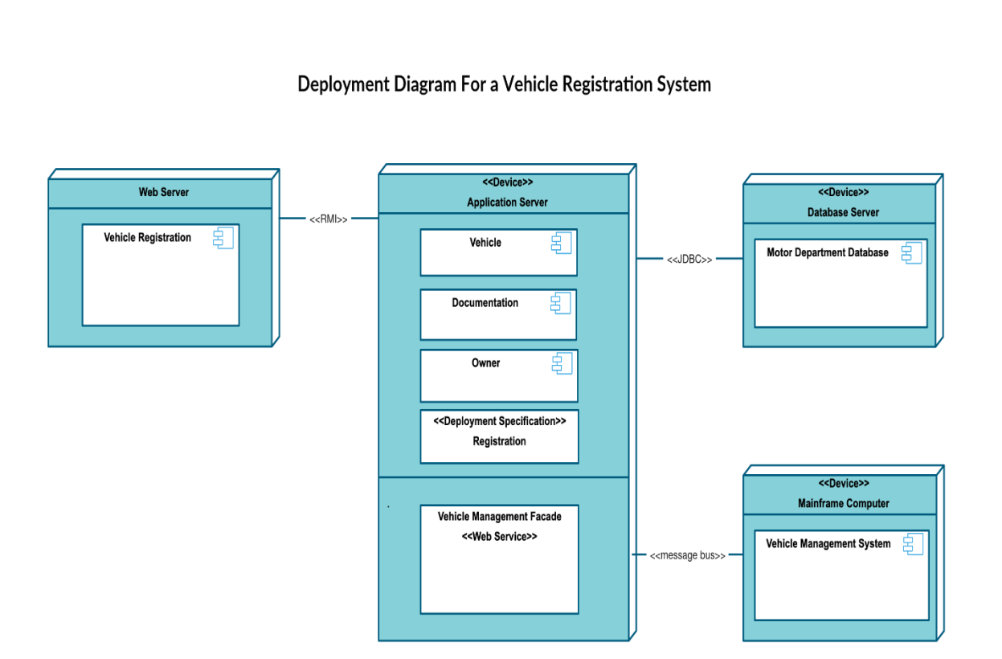

**MySQL Data Tables:**

**Admin Table:**(Table name is admin)

This store admin personal and login details.

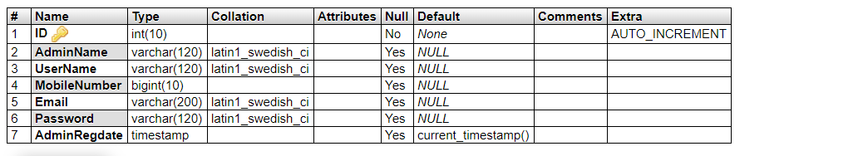

**Category Table(**Table name is tblcategory

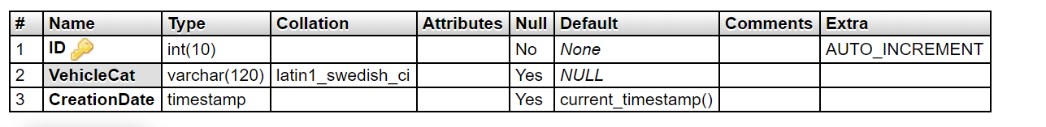

**Vehicle Table:** (Table name is vehicle)

This store the vehicle details and admin remark

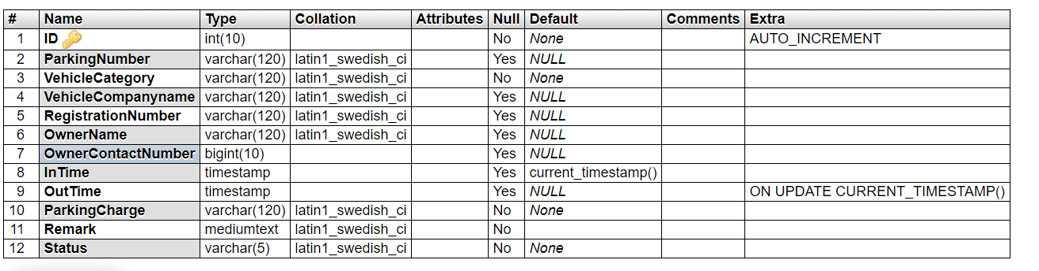

**User Table:** (Table name is tblregusers)

This table stores the details of registered users

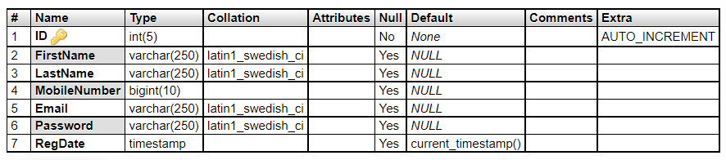

**Implementation and System Testing**

After all phase have been perfectly done, the system will be implemented to the server and the system can be used.

**System Testing**

The goal of the system testing process was to determine all faults in our project .The program was subjected to a set of test inputs and many explanations were made and based on these explanations it will be decided whether the program behaves as expected or not. Our Project went through two levels of testing

1. Unit testing

2. Integration testing

**UNIT TESTING**

Unit testing is commenced when a unit has been created and effectively reviewed .In order to test a single module we need to provide a complete environment i.e. besides the section we would require

* The procedures belonging to other units that the unit under test calls
* Non local data structures that module accesses
* A procedure to call the functions of the unit under test with appropriate parameters

**1. Test for the admin module**

* **Testing admin login form-**This form is used for log in of administrator of the system. In this form we enter the username and password if both are correct administration page will open otherwise if any of data is wrong it will get redirected back to the login page and again ask the details.
* **Report Generation:** admin can generate report from the main database.

**INTEGRATION TESTING**

In the Integration testing we test various combination of the project module by providing the input.

The primary objective is to test the module interfaces in order to confirm that no errors are occurring when one module invokes the other module.

**EVALUATION**

**Project URL: <http://localhost/vpms>**

**Home Page**

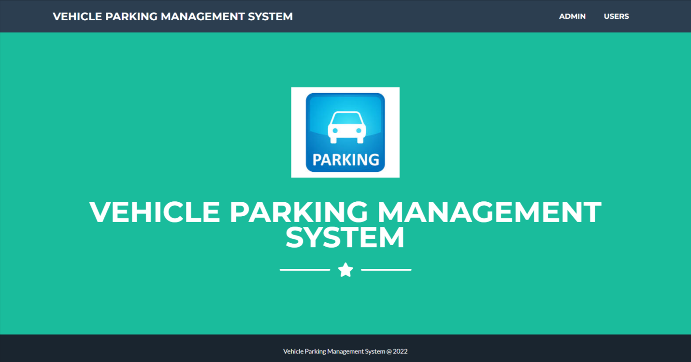

**Admin Login Page**

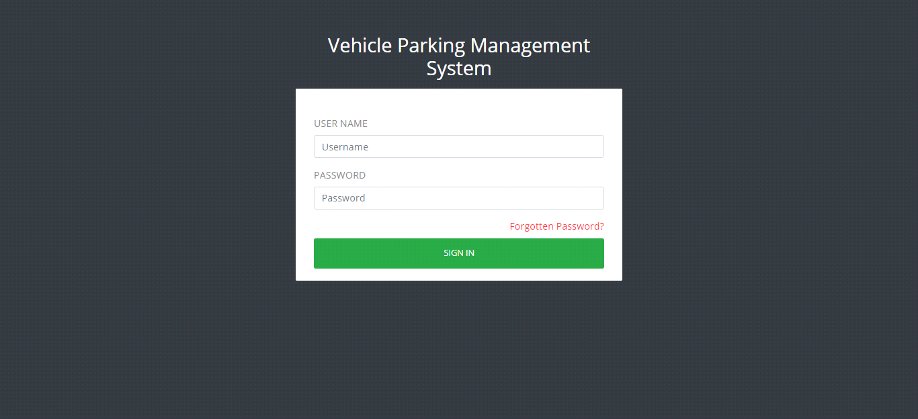

**Dashboard**

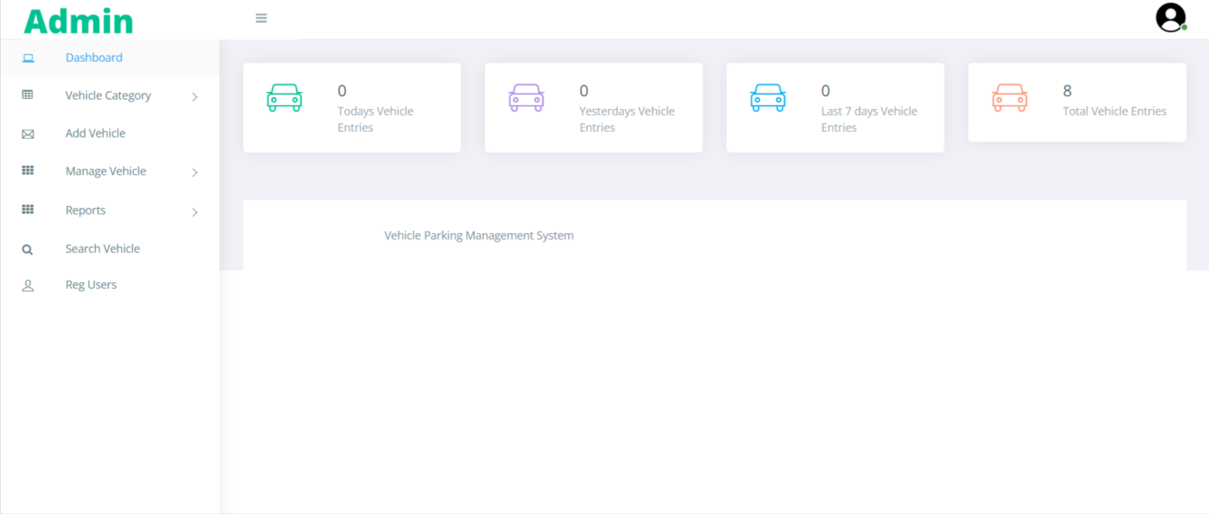

**Profile**

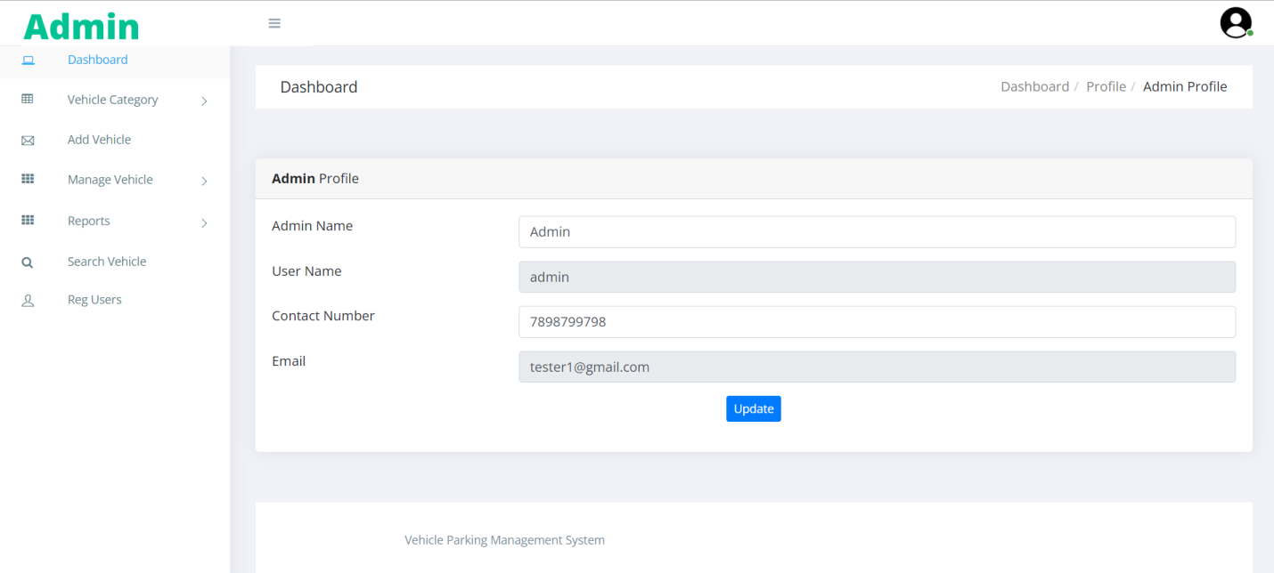

**Change Password**

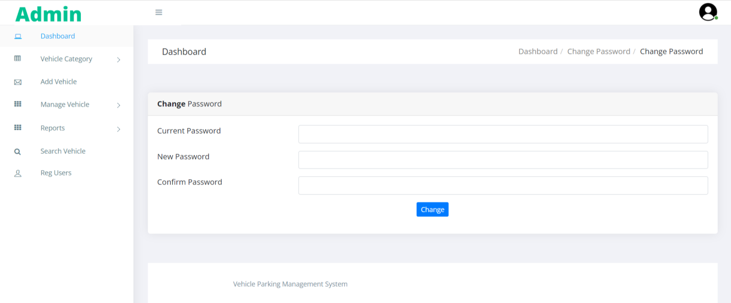

**Add Category**

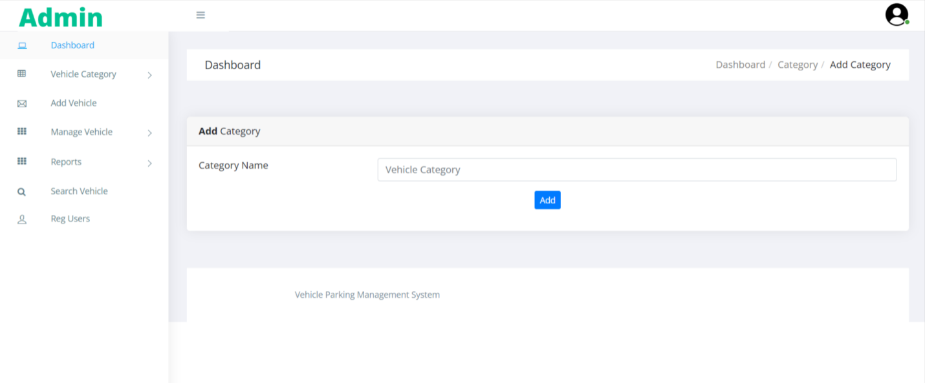

**Manage Category**

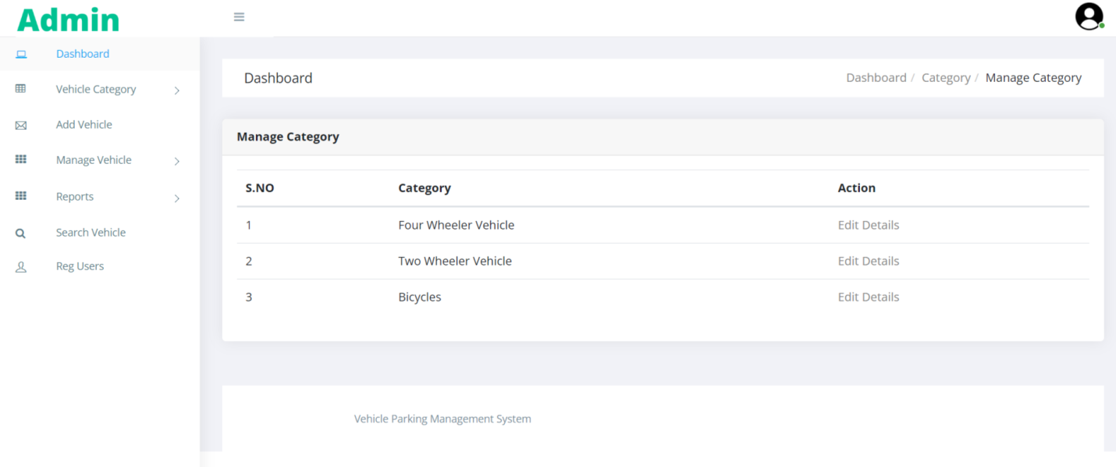

**Update Category**

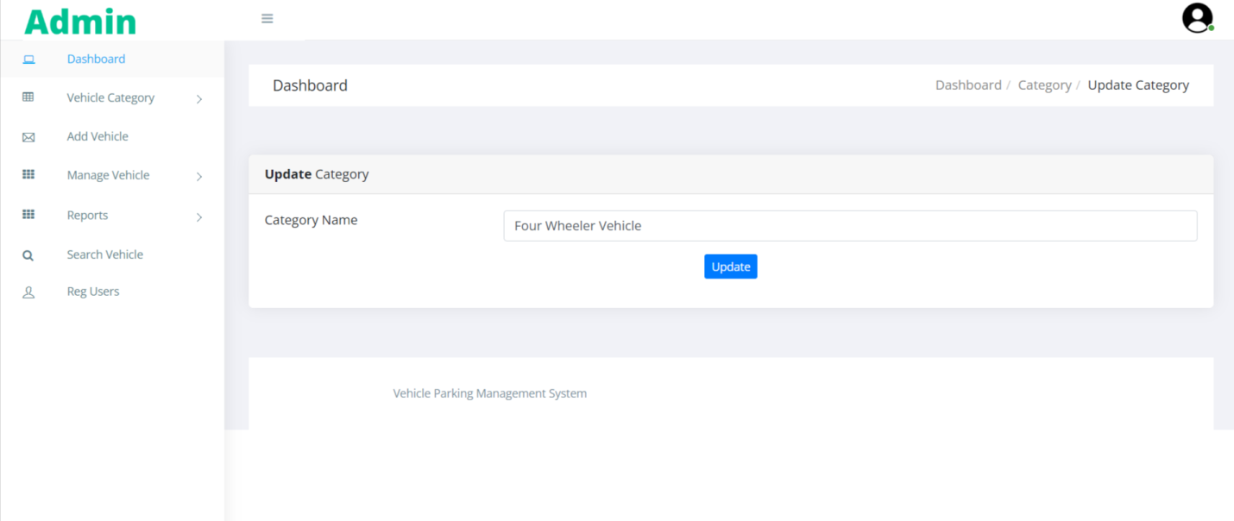

**Add Vehicle**

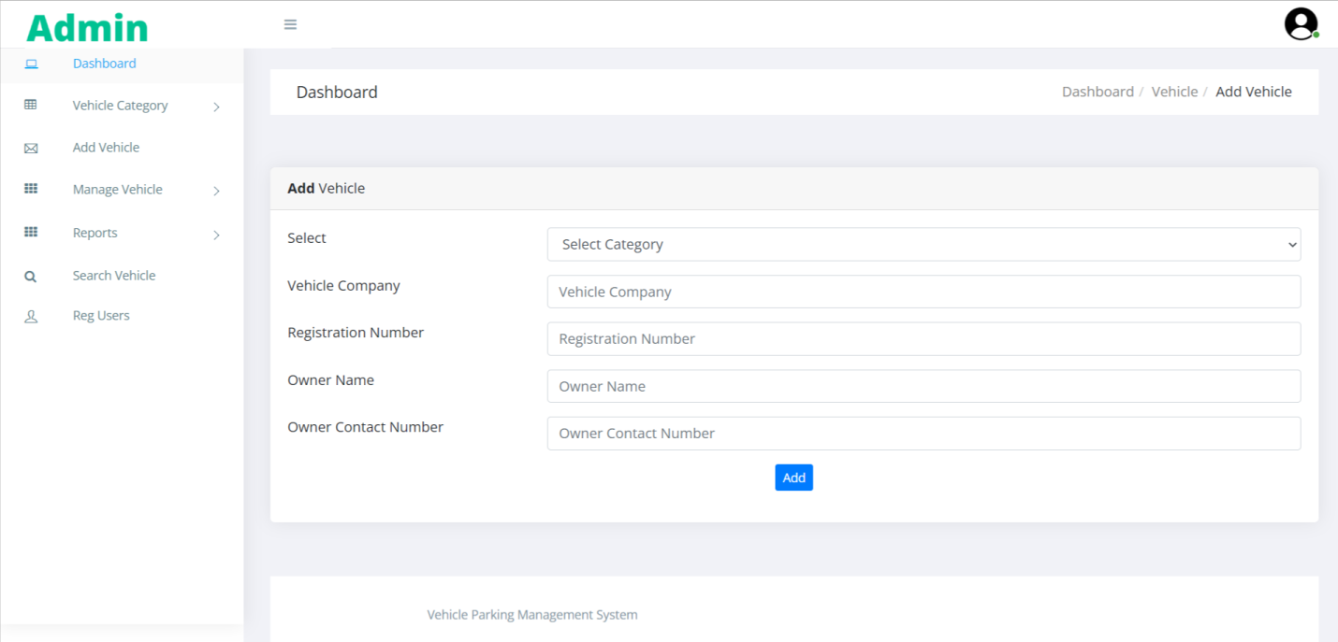

**Manage Incoming Vehicle**

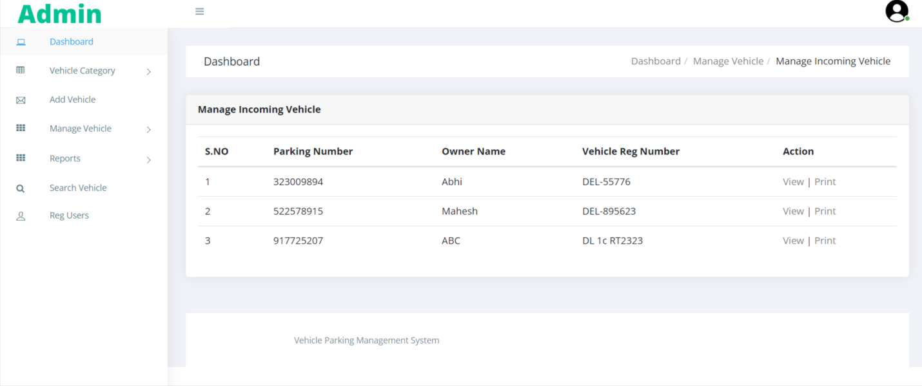

**View Incoming Vehicle**

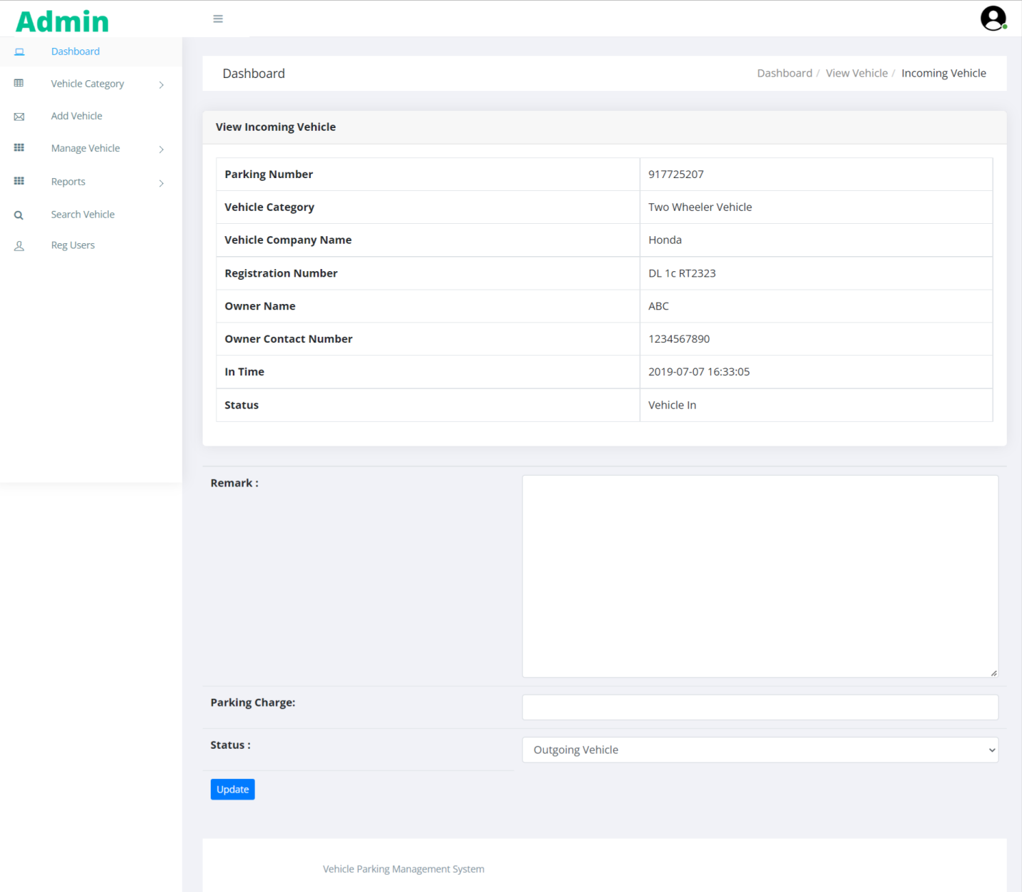

**Parking Receipt**

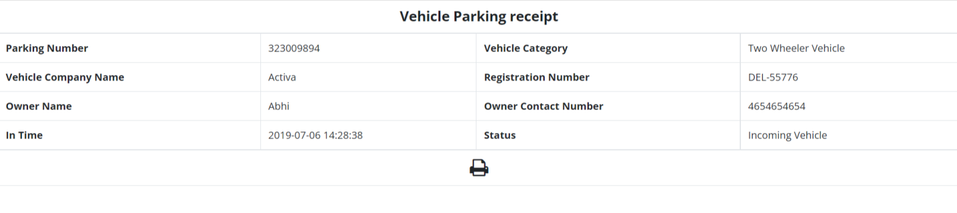

**Manage Outgoing Vehicle**

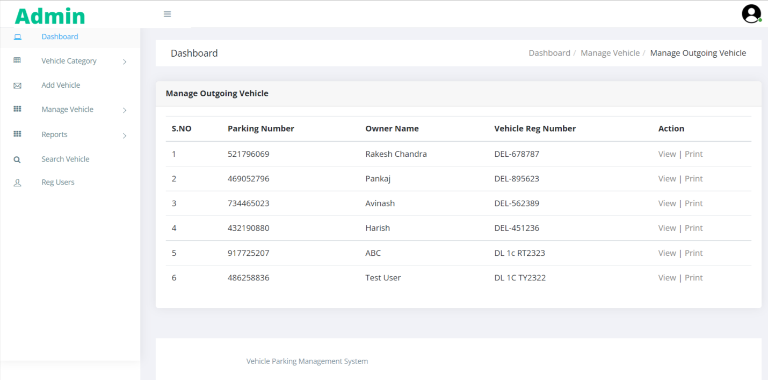

**View Outgoing Vehicle**

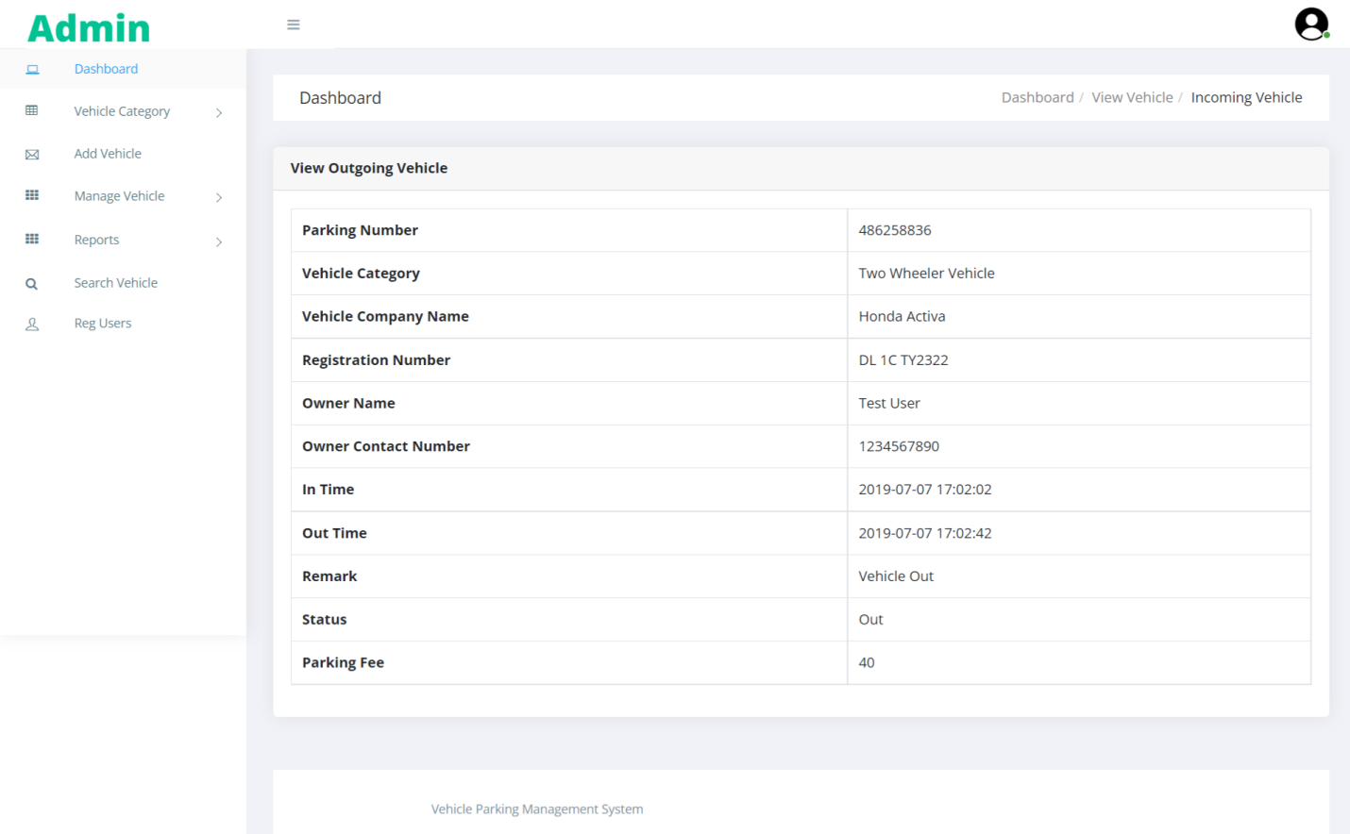

**Vehicle Parking Receipt**

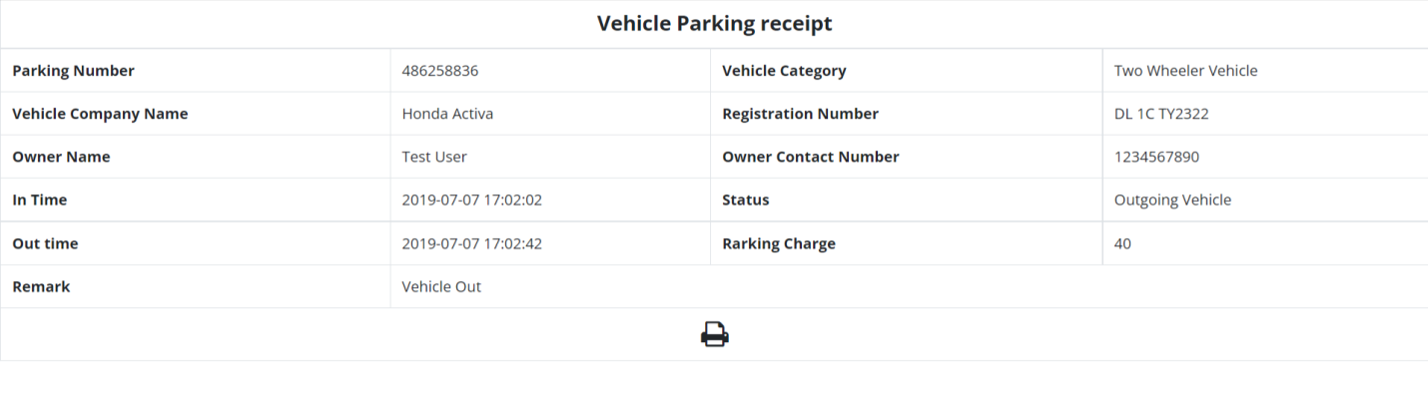

**Between Dates Reports**

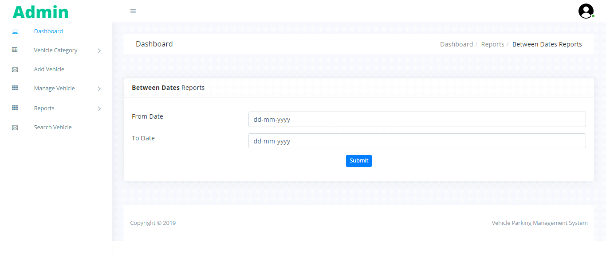

**View Report**

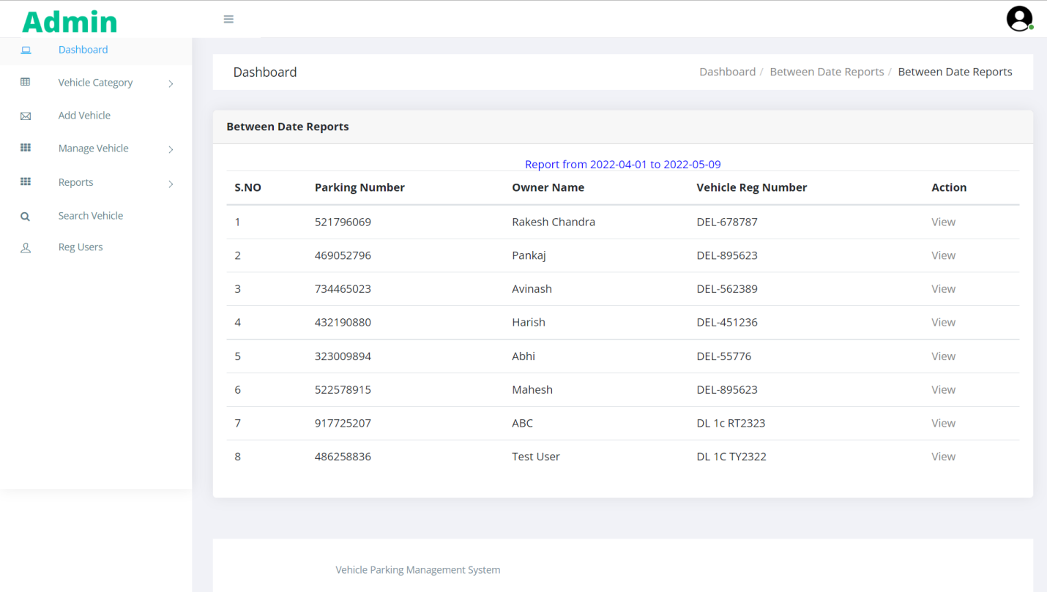

**Search Vehicle**

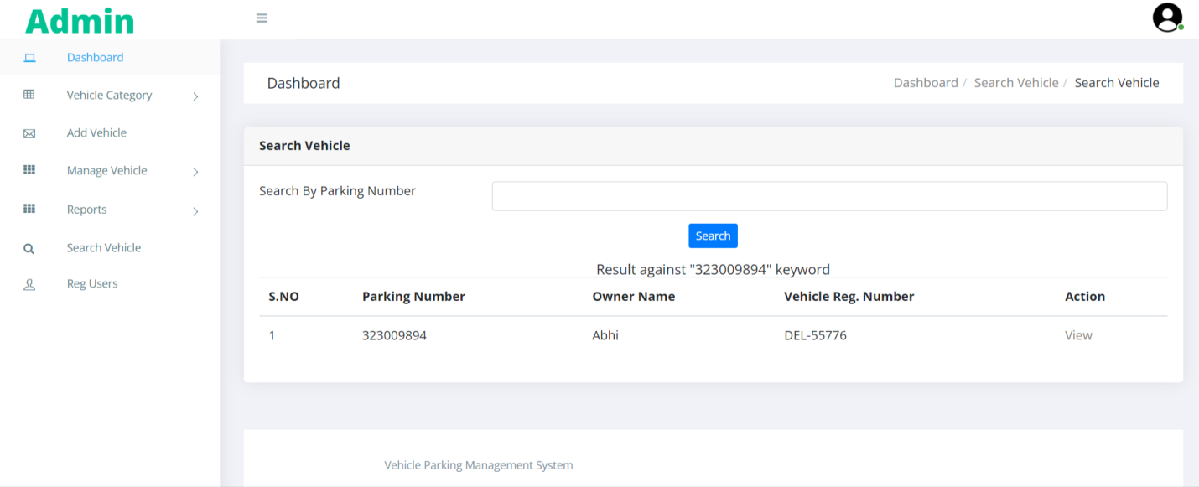

**View Registered Users**

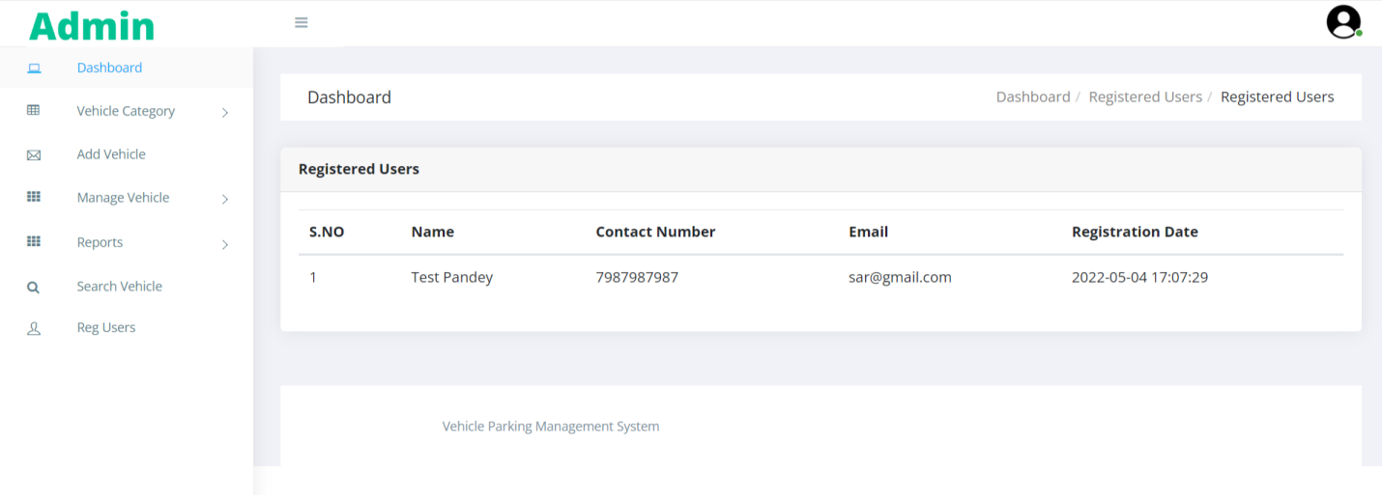

**Forgot Password**

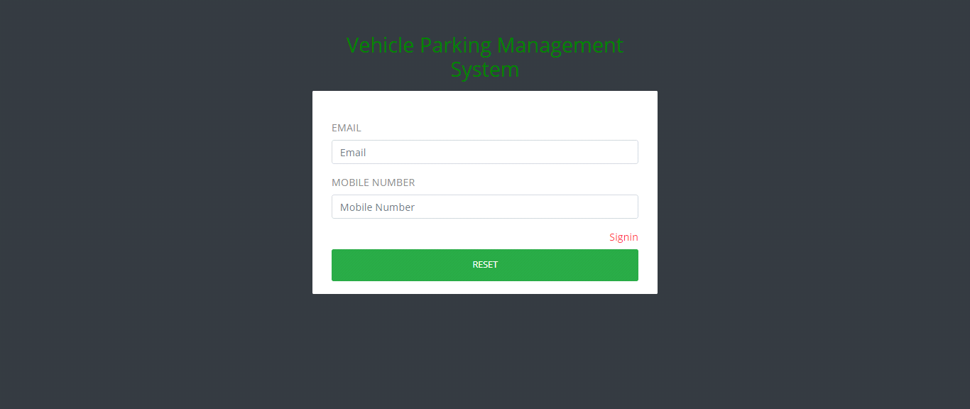

**Reset Password**

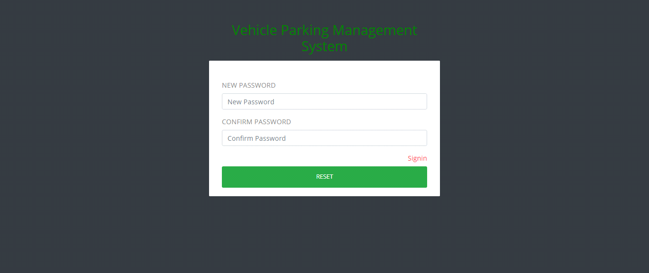

**User Sign up**

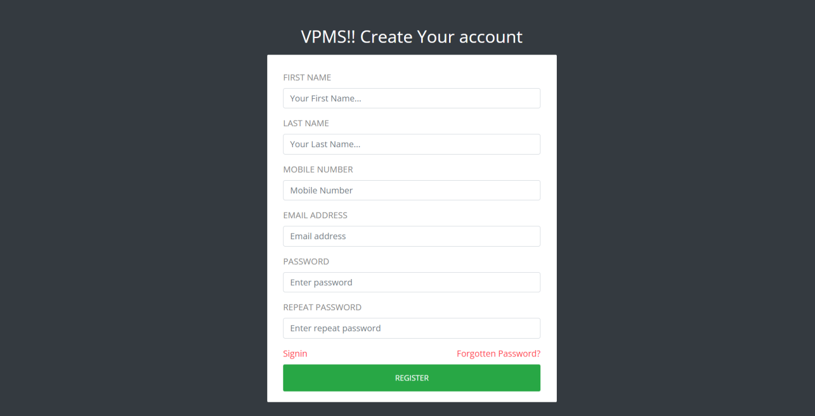

**Sign in**

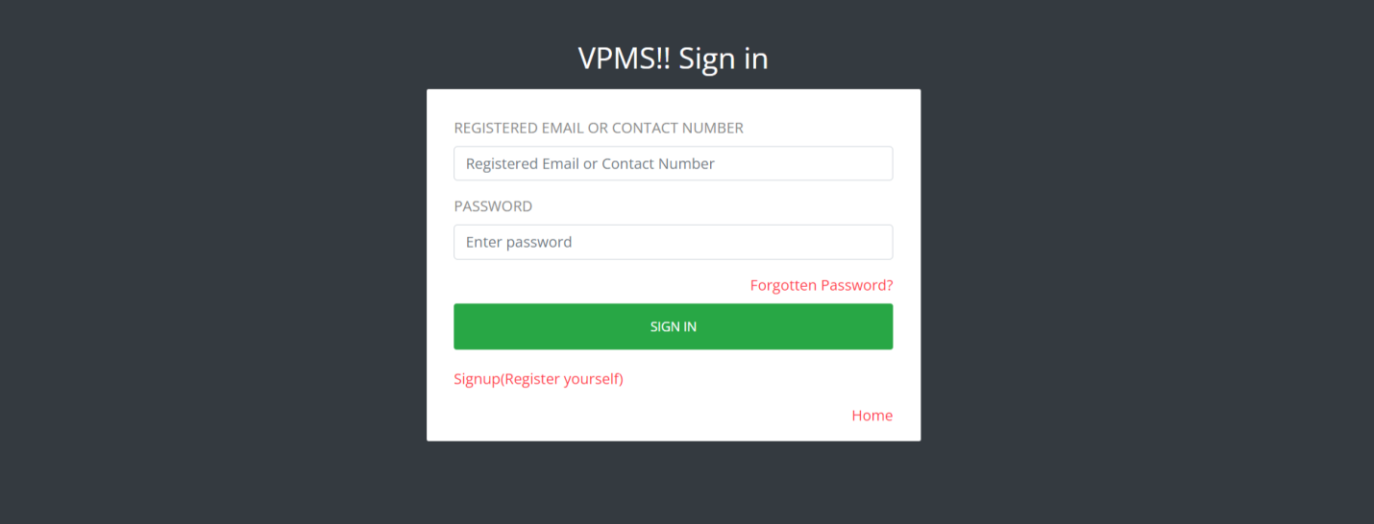

**Dashboard**

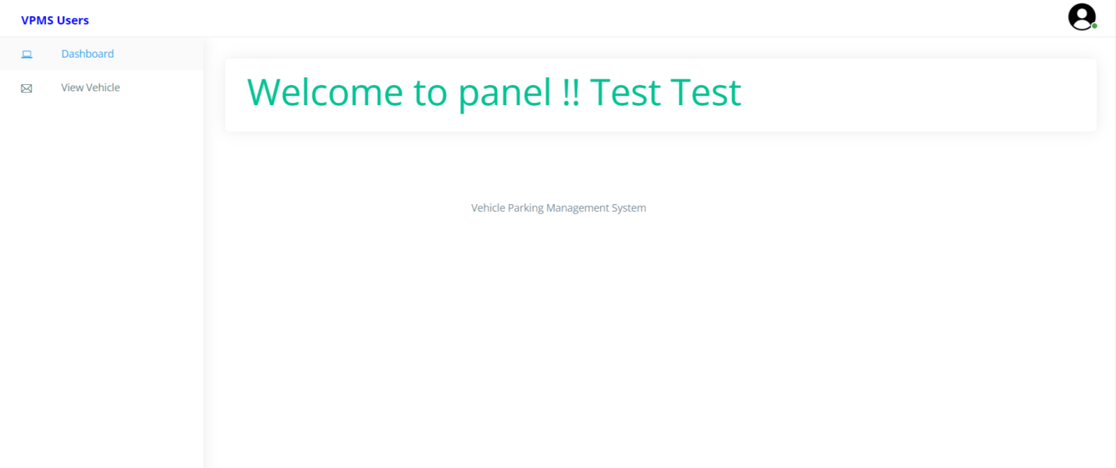

**Profile**

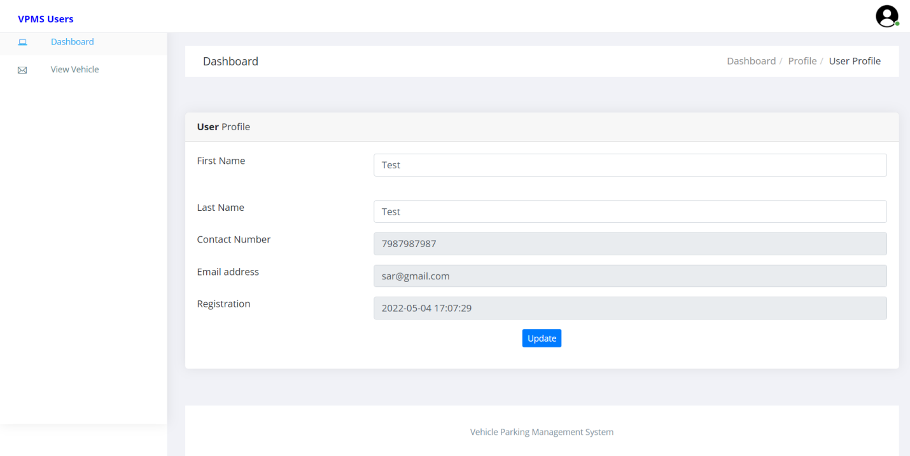

**Change Password**

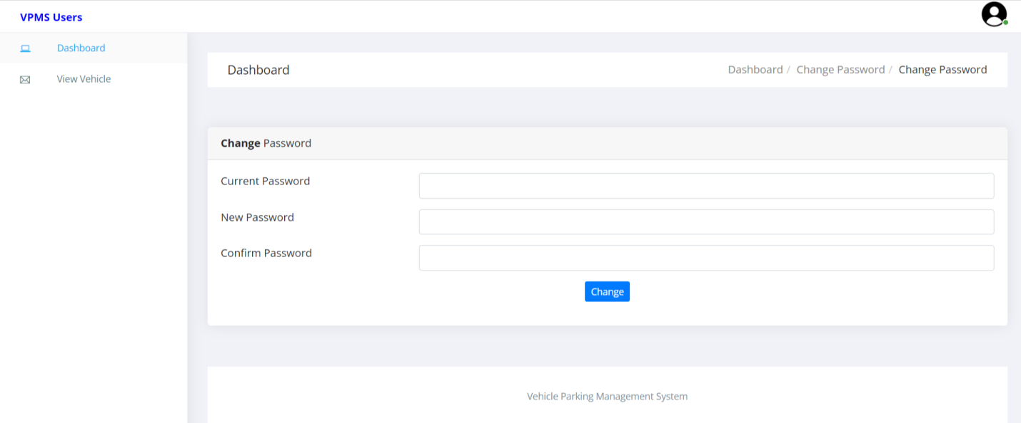

**View Vehicle**

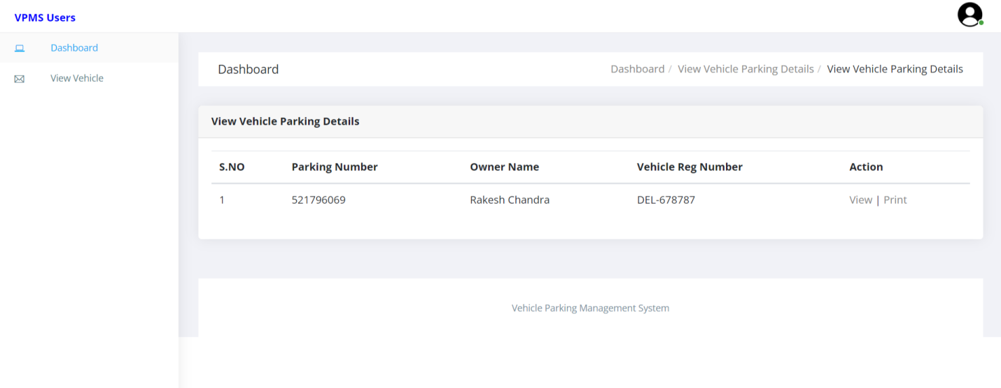

**View Vehicle in details**

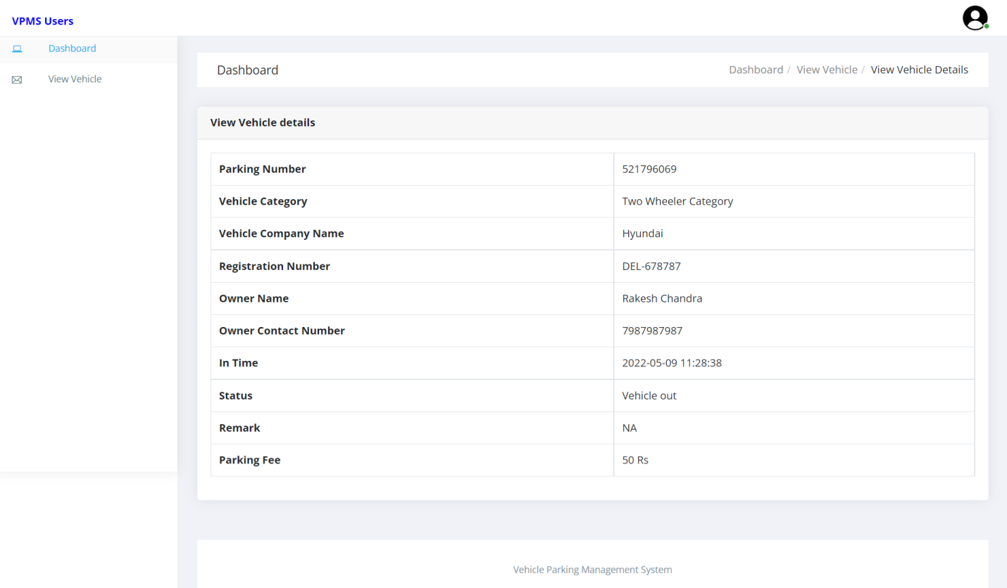

**View Parking Receipt**

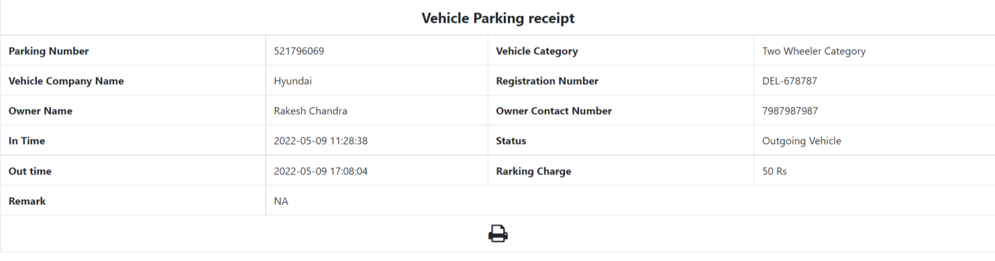

**Forgot Password**

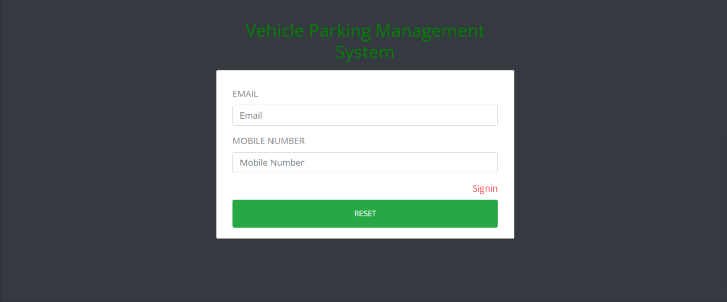

**Reset Password**

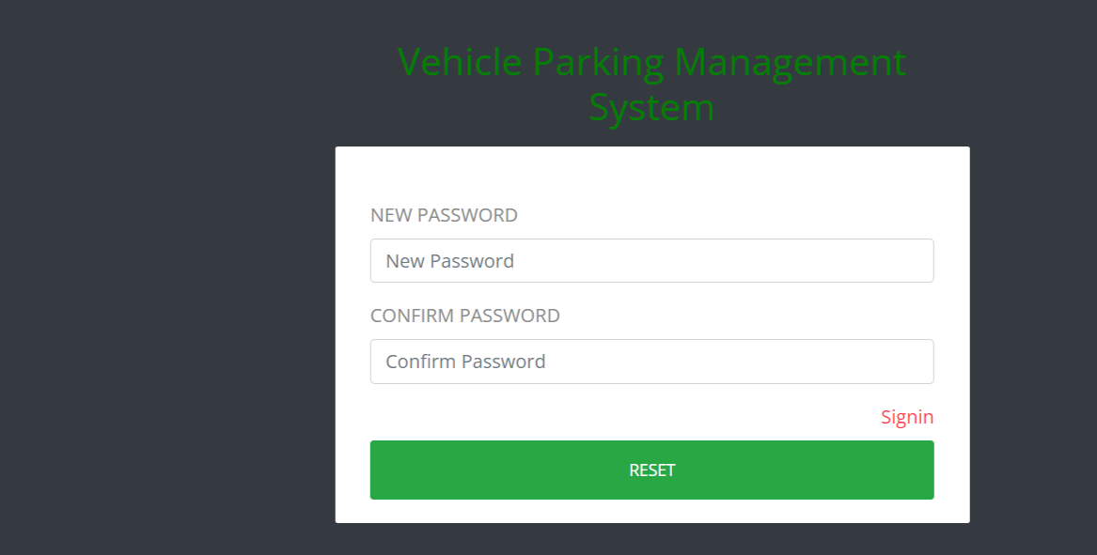

**CONCLUSION:**

This Application provides a computerized version of Vehicle Parking Management System which will benefit the parking premises.

It makes entire process online and can generate reports. It has a facility of staff’s login where staff can fill the visitor details and generate report.

The Application was designed in such a way that future changes can be done easily. The following conclusions can be deduced from the development of the project.

* Automation of the entire system improves the productivity.
* It provides a friendly graphical user interface which proves to be better when compared to the existing system.
* It gives appropriate access to the authorized users depending on their permissions.
* It effectively overcomes the delay in communications.
* Updating of information becomes so easier.
* System security, data security and reliability are the striking features.
* The System has adequate scope for modification in future if it is necessary.

**References**

**For PHP**

* <https://www.w3schools.com/php/default.asp>
* <https://www.sitepoint.com/php/>
* <https://www.php.net/>

**For MySQL**

* <https://www.mysql.com/>
* [http://www.mysqltutorial.org](http://www.mysqltutorial.org/)

**For XAMPP**

* <https://www.apachefriends.org/download.html>