YGR Horsetooth Time Trial Series

sara

31 March 2016

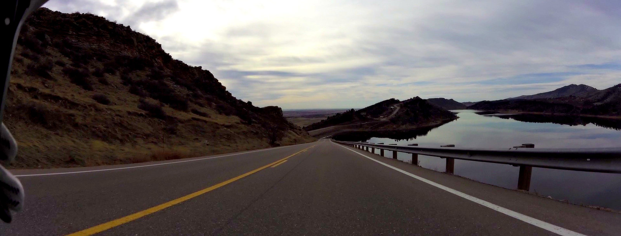 Fort Collins, CO is home to a thriving grassroots racing scene. Your Group Ride hosts an annual time trial every Tuesday in April known as the [Horsetooth Time Trial Series](http://yourgroupride.com/index.php/local-races/horsetooth-time-trial-series). The hilly **14.35 mile** course runs along Horsetooth Reservoire and Horsetooth Mountain Park climbing a total of **1,336 feet**.   
 I wanted to see how the racer turnout compared between men versus women so I plotted race data from 2011-2015. Last year had the greatest turnout for female cyclsts so far with **34 racers** representing **21.25%** of total racers.

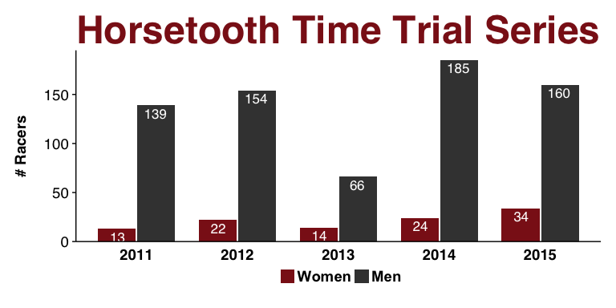 I thought it was a little strange that 2013 had such a low showing. I pulled some temperature data from [WeatherUnderground](https://www.wunderground.com/cgi-bin/findweather/getForecast?query=pws:KCOFORTC71) for each date during the race time and found it was rideable weather for all of the races! 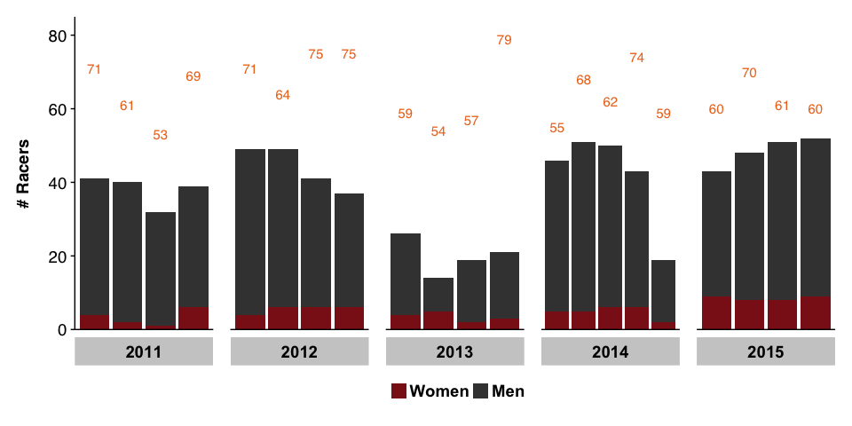 Here's the top 5 times from each category to date: blah blah 'r table.HTTT.R' #####Female Aero

## Date Year Week Sex Division LName FName Time  
## 381 07 April 2015 2015 1 Female Aero Callan Nicole 00:44:26  
## 403 10 April 2012 2012 1 Female Aero Hassel Diana 00:44:51  
## 414 01 May 2012 2012 4 Female Aero Hassel Diana 00:44:58  
## 423 10 April 2012 2012 1 Female Aero Callan Nicole 00:45:08  
## 441 17 April 2012 2012 2 Female Aero Callan Nicole 00:45:33

##### Female Eddy

## Date Year Week Sex Division LName FName Time  
## 439 10 April 2012 2012 1 Female Eddy Archambault Ilka 00:45:31  
## 443 30 April 2013 2013 2 Female Eddy Powelka Jenny 00:45:36  
## 474 28 April 2015 2015 4 Female Eddy Kammlade Sara 00:46:03  
## 483 07 April 2015 2015 1 Female Eddy Oleksy Isabella 00:46:12  
## 515 07 April 2015 2015 1 Female Eddy Witinok-huber Rebecca 00:46:53

##### Female Kerkove

## Date Year Week Sex Division LName FName Time  
## 779 28 April 2015 2015 4 Female Kerkove Arbesman Kendra 00:56:08  
## 793 16 May 2013 2014 4 Female Kerkove Swan Nicole 00:59:16  
## 809 28 April 2015 2015 4 Female Kerkove Ledesma-Feliciano Carmen 01:13:01

##### Male Aero

## Date Year Week Sex Division LName FName Time  
## 77 17 April 2012 2012 2 Male Aero Agofast Ivan 00:34:00  
## 78 17 April 2012 2012 2 Male Aero Wilson Nathan 00:34:26  
## 81 10 April 2012 2012 1 Male Aero Connor Trevor 00:36:24  
## 83 17 April 2012 2012 2 Male Aero Tuttle Ty 00:36:50  
## 84 24 April 2012 2012 3 Male Aero Holt Ian 00:37:02

##### Male Eddy

## Date Year Week Sex Division LName FName Time  
## 93 14 April 2015 2015 2 Male Eddy Kacher Nick 00:37:42  
## 99 07 April 2015 2015 1 Male Eddy Durrer walter 00:38:13  
## 101 15 April 2014 2014 3 Male Eddy Weiler Steve 00:38:17  
## 104 10 April 2012 2012 1 Male Eddy Jake Keyser 00:38:22  
## 106 14 April 2015 2015 2 Male Eddy Fix Brannan 00:38:24

##### Male Kerkove

## Date Year Week Sex Division LName FName Time  
## 277 30 April 2013 2013 2 Male Kerkove Stefko Steven 00:42:32  
## 284 28 April 2015 2015 4 Male Kerkove Stefko Steven 00:42:41  
## 286 14 April 2015 2015 2 Male Kerkove Stefko Steven 00:42:42  
## 315 25 April 2013 2013 1 Male Kerkove Stefko Steven 00:43:10  
## 324 09 May 2013 2013 3 Male Kerkove Stefko Steven 00:43:18

|  |  |  |  |
| --- | --- | --- | --- |
| Centered Header | Default Aligned | Right Aligned | Left Aligned |
| First | row | 12.0 | Example of a row that spans multiple lines. |
| Second | row | 5.0 | Here's another one. Note the blank line between rows. |

Here's the caption. It, too, may span multiple lines.

This is a report on participation in the Horsetooth Time Trial Series from 2011-2015 (data taken from Your Group Ride [google docs](https://docs.google.com/spreadsheets/d/1dNnqC5YTzURecVyo8U4a_RAv-KwQoJtCwnjseIOjg1g/pub?output=html))