Customer Churn Prediction
Business / Marketing / Supply Chain Lab Project Report
Project overview
This report summarizes a supervised machine learning project for predicting customer churn. The project compares Random Forest, XGBoost, and SVM using one shared preprocessing pipeline, cross-validation based hyperparameter tuning, and a common unseen test set.

Item | Value
Dataset rows | 440,832
Modeling sample | 25,000
Selected model | XGBoost
Domain | Business / Marketing / Supply Chain
Target | Churn

1. Introduction
Customer churn is a central business problem because losing active customers reduces revenue and increases the cost of growth. In marketing and customer success teams, a churn model can support retention campaigns by ranking customers according to churn risk.
The objective is to predict the binary target Churn, where 1 means the customer churned and 0 means the customer stayed. This is a supervised classification task with measurable outcomes.
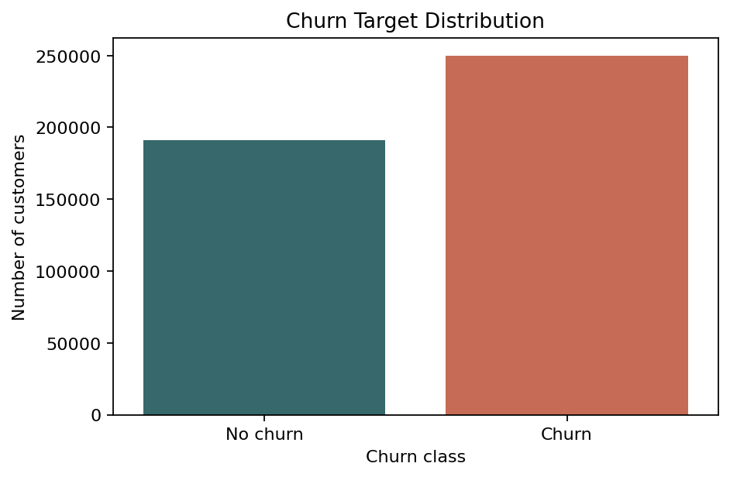
Figure 1. Churn target distribution.

2. Background
The dataset contains demographic, behavioral, contract, spending, and interaction variables. These variables are relevant because churn is often influenced by customer age, tenure, product usage, support burden, payment delay, contract length, subscription type, spending, and recency.
Feature group | Columns
Numeric | Age, Tenure, Usage Frequency, Support Calls, Payment Delay, Total Spend, Last Interaction
Categorical | Gender, Subscription Type, Contract Length
Removed identifier | CustomerID
Target | Churn

3. Methodology
Rows with missing values were removed because the file only contained one incomplete row. CustomerID was excluded because it is an identifier rather than a meaningful predictor. Numeric features were median-imputed and scaled. Categorical features were mode-imputed and one-hot encoded.
A stratified sample was used for modeling so that the notebook remains practical to rerun while preserving the target distribution. The sampled data was split into 80 percent training and 20 percent testing. All three models used the same split and preprocessing pipeline.

Hyperparameter Tuning Summary
Model | Best CV F1 | Best parameters
Random Forest | 0.9922 | {"classifier__max_depth": null, "classifier__n_estimators": 150}
XGBoost | 0.9982 | {"classifier__learning_rate": 0.1, "classifier__max_depth": 5, "classifier__n_estimators": 150}
SVM | 0.9014 | {"classifier__estimator__C": 1.0}

4. Algorithms
Random Forest is an ensemble of decision trees. It reduces overfitting by averaging many trees trained on randomized subsets of the data and features. Important hyperparameters include the number of trees and maximum tree depth.
XGBoost is a gradient boosting method. It builds trees sequentially, where each new tree focuses on correcting previous errors. Important hyperparameters include learning rate, tree depth, and number of boosting rounds.
SVM searches for a separating boundary with a maximum margin. A linear SVM was used for speed and interpretability on the large tabular dataset, with probability calibration for fair ROC-AUC comparison.

5. Results and Interpretation
The comparison uses accuracy, precision, recall, F1-score, and ROC-AUC. F1-score is emphasized because churn prediction requires a balance between finding true churners and limiting false retention alarms.
Model | Accuracy | Precision | Recall | F1 | ROC-AUC
XGBoost | 0.9976 | 1.0000 | 0.9958 | 0.9979 | 1.0000
Random Forest | 0.9902 | 0.9986 | 0.9841 | 0.9913 | 0.9999
SVM | 0.8922 | 0.9262 | 0.8801 | 0.9025 | 0.9566

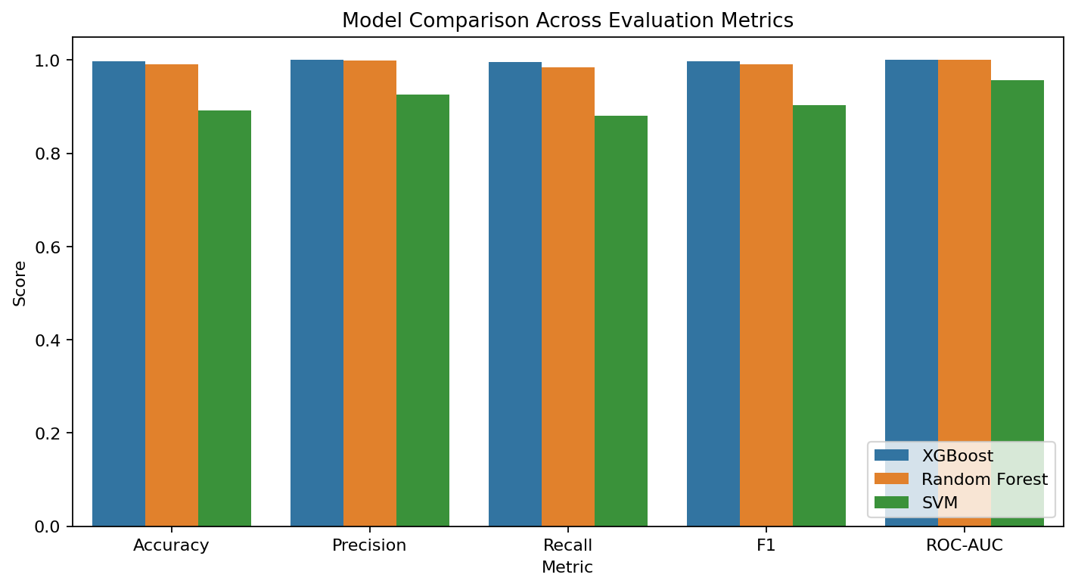
Figure 2. Model comparison across evaluation metrics.

6. Model Selection and Inference
The selected model is XGBoost because it achieved the strongest F1-score on the unseen test data. The ROC and confusion matrix plots support this choice by showing strong class separation and a low number of mistakes.
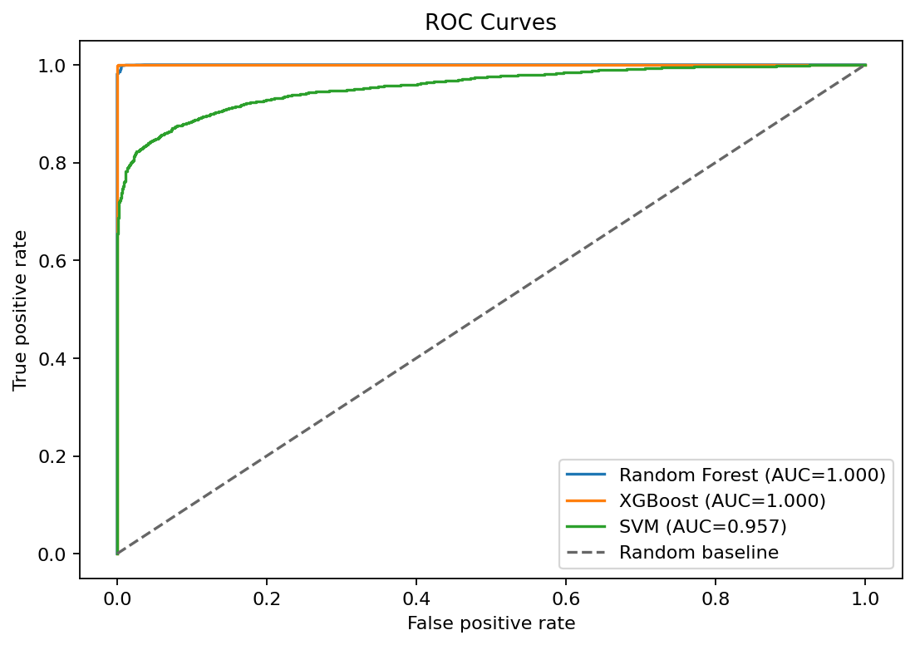
Figure 3. ROC curve comparison.
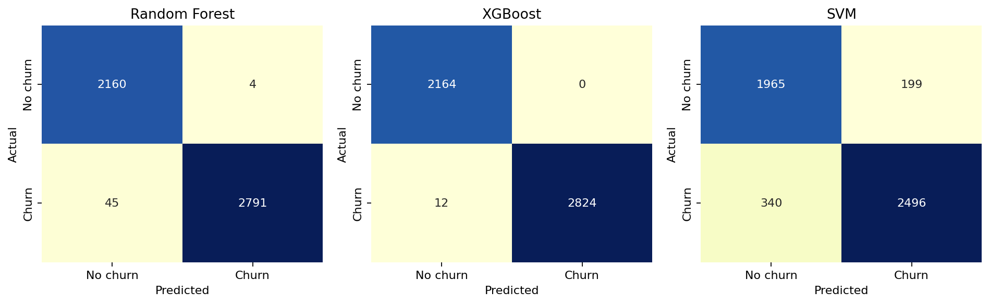
Figure 4. Confusion matrices on the unseen test set.

7. Explainability and Conclusion
The top feature chart helps explain which customer attributes influenced the selected model most. This is useful for a business audience because it connects prediction quality to actionable churn drivers.
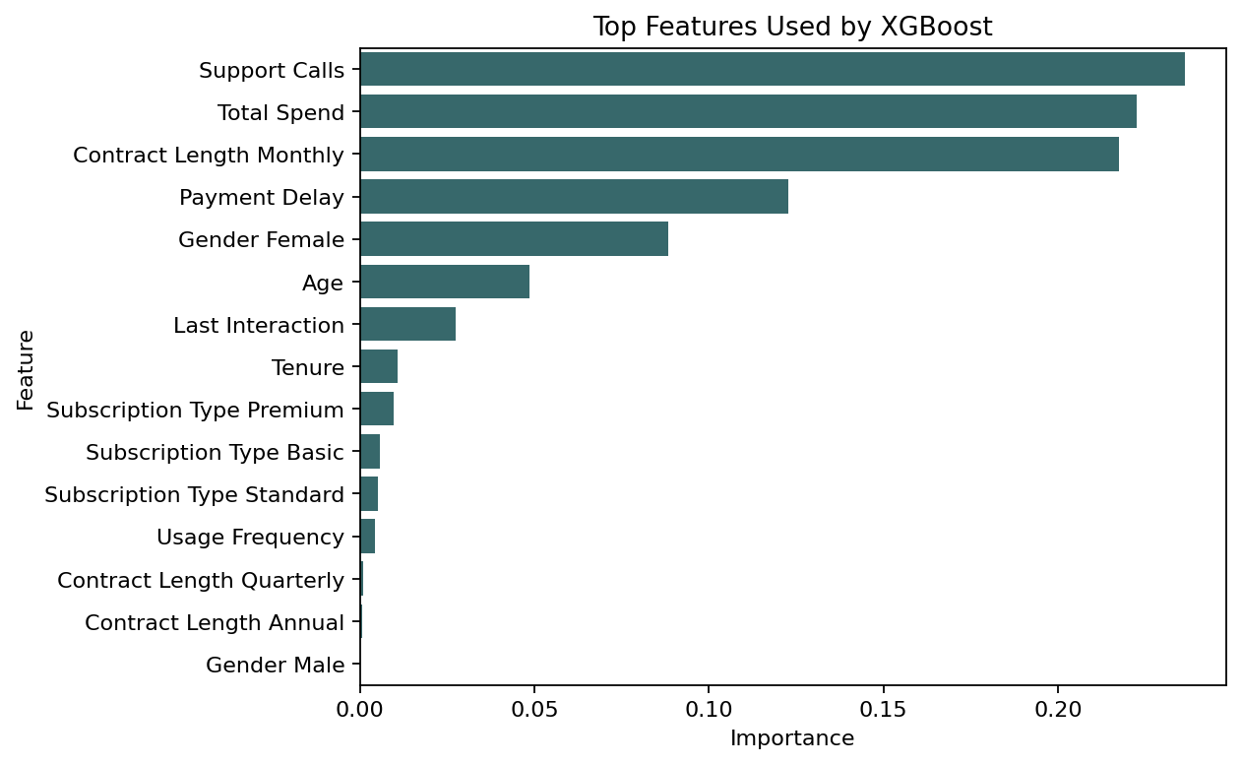
Figure 5. Top features used by XGBoost.

Top Feature Table
Feature | Importance
Support Calls | 0.2364
Total Spend | 0.2225
Contract Length Monthly | 0.2173
Payment Delay | 0.1227
Gender Female | 0.0884
Age | 0.0486
Last Interaction | 0.0274
Tenure | 0.0106
Subscription Type Premium | 0.0095
Subscription Type Basic | 0.0056

Example Inference Output
Actual Churn | Predicted Churn | Churn Probability
0 | 0 | 0.28%
1 | 1 | 100.00%
0 | 0 | 0.46%
1 | 1 | 100.00%
1 | 1 | 100.00%

In conclusion, the project satisfies the core machine learning workflow: clear objective, dataset preparation, preprocessing, model tuning, fair comparison, final model selection, and inference on unseen data. The notebook provides the executable workflow, while the Streamlit dashboard presents the results interactively.

