Customer Churn Prediction Using Machine Learning
CS485 - Artificial Intelligence
Lab Project Report
Project type: Supervised binary classification

Group members: Khalil Landolsi – Skander Bedoui – Rami Riahi – Lassaad Boubarma – Louay Zeidi
Supervized by: Ms. Haifa Beji

Submission date: May 14, 2026
Table of Contents
1. Abstract 3
2. Introduction 4
3. Background and Theoretical Foundation 4
4. Problem Definition 5
5. Dataset Description 5
6. Exploratory Data Analysis 6
7. Data Cleaning and Preprocessing Methodology 9
8. Selected Machine Learning Models 9
8.1 Logistic Regression 9
8.2 K-Nearest Neighbors 9
8.3 Random Forest Classifier 10
9. Experimental Design 10
10. Evaluation Metrics 10
11. Results and Comparative Analysis 11
12. Confusion Matrix and Error Analysis 12
13. ROC Curve and Discriminative Performance 13
14. Final Model Selection 13
15. Model Interpretation and Feature-Level Insights 14
16. Inference on Unseen Customer Profiles 15
17. Streamlit Dashboard 15
18. Discussion 15
19. Limitations 16
20. Future Work 16
21. Conclusion 16
22. References 17

Table of Figures
Figure 1: Churn class distribution in the cleaned training data. 7
Figure 2: Distributions of numerical customer variables in a training sample. 8
Figure 3: Churn rate by categorical variables. 8
Figure 4: Numerical feature distributions compared by churn class. 9
Figure 5: Correlation heatmap for numerical features and Churn. 9
Figure 6: Final model comparison across evaluation metrics. 13
Figure 7: Confusion matrices for the tuned models on the final evaluation sample. 13
Figure 8: ROC curve comparison for Logistic Regression, KNN, and Random Forest. 14
Figure 9: Top transformed features for the selected Logistic Regression pipeline. 15

List of Tables
Table 1: Dataset files and record counts. 6
Table 2: Training target distribution after cleaning. 6
Table 3: Feature description for variables used by the model. 7
Table 4: Experimental data usage and primary metric. 11
Table 5: Untuned baseline validation metrics. 12
Table 6: Hyperparameter tuning summary. 12
Table 7: Final held-out test metrics for tuned models. 12
Table 8: Confusion matrix counts for the selected Logistic Regression model. 13
Table 9: Top feature-level importance values for the selected model. 15
Table 10: Notebook inference examples for unseen customer profiles. 16

1. Abstract
This study investigates customer churn prediction as a supervised machine learning classification problem. Customer churn refers to the loss of customers from a service or subscription base, and accurate prediction can support timely retention actions. The project used the local training and testing files stored in the dataset/ directory and modelled the binary target variable Churn, where 1 denotes churn and 0 denotes no churn. After removing one incomplete training row with a missing target value, the workflow used 440,832 available training records and 64,374 available testing records. A stratified sample of 6,000 training records was used for classroom-feasible tuning, and 4,000 testing records were preserved for final evaluation. The preprocessing pipeline applied median imputation and standard scaling to numerical features and most-frequent imputation plus one-hot encoding to categorical features. Three classifiers were compared: Logistic Regression, K-Nearest Neighbors, and Random Forest Classifier. Hyperparameter tuning used F1-score as the primary metric because churn prediction requires a balance between identifying true churners and limiting unnecessary retention actions. On the final held-out test sample, Logistic Regression achieved the highest F1-score (0.6899) with recall 0.9921 and ROC-AUC 0.7007. The final saved system is therefore a complete preprocessing-plus-classification pipeline suitable for inference on new customer profiles and presentation through the accompanying Streamlit dashboard.

2. Introduction
Customer churn is the event in which a customer stops using a company's product or service. In subscription, telecommunication, software, financial, and service-oriented businesses, churn directly affects revenue, customer lifetime value, and marketing efficiency. Predicting churn before it happens allows an organisation to prioritize customers for support follow-up, payment assistance, contract review, loyalty offers, or other retention actions.
From a machine learning perspective, the problem is naturally framed as binary classification. Each customer is represented by demographic, subscription, usage, payment, support, and spending variables, and the model predicts whether the customer belongs to the churn or no-churn class. The objective of this project was not merely to train one algorithm, but to compare distinct algorithmic families under a consistent preprocessing and evaluation design. Logistic Regression provides a linear probabilistic baseline, K-Nearest Neighbors provides a similarity-based instance model, and Random Forest provides a nonlinear ensemble model.
The contribution of the project is a complete, reproducible churn prediction workflow: data loading and cleaning, exploratory analysis, leakage-safe preprocessing, model tuning, test-set evaluation, model interpretation, inference examples, and a Streamlit dashboard for presentation. The remainder of the report presents the theoretical foundation, dataset, methodology, results, final model selection, practical interpretation, limitations, and future work.

3. Background and Theoretical Foundation
Supervised learning uses examples with known labels to learn a mapping from input variables to an output target. In binary classification, the target contains two possible classes. The model estimates either a class label, a class probability, or both. Generalization is the ability of the fitted model to perform well on unseen observations, not only on the training records used to estimate its parameters.
Train, validation, and test logic is essential for credible evaluation. Training data are used to fit model parameters, validation or cross-validation data are used to compare hyperparameters, and the final test data are used only after model selection. Overfitting occurs when a model captures noise or sample-specific patterns and therefore performs poorly on new data. Underfitting occurs when a model is too simple or insufficiently trained to capture meaningful patterns. The project uses cross-validation and a held-out test file to reduce these risks.
Preprocessing converts raw tabular data into a representation usable by algorithms. Categorical variables such as Gender, Subscription Type, and Contract Length must be encoded because scikit-learn estimators operate on numerical matrices. Numerical scaling matters for Logistic Regression and especially KNN because feature magnitudes influence coefficient optimization and distance calculations. Data leakage is prevented by fitting imputers, encoders, and scalers inside the training pipeline rather than fitting transformations on the full dataset before evaluation.
Classification cannot be evaluated responsibly with accuracy alone. In churn prediction, false negatives represent actual churners missed by the model, while false positives represent non-churners flagged for retention. Precision, recall, F1-score, ROC-AUC, and confusion matrices therefore provide complementary evidence about practical usefulness.

4. Problem Definition
The predictive task is to estimate whether a customer will churn. The input variables used by the implemented model are Age, Gender, Tenure, Usage Frequency, Support Calls, Payment Delay, Subscription Type, Contract Length, Total Spend, Last Interaction. The target variable is Churn. A prediction of 1 means that the customer is classified as likely to churn, while a prediction of 0 means that the customer is classified as likely to remain.
In business terms, a positive prediction can trigger a retention workflow. A false positive may lead to unnecessary discounts or support outreach for a customer who would have stayed. A false negative is more costly in many churn contexts because it means a genuinely at-risk customer is missed and the organisation loses the opportunity to intervene. For this reason, the project selects the final model using F1-score as the primary metric while also reviewing recall, precision, ROC-AUC, and confusion matrices.

5. Dataset Description

Dataset | Path | Raw rows | Clean rows | Features
Training file | dataset\customer_churn_dataset-training-master.csv | 440833 | 440832 | 10
Testing file | dataset\customer_churn_dataset-testing-master.csv | 64374 | 64374 | 10
Table 1: Dataset files and record counts.
The training file initially contained one incomplete row, with one missing value recorded in each column, including the target variable. Because supervised classification requires a known label, this row was removed. No duplicate rows were reported in the training or testing file. Feature-level missing values are nevertheless handled inside the model pipeline through imputation, which keeps the workflow reproducible and prevents leakage.
Class | Count | Percentage
0 - No churn | 190833 | 43.29
1 - Churn | 249999 | 56.71
Table 2: Training target distribution after cleaning.
Feature Name | Feature Type | Description | Role in Prediction
Age | Numerical | Customer age. | Demographic predictor
Gender | Categorical | Customer gender category in the dataset. | Segment-level predictor
Tenure | Numerical | Duration of customer relationship. | Engagement and loyalty signal
Usage Frequency | Numerical | Frequency of service usage. | Behavioural predictor
Support Calls | Numerical | Number of support calls. | Service friction indicator
Payment Delay | Numerical | Delay in payment. | Payment-risk indicator
Subscription Type | Categorical | Basic, Standard, or Premium subscription. | Product tier predictor
Contract Length | Categorical | Annual, Monthly, or Quarterly contract. | Commitment predictor
Total Spend | Numerical | Total amount spent by customer. | Value and engagement signal
Last Interaction | Numerical | Recency of last customer interaction. | Recent engagement indicator
Table 3: Feature description for variables used by the model.

6. Exploratory Data Analysis
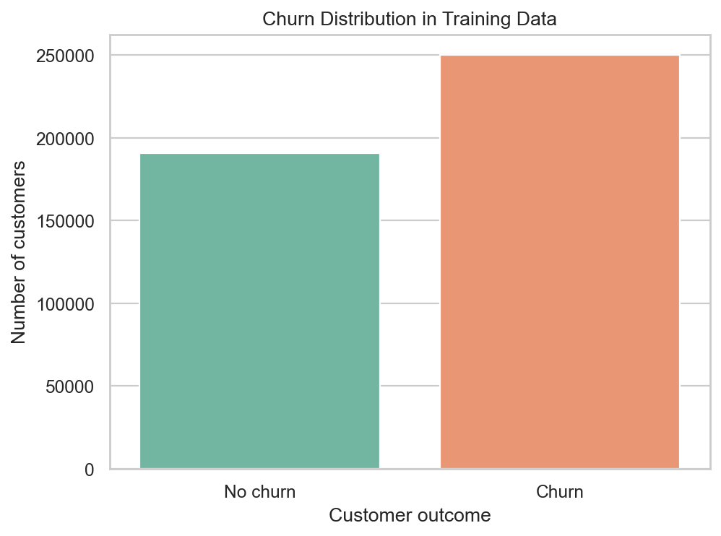
Figure 1: Churn class distribution in the cleaned training data.
The target distribution shows a moderate class imbalance: churners represent 56.71% of the cleaned training records, while non-churners represent 43.29%. This imbalance is not extreme, but it is large enough that accuracy alone could misrepresent model quality. The observed distribution supports the use of precision, recall, F1-score, ROC-AUC, and confusion matrix analysis.
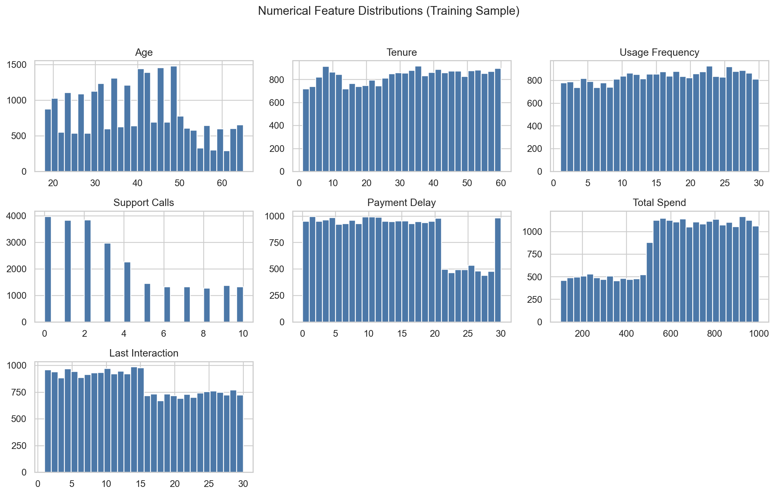
Figure 2: Distributions of numerical customer variables in a training sample.
The numerical variables occupy different ranges: Age varies from 18 to 65, Tenure from 1 to 60, Payment Delay from 0 to 30, and Total Spend from 100 to 1000. These scale differences justify the use of StandardScaler for Logistic Regression and KNN. Summary statistics show that churners had higher mean support calls (5.14 versus 1.59), higher mean payment delay (15.22 versus 10.02), lower mean total spend (541.29 versus 749.95), and slightly shorter tenure than non-churners.
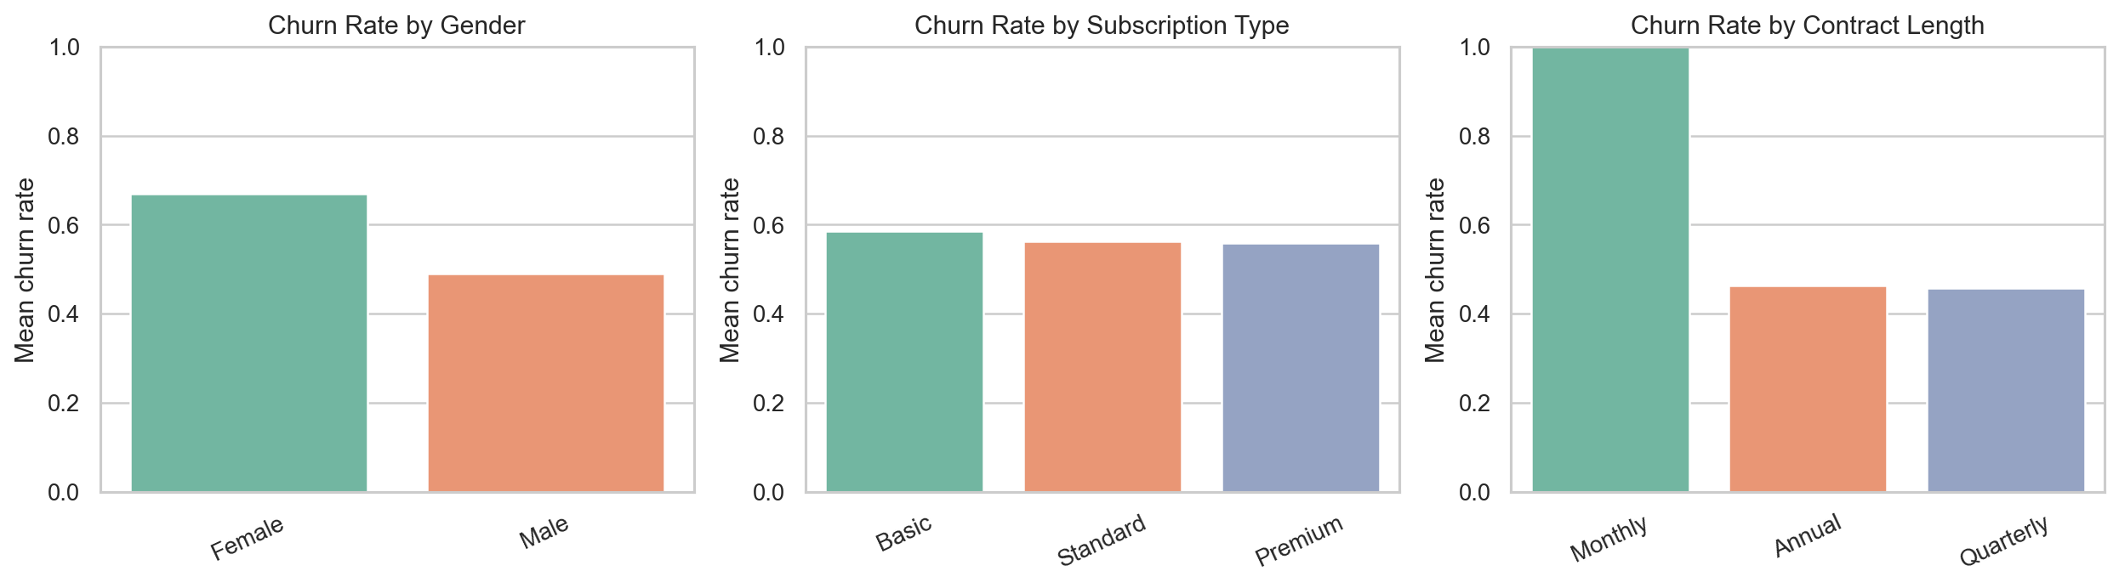
Figure 3: Churn rate by categorical variables.
The categorical analysis indicates meaningful associations. Female customers have a higher observed churn rate (0.6667) than male customers (0.4913). Basic subscription customers have a slightly higher churn rate than Standard and Premium customers. Contract Length is especially notable: the training data show a churn rate of 1.0000 for Monthly contracts, compared with approximately 0.4608 for Annual and 0.4603 for Quarterly contracts. These patterns are predictive associations and should not be interpreted as causal effects.
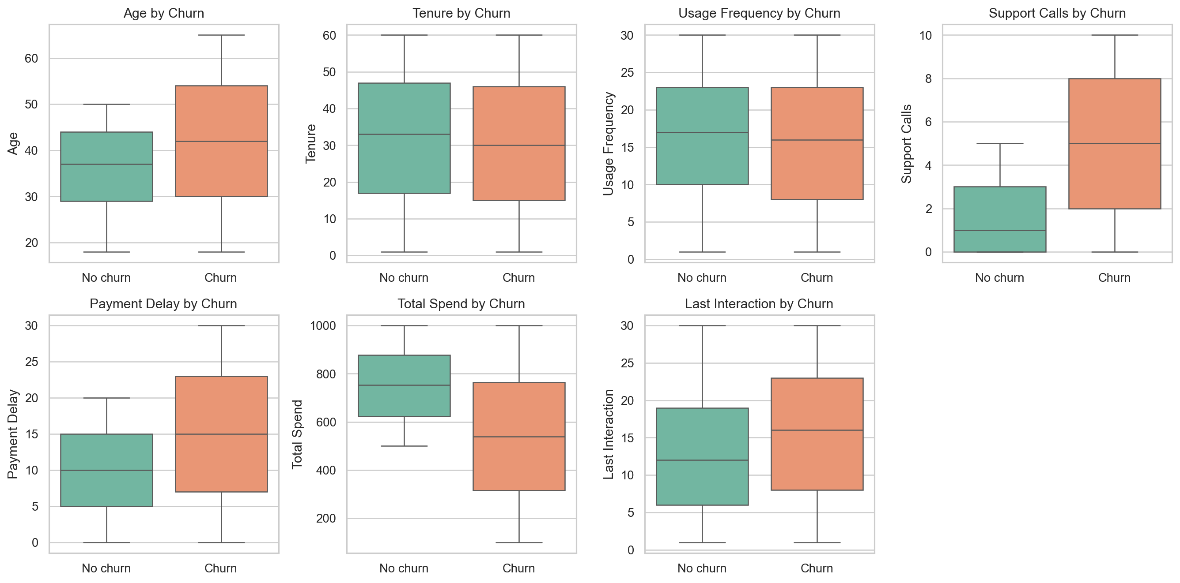
Figure 4: Numerical feature distributions compared by churn class.
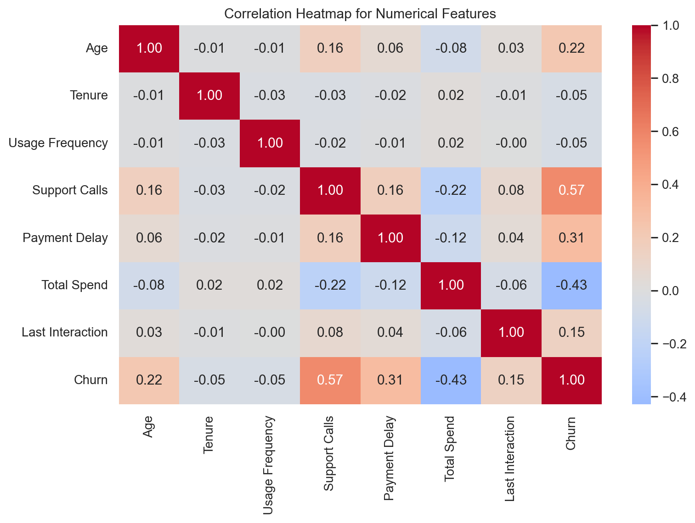
Figure 5: Correlation heatmap for numerical features and Churn.

The strongest numerical association with churn is Support Calls (correlation 0.5743), followed by Total Spend (-0.4294), Payment Delay (0.3121), Age (0.2184), and Last Interaction (0.1496). Tenure and Usage Frequency have weaker negative correlations. These observations informed the modelling stage by suggesting that both service-friction and value-related variables contain useful predictive information.

7. Data Cleaning and Preprocessing Methodology
The data cleaning workflow removed duplicate rows and dropped rows with missing Churn labels. CustomerID was excluded from model features because it is an identifier rather than a behavioural predictor. It was retained only for inspection. The remaining input variables were divided into numerical and categorical groups. Numerical features were Age, Tenure, Usage Frequency, Support Calls, Payment Delay, Total Spend, and Last Interaction. Categorical features were Gender, Subscription Type, and Contract Length.
The implemented preprocessing uses a scikit-learn ColumnTransformer inside each model Pipeline. The numerical pipeline uses SimpleImputer(strategy='median') followed by StandardScaler(with_mean=False). The categorical pipeline uses SimpleImputer(strategy='most_frequent') followed by OneHotEncoder(handle_unknown='ignore'). The handle_unknown setting allows the fitted system to process future customer records even if a categorical level appears that was not observed during training.
Fitting preprocessing inside the pipeline is methodologically important because it ensures that imputation values, scaling parameters, and encoding categories are learned only from the training fold during cross-validation or from the training sample during final fitting. This prevents information from the validation or test data from influencing the model. Scaling is especially important for Logistic Regression and KNN. Random Forest is less sensitive to scaling because tree splits depend on threshold ordering rather than Euclidean distances or coefficient magnitudes.

8. Selected Machine Learning Models

8.1 Logistic Regression
Logistic Regression estimates the probability that a customer belongs to the churn class by applying the logistic function to a linear combination of transformed features. In compact notation, p(y=1|x) = 1 / (1 + e^(-z)), where z is the weighted feature score. The model is a strong baseline because it is efficient, interpretable, and produces class probabilities. The tuned hyperparameters were C=10.0, solver='liblinear', and class_weight=None.

8.2 K-Nearest Neighbors
K-Nearest Neighbors is an instance-based classifier. It stores the training examples and predicts a new customer's class according to nearby observations in the transformed feature space. Distance metrics and the value of k strongly affect predictions, and scaling is essential because unscaled large-magnitude variables can dominate distance. The best tuned configuration used n_neighbors=5, weights='distance', and metric='minkowski'. A limitation is that KNN can become less efficient and less stable in high-dimensional one-hot encoded spaces.

8.3 Random Forest Classifier
Random Forest is an ensemble of decision trees trained with bagging and random feature selection. For classification, the forest aggregates tree predictions through majority voting or averaged probabilities. It can capture nonlinear relationships and interactions that linear models may miss, while reducing the overfitting risk of a single decision tree. The best tuned configuration used n_estimators=100, max_depth=None, min_samples_split=2, min_samples_leaf=1, and class_weight='balanced'.
The three models are appropriately distinct: Logistic Regression is a linear probabilistic model, KNN is a distance-based instance model, and Random Forest is a nonlinear ensemble. Comparing these approaches gives stronger evidence than relying on one algorithmic family.

9. Experimental Design
The dataset already provides separate training and testing files. The testing file was treated as a final holdout set and was not used for preprocessing fits, model training, or hyperparameter selection. To keep runtime appropriate for the lab setting, the notebook used a stratified training sample of 6,000 records and a stratified final evaluation sample of 4,000 testing records. The baseline comparison used an internal 80/20 train-validation split from the sampled training data, while hyperparameter tuning used 3-fold StratifiedKFold cross-validation.
GridSearchCV was used for Logistic Regression and KNN because their search spaces were compact. RandomizedSearchCV was used for Random Forest with six sampled parameter combinations because the tree-based search space was wider. All tuning used F1-score as the scoring metric. Fair comparison was maintained by applying the same feature set, the same pipeline discipline, the same cross-validation strategy, and the same held-out test sample to all three models.
Item | Value
Training rows available after cleaning | 440832
Testing rows available after cleaning | 64374
Rows used for tuning sample | 6000
Rows used for final test evaluation | 4000
Primary optimization metric | F1-score
Table 4: Experimental data usage and primary metric.

10. Evaluation Metrics
The project reports Accuracy, Precision, Recall, F1-score, ROC-AUC, and confusion matrices. In terms of true positives (TP), true negatives (TN), false positives (FP), and false negatives (FN), the main formulas are: Accuracy = (TP + TN) / (TP + TN + FP + FN); Precision = TP / (TP + FP); Recall = TP / (TP + FN); and F1 = 2 x (Precision x Recall) / (Precision + Recall).
In churn prediction, precision answers: among customers predicted to churn, how many truly churned? Recall answers: among actual churners, how many did the model identify? F1-score balances precision and recall, which is useful when both missed churners and unnecessary interventions matter. ROC-AUC measures discriminative ability across classification thresholds rather than at one fixed threshold. The confusion matrix complements these summary metrics by showing the actual counts of correct and incorrect decisions.

11. Results and Comparative Analysis
Model | Accuracy | Precision | Recall | F1 | ROC-AUC
Random Forest | 0.9842 | 0.9911 | 0.9809 | 0.9860 | 0.9981
KNN | 0.9142 | 0.9949 | 0.8532 | 0.9186 | 0.9763
Logistic Regression | 0.9017 | 0.9233 | 0.9016 | 0.9123 | 0.9594
Table 5: Untuned baseline validation metrics.
On the internal validation sample, Random Forest produced the strongest untuned baseline performance with F1-score 0.9860 and ROC-AUC 0.9981. KNN and Logistic Regression also performed strongly on this internal validation split. These baseline results should be interpreted as validation evidence, not final test performance.
Model | Search Method | Best CV F1 | Best Parameters
Logistic Regression | GridSearchCV | 0.9124 | {'classifier__C': 10.0, 'classifier__class_weight': None, 'classifier__solver': 'liblinear'}
KNN | GridSearchCV | 0.9162 | {'classifier__metric': 'minkowski', 'classifier__n_neighbors': 5, 'classifier__weights': 'distance'}
Random Forest | RandomizedSearchCV | 0.9901 | {'classifier__n_estimators': 100, 'classifier__min_samples_split': 2, 'classifier__min_samples_leaf': 1, 'classifier__max_depth': None, 'classifier__class_weight': 'balanced'}
Table 6: Hyperparameter tuning summary.
Model | Accuracy | Precision | Recall | F1 | ROC-AUC
Logistic Regression | 0.5775 | 0.5288 | 0.9921 | 0.6899 | 0.7007
KNN | 0.5848 | 0.5342 | 0.9641 | 0.6875 | 0.6609
Random Forest | 0.5158 | 0.4945 | 0.9979 | 0.6613 | 0.6831
Table 7: Final held-out test metrics for tuned models.
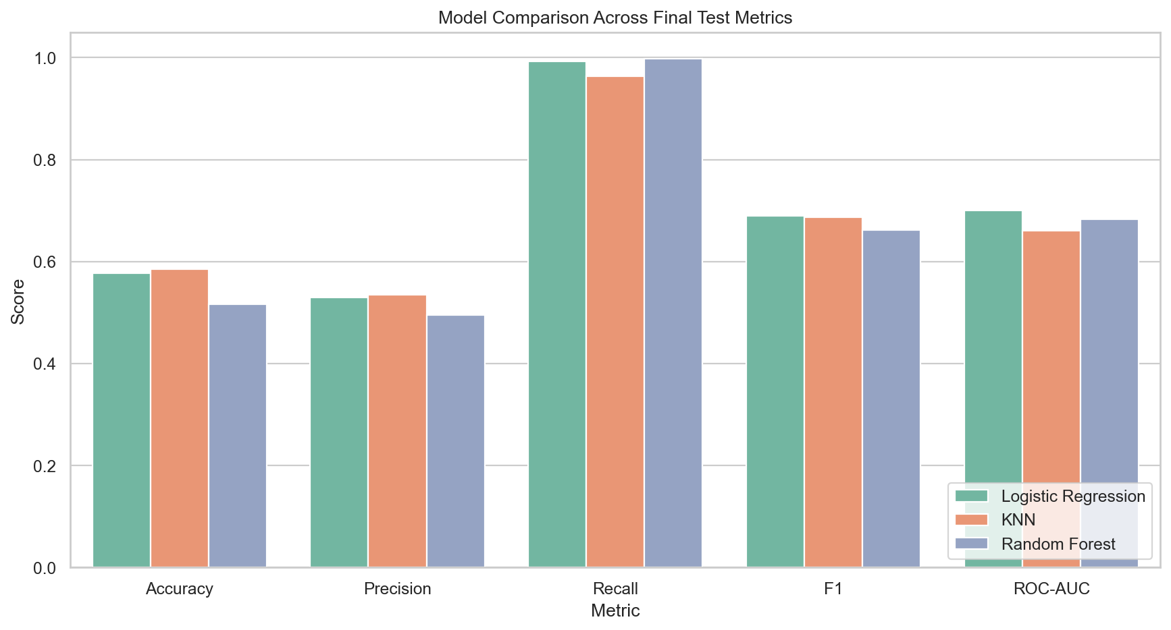
Figure 6: Final model comparison across evaluation metrics.
The final test results differ substantially from the internal validation results. Logistic Regression achieved the highest test F1-score (0.6899) and the highest ROC-AUC (0.7007) among the tuned models. KNN produced a very similar F1-score of 0.6875 but lower ROC-AUC of 0.6609. Random Forest achieved extremely high recall of 0.9979, but its precision of 0.4945 and F1-score of 0.6613 indicate a less favourable balance on the final test sample. The selected model was therefore not chosen on accuracy alone; it was selected because it gave the best overall balance under the project metric.

12. Confusion Matrix and Error Analysis
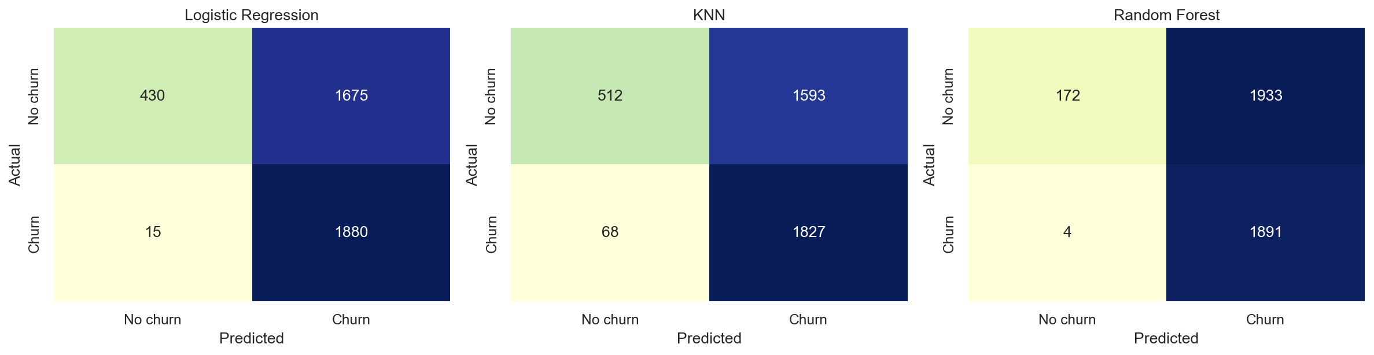
Figure 7: Confusion matrices for the tuned models on the final evaluation sample.
Actual | Predicted | Count
No churn | No churn | 430
No churn | Churn | 1675
Churn | No churn | 15
Churn | Churn | 1880
Table 8: Confusion matrix counts for the selected Logistic Regression model.
For the selected Logistic Regression model, the confusion matrix contains 430 true negatives, 1,880 true positives, 1,675 false positives, and 15 false negatives. The very low false-negative count explains the model's high recall of 0.9921. However, the false-positive count is substantial, which lowers precision to 0.5288. In a churn intervention setting, this tradeoff may be acceptable when missing churners is more expensive than contacting some customers who would not have churned. The matrix makes this tradeoff visible in business terms.

13. ROC Curve and Discriminative Performance
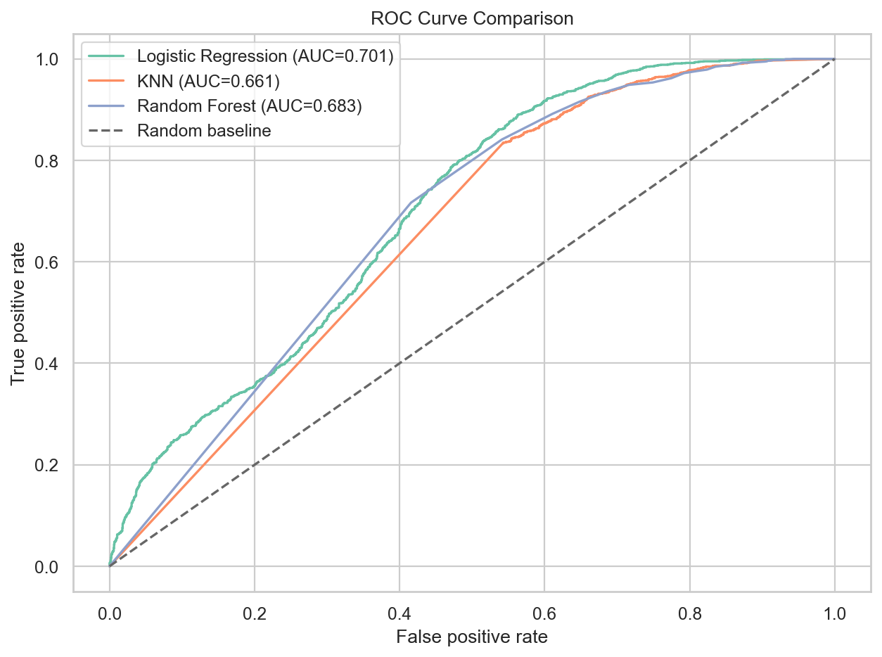
Figure 8: ROC curve comparison for Logistic Regression, KNN, and Random Forest.
The ROC curves compare the true positive rate and false positive rate across varying classification thresholds. Logistic Regression has the highest final ROC-AUC (0.7007), followed by Random Forest (0.6831) and KNN (0.6609). The ROC-AUC values indicate that the models provide usable but imperfect ranking ability on the held-out test sample. This reinforces the need to consider threshold choice and business cost if the model is deployed.

14. Final Model Selection
The final selected model is Logistic Regression. It was selected because it obtained the strongest final test F1-score (0.6899) while maintaining very high recall (0.9921) and the highest ROC-AUC (0.7007) among the compared models. The accepted tradeoff is lower precision, meaning that many customers predicted as churners may not actually churn. In a retention context, this is more defensible than a model with poor recall when the cost of missing a true churner is high.

15. Model Interpretation and Feature-Level Insights
Feature | Importance
Contract Length = Monthly | 6.05
Contract Length = Quarterly | 2.73
Contract Length = Annual | 2.65
Support Calls | 2.33
Total Spend | 1.48
Gender_Female | 0.9278
Payment Delay | 0.8955
Last Interaction | 0.5278
Age | 0.5131
Subscription Type = Basic | 0.3391
Table 9: Top feature-level importance values for the selected model.
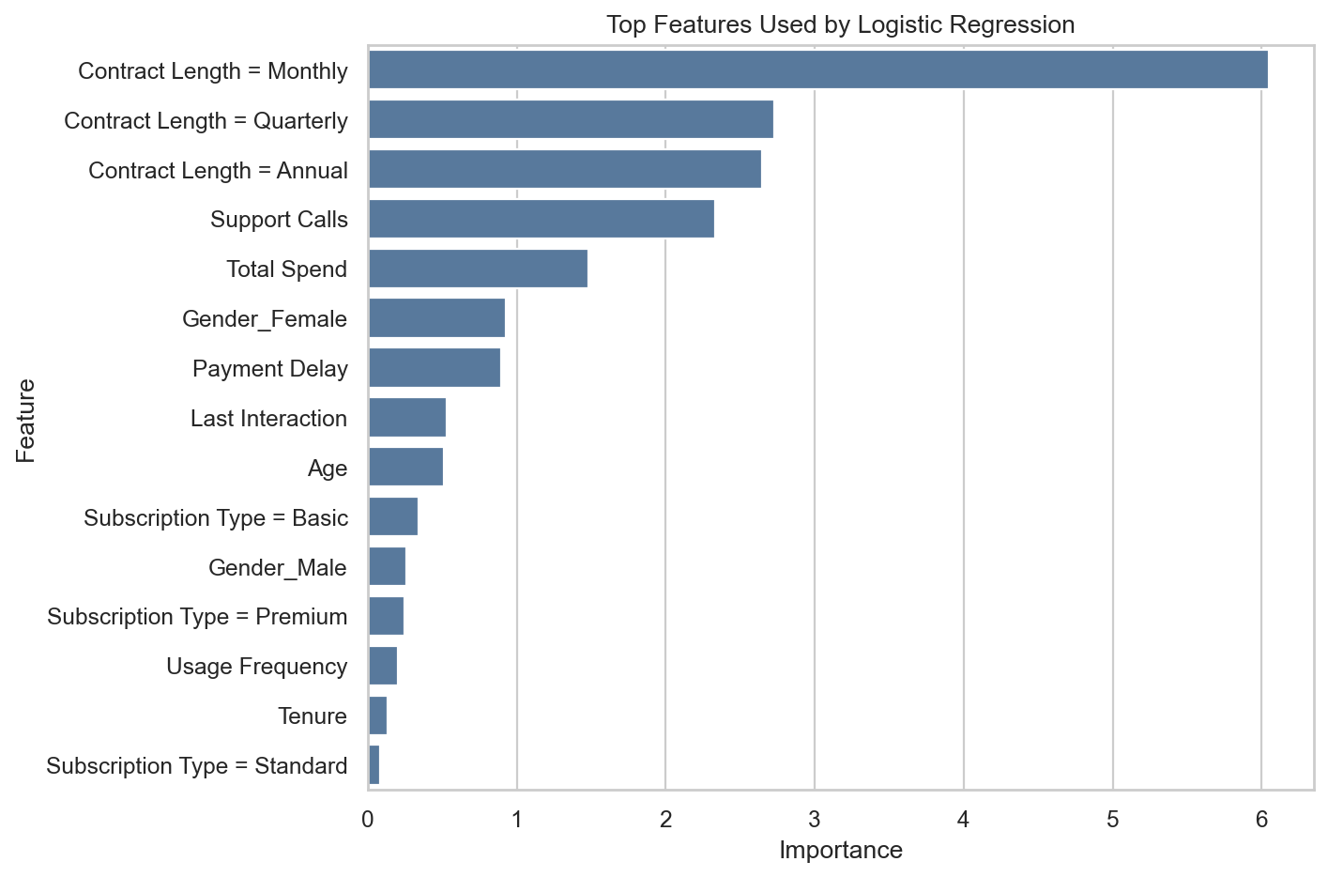
Figure 9: Top transformed features for the selected Logistic Regression pipeline.
Because the selected model is Logistic Regression, the reported importance values are absolute coefficient magnitudes after preprocessing. Contract Length features are the most influential transformed predictors, with Monthly contract status having the largest magnitude. Support Calls, Total Spend, Payment Delay, Gender, Last Interaction, and Age also contribute meaningfully. These values indicate predictive associations within the fitted model; they should not be interpreted as causal effects.

16. Inference on Unseen Customer Profiles
Customer Profile | Predicted Churn Class | Churn Probability | Interpretation
Profile 1: Age 24, Female, tenure 4, Basic subscription, Monthly contract, 8 support calls, payment delay 28, total spend 220. | 1 | 1.0000 | Retention action recommended
Profile 2: Age 46, Male, tenure 48, Premium subscription, Annual contract, 1 support calls, payment delay 2, total spend 890. | 0 | 0.0053 | Lower churn risk based on current profile
Profile 3: Age 61, Female, tenure 18, Standard subscription, Quarterly contract, 5 support calls, payment delay 17, total spend 540. | 1 | 0.9861 | Retention action recommended
Table 10: Notebook inference examples for unseen customer profiles.
The inference stage demonstrates that the saved pipeline can accept raw customer profiles, apply the same preprocessing used during training, and output both a class prediction and churn probability. The first and third synthetic customer profiles were classified as churn risks, with probabilities 1.0000 and 0.9861 respectively, while the second profile was classified as lower risk with probability 0.0053.

17. Streamlit Dashboard
The project includes streamlit_dashboard.py. The dashboard loads outputs/model_metrics.csv, outputs/baseline_metrics.csv, outputs/tuning_summary.csv, outputs/roc_curves.csv, outputs/confusion_matrices.csv, outputs/feature_importance.csv, outputs/data_profile.json, and models/churn_prediction_model.pkl. It presents an overview of the selected model, final metrics, feature importance, model comparison charts, ROC curves, confusion matrices, dataset previews, and a single-customer prediction form.
The dashboard complements the scientific notebook and report. It supports project presentation and practical exploration by allowing a user to enter customer attributes and receive a churn prediction with an estimated probability. It does not replace the methodological evaluation because the final scientific claims still depend on the notebook's controlled training, tuning, and held-out testing workflow.

18. Discussion
The results indicate that model performance must be interpreted in relation to the evaluation stage. Random Forest performed very strongly during internal validation and cross-validation, but its final test performance was weaker in precision and F1-score than Logistic Regression. This contrast suggests that the held-out testing data may differ from the sampled training conditions or that the tree ensemble overfit patterns that did not transfer as effectively. Logistic Regression's selection therefore reflects empirical performance on unseen data rather than algorithmic complexity.
The EDA and interpretation outputs point to plausible churn-related associations: support calls and payment delays are higher among churners, total spend is lower among churners, and contract length is highly informative. These findings make the model useful as decision support because they align predictions with operationally meaningful customer attributes. Nevertheless, the model should guide retention prioritization rather than make irreversible decisions automatically.

19. Limitations
The project depends on the quality and representativeness of the available dataset. The feature set is tabular and does not include richer behavioural histories, intervention outcomes, text from support interactions, or customer lifetime value. The final model also provides predictive associations rather than causal explanations. Because precision is modest, deployment would require business-aware threshold tuning and perhaps cost-sensitive evaluation. The dashboard predictions are decision-support outputs, not guarantees, and the current project does not include production drift monitoring or periodic retraining logic.

20. Future Work
Future work should optimize the classification threshold according to business costs, especially the relative cost of false positives and false negatives. Cost-sensitive learning, customer lifetime value integration, probability calibration, SHAP-based interpretability, fairness checks across customer segments, and richer temporal modelling could improve practical usefulness. If deployed, the system should include drift monitoring, periodic retraining, logging of intervention outcomes, and dashboard hardening for batch prediction and downloadable results.

21. Conclusion
This project developed a complete customer churn prediction workflow using Logistic Regression, K-Nearest Neighbors, and Random Forest Classifier. The dataset was loaded from the local dataset/ folder, cleaned, explored, transformed through a leakage-safe preprocessing pipeline, and evaluated using business-aware metrics. The final selected model was Logistic Regression, which achieved the highest final F1-score (0.6899) on the held-out test sample while maintaining very high recall. The saved model and Streamlit dashboard demonstrate how the workflow can support retention-oriented decision making. Overall, the study shows how machine learning can convert customer data into actionable churn-risk estimates when evaluation, preprocessing, and interpretation are handled carefully.

22. References
Breiman, L. (2001). Random forests. Machine Learning, 45(1), 5-32.
Hastie, T., Tibshirani, R., & Friedman, J. (2009). The Elements of Statistical Learning: Data Mining, Inference, and Prediction (2nd ed.). Springer.
James, G., Witten, D., Hastie, T., & Tibshirani, R. (2021). An Introduction to Statistical Learning with Applications in R (2nd ed.). Springer.
Kuhn, M., & Johnson, K. (2013). Applied Predictive Modeling. Springer.
Pedregosa, F., Varoquaux, G., Gramfort, A., Michel, V., Thirion, B., Grisel, O., Blondel, M., Prettenhofer, P., Weiss, R., Dubourg, V., Vanderplas, J., Passos, A., Cournapeau, D., Brucher, M., Perrot, M., & Duchesnay, E. (2011). Scikit-learn: Machine Learning in Python. Journal of Machine Learning Research, 12, 2825-2830.
Powers, D. M. W. (2011). Evaluation: From precision, recall and F-measure to ROC, informedness, markedness and correlation. Journal of Machine Learning Technologies, 2(1), 37-63.
scikit-learn developers. (2026). scikit-learn User Guide: Supervised learning, model evaluation, preprocessing, and model selection. https://scikit-learn.org/stable/user_guide.html
Shahid Azeem, M. (n.d.). Customer Churn Dataset. Kaggle. https://www.kaggle.com/datasets/muhammadshahidazeem/customer-churn-dataset

