SWE 545 Distributed System Programming, Spring 2016
Instructor: Atay ÖZGÖVDE

Term Project
Design Evaluation Document

Revision 1.0
10.05.2016

By Şenol Kanca
Student Id: 2014719156

Revision History

Revision | Date | Explanation
1.0 | 10.05.2016 | Initial document

Table of Contents

Revision History 2
Table of Contents 3
1. Introduction 4
2. Server XMLRPC API Messages 4
3. System Architecture 4
4. Process Flow 5
5. List of TicTacToe Object’s Methods 5
6. List of Game Object’s Methods 5
References 5

1. Introduction
In this project we’ll implement the server and the client side of a Tic Tac Toe game based on RPC XML.

Tic-tac-toe (also known as Noughts and crosses or Xs and Os) is a paper-and-pencil game for two players, X and O, who take turns marking the spaces in a 3×3 grid. The player who succeeds in placing three of their marks in a horizontal, vertical, or diagonal row wins the game.

In this project Python 2.7 and simplexmlrpcserver module will be used for writing the server side and xmlrpclib module will be used for writing the client side.

2. Server XMLRPC API Messages

TYPE | MESSAGE | PARAMETERS | DESCRIPTION
Request | 0100 |  | Create Game
Response | 0110 | Client Id | Game is successfully created
Response | 0900 |  | Game can not be created
Request | 0200 | Client Id | Start Game
Response | 0210 | Client Id | Game is successfully created
Request | 0300 | Client Id, Position | Move Transaction
Response | 0310 | Client Id, Board (array 3*3) | Move Transaction is successfully created
Response | 0380 | Client Id, Board (array 3 *3) | Game is over, Client have been won
Response | 0390 | Client Id, Board (array 3*3) | Game is over, Computer have been won
Response | 0930 | Client Id, Position | Position is Invalid
Request | 0400 | Client Id | Display Client ID ‘s Board Status
Response | 0410 | Client Id, Board (array 3*3) | Board status
Request | 0800 | Client Id | End Game
Response | 0810 | Client Id, Board (array 3 *3) | Game is Terminated

Figure 01: Server XMLRPC API Messages

3. System Architecture
There can be multiple games simultaneously. A New Game thread ‘ll be created and a unique clientID ‘ll be assigned, for all startGame Request. These Unique ClientID ‘ll be mapped to related thread.
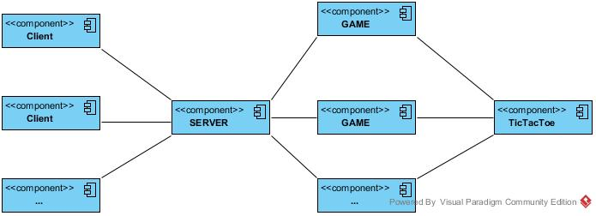

4. Process Flow
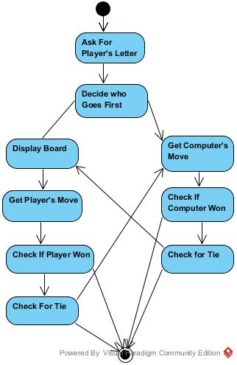
Figure 02 : Flow Chart for Tic Tac Toe Game

5. List of TicTacToe Object’s Methods
- inputPlayerLetter () : Let the player type which letter they want to be. Returns a list with the player player’s letter as the first item, and the computer’s letter as the second.
- whoGoesFirst(): Randomly choose the player who goes first
- makeMove(board, letter,move) :make the move transaction
- isWinner(board, letter): given a board and a player’s letter, this function returns True if that player has won.
- getPlayerMove(board): let the player type in their move.
- getComputerMove(board): create computer move.

6. List of Game Object’s Methods
- clientID start() : produced a new clientID, create a new Game Thread and returns unique clientID.
- stop(clientId): terminate the thread for clientId.
- parse(clientId, request): parse the request according to the Figure 01: Server XMLRPC API Messages

References
- Atay Özgövde, SWE545-Term Project-2016-2
- https://inventwithpython.com/chapter10.html

