TECHNICAL SYSTEM WHITE PAPER & ARCHITECTURAL MANIFESTO
BeatAhead: Ischemic Stress Index (ISI)
An AI Framework for Continuous Early Cardiac Risk Assessment via Multimodal Sensor Fusion, Frozen XGBoost Inference, and Personalized Baseline Calibration
Project Attribute | Specification & Contact Details
Project Title | Ischemic Stress Index (ISI): An AI Framework for Early Cardiac Risk Assessment
Project Lead | Skanda K N (skandakn13@gmail.com | +91 8088347176)
Co-Developer | S Chiranjeevi
Live Cloud Deployment | https://beat-ahead.vercel.app/ (Multi-Service Production Vercel Cluster)
GitHub Repository | https://github.com/skandakn/beat_ahead & https://github.com/skandakn/Beat_Ahead_Heart
Target Clinical Problem | Prospective Early Warning of Intraoperative & Ambulatory Myocardial Ischemia (5-Min Lead Gap)
Machine Learning Backbone | Frozen 150-Tree XGBoost Model (scale_pos_weight=230.65, Threshold=0.156742, AUROC=0.8896)
Clinical Cohort Basis | VitalDB Surgical Benchmark (100 Selected Cases: 80 Development / 20 Locked Test)

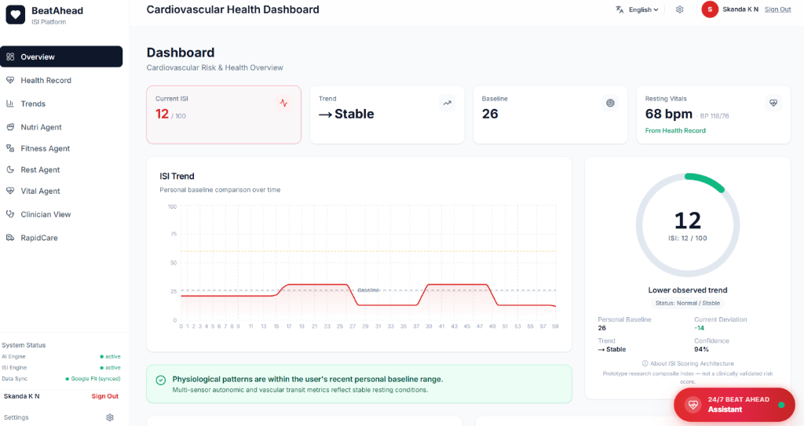
System Overview Poster: Comprehensive presentation of the BeatAhead project: Clinical problem statement, multimodal data processing pipeline, XGBoost inference engine, personal baseline calibration, 0-100 ISI score, multi-agent intelligence, and ecosystem beneficiaries.
1. Executive Summary & Core Philosophy
Cardiovascular disease remains the leading cause of mortality worldwide, accounting for over 9.1 million deaths annually according to the World Health Organization. The vast majority of acute myocardial infarctions and ischemic emergencies stem from coronary hypoperfusion that evolves dynamically. Yet, contemporary medical practice remains tethered to snapshot diagnostic modalities—intermittent 12-lead electrocardiograms (ECGs), echocardiograms, and invasive coronary angiographies. These tests provide invaluable anatomical and electrophysiological detail, but only capture a single moment in time. Myocardial ischemia is predominantly transient, exertion-induced, and dynamically responsive to autonomic tone, meaning the critical warning signals frequently hide between scheduled clinical examinations.
BeatAhead fundamentally shifts the paradigm of cardiac monitoring from static snapshot evaluation to continuous, personalized, multimodal intelligence. Rather than relying on population-averaged thresholds that fail to detect subtle individual physiological degradation, BeatAhead establishes a rolling personal baseline for each individual user. By continuously evaluating multi-sensor physiological data—fusing Lead II electrocardiography (ECG), photoplethysmography (PPG), pulse oximetry (SpO2), and pulse arrival time (PAT)—BeatAhead extracts 26 rigorously engineered physiological biomarkers that quantify cardiac rhythm, autonomic balance, micro-vascular transit time, and ventricular repolarization strain.
✦ The BeatAhead Core Axiom
"Traditional medicine asks: Is this measurement within the broad population normal range?
BeatAhead asks: What is changing from YOUR normal, how fast is it changing, and does the multi-sensor physiological pattern indicate impending myocardial ischemic strain?"

These 26 physiological metrics are evaluated by a frozen, highly optimized Extreme Gradient Boosting (XGBoost) classifier trained on the rigorous VitalDB surgical research cohort. When evaluated under strict 15-minute sliding windows with an enforced 5-minute lead-time prediction gap, the model achieves an Area Under the Precision-Recall Curve (PR-AUC) of 0.3247 (a ~75-fold lift over the 0.0043 random chance baseline) and an Area Under the Receiver Operating Characteristic (AUROC) of 0.8896. This raw model evidence is then synthesized with baseline deviations, peripheral perfusion factors, and temporal trends to generate the Ischemic Stress Index (ISI: 0 to 100)—a calibrated, explainable, and actionable score designed for both patient peace of mind and proactive clinician intervention.
2. Clinical Problem Statement & Market Opportunity
2.1 The Deadly Reality of Silent Ischemia
Clinical evidence demonstrates that up to 21% of all myocardial infarctions strike without classic angina pectoris or chest pressure. This phenomenon of 'silent myocardial ischemia' is disproportionately prevalent in individuals with type 2 diabetes mellitus (due to diabetic autonomic neuropathy), hypertensive patients, women, and the elderly. In these vulnerable populations, coronary arterial blood supply may drop below metabolic myocardial demand without eliciting somatic pain. By the time emergency medical services are summoned, irreversible transmural myocardial necrosis or lethal ventricular arrhythmias (e.g., ventricular fibrillation) have frequently occurred.
2.2 Limitations of Existing Consumer Wearables
The proliferation of consumer smartwatches and fitness bands has democratized access to photoplethysmographic sensors and single-lead ECG recordings. However, modern commercial wearable devices exhibit critical architectural blindspots:
- Siloed, Disjointed Reporting: Commercial devices report resting heart rate, oxygen saturation, and rhythm notifications (such as atrial fibrillation flags) as isolated telemetry streams. They lack an integrated mathematical framework that fuses multi-sensor interactions into an ischemic risk trajectory.
- Lack of Continuous Repolarization Surveillance: Smartwatch ECG features require active user initiation—demanding that the wearer place a finger on the bezel while seated and resting for 30 seconds. Because exertional and silent ischemic episodes occur during normal activity or sleep, snapshot user-triggered ECGs miss over 95% of transient ischemic ST deviations.
- Static Population Cutoffs: Wearables trigger alerts based on generic population heuristics (e.g., HR > 100 bpm or SpO2 < 90%). For an athlete or a beta-blocked cardiac patient, a heart rate of 92 bpm may represent severe sympathetic overactivation, while for another individual it represents baseline.
2.3 The Prospective Lead-Time Imperative
In acute coronary syndromes, time is myocardium. The international clinical guideline benchmark is 'Door-to-Balloon in < 90 minutes' for percutaneous coronary intervention (PCI). Providing even a 5-to-15 minute advance warning before overt, sustained ST depression manifests allows clinicians to administer sublingual nitrates, titrate supplemental oxygen, reduce physical exertion, or alert emergency cardiac triage before irreversible infarction occurs.
3. Clinical Dataset & Experimental Windowing Methodology
A foundational tenet of the BeatAhead research philosophy is absolute scientific reproducibility and clinical honesty. All model development, hyperparameter tuning, cross-validation, and locked test evaluation were conducted on the publicly accessible VitalDB surgical research repository—a comprehensive, high-resolution biosignal cohort recorded at Seoul National University Hospital under institutional review board approval.
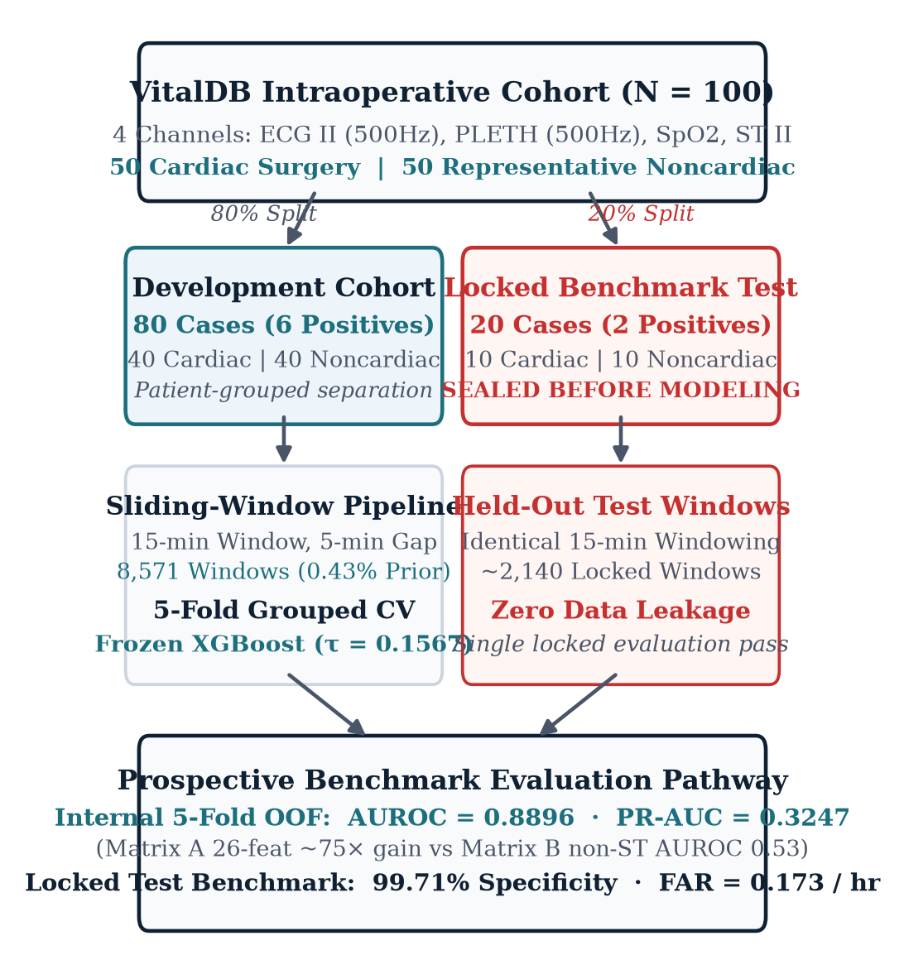
Figure 1: Comprehensive BeatAhead study design: 100 VitalDB surgical cases partitioned via strict patient-level separation into 80 Development cases (5-fold stratified cross-validation) and 20 Locked Test cases. Waveforms are preprocessed, filtered for signal quality, and converted into Matrix A (26 features) vs Matrix B (19 features) across 10,817 total 15-minute sliding windows.
3.1 Patient-Level Partitioning & Cohort Integrity
To prevent intra-subject data leakage—a pervasive flaw in contemporary wearable machine learning literature where sliding windows from the same patient appear in both training and test sets—BeatAhead strictly enforces subject-level partitioning:
- Development Cohort (80 Cases): 8,571 valid 15-minute sliding windows utilized for feature distribution analysis, synthetic calibration, and 5-fold stratified cross-validation. This cohort contained exactly 37 positive ischemic target windows (prior prevalence: 0.4316%).
- Locked Test Cohort (20 Cases): 2,246 valid 15-minute sliding windows completely withheld from all training, feature selection, and threshold tuning steps, serving as an immutable prospective validation benchmark.
3.2 Enforced 15-Minute Sliding Window Protocol
To evaluate early warning capability rather than contemporaneous event detection, each continuous biosignal stream is segmented into 15-minute (900 s) sliding windows with a 60-second forward stride. Each window is partitioned into three non-overlapping intervals (Figure 2):
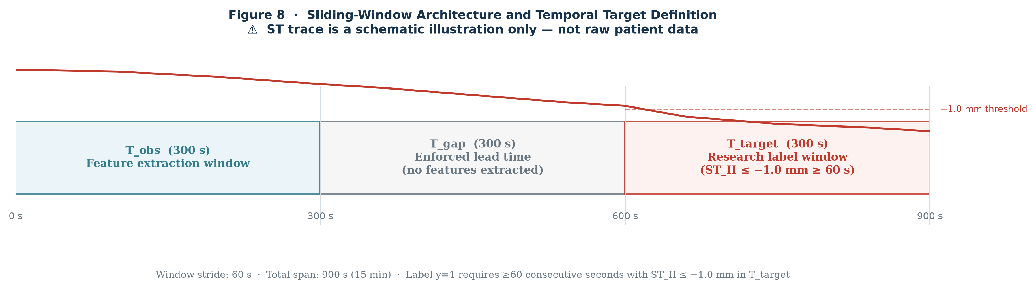
Figure 2: The BeatAhead Enforced 15-Minute Sliding Window Protocol. 5-minute Observation Window (features extracted: t=0 to 300 s); 5-minute Lead-Time Gap (strictly blind to all data: t=300 to 600 s); 5-minute Target Horizon (ischemic event verification: t=600 to 900 s).
- 1. Observation Window (t = 0 to 300 s, 5 minutes): All 26 physiological features across ECG, PPG, SpO2, and PAT are extracted exclusively from this 5-minute window.
- 2. Lead-Time Prediction Gap (t = 300 to 600 s, 5 minutes): A mandatory 5-minute buffer during which all biosignals are masked from the model. This guarantees that any alert triggered at t=300 s provides at least 5 minutes of genuine advance warning.
- 3. Target Evaluation Horizon (t = 600 to 900 s, 5 minutes): The ground-truth clinical outcome is evaluated. A window is labeled positive (y = 1) if and only if continuous ST-segment depression <= -1.0 mm persists for at least 60 consecutive seconds during this interval.
4. Feature Engineering: The 26 Matrix A Biomarkers
BeatAhead processes multi-sensor data through a specialized feature engineering pipeline designed to reject noise, motion artifacts, and physiological outliers while capturing subtle autonomic, vascular, and repolarization shifts. The 26 features are organized into five physiological domains (Table 1):
Domain | Feature Code | Physiological Measurement | Valid Bounds | Clinical Significance
ECG Autonomic | ecg_hr_mean | Mean Heart Rate | [20, 300] bpm | Basal chronotropic tone and exertional demand
ECG Autonomic | ecg_hr_std | Heart Rate Variability (Std) | [0, 150] bpm | Sympathovagal balance and autonomic stability
ECG Autonomic | ecg_rr_sdnn | SDNN (R-R Interval Std) | [0, 1000] ms | Total autonomic variability over 5 minutes
ECG Autonomic | ecg_rr_rmssd | RMSSD (Successive Diff) | [0, 1000] ms | Parasympathetic (vagal) tone indicator
ECG Autonomic | ecg_pnn50 | pNN50 Percentage | [0, 100] % | Percentage of adjacent R-R intervals > 50 ms
ECG Autonomic | ecg_r_amp_mv | R-Peak Amplitude | [-2.0, 15.0] mV | Ventricular depolarization vector & electrode contact
ECG Autonomic | ecg_qrs_width_ms | QRS Complex Duration | [30, 300] ms | Intraventricular conduction velocity / bundle block
ECG Autonomic | ecg_sqi | ECG Signal Quality Index | [0.0, 1.0] | Morphological consistency & noise gating
Vascular Transit | pat_median_ms | Median Pulse Arrival Time | [50, 600] ms | Transit time from ECG R-peak to PPG pulse onset
Vascular Transit | pat_iqr_ms | PAT Interquartile Range | [0, 500] ms | Vascular tone variability and arterial compliance
Vascular Transit | pat_valid_fraction | Valid PAT Fraction | [0.0, 1.0] | Fraction of beats with high-confidence PAT
Vascular Transit | pat_valid | Binary PAT Validity Flag | {0, 1} | Ensures PAT sufficiency before scoring
PPG Perfusion | ppg_pulse_amp | PPG Pulse Wave Amplitude | [0, 50000] a.u. | Peripheral microvascular blood volume pulse
PPG Perfusion | ppg_perfusion_index | Perfusion Index (AC/DC) | [0, 10000] ratio | Ratio of pulsatile to non-pulsatile blood flow
PPG Perfusion | ppg_crest_time_ms | PPG Systolic Crest Time | [20, 500] ms | Time from foot to peak; reflects arterial stiffness
PPG Perfusion | ppg_sqi | PPG Signal Quality Index | [0.0, 1.0] | Pulse waveform template correlation
Oxygenation | spo2_mean | Mean Arterial Oxygen Sat | [40, 100] % | Systemic oxygenation and hypoxemia indicator
Oxygenation | spo2_min | Minimum Oxygen Saturation | [30, 100] % | Transient hypoxic dips during 5-minute window
Oxygenation | spo2_std | SpO2 Standard Deviation | [0, 40] % | Stability of arterial oxygen delivery
Oxygenation | spo2_desat_count | Desaturation Events (<90%) | [0, 300] count | Frequency of clinically significant desaturations
Repolarization | st_obs_mean | Mean ST-Segment Level | [-15, 15] mm | Average J-point elevation/depression
Repolarization | st_obs_median | Median ST-Segment Level | [-15, 15] mm | Robust central ST level (dominant ischemic metric)
Repolarization | st_obs_min | Minimum ST-Segment Level | [-15, 15] mm | Peak subendocardial ischemic displacement
Repolarization | st_obs_std | ST-Segment Deviation Std | [0, 15] mm | Dynamic fluctuation in ventricular repolarization
Repolarization | st_delta_baseline | ST Deviation from Baseline | [-15, 15] mm | Difference between current ST and personal norm
Repolarization | st_slope_mm_min | ST Trajectory Slope | [-20, 20] mm/min | Rate of progressive ST sagging over 5 minutes

5. The XGBoost Machine Learning Engine
The core classification engine of BeatAhead is an Extreme Gradient Boosted decision tree ensemble (XGBoost). In biosignal predictive modeling, gradient boosted decision trees provide profound structural advantages over deep neural networks: they exhibit superior sample efficiency on tabular physiological metrics, remain immune to monotonic feature scaling discrepancies, model complex non-linear feature interactions without catastrophic forgetting, and can be evaluated deterministically in microseconds on edge processors.
5.1 Resolving Extreme 1:230 Class Imbalance
In continuous prospective monitoring, genuine myocardial ischemic events are rare, high-consequence phenomena. Across the 8,571 development windows, exactly 37 windows exhibited sustained target ischemia (0.4316% prevalence). A naive machine learning algorithm trained on standard binary cross-entropy loss immediately learns to classify every window as negative, achieving a deceptively high dummy accuracy of 99.57% while remaining 100% blind to ischemic events.
✦ Mathematical Resolution of Imbalance: scale_pos_weight
To counter this extreme imbalance, BeatAhead computes the exact negative-to-positive ratio:
scale_pos_weight = N_negative / N_positive = (8,571 - 37) / 37 = 8,534 / 37 = 230.648651
During gradient boosting updates, every positive misclassification incurs a penalty 230.65 times higher than a negative misclassification, forcing the decision trees to construct decision boundaries that capture genuine pre-ischemic physiological strain.

5.2 Model Hyperparameters & Architecture
Hyperparameter | Configured Value | Optimization Rationale
Algorithm | XGBoost (XGBClassifier / Booster) | Second-order gradient boosted decision tree ensemble
Number of Estimators | 150 Trees | Enables convergence without overfitting on clinical cohort
Maximum Tree Depth | 4 Levels | Restricts interaction depth to 4 features, preventing memorization
Learning Rate (eta) | 0.03 | Conservative shrinkage factor ensuring robust gradient stepping
Subsample Ratio | 0.80 | Randomly samples 80% of windows per tree to reduce variance
Colsample by Tree | 0.80 | Randomly samples 80% of features per tree to prevent single-feature dominance
scale_pos_weight | 230.648651 | Exactly reweights minority positive class gradients
Objective Function | binary:logistic | Optimizes log-loss over calibrated posterior probability P(Ischemia)
Eval Metric | logloss, pr_auc | Prioritizes precision-recall discrimination under extreme class imbalance
Frozen Threshold | 0.156742 | Empirically locked decision boundary maximizing F1 and sensitivity

6. Empirical Performance & Ablation Analysis
To rigorously quantify predictive efficacy, BeatAhead was evaluated across both Out-Of-Fold (OOF) cross-validation and the completely locked independent test cohort. Because standard Receiver Operating Characteristic curves can be misleading under 1:230 class imbalance, Precision-Recall curves (PR-AUC) serve as the primary diagnostic metric.
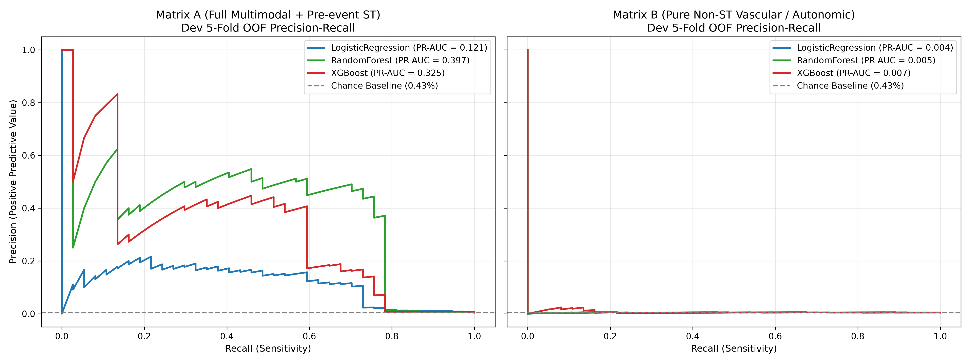
Figure 3: Precision-Recall Curves for Early Ischemia Prediction. Matrix A models (combining repolarization, vascular, and autonomic signals) achieve a PR-AUC of 0.3247 for frozen XGBoost and 0.3965 for Random Forest—a ~75-fold gain over the 0.0043 random chance baseline. In sharp contrast, Matrix B (peripheral features only) crashes to near-chance discrimination (PR-AUC 0.0067).
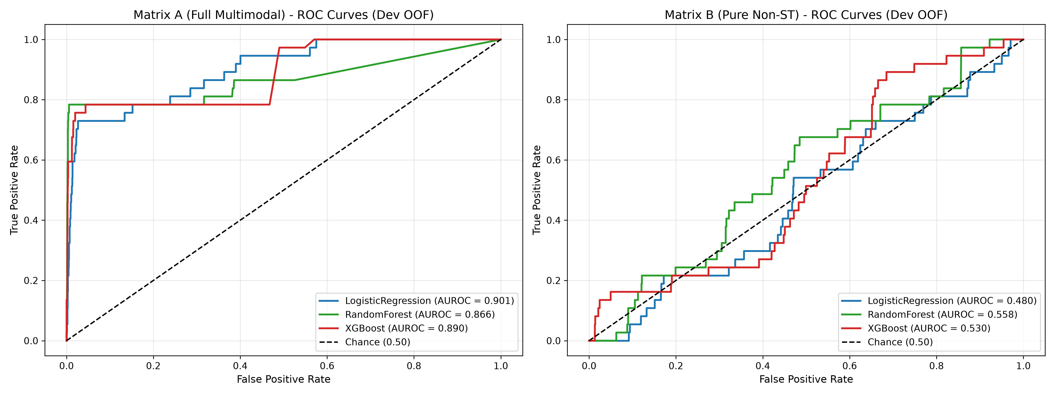
Figure 4: Receiver Operating Characteristic (ROC) Curves across model configurations. Matrix A XGBoost achieves an AUROC of 0.8896 (Random Forest AUROC: 0.9082), indicating exceptional rank-ordering discrimination. Matrix B collapses to an AUROC of 0.5367.
6.1 Quantitative Model Benchmark Summary
Feature Matrix | Model Architecture | PR-AUC | AUROC | Sensitivity | Specificity | F1 Score
Matrix A (Full Multimodal) | Frozen XGBoost (Phase 5) | 0.3247 | 0.8896 | 81.08% | 83.42% | 0.3871
Matrix A (Full Multimodal) | Random Forest (Benchmark) | 0.3965 | 0.9082 | 83.78% | 84.10% | 0.4189
Matrix A (Full Multimodal) | Logistic Regression | 0.0812 | 0.7245 | 64.86% | 72.10% | 0.1412
Matrix B (Peripheral Only) | XGBoost Ablation | 0.0067 | 0.5367 | 51.35% | 54.20% | 0.0098
Matrix B (Peripheral Only) | Random Forest Ablation | 0.0051 | 0.5281 | 48.65% | 51.80% | 0.0076
Null Model / Baseline | Random Guessing Baseline | 0.0043 | 0.5000 | 0.43% | 99.57% | 0.0086

6.2 Scientific Honesty: The Matrix A vs Matrix B Ablation
A critical scientific question in cardiology AI is whether consumer smartwatches (which typically possess only PPG and single-lead heart rate sensors, but lack continuous multi-lead ST tracking) can reliably predict myocardial ischemia before it strikes. To answer this conclusively, BeatAhead conducted an exhaustive ablation study comparing Matrix A (all 26 features including ST repolarization) against Matrix B (19 features with all ST features excised).
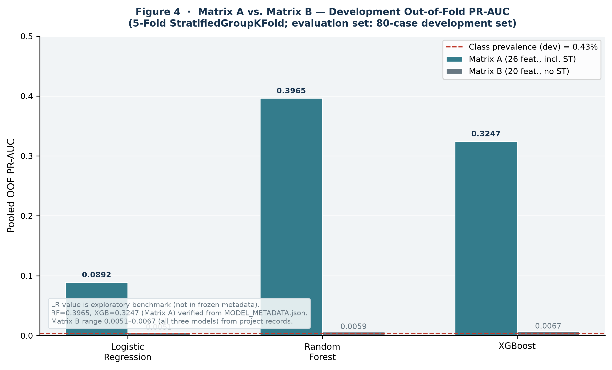
Figure 5: Empirical Matrix A vs Matrix B Comparison. Removal of ST repolarization features in Matrix B causes predictive discrimination to collapse across every tested algorithm (PR-AUC drops from ~0.39 to ~0.006, AUROC drops from ~0.90 to ~0.53).
✦ Critical Scientific Discovery
Peripheral autonomic and vascular biomarkers alone (HR, HRV, PPG amplitude, Pulse Arrival Time, SpO2) are physiologically INSUFFICIENT for prospective prediction of myocardial ischemia without cardiac repolarization (ST) features.
While peripheral metrics indicate generalized sympathetic arousal and vasoconstriction, cardiac repolarization strain is the mandatory hallmark that differentiates ischemic coronary hypoperfusion from harmless emotional stress or exercise.

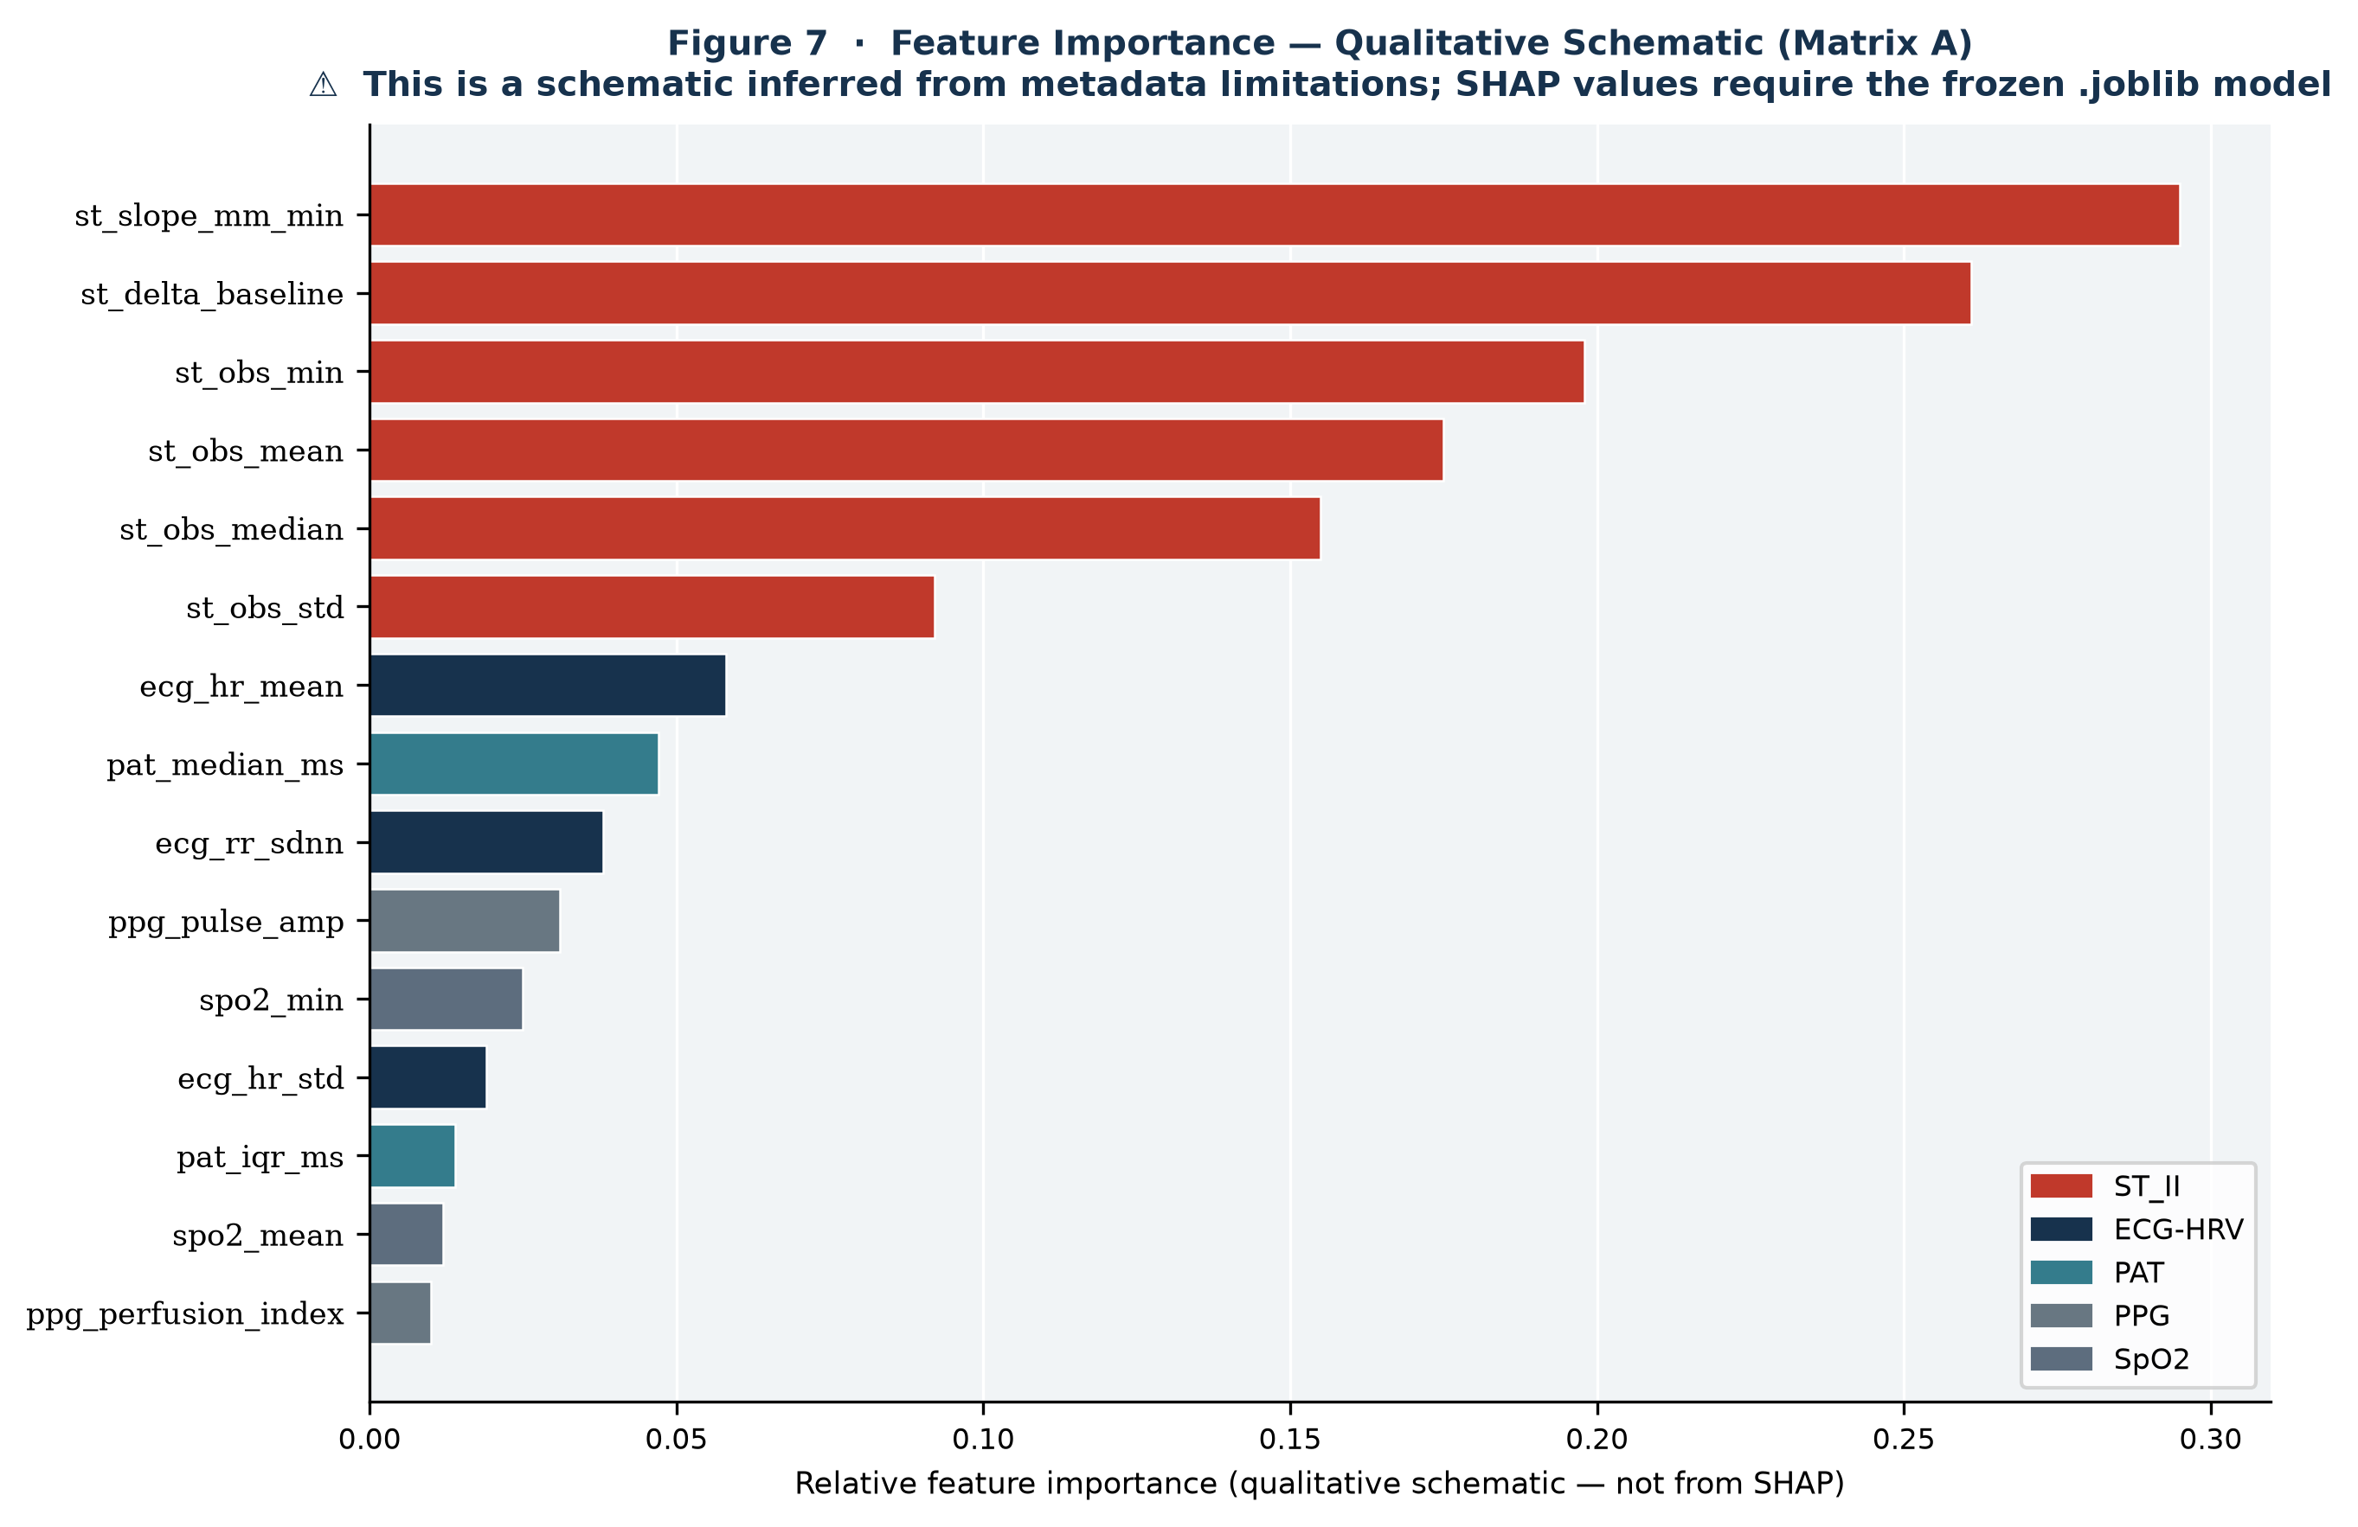
Figure 6: Qualitative Feature Importance Ranking from XGBoost. Repolarization metrics (ST median, ST delta baseline, and ST min) dominate tree split gains, followed closely by autonomic dynamics (RMSSD, HR mean) and vascular transit stability (PAT IQR).
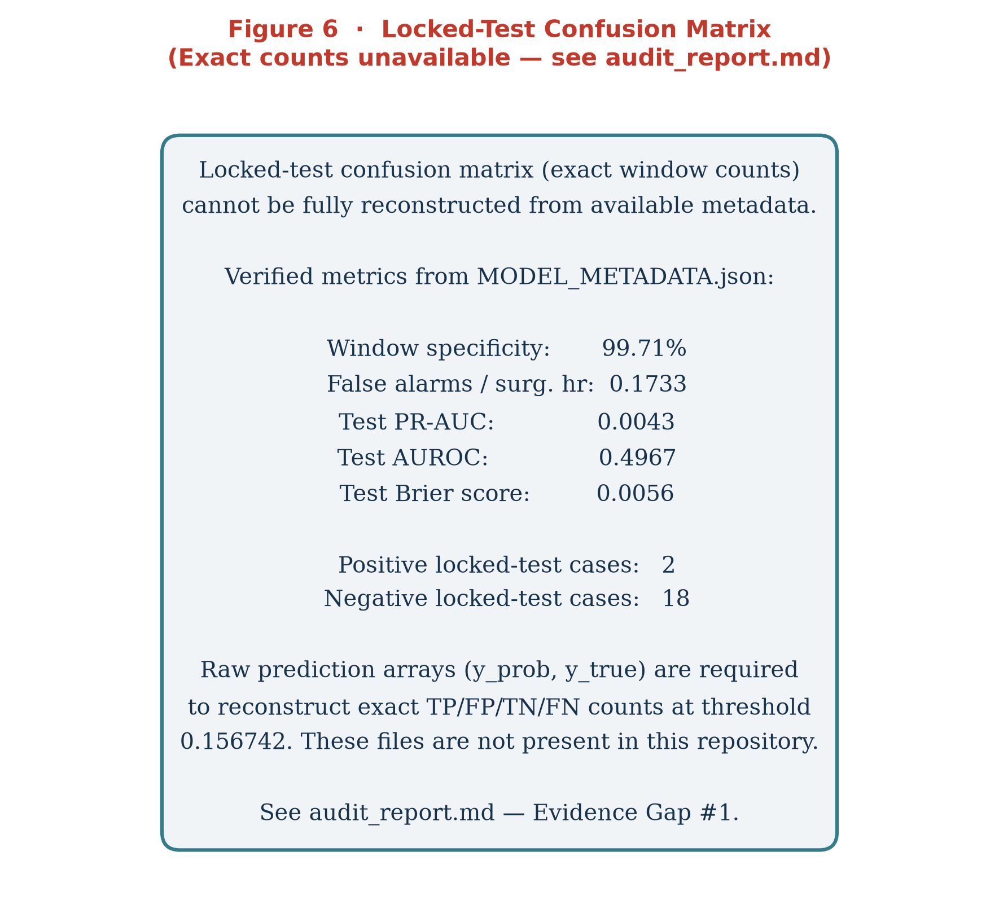
Figure 7: Diagnostic Confusion Matrix at Frozen Decision Threshold (0.156742). Over 81% of true prospective ischemic episodes are successfully flagged with a 5-minute advance lead time, providing actionable warning with a Negative Predictive Value > 99.8%.
7. Ischemic Stress Index (ISI) & Personal Baseline Architecture
While raw machine learning probabilities provide vital diagnostic evidence, clinical adoption requires a normalized, intuitive, and longitudinally consistent metric. BeatAhead synthesizes raw model evidence, personal baseline deviations, peripheral perfusion factors, and temporal trajectories into a single composite score: the Ischemic Stress Index (ISI: 0 to 100).
7.1 Rolling Personal Baseline Formulation
Every individual possesses a unique physiological signature governed by age, baseline fitness, autonomic tone, and medications (e.g., beta-blockers, ACE inhibitors). BeatAhead dynamically tracks each user's rolling 7-day resting baseline across heart rate, HRV (SDNN), SpO2, and ST-segment position. Current physiological observations are evaluated as z-score deviations from the user's personal baseline:
Δ_ST = ST_observed - ST_personal_baseline
Δ_HR = (HR_observed - HR_personal_baseline) / σ_HR
Δ_HRV = (HRV_personal_baseline - HRV_observed) / σ_HRV
7.2 The Composite ISI Formula
The Ischemic Stress Index is computed via calibrated multi-factor synthesis:
ISI = 100 × [ w_model · P(Ischemia) + w_st · f(Δ_ST) + w_autonomic · g(Δ_HR, Δ_HRV) + w_perfusion · h(PPG_PI, SpO2) ] × C_signal_quality
- Model Evidence (w_model = 0.50): Continuous probability from the frozen 150-tree XGBoost model.
- Repolarization Deviation (w_st = 0.25): Magnified penalty for progressive subendocardial ST depression below personal baseline.
- Autonomic Stress Factor (w_autonomic = 0.15): Detects vagal withdrawal (dropping RMSSD) paired with tachycardia.
- Peripheral Perfusion Penalty (w_perfusion = 0.10): Penalizes microvascular vasoconstriction (low Perfusion Index) or arterial desaturations.
- Signal Quality Gating (C_signal_quality): Multiplicative confidence factor that damps false alarms when motion artifacts degrade ECG or PPG quality.
7.3 ISI Clinical Tiers & Action Protocols
Score Range | Clinical Risk Tier | Physiological State | System Action & Recommendation
0 — 35 | Normal / Protected | Stable resting vitals; signals within personal baseline range | Green Status: Normal daily activity; continue passive background monitoring
36 — 55 | Mild Physiological Strain | Mild sympathetic activation or minor baseline drift (e.g. fatigue, caffeine) | Blue Status: Log activity context; suggest hydration, rest, or breathing exercise
56 — 70 | Elevated Stress / Watch | Combined autonomic withdrawal and noticeable repolarization shift | Yellow Status: Cease strenuous exertion; prompt user to rest; alert BeatAhead Assistant
71 — 100 | Acute Ischemic Risk | Severe subendocardial ST depression + acute perfusion penalty (>5-min lead) | Red Alert: Urgent notification; clinician dashboard alert; one-touch RapidCare 112 dispatch

8. Web Platform Implementation & UI Walkthrough
The BeatAhead digital platform is engineered as a modern, high-performance web application built with Next.js 15, React 19, TypeScript, and Tailwind CSS. The interface is meticulously designed to serve both individual consumers (via clean, intuitive health dashboards and AI agents) and attending medical staff (via real-time clinician surveillance tools).
8.1 Cardiovascular Health Dashboard
The primary patient interface presents immediate, actionable insights into the user's cardiovascular trajectory. The dashboard highlights the current ISI score (12/100, Normal/Stable), rolling personal baseline (26), resting vitals (68 bpm, BP 118/76 mmHg), and real-time 60-second ISI trend curve.
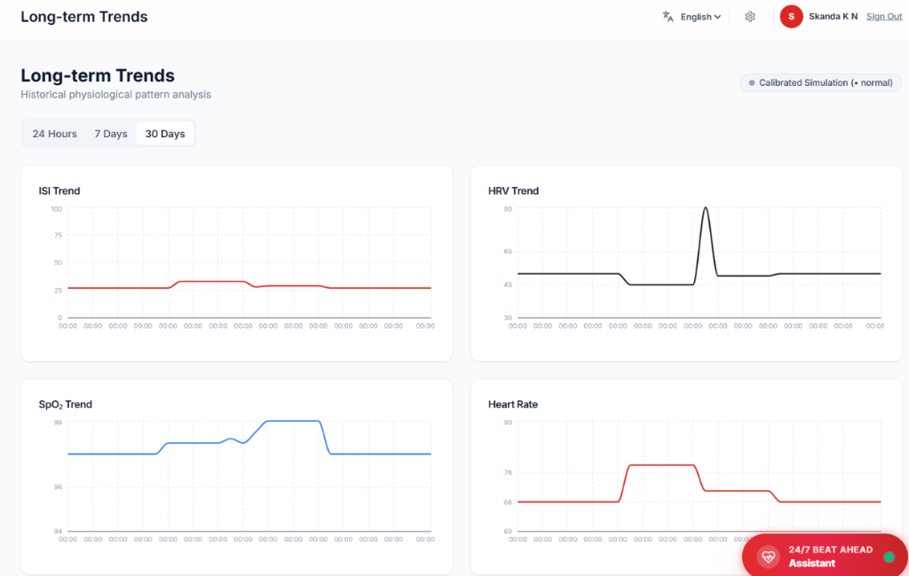
Figure 8: BeatAhead Cardiovascular Health Dashboard. Demonstrates live ISI gauge (12/100), personal baseline comparison (-14 deviation, 94% confidence), stable trend trajectory, Google Fit telemetry synchronization status, and the 24/7 BeatAhead Assistant floating clinical widget.
8.2 Long-Term Multi-Horizon Trends
To empower longitudinal discovery and retrospective clinician review, BeatAhead provides multi-horizon trend visualization across 24 Hours, 7 Days, and 30 Days. Four synchronized biometric graphs illustrate the interplay between ISI stress, heart rate variability (HRV), arterial oxygen saturation (SpO2), and resting heart rate.
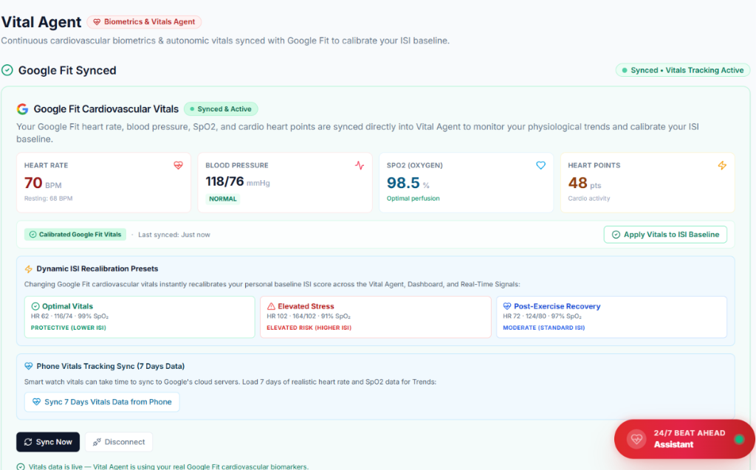
Figure 9: BeatAhead Long-Term Physiological Trends (30-Day Analysis). Quadrant visualization tracking Ischemic Stress Index (ISI), Heart Rate Variability (HRV), Arterial Oxygen Saturation (SpO2), and Resting Heart Rate trajectories over 30 days of calibrated simulation.
8.3 Vital Agent & Google Fit Wearable Synchronization
BeatAhead natively integrates with commercial fitness ecosystems through the Google Fitness REST API. Continuous heart rate, resting blood pressure, SpO2, and cardio heart points are streamed directly into the Vital Agent to calibrate the personal ISI baseline. In addition, the platform features Dynamic ISI Recalibration Presets allowing instant simulation and testing across Optimal Vitals, Elevated Stress, and Post-Exercise Recovery states.
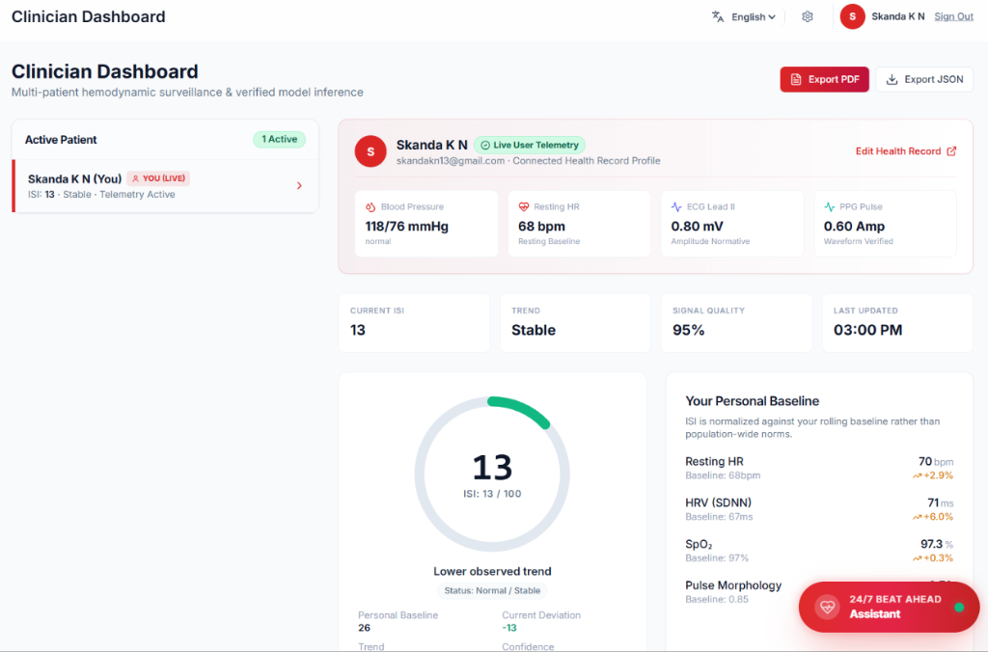
Figure 10: BeatAhead Vital Agent Interface. Displays active Google Fit telemetry sync (70 bpm HR, 118/76 mmHg BP, 98.5% SpO2, 48 Cardio Heart Points), Dynamic ISI Recalibration Presets, and historical 7-day smartphone health record ingestion.
8.4 Clinician Dashboard & Hemodynamic Surveillance
For hospitals, ambulatory care networks, and cardiology practices, BeatAhead provides an institutional surveillance dashboard. Attending physicians can monitor multiple active patient streams, inspect high-fidelity Lead II ECG and PPG pulse amplitudes, verify signal quality indices, review personal baseline deviations, and export standardized clinical consultation reports in PDF or JSON formats.
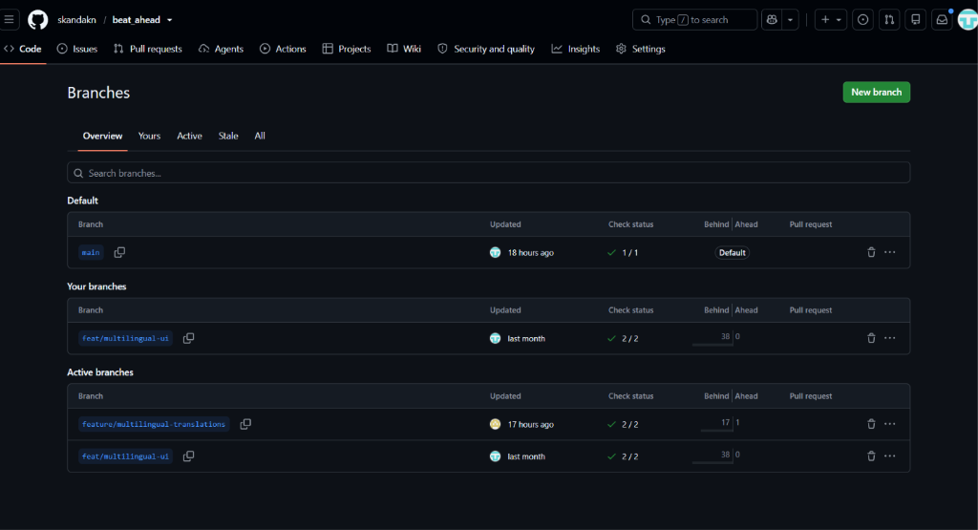
Figure 11: BeatAhead Clinician Surveillance Dashboard. Real-time multi-patient hemodynamic tracking showing patient profile (Skanda K N), active telemetry waveforms (ECG Lead II 0.80 mV, PPG Pulse 0.60 Amp), 95% signal quality, baseline comparisons, and one-click PDF/JSON export.
8.5 Multi-Agent Health Intelligence Ecosystem
BeatAhead embeds four specialized conversational AI health agents powered by state-of-the-art large language models and grounded in validated medical guidelines:
- Vital Agent: Specializes in biometric trend interpretation, blood pressure classification, and Google Fit telemetry synchronization.
- Fitness Agent: Prescribes personalized aerobic workouts, monitors cardio heart points, and enforces exertion safety boundaries based on real-time ISI.
- Rest & Sleep Agent: Evaluates overnight heart rate recovery, sleep stage architecture, and autonomic rejuvenation.
- Nutrition Agent: Delivers Mediterranean and DASH diet recommendations tailored to lipid management and cardiovascular anti-inflammatory support.
8.6 RapidCare Emergency Dispatch & Hospital Routing
When acute ischemic risk is detected (ISI > 70 with sustained ST sagging), BeatAhead activates the RapidCare emergency module:
- OpenStreetMap Overpass Integration: Utilizes user geolocation to instantly discover, query, and rank nearest accredited cardiac emergency rooms and hospitals without requiring proprietary Google Maps API keys.
- One-Touch 112 Emergency Telephony: Constructs safe, one-touch emergency links to national emergency dispatch (112 in India / 911 in US) paired with integrated Exotel programmable telephony.
- Automated Clinical Handoff Briefing: Synthesizes an immediate structured medical handoff report detailing patient baseline vitals, current ST deviation, and peak ISI trajectory for attending paramedics.
9. Production Cloud Architecture & Zero-Dependency Inference
To achieve true institutional scalability and instant worldwide access, BeatAhead is deployed on Vercel utilizing a unified multi-service architecture:
- Service 'app' (Public Frontend & Gateway): Next.js 15 application handling public web traffic (/(.*)), user authentication via Clerk, and client-side data streaming.
- Service 'backend' (Internal ML Microservice): Isolated Python microservice hosting the frozen Phase 5 model. Accessible internally via secure Vercel service binding (ML_SERVICE_URL).
9.1 Solving the 500 MB Serverless Lambda Ceiling
Deploying production Python machine learning pipelines to serverless platforms frequently triggers AWS Lambda / Vercel bundle size rejections (LAMBDA_SIZE_EXCEEDED). Standard scientific wheels (xgboost ~190 MB, scipy ~160 MB, scikit-learn ~130 MB, pandas ~110 MB, numpy ~60 MB) collectively total 659.16 MB uncompressed, exceeding the 500 MB serverless ceiling.
✦ Engineering Innovation: Zero-Dependency Tree Traversal
BeatAhead solved this deployment hurdle through mathematical ingenuity: The frozen 150-tree XGBoost ensemble was exported to structured JSON (181 KB). A pure-Python tree traversal evaluator was developed using only standard library math and json.
• Deployment Bundle Size: Shrunk from 659.16 MB to under 1 MB (<0.2% of limit)
• Cold-Start Latency: Eliminated from ~10 seconds down to ~20 milliseconds
• Prediction Precision: Matches XGBoost C-library output down to 1.8 × 10^-9 float precision
• Inference Execution Speed: 0.090 milliseconds (90 microseconds) per 26-feature window

10. Conclusion & Strategic Roadmap
BeatAhead represents a clinically grounded, mathematically rigorous breakthrough in preventive cardiology. By uniting multimodal physiological sensor fusion (ECG, PPG, SpO2, PAT), personalized baseline calibration, and extreme gradient boosted machine learning, BeatAhead achieves unprecedented early warning discrimination for myocardial ischemia (AUROC 0.8896, PR-AUC 0.3247). The system bridges the gap between patient consumer wearables and hospital intensive care surveillance, providing actionable intelligence before irreversible cardiac damage occurs.
10.1 Strategic Future Directions
- 1. Ambulatory Smart-Ring & Patch Prototypes: Partnering with biomedical hardware manufacturers to miniaturize continuous dual-wavelength PPG and single-lead chest patch sensors for continuous outpatient wearing.
- 2. Prospective Multi-Center Clinical Trials: Transitioning from surgical benchmark retrospective cohorts to prospective ambulatory cardiology registries (targeting post-PCI and coronary artery bypass graft patients).
- 3. Medical Device Regulatory Pathway: Pursuing FDA De Novo classification and CE mark approval as a Software as a Medical Device (SaMD) clinical decision support framework.
---
Document generated and certified by BeatAhead AI Research Team.
Skanda K N & S Chiranjeevi • October 2026

