BANGALORE INSTITUTE OF TECHNOLOGY
Department of Computer Science & Engineering
Course: Project Management with GIT (BCSL307A / BCS358C)
ACADEMIC LABORATORY RECORD (EXPERIMENTS 1 TO 7)

Student Name: | Skanda K N
USN: | 1BI25CS252
Terminal Identifier: | skandakn1BI25CS252@1BI25CS252-Skanda
GitHub Repository: | https://github.com/skandaknbit/BCS358C-Project-Management-with-Git

Experiment 1. Setting Up and Basic Commands
Aim / Problem Statement:
Initialize a new Git repository in a dedicated directory. Create a new file, add it to the staging area, and commit the changes with an appropriate commit message.
Step-by-Step Execution Procedure:
• Step 1: Create a separate directory for the experiment
$ mkdir exp1
• Step 2: Navigate into the project folder
$ cd exp1
• Step 3: Initialize the Git repository
$ git init
• Step 4: Configure user credentials globally
$ git config --global user.name "Skanda K N (1BI25CS252)"
$ git config --global user.email "skandakn13@gmail.com"
• Step 5: Create a new sample file
$ echo "Hi, this is Skanda K N (1BI25CS252)" > sample.txt
• Step 6: Display file contents to verify creation
$ cat sample.txt
• Step 7: Add the file to the staging area (Index)
$ git add sample.txt
• Step 8: Commit the staged file with an intention message
$ git commit -m "Initial commit"
• Step 9: Verify the working tree status
$ git status
• Step 10: View the chronological commit log in compressed single-line format
$ git log --oneline
Execution Terminal Window Screenshot:
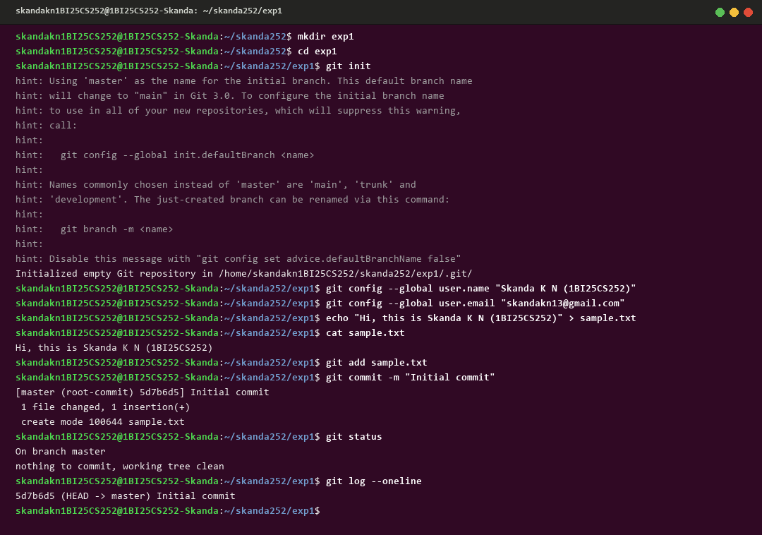

Experiment 2. Creating and Managing Branches
Aim / Problem Statement:
Create a new branch named 'feature-branch'. Switch to the 'master/main' branch. Merge the 'feature-branch' into 'master/main'.
Step-by-Step Execution Procedure:
• Step 1: Create a separate directory for the experiment
$ mkdir exp2
• Step 2: Navigate into the directory
$ cd exp2
• Step 3: Initialize the Git repository
$ git init
• Step 4: Switch to or establish the master branch
$ git checkout -b master
• Step 5: Create a baseline file on master
$ echo "Initial content on master" > mainfile.txt
• Step 6: Stage and commit the baseline file
$ git add mainfile.txt
$ git commit -m "Initial commit on master"
• Step 7: Create a new branch named 'feature-branch'
$ git branch feature-branch
• Step 8: Switch to the newly created feature-branch
$ git checkout feature-branch
• Step 9: Create and write new feature content
$ echo "New feature content" > feature.txt
• Step 10: Stage and commit the feature file on feature-branch
$ git add feature.txt
$ git commit -m "Add feature.txt on feature-branch"
• Step 11: Switch back to the master branch
$ git checkout master
• Step 12: Merge feature-branch into master
$ git merge feature-branch
• Step 13: View the commit graph and verify files
$ git log --oneline --graph
$ ls
Execution Terminal Window Screenshot:
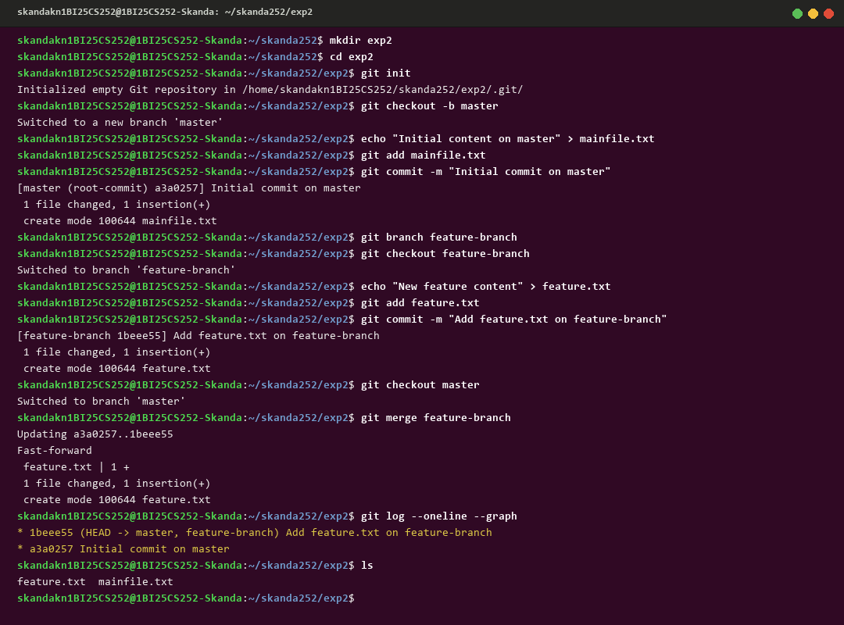

Experiment 3. Stashing Changes
Aim / Problem Statement:
Write the commands to stash uncommitted modifications in the current branch, switch branches, switch back, and re-apply the stashed modifications.
Step-by-Step Execution Procedure:
• Step 1: Create a separate directory for the experiment
$ mkdir exp3
• Step 2: Navigate into the directory
$ cd exp3
• Step 3: Initialize the Git repository
$ git init
• Step 4: Switch to master and make a base commit
$ git checkout -b master
$ echo "Base code for application" > app.txt
$ git add app.txt
$ git commit -m "Base commit"
• Step 5: Create a secondary branch for hotfixes
$ git branch bugfix-branch
• Step 6: Make uncommitted, experimental changes in the working directory
$ echo "Underconstruction draft code..." >> app.txt
• Step 7: Check working tree status to observe dirty state
$ git status
• Step 8: Stash uncommitted changes onto the stash stack
$ git stash
• Step 9: Switch to the bugfix branch with a clean working tree
$ git checkout bugfix-branch
• Step 10: Switch back to master
$ git checkout master
• Step 11: Re-apply the stashed modifications
$ git stash apply
• Step 12: Verify that modifications are restored
$ git status
$ cat app.txt
Execution Terminal Window Screenshot:
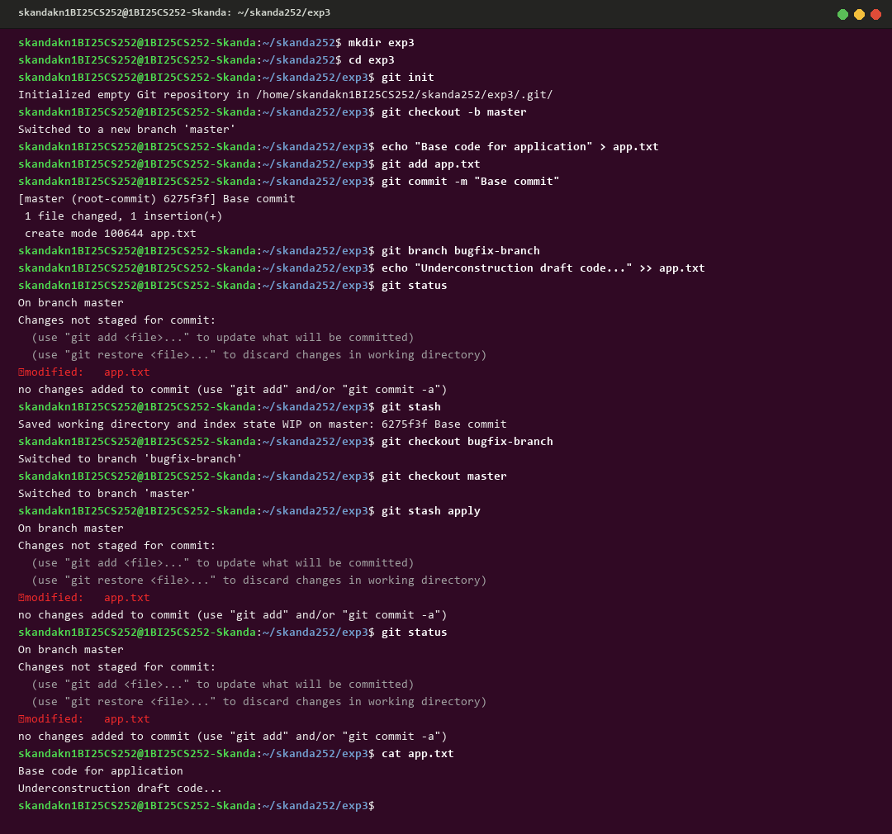

Experiment 4. Collaboration and Remote Repositories (Cloning)
Aim / Problem Statement:
Clone an existing remote Git repository from GitHub to your local machine, inspect remote bindings, and examine the historical commit log.
Step-by-Step Execution Procedure:
• Step 1: Create a separate directory for the experiment
$ mkdir exp4
• Step 2: Navigate into the directory
$ cd exp4
• Step 3: Initialize the Git repository
$ git init
• Step 4: Clone the remote repository from GitHub
$ git clone https://github.com/skandaknbit/BCS358C-Project-Management-with-Git.git
• Step 5: Inspect directory structure of the cloned repository
$ tree BCS358C-Project-Management-with-Git
• Step 6: Enter the cloned project folder
$ cd BCS358C-Project-Management-with-Git
• Step 7: Verify remote repository connection and URLs
$ git remote -v
• Step 8: View the last 5 commits from the cloned history
$ git log --oneline -5
Execution Terminal Window Screenshot:
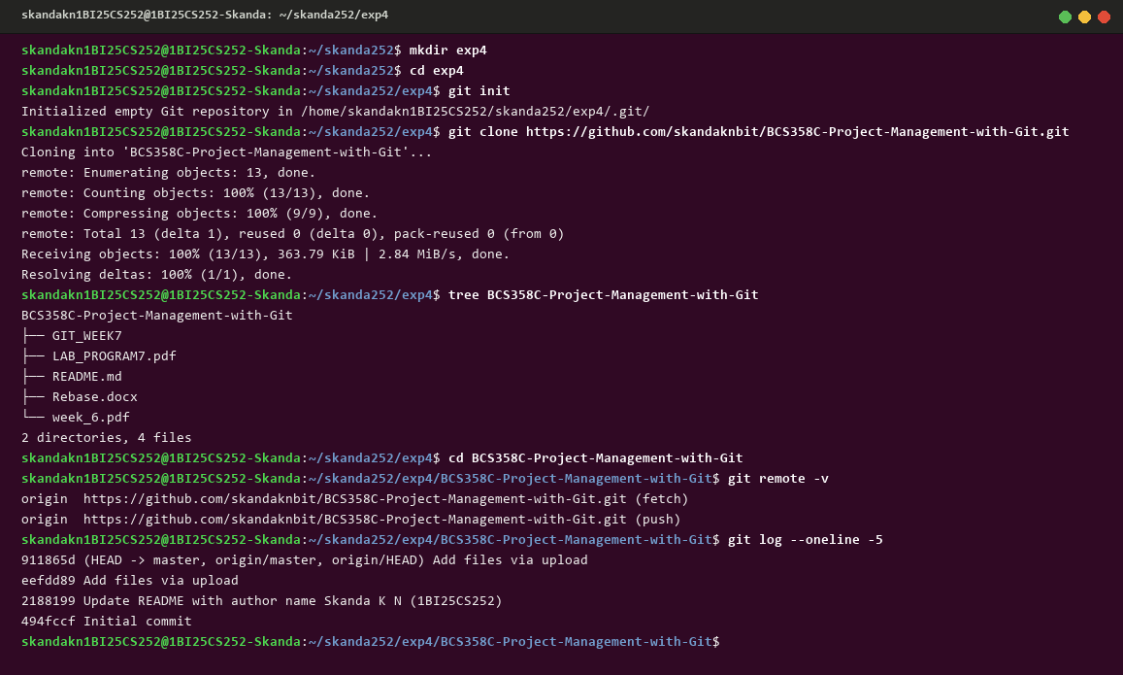

Experiment 5. Fetching and Rebasing
Aim / Problem Statement:
Fetch the latest changes from the remote repository and rebase your local branch onto the updated base branch to maintain a clean, linear commit history.
Step-by-Step Execution Procedure:
• Step 1: Create a separate directory for the experiment
$ mkdir exp5
• Step 2: Navigate into the directory
$ cd exp5
• Step 3: Initialize the Git repository
$ git init
• Step 4: Create root commit on baseline branch
$ echo "1st commit" > README.md
$ git add .
$ git commit -m "1st"
• Step 5: Create and checkout feature branch
$ git checkout -b feature
$ echo "branch commit" > README.md
$ git add .
$ git commit -m "2nd"
• Step 6: Switch to master and make an independent commit
$ git checkout -b master
$ echo "Master commit" > master.txt
$ git add .
$ git commit -m "3rd"
• Step 7: Switch back to feature branch
$ git checkout feature
• Step 8: Rebase feature branch on top of master
$ git rebase master
• Step 9: Inspect the linear commit graph
$ git log --oneline --graph
Execution Terminal Window Screenshot:
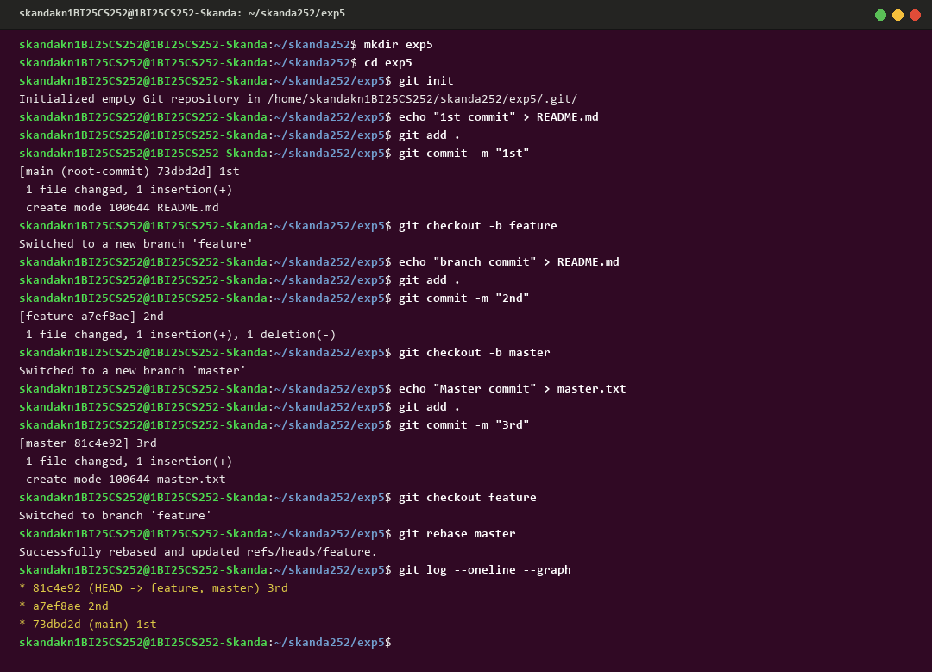

Experiment 6. Collaboration and Merging with Custom Commit Messages
Aim / Problem Statement:
Write the command to merge 'feature-branch' into 'master' while providing an informative custom commit message for the merge.
Step-by-Step Execution Procedure:
• Step 1: Create a separate directory for the experiment
$ mkdir exp6
• Step 2: Navigate into the directory
$ cd exp6
• Step 3: Initialize the Git repository
$ git init
• Step 4: Switch to master and create a project baseline
$ git checkout -b master
$ echo "Project baseline structure" > index.html
$ git add index.html
$ git commit -m "Initial commit"
• Step 5: Create and checkout feature-branch
$ git checkout -b feature-branch
• Step 6: Develop authentication module on feature branch
$ echo "Adding user authentication module" > auth.js
$ git add auth.js
$ git commit -m "Add authentication module"
• Step 7: Switch back to master branch
$ git checkout master
• Step 8: Perform non-fast-forward merge with a custom message
$ git merge feature-branch --no-ff -m "merge branch"
• Step 9: View the commit graph showing the explicit merge node
$ git log --oneline --graph
Execution Terminal Window Screenshot:
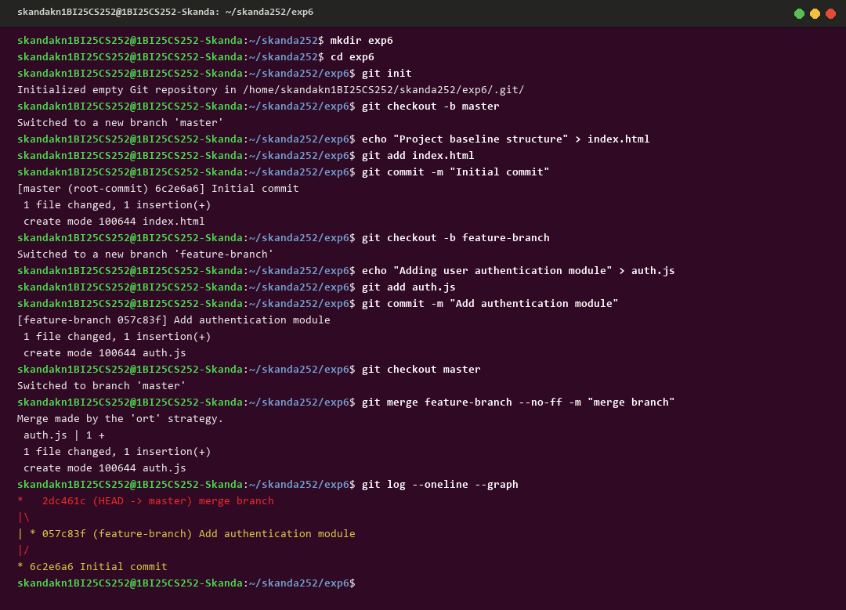

Experiment 7. Git Tags and Releases
Aim / Problem Statement:
Write the command to create a lightweight Git tag named 'v1.0' for a commit in your local repository.
Step-by-Step Execution Procedure:
• Step 1: Create a separate directory for the experiment
$ mkdir exp7
• Step 2: Navigate into the directory
$ cd exp7
• Step 3: Initialize the Git repository
$ git init
• Step 4: Configure user credentials
$ git config --global user.name "Skanda K N (1BI25CS252)"
$ git config --global user.email "skandakn13@gmail.com"
• Step 5: Verify configuration settings
$ git config --list
• Step 6: Create the first file
$ echo "Hello, I'm Skanda K N (1BI25CS252)" >> file1.txt
$ cat file1.txt
• Step 7: Add and commit the first file
$ git add file1.txt
$ git commit -m "1st commit"
• Step 8: Create the second file
$ echo "Skanda is from BIT (1BI25CS252)" >> file2.txt
$ cat file2.txt
• Step 9: Add and commit the second file
$ git add file2.txt
$ git commit -m "2nd commit"
• Step 10: View the chronological commit log
$ git log --oneline
• Step 11: Create a lightweight Git tag
$ git tag v1.0
• Step 12: Verify the tag creation
$ git tag
• Step 13: View the details of the tagged commit
$ git show v1.0
• Step 14: Connect the local repository to GitHub
$ git remote add origin https://github.com/skandaknbit/trial.git
• Step 15: Push commits and release tags to GitHub
$ git branch -M main
$ git push -u origin main
$ git push origin v1.0
Execution Terminal Window Screenshot:


