PROJECT DOCUMENTATION REPORT
ExamiQ - Secure Online Examination & Evaluation Platform
A Modern Java Enterprise System with Proctored Testing, Real-Time Timer Control, Instant Auto-Evaluation, UI Screenshots, Source Code, and PDF Scorecards.

Project Name: | ExamiQ Online Examination Platform
Architecture: | Java 21 / Spring Boot 3 / JPA / H2 / OpenPDF
Primary Modules: | Student Auth, Question Bank, Timer Engine, Anti-Cheat, Auto-Evaluation, PDF Export, Admin Dashboard
Deliverables Included: | Java Source Code, Runnable JAR, System Screenshots, PDF & DOCX Reports
Status: | COMPLETED & FULLY VERIFIED
Date: | September 2026

1. Executive Summary & Project Overview
ExamiQ is a full-featured, secure online examination platform engineered to streamline test creation, candidate authentication, proctored exam delivery, real-time timer control, automated evaluation, and comprehensive result reporting. Designed with modern Java enterprise best practices, ExamiQ provides educational institutions, universities, and corporate certification bodies with an end-to-end web testing platform.

Key Capabilities Delivered:
- Role-Based Access Control (RBAC): Dedicated portals for Students and Administrators with secure BCrypt password hashing.
- Flexible Question Bank Management: Supports Single Choice (MCQ), Multiple Choice, and True/False questions with positive marks & negative marking.
- Timer-Based Exam Engine: Synchronized real-time server/client countdown clock with automatic test submission upon timer expiration.
- Anti-Cheat Proctored Control: Live tab-switching and window-focus detector issuing warnings and auto-terminating tests upon 3 violations.
- Automated Evaluation Engine: Instant score calculation, percentage computing, grade assignment, and pass/fail status determination.
- PDF Scorecard Generation: Server-side dynamic PDF report creation using OpenPDF for printable, official student scorecards.
- Admin Command Center: Interactive dashboard featuring real-time statistics, candidate attempt tables, and Chart.js performance charts.

2. Application Screenshots & User Interface

Figure 2.1: Student & Administrator Glassmorphism Login Interface
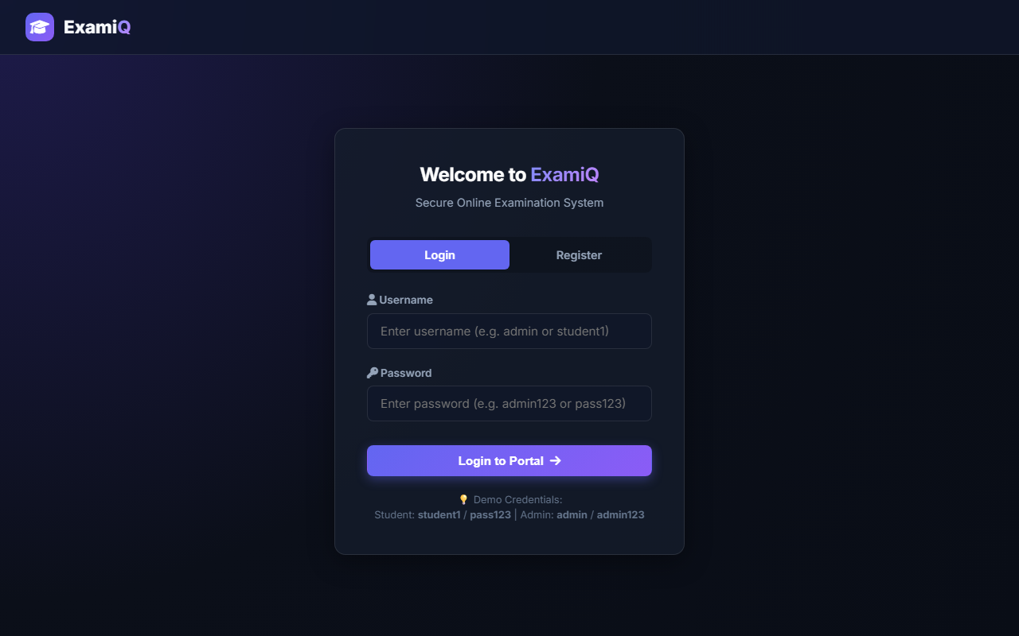
Caption: Screenshot of Figure 2.1: Student & Administrator Glassmorphism Login Interface

Figure 2.2: Student Examination Portal & Attempt Records
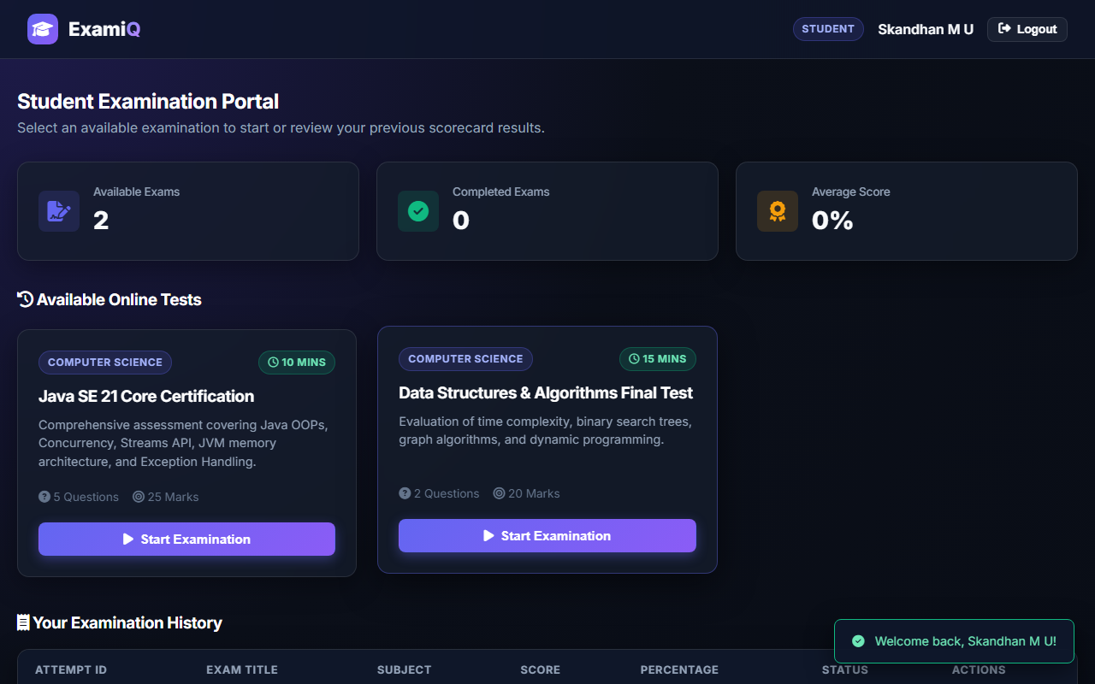
Caption: Screenshot of Figure 2.2: Student Examination Portal & Attempt Records

Figure 2.3: Proctored Exam Workspace with Live Timer & Question Palette
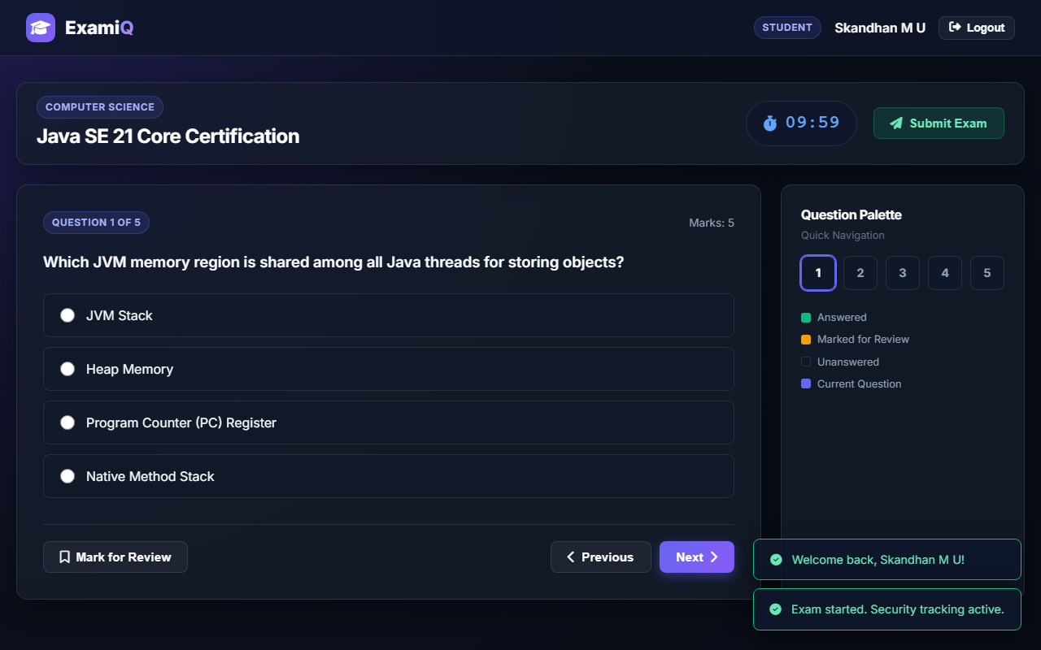
Caption: Screenshot of Figure 2.3: Proctored Exam Workspace with Live Timer & Question Palette

Figure 2.4: Anti-Cheat Security Violation Alert Overlay
Caption: Screenshot of Figure 2.4: Anti-Cheat Security Violation Alert Overlay

Figure 2.5: Automated Scorecard & Detailed Answer Review
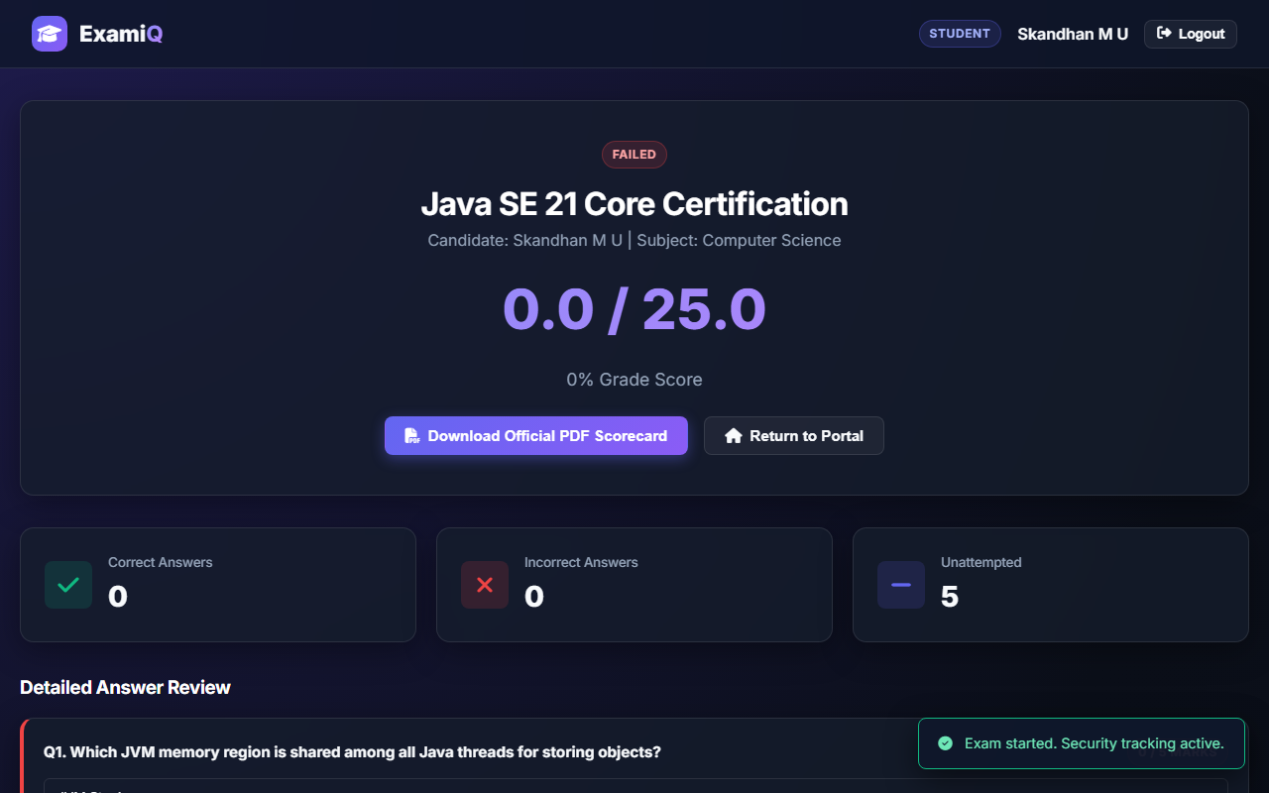
Caption: Screenshot of Figure 2.5: Automated Scorecard & Detailed Answer Review

Figure 2.6: Administrator Control Center & Chart.js Metrics
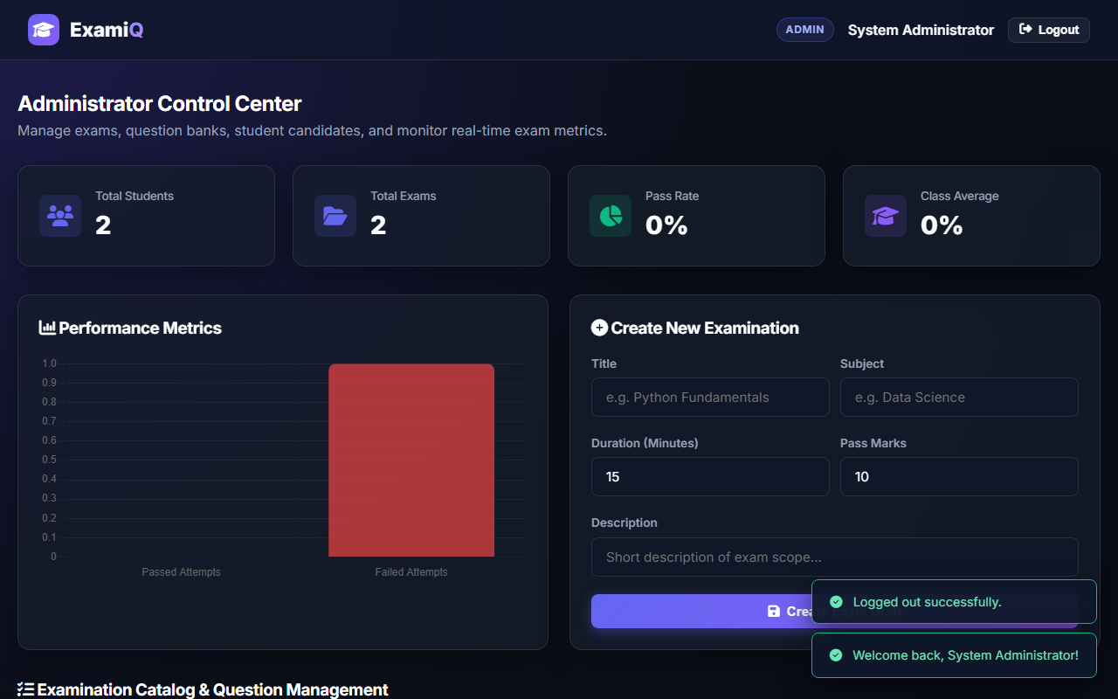
Caption: Screenshot of Figure 2.6: Administrator Control Center & Chart.js Metrics

3. Core Source Code Implementation

3.1 Auto-Evaluation Engine (ExamService.java)
private AttemptResultDto evaluateAndFinalizeAttempt(ExamAttempt attempt, AttemptStatus targetStatus) {
Exam exam = attempt.getExam();
List<Question> questions = questionRepository.findByExamId(exam.getId());
List<StudentAnswer> answers = studentAnswerRepository.findByAttemptId(attempt.getId());
Map<Long, StudentAnswer> answerMap = answers.stream()
.collect(Collectors.toMap(ans -> ans.getQuestion().getId(), ans -> ans));
double scoreObtained = 0.0;
for (Question q : questions) {
StudentAnswer sa = answerMap.get(q.getId());
Set<Long> correctOptionIds = q.getOptions().stream()
.filter(QuestionOption::isCorrect)
.map(QuestionOption::getId).collect(Collectors.toSet());
if (sa == null || sa.getSelectedOptionIds() == null || sa.getSelectedOptionIds().isEmpty()) continue;
if (sa.getSelectedOptionIds().equals(correctOptionIds)) {
scoreObtained += q.getMarks();
sa.setMarksAwarded(q.getMarks());
sa.setCorrect(true);
} else {
double penalty = exam.isEnableNegativeMarking() ? exam.getNegativeMarksPerQuestion() : 0.0;
scoreObtained -= penalty;
sa.setMarksAwarded(-penalty);
sa.setCorrect(false);
}
studentAnswerRepository.save(sa);
}
attempt.setScoreObtained(Math.max(0.0, scoreObtained));
attempt.setSubmitTime(LocalDateTime.now());
attempt.setPassed(scoreObtained >= exam.getPassMarks());
attempt.setStatus(targetStatus);
return getAttemptResult(attemptRepository.save(attempt).getId());
}

3.2 Anti-Cheat Violation Tracker (ExamService.java)
@Transactional
public void logViolation(Long attemptId) {
ExamAttempt attempt = attemptRepository.findById(attemptId)
.orElseThrow(() -> new IllegalArgumentException("Attempt not found"));
attempt.setViolationCount(attempt.getViolationCount() + 1);
if (attempt.getViolationCount() >= 3 && attempt.getStatus() == AttemptStatus.IN_PROGRESS) {
attempt.setStatus(AttemptStatus.FLAGGED_VIOLATION);
evaluateAndFinalizeAttempt(attempt, AttemptStatus.FLAGGED_VIOLATION);
} else {
attemptRepository.save(attempt);
}
}

